ExoBEM-Core: auditing and adapting the EnergyPlus engine for building energy simulation on the Moon and Mars
Liang Zhang^{a,*}
ª University of Arizona, Tucson, AZ, USA
* Corresponding author: liangzhang1@arizona.edu
[Draft for author review — confirm author list, affiliations, funding and target journal before submission.]

Highlights
- An audit of the EnergyPlus v26.2 engine found 252 Earth-specific assumptions in six subsystems.
- A planetary mode adds 1,609 lines to the engine; Earth results stay bit-for-bit identical.
- A body-specific hour-angle rate and a cabin-pressure convention let the existing heat balance run off-Earth.
- Cross-verified against an independent model: cooling within 0.01% (Moon) and 0.7% (Mars).
- Regolith-covered walls need a steady start-up profile; the default start gave a 32% load error.

Abstract
Building energy simulation engines such as EnergyPlus encode the Earth in many places at once: in the length of the hour and the motion of the Sun, in a single air pressure shared by the zone and the outdoors, in convection correlations for air at one atmosphere and in sky and ground models that assume an atmosphere. Simulating a habitat on the Moon or Mars with such an engine requires more than a new weather file. This paper reports ExoBEM-Core, a research fork of the EnergyPlus v26.2 engine with a planetary mode. A systematic audit of the 721-thousand-line C++ code base recorded 252 Earth-specific assumptions with file and line, 76 of them blocking a first habitat simulation. Guided by three rules (Earth results must stay bit-for-bit identical, existing physics is reused rather than rewritten, and inputs that cannot be right off-Earth are refused), the planetary mode adds 1,609 lines. It keeps the Earth clock but moves the Sun at the body's rate with a daily fit to the Mars24 or lunar ephemeris; replaces the weather with a generated planetary environment including a spun-up regolith column; stores the cabin pressure in the variable that zone and HVAC models already read; and replaces the exterior and interior boundary models with vacuum, thin-CO2 and cabin-gas physics. On Earth, 14 EnergyPlus example files give bit-for-bit identical results and all 2,379 unit tests pass. For a regolith-shielded habitat, ExoBEM-Core agrees with the independent Python model ExoBEM within 0.01% in cooling energy at the lunar equator and 0.7% at Jezero crater, with regolith surface temperatures within 0.05–0.21 K RMSE. The comparison exposed a general problem: walls whose time constant exceeds the warm-up period inherit their initial state, which caused a 32% load error until a steady start-up profile was introduced.
Keywords: EnergyPlus; building energy simulation; software verification; lunar habitat; Mars habitat; regolith; code audit

1. Introduction
Crewed surface habitats on the Moon and Mars will be buildings in the most literal sense: enclosed, occupied volumes whose heating, cooling and power systems must be sized for a climate, a schedule and an envelope [1, 2]. Building energy simulation (BES) answers these questions on Earth, and EnergyPlus is its most widely used open-source engine, with a heat-balance formulation that has been tested against analytical, comparative and empirical benchmarks for two decades [3–6]. A planetary habitat, however, violates assumptions that are built into such engines: the Moon's day lasts 29.5 Earth days and it has no atmosphere; Mars has an 88,775-second sol and a 600–800 Pa CO2 atmosphere; and the cabin air is at a pressure unrelated to the outdoors [7–9].
A companion paper presents ExoBEM, a compact Python re-implementation of the EnergyPlus heat-balance method with planetary physics, verified against EnergyPlus on Earth and against planetary reference data [10]. A re-implementation is quick to build and easy to verify, but it gives up most of what the full engine offers. This paper takes the other route and modifies the EnergyPlus engine itself. The main difficulty is not the planetary physics, which ExoBEM already provides, but finding every place where a large engine silently assumes the Earth, and changing them without disturbing terrestrial results.
The paper makes four contributions. (i) A systematic, line-level audit of Earth-specific assumptions in EnergyPlus v26.2, organized by subsystem and by what must change for a first planetary simulation. (ii) The design and implementation of a planetary mode in a fork named ExoBEM-Core, built on three rules that keep Earth results bit-for-bit identical. (iii) Verification on Earth by full-output regression and the unit-test suite, and off-Earth by cross-verification against the independent ExoBEM code. (iv) Lessons for adapting engines, notably the start-up of walls whose time constants exceed the warm-up period. Section 2 reviews how EnergyPlus meets its environment and the routes to off-Earth simulation, Section 3 the audit, Section 4 the planetary mode, Section 5 the verification, Section 6 discusses the approach and its limits, and Section 7 concludes.

2. Background

2.1 Where EnergyPlus meets its environment
EnergyPlus advances a nested loop over run periods, days, hours and zone time steps [3, 5]. At the start of each day the weather manager reads the next day of the weather file, computes the Earth solar declination and equation of time from Fourier fits keyed on the day of year, and interpolates the hourly records to the zone time step. Within the day the solar routines turn clock time, longitude and time-zone meridian into a sun direction with an hour angle that advances 15° per hour. The surface heat balance then applies exterior convection correlations for air, splits long-wave exchange among sky, air and ground, solves conduction with conduction transfer functions (CTF) [11] or the conduction finite difference (CondFD) algorithm [12], couples inside faces to the zone air, and passes the zone load to HVAC, plant and electric-power models, all of which take their air properties from the outdoor barometric pressure.
None of this is wrong on Earth; it is the reason EnergyPlus is fast and robust. But the Earth enters in many places at once, often as literals (3600 s, 15°/h, 1 atm, 9.81 m/s²) or as conventions (the ground is at air temperature; the zone is at outdoor pressure) that are not visible in the input. A model of a lunar habitat therefore cannot be made correct by editing the weather file alone, and an engine fork must first find where the planet is hidden.

2.2 Three routes to off-Earth building simulation
Previous work has taken one of two routes. The first keeps an Earth engine and replaces its weather: Mars Climate Database or rover data are written into EPW files and run through EnergyPlus front-ends [13–15], or climate-model output is coupled with design tools [16]. This keeps the tools but not the physics: the engine still uses a 24-hour Earth sun, air at outdoor pressure for convection and psychrometrics, and Earth sky and ground models. The second route builds a new model. Ross developed a semi-empirical habitat heat balance [17], and the companion ExoBEM tool re-implements the EnergyPlus heat-balance method in about 2,500 lines of Python with planetary physics throughout [10]. A re-implementation can be verified quickly, but it leaves out most of what makes EnergyPlus useful for design: multi-zone HVAC and plant, controls, electric systems, a large and tested input and output ecosystem (OpenStudio and its measures [18]), and decades of comparative testing [6].
The third route, taken here, modifies the engine itself. This is the hardest of the three because the Earth assumptions must be located in a large code base before any physics can be changed, and every change must leave terrestrial results untouched for the fork to remain trustworthy. It is also the route that lets planetary habitats inherit everything else the engine can do.

2.3 Licensing and naming
EnergyPlus is distributed under a BSD-3-Clause license with an additional clause from the U.S. Department of Energy: a modified version may be redistributed, but it may not be called "EnergyPlus", "E+" or a confusingly similar name without DOE consent, and the developers may not be used to endorse it. The fork is therefore named ExoBEM-Core, keeps the original license and copyright notices, states in its README that it is not EnergyPlus and is not endorsed by DOE or the National Laboratory of the Rockies (formerly NREL), and is published as a separate repository with the upstream history intact [19].

3. Auditing the engine for Earth assumptions

3.1 Audit method
The audit covered EnergyPlus v26.2.0, whose src/EnergyPlus directory holds about 721 thousand lines of C++ in .cc and .hh files, plus the third-party libraries it compiles (window calculation engine, Kiva). It was split into six areas that together cover every path from input to output: (1) time base, calendar, weather input and sizing; (2) solar geometry, sky and ground radiation; (3) psychrometrics, pressure, gravity and airflow; (4) the surface heat balance, conduction, convection and ground contact; (5) windows; and (6) HVAC, plant, heat rejection and electric power. Each area was searched for the symbols through which Earth enters the code (time constants, hour-angle and solar-constant literals, OutBaroPress, StdRhoAir, gravity constants, outdoor-air temperature used as a ground or sky proxy, empirical correlation coefficients and validity limits), and each hit was classified as bookkeeping (for example, an hour used as an array index) or physics (an hour used to convert a rate to energy).
Every finding records the file and line, the Earth value assumed, the consequence on the Moon and on Mars, a proposed change and a priority: P0 if it must change for a first single-zone, opaque habitat with constructions, internal gains and ideal loads; P1 if it is needed for windows, HVAC, plant, PV or realistic outputs; and P2 for rarely used modules that are better refused off-Earth than fixed. The search was carried out with the help of large-language-model code agents working from a common written brief, one agent per area; the findings acted on in this work were checked against the source during implementation. The six reports are published with the code [19].

3.2 What the audit found
The audit recorded 252 findings: 76 P0, 97 P1 and 79 P2 (Fig. 1). They are spread over all six areas, but the P0 findings cluster in four: time and weather, solar and sky radiation, pressure and air properties, and the exterior surface boundary. Windows have no P0 finding because no window code runs in a model without fenestration, and HVAC has only four because the ideal-loads system already turns outdoor air off when no outdoor-air specification is given. Table 1 lists representative findings.
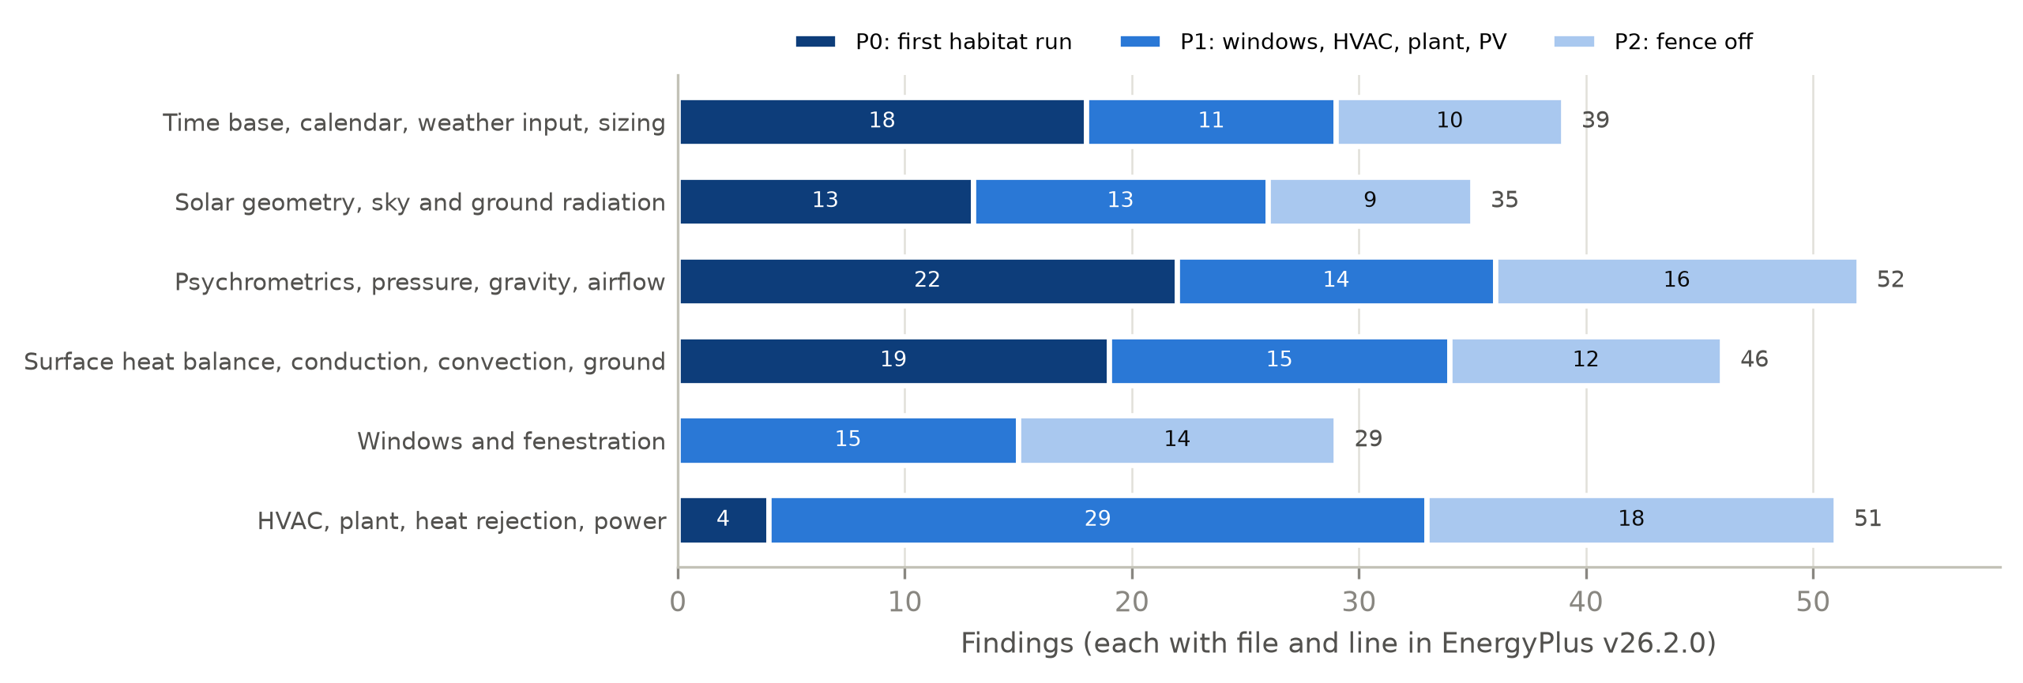
Fig. 1. Earth-specific assumptions found in EnergyPlus v26.2.0 by area and priority (252 findings). P0: needed for a first single-zone habitat with ideal loads; P1: needed for windows, HVAC, plant and PV; P2: rarely used modules that are refused off-Earth.
Table 1. Representative Earth assumptions found by the audit and their treatment in ExoBEM-Core.
Area | Earth assumption in the v26.2 code | Effect off-Earth | ExoBEM-Core M1
Time base | 1 h = 3600 s is a compile-time constant; 118 uses of rSecsInHour, 65 of them physical; CTFs computed in Earth hours | A longer 'planetary hour' would rescale physics in some places but not others, and CTFs by up to ×29.5 on the Moon | Earth clock kept (hour = 3600 s); sun rate generalized
Weather input | EPW range checks: dry-bulb ≥ 99.9 °C treated as missing; pressure ≤ 31 kPa replaced by the standard value | Lunar-day 120 °C and Martian 700 Pa silently altered | Generator overwrites each day after the read
Sun | Declination and equation of time from Earth Fourier fits (two copies); hour angle 15°/h | Wrong sun on any other body | Daily fit to Mars24 / lunar ephemeris; body hour-angle rate
Sky | Perez diffuse model (1353 W/m², Earth air mass); part of the sky long-wave view sees air | No basis in vacuum or dusty CO2 | Isotropic diffuse; all sky long-wave to the sky
Ground | Ground long-wave temperature = outdoor air at 10 sites; monthly ground temperatures | No air on the Moon; regolith swings 290 K | Regolith skin and deep temperatures from a 1-D column
Pressure | One pressure, OutBaroPress, for zone, HVAC and outdoor air (509 uses in 75 files) | Moon (0 Pa): zero air capacity, NaN humidity, one psychrometric routine never returns; Mars: 0.7% of the cabin's thermal mass | OutBaroPress carries the cabin pressure; new AmbientBaroPress
Convection | Every exterior correlation assumes air at 1 atm and 1 g, with a non-zero floor; TARP inside | Heat loss to air that does not exist; cabin convection overestimated about 2.3× on the Moon | Zero (Moon) or CO2 mixed convection (Mars) outside; physical correlation inside
Conduction | CondFD clamps nodes at −100 °C; walls start at 23 °C and warm up by repeating day 1 | Lunar-night surfaces near −180 °C; regolith time constants of months to years | −270 °C limit; steady start-up profile
HVAC and plant | Heat rejection to outdoor air; 354 OutBaroPress and 335 StdRhoAir uses in HVAC and plant | Cooling towers, air-cooled condensers and outdoor-air systems meaningless in vacuum | Refused with an error; space radiator planned
Windows | 4 thermal solvers, each with its own Earth gas and pressure constants | Interior film at outdoor pressure gives the floor value or NaN | Not yet supported

Three findings shaped the design. First, time is the most pervasive assumption but also the least visible. About 1,110 rate-times-time-step products go through two variables that are set in only 4 lines, which makes a variable hour length feasible, but 52 uses of the same constant are genuine unit conversions (kWh, air changes per hour, flow per hour) that must stay 3600 s, and the CTF generator works internally in Earth hours. A longer hour is therefore a deep change. Second, the engine has a single air pressure. About 350 of the 509 uses of OutBaroPress describe air inside the pressure shell and about 133 describe outdoor air; on the Moon the outdoor value is zero. Third, the exterior boundary hides air in places other than convection: in the long-wave split, in the ground temperature and in the moisture balance.

4. Planetary mode

4.1 Design rules
Three rules guided every change (Fig. 2):
- Earth stays bit-for-bit. Planetary mode is active only when the input contains a Site:PlanetaryBody object with Body = Moon or Mars. Every change is either behind that switch or replaces a literal by a variable whose Earth value is the same literal, so that IEEE floating-point results on Earth do not change.
- Reuse, do not rewrite. Planetary values are injected where EnergyPlus already reads its environment (weather arrays, sun direction, ground temperature, exterior and interior coefficients). The heat balance, conduction solvers, shading, view factors, ideal loads and reporting run unchanged.
- Refuse what cannot be right. Objects that need outdoor air or Earth weather stop the run with an error off-Earth instead of producing a plausible-looking wrong answer.
The result is small. The first milestone (M1) adds 1,609 lines and changes 12 in 17 files: a new PlanetaryBody module (1,277 lines), the input-object definition (150 lines) and about 182 lines of hooks in 14 existing files, which is 0.2% of the engine.
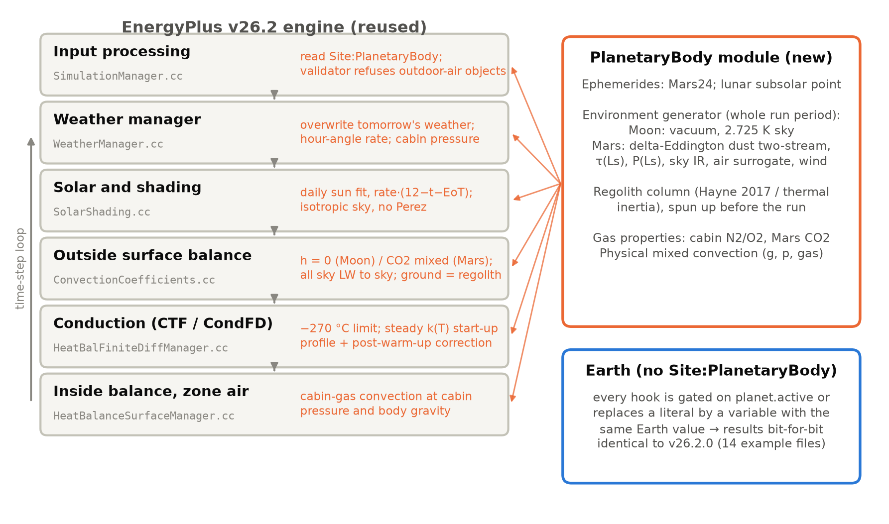
Fig. 2. Where ExoBEM-Core enters the EnergyPlus engine. Grey: unchanged EnergyPlus stages and the source files that carry the hooks; orange: what the hook does off-Earth. The new PlanetaryBody module supplies ephemerides, the environment, regolith temperatures and gas properties.

4.2 Input
A single new object, Site:PlanetaryBody, selects the body (Earth, Moon or Mars), the clock, a reference year and the habitat parameters: gravity (by default the body's surface value: 1.625 m/s² on the Moon, 3.721 m/s² on Mars), cabin pressure (70.3 kPa) and oxygen fraction (0.265), cabin air velocity (0.15 m/s) and a convection length scale. Optional fields set the horizon elevation, the regolith thermal inertia, albedo, emissivity and spin-up cycles, the deep-regolith depth, and for Mars the mean surface pressure, the dust optical-depth model (seasonal climatology or constant, with an optional global storm defined by start and end solar longitude and peak optical depth) and the wind. Everything else in the input file is standard. In M1 a weather file is still required, but it supplies only the calendar and the site; every weather value is replaced (Section 4.4).

4.3 Time base and sun position
The audit showed that a planetary hour would touch about a hundred physical uses of the hour length and the CTF generator. M1 therefore keeps the Earth clock: an hour is 3600 s and a day starts at 00:00 UTC, so that crew schedules, which follow Earth or mission time, are written as on Earth. What changes is the rate at which the Sun moves. EnergyPlus computes the hour angle in several places, all with the same expression; ExoBEM-Core replaces the literal 15 by a variable:
$$H=r\left[12 − \left(t + E\right)\right]+\left(λ_{TZ} − λ\right),r=\frac{{360}^{∘}}{P_{d}/3600s}$$ | (1)
where t is the clock hour, E the equation of time in hours, λ_{TZ} and λ the time-zone meridian and the longitude, and P_{d} the length of the solar day: 86,400 s on Earth (r = 15°/h, the original literal), the synodic month of 29.53 days on the Moon (r = 0.508°/h) and the sol of 88,775 s on Mars (r = 14.6°/h). For each simulated day the declination and E are fitted to the planetary ephemeris at 12:00 UTC: the declination is taken from Mars24 [8] or from the selenographic subsolar point [20], and E is chosen so that Eq. (1) reproduces the ephemeris hour angle H⊙ at mid-day,
$$E_{d}=\frac{H_{⊙}\left(12h\right)+λ_{TZ}−λ}{r}$$ | (2)
Because the hour angle is linear in time over a day on both bodies, Eq. (1) then follows the ephemeris through the day (Section 5.2). All downstream sun and shading routines, including the polygon-clipping shadow calculation, are reused. Two settings change off-Earth: the shading calculation is updated every day, because the declination fitted for one day does not hold for the next, and the hour angle is wrapped to ±180° before the sunrise test, because on the Moon it spans more than one revolution in a lunation.

4.4 Planetary environment
The weather manager reads the next day from the weather file and then calls the PlanetaryBody module, which overwrites every per-time-step value (dry-bulb temperature, beam and diffuse irradiance, sky temperature, pressure, wind) for that day. The values come from an environment generator that is a C++ port of the ExoBEM environment models [10] and is run for the whole run period before the simulation starts. On the Moon there is no diffuse light, the sky is at 2.725 K and the ground is a 1-D regolith column following Hayne et al. [7], spun up over six lunations. On Mars the beam and diffuse irradiance come from a delta-Eddington two-stream solution with a seasonal dust optical depth and an optional global storm [21, 22], the pressure follows the seasonal CO2 cycle, the sky emits as an effective dusty-CO2 layer, the near-surface air follows the ground with a lag, and a thermal-inertia regolith column is spun up over thirty sols. The regolith skin temperature and the deep-regolith temperature are kept for the surface boundary, and seven new output variables report the planetary environment (ground surface and deep temperature, ambient pressure, downwelling long-wave radiation, Sun distance, solar longitude and dust optical depth). Because values are overwritten after the weather file is read, none of the EPW range checks found by the audit can alter them.

4.5 Cabin and ambient pressure
The single-pressure finding admits two fixes: add a cabin pressure and change the roughly 350 zone and HVAC uses of OutBaroPress, or let OutBaroPress carry the cabin pressure and change the outdoor uses. ExoBEM-Core takes the second option. Off-Earth, OutBaroPress holds the cabin pressure, so the zone air balance, psychrometrics, ideal loads and every HVAC component see the air they actually contain, without edits; the standard pressure and density used for volume-to-mass conversions follow the cabin as well. A new variable, AmbientBaroPress, holds the real outdoor pressure (zero on the Moon, 600–800 Pa on Mars) and is used by the exterior convection model and the outputs. Almost all outdoor users of the old variable are outdoor-air systems, infiltration and heat rejection to air, and these are refused off-Earth (Section 4.9), so the option leaves no silent outdoor use of the cabin pressure in a valid input. The cabin gas is treated with moist-air psychrometrics at cabin pressure; at 26.5% oxygen the specific heat and gas constant differ from air by less than 0.4%.

4.6 Exterior boundary
Off-Earth, the exterior convection coefficient is replaced. It is zero in vacuum, and the EnergyPlus lower limit on the coefficient is bypassed. On Mars, a physical mixed-convection correlation is used for CO2 at the ambient pressure and the body's gravity, combining Churchill–Chu or horizontal-plate natural convection with flat-plate forced convection [23, 24]:
$$h={\left(h_{n}^{3} + h_{f}^{3}\right)}^{1/3},h_{n}=\frac{k}{L}Nu\left(Ra\right),Ra=\frac{gβΔTL^{3}ρ^{2}c_{p}}{μk}$$ | (3)
with Sutherland-type gas properties. The sky/air split of the long-wave view, which on Earth sends part of the sky view to the air temperature, is set to send all of it to the sky; the ground view, which on Earth sees the outdoor air temperature, sees the regolith skin temperature; and surfaces in contact with the ground use the deep-regolith temperature. The Perez anisotropic sky model is replaced by an isotropic sky, since its coefficients were fitted to Earth air masses [25]. Outdoor moisture exchange is switched off, and the sanity checks that stop a run when an outdoor or surface temperature falls below −100 °C are skipped.

4.7 Interior convection
Inside, the default TARP correlation describes air at one atmosphere and 1 g [26]. Natural convection scales roughly as (gρ²)^{1/3}, so at lunar gravity and 70.3 kPa TARP overestimates it by about 2.3 times. Off-Earth, ExoBEM-Core applies the same mixed-convection correlation to the cabin gas (nitrogen and oxygen at the cabin pressure and oxygen fraction) with the body's gravity and the cabin air velocity as the forced component. The override is placed before the EnergyPlus Energy Management System override, so users can still set coefficients from EMS.

4.8 Conduction and the start-up of regolith covers
CTF and CondFD run unchanged on the Earth clock. Two things change. The CondFD lower node-temperature limit of −100 °C becomes −270 °C off-Earth. More importantly, the start-up procedure had to be reconsidered. EnergyPlus starts every wall at 23 °C and repeats the first day until zone temperatures and loads converge. That works for walls with time constants of hours to days but not for a metre of regolith, whose time constant is months on Mars and years on the Moon: the warm-up converges on the zone while the regolith is still far from its periodic state. Off-Earth, ExoBEM-Core starts each CondFD construction from its steady conduction profile between the period-mean outer-face temperature T̄_{o} and the initial inside temperature T_{in},
$$T_{i}={\overline{T}}_{o}+\left(T_{in} − {\overline{T}}_{o}\right)\frac{R_{i}}{R_{tot}},R_{i}=\sum_{j<i}{\frac{Δx_{j}}{k_{j}\left(T_{j}\right)}}$$ | (4)
where the resistances follow each layer's temperature-dependent conductivity and are iterated six times. T̄_{o} solves the mean radiative–convective balance of the outer face under the generated environment (absorbed solar radiation, sky and ground long-wave exchange with T⁴-mean temperatures, and convection on Mars). At the end of warm-up the inside faces have reached their real temperature, so the profile is recomputed with that temperature and the difference is added to every node. The correction is zero at the outer face and does not disturb the daily cycle that warm-up has established there.

4.9 Refusing what cannot be right
After input processing, a validator stops the run with a severe error if the input contains an object that needs outdoor air or Earth weather. In M1 the list covers infiltration and ventilation objects, outdoor-air controllers, mixers and nodes, air-cooled and evaporatively cooled equipment (DX coils, packaged terminal units, VRF, the electric EIR chiller), cooling towers, fluid coolers and evaporative coolers, combustion and wind generators, PVWatts, the Kiva foundation model, AirflowNetwork, DElight, design days and sizing. Each of these would otherwise run and return numbers. The list is deliberately conservative; items leave it as their physics is generalized.

5. Verification

5.1 Earth: identical results and unit tests
The first rule was tested directly. 14 example files from the EnergyPlus distribution were run with an unmodified v26.2.0 build and with ExoBEM-Core, built with the same compiler (MSVC 14.44, release mode) and the same weather file (Chicago O'Hare TMY3), and every number of the complete output time series was compared. The files were chosen to exercise every hook (Table 2): CTF and CondFD conduction with temperature-dependent conductivity, every convection path, ground contact, windows and daylighting, sizing and design days, VAV and DX systems, plant and chillers, PV and batteries, moisture models, Kiva and solar collectors. All 14 gave bit-for-bit identical results. A fifteenth file (HAMT_HourlyProfileReport) fails with this weather file in both builds and was excluded. The full EnergyPlus unit-test suite (2,379 tests in 33 suites) also passes on the fork with 0 failures.
Table 2. Earth regression: ExoBEM-Core versus unmodified EnergyPlus v26.2.0, full output time series (Chicago O'Hare TMY3).
Example file | Exercises | Result
1ZoneUncontrolled | CTF, TARP/DOE-2 convection, solar | identical
1ZoneUncontrolledFourAlgorithms | CTF, CondFD, EMPD, HAMT mix | identical
1ZoneUncontrolledCondFDWithVariableKat24C | CondFD with k(T) | identical
1ZoneUncontrolled_FCfactor_Slab_UGWall | ground contact, F/C factor | identical
1ZoneUncontrolled_win_1 | windows | identical
5ZoneAirCooled | VAV, DX, sizing, design days | identical
5ZoneAirCooledConvCoef | user convection coefficients | identical
5ZoneWaterSystems | plant, water use | identical
ShopWithPVandBattery | PV, electric storage | identical
RefBldgSmallOfficeNew2004_Chicago | DOE reference building | identical
EMPD5ZoneWaterCooled_HighRHControl | moisture (EMPD), chillers | identical
ZoneCoupledKivaConvection | Kiva foundation | identical
DaylightingDeviceShelf | daylighting | identical
SolarCollectorFlatPlateWater | solar thermal collector | identical

5.2 Cross-verification against ExoBEM
Off-Earth there is no measured building to compare with, so the engine was compared with an independent implementation of the same physics: the Python ExoBEM, whose terrestrial core agrees with EnergyPlus within 0.7% and whose planetary models reproduce Mars24, Diviner, Appelbaum–Flood and MEDA reference data [10]. This is a comparative verification in the sense of Oberkampf and Roy [27]: agreement shows that the two codes solve the same equations correctly, not that the equations are right, which is the job of the reference-data checks.
Both programs simulated the ExoBEM case-study habitat: a horizontal cylinder of radius 3 m and length 10 m with 16 shell facets, under 1 m of regolith over MLI (Moon) or 20 mm of aerogel (Mars), with a cabin at 70.3 kPa and 26.5% oxygen, constant internal gains of 3,240 W and ideal loads holding 18–27 °C, at 3-minute time steps. The Moon case is at the equator of Mare Tranquillitatis for two lunations from 1 January 2030; the Mars case is at Jezero crater for 31 Earth days from the same date. The two programs share no code. ExoBEM-Core generates its environment with the C++ port and solves conduction with CondFD, the regolith's k(T) and c_{p}(T) entered as standard temperature-dependent material tables; ExoBEM uses its own finite-volume solver with a stretched grid and solves surfaces and air simultaneously. One simplification was needed: CondFD cannot resolve the 4 mm aluminium pressure wall at this time step, so its heat capacity was lumped into the interior panel and its negligible resistance (3×10⁻⁵ m²K/W) dropped. Results are compared over the second lunation on the Moon and days 16–31 on Mars, after both start-up procedures have settled.
Table 3. Agreement between ExoBEM-Core (C++) and ExoBEM (Python) for the regolith-shielded habitat.
Quantity (hourly values) | Moon, equator, 2nd lunation (720 h) | Mars, Jezero, days 16–31 (384 h)
Sensible cooling, C++ / Python (kWh) | 2305.8 / 2306.0 (-0.01%) | 737.5 / 742.9 (-0.73%)
Hourly cooling RMSE (W) | 0.3 | 14
Regolith surface temperature RMSE (K) | 0.05 (range -178.8 to 114.4 °C) | 0.21 (range -82.0 to -10.1 °C)
Sky temperature RMSE (K) | 0.00 | 0.06
Direct normal irradiance R² | 0.9998 | 0.9999
Diffuse horizontal irradiance R² | — (none) | 0.9999
Top facet outer-face temperature RMSE (K) | 0.33 | 0.64
Top facet inner-face temperature RMSE (K) | 0.002 | 0.05
Interior convection coefficient, C++ / Python (W/m²K) | 0.83 / 0.83 | 1.16 / 1.15
Exterior convection coefficient, C++ / Python (W/m²K) | 0 / 0 | 0.236 / 0.237

The environments agree closely (Fig. 3). The solar altitude follows the ephemeris over the whole lunation and over each sol, which confirms that the generalized hour angle with a daily fit is sufficient for both bodies; direct irradiance has R² of 0.9998 on the Moon and 0.9999 on Mars. The regolith surface temperature, from −179 to +114 °C on the Moon, agrees within 0.05 K RMSE and within 0.21 K on Mars; the Martian sky temperature within 0.06 K. The residual differences come from evaluating the sun at the end of each time step (the EnergyPlus convention) rather than at its middle, and from the hourly averaging of sub-hourly values.
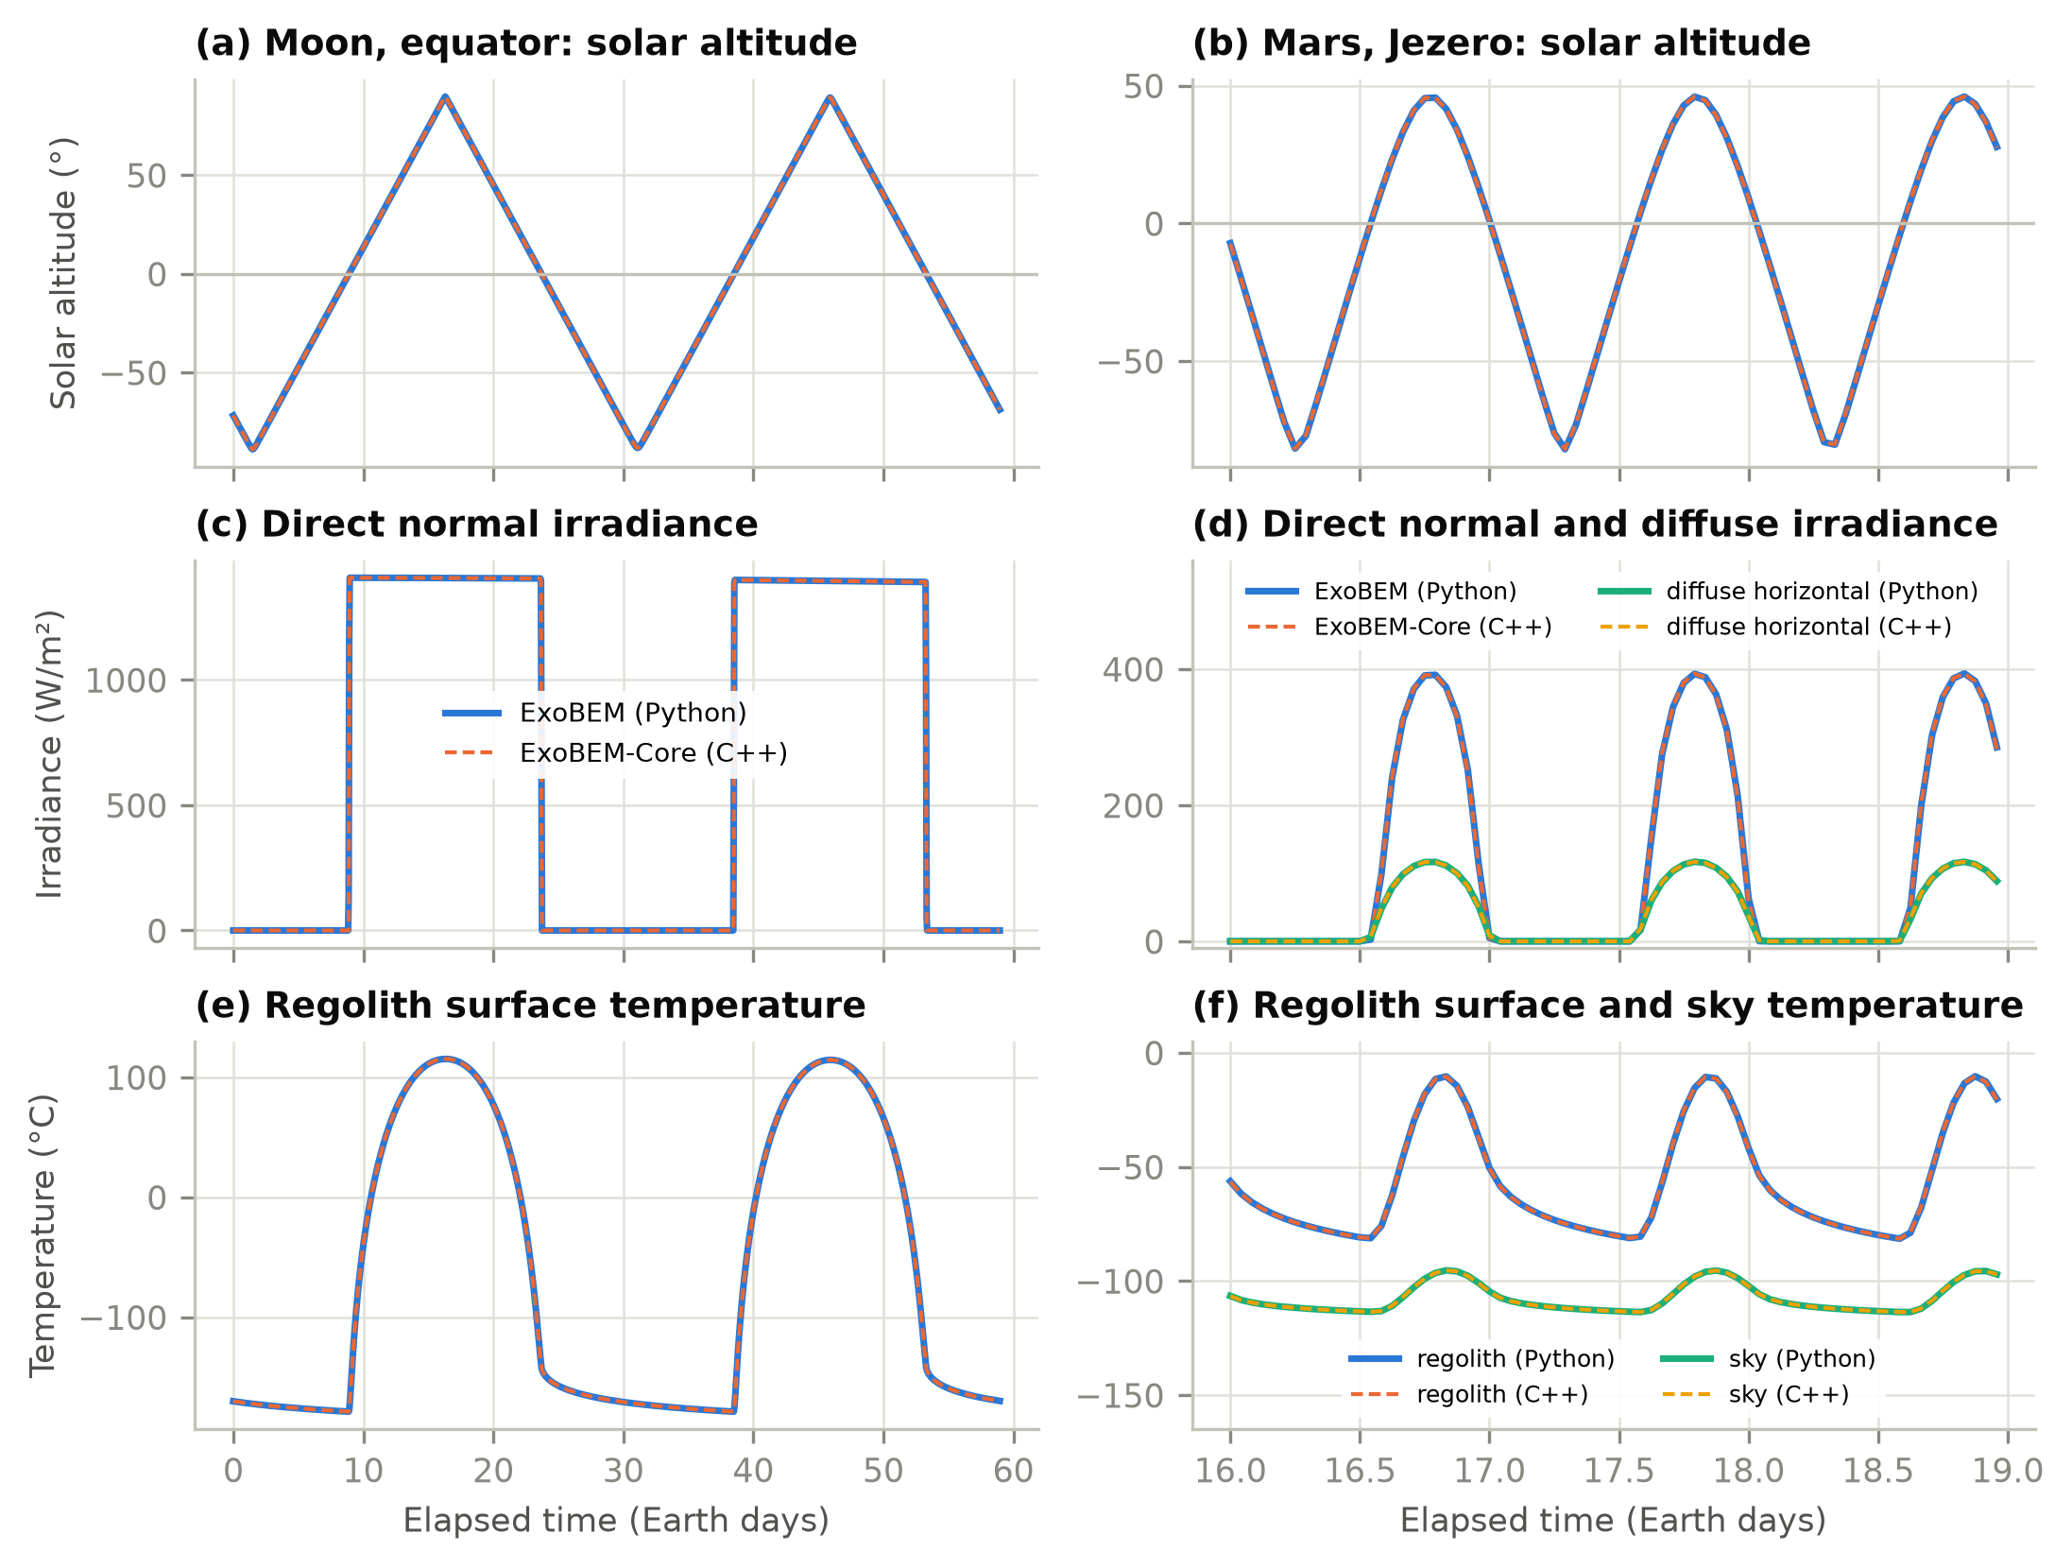
Fig. 3. Environment generated by ExoBEM-Core (C++, dashed) and by ExoBEM (Python, solid) at the lunar equator over two lunations (left) and at Jezero crater over three Earth days (right): (a, b) solar altitude, (c, d) direct normal and diffuse horizontal irradiance, (e, f) regolith surface and sky temperatures.
The habitat responses agree as well (Fig. 4, Table 3). On the Moon the cooling energy over the second lunation differs by -0.01% and the hourly cooling load by 0.3 W RMSE; the top facet's outer face, which follows the 290 K swing of the lunar day, agrees within 0.33 K and its inner face within 0.002 K. On Mars the cooling energy differs by -0.73% (hourly R² 0.998) and the interior convection coefficients by 1%. Most of the Martian difference is a slowly decaying offset: the CO2-filled regolith cover conducts about twenty times better than lunar regolith, so the envelope exchanges about 1.3 kW with the environment and its deep layers are still drifting after a month in both codes, from different starting states (a pseudo-transient steady state in ExoBEM, the profile of Eq. (4) in ExoBEM-Core). Differences in grid (CondFD's uniform nodes per layer versus a stretched grid) contribute as well.
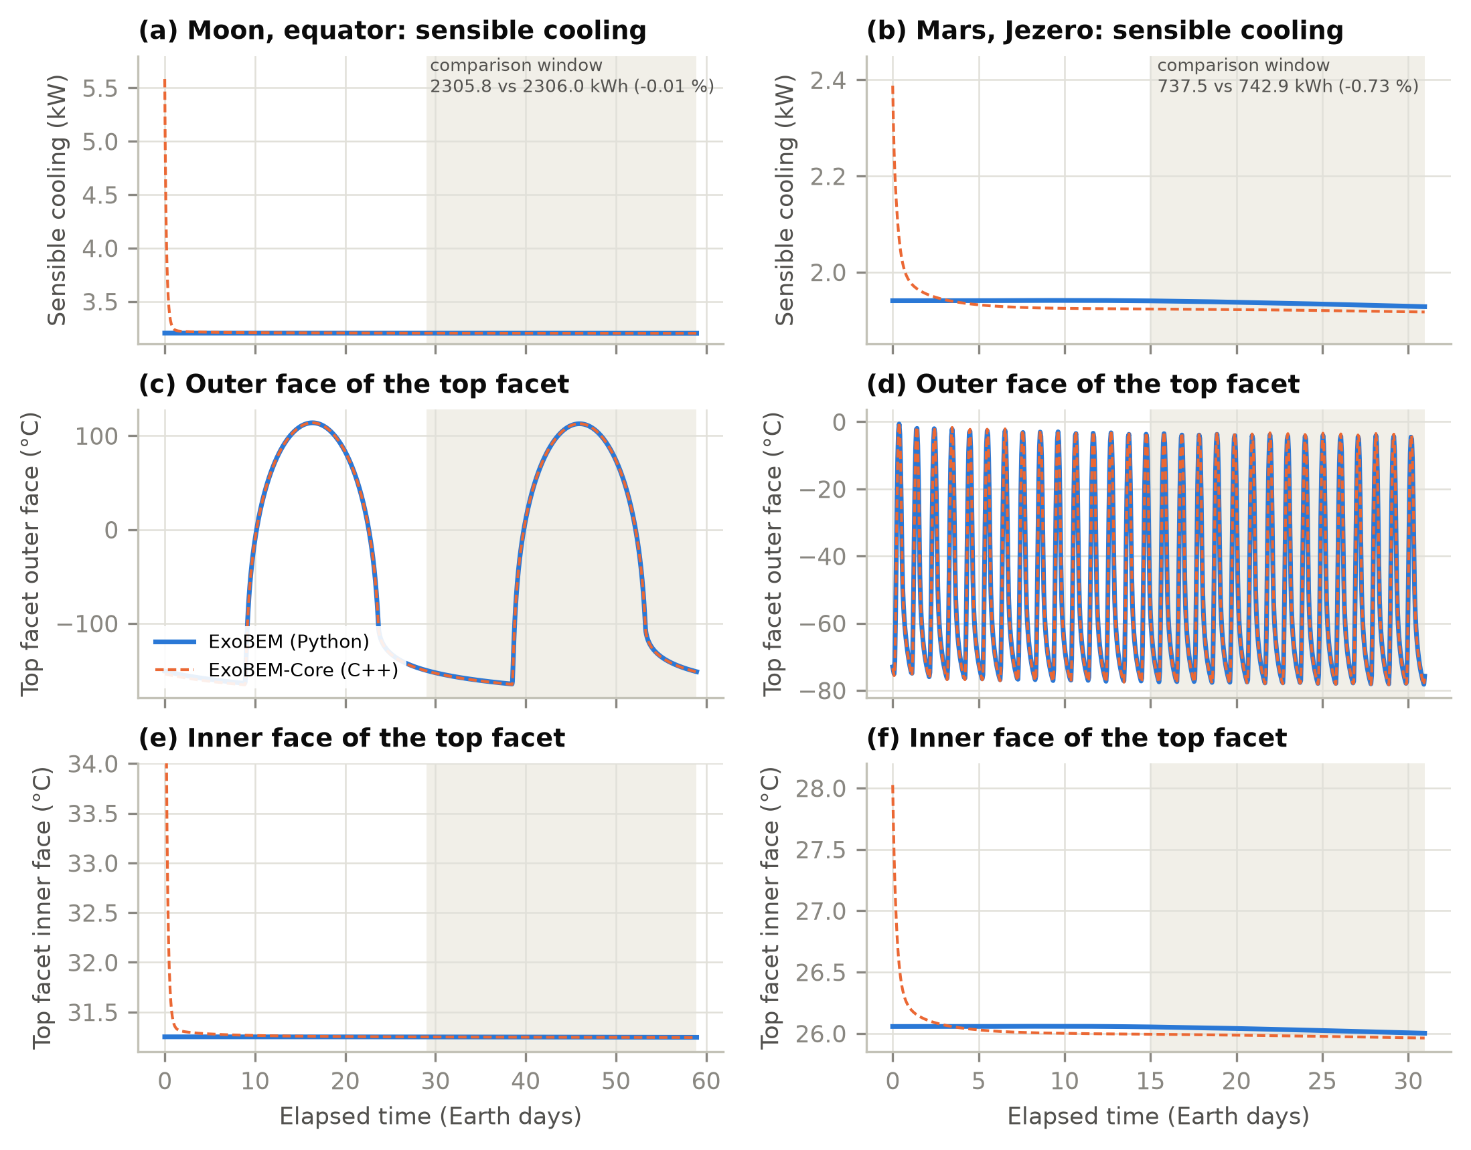
Fig. 4. Habitat response in ExoBEM-Core (C++, dashed) and ExoBEM (Python, solid) at the lunar equator (left) and Jezero crater (right): (a, b) sensible cooling load, (c, d) outer-face and (e, f) inner-face temperature of the top shell facet. The shaded band is the comparison window; the C++ transient in the first day is discussed in Section 5.3.

5.3 Start-up of regolith-covered walls
The start-up procedure turned out to matter more than any other choice in the port (Table 4). With the EnergyPlus default, walls at 23 °C and warm-up by repeating the first day, the Mars cooling load over the comparison period was 32% higher than in ExoBEM, because the inner part of the regolith cover was still releasing the heat of its unrealistically warm start. A steady linear profile with constant conductivities reduced the error to −2.5%, and the k(T)-aware profile of Eq. (4) with the post-warm-up correction to -0.7% on Mars and -0.01% on the Moon. The lesson applies beyond planetary habitats: any construction whose time constant exceeds the warm-up period, such as earth-sheltered walls or thick ground slabs, inherits its initial state for months.
Table 4. Effect of the wall start-up treatment on cooling energy over the comparison window.
Start-up treatment of CondFD walls | Moon cooling vs ExoBEM (%) | Mars cooling vs ExoBEM (%)
Walls start at 23 °C (EnergyPlus default) | not run | +32
Steady profile, constant conductivity | -1 | -2.5
Steady profile with k(T) and post-warm-up correction (M1) | -0.01 | -0.7

A short transient remains (Fig. 4): in the first day after warm-up, the ExoBEM-Core cooling load starts 0.4 kW (Mars) to 2.4 kW (Moon) high and decays within about a day, and the inner face of the shell starts 2 K (Mars) to 7 K (Moon) warm. The likely cause is that the post-warm-up correction is also added to the thin inner layers, which have already reached their real temperature during warm-up. Restricting the correction to layers deeper than the warm-up diffusion length is planned; the comparison windows exclude the transient.

6. Discussion

6.1 Re-implementation or engine modification?
Table 5. The two tools compared. Run times are for 3-minute time steps on the same computer, single thread.
Aspect | ExoBEM (Python) | ExoBEM-Core (C++)
Basis | Re-implementation of the EnergyPlus heat-balance method | Fork of the EnergyPlus v26.2.0 engine
Code | About 2,469 lines of Python (NumPy, SciPy) | 721 thousand lines of C++ reused; 1,609 added
Conduction and solution | Finite volumes on stretched grids; surfaces and air solved simultaneously | EnergyPlus CTF or CondFD; iterative surface and air balances
Scope | Single zone, ideal loads; radiator, heat pump, PV and storage as post-processors | All engine features that do not need outdoor air: multi-zone, HVAC and plant, controls, EMS, outputs; radiator component planned
Time base | Sol clock on Mars; Earth clock on the Moon | Earth clock on both (sol clock planned)
Input | Python objects or JSON | Standard IDF or epJSON plus Site:PlanetaryBody
Earth verification | ASHRAE 140 opaque cases vs EnergyPlus 23.2: annual loads within 0.7% | Bit-for-bit identical to v26.2.0 on 14 files; 2,379 unit tests pass
Planetary verification | Mars24, Diviner, Appelbaum–Flood, MEDA reference data | Against ExoBEM: cooling within 0.01% (Moon) and 0.7% (Mars)
Run time, habitat case | 197 s (Moon, 59 d); 112 s (Mars, 31 d) | 68 s (Moon); 3 s (Mars)
Best use | Early design, parametric studies, teaching, independent reference | Detailed design with EnergyPlus workflows, multi-zone habitats and systems

Table 5 compares the two routes. The re-implementation was the faster way to get the physics right: every planetary model in ExoBEM-Core is a port of an ExoBEM model that had already been checked against reference data, and having an independent code made it possible to find the start-up problem, which a single code would have hidden. The engine fork is the way to use that physics in practice. It inherits multi-zone air balances, HVAC and plant loops, controls, electric systems and reporting, and it runs the habitat cases faster than the Python code. The two are therefore complementary rather than competing: ExoBEM is the reference and the sandbox, ExoBEM-Core the engine.

6.2 Limitations
- Earth clock on Mars. Hours are 3600 s, so the Martian day drifts by about 40 minutes per Earth day against the clock. Physics is right, but schedules cannot follow local solar time.
- Placeholder weather file. A weather file is still read for the calendar and the site; runs without one, and planetary design days and sizing, are planned.
- Windows, radiators and PV. Fenestration, a space-radiator plant component and PV in vacuum are not yet available; heat rejection is represented by ideal loads.
- Cabin gas. Psychrometrics use moist air at cabin pressure; a gas-mixture block for other cabin atmospheres is planned.
- Gravity. Body gravity is used in the new convection correlations only; window gaps, airflow networks and stack effects are refused or still use 9.81 m/s².
- Thin metal layers. CondFD cannot resolve millimetre aluminium shells at minute time steps, so they must be lumped or modelled with CTF.
- Start-up transient. About a day of residual transient follows warm-up (Section 5.3).
- Verification scope. Off-Earth verification is comparative (two codes, one habitat type); empirical data from thermal-vacuum tests or analog habitats are still needed.

6.3 Roadmap
The audit provides the work list for the next milestones. M2 introduces a sol clock for Mars by making the hour length a run-time variable: the audit identified the four lines that set the time-step lengths, the 65 physical uses of the hour constant that must follow it and the 52 unit conversions that must not, and the change to the CTF generator's hour-based units. M2 also adds a cabin gas-mixture block for psychrometrics, body gravity in every buoyancy model, runs without a weather file and planetary design days. M3 adds a space-radiator plant component, modelled on the fluid cooler with a surface link like the flat-plate solar collector, a PV cell-temperature model for vacuum and windows with vacuum-compatible solvers. Because every change is gated on the planetary object and Earth results are unchanged, the planetary mode could in principle be offered upstream as an optional feature; until then it is maintained as a fork that tracks EnergyPlus releases.

7. Conclusions
ExoBEM-Core shows that a mature building energy simulation engine can be adapted to the Moon and Mars with a small, well-placed change. The hard part is finding the Earth: the audit of EnergyPlus v26.2 recorded 252 Earth-specific assumptions, hidden in time constants, a single shared air pressure, exterior boundary conventions and empirical correlations. Once they are known, a planetary mode of 1,609 lines suffices for regolith-shielded habitats with internal gains and ideal loads: the Sun moves at the body's rate, the weather is replaced by a generated planetary environment, the cabin pressure takes the place of the outdoor pressure, and the boundary models follow vacuum, thin CO2 and cabin gas. Earth results are bit-for-bit unchanged, and the engine agrees with an independent Python implementation within 0.01% on the Moon and 0.7% on Mars in cooling energy. Building two independent tools was what revealed the most consequential issue: walls with time constants longer than the warm-up period must be initialized from a physically consistent state. The audit, code and verification cases are open, and the next milestones add a sol clock, a cabin gas mixture, windows and a space radiator.

Software and data availability
ExoBEM-Core (branch exobem-core), the six audit reports, the design notes, the verification cases and the scripts that compare it with EnergyPlus v26.2.0 and with ExoBEM are available at https://github.com/TensorBuildLab/ExoBEM-Core under the EnergyPlus license. ExoBEM and the data behind every figure and table of this paper are available at https://github.com/TensorBuildLab/ExoBEM (BSD-3-Clause).

Declaration of generative AI use
During the preparation of this work the author used Claude (Anthropic) to assist with the code audit, software implementation, verification scripting and drafting of the manuscript. The author reviewed and edited all content and takes full responsibility for the publication. [Authors: confirm and adapt to the target journal's policy.]

CRediT authorship contribution statement
[To be completed by the authors.]

Declaration of competing interest
The authors declare that they have no known competing financial interests or personal relationships that could have appeared to influence the work reported in this paper.

Acknowledgements
EnergyPlus is developed by the U.S. Department of Energy's Building Technologies Office, the National Laboratory of the Rockies (formerly NREL) and their partners; ExoBEM-Core is not EnergyPlus and is not endorsed by them. [Funding to be added.]

References
[1] G. Schunk, S. Babiak, D. Naville, B. Evans, Conceptual thermal control system design for a lunar surface habitat, in: Thermal & Fluids Analysis Workshop (TFAWS), NASA, 2021. https://ntrs.nasa.gov/citations/20210020015
[2] R.G. Schunk, S.D. Babiak, B.W. Evans, Thermal control system architecture and technology challenges for a lunar surface habitat, in: 2022 IEEE Aerospace Conference, IEEE, 2022. https://ntrs.nasa.gov/citations/20210026557
[3] D.B. Crawley, L.K. Lawrie, F.C. Winkelmann, W.F. Buhl, Y.J. Huang, C.O. Pedersen, R.K. Strand, R.J. Liesen, D.E. Fisher, M.J. Witte, J. Glazer, EnergyPlus: creating a new-generation building energy simulation program, Energy Build. 33 (2001) 319–331. https://doi.org/10.1016/S0378-7788(00)00114-6
[4] R.K. Strand, C.O. Pedersen, D.B. Crawley, Modularization and simulation techniques for heat balance-based energy and load calculation programs: the experience of the ASHRAE Loads Toolkit and EnergyPlus, in: Proc. Building Simulation 2001, IBPSA, Rio de Janeiro, 2001, pp. 43–50.
[5] U.S. Department of Energy, EnergyPlus Version 26.2.0 Documentation: Engineering Reference, U.S. DOE Building Technologies Office, 2026.
[6] ANSI/ASHRAE, Standard 140-2020: Standard Method of Test for the Evaluation of Building Energy Analysis Computer Programs, ASHRAE, Atlanta, GA, 2020.
[7] P.O. Hayne, J.L. Bandfield, M.A. Siegler, A.R. Vasavada, R.R. Ghent, J.-P. Williams, B.T. Greenhagen, O. Aharonson, C.M. Elder, P.G. Lucey, D.A. Paige, Global regolith thermophysical properties of the Moon from the Diviner Lunar Radiometer Experiment, J. Geophys. Res. Planets 122 (2017) 2371–2400. https://doi.org/10.1002/2017JE005387
[8] M. Allison, M. McEwen, A post-Pathfinder evaluation of areocentric solar coordinates with improved timing recipes for Mars seasonal/diurnal climate studies, Planet. Space Sci. 48 (2000) 215–235. https://doi.org/10.1016/S0032-0633(99)00092-6
[9] M.S. Anderson, M.K. Ewert, J.F. Keener, Life Support Baseline Values and Assumptions Document, NASA/TP-2015-218570/REV1, NASA Johnson Space Center, Houston, TX, 2018.
[10] L. Zhang, ExoBEM: re-engineering the EnergyPlus heat-balance method for building energy simulation of lunar and Martian habitats, companion manuscript in preparation, 2026.
[11] J.E. Seem, Modeling of Heat Transfer in Buildings, Ph.D. thesis, University of Wisconsin–Madison, 1987.
[12] P.C. Tabares-Velasco, B. Griffith, Diagnostic test cases for verifying surface heat transfer algorithms and boundary conditions in building energy simulation programs, J. Build. Perform. Simul. 5 (2012) 329–346. https://doi.org/10.1080/19401493.2011.595501
[13] T.J.-R. Lagarde, Using computational techniques for the optimal design of evolving habitats, in: 72nd International Astronautical Congress, IAC-21-B3.7.10, Dubai, 2021. https://spacearchitect.org/pubs/IAC-21-B3.7.10.pdf
[14] G.N. Aydemir, An Integrated Framework for Mars-Based Building Performance Simulations (M-BPS): From Site Selection to Habitat Assessment, PhD dissertation, Middle East Technical University, Ankara, 2026. https://hdl.handle.net/11511/118421
[15] E. Millour, F. Forget, A. Spiga, et al., The Mars Climate Database (version 5.3), in: From Mars Express to ExoMars Scientific Workshop, ESA-ESAC, Madrid, 2018.
[16] A. Jadeja, M.M. Jaiswal, S. Ghosh, P. Sanghavi, Thermal comfort analysis of a proposed design for a sustainable living space on Mars, Intell. Build. Int. 8 (2016) 215–233. https://doi.org/10.1080/17508975.2015.1120185
[17] S. Ross, Development of an open source modelling package for thermal balance of crewed Mars habitats, in: 73rd International Astronautical Congress, IAC-22-A5.IP.4, Paris, 2022.
[18] R. Guglielmetti, D. Macumber, N. Long, OpenStudio: an open source integrated analysis platform, in: Proc. Building Simulation 2011, IBPSA, Sydney, 2011, pp. 442–449.
[19] TensorBuildLab, ExoBEM-Core: a planetary mode for the EnergyPlus v26.2 engine, milestone M1, https://github.com/TensorBuildLab/ExoBEM-Core, 2026.
[20] J. Meeus, Astronomical Algorithms, 2nd ed., Willmann-Bell, Richmond, VA, 1998.
[21] J.H. Joseph, W.J. Wiscombe, J.A. Weinman, The delta-Eddington approximation for radiative flux transfer, J. Atmos. Sci. 33 (1976) 2452–2459. https://doi.org/10.1175/1520-0469(1976)033<2452:TDEAFR>2.0.CO;2
[22] J. Appelbaum, D.J. Flood, Solar radiation on Mars, Sol. Energy 45 (1990) 353–363. https://doi.org/10.1016/0038-092X(90)90156-7
[23] S.W. Churchill, H.H.S. Chu, Correlating equations for laminar and turbulent free convection from a vertical plate, Int. J. Heat Mass Transf. 18 (1975) 1323–1329. https://doi.org/10.1016/0017-9310(75)90243-4
[24] F.P. Incropera, D.P. DeWitt, T.L. Bergman, A.S. Lavine, Fundamentals of Heat and Mass Transfer, 6th ed., John Wiley & Sons, Hoboken, NJ, 2007.
[25] R. Perez, P. Ineichen, R. Seals, J. Michalsky, R. Stewart, Modeling daylight availability and irradiance components from direct and global irradiance, Sol. Energy 44 (1990) 271–289. https://doi.org/10.1016/0038-092X(90)90055-H
[26] G.N. Walton, Thermal Analysis Research Program Reference Manual, NBSIR 83-2655, National Bureau of Standards, Washington, DC, 1983.
[27] W.L. Oberkampf, C.J. Roy, Verification and Validation in Scientific Computing, Cambridge University Press, Cambridge, 2010.

