Building energy simulation for lunar and Martian habitats: a planetary re-implementation of the EnergyPlus heat balance and a modified EnergyPlus engine
Liang Zhang^{a,*}
ª University of Arizona, Tucson, AZ, USA
* Corresponding author: liangzhang1@arizona.edu
[Draft for author review — confirm author list, affiliations, funding and target journal before submission.]

Highlights
- Two tools bring the EnergyPlus heat-balance method to the Moon and Mars: ExoBEM and ExoBEM-Core.
- ExoBEM re-implements the method in Python and matches EnergyPlus 23.2 on Earth within 0.7%.
- ExoBEM-Core modifies the EnergyPlus v26.2 engine after an audit of 252 Earth assumptions; Earth results are unchanged.
- The independent tools agree within 0.01% (Moon) and 0.7% (Mars) in cooling energy.
- Regolith-shielded habitats are nearly adiabatic; heat rejection and storage drive their energy design.

Abstract
Building energy simulation (BES) engines such as EnergyPlus encode the Earth in their physics and in their code: a 24-hour day and a Sun moving 15° per hour, a single air pressure shared by the zone and the outdoors, convection correlations for air at one atmosphere and sky and ground models that assume an atmosphere. Future habitats on the Moon and Mars violate all of these. This paper brings the EnergyPlus heat-balance method to both bodies by two independent routes and uses each to verify the other. ExoBEM re-implements the method in Python with planetary physics throughout: the Mars24 and selenographic ephemerides, a delta-Eddington dusty Martian sky, the Hayne et al. lunar regolith model, gas-, pressure- and gravity-aware convection, and radiator heat rejection. In Earth mode it reproduces EnergyPlus 23.2 for opaque ASHRAE 140 cases within 0.7% in annual loads, and its planetary models reproduce Mars24, Diviner, Appelbaum–Flood and MEDA reference data. ExoBEM-Core modifies the EnergyPlus v26.2 engine itself. An audit of its 721-thousand-line C++ code recorded 252 Earth-specific assumptions; a planetary mode of 1,609 lines then moves the Sun at the body's rate, generates the planetary environment, stores the cabin pressure where zone and HVAC models already read it, and replaces the boundary models. Its Earth results are bit-for-bit identical to EnergyPlus on 14 example files, all 2,379 unit tests pass, and it agrees with ExoBEM within 0.01% (Moon) and 0.7% (Mars) in cooling energy. Case studies of a four-crew, regolith-shielded habitat show that the envelope is nearly adiabatic, so design turns on rejecting 67.2 kWh per day of internal heat and on storage across the lunar night or Martian dust storms. Cross-verification also revealed that walls whose time constants exceed the warm-up period need a physically consistent start-up state.
Keywords: building energy simulation; EnergyPlus; lunar habitat; Mars habitat; heat balance; regolith; code audit; cross-verification

1. Introduction
Whole-building energy simulation has matured over five decades into a reliable design tool for terrestrial buildings [1, 2]. EnergyPlus is the most widely used open-source engine; its heat-balance formulation solves coupled surface and zone-air energy balances at sub-hourly time steps and has been tested against analytical, comparative and empirical benchmarks [3–6]. With the Artemis program planning sustained surface operations near the lunar south pole and crewed Mars missions in long-term planning, the questions that BES answers on Earth — how large must the heating, cooling and power systems be, and how do envelope choices trade against each other — must now be answered for habitats on other worlds [7, 8].
The obstacle is that BES engines encode the Earth. The Moon has no atmosphere and a 29.5-day solar day; its regolith swings between about 95 K and 390 K [9, 10]. Mars has an 88,775-second sol, a 600–800 Pa CO2 atmosphere and dust storms that can raise the optical depth above 8 [11–13]. Inside, habitats operate at reduced pressure and gravity [14, 15]. Studies that brought BES tools to Mars did so by writing Martian weather into Earth weather files [16, 17], which changes neither the length of the day, the solar geometry, the convective medium nor the ground model.
There are two ways to remove these assumptions. One re-implements the heat-balance method in a new code designed for planetary physics; it is quick to build and verify but leaves the rest of the engine behind. The other modifies the engine itself, keeping its HVAC, plant, control and reporting capabilities, but first has to find every place where the code assumes the Earth. This paper does both and compares them. Its contributions are: (i) ExoBEM, an open-source Python re-implementation of the EnergyPlus heat-balance method with planetary ephemerides, environments, regolith and convection, verified against EnergyPlus 23.2 and against planetary reference data; (ii) a line-level audit of Earth assumptions in the EnergyPlus v26.2 engine; (iii) ExoBEM-Core, a fork of that engine with a planetary mode that leaves Earth results bit-for-bit unchanged; (iv) cross-verification of the two independent tools; and (v) case studies of a regolith-shielded habitat at the lunar equator, a lunar south-polar ridge and Jezero crater.
Section 2 reviews related work and how EnergyPlus meets its environment, Section 3 the Earth assumptions and the audit, Section 4 ExoBEM, Section 5 ExoBEM-Core, Section 6 the verification of both, Section 7 the case studies, Section 8 the discussion and Section 9 the conclusions.

2. Related work

2.1 Thermal design of lunar and Martian habitats
Early lunar base studies established the thermal control architecture still in use: a single-phase water loop inside the pressure shell, an external ammonia loop and deployable radiators, with heat pumps to lift rejection temperature during the lunar day [18, 19]. Bien and Guentert showed that a vertical radiator at the lunar equator sees an equivalent sink of about 333 K at noon because half of its view is hot regolith [20]. NASA's recent surface-habitat concept rejects about 15 kWt with 48 m² of double-sided panels and must survive eclipses of up to about 100 h near the south pole [7, 8]. Malla and co-workers computed lunar surface and subsurface temperatures and transient temperature fields in regolith-covered domes, showing that a metre of regolith damps the 300 K surface swing [21–23]. Other studies examined 3D-printed regolith walls with phase-change cores [24], steel structures under Martian thermal cycling [25], cabin ventilation by CFD [26] and habitat system-of-systems simulation [27]. Engler et al. forecast energy demand of the HI-SEAS analog habitat from data [28], and Charoenboonvivat and de Weck modeled surface power demand for crewed missions [29].

2.2 Building simulation tools applied off-Earth
Building-simulation tools have been applied to Mars only in a limited way. Jadeja et al. combined PlanetWRF climate output with Ecotect and CFD to study thermal comfort in a Mars module [30]. Lagarde built a Gale-crater EPW weather file for Ladybug/Grasshopper solar and orientation studies and left heating and cooling loads to future work [16]. Aydemir developed a Mars building-performance framework that converts Mars Climate Database output to EPW format for an EnergyPlus-based front-end [17, 31]. Ross developed an open-source semi-empirical heat balance for Mars habitats outside the BES tradition [32]. None of these modify the heat-balance physics: an EPW file can carry Martian temperatures and irradiances, but the engine still computes Earth solar geometry over a 24-hour day, applies air-based convection at 101 kPa and assumes an Earth-like sky. To the authors' knowledge, no previous work has modified EnergyPlus-family physics for vacuum or thin-CO2 convection, regolith ground coupling, the Martian sol or the lunar day, and no lunar application of an EnergyPlus-family tool has been reported.

2.3 Where EnergyPlus meets its environment
EnergyPlus advances a nested loop over run periods, days, hours and zone time steps [3, 33]. At the start of each day the weather manager reads the next day of the weather file, computes the Earth solar declination and equation of time from Fourier fits keyed on the day of year, and interpolates the hourly records to the zone time step. Within the day the solar routines turn clock time, longitude and time-zone meridian into a sun direction with an hour angle that advances 15° per hour. The surface heat balance then applies exterior convection correlations for air, splits long-wave exchange among sky, air and ground, solves conduction with conduction transfer functions (CTF) [34] or the conduction finite difference (CondFD) algorithm [35], couples inside faces to the zone air, and passes the zone load to HVAC, plant and electric-power models, all of which take their air properties from the outdoor barometric pressure.
None of this is wrong on Earth; it is the reason EnergyPlus is fast and robust. But the Earth enters in many places at once, often as literals (3600 s, 15°/h, 1 atm, 9.81 m/s²) or as conventions (the ground is at air temperature; the zone is at outdoor pressure) that are not visible in the input. A model of a lunar habitat therefore cannot be made correct by editing the weather file alone, and an engine fork must first find where the planet is hidden.

2.4 Licensing and naming
EnergyPlus is distributed under a BSD-3-Clause-style license that permits modification and redistribution, including for derived tools, provided the copyright notice is retained, the developers' names are not used for endorsement, and (clause 4) a modified product is not named "EnergyPlus", "E+" or a confusingly similar name without U.S. DOE consent. ExoBEM contains no EnergyPlus source code; it re-implements algorithms documented in the Engineering Reference [5] and credits EnergyPlus in a NOTICE file. ExoBEM-Core is a fork of the EnergyPlus source; it keeps the original license and notices, states that it is not EnergyPlus and is not endorsed by DOE or the National Laboratory of the Rockies (formerly NREL), and carries a different name [36, 37].

3. Earth assumptions in building simulation
Table 1 summarizes, at the level of physics, what a conventional BES engine assumes and what replaces it on the Moon and Mars. The first route (ExoBEM, Section 4) starts from this list. The second route (ExoBEM-Core, Section 5) needs it at the level of code: where, in which file and line, does the engine make each assumption? The audit described next answers that question.
Table 1. Earth-specific assumptions of conventional BES and their planetary replacements in ExoBEM.
Element | Earth BES (EnergyPlus) | Moon (ExoBEM) | Mars (ExoBEM)
Time base | 24 h day, 8760 h year | Synodic month 29.53 d; schedules on Earth clock | Sol 88,775 s; year 668.6 sols; schedules on local mean solar time
Solar position | Earth declination and equation of time | Selenographic subsolar point (Meeus; Cassini laws) | Mars24 (Allison & McEwen 2000)
Sky radiation | Perez diffuse model; sky temperature from weather file | No diffuse light; 2.7 K sky | Delta-Eddington dust transfer; ε_{sky}(τ)σT_{a}⁴
Exterior convection | Air at ~101 kPa (TARP, DOE-2, ...) | None (vacuum) | CO2 at 600–800 Pa, g = 3.72 m/s²
Ground | Monthly ground temperatures | Hayne et al. (2017) regolith model | Thermal-inertia regolith column
Interior convection | Correlations at 1 g, 101 kPa | Scaled to 1.62 m/s², cabin pressure and O2 | Scaled to 3.72 m/s², cabin pressure and O2
Heat rejection | Outdoor air | Radiators; heat-pump lift | Radiators (CO2 convection secondary)

3.1 Audit method
The audit covered EnergyPlus v26.2.0, whose src/EnergyPlus directory holds about 721 thousand lines of C++ in .cc and .hh files, plus the third-party libraries it compiles (window calculation engine, Kiva). It was split into six areas that together cover every path from input to output: (1) time base, calendar, weather input and sizing; (2) solar geometry, sky and ground radiation; (3) psychrometrics, pressure, gravity and airflow; (4) the surface heat balance, conduction, convection and ground contact; (5) windows; and (6) HVAC, plant, heat rejection and electric power. Each area was searched for the symbols through which Earth enters the code (time constants, hour-angle and solar-constant literals, OutBaroPress, StdRhoAir, gravity constants, outdoor-air temperature used as a ground or sky proxy, empirical correlation coefficients and validity limits), and each hit was classified as bookkeeping (for example, an hour used as an array index) or physics (an hour used to convert a rate to energy).
Every finding records the file and line, the Earth value assumed, the consequence on the Moon and on Mars, a proposed change and a priority: P0 if it must change for a first single-zone, opaque habitat with constructions, internal gains and ideal loads; P1 if it is needed for windows, HVAC, plant, PV or realistic outputs; and P2 for rarely used modules that are better refused off-Earth than fixed. The search was carried out with the help of large-language-model code agents working from a common written brief, one agent per area; the findings acted on in this work were checked against the source during implementation. The six reports are published with the code [37].

3.2 What the audit found
The audit recorded 252 findings: 76 P0, 97 P1 and 79 P2 (Fig. 1). They are spread over all six areas, but the P0 findings cluster in four: time and weather, solar and sky radiation, pressure and air properties, and the exterior surface boundary. Windows have no P0 finding because no window code runs in a model without fenestration, and HVAC has only four because the ideal-loads system already turns outdoor air off when no outdoor-air specification is given. Table 2 lists representative findings.
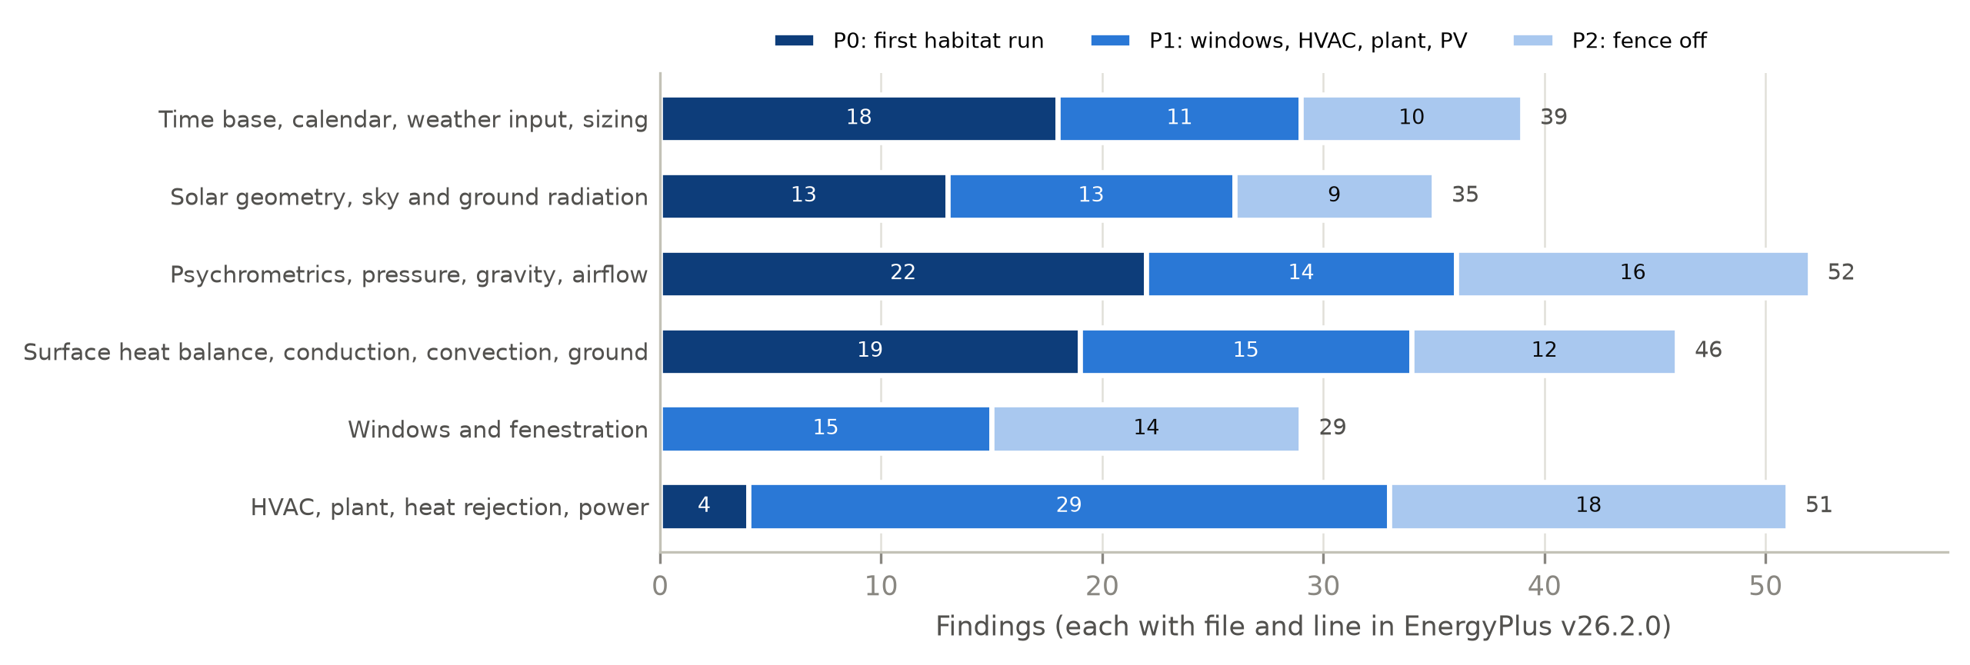
Fig. 1. Earth-specific assumptions found in EnergyPlus v26.2.0 by area and priority (252 findings). P0: needed for a first single-zone habitat with ideal loads; P1: needed for windows, HVAC, plant and PV; P2: rarely used modules that are refused off-Earth.
Table 2. Representative Earth assumptions found by the audit and their treatment in ExoBEM-Core.
Area | Earth assumption in the v26.2 code | Effect off-Earth | ExoBEM-Core M1
Time base | 1 h = 3600 s is a compile-time constant; 118 uses of rSecsInHour, 65 of them physical; CTFs computed in Earth hours | A longer 'planetary hour' would rescale physics in some places but not others, and CTFs by up to ×29.5 on the Moon | Earth clock kept (hour = 3600 s); sun rate generalized
Weather input | EPW range checks: dry-bulb ≥ 99.9 °C treated as missing; pressure ≤ 31 kPa replaced by the standard value | Lunar-day 120 °C and Martian 700 Pa silently altered | Generator overwrites each day after the read
Sun | Declination and equation of time from Earth Fourier fits (two copies); hour angle 15°/h | Wrong sun on any other body | Daily fit to Mars24 / lunar ephemeris; body hour-angle rate
Sky | Perez diffuse model (1353 W/m², Earth air mass); part of the sky long-wave view sees air | No basis in vacuum or dusty CO2 | Isotropic diffuse; all sky long-wave to the sky
Ground | Ground long-wave temperature = outdoor air at 10 sites; monthly ground temperatures | No air on the Moon; regolith swings 290 K | Regolith skin and deep temperatures from a 1-D column
Pressure | One pressure, OutBaroPress, for zone, HVAC and outdoor air (509 uses in 75 files) | Moon (0 Pa): zero air capacity, NaN humidity, one psychrometric routine never returns; Mars: 0.7% of the cabin's thermal mass | OutBaroPress carries the cabin pressure; new AmbientBaroPress
Convection | Every exterior correlation assumes air at 1 atm and 1 g, with a non-zero floor; TARP inside | Heat loss to air that does not exist; cabin convection overestimated about 2.3× on the Moon | Zero (Moon) or CO2 mixed convection (Mars) outside; physical correlation inside
Conduction | CondFD clamps nodes at −100 °C; walls start at 23 °C and warm up by repeating day 1 | Lunar-night surfaces near −180 °C; regolith time constants of months to years | −270 °C limit; steady start-up profile
HVAC and plant | Heat rejection to outdoor air; 354 OutBaroPress and 335 StdRhoAir uses in HVAC and plant | Cooling towers, air-cooled condensers and outdoor-air systems meaningless in vacuum | Refused with an error; space radiator planned
Windows | 4 thermal solvers, each with its own Earth gas and pressure constants | Interior film at outdoor pressure gives the floor value or NaN | Not yet supported

Three findings shaped the design. First, time is the most pervasive assumption but also the least visible. About 1,110 rate-times-time-step products go through two variables that are set in only 4 lines, which makes a variable hour length feasible, but 52 uses of the same constant are genuine unit conversions (kWh, air changes per hour, flow per hour) that must stay 3600 s, and the CTF generator works internally in Earth hours. A longer hour is therefore a deep change. Second, the engine has a single air pressure. About 350 of the 509 uses of OutBaroPress describe air inside the pressure shell and about 133 describe outdoor air; on the Moon the outdoor value is zero. Third, the exterior boundary hides air in places other than convection: in the long-wave split, in the ground temperature and in the moisture balance.

4. ExoBEM: a planetary re-implementation of the heat-balance method

4.1 Overview
ExoBEM (Fig. 2) is organized like EnergyPlus: a site-environment module plays the role of the weather manager, a heat-balance core computes surface and zone-air balances each time step, and post-processors compute thermal-control power and energy storage. The core is planet-agnostic: it receives time series of solar position, beam and diffuse irradiance, sky, ground and air temperatures, gas pressure and composition, wind and gravity, at an arbitrary time step and for an arbitrary day length. Models are defined in Python or in a JSON input file modeled on epJSON. The code is written in Python with NumPy and SciPy and released under the BSD-3-Clause license.
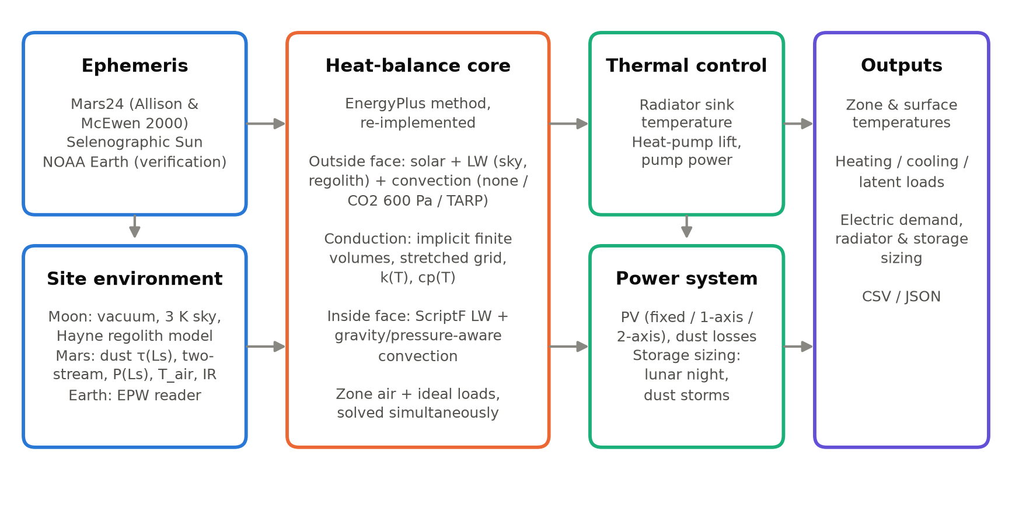
Fig. 2. ExoBEM architecture. The heat-balance core follows the EnergyPlus method; the ephemeris, site-environment, thermal-control and power modules carry the planetary physics.

4.2 Heat-balance core
For each exterior surface, the outside-face heat balance equates absorbed solar radiation, net long-wave exchange, convection and conduction into the wall [5]:
$$α_{s}G_{inc}+εσ\sum_{k}{F_{k}}\left(T_{k}^{4} − T_{so}^{4}\right)+h_{co}\left(T_{a} − T_{so}\right)=q_{ko}$$ | (1)
where the long-wave sum runs over sky (k = sky) and ground (k = g) with view factors F_{sky} = (1+cosβ)/2 and F_{g} = (1−cosβ)/2 for tilt β. On Earth, EnergyPlus splits the sky view into a sky part and an air part with weight sqrt[(1+cosβ)/2] and uses the air temperature for the ground; ExoBEM reproduces this split in Earth mode and uses the computed regolith surface temperature T_{g} elsewhere. The T⁴ term is Newton-linearized about the current iterate,
$$T_{so}^{4}≈4T_{so}^{*3}T_{so}−3T_{so}^{*4}$$ | (2)
which is essential in vacuum: with a 2.7 K sky and almost no conductive coupling through low-conductivity regolith, the fixed-point radiation coefficient used in many BES codes oscillates and fails to converge.
Conduction is solved with the node-centred, fully implicit finite-volume scheme of the EnergyPlus CondFD algorithm [5]:
$$C_{i}\frac{T_{i}^{n+1}−T_{i}^{n}}{Δt}=K_{i−1/2}\left(T_{i−1}^{n+1} − T_{i}^{n+1}\right)+K_{i+1/2}\left(T_{i+1}^{n+1} − T_{i}^{n+1}\right)$$ | (3)
with node capacitances C_{i} (half of each adjacent cell) and conductances K = k/Δx or 1/R for massless layers. Two extensions matter off-Earth. First, metre-thick regolith covers have diffusivities near 2×10⁻⁹ m²/s, so each layer uses a grid stretched geometrically from both faces (first cell ½(αΔt)^{1/2}, growth 1.3). Second, conductivity and specific heat may depend on temperature; they are lagged by one step, as in CondFD.
At the inside face, conduction, convection to zone air, long-wave exchange and radiant internal gains balance:
$$q_{ki}+h_{ci}\left(T_{z} − T_{si}\right)+\sum_{j}{σ}ℱ_{ij}\left(T_{sj}^{4} − T_{si}^{4}\right)+\frac{f_{i}Q_{rad}}{A_{i}}=0$$ | (4)
where ℱ_{ij} are Hottel gray-interchange (ScriptF) factors computed from EnergyPlus-style area-weighted view factors with enforced reciprocity [5, 38], and radiant gains are distributed in proportion to area times emissivity. The zone air balance is
$$C_{z}\frac{dT_{z}}{dt}=\sum_{i}{h_{ci}}A_{i}\left(T_{si} − T_{z}\right)+Q_{conv}+\overset{˙}{m}c_{p}\left(T_{sup} − T_{z}\right)+Q_{sys}$$ | (5)
in which ṁ is outdoor-air infiltration on Earth and leakage make-up gas in a habitat. Q_{sys} is the ideal load that keeps T_{z} inside the heating and cooling set-points.
Simultaneous solution. EnergyPlus iterates between the surface and air balances. ExoBEM instead solves them simultaneously. All constructions are stacked into one tri-diagonal system AT = b + Bu, where the vector u = [T_{si,1}…T_{si,n}, T_{z}] collects the inside-face temperatures and the air temperature that couple surfaces to each other and to the air. Solving the banded system once for n+2 right-hand sides gives
$$T=X_{0}+X_{B}u$$ | (6)
which, substituted into the inside-face and air equations, yields a dense (n+1)×(n+1) system. It is solved free-floating first; if T_{z} leaves the set-point band, T_{z} is fixed at the violated set-point and Q_{sys} follows from the air balance. Only the non-linear coefficients (radiation linearization, convection coefficients and temperature-dependent properties) are updated by fixed-point iteration. The iteration typically converges to 0.005 K in two to three iterations per step.
Initialization. EnergyPlus warms up by repeating the first day. A 1-m lunar regolith cover has a thermal time constant of years, so ExoBEM first solves a pseudo-transient steady state with period-mean boundary conditions (time steps growing geometrically to 10⁹ s, with T⁴-mean sky and ground temperatures). It then repeats the first solar day (one sol or one lunation) once before recording results.

4.3 Planetary ephemerides and time
For Mars, ExoBEM implements the Allison and McEwen (2000) algorithm used by NASA's Mars24 [11, 39]: from the TT Julian date it computes the mean anomaly, the fictitious-mean-Sun angle, seven planetary perturbation terms and the equation of center, giving the areocentric solar longitude L_{s}, solar declination, heliocentric distance and equation of time. Local true solar time then gives the hour angle,
$$L_{s}=α_{FMS}+\left(ν − M\right),sinδ_{s}=0.42565sinL_{s}+{0.25}^{∘}sinL_{s}$$ | (7)
For the Moon, the lunar prime meridian follows the Moon's mean geocentric longitude L′, and the lunar equator is inclined I = 1.5424° to the ecliptic with its descending node at the orbit's ascending node Ω (Cassini's laws). The selenographic subsolar point is therefore [40, 41]
$$λ_{ss}={180}^{∘}−\left(L^{′} − λ_{⊙}\right),β_{ss}=Isin\left(λ_{⊙} − Ω\right)$$ | (8)
where λ⊙ is the Sun's apparent ecliptic longitude. Using the mean rather than the true lunar longitude captures the optical libration in longitude, which shifts lunar local time by up to about half an Earth day. Near the poles, the Sun is treated as a disk of finite angular radius above an azimuth-dependent horizon. Schedules run on local mean solar time on Mars and on Earth (UTC) time on the Moon, where the 29.5-day lunar day cannot set crew rhythms. The total solar irradiance is 1361 W/m² at 1 AU [42].

4.4 Site environments
Moon. There is no diffuse light and no convection; the sky temperature is 2.725 K. Ground temperature comes from a 1-D model of the regolith following Hayne et al. [10]. Density increases with depth as ρ(z) = ρ_{d} − (ρ_{d} − ρ_{s})exp(−z/H) with ρ_{s} = 1100 kg/m³, ρ_{d} = 1800 kg/m³ and H = 0.06 m. Contact conductivity scales with density between 7.4×10⁻⁴ and 3.4×10⁻³ W/(m·K). Radiative conduction between grains is included through
$$k\left(z , T\right)=k_{c}\left(z\right)\left[1 + χ{\left(\frac{T}{350K}\right)}^{3}\right],χ=2.7$$ | (9)
Specific heat follows the fourth-order polynomial fit to Apollo samples [10, 43]. Albedo depends on incidence angle, A = 0.12 + 0.06(i/45°)³ + 0.25(i/90°)⁸; emissivity is 0.95 and the geothermal flux is 0.018 W/m². The column is spun up over six lunations.
Mars. Top-of-atmosphere irradiance is 1361/r² W/m². Beam and diffuse components at the surface follow a delta-Eddington two-stream solution [44–46]:
$$\frac{dF^{±}}{dτ}=±\left(γ_{1}F^{±} − γ_{2}F^{∓}\right)∓γ_{3,4}ω_{0}F_{s}e^{−τ/μ_{0}}$$ | (10)
with a Lambertian surface and a spherical-shell air mass. The broadband single-scattering albedo ω₀ = 0.885 and asymmetry parameter g = 0.74 were fitted to the normalized net-flux tables of Appelbaum and Flood [47, 48]. These are effective solar-band values: they are lower than visible-band retrievals [49, 50] because they absorb near-infrared absorption and two-stream error. Dust optical depth follows a seasonal climatology representative of Jezero crater (0.45 in the aphelion season, 0.85 near L_{s} = 245°) [51–53]. A global-storm scenario raises τ to 6 between L_{s} = 190° and 270° [13]. Surface pressure follows a two-harmonic CO2-cycle fit (mean 710 Pa). Ground temperature comes from a homogeneous regolith column with thermal inertia 350 J m⁻² K⁻¹ s^{-1/2} and albedo 0.14, as measured at Jezero by MEDA [54]. Near-surface air temperature is an empirical boundary-layer surrogate, T_{a} = T̄_{g} + κ(T_{g}(t−0.5 h) − T̄_{g}) with κ = 0.6, which reproduces the roughly 2:1 ratio of ground-to-air diurnal amplitude measured by MEDA and REMS [55–57]. Downwelling long-wave flux is
$$L^{↓}=ε_{sky}\left(τ\right)σT_{a}^{4}+f_{re}{⟨G_{toa,h}−G_{h}⟩}_{sol},ε_{sky}=min\left(0.08+0.125τ,0.6\right)$$ | (11)
The first term is emission by CO2 and dust; the second re-emits a fraction f_{re} = 0.45 of the sunlight that dust removes (sol-running mean), a one-layer-atmosphere energy term. The parameters were calibrated so that the clear-season daily mean is about 30 W/m², as measured by MEDA/TIRS [54], and so that in a global storm the sol-mean temperature drops by about 10 K while the diurnal range collapses, as observed in 2018 [13].

4.5 Convection in thin, foreign and pressurized atmospheres
EnergyPlus's TARP algorithm combines Walton's natural-convection correlations with a Sparrow-type forced term [5, 58]. Both were fitted to air at 101 kPa and 1 g. For turbulent natural convection, h = C k (gβΔT/να)^{1/3}, so for a given gas h scales as (gρ²)^{1/3} [59]. ExoBEM therefore offers a physical convection mode for any gas, pressure and gravity:
$$h={\left(h_{n}^{3} + h_{f}^{3}\right)}^{1/3},Nu_{v}={\left\{0.825 + \frac{0.387Ra^{1/6}}{{\left[1 + {\left(0.492 / Pr\right)}^{9/{16}}\right]}^{8/{27}}}\right\}}^{2}$$ | (12)
Here the natural term uses Churchill–Chu for vertical faces and McAdams/Lloyd–Moran correlations for horizontal faces [59, 60]. The forced term uses flat-plate correlations with the local wind speed (exterior) or the cabin ventilation velocity (interior, 0.15 m/s by default, within the 0.076–0.61 m/s range of BVAD [14]). Gas properties come from Sutherland-type fits: the Mars mixture is 95% CO2, and cabin atmospheres are N2/O2 at 101.3 kPa/21%, 70.3 kPa/26.5% or 56.5 kPa/34% O2 [14, 15]. In Earth mode the TARP formulation is retained for comparability with EnergyPlus.

4.6 Thermal control and power
Because a habitat cannot reject heat to outdoor air, the ideal cooling load (sensible plus crew latent heat removed by a condensing heat exchanger) is passed to a radiator model. The radiator's environmental sink temperature is
$$ε_{r}σT_{sink}^{4}=α_{r}\left(G_{b} + G_{d} + G_{r}\right)+ε_{r}σ\left(F_{sky}T_{sky}^{4} + F_{g}T_{g}^{4}\right)$$ | (13)
The default radiator is two-sided, vertical and pole-facing, 40 m², with silver-Teflon optical properties α = 0.10 and ε = 0.80, midway between beginning and end of life [14]. If the radiator temperature needed to reject the load is below the cabin coolant temperature (2 °C less a 5 K approach), rejection is passive and only pump power (150 W) is drawn. Otherwise a vapor-compression heat pump lifts the heat, with COP equal to 40% of the Carnot value between the evaporator and the radiator temperature plus approach. The radiator temperature is found with a bracketed root search so that radiated power equals Q_{c}(1 + 1/COP). Photovoltaic generation (30% efficient arrays with two-axis or vertical single-axis tracking; a 0.85 dust factor on Mars) and storage capacity are sized so that the habitat's total electric demand (equipment, lighting and thermal control) is met over the period with an 85% storage round-trip efficiency.

5. ExoBEM-Core: a planetary mode for the EnergyPlus engine

5.1 Design rules
Three rules guided every change (Fig. 3):
- Earth stays bit-for-bit. Planetary mode is active only when the input contains a Site:PlanetaryBody object with Body = Moon or Mars. Every change is either behind that switch or replaces a literal by a variable whose Earth value is the same literal, so that IEEE floating-point results on Earth do not change.
- Reuse, do not rewrite. Planetary values are injected where EnergyPlus already reads its environment (weather arrays, sun direction, ground temperature, exterior and interior coefficients). The heat balance, conduction solvers, shading, view factors, ideal loads and reporting run unchanged.
- Refuse what cannot be right. Objects that need outdoor air or Earth weather stop the run with an error off-Earth instead of producing a plausible-looking wrong answer.
The result is small. The first milestone (M1) adds 1,609 lines and changes 12 in 17 files: a new PlanetaryBody module (1,277 lines), the input-object definition (150 lines) and about 182 lines of hooks in 14 existing files, which is 0.2% of the engine.
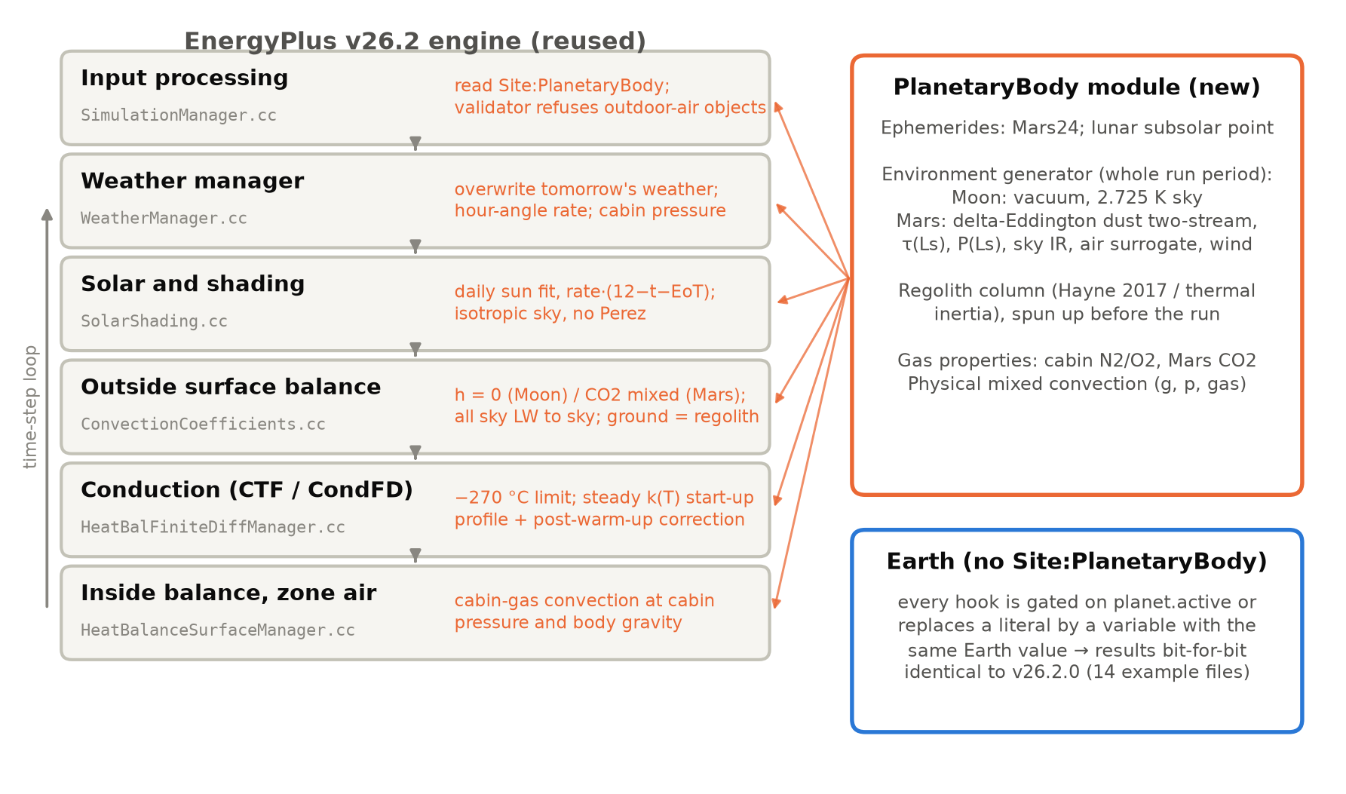
Fig. 3. Where ExoBEM-Core enters the EnergyPlus engine. Grey: unchanged EnergyPlus stages and the source files that carry the hooks; orange: what the hook does off-Earth. The new PlanetaryBody module supplies ephemerides, the environment, regolith temperatures and gas properties.

5.2 Input
A single new object, Site:PlanetaryBody, selects the body (Earth, Moon or Mars), the clock, a reference year and the habitat parameters: gravity (by default the body's surface value: 1.625 m/s² on the Moon, 3.721 m/s² on Mars), cabin pressure (70.3 kPa) and oxygen fraction (0.265), cabin air velocity (0.15 m/s) and a convection length scale. Optional fields set the horizon elevation, the regolith thermal inertia, albedo, emissivity and spin-up cycles, the deep-regolith depth, and for Mars the mean surface pressure, the dust optical-depth model (seasonal climatology or constant, with an optional global storm defined by start and end solar longitude and peak optical depth) and the wind. Everything else in the input file is standard. In M1 a weather file is still required, but it supplies only the calendar and the site; every weather value is replaced (Section 5.4).

5.3 Time base and sun position
The audit showed that a planetary hour would touch about a hundred physical uses of the hour length and the CTF generator. M1 therefore keeps the Earth clock: an hour is 3600 s and a day starts at 00:00 UTC, so that crew schedules, which follow Earth or mission time, are written as on Earth. What changes is the rate at which the Sun moves. EnergyPlus computes the hour angle in several places, all with the same expression; ExoBEM-Core replaces the literal 15 by a variable:
$$H=r\left[12 − \left(t + E\right)\right]+\left(λ_{TZ} − λ\right),r=\frac{{360}^{∘}}{P_{d}/3600s}$$ | (14)
where t is the clock hour, E the equation of time in hours, λ_{TZ} and λ the time-zone meridian and the longitude, and P_{d} the length of the solar day: 86,400 s on Earth (r = 15°/h, the original literal), the synodic month of 29.53 days on the Moon (r = 0.508°/h) and the sol of 88,775 s on Mars (r = 14.6°/h). For each simulated day the declination and E are fitted to the planetary ephemeris at 12:00 UTC: the declination is taken from Mars24 [11] or from the selenographic subsolar point [40], and E is chosen so that Eq. (14) reproduces the ephemeris hour angle H⊙ at mid-day,
$$E_{d}=\frac{H_{⊙}\left(12h\right)+λ_{TZ}−λ}{r}$$ | (15)
Because the hour angle is linear in time over a day on both bodies, Eq. (14) then follows the ephemeris through the day (Section 6.4). All downstream sun and shading routines, including the polygon-clipping shadow calculation, are reused. Two settings change off-Earth: the shading calculation is updated every day, because the declination fitted for one day does not hold for the next, and the hour angle is wrapped to ±180° before the sunrise test, because on the Moon it spans more than one revolution in a lunation.

5.4 Planetary environment
The weather manager reads the next day from the weather file and then calls the PlanetaryBody module, which overwrites every per-time-step value (dry-bulb temperature, beam and diffuse irradiance, sky temperature, pressure, wind) for that day. The values come from an environment generator that is a C++ port of the ExoBEM environment models (Section 4) and is run for the whole run period before the simulation starts. On the Moon there is no diffuse light, the sky is at 2.725 K and the ground is a 1-D regolith column following Hayne et al. [10], spun up over six lunations. On Mars the beam and diffuse irradiance come from a delta-Eddington two-stream solution with a seasonal dust optical depth and an optional global storm [44, 47], the pressure follows the seasonal CO2 cycle, the sky emits as an effective dusty-CO2 layer, the near-surface air follows the ground with a lag, and a thermal-inertia regolith column is spun up over thirty sols. The regolith skin temperature and the deep-regolith temperature are kept for the surface boundary, and seven new output variables report the planetary environment (ground surface and deep temperature, ambient pressure, downwelling long-wave radiation, Sun distance, solar longitude and dust optical depth). Because values are overwritten after the weather file is read, none of the EPW range checks found by the audit can alter them.

5.5 Cabin and ambient pressure
The single-pressure finding admits two fixes: add a cabin pressure and change the roughly 350 zone and HVAC uses of OutBaroPress, or let OutBaroPress carry the cabin pressure and change the outdoor uses. ExoBEM-Core takes the second option. Off-Earth, OutBaroPress holds the cabin pressure, so the zone air balance, psychrometrics, ideal loads and every HVAC component see the air they actually contain, without edits; the standard pressure and density used for volume-to-mass conversions follow the cabin as well. A new variable, AmbientBaroPress, holds the real outdoor pressure (zero on the Moon, 600–800 Pa on Mars) and is used by the exterior convection model and the outputs. Almost all outdoor users of the old variable are outdoor-air systems, infiltration and heat rejection to air, and these are refused off-Earth (Section 5.9), so the option leaves no silent outdoor use of the cabin pressure in a valid input. The cabin gas is treated with moist-air psychrometrics at cabin pressure; at 26.5% oxygen the specific heat and gas constant differ from air by less than 0.4%.

5.6 Exterior boundary
Off-Earth, the exterior convection coefficient is replaced. It is zero in vacuum, and the EnergyPlus lower limit on the coefficient is bypassed. On Mars, a physical mixed-convection correlation is used for CO2 at the ambient pressure and the body's gravity, combining Churchill–Chu or horizontal-plate natural convection with flat-plate forced convection [59, 60], as in ExoBEM (Section 4).
Gas properties follow Sutherland-type fits. The sky/air split of the long-wave view, which on Earth sends part of the sky view to the air temperature, is set to send all of it to the sky; the ground view, which on Earth sees the outdoor air temperature, sees the regolith skin temperature; and surfaces in contact with the ground use the deep-regolith temperature. The Perez anisotropic sky model is replaced by an isotropic sky, since its coefficients were fitted to Earth air masses [61]. Outdoor moisture exchange is switched off, and the sanity checks that stop a run when an outdoor or surface temperature falls below −100 °C are skipped.

5.7 Interior convection
Inside, the default TARP correlation describes air at one atmosphere and 1 g [58]. Natural convection scales roughly as (gρ²)^{1/3}, so at lunar gravity and 70.3 kPa TARP overestimates it by about 2.3 times. Off-Earth, ExoBEM-Core applies the same mixed-convection correlation to the cabin gas (nitrogen and oxygen at the cabin pressure and oxygen fraction) with the body's gravity and the cabin air velocity as the forced component. The override is placed before the EnergyPlus Energy Management System override, so users can still set coefficients from EMS.

5.8 Conduction and the start-up of regolith covers
CTF and CondFD run unchanged on the Earth clock. Two things change. The CondFD lower node-temperature limit of −100 °C becomes −270 °C off-Earth. More importantly, the start-up procedure had to be reconsidered. EnergyPlus starts every wall at 23 °C and repeats the first day until zone temperatures and loads converge. That works for walls with time constants of hours to days but not for a metre of regolith, whose time constant is months on Mars and years on the Moon: the warm-up converges on the zone while the regolith is still far from its periodic state. Off-Earth, ExoBEM-Core starts each CondFD construction from its steady conduction profile between the period-mean outer-face temperature T̄_{o} and the initial inside temperature T_{in},
$$T_{i}={\overline{T}}_{o}+\left(T_{in} − {\overline{T}}_{o}\right)\frac{R_{i}}{R_{tot}},R_{i}=\sum_{j<i}{\frac{Δx_{j}}{k_{j}\left(T_{j}\right)}}$$ | (16)
where the resistances follow each layer's temperature-dependent conductivity and are iterated six times. T̄_{o} solves the mean radiative–convective balance of the outer face under the generated environment (absorbed solar radiation, sky and ground long-wave exchange with T⁴-mean temperatures, and convection on Mars). At the end of warm-up the inside faces have reached their real temperature, so the profile is recomputed with that temperature and the difference is added to every node. The correction is zero at the outer face and does not disturb the daily cycle that warm-up has established there.

5.9 Refusing what cannot be right
After input processing, a validator stops the run with a severe error if the input contains an object that needs outdoor air or Earth weather. In M1 the list covers infiltration and ventilation objects, outdoor-air controllers, mixers and nodes, air-cooled and evaporatively cooled equipment (DX coils, packaged terminal units, VRF, the electric EIR chiller), cooling towers, fluid coolers and evaporative coolers, combustion and wind generators, PVWatts, the Kiva foundation model, AirflowNetwork, DElight, design days and sizing. Each of these would otherwise run and return numbers. The list is deliberately conservative; items leave it as their physics is generalized.

6. Verification
Verification proceeds in four steps: ExoBEM's terrestrial core against EnergyPlus (Section 6.1), ExoBEM's planetary models against reference data (Section 6.2), ExoBEM-Core against unmodified EnergyPlus on Earth (Section 6.3), and the two tools against each other off-Earth (Section 6.4).

6.1 Comparative verification against EnergyPlus 23.2
The terrestrial core was compared with EnergyPlus 23.2 on opaque versions of ASHRAE Standard 140 Cases 600 (lightweight) and 900 (heavyweight) [6, 62]. In these versions the 12 m² south window is replaced by wall so that the comparison isolates the opaque heat balance, which is the part relevant to windowless habitats. The 8 m × 6 m × 2.7 m zone has 200 W of internal gains (60% radiant), 0.5 ACH infiltration, a floor on R-25 insulation over ground at 10 °C, and 20/27 °C ideal-load set-points; free-floating variants (600FF, 900FF) have no HVAC. Both programs used the Golden, Colorado TMY3 file [63], 10-minute time steps, TARP convection inside and outside, the Perez sky model [61] and Country terrain. EnergyPlus used conduction transfer functions; ExoBEM used its finite-volume solver. EnergyPlus input files are generated by a script in the repository.
Table 3. Annual loads, ExoBEM (Earth mode) versus EnergyPlus 23.2, opaque ASHRAE 140 cases, Golden CO.
Case | Heating E+ (kWh) | Heating ExoBEM (kWh) | Diff. | Cooling E+ (kWh) | Cooling ExoBEM (kWh) | Diff. | Peak heat E+/Exo (kW) | Peak cool E+/Exo (kW) | Hourly R² | CV(RMSE) %
Case 600 | 4,504 | 4,507 | +0.07% | 392 | 394 | +0.46% | 3.00 / 3.00 | 1.30 / 1.28 | 0.9987 | 4.2
Case 900 | 4,147 | 4,144 | -0.07% | 124 | 125 | +0.67% | 2.63 / 2.63 | 0.67 / 0.67 | 0.9987 | 4.1

Table 4. Free-floating zone air temperature (°C), ExoBEM versus EnergyPlus 23.2, 10-minute values over one year.
Case | T_{min} E+ | T_{min} Exo | T_{max} E+ | T_{max} Exo | T_{mean} E+ | T_{mean} Exo | RMSE (K) | MBE (K) | R²
Case 600FF | -17.20 | -17.33 | 39.02 | 39.09 | 14.77 | 14.77 | 0.31 | -0.003 | 0.9991
Case 900FF | -7.23 | -7.31 | 32.49 | 32.51 | 14.70 | 14.74 | 0.47 | +0.041 | 0.9974

Annual heating differs by +0.07% (Case 600) and -0.07% (Case 900), and annual cooling by +0.46% and +0.67% (Table 3). Peak loads agree within 1%, and hourly net loads have R² above 0.998 (Fig. 4a). These differences are far smaller than the spread between programs in the ASHRAE 140 reference results. Free-floating temperatures agree with an annual RMSE of 0.31 K (600FF) and 0.47 K (900FF) and a mean bias under 0.05 K (Table 4, Fig. 4b–c). The remaining differences come from documented implementation choices: finite volumes versus conduction transfer functions, implicit Euler versus third-order backward differencing of the air balance, the sub-hourly interpolation of weather data, and the solar-position algorithm.
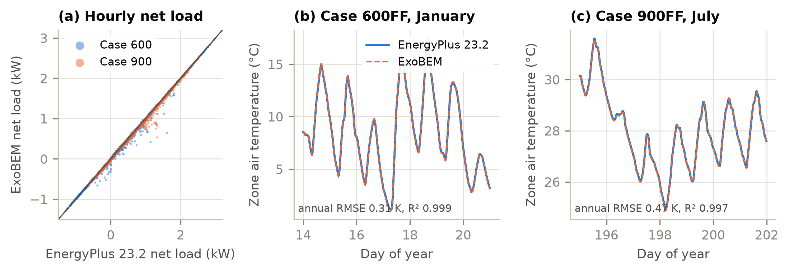
Fig. 4. Comparative verification against EnergyPlus 23.2 (Golden CO, TMY3). (a) Hourly net load (heating positive) for opaque Cases 600 and 900. (b, c) Free-floating zone air temperature over one winter and one summer week.

6.2 Verification of the planetary models
Table 5. Verification of the planetary models against reference data and analytical solutions.
Quantity | Reference | ExoBEM | Source
Mars24 worked example, 2000-01-06 00:00 UTC | L_{s} = 277.18758°, EOT = −5.18774°, r = 1.39358 AU, MST = 23.99425 h | Identical to 5 decimals | [39]
Lunar equatorial surface temperature (Diviner) | ≈385–390 K noon; ≈95 K pre-dawn; ≈252–256 K at ~1 m | 388 K; 94 K; 259 K (3 m) | [9, 10]
Mars net-flux function f(z, τ), 20 table values | Appelbaum & Flood tables, albedo 0.1 | RMSE 0.014, max. error 0.035 | [47]
Jezero surface pressure (daily means) | ≈625–790 Pa | 626–785 Pa | [57]
Jezero air temperature at 1.45 m | ≈188–262 K | 199–263 K | [57]
Jezero ground temperature | ≈183–290 K | 190–284 K | [54]
Jezero downwelling long-wave flux | ≈30 W/m² daily mean (20–45 W/m²) | 37 W/m² mean (19–64 W/m²) | [54]
Lunar south-polar ridge illumination | 92.3% at 2 m (Connecting Ridge) | 92.4% (horizon −1.65°) | [64]
Vertical radiator sink, lunar equator, noon | ≈333 K | 328 K | [20]
Analytical: steady conduction, semi-infinite step (erfc), parallel-plate ScriptF, vacuum steady state | Exact solutions | Errors < 0.1% (unit tests) | [59]

Table 5 summarizes the checks of the planetary models; all are automated in the test suite. Mars24's worked example is reproduced exactly. The regolith model reproduces Diviner's equatorial noon and pre-dawn temperatures and the Apollo heat-flow subsurface temperatures (Fig. 5a). The fitted delta-Eddington model reproduces the Appelbaum–Flood insolation tables over 0.1 ≤ τ ≤ 3 and 0° ≤ z ≤ 80° (Fig. 5b). The Jezero environment falls within the ranges MEDA observed for pressure, air and ground temperature and downwelling infrared. The lunar radiator sink agrees with the classic Bien–Guentert estimate. The polar horizon depression of −1.65° was chosen to match the 92.3% illumination of the best Connecting Ridge site [64]. Because a uniform horizon concentrates darkness into seasons, it yields a longest eclipse of 12 days, against 3–5 days for real ridge terrain [64, 65]. Polar storage results below are therefore conservative.
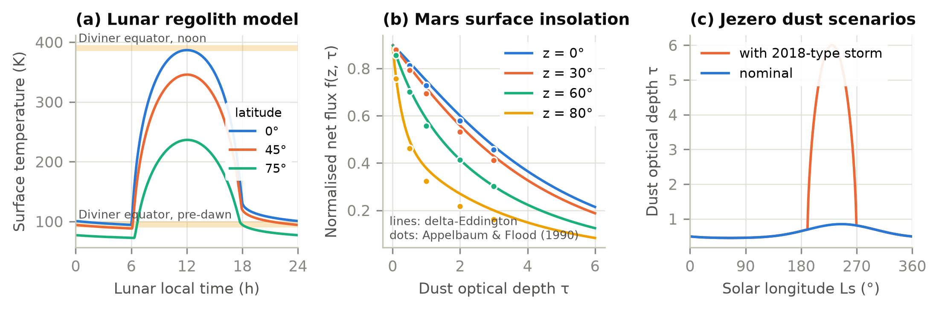
Fig. 5. Planetary environment models. (a) Lunar regolith surface temperature over a lunation at three latitudes, with Diviner equatorial ranges. (b) Normalized Martian surface net flux from the fitted delta-Eddington model (lines) and the Appelbaum–Flood tables (dots). (c) Seasonal dust optical depth at Jezero, nominal and with a 2018-type global dust storm.

6.3 Earth: identical results and unit tests
The first rule was tested directly. 14 example files from the EnergyPlus distribution were run with an unmodified v26.2.0 build and with ExoBEM-Core, built with the same compiler (MSVC 14.44, release mode) and the same weather file (Chicago O'Hare TMY3), and every number of the complete output time series was compared. The files were chosen to exercise every hook (Table 6): CTF and CondFD conduction with temperature-dependent conductivity, every convection path, ground contact, windows and daylighting, sizing and design days, VAV and DX systems, plant and chillers, PV and batteries, moisture models, Kiva and solar collectors. All 14 gave bit-for-bit identical results. A fifteenth file (HAMT_HourlyProfileReport) fails with this weather file in both builds and was excluded. The full EnergyPlus unit-test suite (2,379 tests in 33 suites) also passes on the fork with 0 failures.
Table 6. Earth regression: ExoBEM-Core versus unmodified EnergyPlus v26.2.0, full output time series (Chicago O'Hare TMY3).
Example file | Exercises | Result
1ZoneUncontrolled | CTF, TARP/DOE-2 convection, solar | identical
1ZoneUncontrolledFourAlgorithms | CTF, CondFD, EMPD, HAMT mix | identical
1ZoneUncontrolledCondFDWithVariableKat24C | CondFD with k(T) | identical
1ZoneUncontrolled_FCfactor_Slab_UGWall | ground contact, F/C factor | identical
1ZoneUncontrolled_win_1 | windows | identical
5ZoneAirCooled | VAV, DX, sizing, design days | identical
5ZoneAirCooledConvCoef | user convection coefficients | identical
5ZoneWaterSystems | plant, water use | identical
ShopWithPVandBattery | PV, electric storage | identical
RefBldgSmallOfficeNew2004_Chicago | DOE reference building | identical
EMPD5ZoneWaterCooled_HighRHControl | moisture (EMPD), chillers | identical
ZoneCoupledKivaConvection | Kiva foundation | identical
DaylightingDeviceShelf | daylighting | identical
SolarCollectorFlatPlateWater | solar thermal collector | identical

6.4 Cross-verification against ExoBEM
Off-Earth there is no measured building to compare with, so the engine was compared with an independent implementation of the same physics: the Python ExoBEM, whose terrestrial core agrees with EnergyPlus within 0.7% and whose planetary models reproduce Mars24, Diviner, Appelbaum–Flood and MEDA reference data (Section 4). This is a comparative verification in the sense of Oberkampf and Roy [66]: agreement shows that the two codes solve the same equations correctly, not that the equations are right, which is the job of the reference-data checks.
Both programs simulated the ExoBEM case-study habitat: a horizontal cylinder of radius 3 m and length 10 m with 16 shell facets, under 1 m of regolith over MLI (Moon) or 20 mm of aerogel (Mars), with a cabin at 70.3 kPa and 26.5% oxygen, constant internal gains of 3,240 W and ideal loads holding 18–27 °C, at 3-minute time steps. The Moon case is at the equator of Mare Tranquillitatis for two lunations from 1 January 2030; the Mars case is at Jezero crater for 31 Earth days from the same date. The two programs share no code. ExoBEM-Core generates its environment with the C++ port and solves conduction with CondFD, the regolith's k(T) and c_{p}(T) entered as standard temperature-dependent material tables; ExoBEM uses its own finite-volume solver with a stretched grid and solves surfaces and air simultaneously. One simplification was needed: CondFD cannot resolve the 4 mm aluminium pressure wall at this time step, so its heat capacity was lumped into the interior panel and its negligible resistance (3×10⁻⁵ m²K/W) dropped. Results are compared over the second lunation on the Moon and days 16–31 on Mars, after both start-up procedures have settled.
Table 7. Agreement between ExoBEM-Core (C++) and ExoBEM (Python) for the regolith-shielded habitat.
Quantity (hourly values) | Moon, equator, 2nd lunation (720 h) | Mars, Jezero, days 16–31 (384 h)
Sensible cooling, C++ / Python (kWh) | 2305.8 / 2306.0 (-0.01%) | 737.5 / 742.9 (-0.73%)
Hourly cooling RMSE (W) | 0.3 | 14
Regolith surface temperature RMSE (K) | 0.05 (range -178.8 to 114.4 °C) | 0.21 (range -82.0 to -10.1 °C)
Sky temperature RMSE (K) | 0.00 | 0.06
Direct normal irradiance R² | 0.9998 | 0.9999
Diffuse horizontal irradiance R² | — (none) | 0.9999
Top facet outer-face temperature RMSE (K) | 0.33 | 0.64
Top facet inner-face temperature RMSE (K) | 0.002 | 0.05
Interior convection coefficient, C++ / Python (W/m²K) | 0.83 / 0.83 | 1.16 / 1.15
Exterior convection coefficient, C++ / Python (W/m²K) | 0 / 0 | 0.236 / 0.237

The environments agree closely (Fig. 6). The solar altitude follows the ephemeris over the whole lunation and over each sol, which confirms that the generalized hour angle with a daily fit is sufficient for both bodies; direct irradiance has R² of 0.9998 on the Moon and 0.9999 on Mars. The regolith surface temperature, from −179 to +114 °C on the Moon, agrees within 0.05 K RMSE and within 0.21 K on Mars; the Martian sky temperature within 0.06 K. The residual differences come from evaluating the sun at the end of each time step (the EnergyPlus convention) rather than at its middle, and from the hourly averaging of sub-hourly values.
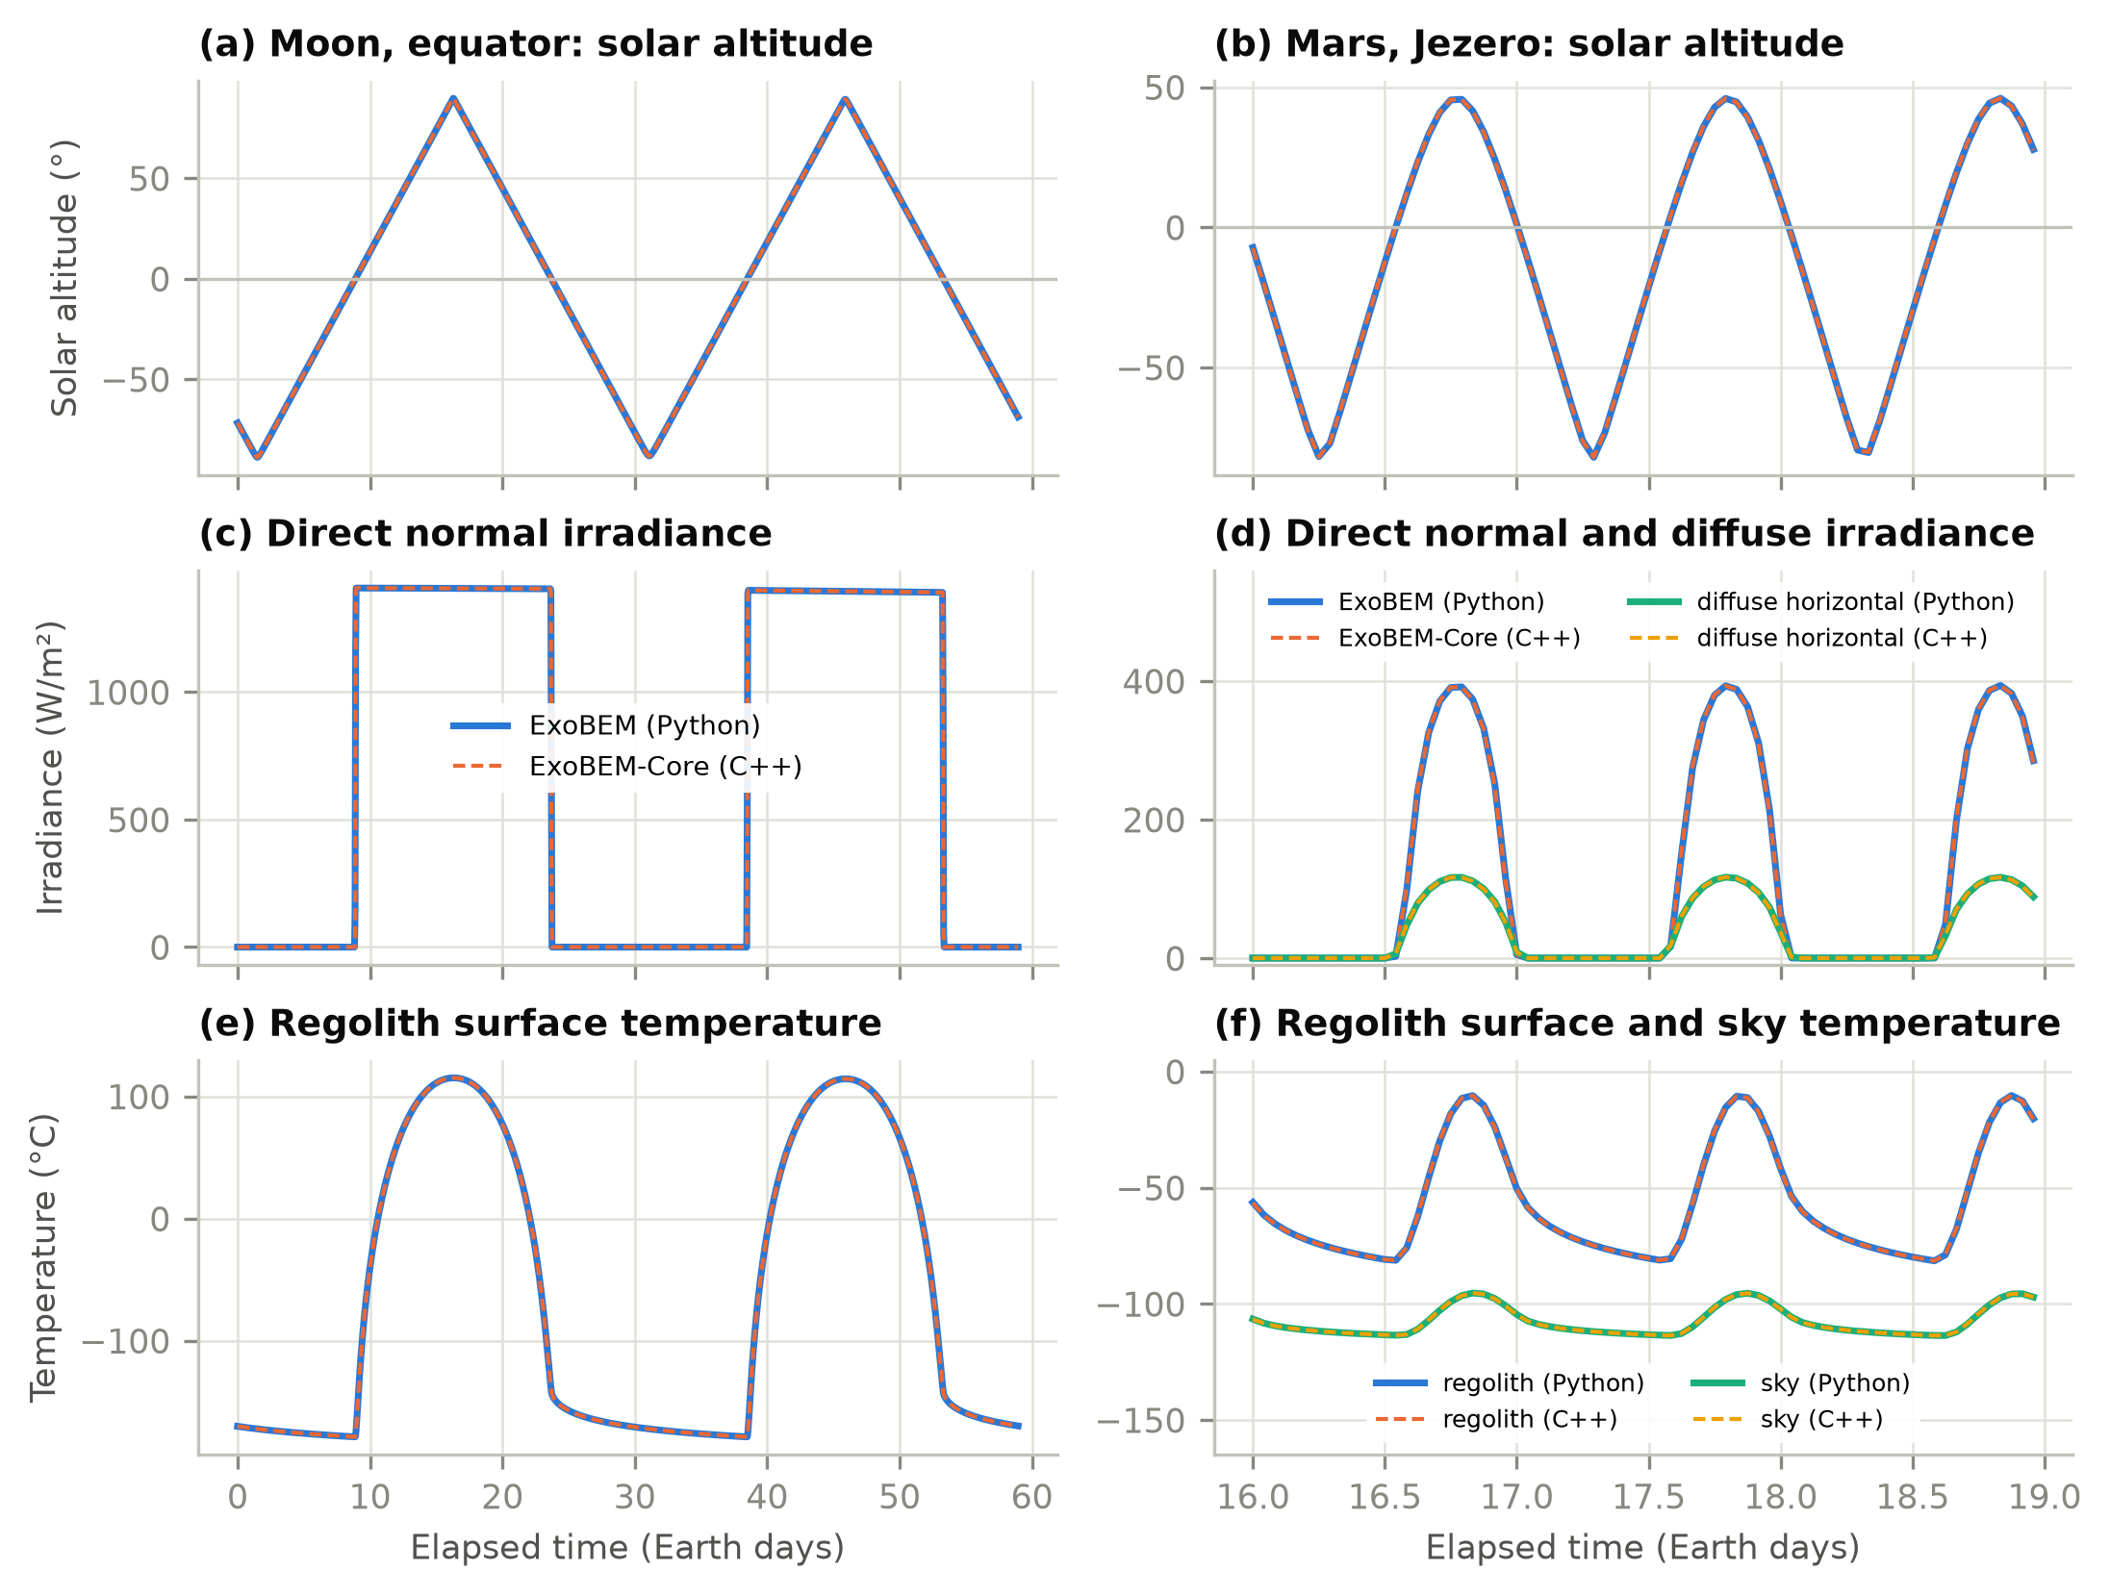
Fig. 6. Environment generated by ExoBEM-Core (C++, dashed) and by ExoBEM (Python, solid) at the lunar equator over two lunations (left) and at Jezero crater over three Earth days (right): (a, b) solar altitude, (c, d) direct normal and diffuse horizontal irradiance, (e, f) regolith surface and sky temperatures.
The habitat responses agree as well (Fig. 7, Table 7). On the Moon the cooling energy over the second lunation differs by -0.01% and the hourly cooling load by 0.3 W RMSE; the top facet's outer face, which follows the 290 K swing of the lunar day, agrees within 0.33 K and its inner face within 0.002 K. On Mars the cooling energy differs by -0.73% (hourly R² 0.998) and the interior convection coefficients by 1%. Most of the Martian difference is a slowly decaying offset: the CO2-filled regolith cover conducts about twenty times better than lunar regolith, so the envelope exchanges about 1.3 kW with the environment and its deep layers are still drifting after a month in both codes, from different starting states (a pseudo-transient steady state in ExoBEM, the profile of Eq. (16) in ExoBEM-Core). Differences in grid (CondFD's uniform nodes per layer versus a stretched grid) contribute as well.
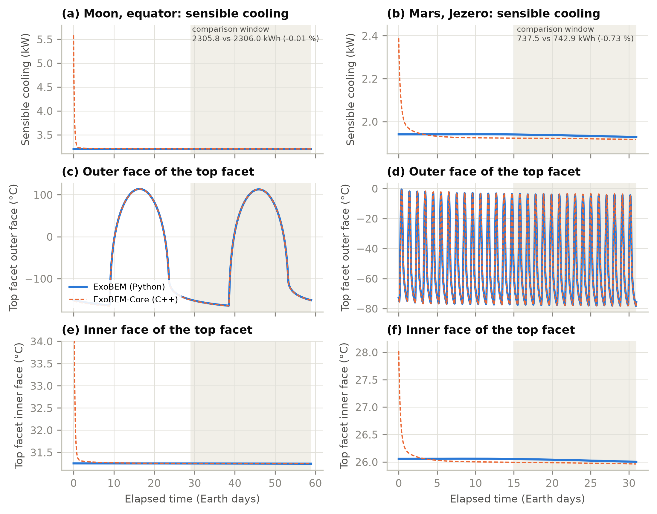
Fig. 7. Habitat response in ExoBEM-Core (C++, dashed) and ExoBEM (Python, solid) at the lunar equator (left) and Jezero crater (right): (a, b) sensible cooling load, (c, d) outer-face and (e, f) inner-face temperature of the top shell facet. The shaded band is the comparison window; the C++ transient in the first day is discussed in Section 6.5.

6.5 Start-up of regolith-covered walls
The start-up procedure turned out to matter more than any other choice in the port (Table 8). With the EnergyPlus default, walls at 23 °C and warm-up by repeating the first day, the Mars cooling load over the comparison period was 32% higher than in ExoBEM, because the inner part of the regolith cover was still releasing the heat of its unrealistically warm start. A steady linear profile with constant conductivities reduced the error to −2.5%, and the k(T)-aware profile of Eq. (16) with the post-warm-up correction to -0.7% on Mars and -0.01% on the Moon. The lesson applies beyond planetary habitats: any construction whose time constant exceeds the warm-up period, such as earth-sheltered walls or thick ground slabs, inherits its initial state for months.
Table 8. Effect of the wall start-up treatment on cooling energy over the comparison window.
Start-up treatment of CondFD walls | Moon cooling vs ExoBEM (%) | Mars cooling vs ExoBEM (%)
Walls start at 23 °C (EnergyPlus default) | not run | +32
Steady profile, constant conductivity | -1 | -2.5
Steady profile with k(T) and post-warm-up correction (M1) | -0.01 | -0.7

A short transient remains (Fig. 7): in the first day after warm-up, the ExoBEM-Core cooling load starts 0.4 kW (Mars) to 2.4 kW (Moon) high and decays within about a day, and the inner face of the shell starts 2 K (Mars) to 7 K (Moon) warm. The likely cause is that the post-warm-up correction is also added to the thin inner layers, which have already reached their real temperature during warm-up. Restricting the correction to layers deeper than the warm-up diffusion length is planned; the comparison windows exclude the transient.

7. Case studies
The case studies below were computed with ExoBEM, which includes the radiator, heat-pump and power-system models that ExoBEM-Core does not yet have. Section 6.4 showed that ExoBEM-Core reproduces ExoBEM's loads for the same habitat with constant internal gains.

7.1 Habitat model and sites
The reference habitat is a horizontal cylinder 6 m in diameter and 10 m long (about 280 m³), a size typical of rigid or inflatable surface modules. Sixteen shell facets resolve orientation; the two lowest rest on a regolith berm. The shell consists, from outside to inside, of a regolith radiation shield, beta cloth, insulation, a 4 mm aluminium-2219 pressure wall and a 10 mm interior panel. Insulation is 20-layer MLI on the Moon. On Mars, where MLI is ineffective at 600–800 Pa [67], it is a 20 mm silica-aerogel blanket (k = 0.012 W/(m·K) in CO2 [68]). Four crew contribute the BVAD nominal 85.1 W sensible and 53.8 W latent heat each [14], with sleep from 22:00 to 06:00. Equipment draws 2.5 kW (70% at night) and lighting 0.4 kW. The cabin is held at 70.3 kPa and 26.5% O2, between 18 and 27 °C [14, 69], with 0.1 kg/day of leakage. Table 9 lists the sites.
Table 9. Case-study sites and simulation periods.
Case | Site | Period | Time step | Environment
Moon, equator | Mare Tranquillitatis, 0.67°N 23.47°E | 2 lunations from 2030-01-01 | 30 min | Vacuum; 2.7 K sky; regolith 94–388 K
Moon, south pole | Ridge at 89.5°S, horizon −1.65° | 12 lunations (354 d) | 60 min | 92% sunlit; regolith 34–116 K
Mars, Jezero | 18.44°N 77.45°E | 1 Mars year from L_{s} = 0° (2028-08-17) | 1/24 sol | P 626–785 Pa; τ 0.45–0.85
Mars, Jezero, dust storm | As above | As above | 1/24 sol | τ up to 6 at L_{s} 190–270°

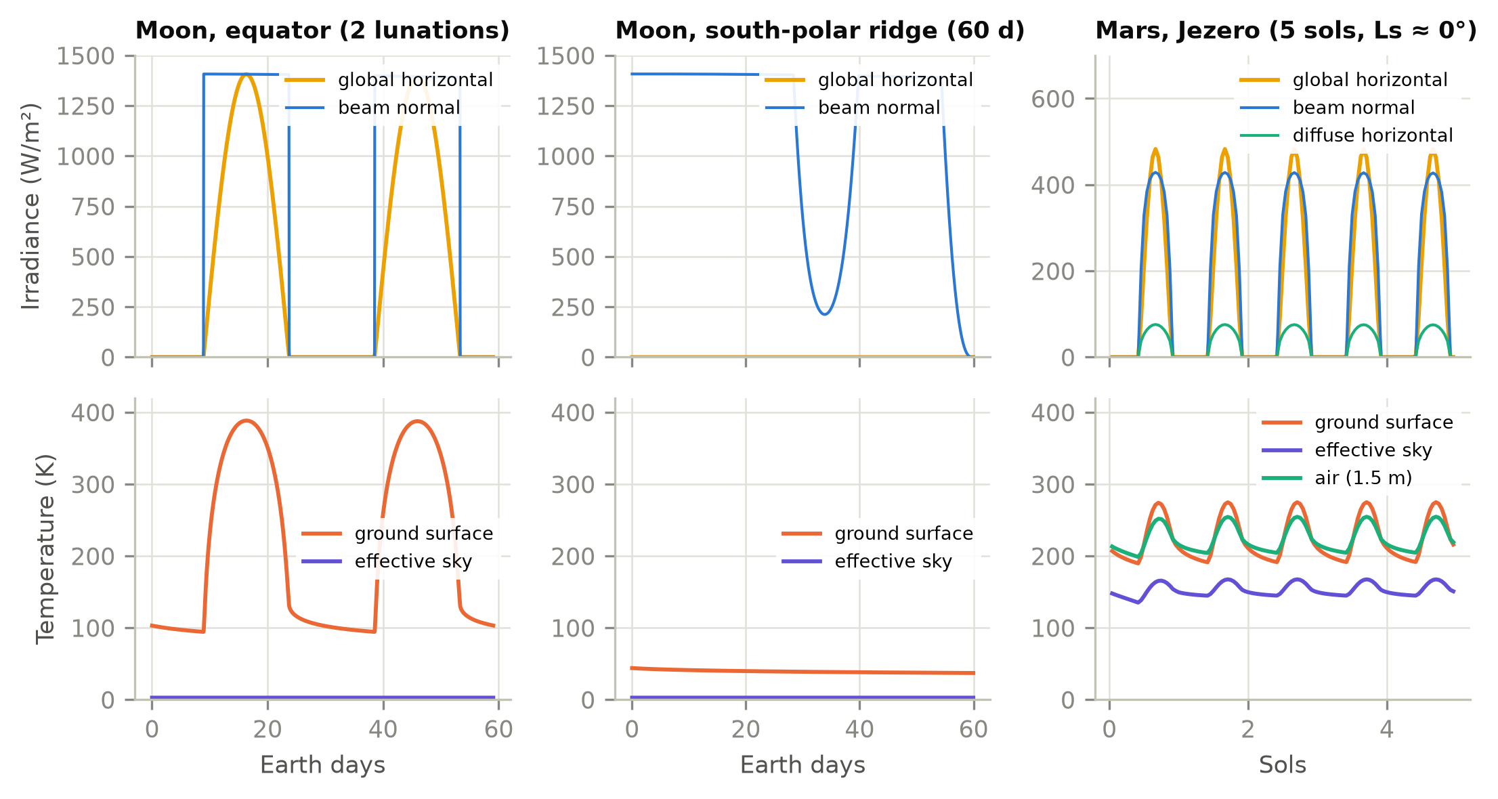
Fig. 8. Simulated surface environments: irradiance (top) and ground, sky and air temperatures (bottom) at the lunar equator, a lunar south-polar ridge and Jezero crater.

7.2 Results
Fig. 8 contrasts the three environments. At the lunar equator, 14.8 days of sunlight at up to 1406 W/m² alternate with 14.8 days of darkness, and the regolith swings from 94 to 388 K. At the polar ridge the Sun circles the horizon at grazing elevation: beam irradiance on a vertical surface is high, but the flat ground stays below 116 K. At Jezero the cycle repeats every sol. In the clear season, dust removes about a fifth of the noon beam and turns much of it into diffuse light, and the CO2 atmosphere keeps the effective sky above 135 K.
Table 10. Baseline results for the regolith-shielded habitat (1 m cover). Energies per Earth day.
Case | Heating (kWh/d) | Cooling (kWh/d) | Peak cooling (kW) | Mean envelope gain (W) | Outer surface (K) | Heat-pump time (%) | Thermal-control electricity (kWh/d) | Radiator sink (K)
Moon, equator | 0.0 | 67.2 | 3.21 | -36 | 108–401 | 37 | 18.4 | 79–328
Moon, south pole | 0.0 | 66.1 | 3.17 | -84 | 51–388 | 0 | 3.6 | 30–172
Mars, Jezero | 0.0 | 38.3 | 2.06 | -1,240 | 189–289 | 1 | 3.6 | 169–253
Mars, dust storm | 0.0 | 39.6 | 2.26 | -1,188 | 189–288 | 2 | 3.7 | 169–264

The shielded habitat is cooling-dominated everywhere (Table 10). With 1 m of regolith, the envelope exchanges on average only 36 W at the lunar equator and 84 W at the pole, about 1–3% of the 2.9 kW of internal sensible gains. The cabin never needs heating, and the cooling load (67.2 and 66.1 kWh/d) is essentially the internal gain. The reason is the extraordinarily low conductivity of lunar regolith (3–5 mW/(m·K)): a 1-m cover has a thermal resistance of roughly 200 m²·K/W, an order of magnitude more than the MLI beneath it. On Mars, CO2 in the pores raises regolith conductivity to about 0.08 W/(m·K), and the envelope loses 1.24 kW to the −60 °C environment. The cooling load (38.3 kWh/d) is therefore a little over half the lunar value. The outer regolith surface follows the environment (108–401 K at the lunar equator), but the inside surfaces vary by about 1 K (Fig. 9a).
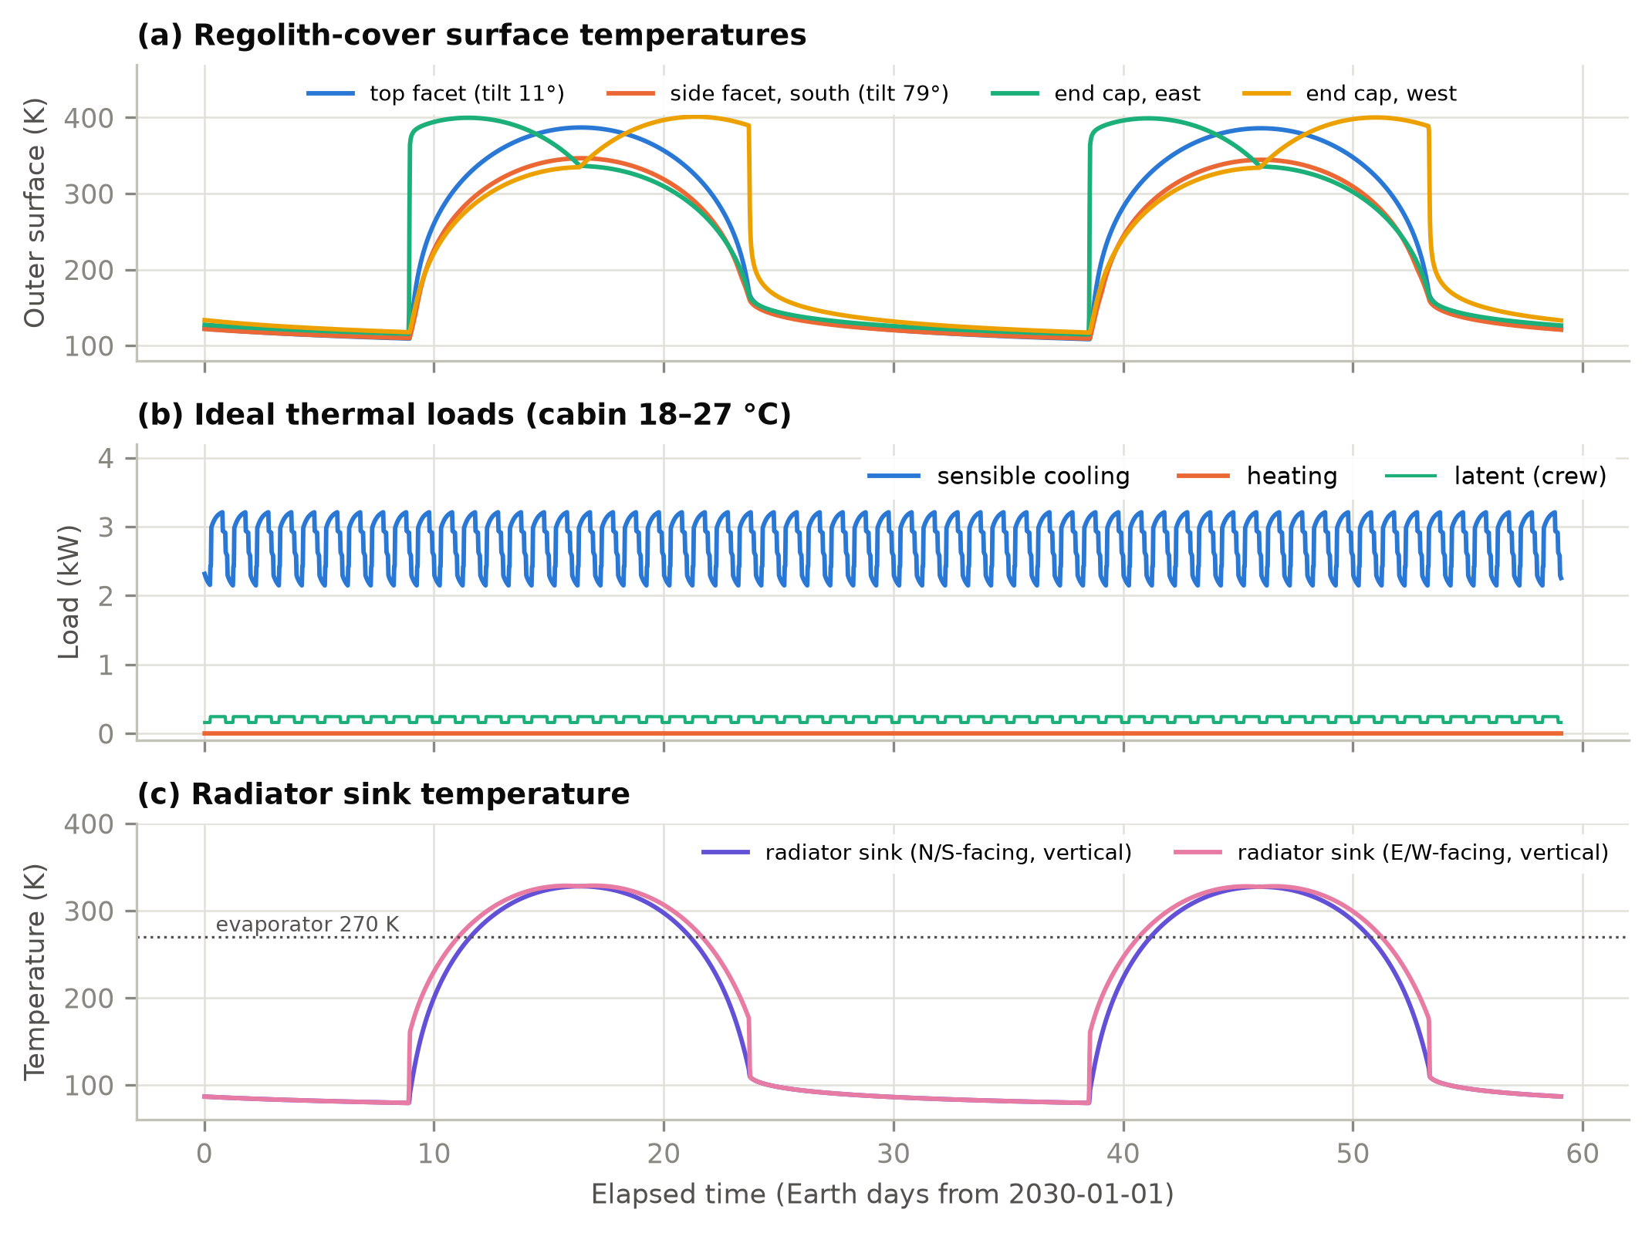
Fig. 9. Regolith-shielded habitat at the lunar equator over two lunations. (a) Outer surface temperatures of selected facets. (b) Ideal sensible cooling, heating and crew latent loads. (c) Sink temperature of a vertical two-sided radiator facing north/south or east/west, compared with the 270 K evaporator temperature.
Heat rejection is where the Moon's equator differs from the pole. The sink temperature of a vertical radiator at the equator rises to 328 K at noon because half of its view is regolith at nearly 390 K (Fig. 9c). For 37% of the lunation, heat can only be rejected by lifting it with a heat pump; the COP falls to 1.3, and the thermal-control system draws 18.4 kWh/d, 5.1 times the passive pump-only demand at the pole, where the sink never exceeds 172 K. On Mars the sink peaks at 253 K and rejection is passive for 99.5% of the year (98.3% with the dust storm, whose infrared glow warms the sink).
Table 11. Effect of radiator orientation and surface degradation at the lunar equator (α = 0.10 unless noted).
Radiator configuration (40 m², ε = 0.80) | Thermal-control electricity (kWh/d) | Peak power (kW) | Max. sink (K) | Heat-pump time (%)
Vertical, faces N/S (pole-facing) | 18.4 | 2.84 | 328 | 37
Vertical, faces E/W | 20.6 | 2.87 | 329 | 41
Horizontal, faces up | 3.6 | 0.15 | 236 | 0
Horizontal, dust-degraded (alpha = 0.35) | 18.3 | 2.69 | 323 | 39
Vertical N/S, 2x area | 15.7 | 2.49 | 328 | 35

Table 11 compares radiator options at the equator. Turning a vertical radiator from the poles to east–west slightly worsens performance because it then faces the low morning and evening Sun. Doubling the vertical area saves only about 14%, because the noon sink is above the cabin temperature whatever the area. A horizontal radiator does not see the regolith: with a clean silver-Teflon surface its sink stays at 236 K, and rejection is passive throughout (3.6 kWh/d). If lunar dust raises its absorptance to 0.35 [70], the noon sink climbs to 323 K and the heat pump runs 39% of the time (18.3 kWh/d). Radiator orientation and dust mitigation are thus first-order energy decisions for equatorial bases.
Envelope choices. Fig. 10 compares envelope variants. On the Moon, removing the regolith (MLI alone) cuts the cooling load by 44% at the equator and 58% at the pole. This is not a benefit: the bare habitat simply leaks heat to space, and its internal surfaces follow the lunar day. Once 0.5 m of regolith is present, additional thickness or MLI changes the load by less than 3%. On Mars the picture is reversed. A habitat insulated only with 20 mm of aerogel or 50 mm of polyimide foam needs 94.7 kWh/d of heating, about 4 kW on average. A 1 m regolith cover, with or without insulation, turns it into a cooling-dominated building. MLI in the CO2 atmosphere adds almost nothing to the regolith.
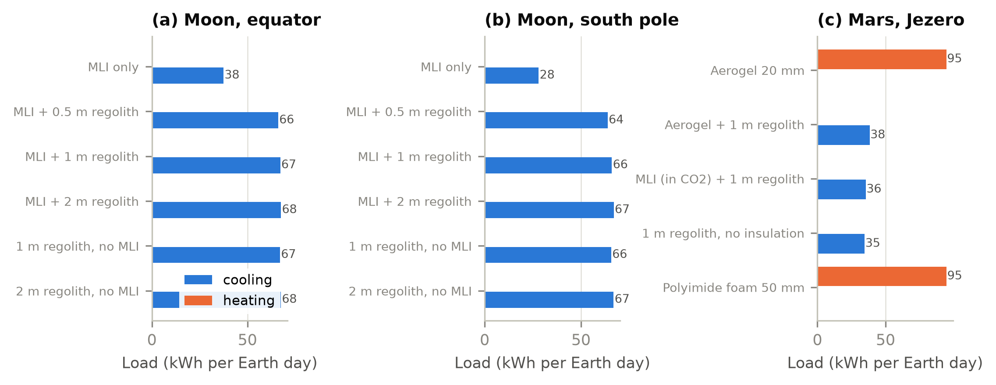
Fig. 10. Daily heating and cooling loads for envelope variants at the three sites (kWh per Earth day).
Mars seasons and dust storms. Over the Mars year at Jezero (Fig. 11), sol-mean insolation varies between 105 and 161 W/m², and sol-mean air temperature between -56 and -42 °C. A 2018-type global storm cuts sol-mean insolation to 21 W/m² and keeps it below 60 W/m² for 104 sols. Dust re-emits part of the absorbed sunlight as infrared, so the nights warm, the days cool and the sol-mean air temperature falls by at most 0 K, consistent with the 2018 observations [13]. The habitat barely notices: its sol-mean cooling load changes by at most 285 W. The power system notices a great deal, as shown next.
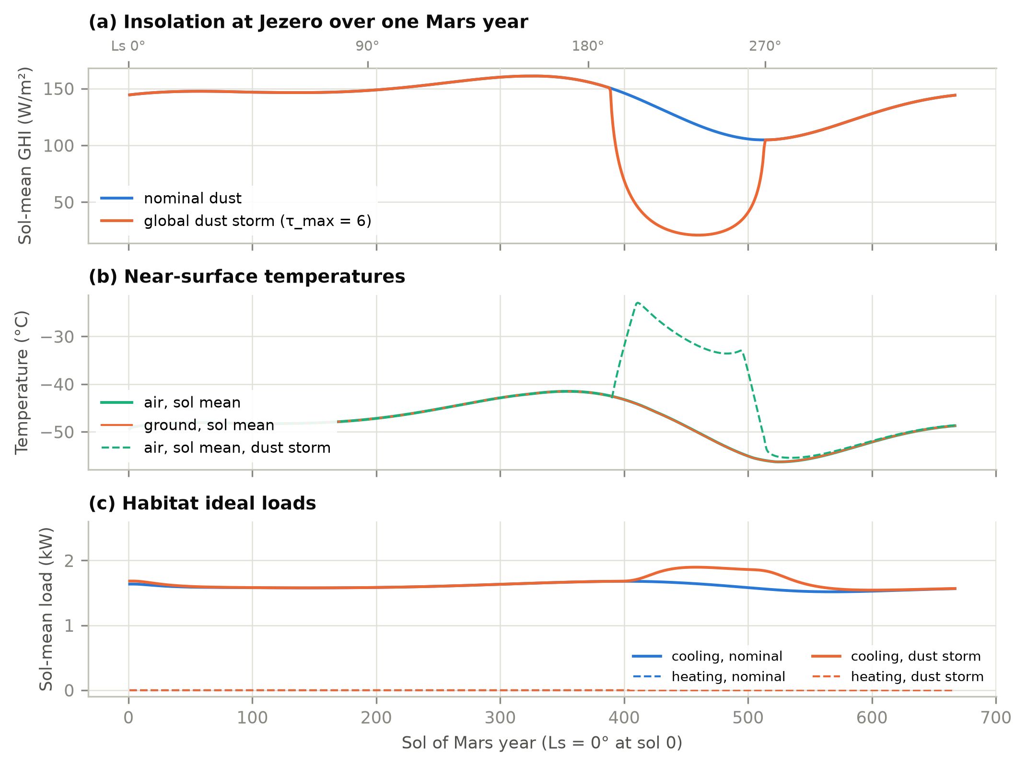
Fig. 11. One Mars year at Jezero crater. (a) Sol-mean global horizontal irradiance, nominal and with a global dust storm. (b) Sol-mean air and ground temperatures. (c) Sol-mean habitat ideal loads.
Table 12. Power-system sizing for the habitat's total electric load (equipment, lighting and thermal control).
Case | Mean electric load (kW) | Peak load (kW) | Thermal-control share (%) | PV area for energy balance (m²) | Storage needed (kWh)
Moon, equator (2-axis PV) | 3.26 | 5.74 | 23 | 17 | 1,023
Moon, pole (vertical 1-axis PV) | 2.65 | 3.05 | 6 | 7 | 1,914
Mars, Jezero (2-axis PV) | 2.65 | 3.19 | 6 | 60 | 1,494
Mars, dust storm (2-axis PV) | 2.65 | 3.41 | 6 | 69 | 6,481

Power-system implications (Table 12). With arrays sized for energy balance, the equatorial lunar base needs about 1,023 kWh of storage to cross the 354-hour night, and its thermal-control system accounts for 23% of the electric load. At the polar ridge the array shrinks to 7 m², but the idealized horizon's 12-day eclipses still call for 1,914 kWh. Real ridge terrain, whose eclipses last only 3–5 days [64], would need far less. At Jezero, nominal dust requires 60 m² of arrays and 1,494 kWh of storage, mostly to buffer the dusty, low-sun northern winter. A global dust storm multiplies the storage by 4.3, to 6,481 kWh, although the thermal loads hardly change. Oversizing the arrays trades directly against these storage figures.

7.3 Convection under reduced gravity and pressure
Fig. 12 quantifies why convection coefficients cannot be carried over from Earth. Cabin natural convection on a 2.5 m wall with a 3 K temperature difference drops from about 2.1 W/(m²·K) at 1 g and 101 kPa to about 0.9 W/(m²·K) at lunar gravity and 70.3 kPa. That is comparable to the forced coefficient at a 0.15 m/s ventilation velocity, so cabin ventilation, not buoyancy, controls interior surface heat transfer on the Moon. Outside on Mars, mixed convection in 700 Pa CO2 gives 0.15–0.7 W/(m²·K) over the full range of wind speeds, 20–70 times less than on Earth at the same wind speed. Exterior convection on Mars is therefore a correction to the radiative balance rather than a dominant term. This is consistent with the small sensible heat fluxes MEDA measured [54].
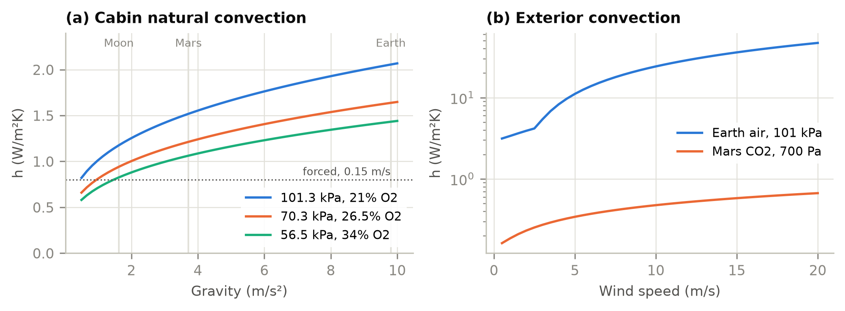
Fig. 12. (a) Interior natural convection coefficient versus gravity for three cabin atmospheres (2.5 m vertical wall, ΔT = 3 K), with the forced-convection value at 0.15 m/s. (b) Exterior mixed convection versus wind speed for a 3 m surface on Earth and Mars (ΔT = 10 K and 30 K, respectively).

8. Discussion

8.1 Re-implementation or engine modification?
Table 13. The two tools compared. Run times are for 3-minute time steps on the same computer, single thread.
Aspect | ExoBEM (Python) | ExoBEM-Core (C++)
Basis | Re-implementation of the EnergyPlus heat-balance method | Fork of the EnergyPlus v26.2.0 engine
Code | About 2,469 lines of Python (NumPy, SciPy) | 721 thousand lines of C++ reused; 1,609 added
Conduction and solution | Finite volumes on stretched grids; surfaces and air solved simultaneously | EnergyPlus CTF or CondFD; iterative surface and air balances
Scope | Single zone, ideal loads; radiator, heat pump, PV and storage as post-processors | All engine features that do not need outdoor air: multi-zone, HVAC and plant, controls, EMS, outputs; radiator component planned
Time base | Sol clock on Mars; Earth clock on the Moon | Earth clock on both (sol clock planned)
Input | Python objects or JSON | Standard IDF or epJSON plus Site:PlanetaryBody
Earth verification | ASHRAE 140 opaque cases vs EnergyPlus 23.2: annual loads within 0.7% | Bit-for-bit identical to v26.2.0 on 14 files; 2,379 unit tests pass
Planetary verification | Mars24, Diviner, Appelbaum–Flood, MEDA reference data | Against ExoBEM: cooling within 0.01% (Moon) and 0.7% (Mars)
Run time, habitat case | 197 s (Moon, 59 d); 112 s (Mars, 31 d) | 68 s (Moon); 3 s (Mars)
Best use | Early design, parametric studies, teaching, independent reference | Detailed design with EnergyPlus workflows, multi-zone habitats and systems

Table 13 compares the two routes. The re-implementation was the faster way to get the physics right: every planetary model in ExoBEM-Core is a port of an ExoBEM model that had already been checked against reference data, and having an independent code made it possible to find the start-up problem, which a single code would have hidden. The engine fork is the way to use that physics in practice. It inherits multi-zone air balances, HVAC and plant loops, controls, electric systems and reporting, and it runs the habitat cases faster than the Python code. The two are therefore complementary rather than competing: ExoBEM is the reference and the sandbox, ExoBEM-Core the engine.

8.2 Implications for habitat design
The case studies suggest a shift in emphasis for habitat energy design. On Earth, BES spends most of its effort on the envelope; a regolith-shielded habitat on the Moon is so well insulated by its radiation shield that envelope optimization is nearly moot. Design then turns on (i) internal heat generation, (ii) where and how that heat is rejected, and (iii) storage across darkness. Radiator placement, coating degradation by dust, and site choice (equator versus pole) change thermal-control energy by a factor of five. On Mars, insulation matters again because CO2-filled regolith and the atmosphere conduct, but power-system sizing is dominated by dust. These conclusions are qualitatively known to spacecraft thermal engineers [8, 18]. What ExoBEM adds is a way to quantify them with the annual, schedule-driven methods of building science, and to carry the same model from early massing studies to detailed design.

8.3 Limitations of ExoBEM
- Single zone. Multi-zone habitats, airlocks and inter-module air exchange are not yet modelled.
- Sensible-only air balance. Crew latent heat is passed to the coolant loop, but cabin humidity is not tracked.
- Idealized terrain. Horizons are uniform or user-supplied profiles; DEM horizons (LOLA, HiRISE) and shading between modules are planned.
- Empirical Mars boundary layer. Near-surface air temperature uses a calibrated surrogate rather than a surface-layer model; Mars Climate Database input is planned [31, 71].
- Effective dust optics. Broadband scattering parameters are fitted to Appelbaum–Flood tables; spectral and site-specific optics would refine the beam/diffuse split [49, 50].
- Storm infrared. The dust re-emission term was calibrated to the observed temperature response; peak downwelling infrared in the τ = 6 storm (223 W/m²) is probably overestimated and should be checked against MEDA and REMS storm data.
- Ideal thermal control. Radiators, heat pumps and storage are quasi-steady post-processors without component dynamics or capacity limits.
- Verification scope. The Earth core was compared with EnergyPlus on opaque cases; windows, empirical validation in thermal-vacuum chambers and analog habitats remain to be done.

8.4 Limitations of ExoBEM-Core
- Earth clock on Mars. Hours are 3600 s, so the Martian day drifts by about 40 minutes per Earth day against the clock. Physics is right, but schedules cannot follow local solar time.
- Placeholder weather file. A weather file is still read for the calendar and the site; runs without one, and planetary design days and sizing, are planned.
- Windows, radiators and PV. Fenestration, a space-radiator plant component and PV in vacuum are not yet available; heat rejection is represented by ideal loads.
- Cabin gas. Psychrometrics use moist air at cabin pressure; a gas-mixture block for other cabin atmospheres is planned.
- Gravity. Body gravity is used in the new convection correlations only; window gaps, airflow networks and stack effects are refused or still use 9.81 m/s².
- Thin metal layers. CondFD cannot resolve millimetre aluminium shells at minute time steps, so they must be lumped or modelled with CTF.
- Start-up transient. About a day of residual transient follows warm-up (Section 6.5).
- Verification scope. Off-Earth verification is comparative (two codes, one habitat type); empirical data from thermal-vacuum tests or analog habitats are still needed.

8.5 Roadmap
The audit provides the work list for the next milestones. M2 introduces a sol clock for Mars by making the hour length a run-time variable: the audit identified the four lines that set the time-step lengths, the 65 physical uses of the hour constant that must follow it and the 52 unit conversions that must not, and the change to the CTF generator's hour-based units. M2 also adds a cabin gas-mixture block for psychrometrics, body gravity in every buoyancy model, runs without a weather file and planetary design days. M3 adds a space-radiator plant component, modelled on the fluid cooler with a surface link like the flat-plate solar collector, a PV cell-temperature model for vacuum and windows with vacuum-compatible solvers. Because every change is gated on the planetary object and Earth results are unchanged, the planetary mode could in principle be offered upstream as an optional feature; until then it is maintained as a fork that tracks EnergyPlus releases.

9. Conclusions
This paper brought the EnergyPlus heat-balance method to the Moon and Mars by two independent routes. ExoBEM re-implements the method with planetary physics; its terrestrial core matches EnergyPlus 23.2 within 0.7% in annual loads and its planetary models reproduce Mars24, Diviner, Appelbaum–Flood and MEDA reference data. ExoBEM-Core modifies the EnergyPlus engine itself: an audit found 252 Earth assumptions (76 blocking a first habitat run), and a planetary mode of 1,609 lines removes them for regolith-shielded habitats while leaving Earth results bit-for-bit unchanged. The two tools agree within 0.01% on the Moon and 0.7% on Mars in cooling energy, and their comparison exposed the need to start long-time-constant walls from a consistent state. For a four-crew habitat under 1 m of regolith the envelope is nearly adiabatic on the Moon; the energy problem becomes rejecting about 3 kW of internal heat, which costs several times more electricity at the lunar equator than at the pole or on Mars, while dust storms dominate storage on Mars. ExoBEM is suited to fast exploration and serves as the reference; ExoBEM-Core carries the physics into the full engine. Both are open source.

Software and data availability
ExoBEM v0.1.0, its EnergyPlus verification inputs, case-study scripts and the data behind every figure and table are available at https://github.com/TensorBuildLab/ExoBEM (BSD-3-Clause). ExoBEM-Core, the audit reports and its verification cases are available at https://github.com/TensorBuildLab/ExoBEM-Core under the EnergyPlus license. EnergyPlus and the TMY3 weather files are available from the U.S. DOE.

Declaration of generative AI use
During the preparation of this work the author used Claude (Anthropic) to assist with literature search, the code audit, software implementation, verification scripting and drafting of the manuscript. The author reviewed and edited all content and takes full responsibility for the publication. [Authors: confirm and adapt to the target journal's policy.]

CRediT authorship contribution statement
[To be completed by the authors.]

Declaration of competing interest
The authors declare that they have no known competing financial interests or personal relationships that could have appeared to influence the work reported in this paper.

Acknowledgements
EnergyPlus is developed by the U.S. Department of Energy's Building Technologies Office, the National Laboratory of the Rockies (formerly NREL) and their partners; neither ExoBEM nor ExoBEM-Core is endorsed by them. [Funding to be added.]

References
[1] T. Hong, S.K. Chou, T.Y. Bong, Building simulation: an overview of developments and information sources, Build. Environ. 35 (2000) 347–361. https://doi.org/10.1016/S0360-1323(99)00023-2
[2] D.B. Crawley, J.W. Hand, M. Kummert, B.T. Griffith, Contrasting the capabilities of building energy performance simulation programs, Build. Environ. 43 (2008) 661–673. https://doi.org/10.1016/j.buildenv.2006.10.027
[3] D.B. Crawley, L.K. Lawrie, F.C. Winkelmann, W.F. Buhl, Y.J. Huang, C.O. Pedersen, R.K. Strand, R.J. Liesen, D.E. Fisher, M.J. Witte, J. Glazer, EnergyPlus: creating a new-generation building energy simulation program, Energy Build. 33 (2001) 319–331. https://doi.org/10.1016/S0378-7788(00)00114-6
[4] R.K. Strand, C.O. Pedersen, D.B. Crawley, Modularization and simulation techniques for heat balance-based energy and load calculation programs: the experience of the ASHRAE Loads Toolkit and EnergyPlus, in: Proc. Building Simulation 2001, IBPSA, Rio de Janeiro, 2001, pp. 43–50.
[5] U.S. Department of Energy, EnergyPlus Version 23.2.0 Documentation: Engineering Reference, U.S. DOE Building Technologies Office, 2023.
[6] ANSI/ASHRAE, Standard 140-2020: Standard Method of Test for the Evaluation of Building Energy Analysis Computer Programs, ASHRAE, Atlanta, GA, 2020.
[7] G. Schunk, S. Babiak, D. Naville, B. Evans, Conceptual thermal control system design for a lunar surface habitat, in: Thermal & Fluids Analysis Workshop (TFAWS), NASA, 2021. https://ntrs.nasa.gov/citations/20210020015
[8] R.G. Schunk, S.D. Babiak, B.W. Evans, Thermal control system architecture and technology challenges for a lunar surface habitat, in: 2022 IEEE Aerospace Conference, IEEE, 2022. https://ntrs.nasa.gov/citations/20210026557
[9] A.R. Vasavada, J.L. Bandfield, B.T. Greenhagen, P.O. Hayne, M.A. Siegler, J.-P. Williams, D.A. Paige, Lunar equatorial surface temperatures and regolith properties from the Diviner Lunar Radiometer Experiment, J. Geophys. Res. 117 (2012) E00H18. https://doi.org/10.1029/2011JE003987
[10] P.O. Hayne, J.L. Bandfield, M.A. Siegler, A.R. Vasavada, R.R. Ghent, J.-P. Williams, B.T. Greenhagen, O. Aharonson, C.M. Elder, P.G. Lucey, D.A. Paige, Global regolith thermophysical properties of the Moon from the Diviner Lunar Radiometer Experiment, J. Geophys. Res. Planets 122 (2017) 2371–2400. https://doi.org/10.1002/2017JE005387
[11] M. Allison, M. McEwen, A post-Pathfinder evaluation of areocentric solar coordinates with improved timing recipes for Mars seasonal/diurnal climate studies, Planet. Space Sci. 48 (2000) 215–235. https://doi.org/10.1016/S0032-0633(99)00092-6
[12] G.M. Martínez, C.N. Newman, A. De Vicente-Retortillo, et al., The modern near-surface Martian climate: a review of in-situ meteorological data from Viking to Curiosity, Space Sci. Rev. 212 (2017) 295–338. https://doi.org/10.1007/s11214-017-0360-x
[13] S.D. Guzewich, M. Lemmon, C.L. Smith, et al., Mars Science Laboratory observations of the 2018/Mars Year 34 global dust storm, Geophys. Res. Lett. 46 (2019) 71–79. https://doi.org/10.1029/2018GL080839
[14] M.S. Anderson, M.K. Ewert, J.F. Keener, Life Support Baseline Values and Assumptions Document, NASA/TP-2015-218570/REV1, NASA Johnson Space Center, Houston, TX, 2018.
[15] NASA Exploration Atmospheres Working Group, Recommendations for Exploration Spacecraft Internal Atmospheres: The Final Report of the NASA Exploration Atmospheres Working Group, NASA/TP-2010-216134, NASA Johnson Space Center, Houston, TX, 2010.
[16] T.J.-R. Lagarde, Using computational techniques for the optimal design of evolving habitats, in: 72nd International Astronautical Congress, IAC-21-B3.7.10, Dubai, 2021. https://spacearchitect.org/pubs/IAC-21-B3.7.10.pdf
[17] G.N. Aydemir, An Integrated Framework for Mars-Based Building Performance Simulations (M-BPS): From Site Selection to Habitat Assessment, PhD dissertation, Middle East Technical University, Ankara, 2026. https://hdl.handle.net/11511/118421
[18] L.C. Simonsen, M.J. DeBarro, J.T. Farmer, Conceptual design of a lunar base thermal control system, in: The Second Conference on Lunar Bases and Space Activities of the 21st Century, NASA CP-3166, 1992, pp. 579–591. https://ntrs.nasa.gov/citations/19930004815
[19] K. Gadkari, S.K. Goyal, J. Vanniasinkam, Conceptual design of a thermal control system for an inflatable lunar habitat module, NASA-CR-192014, 1991. https://ntrs.nasa.gov/citations/19930008924
[20] D.D. Bien, D.C. Guentert, A method for reducing the equivalent sink temperature of a vertically oriented radiator on the lunar surface, NASA TM X-1729, NASA Lewis Research Center, Cleveland, OH, 1969. https://ntrs.nasa.gov/citations/19690007893
[21] R.B. Malla, K.M. Brown, Determination of temperature variation on lunar surface and subsurface for habitat analysis and design, Acta Astronaut. 107 (2015) 196–207. https://doi.org/10.1016/j.actaastro.2014.10.038
[22] S. Tripathi, J.T. Steiner, R.B. Malla, Three-dimensional temperature profile in a dome-shaped habitat structure on the Moon, Acta Astronaut. 204 (2023) 263–280. https://doi.org/10.1016/j.actaastro.2022.12.040
[23] J.T. Steiner, S. Tripathi, R.B. Malla, Air pressure and temperature distribution within a dome habitat structure on the lunar surface, in: Earth and Space 2022, ASCE, 2023, pp. 946–955. https://doi.org/10.1061/9780784484470.079
[24] A. Borshchak Kachalov, P. Salgado Sánchez, M.T. Mollah, J.M. Ezquerro, J. Spangenberg, B. Šeta, Numerical analysis of coaxially 3D printed lunar habitats: integrating regolith and PCM for passive temperature control, Microgravity Sci. Technol. 37 (2025) 38. https://doi.org/10.1007/s12217-025-10194-4
[25] J. Li, Y. Bai, S. Bi, M. Beer, Thermomechanical behavior of steel structural configurations subjected to cyclic cryogenic conditions in Martian environment, Adv. Space Res. 76 (2025) 3700–3716. https://doi.org/10.1016/j.asr.2025.06.069
[26] M. von Einem, R. Groll, C. Heinicke, Computational modeling of a ventilation concept for a lunar habitat laboratory, J. Space Saf. Eng. 9 (2022) 145–153. https://doi.org/10.1016/j.jsse.2022.02.005
[27] M. Azimi, et al., HabSim: a modular-coupled virtual testbed for simulating extraterrestrial habitat systems, AIAA J. 63 (2025) 376–388. https://doi.org/10.2514/1.J063845
[28] S.T. Engler, K. Binsted, H. Leung, HI-SEAS habitat energy requirements and forecasting, Acta Astronaut. 162 (2019) 50–55. https://doi.org/10.1016/j.actaastro.2019.05.049
[29] Y. Charoenboonvivat, O. de Weck, Surface power demand modeling for human Martian and lunar missions, in: AIAA SciTech 2026 Forum, AIAA 2026-1922, 2026. https://doi.org/10.2514/6.2026-1922
[30] A. Jadeja, M.M. Jaiswal, S. Ghosh, P. Sanghavi, Thermal comfort analysis of a proposed design for a sustainable living space on Mars, Intell. Build. Int. 8 (2016) 215–233. https://doi.org/10.1080/17508975.2015.1120185
[31] E. Millour, F. Forget, A. Spiga, et al., The Mars Climate Database (version 5.3), in: From Mars Express to ExoMars Scientific Workshop, ESA-ESAC, Madrid, 2018.
[32] S. Ross, Development of an open source modelling package for thermal balance of crewed Mars habitats, in: 73rd International Astronautical Congress, IAC-22-A5.IP.4, Paris, 2022.
[33] U.S. Department of Energy, EnergyPlus Version 26.2.0 Documentation: Engineering Reference, U.S. DOE Building Technologies Office, 2026.
[34] J.E. Seem, Modeling of Heat Transfer in Buildings, Ph.D. thesis, University of Wisconsin–Madison, 1987.
[35] P.C. Tabares-Velasco, B. Griffith, Diagnostic test cases for verifying surface heat transfer algorithms and boundary conditions in building energy simulation programs, J. Build. Perform. Simul. 5 (2012) 329–346. https://doi.org/10.1080/19401493.2011.595501
[36] TensorBuildLab, ExoBEM: building energy simulation for lunar and Martian habitats, version 0.1.0, https://github.com/TensorBuildLab/ExoBEM, 2026.
[37] TensorBuildLab, ExoBEM-Core: a planetary mode for the EnergyPlus v26.2 engine, milestone M1, https://github.com/TensorBuildLab/ExoBEM-Core, 2026.
[38] H.C. Hottel, A.F. Sarofim, Radiative Transfer, McGraw-Hill, New York, 1967.
[39] NASA Goddard Institute for Space Studies, Mars24 Sunclock — Algorithm and Worked Examples, https://www.giss.nasa.gov/tools/mars24/help/algorithm.html (accessed 8 November 2026).
[40] J. Meeus, Astronomical Algorithms, 2nd ed., Willmann-Bell, Richmond, VA, 1998.
[41] B.A. Archinal, C.H. Acton, M.F. A'Hearn, et al., Report of the IAU Working Group on Cartographic Coordinates and Rotational Elements: 2015, Celest. Mech. Dyn. Astron. 130 (2018) 22. https://doi.org/10.1007/s10569-017-9805-5
[42] G. Kopp, J.L. Lean, A new, lower value of total solar irradiance: evidence and climate significance, Geophys. Res. Lett. 38 (2011) L01706. https://doi.org/10.1029/2010GL045777
[43] B.S. Hemingway, R.A. Robie, W.H. Wilson, Specific heats of lunar soils, basalt, and breccias from the Apollo 14, 15, and 16 landing sites, between 90 and 350 K, in: Proc. Lunar Planet. Sci. Conf. 12th, 1981, pp. 2259–2268.
[44] J.H. Joseph, W.J. Wiscombe, J.A. Weinman, The delta-Eddington approximation for radiative flux transfer, J. Atmos. Sci. 33 (1976) 2452–2459. https://doi.org/10.1175/1520-0469(1976)033<2452:TDEAFR>2.0.CO;2
[45] W.E. Meador, W.R. Weaver, Two-stream approximations to radiative transfer in planetary atmospheres: a unified description of existing methods and a new improvement, J. Atmos. Sci. 37 (1980) 630–643. https://doi.org/10.1175/1520-0469(1980)037<0630:TSATRT>2.0.CO;2
[46] O.B. Toon, C.P. McKay, T.P. Ackerman, K. Santhanam, Rapid calculation of radiative heating rates and photodissociation rates in inhomogeneous multiple scattering atmospheres, J. Geophys. Res. 94 (1989) 16287–16301. https://doi.org/10.1029/JD094iD13p16287
[47] J. Appelbaum, D.J. Flood, Solar radiation on Mars, Sol. Energy 45 (1990) 353–363. https://doi.org/10.1016/0038-092X(90)90156-7
[48] J. Appelbaum, G.A. Landis, I. Sherman, Solar radiation on Mars—update 1991, Sol. Energy 50 (1993) 35–51. https://doi.org/10.1016/0038-092X(93)90006-A
[49] M.J. Wolff, M.D. Smith, R.T. Clancy, et al., Wavelength dependence of dust aerosol single scattering albedo as observed by the Compact Reconnaissance Imaging Spectrometer, J. Geophys. Res. 114 (2009) E00D04. https://doi.org/10.1029/2009JE003350
[50] H. Chen-Chen, S. Pérez-Hoyos, A. Sánchez-Lavega, Characterisation of Martian dust aerosol phase function from sky radiance measurements by MSL engineering cameras, Icarus 330 (2019) 16–29. https://doi.org/10.1016/j.icarus.2019.04.004
[51] M.T. Lemmon, M.J. Wolff, J.F. Bell III, M.D. Smith, B.A. Cantor, P.H. Smith, Dust aerosol, clouds, and the atmospheric optical depth record over 5 Mars years of the Mars Exploration Rover mission, Icarus 251 (2015) 96–111. https://doi.org/10.1016/j.icarus.2014.03.029
[52] M.T. Lemmon, M.D. Smith, D. Viúdez-Moreiras, et al., Dust, sand, and winds within an active Martian storm in Jezero crater, Geophys. Res. Lett. 49 (2022) e2022GL100126. https://doi.org/10.1029/2022GL100126
[53] L. Montabone, F. Forget, E. Millour, et al., Eight-year climatology of dust optical depth on Mars, Icarus 251 (2015) 65–95. https://doi.org/10.1016/j.icarus.2014.12.034
[54] G.M. Martínez, E. Sebastián, A. Vicente-Retortillo, M.D. Smith, J.R. Johnson, E. Fischer, H. Savijärvi, et al., Surface energy budget, albedo, and thermal inertia at Jezero crater, Mars, as observed from the Mars 2020 MEDA instrument, J. Geophys. Res. Planets 128 (2023) e2022JE007537. https://doi.org/10.1029/2022JE007537
[55] J.A. Rodriguez-Manfredi, M. de la Torre Juárez, A. Alonso, et al., The Mars Environmental Dynamics Analyzer, MEDA. A suite of environmental sensors for the Mars 2020 mission, Space Sci. Rev. 217 (2021) 48. https://doi.org/10.1007/s11214-021-00816-9
[56] J. Gómez-Elvira, C. Armiens, L. Castañer, et al., REMS: The environmental sensor suite for the Mars Science Laboratory rover, Space Sci. Rev. 170 (2012) 583–640. https://doi.org/10.1007/s11214-012-9921-1
[57] J.A. Rodríguez-Manfredi, M. de la Torre Juárez, A. Sánchez-Lavega, R. Hueso, G.M. Martínez, et al., The diverse meteorology of Jezero crater over the first 250 sols of Perseverance on Mars, Nat. Geosci. 16 (2023) 19–28. https://doi.org/10.1038/s41561-022-01084-0
[58] G.N. Walton, Thermal Analysis Research Program Reference Manual, NBSIR 83-2655, National Bureau of Standards, Washington, DC, 1983.
[59] F.P. Incropera, D.P. DeWitt, T.L. Bergman, A.S. Lavine, Fundamentals of Heat and Mass Transfer, 6th ed., John Wiley & Sons, Hoboken, NJ, 2007.
[60] S.W. Churchill, H.H.S. Chu, Correlating equations for laminar and turbulent free convection from a vertical plate, Int. J. Heat Mass Transf. 18 (1975) 1323–1329. https://doi.org/10.1016/0017-9310(75)90243-4
[61] R. Perez, P. Ineichen, R. Seals, J. Michalsky, R. Stewart, Modeling daylight availability and irradiance components from direct and global irradiance, Sol. Energy 44 (1990) 271–289. https://doi.org/10.1016/0038-092X(90)90055-H
[62] R. Judkoff, J. Neymark, International Energy Agency Building Energy Simulation Test (BESTEST) and Diagnostic Method, NREL/TP-472-6231, National Renewable Energy Laboratory, Golden, CO, 1995.
[63] S. Wilcox, W. Marion, Users Manual for TMY3 Data Sets, NREL/TP-581-43156, National Renewable Energy Laboratory, Golden, CO, 2008.
[64] P. Gläser, F. Scholten, D. De Rosa, et al., Illumination conditions at the lunar south pole using high resolution Digital Terrain Models from LOLA, Icarus 243 (2014) 78–90. https://doi.org/10.1016/j.icarus.2014.08.013
[65] E. Mazarico, G.A. Neumann, D.E. Smith, M.T. Zuber, M.H. Torrence, Illumination conditions of the lunar polar regions using LOLA topography, Icarus 211 (2011) 1066–1081. https://doi.org/10.1016/j.icarus.2010.10.030
[66] W.L. Oberkampf, C.J. Roy, Verification and Validation in Scientific Computing, Cambridge University Press, Cambridge, 2010.
[67] L.A. Trevino, E.S. Orndoff, Advanced space suit insulation feasibility study, in: 30th International Conference on Environmental Systems, SAE 2000-01-2479, 2000. https://ntrs.nasa.gov/citations/20100042640
[68] G.S. Hickey, D. Braun, L.-C. Wen, H.J. Eisen, Integrated lightweight structure and thermal insulation for Mars rover, SAE Technical Paper 951523, 1995. https://doi.org/10.4271/951523
[69] NASA, NASA Space Flight Human-System Standard, Volume 2: Human Factors, Habitability, and Environmental Health, NASA-STD-3001 Vol. 2 Rev. C, NASA, Washington, DC, 2023.
[70] J.R. Gaier, J. Siamidis, S.R. Panko, K.J. Rogers, E.M.G. Larkin, The effect of simulated lunar dust on the absorptivity, emissivity, and operating temperature of AZ-93 and Ag/FEP thermal control surfaces, NASA/TM-2008-215492, 2008. https://ntrs.nasa.gov/citations/20090005996
[71] F. Forget, F. Hourdin, R. Fournier, et al., Improved general circulation models of the Martian atmosphere from the surface to above 80 km, J. Geophys. Res. 104 (1999) 24155–24175. https://doi.org/10.1029/1999JE001025

