ExoBEM: re-engineering the EnergyPlus heat-balance method for building energy simulation of lunar and Martian habitats
Liang Zhang^{a,*}
ª University of Arizona, Tucson, AZ, USA
* Corresponding author: liangzhang1@arizona.edu
[Draft for author review — confirm author list, affiliations, funding and target journal before submission.]

Highlights
- ExoBEM re-implements the EnergyPlus zone heat balance for the Moon and Mars.
- Earth-mode verification against EnergyPlus 23.2: annual loads within 0.7%.
- Planetary physics: Mars24 time, dusty-sky transfer, regolith ground, vacuum and CO2 convection.
- Regolith-shielded habitats are nearly adiabatic; heat rejection, not insulation, drives energy.
- Lunar radiator orientation and dust storms on Mars dominate power-system sizing.

Abstract
Building energy simulation (BES) programs such as EnergyPlus encode Earth in their physics: a 24-hour day, terrestrial solar geometry, outdoor air as the convective and long-wave medium, and empirical sky and ground models. None of these hold on the Moon or Mars, where future crewed habitats must be designed for 354-hour lunar nights, a 600–800 Pa CO2 atmosphere, global dust storms and regolith radiation shields. This paper presents ExoBEM, an open-source BES engine that re-implements the EnergyPlus heat-balance method (surface heat balances, conduction finite differences, TARP convection, ScriptF interior radiation, zone air balance and ideal loads) and replaces each Earth-specific assumption with planetary physics: the Mars24 areocentric ephemeris and a selenographic solar model; a delta-Eddington treatment of dusty Martian skies fitted to the Appelbaum–Flood tables; the Hayne et al. lunar regolith thermophysical model; gas-, pressure- and gravity-aware convection; and radiator-based heat rejection with heat-pump lift. In Earth mode, ExoBEM reproduces EnergyPlus 23.2 for opaque ASHRAE 140 Cases 600 and 900 within 0.07% and 0.07% in annual heating, with hourly-load R² of 0.999 and free-floating temperature RMSE of 0.31–0.47 K. The planetary models reproduce Mars24 reference values, Diviner lunar surface temperatures, Appelbaum–Flood surface insolation and MEDA observations at Jezero crater. Case studies of a four-crew, regolith-shielded habitat show that a metre of regolith makes the envelope nearly adiabatic on both bodies, so the thermal design problem becomes one of rejecting 67.2 kWh per day of internal heat. Equatorial lunar radiators need heat-pump lift during 37% of the lunation, while polar and Martian radiators reject heat passively almost all the time. Energy storage, set by the lunar night or by global dust storms, dominates the power system. ExoBEM also serves as the independent reference for ExoBEM-Core, a modified EnergyPlus engine reported in a companion paper.
Keywords: building energy simulation; EnergyPlus; lunar habitat; Mars habitat; heat balance; regolith; space architecture; thermal control

1. Introduction
Whole-building energy simulation has matured over five decades into a reliable design tool for terrestrial buildings [1, 2]. EnergyPlus, developed by the U.S. Department of Energy, is the most widely used open-source engine; its heat-balance formulation solves coupled surface and zone-air energy balances at sub-hourly time steps and has been tested against analytical, comparative and empirical benchmarks [3–6]. With the Artemis program planning sustained surface operations near the lunar south pole and with crewed Mars missions in long-term planning, the same questions that BES answers on Earth — how large must the heating, cooling and power systems be, and how do envelope choices trade against each other — must now be answered for habitats on other worlds [7, 8].
Existing habitat thermal analyses come from two traditions. Spacecraft thermal engineering uses lumped-network or finite-element tools and focuses on radiator sizing, worst-case hot and cold cases and component temperatures [8–11]. Structural and civil-engineering studies solve conduction through regolith-covered shells to obtain temperature fields for design [12–16]. Neither tradition provides the annual, schedule-driven, whole-zone energy accounting that building scientists use to compare design alternatives. A small number of studies have tried to bring building-simulation tools to Mars, but they did so by constructing Mars-like weather files and running unmodified Earth engines or front-ends [17, 18], or by using design tools without a transient heat balance [19]. This is not sufficient: changing a weather file changes neither the length of the day, the solar geometry, the convective medium nor the ground model.
Table 1 lists the Earth assumptions embedded in a conventional BES engine and what replaces them on the Moon and Mars. The Moon has no atmosphere, so there is no exterior convection, the sky is a 3 K sink and the regolith swings between about 95 K and 390 K over a 29.5-day lunar day [20, 21]. Mars has a 88,775-second sol, a 668.6-sol year with strong eccentricity-driven seasons, a 600–800 Pa CO2 atmosphere in which convection coefficients are one to two orders of magnitude lower than on Earth, and suspended dust whose optical depth ranges from about 0.3 to more than 8 during global storms [22–24]. Inside, habitats operate at reduced pressure (70.3 or 56.5 kPa) and reduced gravity, both of which weaken natural convection [25, 26].
Table 1. Earth-specific assumptions of conventional BES and their planetary replacements in ExoBEM.
Element | Earth BES (EnergyPlus) | Moon (ExoBEM) | Mars (ExoBEM)
Time base | 24 h day, 8760 h year | Synodic month 29.53 d; schedules on Earth clock | Sol 88,775 s; year 668.6 sols; schedules on local mean solar time
Solar position | Earth declination and equation of time | Selenographic subsolar point (Meeus; Cassini laws) | Mars24 (Allison & McEwen 2000)
Sky radiation | Perez diffuse model; sky temperature from weather file | No diffuse light; 2.7 K sky | Delta-Eddington dust transfer; ε_{sky}(τ)σT_{a}⁴
Exterior convection | Air at ~101 kPa (TARP, DOE-2, ...) | None (vacuum) | CO2 at 600–800 Pa, g = 3.72 m/s²
Ground | Monthly ground temperatures | Hayne et al. (2017) regolith model | Thermal-inertia regolith column
Interior convection | Correlations at 1 g, 101 kPa | Scaled to 1.62 m/s², cabin pressure and O2 | Scaled to 3.72 m/s², cabin pressure and O2
Heat rejection | Outdoor air | Radiators; heat-pump lift | Radiators (CO2 convection secondary)

This paper makes four contributions. (i) It presents ExoBEM, to the authors' knowledge the first open-source re-implementation of the EnergyPlus heat-balance method with physics modifications for planetary surface environments. (ii) It verifies the terrestrial core against EnergyPlus 23.2 and the planetary models against published reference data. (iii) It applies the tool to a regolith-shielded habitat at the lunar equator, at a lunar south-polar ridge and at Jezero crater on Mars, including a global dust storm. (iv) It provides the verified reference model for ExoBEM-Core, a modified EnergyPlus engine described in a companion paper [27]. Section 2 reviews related work, Section 3 describes the method, Section 4 the verification, Section 5 the case studies, Section 6 discusses implications and limitations, and Section 7 concludes.

2. Related work

2.1 Thermal design of lunar and Martian habitats
Early lunar base studies established the thermal control architecture still in use: a single-phase water loop inside the pressure shell, an external ammonia loop and deployable radiators, with heat pumps to lift rejection temperature during the lunar day [10, 11]. Bien and Guentert showed that a vertical radiator at the lunar equator sees an equivalent sink of about 333 K at noon because half of its view is hot regolith [28]. NASA's recent surface-habitat concept rejects about 15 kWt with 48 m² of double-sided panels and must survive eclipses of up to about 100 h near the south pole [7, 8]. Malla and co-workers computed lunar surface and subsurface temperatures and transient temperature fields in regolith-covered domes, showing that a metre of regolith damps the 300 K surface swing [12–14]. Other studies examined 3D-printed regolith walls with phase-change cores [15], steel structures under Martian thermal cycling [16], cabin ventilation by CFD [29] and habitat system-of-systems simulation [30]. Engler et al. forecast energy demand of the HI-SEAS analog habitat from data [31], and Charoenboonvivat and de Weck modeled surface power demand for crewed missions [32].

2.2 Building simulation tools applied off-Earth
Building-simulation tools have been applied to Mars only in a limited way. Jadeja et al. combined PlanetWRF climate output with Ecotect and CFD to study thermal comfort in a Mars module [19]. Lagarde built a Gale-crater EPW weather file for Ladybug/Grasshopper solar and orientation studies and left heating and cooling loads to future work [17]. Aydemir developed a Mars building-performance framework that converts Mars Climate Database output to EPW format for an EnergyPlus-based front-end [18, 33]. Ross developed an open-source semi-empirical heat balance for Mars habitats outside the BES tradition [34]. None of these modify the heat-balance physics: an EPW file can carry Martian temperatures and irradiances, but the engine still computes Earth solar geometry over a 24-hour day, applies air-based convection at 101 kPa and assumes an Earth-like sky. To the authors' knowledge, no previous work has modified EnergyPlus-family physics for vacuum or thin-CO2 convection, regolith ground coupling, the Martian sol or the lunar day, and no lunar application of an EnergyPlus-family tool has been reported.

2.3 Licensing and naming
EnergyPlus is distributed under a BSD-3-Clause-style license that permits modification and redistribution, including for derived tools, provided the copyright notice is retained, the developers' names are not used for endorsement, and (clause 4) a modified product is not named "EnergyPlus", "E+" or a confusingly similar name without U.S. DOE consent. ExoBEM contains no EnergyPlus source code; it re-implements algorithms documented in the Engineering Reference [5], credits EnergyPlus in a NOTICE file and uses a distinct name.

3. Method

3.1 Overview
ExoBEM (Fig. 1) is organized like EnergyPlus: a site-environment module plays the role of the weather manager, a heat-balance core computes surface and zone-air balances each time step, and post-processors compute thermal-control power and energy storage. The core is planet-agnostic: it receives time series of solar position, beam and diffuse irradiance, sky, ground and air temperatures, gas pressure and composition, wind and gravity, at an arbitrary time step and for an arbitrary day length. Models are defined in Python or in a JSON input file modeled on epJSON. The code is written in Python with NumPy and SciPy and released under the BSD-3-Clause license.
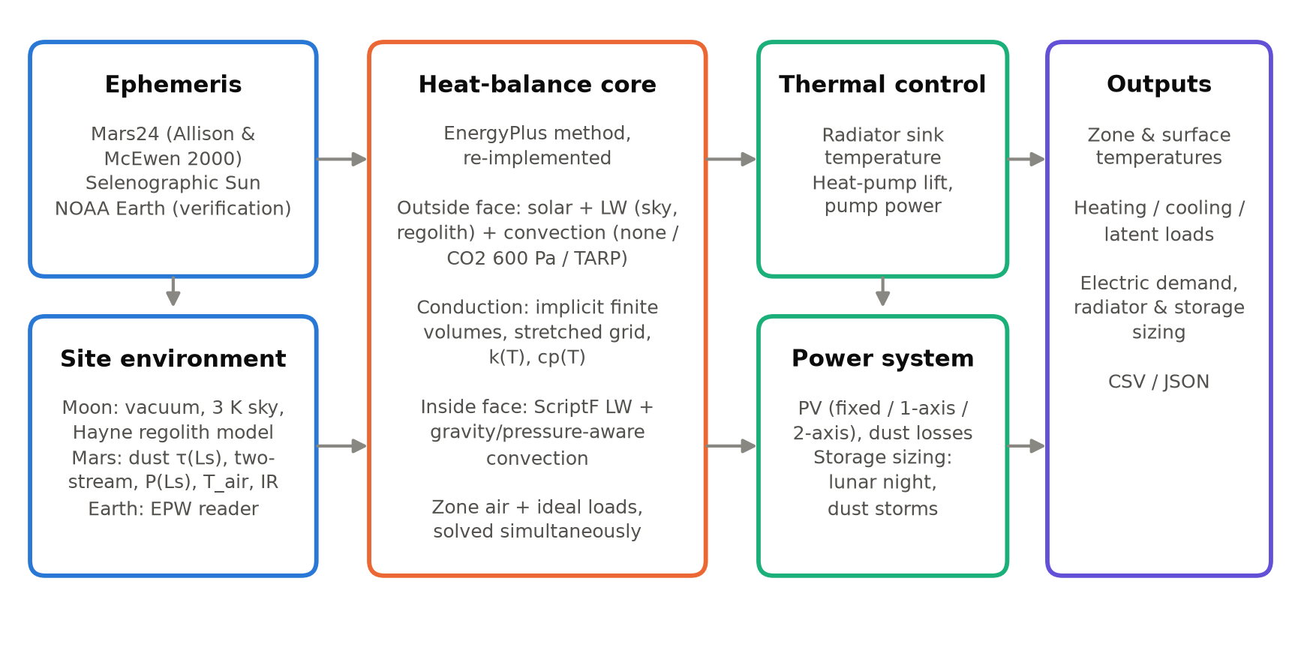
Fig. 1. ExoBEM architecture. The heat-balance core follows the EnergyPlus method; the ephemeris, site-environment, thermal-control and power modules carry the planetary physics.

3.2 Heat-balance core
For each exterior surface, the outside-face heat balance equates absorbed solar radiation, net long-wave exchange, convection and conduction into the wall [5]:
$$α_{s}G_{inc}+εσ\sum_{k}{F_{k}}\left(T_{k}^{4} − T_{so}^{4}\right)+h_{co}\left(T_{a} − T_{so}\right)=q_{ko}$$ | (1)
where the long-wave sum runs over sky (k = sky) and ground (k = g) with view factors F_{sky} = (1+cosβ)/2 and F_{g} = (1−cosβ)/2 for tilt β. On Earth, EnergyPlus splits the sky view into a sky part and an air part with weight sqrt[(1+cosβ)/2] and uses the air temperature for the ground; ExoBEM reproduces this split in Earth mode and uses the computed regolith surface temperature T_{g} elsewhere. The T⁴ term is Newton-linearized about the current iterate,
$$T_{so}^{4}≈4T_{so}^{*3}T_{so}−3T_{so}^{*4}$$ | (2)
which is essential in vacuum: with a 2.7 K sky and almost no conductive coupling through low-conductivity regolith, the fixed-point radiation coefficient used in many BES codes oscillates and fails to converge.
Conduction is solved with the node-centred, fully implicit finite-volume scheme of the EnergyPlus CondFD algorithm [5]:
$$C_{i}\frac{T_{i}^{n+1}−T_{i}^{n}}{Δt}=K_{i−1/2}\left(T_{i−1}^{n+1} − T_{i}^{n+1}\right)+K_{i+1/2}\left(T_{i+1}^{n+1} − T_{i}^{n+1}\right)$$ | (3)
with node capacitances C_{i} (half of each adjacent cell) and conductances K = k/Δx or 1/R for massless layers. Two extensions matter off-Earth. First, metre-thick regolith covers have diffusivities near 2×10⁻⁹ m²/s, so each layer uses a grid stretched geometrically from both faces (first cell ½(αΔt)^{1/2}, growth 1.3). Second, conductivity and specific heat may depend on temperature; they are lagged by one step, as in CondFD.
At the inside face, conduction, convection to zone air, long-wave exchange and radiant internal gains balance:
$$q_{ki}+h_{ci}\left(T_{z} − T_{si}\right)+\sum_{j}{σ}ℱ_{ij}\left(T_{sj}^{4} − T_{si}^{4}\right)+\frac{f_{i}Q_{rad}}{A_{i}}=0$$ | (4)
where ℱ_{ij} are Hottel gray-interchange (ScriptF) factors computed from EnergyPlus-style area-weighted view factors with enforced reciprocity [5, 35], and radiant gains are distributed in proportion to area times emissivity. The zone air balance is
$$C_{z}\frac{dT_{z}}{dt}=\sum_{i}{h_{ci}}A_{i}\left(T_{si} − T_{z}\right)+Q_{conv}+\overset{˙}{m}c_{p}\left(T_{sup} − T_{z}\right)+Q_{sys}$$ | (5)
in which ṁ is outdoor-air infiltration on Earth and leakage make-up gas in a habitat. Q_{sys} is the ideal load that keeps T_{z} inside the heating and cooling set-points.
Simultaneous solution. EnergyPlus iterates between the surface and air balances. ExoBEM instead solves them simultaneously. All constructions are stacked into one tri-diagonal system AT = b + Bu, where the vector u = [T_{si,1}…T_{si,n}, T_{z}] collects the inside-face temperatures and the air temperature that couple surfaces to each other and to the air. Solving the banded system once for n+2 right-hand sides gives
$$T=X_{0}+X_{B}u$$ | (6)
which, substituted into the inside-face and air equations, yields a dense (n+1)×(n+1) system. It is solved free-floating first; if T_{z} leaves the set-point band, T_{z} is fixed at the violated set-point and Q_{sys} follows from the air balance. Only the non-linear coefficients (radiation linearization, convection coefficients and temperature-dependent properties) are updated by fixed-point iteration. The iteration typically converges to 0.005 K in two to three iterations per step.
Initialization. EnergyPlus warms up by repeating the first day. A 1-m lunar regolith cover has a thermal time constant of years, so ExoBEM first solves a pseudo-transient steady state with period-mean boundary conditions (time steps growing geometrically to 10⁹ s, with T⁴-mean sky and ground temperatures). It then repeats the first solar day (one sol or one lunation) once before recording results.

3.3 Planetary ephemerides and time
For Mars, ExoBEM implements the Allison and McEwen (2000) algorithm used by NASA's Mars24 [22, 36]: from the TT Julian date it computes the mean anomaly, the fictitious-mean-Sun angle, seven planetary perturbation terms and the equation of center, giving the areocentric solar longitude L_{s}, solar declination, heliocentric distance and equation of time. Local true solar time then gives the hour angle,
$$L_{s}=α_{FMS}+\left(ν − M\right),sinδ_{s}=0.42565sinL_{s}+{0.25}^{∘}sinL_{s}$$ | (7)
For the Moon, the lunar prime meridian follows the Moon's mean geocentric longitude L′, and the lunar equator is inclined I = 1.5424° to the ecliptic with its descending node at the orbit's ascending node Ω (Cassini's laws). The selenographic subsolar point is therefore [37, 38]
$$λ_{ss}={180}^{∘}−\left(L^{′} − λ_{⊙}\right),β_{ss}=Isin\left(λ_{⊙} − Ω\right)$$ | (8)
where λ⊙ is the Sun's apparent ecliptic longitude. Using the mean rather than the true lunar longitude captures the optical libration in longitude, which shifts lunar local time by up to about half an Earth day. Near the poles, the Sun is treated as a disk of finite angular radius above an azimuth-dependent horizon. Schedules run on local mean solar time on Mars and on Earth (UTC) time on the Moon, where the 29.5-day lunar day cannot set crew rhythms. The total solar irradiance is 1361 W/m² at 1 AU [39].

3.4 Site environments
Moon. There is no diffuse light and no convection; the sky temperature is 2.725 K. Ground temperature comes from a 1-D model of the regolith following Hayne et al. [21]. Density increases with depth as ρ(z) = ρ_{d} − (ρ_{d} − ρ_{s})exp(−z/H) with ρ_{s} = 1100 kg/m³, ρ_{d} = 1800 kg/m³ and H = 0.06 m. Contact conductivity scales with density between 7.4×10⁻⁴ and 3.4×10⁻³ W/(m·K). Radiative conduction between grains is included through
$$k\left(z , T\right)=k_{c}\left(z\right)\left[1 + χ{\left(\frac{T}{350K}\right)}^{3}\right],χ=2.7$$ | (9)
Specific heat follows the fourth-order polynomial fit to Apollo samples [21, 40]. Albedo depends on incidence angle, A = 0.12 + 0.06(i/45°)³ + 0.25(i/90°)⁸; emissivity is 0.95 and the geothermal flux is 0.018 W/m². The column is spun up over six lunations.
Mars. Top-of-atmosphere irradiance is 1361/r² W/m². Beam and diffuse components at the surface follow a delta-Eddington two-stream solution [41–43]:
$$\frac{dF^{±}}{dτ}=±\left(γ_{1}F^{±} − γ_{2}F^{∓}\right)∓γ_{3,4}ω_{0}F_{s}e^{−τ/μ_{0}}$$ | (10)
with a Lambertian surface and a spherical-shell air mass. The broadband single-scattering albedo ω₀ = 0.885 and asymmetry parameter g = 0.74 were fitted to the normalized net-flux tables of Appelbaum and Flood [44, 45]. These are effective solar-band values: they are lower than visible-band retrievals [46, 47] because they absorb near-infrared absorption and two-stream error. Dust optical depth follows a seasonal climatology representative of Jezero crater (0.45 in the aphelion season, 0.85 near L_{s} = 245°) [48–50]. A global-storm scenario raises τ to 6 between L_{s} = 190° and 270° [24]. Surface pressure follows a two-harmonic CO2-cycle fit (mean 710 Pa). Ground temperature comes from a homogeneous regolith column with thermal inertia 350 J m⁻² K⁻¹ s^{-1/2} and albedo 0.14, as measured at Jezero by MEDA [51]. Near-surface air temperature is an empirical boundary-layer surrogate, T_{a} = T̄_{g} + κ(T_{g}(t−0.5 h) − T̄_{g}) with κ = 0.6, which reproduces the roughly 2:1 ratio of ground-to-air diurnal amplitude measured by MEDA and REMS [52–54]. Downwelling long-wave flux is
$$L^{↓}=ε_{sky}\left(τ\right)σT_{a}^{4}+f_{re}{⟨G_{toa,h}−G_{h}⟩}_{sol},ε_{sky}=min\left(0.08+0.125τ,0.6\right)$$ | (11)
The first term is emission by CO2 and dust; the second re-emits a fraction f_{re} = 0.45 of the sunlight that dust removes (sol-running mean), a one-layer-atmosphere energy term. The parameters were calibrated so that the clear-season daily mean is about 30 W/m², as measured by MEDA/TIRS [51], and so that in a global storm the sol-mean temperature drops by about 10 K while the diurnal range collapses, as observed in 2018 [24].

3.5 Convection in thin, foreign and pressurized atmospheres
EnergyPlus's TARP algorithm combines Walton's natural-convection correlations with a Sparrow-type forced term [5, 55]. Both were fitted to air at 101 kPa and 1 g. For turbulent natural convection, h = C k (gβΔT/να)^{1/3}, so for a given gas h scales as (gρ²)^{1/3} [56]. ExoBEM therefore offers a physical convection mode for any gas, pressure and gravity:
$$h={\left(h_{n}^{3} + h_{f}^{3}\right)}^{1/3},Nu_{v}={\left\{0.825 + \frac{0.387Ra^{1/6}}{{\left[1 + {\left(0.492 / Pr\right)}^{9/{16}}\right]}^{8/{27}}}\right\}}^{2}$$ | (12)
Here the natural term uses Churchill–Chu for vertical faces and McAdams/Lloyd–Moran correlations for horizontal faces [56, 57]. The forced term uses flat-plate correlations with the local wind speed (exterior) or the cabin ventilation velocity (interior, 0.15 m/s by default, within the 0.076–0.61 m/s range of BVAD [25]). Gas properties come from Sutherland-type fits: the Mars mixture is 95% CO2, and cabin atmospheres are N2/O2 at 101.3 kPa/21%, 70.3 kPa/26.5% or 56.5 kPa/34% O2 [25, 26]. In Earth mode the TARP formulation is retained for comparability with EnergyPlus.

3.6 Thermal control and power
Because a habitat cannot reject heat to outdoor air, the ideal cooling load (sensible plus crew latent heat removed by a condensing heat exchanger) is passed to a radiator model. The radiator's environmental sink temperature is
$$ε_{r}σT_{sink}^{4}=α_{r}\left(G_{b} + G_{d} + G_{r}\right)+ε_{r}σ\left(F_{sky}T_{sky}^{4} + F_{g}T_{g}^{4}\right)$$ | (13)
The default radiator is two-sided, vertical and pole-facing, 40 m², with silver-Teflon optical properties α = 0.10 and ε = 0.80, midway between beginning and end of life [25]. If the radiator temperature needed to reject the load is below the cabin coolant temperature (2 °C less a 5 K approach), rejection is passive and only pump power (150 W) is drawn. Otherwise a vapor-compression heat pump lifts the heat, with COP equal to 40% of the Carnot value between the evaporator and the radiator temperature plus approach. The radiator temperature is found with a bracketed root search so that radiated power equals Q_{c}(1 + 1/COP). Photovoltaic generation (30% efficient arrays with two-axis or vertical single-axis tracking; a 0.85 dust factor on Mars) and storage capacity are sized so that the habitat's total electric demand (equipment, lighting and thermal control) is met over the period with an 85% storage round-trip efficiency.

4. Verification

4.1 Comparative verification against EnergyPlus 23.2
The terrestrial core was compared with EnergyPlus 23.2 on opaque versions of ASHRAE Standard 140 Cases 600 (lightweight) and 900 (heavyweight) [6, 58]. In these versions the 12 m² south window is replaced by wall so that the comparison isolates the opaque heat balance, which is the part relevant to windowless habitats. The 8 m × 6 m × 2.7 m zone has 200 W of internal gains (60% radiant), 0.5 ACH infiltration, a floor on R-25 insulation over ground at 10 °C, and 20/27 °C ideal-load set-points; free-floating variants (600FF, 900FF) have no HVAC. Both programs used the Golden, Colorado TMY3 file [59], 10-minute time steps, TARP convection inside and outside, the Perez sky model [60] and Country terrain. EnergyPlus used conduction transfer functions; ExoBEM used its finite-volume solver. EnergyPlus input files are generated by a script in the repository.
Table 2. Annual loads, ExoBEM (Earth mode) versus EnergyPlus 23.2, opaque ASHRAE 140 cases, Golden CO.
Case | Heating E+ (kWh) | Heating ExoBEM (kWh) | Diff. | Cooling E+ (kWh) | Cooling ExoBEM (kWh) | Diff. | Peak heat E+/Exo (kW) | Peak cool E+/Exo (kW) | Hourly R² | CV(RMSE) %
Case 600 | 4,504 | 4,507 | +0.07% | 392 | 394 | +0.46% | 3.00 / 3.00 | 1.30 / 1.28 | 0.9987 | 4.2
Case 900 | 4,147 | 4,144 | -0.07% | 124 | 125 | +0.67% | 2.63 / 2.63 | 0.67 / 0.67 | 0.9987 | 4.1

Table 3. Free-floating zone air temperature (°C), ExoBEM versus EnergyPlus 23.2, 10-minute values over one year.
Case | T_{min} E+ | T_{min} Exo | T_{max} E+ | T_{max} Exo | T_{mean} E+ | T_{mean} Exo | RMSE (K) | MBE (K) | R²
Case 600FF | -17.20 | -17.33 | 39.02 | 39.09 | 14.77 | 14.77 | 0.31 | -0.003 | 0.9991
Case 900FF | -7.23 | -7.31 | 32.49 | 32.51 | 14.70 | 14.74 | 0.47 | +0.041 | 0.9974

Annual heating differs by +0.07% (Case 600) and -0.07% (Case 900), and annual cooling by +0.46% and +0.67% (Table 2). Peak loads agree within 1%, and hourly net loads have R² above 0.998 (Fig. 2a). These differences are far smaller than the spread between programs in the ASHRAE 140 reference results. Free-floating temperatures agree with an annual RMSE of 0.31 K (600FF) and 0.47 K (900FF) and a mean bias under 0.05 K (Table 3, Fig. 2b–c). The remaining differences come from documented implementation choices: finite volumes versus conduction transfer functions, implicit Euler versus third-order backward differencing of the air balance, the sub-hourly interpolation of weather data, and the solar-position algorithm.
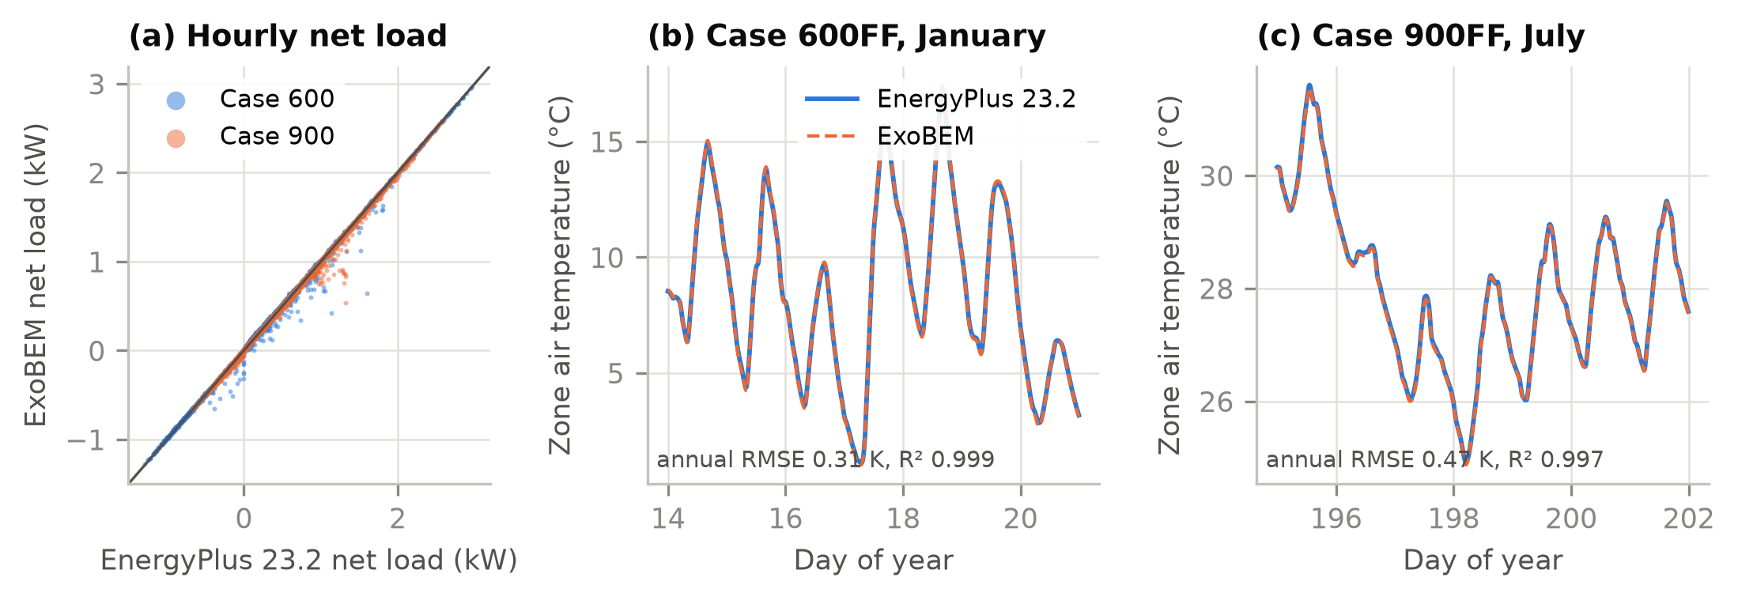
Fig. 2. Comparative verification against EnergyPlus 23.2 (Golden CO, TMY3). (a) Hourly net load (heating positive) for opaque Cases 600 and 900. (b, c) Free-floating zone air temperature over one winter and one summer week.

4.2 Verification of the planetary models
Table 4. Verification of the planetary models against reference data and analytical solutions.
Quantity | Reference | ExoBEM | Source
Mars24 worked example, 2000-01-06 00:00 UTC | L_{s} = 277.18758°, EOT = −5.18774°, r = 1.39358 AU, MST = 23.99425 h | Identical to 5 decimals | [36]
Lunar equatorial surface temperature (Diviner) | ≈385–390 K noon; ≈95 K pre-dawn; ≈252–256 K at ~1 m | 388 K; 94 K; 259 K (3 m) | [20, 21]
Mars net-flux function f(z, τ), 20 table values | Appelbaum & Flood tables, albedo 0.1 | RMSE 0.014, max. error 0.035 | [44]
Jezero surface pressure (daily means) | ≈625–790 Pa | 626–785 Pa | [54]
Jezero air temperature at 1.45 m | ≈188–262 K | 199–263 K | [54]
Jezero ground temperature | ≈183–290 K | 190–284 K | [51]
Jezero downwelling long-wave flux | ≈30 W/m² daily mean (20–45 W/m²) | 37 W/m² mean (19–64 W/m²) | [51]
Lunar south-polar ridge illumination | 92.3% at 2 m (Connecting Ridge) | 92.4% (horizon −1.65°) | [61]
Vertical radiator sink, lunar equator, noon | ≈333 K | 328 K | [28]
Analytical: steady conduction, semi-infinite step (erfc), parallel-plate ScriptF, vacuum steady state | Exact solutions | Errors < 0.1% (unit tests) | [56]

Table 4 summarizes the checks of the planetary models; all are automated in the test suite. Mars24's worked example is reproduced exactly. The regolith model reproduces Diviner's equatorial noon and pre-dawn temperatures and the Apollo heat-flow subsurface temperatures (Fig. 3a). The fitted delta-Eddington model reproduces the Appelbaum–Flood insolation tables over 0.1 ≤ τ ≤ 3 and 0° ≤ z ≤ 80° (Fig. 3b). The Jezero environment falls within the ranges MEDA observed for pressure, air and ground temperature and downwelling infrared. The lunar radiator sink agrees with the classic Bien–Guentert estimate. The polar horizon depression of −1.65° was chosen to match the 92.3% illumination of the best Connecting Ridge site [61]. Because a uniform horizon concentrates darkness into seasons, it yields a longest eclipse of 12 days, against 3–5 days for real ridge terrain [61, 62]. Polar storage results below are therefore conservative.
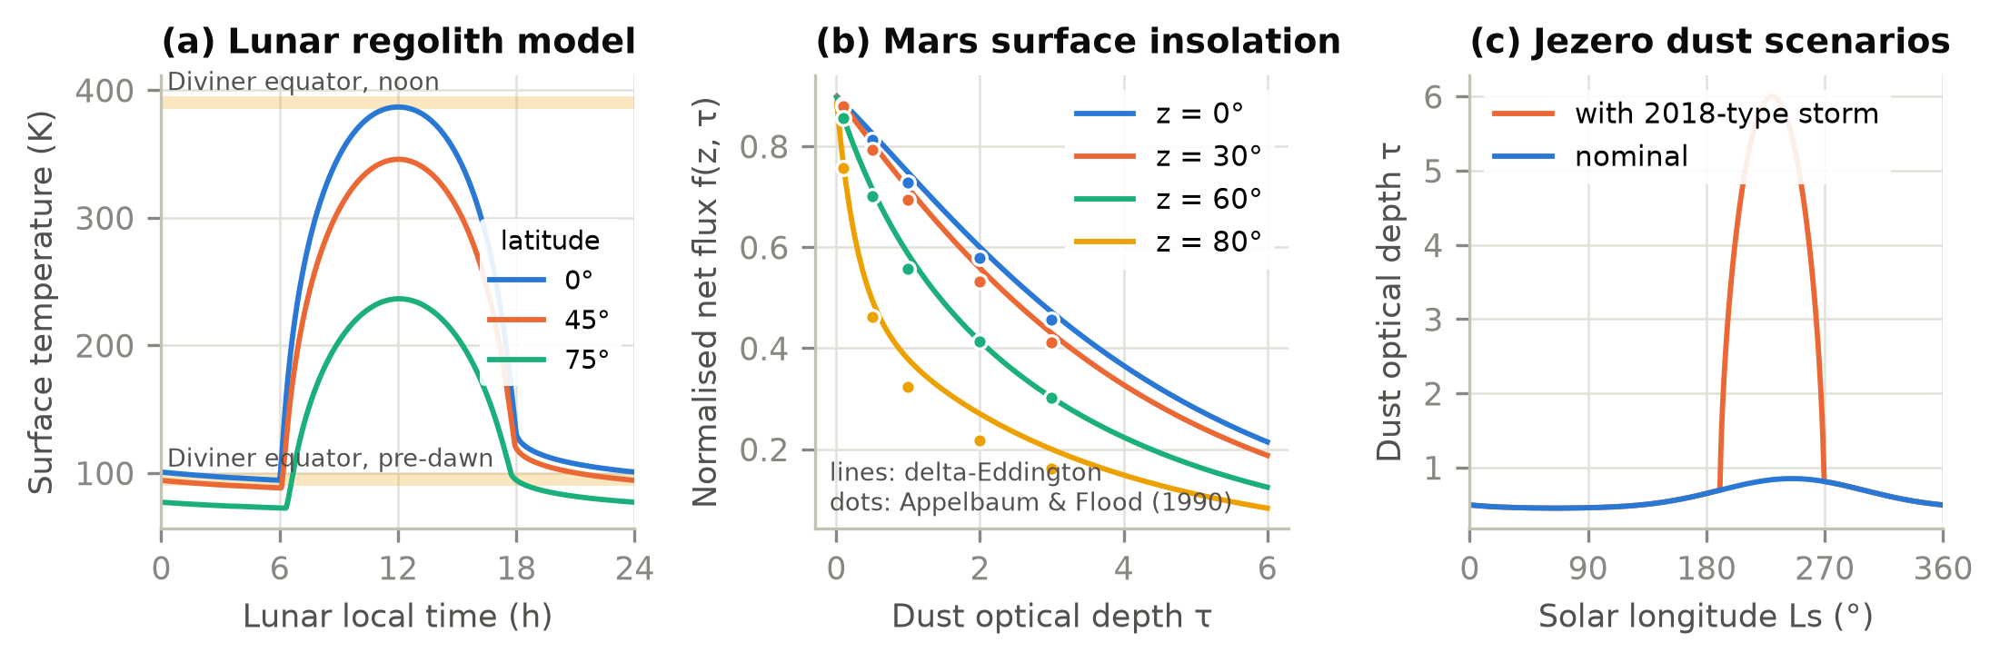
Fig. 3. Planetary environment models. (a) Lunar regolith surface temperature over a lunation at three latitudes, with Diviner equatorial ranges. (b) Normalized Martian surface net flux from the fitted delta-Eddington model (lines) and the Appelbaum–Flood tables (dots). (c) Seasonal dust optical depth at Jezero, nominal and with a 2018-type global dust storm.

5. Case studies

5.1 Habitat model and sites
The reference habitat is a horizontal cylinder 6 m in diameter and 10 m long (about 280 m³), a size typical of rigid or inflatable surface modules. Sixteen shell facets resolve orientation; the two lowest rest on a regolith berm. The shell consists, from outside to inside, of a regolith radiation shield, beta cloth, insulation, a 4 mm aluminium-2219 pressure wall and a 10 mm interior panel. Insulation is 20-layer MLI on the Moon. On Mars, where MLI is ineffective at 600–800 Pa [63], it is a 20 mm silica-aerogel blanket (k = 0.012 W/(m·K) in CO2 [64]). Four crew contribute the BVAD nominal 85.1 W sensible and 53.8 W latent heat each [25], with sleep from 22:00 to 06:00. Equipment draws 2.5 kW (70% at night) and lighting 0.4 kW. The cabin is held at 70.3 kPa and 26.5% O2, between 18 and 27 °C [25, 65], with 0.1 kg/day of leakage. Table 5 lists the sites.
Table 5. Case-study sites and simulation periods.
Case | Site | Period | Time step | Environment
Moon, equator | Mare Tranquillitatis, 0.67°N 23.47°E | 2 lunations from 2030-01-01 | 30 min | Vacuum; 2.7 K sky; regolith 94–388 K
Moon, south pole | Ridge at 89.5°S, horizon −1.65° | 12 lunations (354 d) | 60 min | 92% sunlit; regolith 34–116 K
Mars, Jezero | 18.44°N 77.45°E | 1 Mars year from L_{s} = 0° (2028-08-17) | 1/24 sol | P 626–785 Pa; τ 0.45–0.85
Mars, Jezero, dust storm | As above | As above | 1/24 sol | τ up to 6 at L_{s} 190–270°

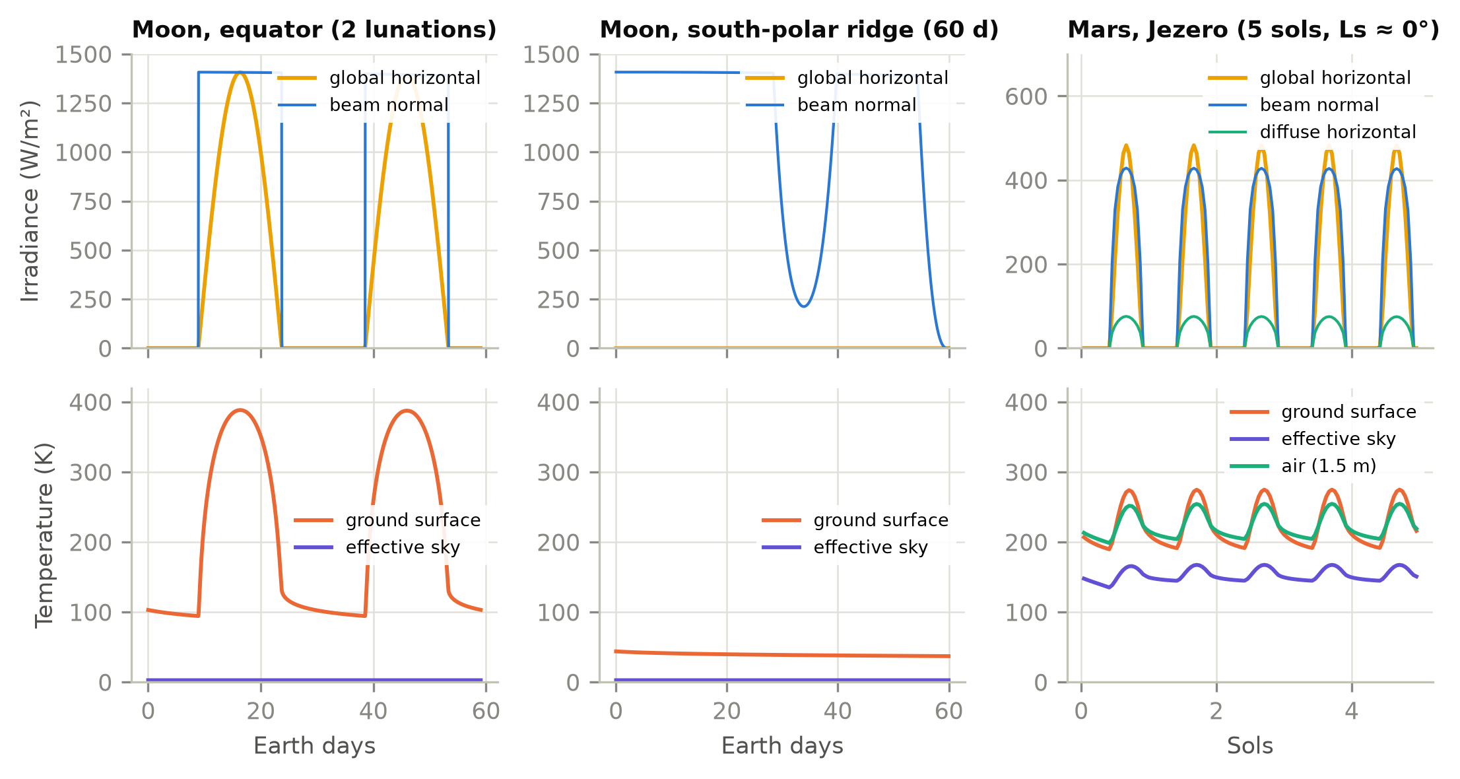
Fig. 4. Simulated surface environments: irradiance (top) and ground, sky and air temperatures (bottom) at the lunar equator, a lunar south-polar ridge and Jezero crater.

5.2 Results
Fig. 4 contrasts the three environments. At the lunar equator, 14.8 days of sunlight at up to 1406 W/m² alternate with 14.8 days of darkness, and the regolith swings from 94 to 388 K. At the polar ridge the Sun circles the horizon at grazing elevation: beam irradiance on a vertical surface is high, but the flat ground stays below 116 K. At Jezero the cycle repeats every sol. In the clear season, dust removes about a fifth of the noon beam and turns much of it into diffuse light, and the CO2 atmosphere keeps the effective sky above 135 K.
Table 6. Baseline results for the regolith-shielded habitat (1 m cover). Energies per Earth day.
Case | Heating (kWh/d) | Cooling (kWh/d) | Peak cooling (kW) | Mean envelope gain (W) | Outer surface (K) | Heat-pump time (%) | Thermal-control electricity (kWh/d) | Radiator sink (K)
Moon, equator | 0.0 | 67.2 | 3.21 | -36 | 108–401 | 37 | 18.4 | 79–328
Moon, south pole | 0.0 | 66.1 | 3.17 | -84 | 51–388 | 0 | 3.6 | 30–172
Mars, Jezero | 0.0 | 38.3 | 2.06 | -1,240 | 189–289 | 1 | 3.6 | 169–253
Mars, dust storm | 0.0 | 39.6 | 2.26 | -1,188 | 189–288 | 2 | 3.7 | 169–264

The shielded habitat is cooling-dominated everywhere (Table 6). With 1 m of regolith, the envelope exchanges on average only 36 W at the lunar equator and 84 W at the pole, about 1–3% of the 2.9 kW of internal sensible gains. The cabin never needs heating, and the cooling load (67.2 and 66.1 kWh/d) is essentially the internal gain. The reason is the extraordinarily low conductivity of lunar regolith (3–5 mW/(m·K)): a 1-m cover has a thermal resistance of roughly 200 m²·K/W, an order of magnitude more than the MLI beneath it. On Mars, CO2 in the pores raises regolith conductivity to about 0.08 W/(m·K), and the envelope loses 1.24 kW to the −60 °C environment. The cooling load (38.3 kWh/d) is therefore a little over half the lunar value. The outer regolith surface follows the environment (108–401 K at the lunar equator), but the inside surfaces vary by about 1 K (Fig. 5a).
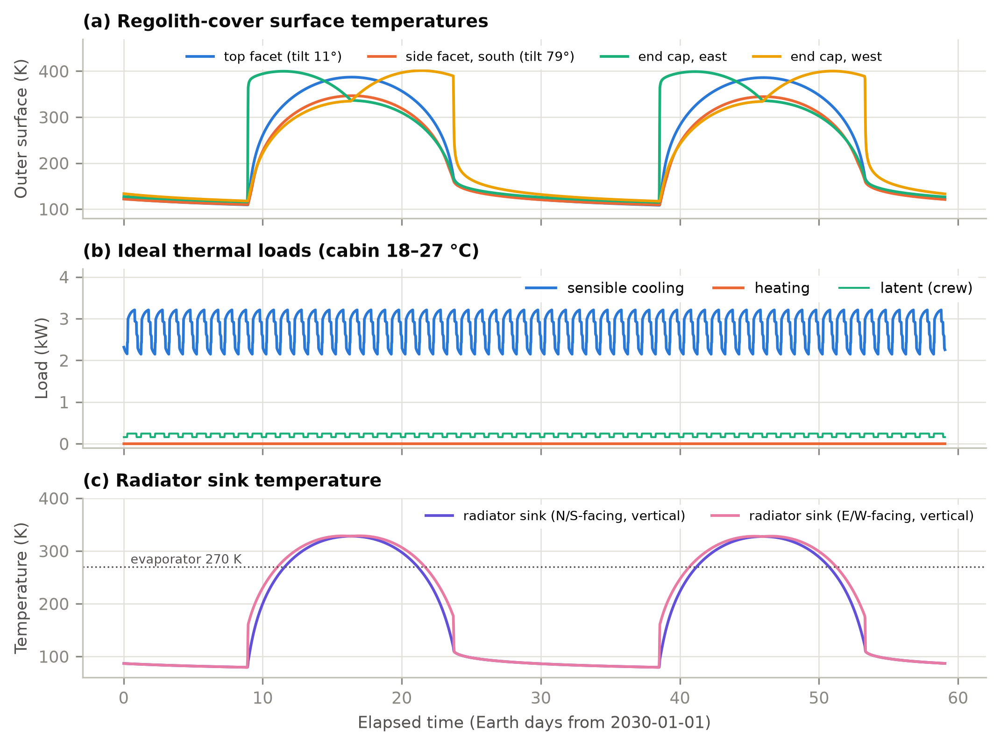
Fig. 5. Regolith-shielded habitat at the lunar equator over two lunations. (a) Outer surface temperatures of selected facets. (b) Ideal sensible cooling, heating and crew latent loads. (c) Sink temperature of a vertical two-sided radiator facing north/south or east/west, compared with the 270 K evaporator temperature.
Heat rejection is where the Moon's equator differs from the pole. The sink temperature of a vertical radiator at the equator rises to 328 K at noon because half of its view is regolith at nearly 390 K (Fig. 5c). For 37% of the lunation, heat can only be rejected by lifting it with a heat pump; the COP falls to 1.3, and the thermal-control system draws 18.4 kWh/d, 5.1 times the passive pump-only demand at the pole, where the sink never exceeds 172 K. On Mars the sink peaks at 253 K and rejection is passive for 99.5% of the year (98.3% with the dust storm, whose infrared glow warms the sink).
Table 7. Effect of radiator orientation and surface degradation at the lunar equator (α = 0.10 unless noted).
Radiator configuration (40 m², ε = 0.80) | Thermal-control electricity (kWh/d) | Peak power (kW) | Max. sink (K) | Heat-pump time (%)
Vertical, faces N/S (pole-facing) | 18.4 | 2.84 | 328 | 37
Vertical, faces E/W | 20.6 | 2.87 | 329 | 41
Horizontal, faces up | 3.6 | 0.15 | 236 | 0
Horizontal, dust-degraded (alpha = 0.35) | 18.3 | 2.69 | 323 | 39
Vertical N/S, 2x area | 15.7 | 2.49 | 328 | 35

Table 7 compares radiator options at the equator. Turning a vertical radiator from the poles to east–west slightly worsens performance because it then faces the low morning and evening Sun. Doubling the vertical area saves only about 14%, because the noon sink is above the cabin temperature whatever the area. A horizontal radiator does not see the regolith: with a clean silver-Teflon surface its sink stays at 236 K, and rejection is passive throughout (3.6 kWh/d). If lunar dust raises its absorptance to 0.35 [66], the noon sink climbs to 323 K and the heat pump runs 39% of the time (18.3 kWh/d). Radiator orientation and dust mitigation are thus first-order energy decisions for equatorial bases.
Envelope choices. Fig. 6 compares envelope variants. On the Moon, removing the regolith (MLI alone) cuts the cooling load by 44% at the equator and 58% at the pole. This is not a benefit: the bare habitat simply leaks heat to space, and its internal surfaces follow the lunar day. Once 0.5 m of regolith is present, additional thickness or MLI changes the load by less than 3%. On Mars the picture is reversed. A habitat insulated only with 20 mm of aerogel or 50 mm of polyimide foam needs 94.7 kWh/d of heating, about 4 kW on average. A 1 m regolith cover, with or without insulation, turns it into a cooling-dominated building. MLI in the CO2 atmosphere adds almost nothing to the regolith.
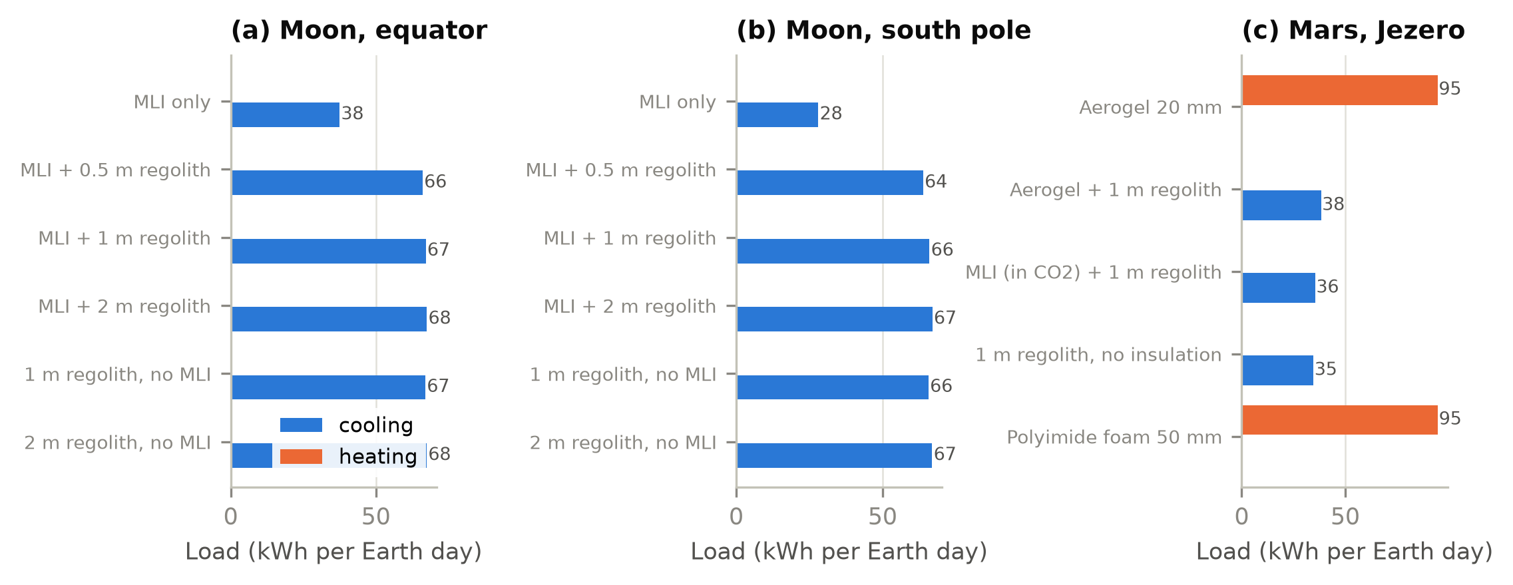
Fig. 6. Daily heating and cooling loads for envelope variants at the three sites (kWh per Earth day).
Mars seasons and dust storms. Over the Mars year at Jezero (Fig. 7), sol-mean insolation varies between 105 and 161 W/m², and sol-mean air temperature between -56 and -42 °C. A 2018-type global storm cuts sol-mean insolation to 21 W/m² and keeps it below 60 W/m² for 104 sols. Dust re-emits part of the absorbed sunlight as infrared, so the nights warm, the days cool and the sol-mean air temperature falls by at most 0 K, consistent with the 2018 observations [24]. The habitat barely notices: its sol-mean cooling load changes by at most 285 W. The power system notices a great deal, as shown next.
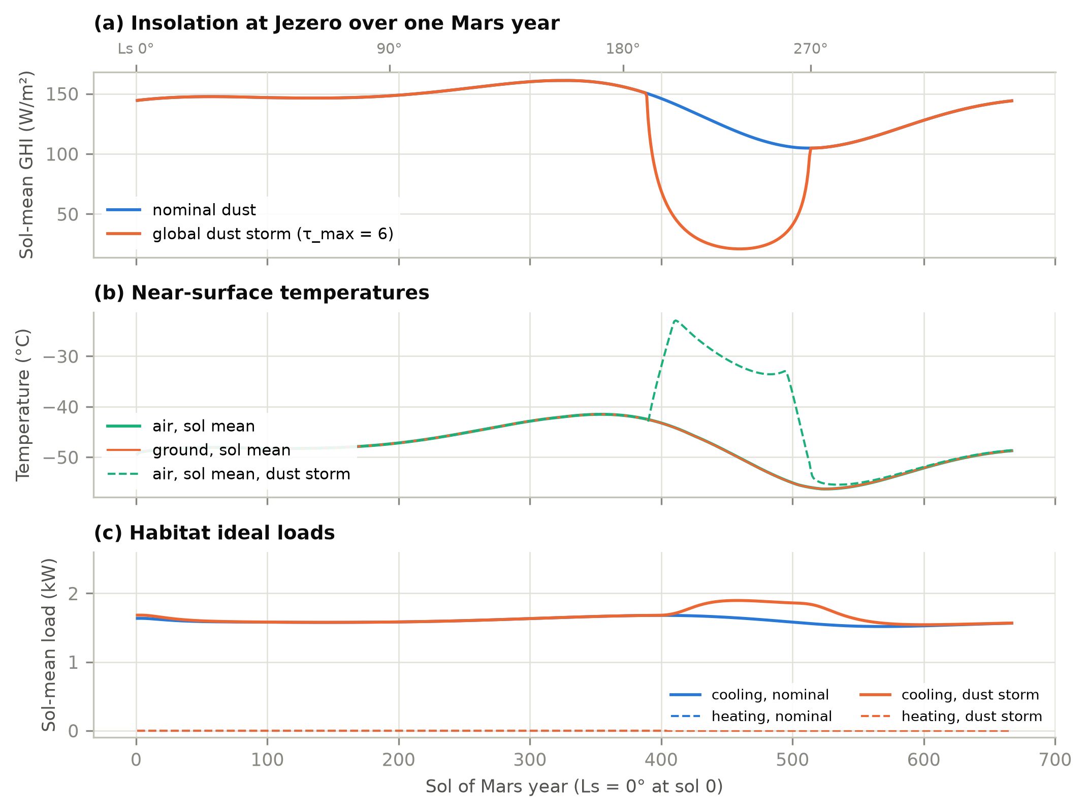
Fig. 7. One Mars year at Jezero crater. (a) Sol-mean global horizontal irradiance, nominal and with a global dust storm. (b) Sol-mean air and ground temperatures. (c) Sol-mean habitat ideal loads.
Table 8. Power-system sizing for the habitat's total electric load (equipment, lighting and thermal control).
Case | Mean electric load (kW) | Peak load (kW) | Thermal-control share (%) | PV area for energy balance (m²) | Storage needed (kWh)
Moon, equator (2-axis PV) | 3.26 | 5.74 | 23 | 17 | 1,023
Moon, pole (vertical 1-axis PV) | 2.65 | 3.05 | 6 | 7 | 1,914
Mars, Jezero (2-axis PV) | 2.65 | 3.19 | 6 | 60 | 1,494
Mars, dust storm (2-axis PV) | 2.65 | 3.41 | 6 | 69 | 6,481

Power-system implications (Table 8). With arrays sized for energy balance, the equatorial lunar base needs about 1,023 kWh of storage to cross the 354-hour night, and its thermal-control system accounts for 23% of the electric load. At the polar ridge the array shrinks to 7 m², but the idealized horizon's 12-day eclipses still call for 1,914 kWh. Real ridge terrain, whose eclipses last only 3–5 days [61], would need far less. At Jezero, nominal dust requires 60 m² of arrays and 1,494 kWh of storage, mostly to buffer the dusty, low-sun northern winter. A global dust storm multiplies the storage by 4.3, to 6,481 kWh, although the thermal loads hardly change. Oversizing the arrays trades directly against these storage figures.

5.3 Convection under reduced gravity and pressure
Fig. 8 quantifies why convection coefficients cannot be carried over from Earth. Cabin natural convection on a 2.5 m wall with a 3 K temperature difference drops from about 2.1 W/(m²·K) at 1 g and 101 kPa to about 0.9 W/(m²·K) at lunar gravity and 70.3 kPa. That is comparable to the forced coefficient at a 0.15 m/s ventilation velocity, so cabin ventilation, not buoyancy, controls interior surface heat transfer on the Moon. Outside on Mars, mixed convection in 700 Pa CO2 gives 0.15–0.7 W/(m²·K) over the full range of wind speeds, 20–70 times less than on Earth at the same wind speed. Exterior convection on Mars is therefore a correction to the radiative balance rather than a dominant term. This is consistent with the small sensible heat fluxes MEDA measured [51].
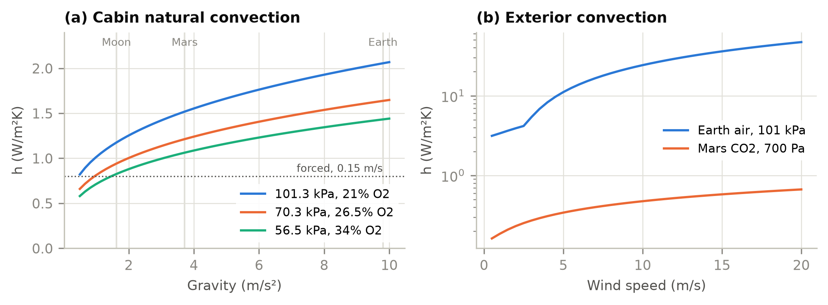
Fig. 8. (a) Interior natural convection coefficient versus gravity for three cabin atmospheres (2.5 m vertical wall, ΔT = 3 K), with the forced-convection value at 0.15 m/s. (b) Exterior mixed convection versus wind speed for a 3 m surface on Earth and Mars (ΔT = 10 K and 30 K, respectively).

6. Discussion

6.1 Implications for habitat design
The case studies suggest a shift in emphasis for habitat energy design. On Earth, BES spends most of its effort on the envelope; a regolith-shielded habitat on the Moon is so well insulated by its radiation shield that envelope optimization is nearly moot. Design then turns on (i) internal heat generation, (ii) where and how that heat is rejected, and (iii) storage across darkness. Radiator placement, coating degradation by dust, and site choice (equator versus pole) change thermal-control energy by a factor of five. On Mars, insulation matters again because CO2-filled regolith and the atmosphere conduct, but power-system sizing is dominated by dust. These conclusions are qualitatively known to spacecraft thermal engineers [8, 10]. What ExoBEM adds is a way to quantify them with the annual, schedule-driven methods of building science, and to carry the same model from early massing studies to detailed design.

6.2 Limitations
- Single zone. Multi-zone habitats, airlocks and inter-module air exchange are not yet modelled.
- Sensible-only air balance. Crew latent heat is passed to the coolant loop, but cabin humidity is not tracked.
- Idealized terrain. Horizons are uniform or user-supplied profiles; DEM horizons (LOLA, HiRISE) and shading between modules are planned.
- Empirical Mars boundary layer. Near-surface air temperature uses a calibrated surrogate rather than a surface-layer model; Mars Climate Database input is planned [33, 67].
- Effective dust optics. Broadband scattering parameters are fitted to Appelbaum–Flood tables; spectral and site-specific optics would refine the beam/diffuse split [46, 47].
- Storm infrared. The dust re-emission term was calibrated to the observed temperature response; peak downwelling infrared in the τ = 6 storm (223 W/m²) is probably overestimated and should be checked against MEDA and REMS storm data.
- Ideal thermal control. Radiators, heat pumps and storage are quasi-steady post-processors without component dynamics or capacity limits.
- Verification scope. The Earth core was compared with EnergyPlus on opaque cases; windows, empirical validation in thermal-vacuum chambers and analog habitats remain to be done.

6.3 From ExoBEM to a modified EnergyPlus engine
Re-implementing the method in a compact engine allowed the planetary physics to be developed and verified quickly, but it leaves out most of what EnergyPlus offers: multi-zone air and HVAC systems, plant loops, electric power, control and an established input and output ecosystem. A companion paper [27] describes ExoBEM-Core, a fork of the EnergyPlus v26.2 C++ engine that adds a planetary mode. It audits the engine for Earth-specific assumptions, injects the ExoBEM ephemerides, environment generator, convection and regolith models at the points where EnergyPlus reads its environment, keeps Earth results bit-for-bit identical, and agrees with ExoBEM within 1% in cooling energy for the habitat of Section 5. Under clause 4 of the EnergyPlus license, the fork carries a different name. ExoBEM remains the faster tool for exploring design options and the independent reference for regression testing of the engine.

7. Conclusions
ExoBEM brings whole-building energy simulation to the Moon and Mars by re-implementing the EnergyPlus heat-balance method and replacing its Earth-specific physics with planetary ephemerides, airless and thin-CO2 environments, regolith thermophysics, gravity- and pressure-aware convection and radiator heat rejection. Its terrestrial core matches EnergyPlus 23.2 within 0.7% in annual loads, and its planetary models reproduce Mars24, Diviner, Appelbaum–Flood and MEDA reference data. For a four-crew habitat under 1 m of regolith, the envelope is nearly adiabatic on the Moon; the energy problem becomes rejecting about 3 kW of internal heat. That costs several times more electricity at the lunar equator, where radiators see hot regolith, than at the pole or on Mars. On Mars, insulation matters again and dust storms dominate storage sizing. The code, verification scripts and inputs are open source, and ExoBEM serves as the reference model for the ExoBEM-Core engine.

Software and data availability
ExoBEM v0.1.0, the EnergyPlus verification inputs, case-study scripts and the data behind every figure and table are available at https://github.com/TensorBuildLab/ExoBEM (BSD-3-Clause). The companion engine ExoBEM-Core is available at https://github.com/TensorBuildLab/ExoBEM-Core. EnergyPlus 23.2 and the TMY3 weather file are available from the U.S. DOE.

Declaration of generative AI use
During the preparation of this work the author used Claude (Anthropic) to assist with literature search, software implementation, verification scripting and drafting of the manuscript. The author reviewed and edited all content and takes full responsibility for the publication. [Authors: confirm and adapt to the target journal's policy.]

CRediT authorship contribution statement
[To be completed by the authors.]

Declaration of competing interest
The authors declare that they have no known competing financial interests or personal relationships that could have appeared to influence the work reported in this paper.

Acknowledgements
EnergyPlus is developed by the U.S. Department of Energy's Building Technologies Office and its national laboratory and university partners; ExoBEM is not endorsed by them. [Funding to be added.]

References
[1] T. Hong, S.K. Chou, T.Y. Bong, Building simulation: an overview of developments and information sources, Build. Environ. 35 (2000) 347–361. https://doi.org/10.1016/S0360-1323(99)00023-2
[2] D.B. Crawley, J.W. Hand, M. Kummert, B.T. Griffith, Contrasting the capabilities of building energy performance simulation programs, Build. Environ. 43 (2008) 661–673. https://doi.org/10.1016/j.buildenv.2006.10.027
[3] D.B. Crawley, L.K. Lawrie, F.C. Winkelmann, W.F. Buhl, Y.J. Huang, C.O. Pedersen, R.K. Strand, R.J. Liesen, D.E. Fisher, M.J. Witte, J. Glazer, EnergyPlus: creating a new-generation building energy simulation program, Energy Build. 33 (2001) 319–331. https://doi.org/10.1016/S0378-7788(00)00114-6
[4] R.K. Strand, C.O. Pedersen, D.B. Crawley, Modularization and simulation techniques for heat balance-based energy and load calculation programs: the experience of the ASHRAE Loads Toolkit and EnergyPlus, in: Proc. Building Simulation 2001, IBPSA, Rio de Janeiro, 2001, pp. 43–50.
[5] U.S. Department of Energy, EnergyPlus Version 23.2.0 Documentation: Engineering Reference, U.S. DOE Building Technologies Office, 2023.
[6] ANSI/ASHRAE, Standard 140-2020: Standard Method of Test for the Evaluation of Building Energy Analysis Computer Programs, ASHRAE, Atlanta, GA, 2020.
[7] G. Schunk, S. Babiak, D. Naville, B. Evans, Conceptual thermal control system design for a lunar surface habitat, in: Thermal & Fluids Analysis Workshop (TFAWS), NASA, 2021. https://ntrs.nasa.gov/citations/20210020015
[8] R.G. Schunk, S.D. Babiak, B.W. Evans, Thermal control system architecture and technology challenges for a lunar surface habitat, in: 2022 IEEE Aerospace Conference, IEEE, 2022. https://ntrs.nasa.gov/citations/20210026557
[9] D.G. Gilmore (Ed.), Spacecraft Thermal Control Handbook, Volume I: Fundamental Technologies, 2nd ed., The Aerospace Press, El Segundo, CA, 2002.
[10] L.C. Simonsen, M.J. DeBarro, J.T. Farmer, Conceptual design of a lunar base thermal control system, in: The Second Conference on Lunar Bases and Space Activities of the 21st Century, NASA CP-3166, 1992, pp. 579–591. https://ntrs.nasa.gov/citations/19930004815
[11] K. Gadkari, S.K. Goyal, J. Vanniasinkam, Conceptual design of a thermal control system for an inflatable lunar habitat module, NASA-CR-192014, 1991. https://ntrs.nasa.gov/citations/19930008924
[12] R.B. Malla, K.M. Brown, Determination of temperature variation on lunar surface and subsurface for habitat analysis and design, Acta Astronaut. 107 (2015) 196–207. https://doi.org/10.1016/j.actaastro.2014.10.038
[13] S. Tripathi, J.T. Steiner, R.B. Malla, Three-dimensional temperature profile in a dome-shaped habitat structure on the Moon, Acta Astronaut. 204 (2023) 263–280. https://doi.org/10.1016/j.actaastro.2022.12.040
[14] J.T. Steiner, S. Tripathi, R.B. Malla, Air pressure and temperature distribution within a dome habitat structure on the lunar surface, in: Earth and Space 2022, ASCE, 2023, pp. 946–955. https://doi.org/10.1061/9780784484470.079
[15] A. Borshchak Kachalov, P. Salgado Sánchez, M.T. Mollah, J.M. Ezquerro, J. Spangenberg, B. Šeta, Numerical analysis of coaxially 3D printed lunar habitats: integrating regolith and PCM for passive temperature control, Microgravity Sci. Technol. 37 (2025) 38. https://doi.org/10.1007/s12217-025-10194-4
[16] J. Li, Y. Bai, S. Bi, M. Beer, Thermomechanical behavior of steel structural configurations subjected to cyclic cryogenic conditions in Martian environment, Adv. Space Res. 76 (2025) 3700–3716. https://doi.org/10.1016/j.asr.2025.06.069
[17] T.J.-R. Lagarde, Using computational techniques for the optimal design of evolving habitats, in: 72nd International Astronautical Congress, IAC-21-B3.7.10, Dubai, 2021. https://spacearchitect.org/pubs/IAC-21-B3.7.10.pdf
[18] G.N. Aydemir, An Integrated Framework for Mars-Based Building Performance Simulations (M-BPS): From Site Selection to Habitat Assessment, PhD dissertation, Middle East Technical University, Ankara, 2026. https://hdl.handle.net/11511/118421
[19] A. Jadeja, M.M. Jaiswal, S. Ghosh, P. Sanghavi, Thermal comfort analysis of a proposed design for a sustainable living space on Mars, Intell. Build. Int. 8 (2016) 215–233. https://doi.org/10.1080/17508975.2015.1120185
[20] A.R. Vasavada, J.L. Bandfield, B.T. Greenhagen, P.O. Hayne, M.A. Siegler, J.-P. Williams, D.A. Paige, Lunar equatorial surface temperatures and regolith properties from the Diviner Lunar Radiometer Experiment, J. Geophys. Res. 117 (2012) E00H18. https://doi.org/10.1029/2011JE003987
[21] P.O. Hayne, J.L. Bandfield, M.A. Siegler, A.R. Vasavada, R.R. Ghent, J.-P. Williams, B.T. Greenhagen, O. Aharonson, C.M. Elder, P.G. Lucey, D.A. Paige, Global regolith thermophysical properties of the Moon from the Diviner Lunar Radiometer Experiment, J. Geophys. Res. Planets 122 (2017) 2371–2400. https://doi.org/10.1002/2017JE005387
[22] M. Allison, M. McEwen, A post-Pathfinder evaluation of areocentric solar coordinates with improved timing recipes for Mars seasonal/diurnal climate studies, Planet. Space Sci. 48 (2000) 215–235. https://doi.org/10.1016/S0032-0633(99)00092-6
[23] G.M. Martínez, C.N. Newman, A. De Vicente-Retortillo, et al., The modern near-surface Martian climate: a review of in-situ meteorological data from Viking to Curiosity, Space Sci. Rev. 212 (2017) 295–338. https://doi.org/10.1007/s11214-017-0360-x
[24] S.D. Guzewich, M. Lemmon, C.L. Smith, et al., Mars Science Laboratory observations of the 2018/Mars Year 34 global dust storm, Geophys. Res. Lett. 46 (2019) 71–79. https://doi.org/10.1029/2018GL080839
[25] M.S. Anderson, M.K. Ewert, J.F. Keener, Life Support Baseline Values and Assumptions Document, NASA/TP-2015-218570/REV1, NASA Johnson Space Center, Houston, TX, 2018.
[26] NASA Exploration Atmospheres Working Group, Recommendations for Exploration Spacecraft Internal Atmospheres: The Final Report of the NASA Exploration Atmospheres Working Group, NASA/TP-2010-216134, NASA Johnson Space Center, Houston, TX, 2010.
[27] L. Zhang, ExoBEM-Core: auditing and adapting the EnergyPlus engine for building energy simulation on the Moon and Mars, companion manuscript in preparation, 2026.
[28] D.D. Bien, D.C. Guentert, A method for reducing the equivalent sink temperature of a vertically oriented radiator on the lunar surface, NASA TM X-1729, NASA Lewis Research Center, Cleveland, OH, 1969. https://ntrs.nasa.gov/citations/19690007893
[29] M. von Einem, R. Groll, C. Heinicke, Computational modeling of a ventilation concept for a lunar habitat laboratory, J. Space Saf. Eng. 9 (2022) 145–153. https://doi.org/10.1016/j.jsse.2022.02.005
[30] M. Azimi, et al., HabSim: a modular-coupled virtual testbed for simulating extraterrestrial habitat systems, AIAA J. 63 (2025) 376–388. https://doi.org/10.2514/1.J063845
[31] S.T. Engler, K. Binsted, H. Leung, HI-SEAS habitat energy requirements and forecasting, Acta Astronaut. 162 (2019) 50–55. https://doi.org/10.1016/j.actaastro.2019.05.049
[32] Y. Charoenboonvivat, O. de Weck, Surface power demand modeling for human Martian and lunar missions, in: AIAA SciTech 2026 Forum, AIAA 2026-1922, 2026. https://doi.org/10.2514/6.2026-1922
[33] E. Millour, F. Forget, A. Spiga, et al., The Mars Climate Database (version 5.3), in: From Mars Express to ExoMars Scientific Workshop, ESA-ESAC, Madrid, 2018.
[34] S. Ross, Development of an open source modelling package for thermal balance of crewed Mars habitats, in: 73rd International Astronautical Congress, IAC-22-A5.IP.4, Paris, 2022.
[35] H.C. Hottel, A.F. Sarofim, Radiative Transfer, McGraw-Hill, New York, 1967.
[36] NASA Goddard Institute for Space Studies, Mars24 Sunclock — Algorithm and Worked Examples, https://www.giss.nasa.gov/tools/mars24/help/algorithm.html (accessed 8 November 2026).
[37] J. Meeus, Astronomical Algorithms, 2nd ed., Willmann-Bell, Richmond, VA, 1998.
[38] B.A. Archinal, C.H. Acton, M.F. A'Hearn, et al., Report of the IAU Working Group on Cartographic Coordinates and Rotational Elements: 2015, Celest. Mech. Dyn. Astron. 130 (2018) 22. https://doi.org/10.1007/s10569-017-9805-5
[39] G. Kopp, J.L. Lean, A new, lower value of total solar irradiance: evidence and climate significance, Geophys. Res. Lett. 38 (2011) L01706. https://doi.org/10.1029/2010GL045777
[40] B.S. Hemingway, R.A. Robie, W.H. Wilson, Specific heats of lunar soils, basalt, and breccias from the Apollo 14, 15, and 16 landing sites, between 90 and 350 K, in: Proc. Lunar Planet. Sci. Conf. 12th, 1981, pp. 2259–2268.
[41] J.H. Joseph, W.J. Wiscombe, J.A. Weinman, The delta-Eddington approximation for radiative flux transfer, J. Atmos. Sci. 33 (1976) 2452–2459. https://doi.org/10.1175/1520-0469(1976)033<2452:TDEAFR>2.0.CO;2
[42] W.E. Meador, W.R. Weaver, Two-stream approximations to radiative transfer in planetary atmospheres: a unified description of existing methods and a new improvement, J. Atmos. Sci. 37 (1980) 630–643. https://doi.org/10.1175/1520-0469(1980)037<0630:TSATRT>2.0.CO;2
[43] O.B. Toon, C.P. McKay, T.P. Ackerman, K. Santhanam, Rapid calculation of radiative heating rates and photodissociation rates in inhomogeneous multiple scattering atmospheres, J. Geophys. Res. 94 (1989) 16287–16301. https://doi.org/10.1029/JD094iD13p16287
[44] J. Appelbaum, D.J. Flood, Solar radiation on Mars, Sol. Energy 45 (1990) 353–363. https://doi.org/10.1016/0038-092X(90)90156-7
[45] J. Appelbaum, G.A. Landis, I. Sherman, Solar radiation on Mars—update 1991, Sol. Energy 50 (1993) 35–51. https://doi.org/10.1016/0038-092X(93)90006-A
[46] M.J. Wolff, M.D. Smith, R.T. Clancy, et al., Wavelength dependence of dust aerosol single scattering albedo as observed by the Compact Reconnaissance Imaging Spectrometer, J. Geophys. Res. 114 (2009) E00D04. https://doi.org/10.1029/2009JE003350
[47] H. Chen-Chen, S. Pérez-Hoyos, A. Sánchez-Lavega, Characterisation of Martian dust aerosol phase function from sky radiance measurements by MSL engineering cameras, Icarus 330 (2019) 16–29. https://doi.org/10.1016/j.icarus.2019.04.004
[48] M.T. Lemmon, M.J. Wolff, J.F. Bell III, M.D. Smith, B.A. Cantor, P.H. Smith, Dust aerosol, clouds, and the atmospheric optical depth record over 5 Mars years of the Mars Exploration Rover mission, Icarus 251 (2015) 96–111. https://doi.org/10.1016/j.icarus.2014.03.029
[49] M.T. Lemmon, M.D. Smith, D. Viúdez-Moreiras, et al., Dust, sand, and winds within an active Martian storm in Jezero crater, Geophys. Res. Lett. 49 (2022) e2022GL100126. https://doi.org/10.1029/2022GL100126
[50] L. Montabone, F. Forget, E. Millour, et al., Eight-year climatology of dust optical depth on Mars, Icarus 251 (2015) 65–95. https://doi.org/10.1016/j.icarus.2014.12.034
[51] G.M. Martínez, E. Sebastián, A. Vicente-Retortillo, M.D. Smith, J.R. Johnson, E. Fischer, H. Savijärvi, et al., Surface energy budget, albedo, and thermal inertia at Jezero crater, Mars, as observed from the Mars 2020 MEDA instrument, J. Geophys. Res. Planets 128 (2023) e2022JE007537. https://doi.org/10.1029/2022JE007537
[52] J.A. Rodriguez-Manfredi, M. de la Torre Juárez, A. Alonso, et al., The Mars Environmental Dynamics Analyzer, MEDA. A suite of environmental sensors for the Mars 2020 mission, Space Sci. Rev. 217 (2021) 48. https://doi.org/10.1007/s11214-021-00816-9
[53] J. Gómez-Elvira, C. Armiens, L. Castañer, et al., REMS: The environmental sensor suite for the Mars Science Laboratory rover, Space Sci. Rev. 170 (2012) 583–640. https://doi.org/10.1007/s11214-012-9921-1
[54] J.A. Rodríguez-Manfredi, M. de la Torre Juárez, A. Sánchez-Lavega, R. Hueso, G.M. Martínez, et al., The diverse meteorology of Jezero crater over the first 250 sols of Perseverance on Mars, Nat. Geosci. 16 (2023) 19–28. https://doi.org/10.1038/s41561-022-01084-0
[55] G.N. Walton, Thermal Analysis Research Program Reference Manual, NBSIR 83-2655, National Bureau of Standards, Washington, DC, 1983.
[56] F.P. Incropera, D.P. DeWitt, T.L. Bergman, A.S. Lavine, Fundamentals of Heat and Mass Transfer, 6th ed., John Wiley & Sons, Hoboken, NJ, 2007.
[57] S.W. Churchill, H.H.S. Chu, Correlating equations for laminar and turbulent free convection from a vertical plate, Int. J. Heat Mass Transf. 18 (1975) 1323–1329. https://doi.org/10.1016/0017-9310(75)90243-4
[58] R. Judkoff, J. Neymark, International Energy Agency Building Energy Simulation Test (BESTEST) and Diagnostic Method, NREL/TP-472-6231, National Renewable Energy Laboratory, Golden, CO, 1995.
[59] S. Wilcox, W. Marion, Users Manual for TMY3 Data Sets, NREL/TP-581-43156, National Renewable Energy Laboratory, Golden, CO, 2008.
[60] R. Perez, P. Ineichen, R. Seals, J. Michalsky, R. Stewart, Modeling daylight availability and irradiance components from direct and global irradiance, Sol. Energy 44 (1990) 271–289. https://doi.org/10.1016/0038-092X(90)90055-H
[61] P. Gläser, F. Scholten, D. De Rosa, et al., Illumination conditions at the lunar south pole using high resolution Digital Terrain Models from LOLA, Icarus 243 (2014) 78–90. https://doi.org/10.1016/j.icarus.2014.08.013
[62] E. Mazarico, G.A. Neumann, D.E. Smith, M.T. Zuber, M.H. Torrence, Illumination conditions of the lunar polar regions using LOLA topography, Icarus 211 (2011) 1066–1081. https://doi.org/10.1016/j.icarus.2010.10.030
[63] L.A. Trevino, E.S. Orndoff, Advanced space suit insulation feasibility study, in: 30th International Conference on Environmental Systems, SAE 2000-01-2479, 2000. https://ntrs.nasa.gov/citations/20100042640
[64] G.S. Hickey, D. Braun, L.-C. Wen, H.J. Eisen, Integrated lightweight structure and thermal insulation for Mars rover, SAE Technical Paper 951523, 1995. https://doi.org/10.4271/951523
[65] NASA, NASA Space Flight Human-System Standard, Volume 2: Human Factors, Habitability, and Environmental Health, NASA-STD-3001 Vol. 2 Rev. C, NASA, Washington, DC, 2023.
[66] J.R. Gaier, J. Siamidis, S.R. Panko, K.J. Rogers, E.M.G. Larkin, The effect of simulated lunar dust on the absorptivity, emissivity, and operating temperature of AZ-93 and Ag/FEP thermal control surfaces, NASA/TM-2008-215492, 2008. https://ntrs.nasa.gov/citations/20090005996
[67] F. Forget, F. Hourdin, R. Fournier, et al., Improved general circulation models of the Martian atmosphere from the surface to above 80 km, J. Geophys. Res. 104 (1999) 24155–24175. https://doi.org/10.1029/1999JE001025

