ExoBEM: building energy simulation of sealed lunar and Martian habitats based on the EnergyPlus heat-balance method
Liang Zhang^{a,*}
ª University of Arizona, Tucson, AZ, USA
* Corresponding author: liangzhang1@arizona.edu
[Draft for author review — confirm author list, affiliations, funding and target journal before submission.]

Highlights
- ExoBEM adapts the EnergyPlus heat balance to sealed habitats on the Moon and Mars.
- Earth-mode verification against EnergyPlus 23.2: annual loads within 0.7%.
- Habitat loads are coupled with PV, battery, fuel-cell and fission power systems.
- Sealed-cabin model: no infiltration; leakage, humidity and condensation risk tracked.
- Night and dust-storm storage dominates solar power; a 40 kWe fission unit covers all.

Abstract
Building energy simulation (BES) programs such as EnergyPlus encode Earth in their physics: a 24-hour day, terrestrial solar geometry, outdoor air for convection, ventilation and humidity, and empirical sky and ground models. None of these hold for the sealed, pressurized habitats that crews will live in on the Moon and Mars. This paper presents ExoBEM, an open-source Python BES tool that re-implements the EnergyPlus heat-balance method and, starting from a factor-by-factor analysis of how the Moon and Mars differ from Earth, adds planetary ephemerides, airless and dusty-CO2 skies, regolith ground in periodic equilibrium, gas-, pressure- and gravity-aware convection, curved regolith shields, a sealed cabin with leakage, airlock losses and condensation checks, radiator heat rejection and a power system with photovoltaics, batteries, regenerative fuel cells and fission. Environments are exchanged through a new planetary weather-file format. In Earth mode ExoBEM reproduces EnergyPlus 23.2 for opaque ASHRAE 140 cases within 0.7% in annual loads; its planetary models reproduce Mars24, Diviner, Appelbaum–Flood and MEDA reference data, and its envelope, calibrated to NASA's night-time heat leak of the Artemis surface habitat, predicts the daylight loss within 24%. For NASA-class four-crew lunar and six-crew Mars habitats, heat rejection dominates (12.7 kW and 8.6 kW). Equatorial lunar radiators need heat-pump lift 41% of the time, an aerogel-only Mars habitat with a 25 °C, 60% RH cabin risks condensation for 4839 hours a year, and storage across the lunar night or a dust storm dominates solar power, while a 40 kWe fission unit covers every case.
Keywords: building energy simulation; EnergyPlus; lunar habitat; Mars habitat; heat balance; regolith; humidity; power systems; space architecture

1. Introduction
Whole-building energy simulation has matured over five decades into a reliable design tool for terrestrial buildings [1, 2]. EnergyPlus, developed by the U.S. Department of Energy, is the most widely used open-source engine; its heat-balance formulation solves coupled surface and zone-air energy balances at sub-hourly time steps and has been tested against analytical, comparative and empirical benchmarks [3–6]. With the Artemis program planning sustained surface operations near the lunar south pole and with crewed Mars missions in long-term planning, the same questions that BES answers on Earth — how large must the heating, cooling and power systems be, and how do envelope choices trade against each other — must now be answered for the first habitats on other worlds [7–9].
Existing habitat thermal analyses come from two traditions. Spacecraft thermal engineering uses lumped-network or finite-element tools and focuses on radiator sizing, worst-case hot and cold cases and component temperatures [8, 10–12]. Structural and civil-engineering studies solve conduction through regolith-covered shells to obtain temperature fields for design [13–17]. Neither tradition provides the annual, schedule-driven, whole-zone energy accounting that building scientists use to compare design alternatives. A small number of studies have tried to bring building-simulation tools to Mars, but they did so by constructing Mars-like weather files and running unmodified Earth engines or front-ends [18, 19], or by using design tools without a transient heat balance [20]. This is not sufficient: changing a weather file changes neither the length of the day, the solar geometry, the convective medium nor the ground model, and an Earth engine still exchanges air and moisture with the outdoors.
Getting this right matters because the result will size life-critical systems. This work therefore starts from a systematic analysis of every factor that distinguishes a sealed planetary habitat from an Earth building (Section 3, Table 1) and makes each one either a modelled physical process, a documented input, a check that stops an invalid run, or an explicitly justified omission. The paper makes five contributions. (i) It presents ExoBEM, to the author's knowledge the first open-source re-implementation of the EnergyPlus heat-balance method for planetary surface habitats, distributed as an installable Python package with a tutorial. (ii) It explains how the tool coordinates its components and how it relates, element by element, to EnergyPlus. (iii) It adds the sealed-cabin physics (leakage, airlock losses, humidity, condensation risk), a planetary weather-file format and an electric power system to the building model. (iv) It verifies the terrestrial core against EnergyPlus 23.2 and the planetary models against reference data, and calibrates and checks the envelope against NASA's thermal analysis of the Artemis surface habitat. (v) It applies the tool to NASA-class habitats for the first crews on the Moon and Mars. Section 2 reviews related work, Section 3 analyzes the planetary factors, Section 4 describes the method, Section 5 the verification, Section 6 the case studies and Section 7 the implications and limitations; Appendix A shows how to use the tool.

2. Related work

2.1 Thermal design of lunar and Martian habitats
Early lunar base studies established the thermal control architecture still in use: a single-phase water loop inside the pressure shell, an external ammonia loop and deployable radiators, with heat pumps to lift rejection temperature during the lunar day [11, 12]. Bien and Guentert showed that a vertical radiator at the lunar equator sees an equivalent sink of about 333 K at noon because half of its view is hot regolith [21]. NASA's Artemis surface habitat is a 174 m³ module for up to four crew; its thermal control system rejects about 15 kWt with 48 m² of double-sided radiator panels and must survive eclipses of up to about 100 h near the south pole [7, 8, 22, 23]. NASA's Mars Design Reference Architecture 5.0 sizes a surface habitat for six crew and about 500 sols, powered by fission or by large solar arrays with regenerative fuel cells [9, 24]. Malla and co-workers computed lunar surface and subsurface temperatures and transient temperature fields in regolith-covered domes, showing that a metre of regolith damps the 300 K surface swing [13–15]. Other studies examined 3D-printed regolith walls with phase-change cores [16], steel structures under Martian thermal cycling [17], cabin ventilation by CFD [25] and habitat system-of-systems simulation [26]. Engler et al. forecast energy demand of the HI-SEAS analog habitat from data [27], and Charoenboonvivat and de Weck modeled surface power demand for crewed missions [28].

2.2 Building simulation tools applied off-Earth
Building-simulation tools have been applied to Mars only in a limited way. Jadeja et al. combined PlanetWRF climate output with Ecotect and CFD to study thermal comfort in a Mars module [20]. Lagarde built a Gale-crater EPW weather file for Ladybug/Grasshopper solar and orientation studies and left heating and cooling loads to future work [18]. Aydemir developed a Mars building-performance framework that converts Mars Climate Database output to EPW format for an EnergyPlus-based front-end [19, 29]. Ross developed an open-source semi-empirical heat balance for Mars habitats outside the BES tradition [30]. None of these modify the heat-balance physics: an EPW file can carry Martian temperatures and irradiances, but the engine still computes Earth solar geometry over a 24-hour day, applies air-based convection at 101 kPa, assumes an Earth-like sky and lets outdoor air into the zone. To the author's knowledge, no previous work has modified EnergyPlus-family physics for vacuum or thin-CO2 convection, regolith ground coupling, the Martian sol or the lunar day, and no lunar application of an EnergyPlus-family tool has been reported.

2.3 Licensing and naming
EnergyPlus is distributed under a BSD-3-Clause-style license that permits modification and redistribution, including for derived tools, provided the copyright notice is retained, the developers' names are not used for endorsement, and (clause 4) a modified product is not named "EnergyPlus", "E+" or a confusingly similar name without U.S. DOE consent. ExoBEM contains no EnergyPlus source code; it re-implements algorithms documented in the Engineering Reference [5], credits EnergyPlus in a NOTICE file and uses a distinct name.

3. What changes on the Moon and Mars
Table 1 lists, category by category, the factors that set the energy balance of a building and how each changes on the Moon and Mars. Time and Sun: the lunar day lasts 29.5 Earth days and the Martian sol 24.66 h, Mars has strong orbital seasons, and polar terrain hides the Sun for days. Atmosphere and sky: the Moon has no atmosphere, so there is no convection, no diffuse light and a 2.7 K sky; Mars has a thin, dusty CO2 atmosphere whose dust can blot out the Sun for weeks. Ground: regolith is a superb insulator on the Moon and swings by about 290 K over a lunar day. Envelope: radiation shields of regolith add months to years of thermal time constant, multi-layer insulation works in vacuum but not in Martian CO2, and the cabin is a pressure vessel with no windows to speak of. Cabin: there is no outdoor air at all; the only exchanges are leakage and airlock venting, all moisture comes from the crew and must be condensed out, the gas is at reduced pressure and raised oxygen fraction, and natural convection is weakened by low gravity. Systems: heat can only be radiated, and electric power must be generated and stored on site through the night, polar eclipses or dust storms. The last column of Table 1 states how ExoBEM treats each factor; the following section gives the equations.
Table 1. Factors that distinguish a lunar or Martian habitat from an Earth building in an energy simulation, and how ExoBEM treats each one. modelled: physics implemented and verified; input: a parameter with a documented default; enforced: contradicting input stops the run; neglected: left out, with the reason.
Factor | Earth | Moon | Mars | Treatment in ExoBEM
Time and Sun
Length of the solar day | 24 h | 29.53 d (708.7 h): 354 h of light, 354 h of night | 1 sol = 24.66 h (88,775 s) | modelled: any day length; time step independent of the day
Seasons and orbit | 365.25 d; obliquity 23.4°; e = 0.017 | Spin axis 1.5° from the ecliptic: almost no seasons; Sun grazes the horizon at the poles | 668.6 sols; obliquity 25.2°; e = 0.093 | modelled: Mars24 ephemeris; lunar subsolar point
Solar irradiance at the top of the atmosphere | 1361 W/m² (±3.4 %) | 1361 W/m² (±3.4 %), no atmosphere | 490–714 W/m² (1.38–1.67 AU) | modelled: 1361/r²
Clock for crew schedules | Local civil time | Earth (UTC) mission time; the lunar day cannot set crew rhythms | Local mean solar time (sol) | modelled: UTC on the Moon, LMST on Mars
Terrain horizon and eclipses | Usually ignored | Polar ridges: Sun circles the horizon; multi-day eclipses | Crater rims | modelled: horizon profile with finite solar disk
Earthshine and Earth's shadow | – | Earthshine < 0.2 W/m²; lunar eclipses of up to a few hours, 0–3 per year | – | neglected: < 0.02 % of sunlight; eclipse hours are within normal night
Atmosphere and sky
Ambient gas and pressure | Air, 101 kPa | Vacuum (~10⁻¹² kPa) | 95 % CO2, 0.6–0.8 kPa, ±12 % seasonal cycle | modelled: vacuum or CO2 with seasonal pressure
Diffuse sunlight | Clouds and aerosols (Perez model) | None | Dust scattering; τ = 0.3 to > 6 in global storms | modelled: delta-Eddington two-stream, τ(Ls), storm scenario
Sky long-wave radiation | Effective sky 230–290 K | 2.7 K cosmic background | CO2 and dust emission, sky ≈ 150–200 K | modelled
Near-surface air temperature | From weather file | No air | Large diurnal swing, follows the ground | modelled: lagged ground surrogate calibrated to MEDA
Wind | Main driver of exterior convection | None | 2–10 m/s, but ~1 % of Earth's dynamic pressure | modelled: diurnal wind for convection
Humidity, rain, snow, clouds | Important for loads and envelopes | None | Trace water; seasonal CO2 frost at high latitude | neglected (none present; frost sites excluded)
Ground
Ground thermal model | Monthly ground temperatures | Regolith k ≈ 1–10 mW/(m·K), surface 95–390 K | Regolith with CO2 in pores, thermal inertia ≈ 350 SI | modelled: 1-D regolith column (Hayne et al. 2017; thermal inertia)
Geothermal heat flux | 60–90 mW/m² | 18 mW/m² (Apollo heat flow) | ~20 mW/m² (estimated) | modelled on the Moon; neglected on Mars (< 0.1 % of loads)
Ground reflectance | 0.2, snow up to 0.7 | 0.12, rising at grazing incidence | 0.14 (Jezero) | modelled
Envelope
Exterior convection | Correlations for air at 1 atm (TARP, DOE-2) | None | Mixed convection in thin CO2 at 3.72 m/s², 20–70× weaker | modelled: physical correlation for any gas, pressure, gravity
Exterior long-wave exchange | Ground at air temperature; part of the sky view to air | Sky 2.7 K; hot or cold regolith | Sky and regolith | modelled: sky and regolith only
Thermal extremes and materials | −30 to +40 °C | −180 to +120 °C at the surface | −90 to +20 °C | modelled: k(T), cp(T) for regolith; no lower temperature limit
Radiation shield as thermal mass | – | ≥ 0.5–1 m regolith cover: time constant of years | Time constant of months | modelled: stretched grid; steady start-up solve
Multi-layer insulation | – | Effective in vacuum | Degraded by gas conduction at 0.6–0.8 kPa (use aerogel) | input: separate vacuum and Mars insulation materials
Windows and solar gains | Major load component | Small ports at most | Small ports at most | neglected: windowless reference habitats
Dust on exterior surfaces | – | Raises solar absorptance (0.1 → 0.35 on radiators) | Dust settling | input: absorptance scenarios
Cabin
Outdoor air: infiltration, ventilation, economizers | Major load component | None: sealed pressure vessel | None: sealed pressure vessel | enforced: infiltration must be 0
Cabin gas lost overboard | – | Leakage ~0.1–0.2 kg/d; airlock venting per EVA | Same | modelled: leakage + airlock losses, make-up gas energy and mass
Cabin pressure and composition | 101 kPa, 21 % O2 | 70.3 kPa / 26.5 % O2 or 56.5 kPa / 34 % O2 | Same | modelled: density, cp, conductivity, psychrometrics of the cabin gas
Oxygen limits | – | Hypoxia below ~16 kPa O2; flammability above 34 % O2 | Same | enforced: input checks
Humidity and condensate | Outdoor-air humidity dominates | Only crew and plants add water; condensing heat exchanger removes it | Same | modelled: vapour balance, RH 25–60 %, condensate reported
Natural convection inside | 1 g, 101 kPa | 1.62 m/s², 56.5 kPa: ~2.5× weaker | 3.72 m/s², 56.5 kPa: ~1.9× weaker | modelled: physical mixed convection with forced cabin flow 0.15 m/s
Life support (CO2 removal, O2 generation, water processing) | – | Kilowatts of electric power, released as cabin heat | Same | modelled: electric internal gains
Crew metabolism and schedules | Occupant densities | BVAD: 85 W sensible + 54 W latent per person (mean) | Same | modelled: BVAD values, sleep/work schedule
Interior thermal mass (racks, stowage) | Furniture | Racks and stowage | Same | modelled: internal mass
Systems
Heat rejection | Outdoor air, cooling towers | Radiators only; hot regolith can force heat-pump lift | Radiators (thin-gas convection secondary) | modelled: radiator sink, heat-pump COP, pump power
Electric power generation | Grid | PV with lunar-night storage, or fission | PV with dust losses, or fission | modelled: PV (cell temperature in vacuum), batteries, RFC, fission, dispatch
Energy storage | Optional | 354 h night at the equator; multi-day polar eclipses | Night and global dust storms (weeks) | modelled: battery and RFC state of charge
Gravity in fluids and equipment | 9.81 m/s² | 1.62 m/s² | 3.72 m/s² | modelled in convection; pumps/fans as electric loads

4. Method

4.1 Architecture
ExoBEM (Fig. 1) is organized like EnergyPlus: a site-environment module plays the role of the weather manager, a heat-balance core computes surface and zone-air balances at every time step, and further modules compute the thermal control system and the electric power system. The core is planet-agnostic: it receives time series of solar position, beam and diffuse irradiance, sky, ground and air temperatures, ambient gas and pressure, wind and gravity, at an arbitrary time step and for an arbitrary day length, and a description of a sealed habitat: its geometry, constructions, cabin atmosphere, internal gains and life-support losses. ExoBEM is a Python package (NumPy and SciPy, about 3,800 lines, BSD-3-Clause) with a command-line tool; models are written as JSON files modeled on epJSON or built in Python (Appendix A).
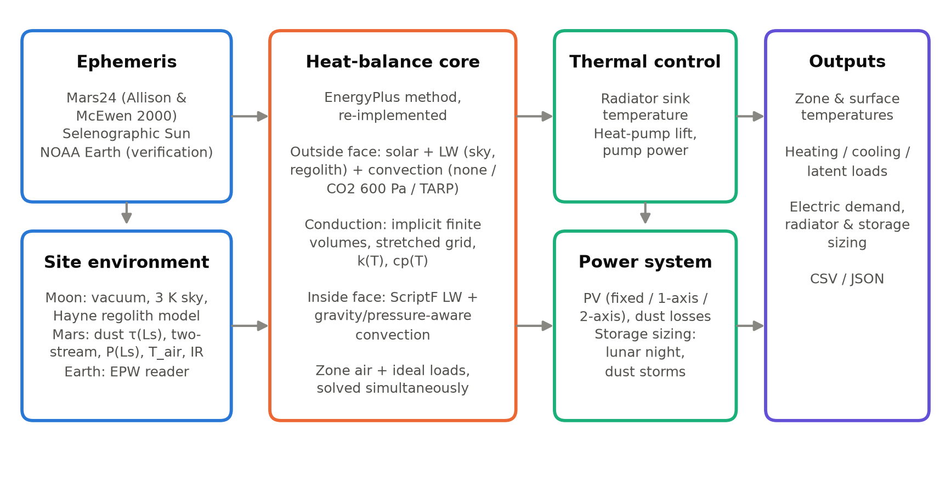
Fig. 1. ExoBEM architecture. The heat-balance core follows the EnergyPlus method; the ephemeris, site-environment, thermal-control and power modules carry the planetary physics.

4.2 How a simulation is coordinated
Fig. 2 shows the order in which the components act in a run, and the EnergyPlus module that plays each role. (1) The model input defines materials, constructions, geometry, the cabin and its gains, the thermal control system and the power system. (2) The site environment is either read from a planetary weather file (Section 4.7) or generated by the ephemeris, radiation and regolith models for the whole run period at the simulation time step. (3) In pre-processing, ExoBEM checks the model against its environment, builds one stacked finite-volume grid for all constructions, computes interior view factors and Hottel script-F factors, evaluates every schedule and the incident solar radiation on every surface for every step, and evaluates the cabin-gas properties. (4) Initialization brings the long time constants of regolith covers and of the ground to a consistent state (Section 4.3). (5) The time-step loop then solves, at each step, the outside-face balances, conduction, inside-face balances and zone air together, applies the ideal loads, and updates the cabin humidity. (6) The thermal control model turns the heat collected from the cabin, the cold plates and the condensing heat exchanger into radiator temperatures and heat-pump power, and (7) the power model dispatches generation and storage against the total electric demand. Steps 6 and 7 do not feed back to the cabin, because the radiators, heat pumps, arrays and storage are outside the pressure shell (their heat does not enter the zone); the electric power used inside the shell is a gain already counted in step 5.
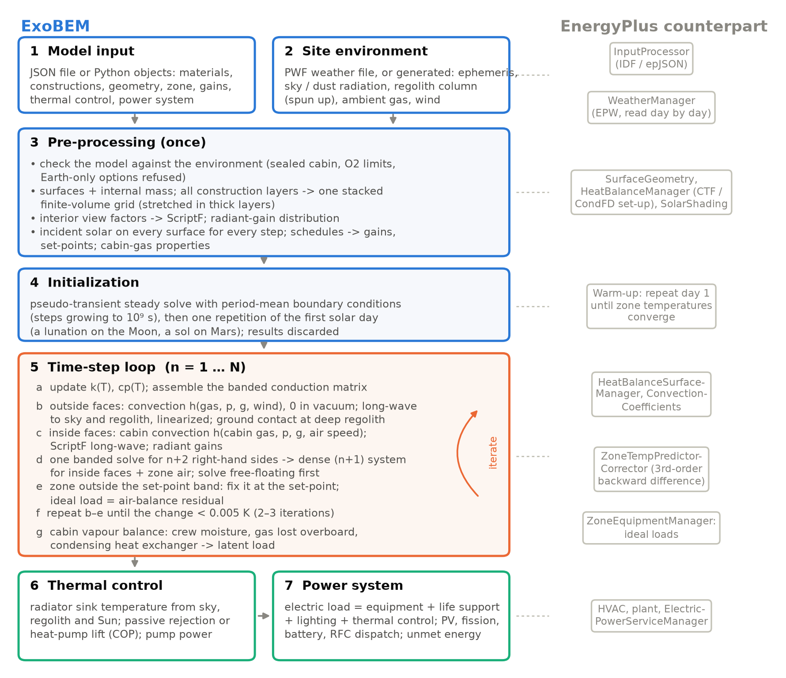
Fig. 2. How ExoBEM coordinates a simulation (left) and the EnergyPlus modules with the same role (right).
Table 2 compares ExoBEM with EnergyPlus element by element. The surface heat balances, the interior long-wave exchange, the convection correlations used on Earth and the CondFD conduction formulation are the same, and they reproduce EnergyPlus on Earth (Section 5.1). The differences fall into three groups. Some are generalizations of the same structure to other planets (weather, time base, solar position, exterior boundary, gas properties). Some are numerical choices (implicit Euler with a simultaneous solution of surfaces and air instead of a predictor–corrector; finite volumes instead of conduction transfer functions, because temperature-dependent regolith properties and metre-thick layers are outside the range of CTFs). The rest are deliberate reductions of scope: ExoBEM has a single zone and represents HVAC by ideal loads and post-processed thermal-control and power systems (Section 7).
Table 2. ExoBEM compared with EnergyPlus.
Element | EnergyPlus | ExoBEM | Relation
Input | IDF / epJSON text files; ~800 object types | JSON file (epJSON-inspired sections) or Python objects; ~15 object types | adapted
Program structure | Managers called from SimulationManager in nested environment / day / hour / time-step loops | Pre-processing, one time-step loop (simulate), post-processing (thermal control, power); see Fig. 2 | adapted
Weather | EPW file: 8,760 hourly records, read day by day, interpolated to the time step | PWF file or generated environment for the whole run at the time step; no Earth range checks | different
Time base | 24-hour days, 1-60 time steps per hour | Any time step; day length free (lunation, sol) | different
Solar position | Earth Fourier fits for declination and equation of time; 15°/h | NOAA (Earth), Mars24 (Mars), selenographic subsolar point (Moon) | different
Sky diffuse model | Perez anisotropic | Perez on Earth; isotropic + dust two-stream off-Earth | same on Earth
Outside-face heat balance | Absorbed solar + long-wave (sky, air, ground) + convection = conduction | Same terms; long-wave linearized about the current iterate; sky, ground and air terms set by the planet | same on Earth
Exterior convection | TARP, DOE-2, MoWiTT, adaptive | TARP (Earth); physical correlation for any gas, pressure, gravity; none in vacuum | same on Earth
Conduction | Conduction transfer functions (default) or CondFD | Implicit finite volumes (CondFD formulation), stretched grids, k(T) and cp(T), optional curved shells | adapted
Inside-face heat balance | Conduction + convection + ScriptF long-wave + radiant gains | Same | same
Interior convection | TARP and others (air at 1 atm, 1 g) | TARP (Earth); physical mixed convection for the cabin gas at cabin pressure and body gravity | same on Earth
Interior long-wave | ScriptF from approximate view factors | Same (Hottel ScriptF, area-weighted view factors with reciprocity) | same
Zone air balance | Predictor-corrector, 3rd-order backward difference; surfaces and air iterated | Implicit Euler; surfaces, interior radiation and air solved simultaneously by superposition | different
Loads | Ideal loads air system or full HVAC | Ideal loads (sensible) + condensing-heat-exchanger latent load + cold plates | adapted
Outdoor air | Infiltration, ventilation, outdoor-air systems | Earth only; forbidden off-Earth (sealed cabin); leakage and airlock losses instead | different
Moisture | Zone humidity balance; EMPD, HAMT for materials | Cabin vapour balance with condensing heat exchanger and dew-point check | adapted
Warm-up | Repeat the first day until zone temperatures converge | Steady pseudo-transient solve + one repetition of the first solar day; regolith columns equilibrated | different
Heat rejection and HVAC | Coils, chillers, towers, plant loops | Radiator sink temperature, heat-pump lift, pump power (post-processing) | different
Electric power | ElectricLoadCenter: PV, batteries, generators | PV with vacuum cell temperature and dust, Li-ion, regenerative fuel cell, fission; dispatch | adapted
Output | ESO / SQLite / tabular reports, report variables | CSV time series + JSON summary; Python result objects | adapted
Implementation | C++, ~720,000 lines | Python (NumPy, SciPy), ~3,800 lines | different

4.3 Heat-balance core
For each exterior surface, the outside-face heat balance equates absorbed solar radiation, net long-wave exchange, convection and conduction into the wall [5]:
$$α_{s}G_{inc}+εσ\sum_{k}{F_{k}}\left(T_{k}^{4} − T_{so}^{4}\right)+h_{co}\left(T_{a} − T_{so}\right)=q_{ko}$$ | (1)
where the long-wave sum runs over sky (k = sky) and ground (k = g) with view factors F_{sky} = (1+cosβ)/2 and F_{g} = (1−cosβ)/2 for tilt β. On Earth, EnergyPlus splits the sky view into a sky part and an air part with weight sqrt[(1+cosβ)/2] and uses the air temperature for the ground; ExoBEM reproduces this split in Earth mode and uses the computed regolith surface temperature T_{g} elsewhere. The T⁴ term is Newton-linearized about the current iterate,
$$T_{so}^{4}≈4T_{so}^{*3}T_{so}−3T_{so}^{*4}$$ | (2)
which is essential in vacuum: with a 2.7 K sky and almost no conductive coupling through low-conductivity regolith, the fixed-point radiation coefficient used in many BES codes oscillates and fails to converge. The incident beam uses the direct normal irradiance, which already includes the fraction of the solar disk above the local horizon (Section 4.6).
Conduction is solved with the node-centred, fully implicit finite-volume scheme of the EnergyPlus CondFD algorithm [5]:
$$C_{i}\frac{T_{i}^{n+1}−T_{i}^{n}}{Δt}=K_{i−1/2}\left(T_{i−1}^{n+1} − T_{i}^{n+1}\right)+K_{i+1/2}\left(T_{i+1}^{n+1} − T_{i}^{n+1}\right)$$ | (3)
with node capacitances C_{i} (half of each adjacent cell) and conductances K = k/Δx or 1/R for massless layers. Three extensions matter off-Earth. First, metre-thick regolith covers have diffusivities near 2×10⁻⁹ m²/s, so each layer uses a grid stretched geometrically from both faces (first cell ½(αΔt)^{1/2}, growth 1.3). Second, conductivity and specific heat may depend on temperature; they are lagged by one step, as in CondFD. Third, a thick cover on a cylindrical or domed module is not a flat slab: per unit inner area a 1 m cover on a 3 m radius conducts 14% (cylinder) to 25% (sphere) more than a slab, and its outer area is 33–78% larger. For surfaces generated as cylinders or domes, ExoBEM therefore uses the exact shell conductances and volume-weighted capacitances,
$$K_{cyl}=\frac{k}{r_{i}ln\left(r_{2} / r_{1}\right)},K_{sph}=\frac{kr_{1}r_{2}}{r_{i}^{2}\left(r_{2} − r_{1}\right)}$$ | (4)
per unit inner area r_{i} for a cell between radii r₁ < r₂, and scales the outer-face terms by the ratio of outer to inner area. The planar formulation of EnergyPlus is recovered with curvature switched off.
At the inside face, conduction, convection to zone air, long-wave exchange and radiant internal gains balance:
$$q_{ki}+h_{ci}\left(T_{z} − T_{si}\right)+\sum_{j}{σ}ℱ_{ij}\left(T_{sj}^{4} − T_{si}^{4}\right)+\frac{f_{i}Q_{rad}}{A_{i}}=0$$ | (5)
where ℱ_{ij} are Hottel gray-interchange (ScriptF) factors computed from EnergyPlus-style area-weighted view factors with enforced reciprocity [5, 31], and radiant gains are distributed in proportion to area times emissivity. Equipment racks and stowage are internal-mass surfaces (one face to the cabin, the other adiabatic), as in EnergyPlus. The zone air balance of the sealed cabin is
$$C_{z}\frac{dT_{z}}{dt}=\sum_{i}{h_{ci}}A_{i}\left(T_{si} − T_{z}\right)+Q_{conv}+{\overset{˙}{m}}_{loss}c_{p}\left(T_{mu} − T_{z}\right)+Q_{sys}$$ | (6)
in which C_{z} uses the density and specific heat of the cabin gas at cabin pressure, ṁ_{loss} is the cabin gas lost overboard and replaced from storage at temperature T_{mu} (Section 4.4), and Q_{sys} is the ideal load that keeps T_{z} inside the heating and cooling set-points. On Earth the same term carries outdoor-air infiltration.
Simultaneous solution. EnergyPlus iterates between the surface and air balances. ExoBEM instead solves them simultaneously. All constructions are stacked into one tri-diagonal system AT = b + Bu, where the vector u = [T_{si,1}…T_{si,n}, T_{z}] collects the inside-face temperatures and the air temperature that couple surfaces to each other and to the air. Solving the banded system once for n+2 right-hand sides gives
$$T=X_{0}+X_{B}u$$ | (7)
which, substituted into the inside-face and air equations, yields a dense (n+1)×(n+1) system. It is solved free-floating first; if T_{z} leaves the set-point band, T_{z} is fixed at the violated set-point and Q_{sys} follows from the air balance. Only the non-linear coefficients (radiation linearization, convection coefficients and temperature-dependent properties) are updated by fixed-point iteration, which converges to 0.005 K in two to three iterations per step; steps that do not converge within the iteration limit are counted and reported.
Initialization. EnergyPlus warms up by repeating the first day. A 1-m lunar regolith cover has a thermal time constant of years, so ExoBEM first solves a pseudo-transient steady state with period-mean boundary conditions (time steps growing geometrically to 10⁹ s, with T⁴-mean sky and ground temperatures). It then repeats the first solar day (one sol or one lunation) once before recording results.

4.4 The sealed cabin
A pressurized habitat exchanges no air with its surroundings, and ExoBEM enforces this: off-Earth, a model with infiltration, an Earth-air exterior convection correlation, a hypoxic cabin (oxygen partial pressure below 15.8 kPa, the 2,440 m cabin-altitude limit of transport aircraft [32]) or an Earth-only sky model is rejected before the run, and set-points or humidity limits outside the NASA-STD-3001 ranges raise warnings [33]. What remains is a small outward mass flow that has to be made up from storage:
$${\overset{˙}{m}}_{loss}={\overset{˙}{m}}_{leak}+n_{EVA}\frac{p_{res}V_{al}}{R_{cab}T_{al}}$$ | (8)
where ṁ_{leak} is the structural leakage (0.05% of the cabin gas mass per day for the reference habitats [34]), n_{EVA} the number of airlock cycles per day, and the second term the gas left in an airlock of volume V_{al} when it is vented at the residual pressure p_{res} after pump-down (6.9 kPa assumed). The energy effect enters Eq. (6); the mass is reported as a consumable.
Without outdoor air, all moisture comes from the crew (and plants) and leaves through a condensing heat exchanger. ExoBEM solves the vapour balance of the cabin,
$$m_{d}\frac{dw}{dt}=\frac{Q_{lat}}{h_{fg}}−{\overset{˙}{m}}_{loss}w−\overset{˙}{R},w=\frac{M_{w}}{M_{cab}}\frac{p_{v}}{P_{cab}−p_{v}}$$ | (9)
implicitly at every step, where m_{d} is the dry-gas mass of the cabin, Q_{lat} the latent heat released by the crew, h_{fg} = 2.454 MJ/kg and the molar-mass ratio uses the cabin gas (0.6197 for 70.3 kPa / 26.5% O2, against 0.6220 for air). The condensing heat exchanger removes Ṙ so that the relative humidity, with the saturation pressure from the Magnus form [35], stays within the control band (30–60%); Ṙh_{fg} is the latent load. The cabin dew point is compared with every inside-surface temperature at every step, and the hours with any surface below it are reported as condensation risk, a habitability hazard [33]. Electric gains carry two further attributes: the fraction of their power released as heat (0.22 for water electrolysis, whose energy leaves as hydrogen and oxygen) and the fraction collected by cold plates, which goes straight to the coolant loop instead of the cabin air.

4.5 Planetary ephemerides and time
For Mars, ExoBEM implements the Allison and McEwen (2000) algorithm used by NASA's Mars24 [36, 37]: from the TT Julian date it computes the mean anomaly, the fictitious-mean-Sun angle, seven planetary perturbation terms and the equation of center, giving the areocentric solar longitude L_{s}, solar declination, heliocentric distance and equation of time. Local true solar time then gives the hour angle,
$$L_{s}=α_{FMS}+\left(ν − M\right),sinδ_{s}=0.42565sinL_{s}+{0.25}^{∘}sinL_{s}$$ | (10)
For the Moon, the lunar prime meridian follows the Moon's mean geocentric longitude L′, and the lunar equator is inclined I = 1.5424° to the ecliptic with its descending node at the orbit's ascending node Ω (Cassini's laws). The selenographic subsolar point is therefore [38, 39]
$$λ_{ss}={180}^{∘}−\left(L^{′} − λ_{⊙}\right),β_{ss}=Isin\left(λ_{⊙} − Ω\right)$$ | (11)
where λ⊙ is the Sun's apparent ecliptic longitude. Using the mean rather than the true lunar longitude captures the optical libration in longitude, which shifts lunar local time by up to about half an Earth day. Near the poles the Sun is a disk of angular radius ρ⊙ above an azimuth-dependent horizon h; the visible fraction of its area, with x = (e − h)/ρ⊙ for solar elevation e, is
$$f_{vis}=\frac{arccos\left( − x\right)+x\sqrt{1−x^{2}}}{π},−1≤x≤1$$ | (12)
and multiplies the direct normal irradiance. Schedules run on local mean solar time on Mars and on Earth (UTC) time on the Moon, where the 29.5-day lunar day cannot set crew rhythms. The total solar irradiance is 1361 W/m² at 1 AU [40].

4.6 Site environments
Moon. There is no diffuse light and no convection; the sky temperature is 2.725 K. Ground temperature comes from a 1-D model of the regolith following Hayne et al. [41]. Density increases with depth as ρ(z) = ρ_{d} − (ρ_{d} − ρ_{s})exp(−z/H) with ρ_{s} = 1100 kg/m³, ρ_{d} = 1800 kg/m³ and H = 0.06 m. Contact conductivity scales with density between 7.4×10⁻⁴ and 3.4×10⁻³ W/(m·K). Radiative conduction between grains is included through
$$k\left(z , T\right)=k_{c}\left(z\right)\left[1 + χ{\left(\frac{T}{350K}\right)}^{3}\right],χ=2.7$$ | (13)
Specific heat follows the fourth-order polynomial fit to Apollo samples [41, 42]. Albedo depends on incidence angle, A = 0.12 + 0.06(i/45°)³ + 0.25(i/90°)⁸; emissivity is 0.95 and the geothermal flux is 0.018 W/m². Metre depths of the column take decades to forget an initial guess, so the column is first brought to periodic equilibrium with the solar forcing of the preceding year: each iteration runs one year at 1 h steps, takes the period-mean temperature below the reach of the lunar-day wave (0.15 m) and rebuilds the deeper profile so that it carries the geothermal flux, dT/dz = q_{geo}/k(z,T). This converges in a few iterations and agrees with brute-force integration over 2,500 lunations within 0.3 K at 3 m depth. The near-surface layer is then spun up over the lunation before the start.
Mars. Top-of-atmosphere irradiance is 1361/r² W/m². The total (direct plus diffuse) flux reaching the surface follows a delta-Eddington two-stream solution [43–45]:
$$\frac{dF^{±}}{dτ}=±\left(γ_{1}F^{±} − γ_{2}F^{∓}\right)∓γ_{3,4}ω_{0}F_{s}e^{−τ/μ_{0}}$$ | (14)
with a Lambertian surface and a spherical-shell air mass m. The broadband single-scattering albedo ω₀ = 0.885 and asymmetry parameter g = 0.74 were fitted to the normalized net-flux tables of Appelbaum and Flood [46, 47]. These are effective solar-band values: they are lower than visible-band retrievals [48, 49] because they also absorb the effects of near-infrared gas absorption and of the two-stream approximation. The delta-scaled 'direct' flux of the solution includes the forward-scattering peak, which is not part of the beam a tilted surface sees from the solar disk; the beam is therefore taken from Beer's law with the true optical depth, G_{b,n} = (S/r²)exp(−τm), and the rest of the two-stream total is diffuse. Dust optical depth follows a seasonal climatology representative of Jezero crater (0.45 in the aphelion season, 0.85 near L_{s} = 245°) [50–52]. A global-storm scenario raises τ to 6 between L_{s} = 190° and 270° [53], beyond the τ ≤ 3 range of the fit (Section 7.2). Surface pressure follows a two-harmonic fit to the CO2 cycle with its minimum at L_{s} ≈ 157° (growth of the southern seasonal cap), its maximum at L_{s} ≈ 269° and a secondary maximum at L_{s} ≈ 64°, with a mean of 710 Pa. Ground temperature comes from a homogeneous regolith column with thermal inertia 350 J m⁻² K⁻¹ s^{-1/2} and albedo 0.14, as measured at Jezero by MEDA [54], equilibrated over the preceding Mars year as on the Moon (its deep temperature then varies by less than 1 K with the start date, against 15 K with a 30-sol spin-up). Near-surface air temperature is an empirical boundary-layer surrogate, T_{a} = T̄_{g} + κ(T_{g}(t−0.5 h) − T̄_{g}) with κ = 0.6, which reproduces the roughly 2:1 ratio of ground-to-air diurnal amplitude measured by MEDA and REMS [55–57]. Downwelling long-wave flux is
$$L^{↓}=ε_{sky}\left(τ\right)σT_{a}^{4}+f_{re}{⟨G_{toa,h}−G_{h}⟩}_{sol},ε_{sky}=min\left(e_{0}+e_{1}τ,0.6\right)$$ | (15)
The first term is emission by CO2 and dust; the second re-emits a fraction f_{re} of the sunlight that dust removes (sol-running mean), a one-layer-atmosphere energy term. The three parameters (e₀ = 0.12, e₁ = 0.10, f_{re} = 0.20) were calibrated against two observations: the clear-season daily mean of about 30 W/m² measured by MEDA/TIRS [54] (model 30 W/m²), and the response to the 2018 global dust storm, during which Curiosity saw the diurnal range of air temperature collapse while its diurnal mean fell by only about 4 K [53, 58] (model -5 K). The storm response is sensitive to f_{re}: without re-emission the sol-mean air temperature would fall by more than 20 K, and with f_{re} near 0.5 it would rise.

4.7 Planetary weather files
EnergyPlus reads its environment from EPW files: 8,760 one-hour records of an Earth year, with fields for humidity, precipitation and cloud cover, and range checks that would treat a lunar-noon regolith temperature of 120 °C as missing data or replace a Martian pressure of 700 Pa by the standard value. ExoBEM defines a Planetary Weather Format (PWF) instead. A PWF file is plain CSV text preceded by a header that states the body, site, start time (UTC), record length, solar-day length, gravity, ambient gas and the clock used by schedules. Records are equally spaced and of any number; solar quantities refer to the middle of each interval and state quantities to its end (Table 3). Missing or inapplicable values are written as nan (for example the air temperature in vacuum). On reading, ExoBEM applies physical checks only: non-negative irradiance, temperatures above the 2.725 K cosmic background, a pressure consistent with the declared atmosphere. The command exobem weather writes PWF files from the generators of Section 4.6, other sources (the Mars Climate Database [29], rover data) can be converted to it, and because the format is plain text with a self-describing header, other simulation programs can read the same files and be run on identical environments.
Table 3. Columns of a Planetary Weather Format (PWF) file. The full specification is in docs/weather_format.md.
Column | Unit | Meaning | Required
time_s | s | end of the record interval, seconds since start_utc | yes
local_time_h | h | clock hour used by schedules (see header 'clock') | yes
day_index | - | integer day (Earth day or sol) used by schedules | yes
zenith_deg | deg | solar zenith angle at interval middle | yes
sun_azimuth_deg | deg | solar azimuth, clockwise from north | yes
sun_visible | - | fraction of the solar disk above the local horizon | yes
dni_W_m2 | W/m2 | direct (beam) normal irradiance | yes
dhi_W_m2 | W/m2 | diffuse horizontal irradiance | yes
ghi_W_m2 | W/m2 | global horizontal irradiance | yes
T_air_K | K | near-surface air temperature (nan in vacuum) | yes
T_sky_K | K | effective sky temperature for long-wave exchange | yes
T_ground_K | K | ground (regolith) surface temperature | yes
T_deep_K | K | deep-ground temperature for ground-contact surfaces | yes
ground_albedo | - | ground solar reflectance | yes
pressure_Pa | Pa | ambient (outdoor) pressure, 0 in vacuum | yes
wind_m_s | m/s | wind speed at measurement height | yes
wind_dir_deg | deg | wind direction, clockwise from north | yes
L_down_W_m2 | W/m2 | downwelling long-wave radiation | no
Ls_deg | deg | areocentric solar longitude, Mars | no
dust_tau | - | column dust optical depth, Mars | no
ltst_h | h | local true solar time, Mars | no
lunar_local_time_h | h | lunar local solar time | no
humidity_ratio | kg/kg | outdoor humidity ratio, Earth | no

4.8 Convection in thin, foreign and pressurized atmospheres
EnergyPlus's TARP algorithm combines Walton's natural-convection correlations with a Sparrow-type forced term [5, 59]. Both were fitted to air at 101 kPa and 1 g. For turbulent natural convection, h = C k (gβΔT/να)^{1/3}, so for a given gas h scales as (gρ²)^{1/3} [60]. ExoBEM therefore offers a physical convection mode for any gas, pressure and gravity:
$$h={\left(h_{n}^{3} + h_{f}^{3}\right)}^{1/3},Nu_{v}={\left\{0.825 + \frac{0.387Ra^{1/6}}{{\left[1 + {\left(0.492 / Pr\right)}^{9/{16}}\right]}^{8/{27}}}\right\}}^{2}$$ | (16)
Here the natural term uses Churchill–Chu for vertical faces and McAdams/Lloyd–Moran correlations for horizontal faces [60, 61]. The forced term uses flat-plate correlations with the local wind speed (exterior) or the cabin ventilation velocity (interior, 0.15 m/s by default, within the 0.076–0.61 m/s range of NASA-STD-3001 [33]). Gas properties come from Sutherland-type fits: the Mars mixture is 95% CO2, and cabin atmospheres are N2/O2 at 101.3 kPa/21%, 70.3 kPa/26.5% or 56.5 kPa/34% O2 [34, 62], with the specific heat weighted by the mass fractions of N2 and O2. In Earth mode the TARP formulation is retained for comparability with EnergyPlus.

4.9 Thermal control
A habitat cannot reject heat to outdoor air. ExoBEM passes the heat collected by the thermal control system, Q_{TCS} = Q_{c} + Ṙh_{fg} + Q_{cp} (sensible cabin load, condensing-heat-exchanger latent load and cold-plate heat), to a radiator model. The radiator's environmental sink temperature is
$$ε_{r}σT_{sink}^{4}=α_{r}\left(G_{b} + G_{d} + G_{r}\right)+ε_{r}σ\left(F_{sky}T_{sky}^{4} + F_{g}T_{g}^{4}\right)$$ | (17)
The default radiator is two-sided, vertical and pole-facing, with silver-Teflon optical properties α = 0.10 and ε = 0.80, midway between beginning and end of life [34]. If the radiator temperature needed to reject the load is below the coolant temperature (2 °C less a 5 K approach), rejection is passive and only pump power (150 W) is drawn. Otherwise a vapor-compression heat pump lifts the heat, with COP equal to 40% of the Carnot value between the evaporator and the radiator temperature plus approach; the radiator temperature is found with a bracketed root search so that radiated power equals Q_{TCS}(1 + 1/COP). Humidification, when the cabin is too dry, is an electric load.

4.10 Power generation and storage
The power model serves the total electric demand of the habitat, P_{load} = P_{int} + P_{TCS} + P_{ext}: the electric gains inside the pressure shell, the thermal-control power and any external load. Four kinds of components are available. Photovoltaic arrays (fixed, horizontal, vertical single-axis or two-axis tracking) receive the plane-of-array irradiance from the same beam, diffuse and ground-reflected components as the envelope. Their cell temperature follows from the energy balance of a thin panel whose two faces radiate to the sky and the ground seen by each face, with convection on both faces on Mars:
$$\left(α_{pv} − η\right)G_{poa}=ε_{f}σ\left(T_{c}^{4} − {\overline{T}}_{f}^{4}\right)+ε_{b}σ\left(T_{c}^{4} − {\overline{T}}_{b}^{4}\right)+2h\left(T_{c} − T_{a}\right)$$ | (18)
solved by Newton iteration together with the efficiency
$$η=η_{ref}f_{arr}\left[1 + γ\left(T_{c} − T_{ref}\right)\right]\left(1 − dt\right)$$ | (19)
with η_{ref} = 0.295 for triple-junction cells, γ = −0.0023 K⁻¹, α_{pv} = 0.91 [63], an array factor f_{arr} = 0.85 for packing, wiring and conversion (assumption), and on Mars a soiling loss d of 0.25% per sol removed by cleaning every 45 sols [64, 65]. The Earth NOCT relation used by building simulation tools does not apply: in vacuum a sunlit lunar array runs at 330–380 K. Fission surface power delivers a constant electric output (40 kWe, 18.1% end-to-end efficiency [66, 67]) and rejects its waste heat through its own radiator. Li-ion batteries have a charge and discharge efficiency of 0.97 each and a minimum state of charge of 0.2. Regenerative fuel cells (H2/O2 electrolyser and fuel cell) have efficiencies of 0.85 and 0.60, a round trip of 0.51 in the 50–55% range demonstrated [68, 69]. At every step the dispatch serves the load from generation; a surplus charges the battery, then the fuel-cell storage, and is otherwise shunted; a deficit draws the battery first, then the fuel cell, and any remainder is reported as unmet energy. Sizing helpers find the array area that balances the energy over the period (including storage losses) and the storage that then keeps the load met over the periodic cycle.

5. Verification

5.1 Comparative verification against EnergyPlus 23.2
The terrestrial core was compared with EnergyPlus 23.2 on opaque versions of ASHRAE Standard 140 Cases 600 (lightweight) and 900 (heavyweight) [6, 70]. In these versions the 12 m² south window is replaced by wall so that the comparison isolates the opaque heat balance, which is the part relevant to windowless habitats. The 8 m × 6 m × 2.7 m zone has 200 W of internal gains (60% radiant), 0.5 ACH infiltration, a floor on R-25 insulation over ground at 10 °C, and 20/27 °C ideal-load set-points; free-floating variants (600FF, 900FF) have no HVAC. Both programs used the Golden, Colorado TMY3 file [71], 10-minute time steps, TARP convection inside and outside, the Perez sky model [72] and Country terrain. EnergyPlus used conduction transfer functions; ExoBEM used its finite-volume solver. EnergyPlus input files are generated by a script in the repository.
Table 4. Annual loads, ExoBEM (Earth mode) versus EnergyPlus 23.2, opaque ASHRAE 140 cases, Golden CO.
Case | Heating E+ (kWh) | Heating ExoBEM (kWh) | Diff. | Cooling E+ (kWh) | Cooling ExoBEM (kWh) | Diff. | Peak heat E+/Exo (kW) | Peak cool E+/Exo (kW) | Hourly R² | CV(RMSE) %
Case 600 | 4,504 | 4,507 | +0.07% | 392 | 394 | +0.46% | 2.996 / 2.997 | 1.296 / 1.283 | 0.9987 | 4.2
Case 900 | 4,147 | 4,144 | -0.07% | 124 | 125 | +0.67% | 2.629 / 2.632 | 0.673 / 0.670 | 0.9987 | 4.1

Table 5. Free-floating zone air temperature (°C), ExoBEM versus EnergyPlus 23.2, 10-minute values over one year.
Case | T_{min} E+ | T_{min} Exo | T_{max} E+ | T_{max} Exo | T_{mean} E+ | T_{mean} Exo | RMSE (K) | MBE (K) | R²
Case 600FF | -17.20 | -17.33 | 39.02 | 39.09 | 14.77 | 14.77 | 0.31 | -0.003 | 0.9991
Case 900FF | -7.23 | -7.31 | 32.49 | 32.51 | 14.70 | 14.74 | 0.47 | +0.041 | 0.9974

Annual heating differs by +0.07% (Case 600) and -0.07% (Case 900), and annual cooling by +0.46% and +0.67% (Table 4). Peak heating loads agree within 0.1% and peak cooling loads within 1.0%, and hourly net loads have R² above 0.998 (Fig. 3a). Because the windows were removed, the acceptance ranges of ASHRAE 140 do not apply to these cases; the comparison is code-to-code and tests the opaque heat balance, not the planetary physics, which is checked in Section 5.2. Free-floating temperatures agree with an annual RMSE of 0.31 K (600FF) and 0.47 K (900FF) and a mean bias under 0.05 K (Table 5, Fig. 3b–c). The remaining differences come from documented implementation choices: finite volumes versus conduction transfer functions, implicit Euler versus third-order backward differencing of the air balance, the sub-hourly interpolation of weather data, and the solar-position algorithm. The planetary extensions of this paper are inactive in Earth mode, and these results are unchanged by them.
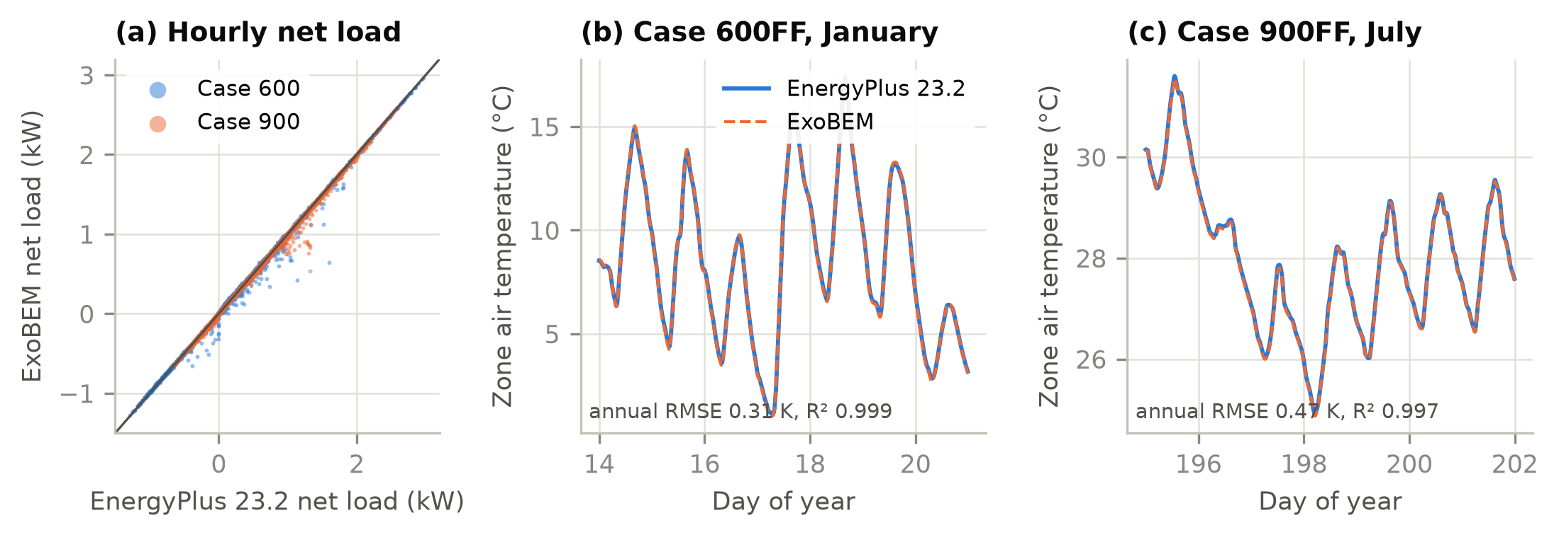
Fig. 3. Comparative verification against EnergyPlus 23.2 (Golden CO, TMY3). (a) Hourly net load (heating positive) for opaque Cases 600 and 900. (b, c) Free-floating zone air temperature over one winter and one summer week.

5.2 Verification of the planetary and habitat models
Table 6. Verification of the planetary and habitat models against reference data and analytical solutions.
Quantity | Reference | ExoBEM | Source
Mars24 worked example, 2000-01-06 00:00 UTC | L_{s} = 277.18758°, EOT = −5.18774°, r = 1.39358 AU, MST = 23.99425 h | Identical to 5 decimals | [37]
Lunar equatorial surface temperature (Diviner) | ≈385–390 K noon; ≈95 K pre-dawn; ≈252–256 K at ~1 m | 388 K; 94 K; 253 K (1 m) | [41, 73]
Deep regolith equilibrium (accelerated method) | Brute-force integration, 2,500 lunations | Within 0.3 K at 3 m | This work
Mars net-flux function f(z, τ), 20 table values | Appelbaum & Flood tables, albedo 0.1 | RMSE 0.014, max. error 0.035 | [46]
Jezero surface pressure (daily means) | ≈625–790 Pa; minimum near L_{s} 150° | 635–794 Pa; minimum at L_{s} 157° | [57]
Jezero air temperature at 1.45 m | ≈188–262 K | 197–262 K | [57]
Jezero ground temperature | ≈183–290 K | 186–284 K | [54]
Jezero downwelling long-wave flux | ≈30 W/m² clear-season daily mean (20–45 W/m²) | 30 W/m² clear-season mean (18–57 W/m² over the year) | [54]
2018 global dust storm, change of diurnal-mean air temperature | about −4 K (Gale) | -4 K (Jezero, τ = 6) | [58]
Lunar south-polar ridge illumination | 92.3% at 2 m (Connecting Ridge) | 92.6% (horizon −1.65°) | [74]
Vertical radiator sink, lunar equator, noon | ≈333 K | 328 K | [21]
Lunar habitat night heat leak at 293 K (NASA) | ≈1550 W (used to calibrate the MLI) | 1550 W (MLI R = 19.2 m²K/W) | [8]
Lunar habitat daylight net loss (NASA) | ≈850 W | 1053 W (+24%) | [8]
Steady conduction through cylindrical and spherical shells | Exact solutions | Error < 10⁻⁶ (unit tests) | [60]
PV cell in vacuum, both faces to a 2.7 K sink | (α − η)G = 2εσT⁴ | Error < 10⁻⁶ (unit test) | Analytic
Cabin vapour balance at steady state | Condensate = crew moisture | Within 0.2% (unit test) | Analytic
Steady conduction, semi-infinite step (erfc), parallel-plate ScriptF, vacuum steady state | Exact solutions | Errors < 0.1% (unit tests) | [60]

Table 6 summarizes the checks of the planetary and habitat models; all are automated in the test suite. Mars24's worked example is reproduced exactly. The regolith model reproduces Diviner's equatorial noon and pre-dawn temperatures and the Apollo subsurface temperatures (Fig. 4a), and the accelerated equilibrium of the column matches brute-force integration. The fitted delta-Eddington model reproduces the Appelbaum–Flood insolation tables over 0.1 ≤ τ ≤ 3 and 0° ≤ z ≤ 80° (Fig. 4b). The Jezero environment falls within the ranges MEDA observed for pressure, air and ground temperature and downwelling infrared, with the pressure minimum in the right season. The lunar radiator sink agrees with the classic Bien–Guentert estimate. The habitat envelope was calibrated to NASA's thermal analysis of the Artemis surface habitat: an effective MLI resistance of 19.2 m²K/W reproduces the night-time heat leak of 1550 W at 293 K, and the daylight net loss then comes out at 1053 W against NASA's 850 W (+24%), an independent check whose residual reflects the unknown sun geometry of the NASA daylight case and the uniform horizon used here. The polar horizon depression of −1.65° was chosen to match the 92.3% illumination of the best Connecting Ridge site [74]. Because a uniform horizon concentrates darkness into seasons, it yields a longest eclipse of 12 days, against 3–5 days for real ridge terrain [74, 75]; polar storage results below are therefore given both for this horizon and for NASA's 100-hour design eclipse.
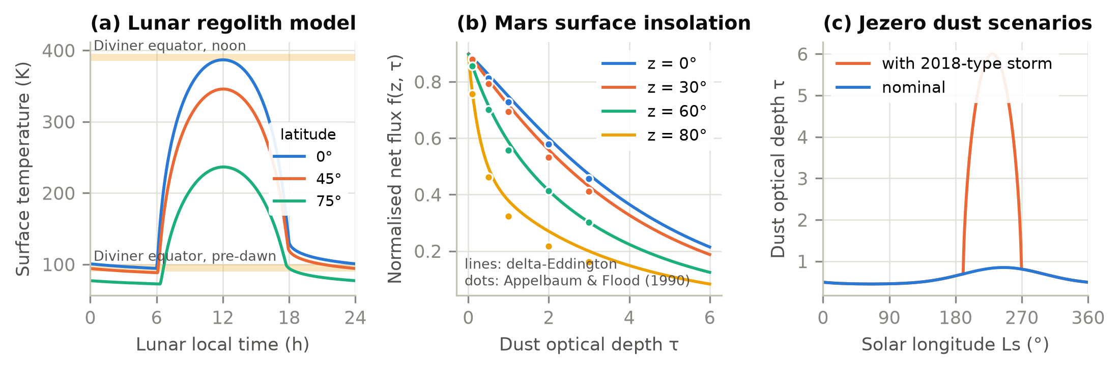
Fig. 4. Planetary environment models. (a) Lunar regolith surface temperature over a lunation at three latitudes, with Diviner equatorial ranges. (b) Normalized Martian surface net flux from the fitted delta-Eddington model (lines) and the Appelbaum–Flood tables (dots). (c) Seasonal dust optical depth at Jezero, nominal and with a 2018-type global dust storm.

6. Case studies

6.1 Reference habitats for the first crews
The case studies use two habitats sized from NASA mission concepts (Fig. 5, Table 7). The lunar habitat follows the Artemis surface habitat: a vertical module 6.5 m in diameter and 5.25 m high (174 m³ pressurized, about 32 m³ of habitable volume per person) for four crew on stays of 30–60 days, standing on legs 1.5 m above the regolith [22, 23, 76]. Its envelope is beta cloth (α = 0.40, ε = 0.90) over multi-layer insulation over the aluminium structure [8]. The Mars habitat follows Design Reference Architecture 5.0: six crew for about 500 sols in a two-deck module 7.2 m in diameter and 5.5 m high (224 m³; 25 m³ of habitable volume per person [77]) [9, 78]; because multi-layer insulation loses most of its performance in 0.7 kPa of CO2, it is insulated with 40 mm of silica aerogel. Both cabins are at 56.5 kPa with 34% O2, the exploration atmosphere for frequent EVA, between 20 and 25 °C and 30–60% relative humidity [33, 34]. Crew heat and moisture follow the NASA Baseline Values and Assumptions Document, with sleep, work and exercise periods and two-person EVAs (twice a week on the Moon, every workday on Mars) [34]. Electric power inside the shell, 14.0 kW on the Moon and 13.3 kW on Mars, follows the NASA habitat power levels [7, 9, 24] and is divided into life support (25%, assumption), water electrolysis, fans, lighting (7 W/m² of deck) and avionics and crew equipment, with part of the life-support and avionics heat on cold plates. Racks and stowage add internal mass equal to twice the deck area.
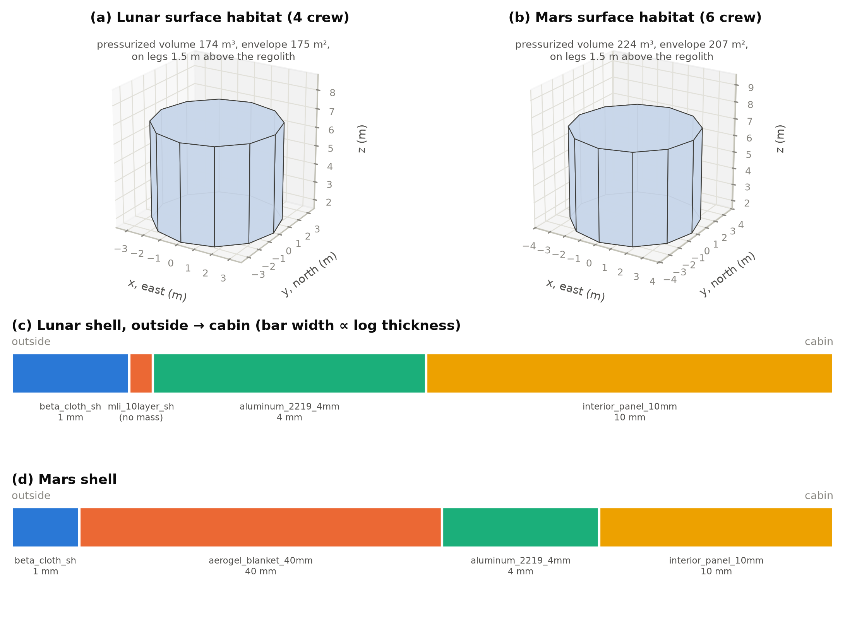
Fig. 5. Reference habitats. (a) Four-crew lunar surface habitat and (b) six-crew Mars surface habitat as modelled (12-sided prisms with the floor area and volume of the cylinders). (c, d) Layers of their shells from the outside to the cabin.
Table 7. Reference habitats (sources in the text and in docs/research of the repository).
Parameter | Lunar surface habitat | Mars surface habitat
Crew; stay | 4; 30–60 d | 6; ~500 sols
Shape; size | Vertical cylinder D 6.5 m × H 5.25 m | Vertical two-deck cylinder D 7.2 m × H 5.5 m
Pressurized volume; envelope area | 174 m³; 175 m² | 224 m³; 207 m²
Envelope (outside → in) | Beta cloth / MLI (R 19.2 m²K/W) / Al 4 mm / panel 10 mm | Beta cloth / aerogel 40 mm / Al 4 mm / panel 10 mm
Cabin atmosphere; control band | 56.5 kPa, 34% O2; 20–25 °C, RH 30–60% | Same
Crew heat per person (sensible + latent, daily mean) | 85.1 + 53.8 W | 76.5 + 76.3 W (long-duration)
Electric power inside the shell | 14.0 kW (life support 3.5, electrolysis 0.9, fans 0.5, lighting 0.46) | 13.3 kW (life support 3.0, electrolysis 1.35, fans 0.5, lighting 0.57)
Leakage; airlock venting | 0.059 kg/d; 0.99 kg × 2 cycles/week | 0.076 kg/d; 0.35 kg × 5 cycles/week
Radiator | 96 m² (48 m² panel, two faces), vertical, pole-facing | 80 m², vertical, two faces

Table 8. Case-study sites and simulation periods.
Case | Site | Period | Time step | Environment
Moon, south pole | Ridge at 89.5°S, horizon −1.65° | 1 year from 2030-01-01 | 1 h | 93% sunlit; regolith 42–117 K
Moon, equator | Mare Tranquillitatis, 0.67°N 23.47°E | 2 lunations from 2030-01-01 | 30 min | Regolith 94–388 K
Mars, Jezero | 18.44°N 77.45°E | 1 Mars year from L_{s} = 0° (2028-08-17) | 1/24 sol | P 635–794 Pa; τ 0.45–0.85
Mars, Jezero, dust storm | As above | As above | 1/24 sol | τ up to 6 at L_{s} 190–270°

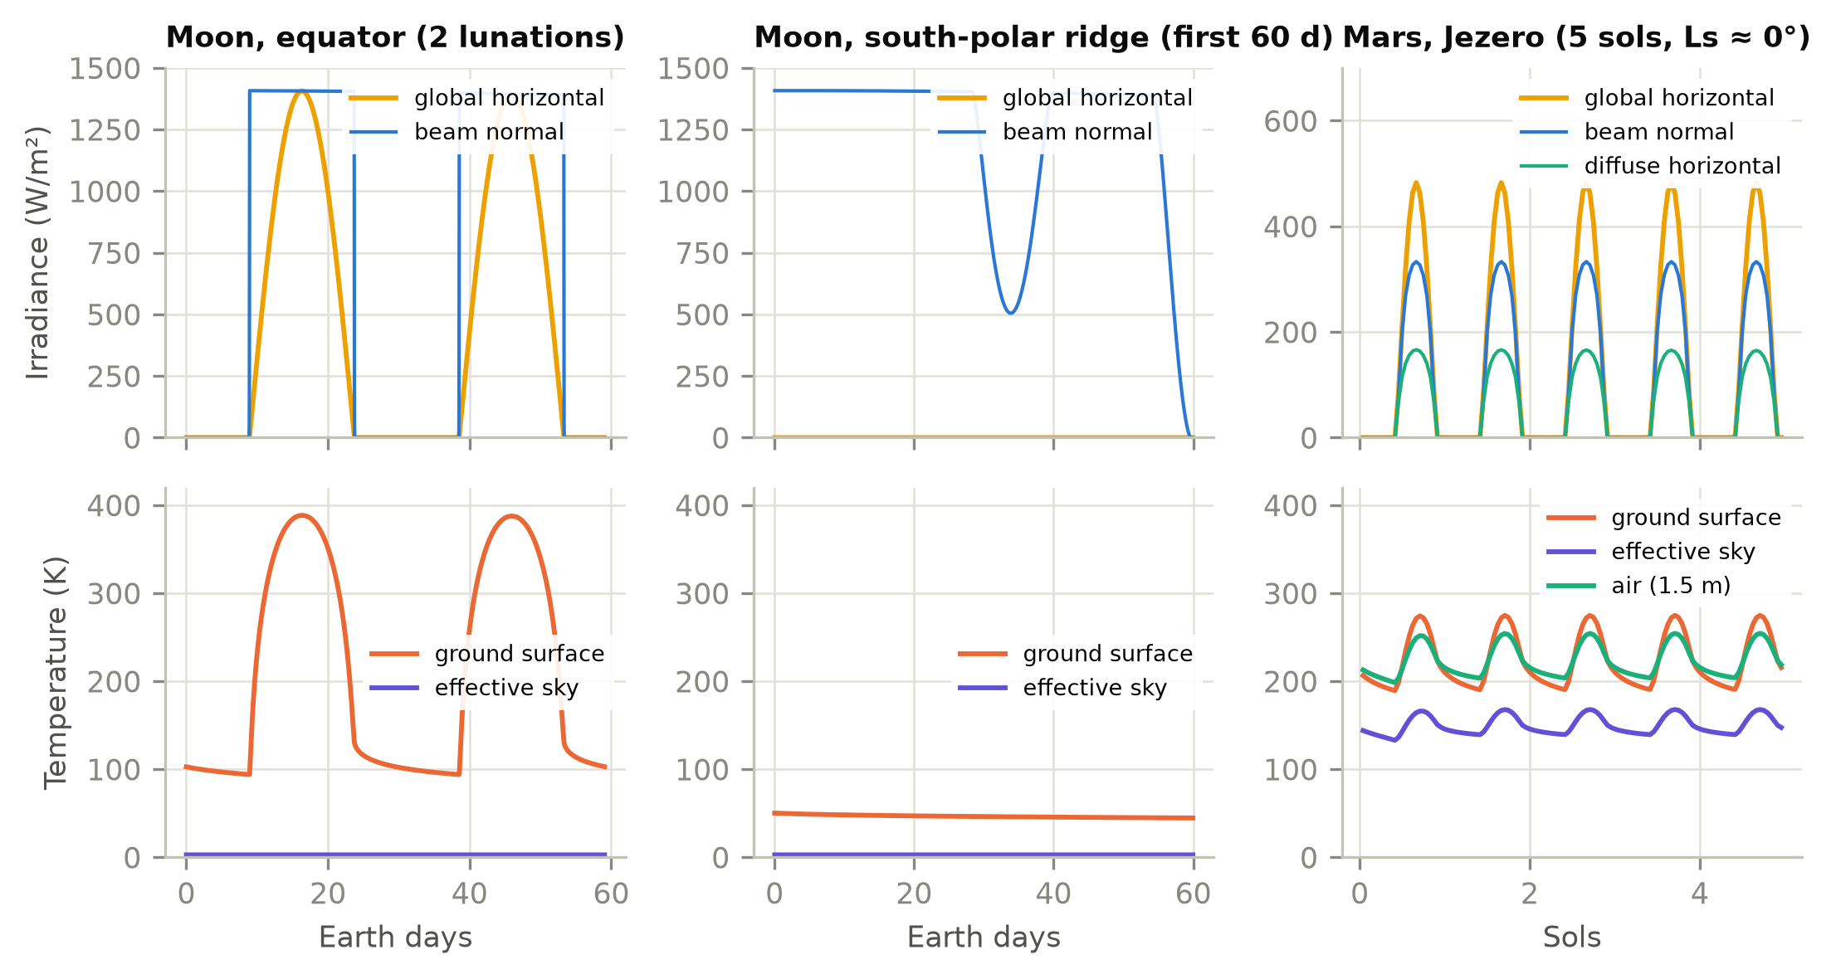
Fig. 6. Simulated surface environments: irradiance (top) and ground, sky and air temperatures (bottom) at the lunar equator, a lunar south-polar ridge and Jezero crater.

6.2 Thermal results
Fig. 6 contrasts the three environments. At the lunar equator, 14.8 days of sunlight at up to 1407 W/m² alternate with 14.8 days of darkness, and the regolith swings from 94 to 388 K. At the polar ridge the Sun circles the horizon at grazing elevation: beam irradiance on a vertical surface is high, but the flat ground stays below 117 K. At Jezero the cycle repeats every sol; dust removes about a fifth of the noon beam and turns much of it into diffuse light, and the CO2 atmosphere keeps the effective sky above 133 K.
Table 9. Thermal results for the reference habitats (energies per Earth day).
Case | Cabin cooling (kWh/d) | Cold plates (kWh/d) | Latent (kWh/d) | Heat to radiators (kWh/d) | Mean envelope gain (W) | Heat-pump time (%) | TCS electricity (kWh/d) | Min. surface − dew point (K) | Condensation risk (h) | Gas make-up (kg/d) | Condensate (kg/d)
Moon, south pole | 127.8 | 170.5 | 5.4 | 303.7 | -1,176 | 0 | 3.6 | +8.4 | 0 | 0.34 | 8.0
Moon, equator | 136.2 | 169.6 | 5.0 | 310.7 | -794 | 41 | 97.8 | +8.4 | 0 | 0.34 | 7.3
Mars, Jezero | 42.9 | 153.7 | 10.4 | 207.0 | -4,341 | 26 | 14.6 | -1.9 | 4839 | 0.33 | 15.2
Mars, dust storm | 43.6 | 153.7 | 10.4 | 207.7 | -4,309 | 24 | 13.5 | -2.0 | 4041 | 0.33 | 15.2

Both habitats are cooling-dominated (Table 9). The lunar habitat collects 303.7 kWh/d at the pole (12.7 kW on average): the electric power used inside the shell, plus crew heat, minus what the envelope loses. Its MLI envelope loses 1176 W on average at the pole and 794 W at the equator, under a tenth of the internal gains, so the envelope matters little to the cooling load; about 55% of the heat reaches the coolant through cold plates rather than the cabin air. The Mars habitat is different: its aerogel envelope loses 4.3 kW to the cold, CO2-filled surroundings, so the cabin needs only 42.9 kWh/d of sensible cooling, but some inner surfaces fall 1.9 K below the dew point of the 25 °C, 60% RH cabin. Condensation is possible for 4839 hours of the Mars year, a habitability and corrosion risk that a heat-balance model without a humidity balance would not reveal; Section 6.3 shows how to remove it. Over a year the lunar crew release about 8 kg of water a day that the condensing heat exchanger recovers, and 0.34 kg/d (Moon) to 0.33 kg/d (Mars) of cabin gas must be made up for leakage and airlock venting, a negligible energy term but a consumable to plan. Inside, the cabin air temperature stays within the band at all times and the inside surfaces vary by about 1 K, while the outer surfaces follow the environment (Fig. 7a).
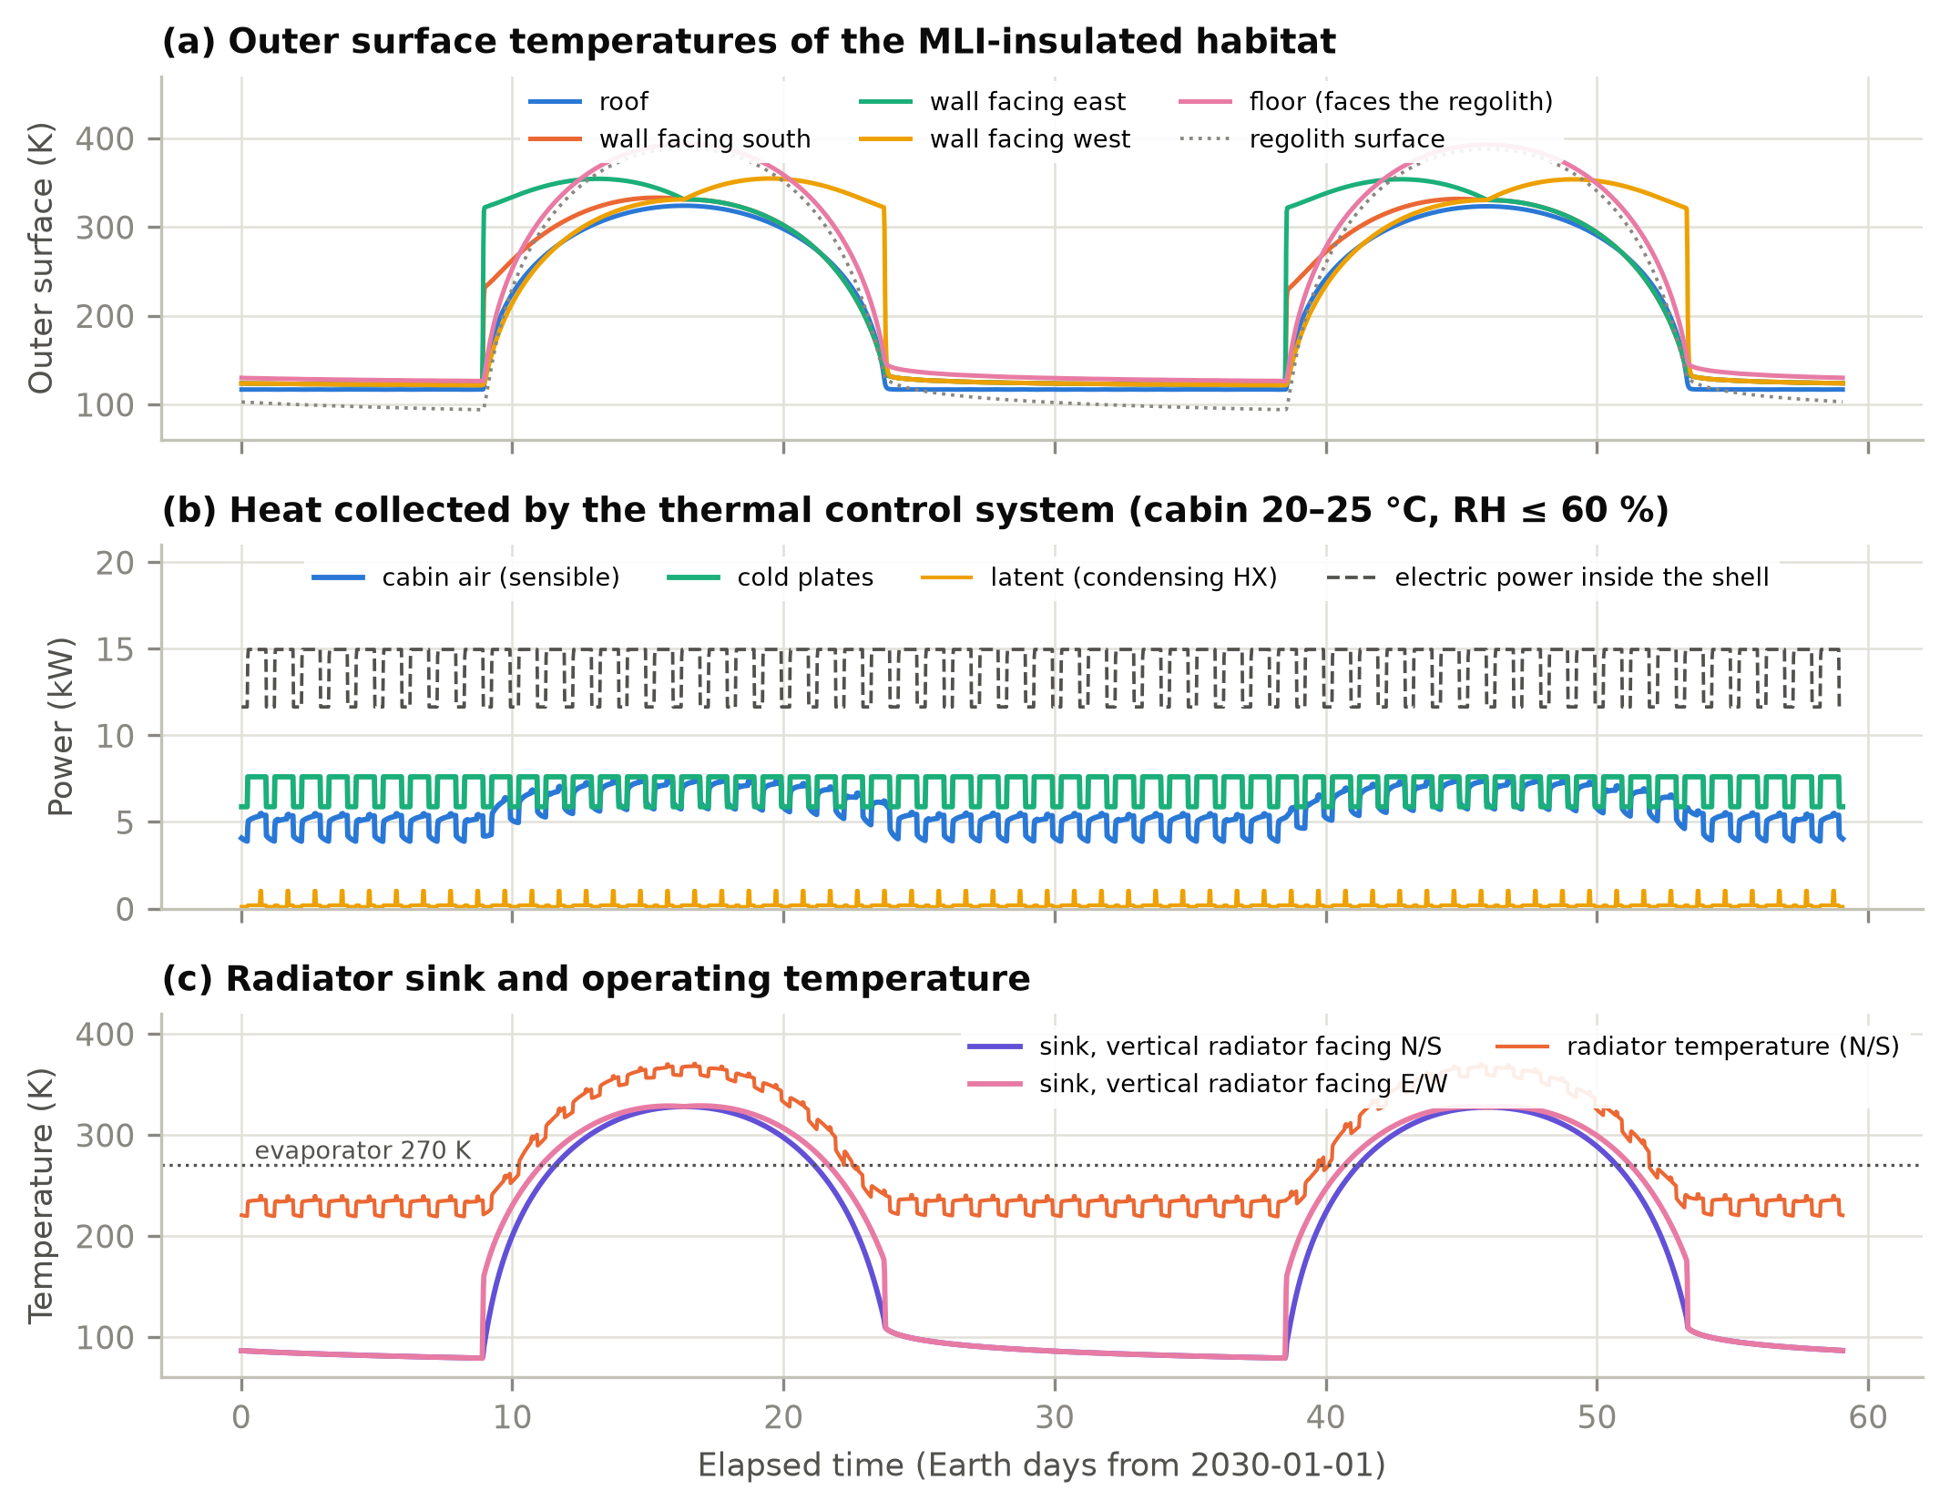
Fig. 7. Lunar surface habitat at the equator over two lunations. (a) Outer surface temperatures. (b) Heat collected by the thermal control system from the cabin air, the cold plates and the condensing heat exchanger, and the electric power used inside the shell. (c) Sink temperature of a vertical two-sided radiator facing N/S or E/W and the radiator temperature, with the 270 K evaporator temperature.
Heat rejection is where the equator differs from the pole. The sink temperature of a vertical radiator at the equator rises to 328 K at noon because half of its view is regolith at nearly 390 K (Fig. 7c). For 41% of the lunation the heat can only be rejected by lifting it with a heat pump; the COP falls to 1.03, and the thermal control system draws 97.8 kWh/d with peaks of 15.9 kW, against 3.6 kWh/d of pump power at the pole, where the sink never exceeds 172 K. On Mars the sink peaks at 253 K and the heat pump runs 26% of the time (24% with the dust storm, whose infrared glow warms the sink).
Table 10. Effect of radiator orientation, area and dust degradation at the lunar equator (α = 0.10 unless noted).
Radiator configuration (ε = 0.80) | Thermal-control electricity (kWh/d) | Peak power (kW) | Max. sink (K) | Heat-pump time (%)
Vertical, faces N/S (baseline, 96 m2) | 97.8 | 15.85 | 328 | 41
Vertical, faces E/W | 110.4 | 15.97 | 329 | 46
Horizontal, faces up (48 m2 one side) | 138.7 | 14.53 | 236 | 83
Horizontal, dust-degraded (alpha = 0.35) | 198.7 | 21.66 | 323 | 84
Vertical N/S, 2x area | 71.0 | 12.63 | 328 | 37

Table 10 compares radiator options at the equator. Turning the vertical radiator from the poles to east–west makes it face the low morning and evening Sun and costs about 13% more electricity. Doubling the vertical area saves 27%, less than one might expect: the larger area lowers the radiator temperature needed in the morning and evening, but at noon the sink is above the cabin temperature whatever the area. A horizontal radiator does not see the regolith and its clean sink never exceeds 236 K, but with one radiating face it needs lift 83% of the time; if lunar dust raises its absorptance to 0.35 [79] its noon sink climbs to 323 K and it draws 198.7 kWh/d. Radiator orientation and dust mitigation are thus first-order energy decisions for equatorial bases.

6.3 Envelope variants
Fig. 8 compares envelope variants. On the Moon, adding a regolith radiation shield on top of the MLI (with the habitat then resting on the ground) reduces the envelope loss from 1176 W to 68 W at the pole and so raises the cooling load by 21%: a sealed, well-insulated habitat full of electronics is a heat-rejection problem, and the shield, needed for radiation protection, removes the small help the bare envelope gives. Once 0.5 m of regolith is present, more thickness or MLI changes the load by less than 2%, because lunar regolith (3–5 mW/(m·K)) is itself an excellent insulator. On Mars the picture is reversed. CO2 in the pores raises regolith conductivity to about 0.08 W/(m·K), and the bare habitat on legs loses heat by conduction and convection to the cold atmosphere. With multi-layer insulation, whose performance collapses in 0.7 kPa of CO2, the habitat needs 173.8 kWh/d of heating and its walls fall 19 K below the dew point; 50 mm of polyimide foam is better but still condenses; 40 mm of aerogel reduces the risk to 4839 hours a year at 1.9 K below the dew point; a 1 m regolith cover removes it entirely (surfaces stay 9.4 K above the dew point) while turning the habitat into a cooling-dominated building. The condensation result depends on the cabin set-points. The baseline cabin sits at the top of its control band, 25 °C and 60% relative humidity, because the habitat always needs cooling and the crew always add water. Limiting the humidity to 50% or 40% reduces the risk to 0 and 0 hours a year; the water removed is the same, but the condensing heat exchanger must then run at a lower dew point, a cost the ideal-load model does not resolve. A 22 °C cabin at 60% gives 4425 hours and at 50% 0 hours.
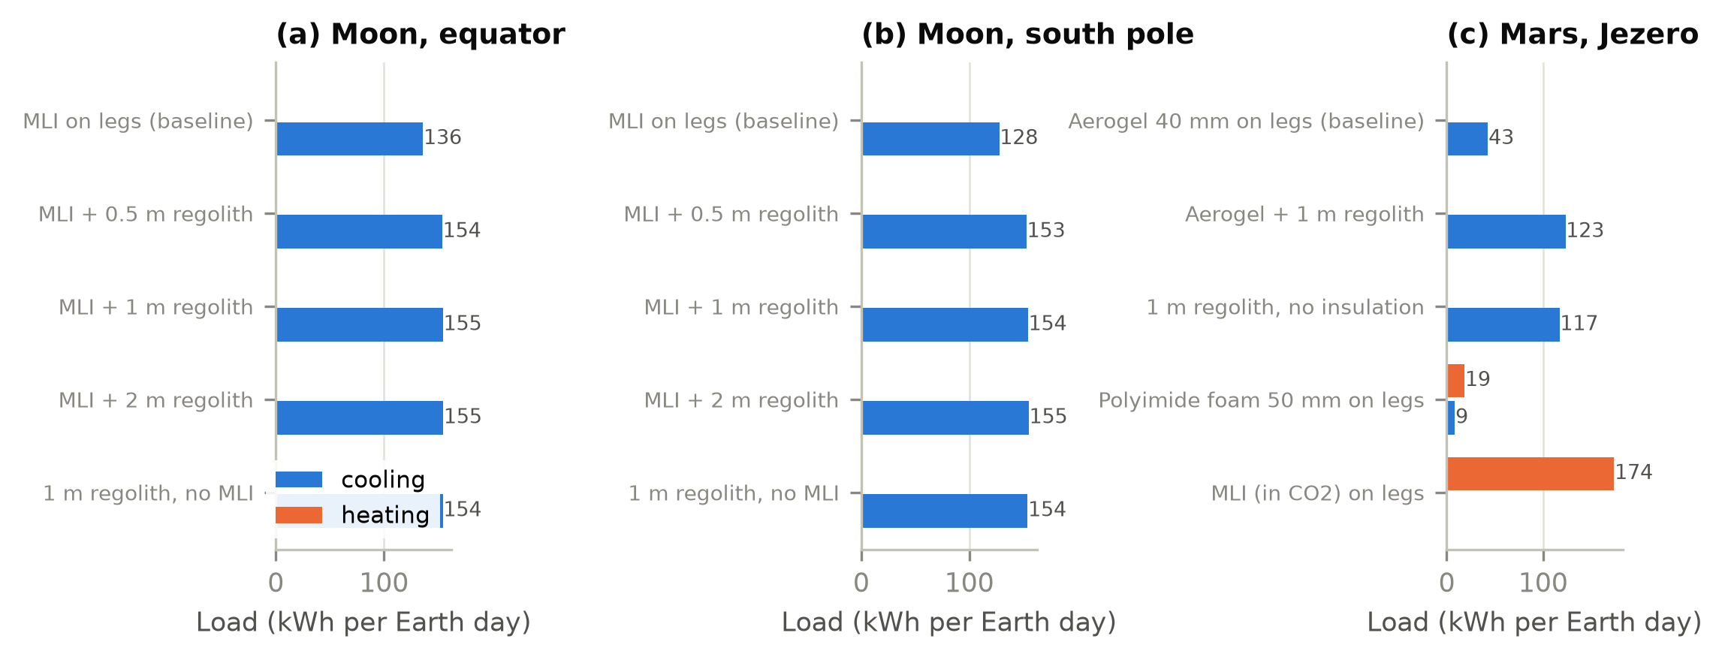
Fig. 8. Daily heating and cooling loads of the cabin air for envelope variants at the three sites (kWh per Earth day).

6.4 Mars seasons and dust storms
Over the Mars year at Jezero (Fig. 9), sol-mean insolation varies between 105 and 161 W/m², and sol-mean air temperature between -60 and -43 °C. A 2018-type global storm cuts sol-mean insolation to 21 W/m² and keeps it below 60 W/m² for 104 sols. Dust re-emits part of the absorbed sunlight as infrared, so the nights warm and the days cool: at peak opacity the diurnal air-temperature range shrinks from 46 to 11 K while the sol-mean air temperature changes by -4 K, as observed by Curiosity in 2018 [53, 58]. The habitat responds through its envelope and its radiator. Its envelope loses less heat to the warmer night sky, so its sol-mean cabin cooling load rises by up to 0.4 kW; by day the dimmed Sun lowers the radiator sink, so thermal-control power falls by up to 0.4 kW. These are modest changes for a habitat whose internal gains are about 14 kW; the power system is affected far more, as shown next.
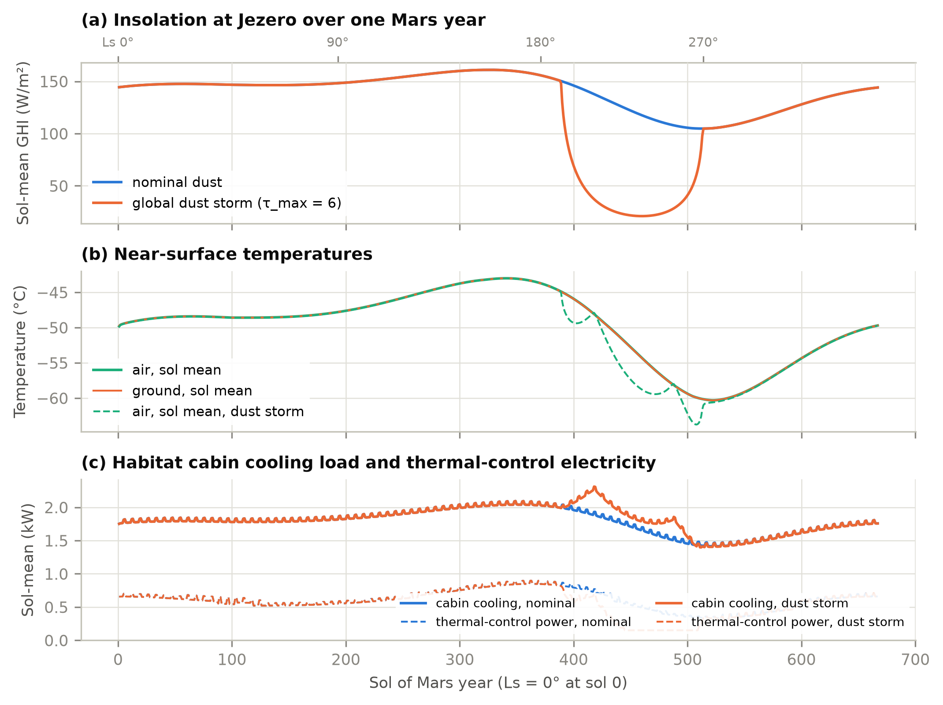
Fig. 9. One Mars year at Jezero crater. (a) Sol-mean global horizontal irradiance, nominal and with a global dust storm. (b) Sol-mean air and ground temperatures. (c) Sol-mean cabin cooling load and thermal-control electricity.

6.5 Power systems
Table 11. Power systems that meet the habitat's electric demand with no shortfall over the simulated period (storage is nameplate; Li-ion mass at 160 Wh/kg packaged [80]).
Case | Mean load (kW) | Peak load (kW) | Thermal-control share (%) | PV + Li-ion, balance area: PV m²; storage MWh (mass) | PV × 2 + Li-ion: PV m²; storage MWh (mass) | PV + RFC: PV m²; storage MWh | Fission 40 kWe
Moon, south pole | 14.12 | 15.11 | 1 | 46; 9.5 (59 t) | 91; 4.23 (26.4 t) | 49; 10.6 | 1 unit; 183% shunted
Moon, equator | 17.98 | 30.81 | 23 | 120; 6.6 (41 t) | 237; 6.60 (41.3 t) | 160; 7.6 | 1 unit; 122% shunted
Mars, Jezero | 13.78 | 17.76 | 4 | 354; 14.9 (93 t) | 701; 0.25 (1.6 t) | 507; 16.2 | 1 unit; 190% shunted
Mars, dust storm | 13.73 | 17.76 | 4 | 399; 42.6 (266 t) | 791; 27.13 (169.5 t) | 580; 44.0 | 1 unit; 191% shunted

Table 11 and Fig. 10 size three power systems that meet the electric demand of each habitat with no shortfall. Two numbers dominate. First, at the lunar equator the 354-hour night sets the storage whatever the array: 6.6 MWh of Li-ion (41 t) or 7.6 MWh of regenerative fuel cells, and thermal control is 23% of the load because of heat-pump lift. Second, sizing arrays only for the energy balance shifts surplus from summer to winter and asks storage to carry seasons: 14.9 MWh (93 t) at Jezero. Doubling the array cuts this to 0.25 MWh, only the nightly deficit (Fig. 10a), a trade-off that favours larger arrays on Mars. A global dust storm undoes it: even with twice the array, 27 MWh (170 t) is needed to ride out the weeks of darkness, while the habitat's thermal loads hardly change. At the polar ridge the uniform horizon produces a polar-winter eclipse of 12 days and 4.2 MWh of storage with twice the array; NASA's 100-hour design eclipse would need 1.8 MWh (nameplate, as in Table 11). A single 40 kWe fission unit meets every case independently of light and dust; it produces more than twice the demand, so the surplus is available for other surface loads (in-situ resource production, rovers) or is shunted, and it rejects about 181 kW of waste heat through its own radiator. The comparison of energy is not a comparison of systems: NASA's Fission Surface Power design goal is under 6 t for a 10-year life [66], against 26–41 t of Li-ion for the lunar cases, but it excludes the reactor's radiator, power cable and emplacement, and a single reactor is a single point of failure that a crewed base would back up with a second unit or with storage sized for the critical load. In vacuum the sunlit cells of a lunar two-axis array run at 330–380 K, lowering their efficiency by 7–18% relative to the 28 °C rating (γ = −0.0023 K⁻¹), an effect absent from Earth building tools.
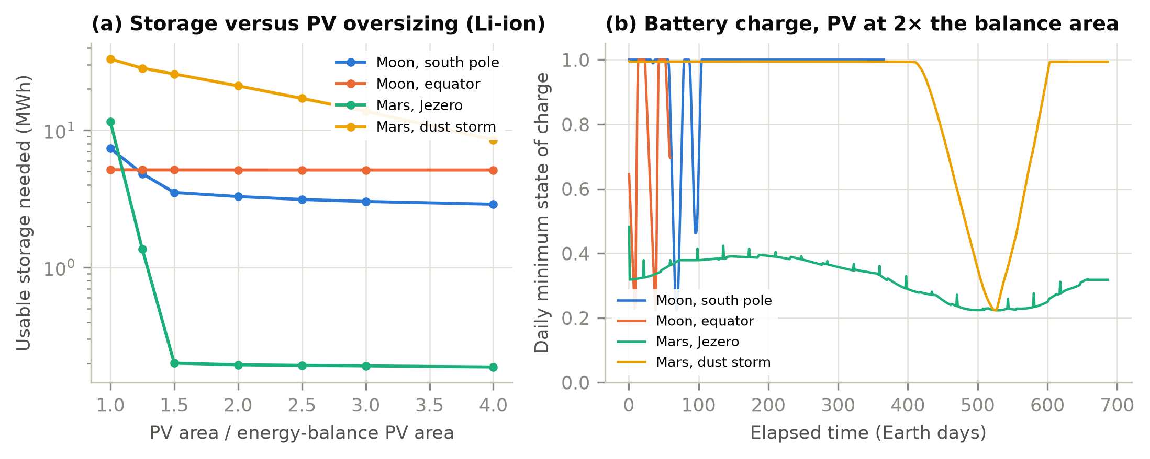
Fig. 10. Power systems. (a) Usable storage needed to meet the load against the PV array area (multiples of the energy-balance area), Li-ion. (b) Daily minimum battery state of charge with twice the energy-balance array.

6.6 Convection under reduced gravity and pressure
Fig. 11 quantifies why convection coefficients cannot be carried over from Earth. Cabin natural convection on a 2.5 m wall with a 3 K temperature difference drops from about 2.1 W/(m²·K) at 1 g and 101 kPa to about 0.83 W/(m²·K) at lunar gravity in the 56.5 kPa cabin of the reference habitats (1.07 W/(m²·K) at Mars gravity). That is comparable to the forced coefficient at a 0.15 m/s ventilation velocity, so cabin ventilation, not buoyancy, controls interior surface heat transfer on the Moon. Outside on Mars, mixed convection in 700 Pa CO2 gives 0.15–0.7 W/(m²·K) over the full range of wind speeds, 20–70 times less than on Earth at the same wind speed. Exterior convection on Mars is therefore a correction to the radiative balance rather than a dominant term, consistent with the small sensible heat fluxes MEDA measured [54].
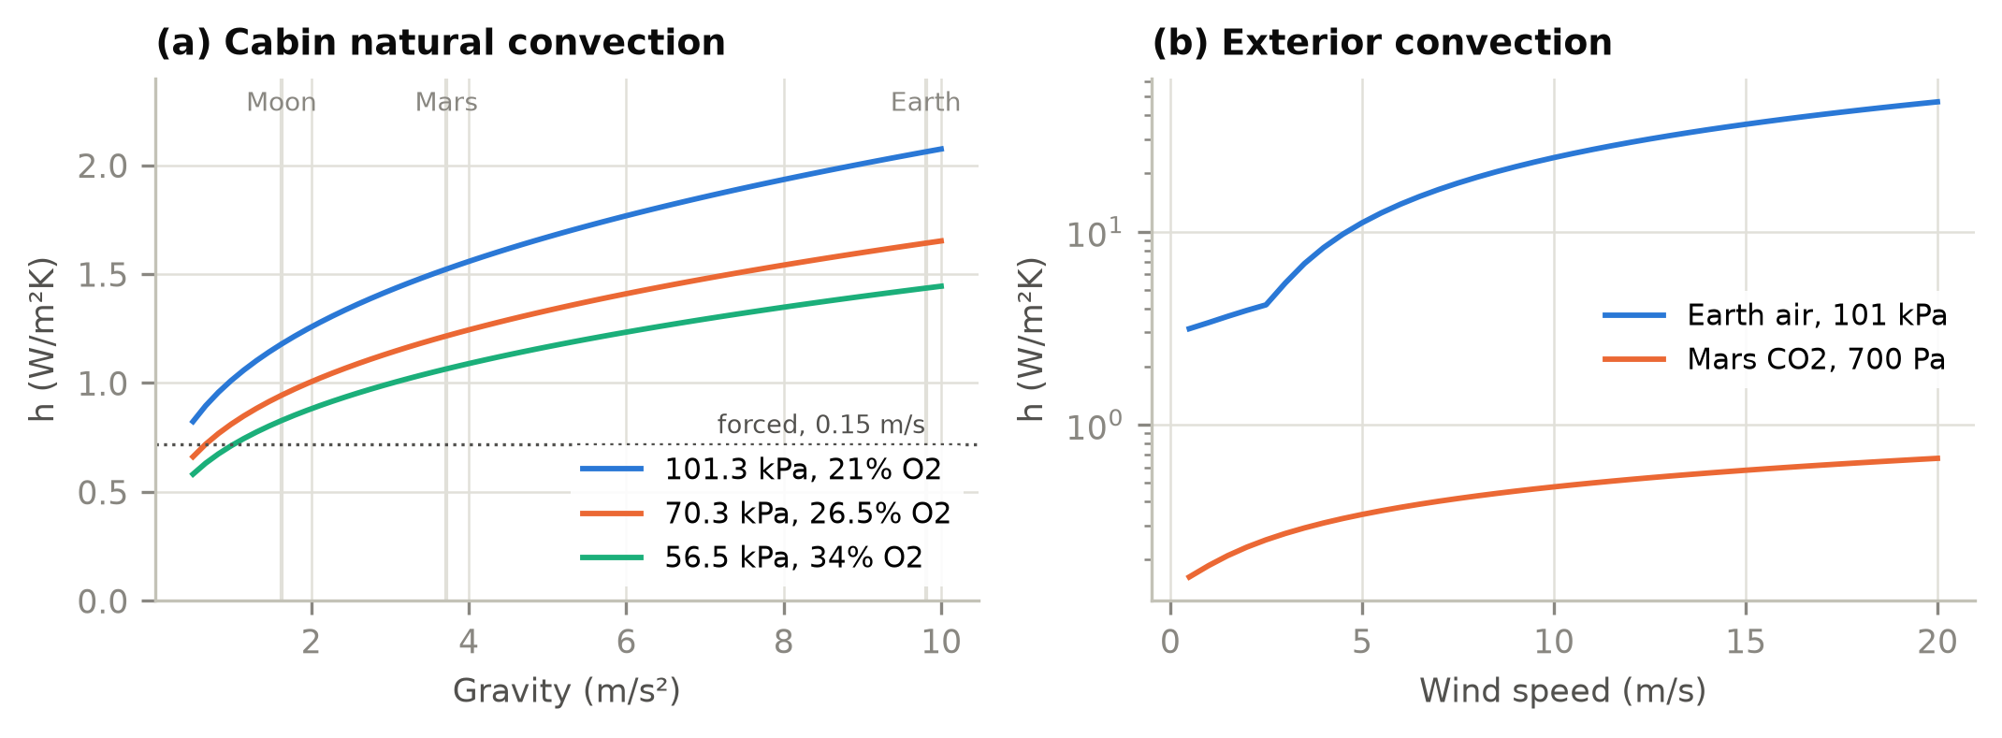
Fig. 11. (a) Interior natural convection coefficient versus gravity for three cabin atmospheres (2.5 m vertical wall, ΔT = 3 K), with the forced-convection value at 0.15 m/s. (b) Exterior mixed convection versus wind speed for a 3 m surface on Earth and Mars (ΔT = 10 K and 30 K, respectively).

7. Discussion

7.1 Implications for habitat design
The case studies suggest a shift in emphasis for habitat energy design. On Earth, BES spends most of its effort on the envelope; a sealed habitat full of life-support equipment and electronics is a heat-rejection problem whose envelope mainly decides how much of the internal heat leaks away for free, whether its inner surfaces stay above the dew point, and how much radiation shielding costs in extra cooling. Design then turns on (i) internal heat generation and where it is collected (cabin air or cold plates), (ii) where and how it is rejected, and (iii) electric storage across darkness, which is set by the lunar night, polar terrain or Martian dust rather than by the habitat. Radiator placement and coating degradation by dust change thermal-control energy by a factor of two at the lunar equator; array oversizing trades against storage by two orders of magnitude on Mars; and a single fission unit removes the dependence on light. These conclusions are qualitatively known to spacecraft thermal and power engineers [8, 11, 24]. What ExoBEM adds is a way to quantify them with the annual, schedule-driven methods of building science, including humidity and consumables, and to carry the same model from early massing studies to detailed design.

7.2 Limitations
- Single zone. Multi-zone habitats, airlocks as separate zones and inter-module air exchange are not yet modelled.
- Ideal systems. Radiators, heat pumps and storage are quasi-steady models without component dynamics; cold-plate fractions and the life-support share of the electric load are assumptions where no public source exists.
- Idealized terrain. Horizons are uniform or user-supplied profiles; DEM horizons (LOLA, HiRISE) and shading between modules are planned. The uniform polar horizon overstates eclipse length.
- Empirical Mars boundary layer. Near-surface air temperature uses a calibrated surrogate, and the regolith surface exchanges no sensible heat with the air; Mars Climate Database input through the PWF format is the planned route to better atmospheres [29, 81].
- Effective dust optics. Broadband scattering parameters are fitted to Appelbaum–Flood tables; the Beer-law beam with the forward-scattered peak counted as diffuse is a modelling choice that measured Martian direct/diffuse data should confirm [48, 49].
- Dust storms. The storm case (τ = 6) lies outside the 0.1 ≤ τ ≤ 3 range of the Appelbaum–Flood tables used to fit the two-stream model, so its insolation is an extrapolation; the dust re-emission term is calibrated to a single storm response observed at another site (Gale crater), and the peak downwelling infrared in the storm (135 W/m²) has not been checked against measurements. Storm results are scenarios, not predictions.
- Verification scope. The EnergyPlus comparison tests the Earth heat balance only; the planetary models are checked against reference data component by component, and the habitat envelope is calibrated to one NASA thermal analysis and checked at a second operating point (+24%). Empirical validation of a whole habitat in thermal-vacuum chambers or analog habitats remains to be done.

7.3 Relation to the EnergyPlus engine
Re-implementing the method in a compact engine allowed the planetary physics to be developed and verified quickly, but it leaves out most of what EnergyPlus offers: multi-zone air and HVAC systems, plant loops, controls and an established input and output ecosystem. Carrying the planetary models into the EnergyPlus engine itself would give habitat designers those features. ExoBEM is built to support that step: its physics follows the EnergyPlus structure element by element (Table 2), its planetary weather format can be read by any program, and its verification cases can serve as the reference for an engine implementation. Until then, ExoBEM is the faster tool for exploring design options, sizing power systems and studying cabin humidity.

8. Conclusions
ExoBEM brings whole-building energy simulation to sealed habitats on the Moon and Mars. It re-implements the EnergyPlus heat-balance method and, guided by a systematic analysis of how the Moon and Mars differ from Earth, replaces its Earth-specific physics with planetary ephemerides, airless and dusty skies, equilibrated regolith ground, gravity- and pressure-aware convection, curved shields, a sealed cabin with leakage, airlock losses and humidity, radiator heat rejection and an on-site power system, all driven by a documented planetary weather format. Its terrestrial core matches EnergyPlus 23.2 within 0.7% in annual loads, its planetary models reproduce Mars24, Diviner, Appelbaum–Flood and MEDA reference data, and its envelope model, calibrated to NASA's night-time heat leak of the Artemis surface habitat, predicts the daytime value within 24%. For NASA-class habitats for the first crews the design problem is to reject 9–13 kW of internal heat, which costs heat-pump power at the lunar equator but almost none at the pole or on Mars; to keep the inner surfaces of a Mars habitat above the dew point, which an aerogel envelope achieves only if cabin humidity is held at or below 50%; and to store energy through the lunar night, polar eclipses or dust storms, which favours large arrays on Mars and fission where darkness lasts. The package, tutorial, weather files and every script behind this paper are open source.

Software and data availability
ExoBEM v0.2.0 is available at https://github.com/TensorBuildLab/ExoBEM (BSD-3-Clause) and is installed with python -m pip install "exobem[plot] @ git+https://github.com/TensorBuildLab/ExoBEM". The repository contains the tutorial (docs/tutorial), the planetary weather-format specification (docs/weather_format.md), the example models and weather files, the EnergyPlus verification inputs, the case-study scripts and the data behind every figure and table. EnergyPlus 23.2 and the TMY3 weather file are available from the U.S. DOE.

Declaration of generative AI use
During the preparation of this work the author used Claude (Anthropic) to assist with literature search, software implementation, an independent review of the equations, verification scripting and drafting of the manuscript. The author reviewed and edited all content and takes full responsibility for the publication. [Authors: confirm and adapt to the target journal's policy.]

CRediT authorship contribution statement
[To be completed by the authors.]

Declaration of competing interest
The author declares no known competing financial interests or personal relationships that could have appeared to influence the work reported in this paper.

Acknowledgements
EnergyPlus is developed by the U.S. Department of Energy's Building Technologies Office and its national laboratory and university partners; ExoBEM is not endorsed by them. [Funding to be added.]

Appendix A. Using ExoBEM: installation and a worked example
ExoBEM is installed with pip and provides a Python package and a command-line tool. A step-by-step tutorial with this example is in the repository (docs/tutorial); here are its main steps.
1. Install and copy the examples:
python -m pip install "exobem[plot] @ git+https://github.com/TensorBuildLab/ExoBEM"
exobem examples my_project
2. Generate a planetary weather file for 30 days at a lunar south-polar ridge, hourly:
exobem weather --body moon --lat -89.5 --lon 0 --horizon -1.65 --days 30 --timestep 3600 -o south_pole_30d.pwf
3. Inspect the model and its geometry. The model file lunar_surface_habitat.json has the sections simulation, site (here "weather_file": "south_pole_30d.pwf"), materials, constructions, geometry, zone (cabin pressure and oxygen, set-points, leakage, airlock, humidity limits, internal mass), gains (crew, life support, electrolysis, fans, lighting, equipment, each with a 24-hour schedule, electric, heat and cold-plate fractions), thermal_control and power:
exobem geometry lunar_surface_habitat.json -o habitat.png
4. Run it:
exobem run lunar_surface_habitat.json -o out
The run takes about a second and writes out/timeseries.csv (zone and surface temperatures, loads), out/environment.csv, out/power.csv (generation, storage state of charge, unmet energy) and out/summary.json with the cabin cooling, cold-plate and latent energy, the humidity range, the minimum margin between the inside surfaces and the dew point, the condensation-risk hours, the cabin gas to make up, the thermal-control electricity and the power-system summary.
5. Use the Python interface to change the design and compare, for example adding a regolith cover:
import json, exobem
from exobem.io import build_model
from exobem.weather import read_pwf
cfg = json.load(open('lunar_surface_habitat.json'))
cfg['constructions']['covered'] = ['lunar_regolith_cover_1m'] + cfg['constructions']['shell']
cfg['geometry'].update(wall='covered', roof='covered')
res = exobem.simulate(build_model(cfg), read_pwf('south_pole_30d.pwf'))
print(res.summary())

Appendix B. Header of a planetary weather file
# PWF 1.0
# body: mars
# site_name: Jezero crater
# latitude_deg: 18.440000
# longitude_deg: 77.450000
# start_utc: 2030-01-01T00:00:00
# timestep_s: 1800
# n_records: 1488
# solar_day_s: 88775.244147
# gravity_m_s2: 3.72100
# atmosphere: mars_co2
# clock: mars_lmst
# sky_includes_air: false
# generator: exobem 0.2.0 weather --body mars ...
time_s,local_time_h,day_index,zenith_deg,sun_azimuth_deg,sun_visible,dni_W_m2,dhi_W_m2,ghi_W_m2,T_air_K,...
1800,4.076848,0,121.9043,107.584,0,0,0,0,205.549,...

References
[1] T. Hong, S.K. Chou, T.Y. Bong, Building simulation: an overview of developments and information sources, Build. Environ. 35 (2000) 347–361. https://doi.org/10.1016/S0360-1323(99)00023-2
[2] D.B. Crawley, J.W. Hand, M. Kummert, B.T. Griffith, Contrasting the capabilities of building energy performance simulation programs, Build. Environ. 43 (2008) 661–673. https://doi.org/10.1016/j.buildenv.2006.10.027
[3] D.B. Crawley, L.K. Lawrie, F.C. Winkelmann, W.F. Buhl, Y.J. Huang, C.O. Pedersen, R.K. Strand, R.J. Liesen, D.E. Fisher, M.J. Witte, J. Glazer, EnergyPlus: creating a new-generation building energy simulation program, Energy Build. 33 (2001) 319–331. https://doi.org/10.1016/S0378-7788(00)00114-6
[4] R.K. Strand, C.O. Pedersen, D.B. Crawley, Modularization and simulation techniques for heat balance-based energy and load calculation programs: the experience of the ASHRAE Loads Toolkit and EnergyPlus, in: Proc. Building Simulation 2001, IBPSA, Rio de Janeiro, 2001, pp. 43–50.
[5] U.S. Department of Energy, EnergyPlus Version 23.2.0 Documentation: Engineering Reference, U.S. DOE Building Technologies Office, 2023.
[6] ANSI/ASHRAE, Standard 140-2020: Standard Method of Test for the Evaluation of Building Energy Analysis Computer Programs, ASHRAE, Atlanta, GA, 2020.
[7] G. Schunk, S. Babiak, D. Naville, B. Evans, Conceptual thermal control system design for a lunar surface habitat, in: Thermal & Fluids Analysis Workshop (TFAWS), NASA, 2021. https://ntrs.nasa.gov/citations/20210020015
[8] R.G. Schunk, S.D. Babiak, B.W. Evans, Thermal control system architecture and technology challenges for a lunar surface habitat, in: 2022 IEEE Aerospace Conference, IEEE, 2022. https://ntrs.nasa.gov/citations/20210026557
[9] B.G. Drake (Ed.), Human Exploration of Mars Design Reference Architecture 5.0, NASA/SP-2009-566, NASA Headquarters, Washington, DC, 2009. https://www.nasa.gov/pdf/373665main_NASA-SP-2009-566.pdf
[10] D.G. Gilmore (Ed.), Spacecraft Thermal Control Handbook, Volume I: Fundamental Technologies, 2nd ed., The Aerospace Press, El Segundo, CA, 2002.
[11] L.C. Simonsen, M.J. DeBarro, J.T. Farmer, Conceptual design of a lunar base thermal control system, in: The Second Conference on Lunar Bases and Space Activities of the 21st Century, NASA CP-3166, 1992, pp. 579–591. https://ntrs.nasa.gov/citations/19930004815
[12] K. Gadkari, S.K. Goyal, J. Vanniasinkam, Conceptual design of a thermal control system for an inflatable lunar habitat module, NASA-CR-192014, 1991. https://ntrs.nasa.gov/citations/19930008924
[13] R.B. Malla, K.M. Brown, Determination of temperature variation on lunar surface and subsurface for habitat analysis and design, Acta Astronaut. 107 (2015) 196–207. https://doi.org/10.1016/j.actaastro.2014.10.038
[14] S. Tripathi, J.T. Steiner, R.B. Malla, Three-dimensional temperature profile in a dome-shaped habitat structure on the Moon, Acta Astronaut. 204 (2023) 263–280. https://doi.org/10.1016/j.actaastro.2022.12.040
[15] J.T. Steiner, S. Tripathi, R.B. Malla, Air pressure and temperature distribution within a dome habitat structure on the lunar surface, in: Earth and Space 2022, ASCE, 2023, pp. 946–955. https://doi.org/10.1061/9780784484470.079
[16] A. Borshchak Kachalov, P. Salgado Sánchez, M.T. Mollah, J.M. Ezquerro, J. Spangenberg, B. Šeta, Numerical analysis of coaxially 3D printed lunar habitats: integrating regolith and PCM for passive temperature control, Microgravity Sci. Technol. 37 (2025) 38. https://doi.org/10.1007/s12217-025-10194-4
[17] J. Li, Y. Bai, S. Bi, M. Beer, Thermomechanical behavior of steel structural configurations subjected to cyclic cryogenic conditions in Martian environment, Adv. Space Res. 76 (2025) 3700–3716. https://doi.org/10.1016/j.asr.2025.06.069
[18] T.J.-R. Lagarde, Using computational techniques for the optimal design of evolving habitats, in: 72nd International Astronautical Congress, IAC-21-B3.7.10, Dubai, 2021. https://spacearchitect.org/pubs/IAC-21-B3.7.10.pdf
[19] G.N. Aydemir, An Integrated Framework for Mars-Based Building Performance Simulations (M-BPS): From Site Selection to Habitat Assessment, PhD dissertation, Middle East Technical University, Ankara, 2026. https://hdl.handle.net/11511/118421
[20] A. Jadeja, M.M. Jaiswal, S. Ghosh, P. Sanghavi, Thermal comfort analysis of a proposed design for a sustainable living space on Mars, Intell. Build. Int. 8 (2016) 215–233. https://doi.org/10.1080/17508975.2015.1120185
[21] D.D. Bien, D.C. Guentert, A method for reducing the equivalent sink temperature of a vertically oriented radiator on the lunar surface, NASA TM X-1729, NASA Lewis Research Center, Cleveland, OH, 1969. https://ntrs.nasa.gov/citations/19690007893
[22] P. Kessler, T. Prater, T. Nickens, D. Harris, Artemis deep space habitation: Enabling a sustained human presence on the Moon and beyond, in: 2022 IEEE Aerospace Conference (AERO), Big Sky, MT, 2022, pp. 1–12. https://doi.org/10.1109/AERO53065.2022.9843393
[23] C. Stromgren, C. Lynch, C. Burke, J. Cho, N. Mary, Evaluating extravehicular activity access options for a lunar surface habitat, in: 2023 IEEE Aerospace Conference (AERO), Big Sky, MT, 2023. https://doi.org/10.1109/AERO55745.2023.10115984 (slides: NASA NTRS 20230002484)
[24] R.L. Cataldo, Power requirements for the NASA Mars Design Reference Architecture (DRA) 5.0, in: Proc. Nuclear and Emerging Technologies for Space (NETS 2009), Atlanta, GA, 14–19 June 2009, Paper 203603. NASA NTRS 20120012929. https://ntrs.nasa.gov/citations/20120012929
[25] M. von Einem, R. Groll, C. Heinicke, Computational modeling of a ventilation concept for a lunar habitat laboratory, J. Space Saf. Eng. 9 (2022) 145–153. https://doi.org/10.1016/j.jsse.2022.02.005
[26] M. Azimi, et al., HabSim: a modular-coupled virtual testbed for simulating extraterrestrial habitat systems, AIAA J. 63 (2025) 376–388. https://doi.org/10.2514/1.J063845
[27] S.T. Engler, K. Binsted, H. Leung, HI-SEAS habitat energy requirements and forecasting, Acta Astronaut. 162 (2019) 50–55. https://doi.org/10.1016/j.actaastro.2019.05.049
[28] Y. Charoenboonvivat, O. de Weck, Surface power demand modeling for human Martian and lunar missions, in: AIAA SciTech 2026 Forum, AIAA 2026-1922, 2026. https://doi.org/10.2514/6.2026-1922
[29] E. Millour, F. Forget, A. Spiga, et al., The Mars Climate Database (version 5.3), in: From Mars Express to ExoMars Scientific Workshop, ESA-ESAC, Madrid, 2018.
[30] S. Ross, Development of an open source modelling package for thermal balance of crewed Mars habitats, in: 73rd International Astronautical Congress, IAC-22-A5.IP.4, Paris, 2022.
[31] H.C. Hottel, A.F. Sarofim, Radiative Transfer, McGraw-Hill, New York, 1967.
[32] U.S. Federal Aviation Administration, 14 CFR 25.841 Pressurized cabins (cabin pressure altitude not more than 8,000 ft under normal operating conditions), Electronic Code of Federal Regulations.
[33] NASA, NASA Spaceflight Human-System Standard, Volume 2: Human Factors, Habitability, and Environmental Health, NASA-STD-3001 Vol. 2 Rev. F, NASA Office of the Chief Health and Medical Officer, Washington, DC, approved 14 July 2026. https://standards.nasa.gov/system/files/tmp/NASA-STD-3001%20Vol%202%20Rev%20F.pdf
[34] M.S. Anderson, M.K. Ewert, J.F. Keener, Life Support Baseline Values and Assumptions Document, NASA/TP-2015-218570/REV1, NASA Johnson Space Center, Houston, TX, 2018.
[35] O.A. Alduchov, R.E. Eskridge, Improved Magnus form approximation of saturation vapor pressure, J. Appl. Meteorol. 35 (1996) 601–609. https://doi.org/10.1175/1520-0450(1996)035<0601:IMFAOS>2.0.CO;2
[36] M. Allison, M. McEwen, A post-Pathfinder evaluation of areocentric solar coordinates with improved timing recipes for Mars seasonal/diurnal climate studies, Planet. Space Sci. 48 (2000) 215–235. https://doi.org/10.1016/S0032-0633(99)00092-6
[37] NASA Goddard Institute for Space Studies, Mars24 Sunclock — Algorithm and Worked Examples, https://www.giss.nasa.gov/tools/mars24/help/algorithm.html (accessed 8 November 2026).
[38] J. Meeus, Astronomical Algorithms, 2nd ed., Willmann-Bell, Richmond, VA, 1998.
[39] B.A. Archinal, C.H. Acton, M.F. A'Hearn, et al., Report of the IAU Working Group on Cartographic Coordinates and Rotational Elements: 2015, Celest. Mech. Dyn. Astron. 130 (2018) 22. https://doi.org/10.1007/s10569-017-9805-5
[40] G. Kopp, J.L. Lean, A new, lower value of total solar irradiance: evidence and climate significance, Geophys. Res. Lett. 38 (2011) L01706. https://doi.org/10.1029/2010GL045777
[41] P.O. Hayne, J.L. Bandfield, M.A. Siegler, A.R. Vasavada, R.R. Ghent, J.-P. Williams, B.T. Greenhagen, O. Aharonson, C.M. Elder, P.G. Lucey, D.A. Paige, Global regolith thermophysical properties of the Moon from the Diviner Lunar Radiometer Experiment, J. Geophys. Res. Planets 122 (2017) 2371–2400. https://doi.org/10.1002/2017JE005387
[42] B.S. Hemingway, R.A. Robie, W.H. Wilson, Specific heats of lunar soils, basalt, and breccias from the Apollo 14, 15, and 16 landing sites, between 90 and 350 K, in: Proc. Lunar Planet. Sci. Conf. 12th, 1981, pp. 2259–2268.
[43] J.H. Joseph, W.J. Wiscombe, J.A. Weinman, The delta-Eddington approximation for radiative flux transfer, J. Atmos. Sci. 33 (1976) 2452–2459. https://doi.org/10.1175/1520-0469(1976)033<2452:TDEAFR>2.0.CO;2
[44] W.E. Meador, W.R. Weaver, Two-stream approximations to radiative transfer in planetary atmospheres: a unified description of existing methods and a new improvement, J. Atmos. Sci. 37 (1980) 630–643. https://doi.org/10.1175/1520-0469(1980)037<0630:TSATRT>2.0.CO;2
[45] O.B. Toon, C.P. McKay, T.P. Ackerman, K. Santhanam, Rapid calculation of radiative heating rates and photodissociation rates in inhomogeneous multiple scattering atmospheres, J. Geophys. Res. 94 (1989) 16287–16301. https://doi.org/10.1029/JD094iD13p16287
[46] J. Appelbaum, D.J. Flood, Solar radiation on Mars, Sol. Energy 45 (1990) 353–363. https://doi.org/10.1016/0038-092X(90)90156-7
[47] J. Appelbaum, G.A. Landis, I. Sherman, Solar radiation on Mars—update 1991, Sol. Energy 50 (1993) 35–51. https://doi.org/10.1016/0038-092X(93)90006-A
[48] M.J. Wolff, M.D. Smith, R.T. Clancy, et al., Wavelength dependence of dust aerosol single scattering albedo as observed by the Compact Reconnaissance Imaging Spectrometer, J. Geophys. Res. 114 (2009) E00D04. https://doi.org/10.1029/2009JE003350
[49] H. Chen-Chen, S. Pérez-Hoyos, A. Sánchez-Lavega, Characterisation of Martian dust aerosol phase function from sky radiance measurements by MSL engineering cameras, Icarus 330 (2019) 16–29. https://doi.org/10.1016/j.icarus.2019.04.004
[50] M.T. Lemmon, M.J. Wolff, J.F. Bell III, M.D. Smith, B.A. Cantor, P.H. Smith, Dust aerosol, clouds, and the atmospheric optical depth record over 5 Mars years of the Mars Exploration Rover mission, Icarus 251 (2015) 96–111. https://doi.org/10.1016/j.icarus.2014.03.029
[51] M.T. Lemmon, M.D. Smith, D. Viúdez-Moreiras, et al., Dust, sand, and winds within an active Martian storm in Jezero crater, Geophys. Res. Lett. 49 (2022) e2022GL100126. https://doi.org/10.1029/2022GL100126
[52] L. Montabone, F. Forget, E. Millour, et al., Eight-year climatology of dust optical depth on Mars, Icarus 251 (2015) 65–95. https://doi.org/10.1016/j.icarus.2014.12.034
[53] S.D. Guzewich, M. Lemmon, C.L. Smith, et al., Mars Science Laboratory observations of the 2018/Mars Year 34 global dust storm, Geophys. Res. Lett. 46 (2019) 71–79. https://doi.org/10.1029/2018GL080839
[54] G.M. Martínez, E. Sebastián, A. Vicente-Retortillo, M.D. Smith, J.R. Johnson, E. Fischer, H. Savijärvi, et al., Surface energy budget, albedo, and thermal inertia at Jezero crater, Mars, as observed from the Mars 2020 MEDA instrument, J. Geophys. Res. Planets 128 (2023) e2022JE007537. https://doi.org/10.1029/2022JE007537
[55] J.A. Rodriguez-Manfredi, M. de la Torre Juárez, A. Alonso, et al., The Mars Environmental Dynamics Analyzer, MEDA. A suite of environmental sensors for the Mars 2020 mission, Space Sci. Rev. 217 (2021) 48. https://doi.org/10.1007/s11214-021-00816-9
[56] J. Gómez-Elvira, C. Armiens, L. Castañer, et al., REMS: The environmental sensor suite for the Mars Science Laboratory rover, Space Sci. Rev. 170 (2012) 583–640. https://doi.org/10.1007/s11214-012-9921-1
[57] J.A. Rodríguez-Manfredi, M. de la Torre Juárez, A. Sánchez-Lavega, R. Hueso, G.M. Martínez, et al., The diverse meteorology of Jezero crater over the first 250 sols of Perseverance on Mars, Nat. Geosci. 16 (2023) 19–28. https://doi.org/10.1038/s41561-022-01084-0
[58] D. Viúdez-Moreiras, C.E. Newman, M. de la Torre, et al., Effects of the MY34/2018 global dust storm as measured by MSL REMS in Gale crater, J. Geophys. Res. Planets 124 (2019) 1899–1912. https://doi.org/10.1029/2019JE005985
[59] G.N. Walton, Thermal Analysis Research Program Reference Manual, NBSIR 83-2655, National Bureau of Standards, Washington, DC, 1983.
[60] F.P. Incropera, D.P. DeWitt, T.L. Bergman, A.S. Lavine, Fundamentals of Heat and Mass Transfer, 6th ed., John Wiley & Sons, Hoboken, NJ, 2007.
[61] S.W. Churchill, H.H.S. Chu, Correlating equations for laminar and turbulent free convection from a vertical plate, Int. J. Heat Mass Transf. 18 (1975) 1323–1329. https://doi.org/10.1016/0017-9310(75)90243-4
[62] NASA Exploration Atmospheres Working Group, Recommendations for Exploration Spacecraft Internal Atmospheres: The Final Report of the NASA Exploration Atmospheres Working Group, NASA/TP-2010-216134, NASA Johnson Space Center, Houston, TX, 2010.
[63] AZUR SPACE Solar Power GmbH, 30% Triple-Junction Bare Solar Cells & Assemblies TJ 3G30-Advanced (4x8), datasheet DB 00010891-01, Heilbronn, 11 April 2025. https://www.azurspace.com/media/uploads/file_links/file/bdb_00010891-01-00_tj3g30-advanced_4x8.pdf
[64] G.A. Landis, P.P. Jenkins, Measurement of the settling rate of atmospheric dust on Mars by the MAE instrument on Mars Pathfinder, J. Geophys. Res. Planets 105 (E1) (2000) 1855–1857. https://doi.org/10.1029/1999JE001029
[65] R.D. Lorenz, G.M. Martínez, A. Spiga, A. Vicente-Retortillo, C.E. Newman, N. Murdoch, F. Forget, E. Millour, T. Pierron, Lander and rover histories of dust accumulation on and removal from solar arrays on Mars, Planet. Space Sci. 207 (2021) 105337. https://doi.org/10.1016/j.pss.2021.105337
[66] L.K. Kaldon, A.L. Presby, L.S. Mason, B.K. Smith, A.S. Weaver, Current status of NASA's Fission Surface Power project, in: 75th International Astronautical Congress, Milan, Italy, 2024, IAC-24-C3.3.4. NASA NTRS 20240011694. https://ntrs.nasa.gov/citations/20240011694
[67] S. Oleson, T. Packard, E. Turnbull, M. Gibson, D. Rao, C. Barth, S. Wilson, P. Schmitz, A. Colozza, B. Klefman, L. Tian, L. Mason, A deployable 40 kWe lunar fission surface power concept, in: Nuclear and Emerging Technologies for Space (NETS-2022), American Nuclear Society, Cleveland, OH, 2022. NASA NTRS 20220004670. https://ntrs.nasa.gov/citations/20220004670
[68] R. Gilligan, I. Jakupca, FY23 Regenerative Fuel Cell (RFC) annual review, NASA STMD Game Changing Development Program, 20 September 2023. NASA NTRS 20230012948. https://ntrs.nasa.gov/citations/20230012948
[69] P.J. Smith, K.P. Cain, R.P. Gilligan, I.J. Jakupca, Lunar Equator Regenerative Fuel Cell System Efficiency Analysis, NASA/TM-20210014627, NASA Glenn Research Center, Cleveland, OH, 2022. https://ntrs.nasa.gov/citations/20210014627
[70] R. Judkoff, J. Neymark, International Energy Agency Building Energy Simulation Test (BESTEST) and Diagnostic Method, NREL/TP-472-6231, National Renewable Energy Laboratory, Golden, CO, 1995.
[71] S. Wilcox, W. Marion, Users Manual for TMY3 Data Sets, NREL/TP-581-43156, National Renewable Energy Laboratory, Golden, CO, 2008.
[72] R. Perez, P. Ineichen, R. Seals, J. Michalsky, R. Stewart, Modeling daylight availability and irradiance components from direct and global irradiance, Sol. Energy 44 (1990) 271–289. https://doi.org/10.1016/0038-092X(90)90055-H
[73] A.R. Vasavada, J.L. Bandfield, B.T. Greenhagen, P.O. Hayne, M.A. Siegler, J.-P. Williams, D.A. Paige, Lunar equatorial surface temperatures and regolith properties from the Diviner Lunar Radiometer Experiment, J. Geophys. Res. 117 (2012) E00H18. https://doi.org/10.1029/2011JE003987
[74] P. Gläser, F. Scholten, D. De Rosa, et al., Illumination conditions at the lunar south pole using high resolution Digital Terrain Models from LOLA, Icarus 243 (2014) 78–90. https://doi.org/10.1016/j.icarus.2014.08.013
[75] E. Mazarico, G.A. Neumann, D.E. Smith, M.T. Zuber, M.H. Torrence, Illumination conditions of the lunar polar regions using LOLA topography, Icarus 211 (2011) 1066–1081. https://doi.org/10.1016/j.icarus.2010.10.030
[76] C. Burke, R.L. Howard Jr., P. Kessler, Internal layout of a lunar surface habitat, in: ASCEND 2022, AIAA, Las Vegas, NV, 2022. NASA NTRS 20220013669. https://ntrs.nasa.gov/citations/20220013669
[77] A. Whitmire, L. Leveton, H. Broughton, M. Basner, A. Kearney, Minimum Acceptable Net Habitable Volume for Long-Duration Exploration Missions: Subject Matter Expert Consensus Session Report, NASA Johnson Space Center, JSC-CN-32284, Houston, TX, 2014. NASA NTRS 20140016951. https://ntrs.nasa.gov/citations/20140016951
[78] M.A. Rucker, S.J. Hoffman, A. Andrews, K.D. Watts, Advantages of a modular Mars surface habitat approach, in: 2018 AIAA SPACE and Astronautics Forum and Exposition, Orlando, FL, 2018, AIAA 2018-5102. https://doi.org/10.2514/6.2018-5102
[79] J.R. Gaier, J. Siamidis, S.R. Panko, K.J. Rogers, E.M.G. Larkin, The effect of simulated lunar dust on the absorptivity, emissivity, and operating temperature of AZ-93 and Ag/FEP thermal control surfaces, NASA/TM-2008-215492, 2008. https://ntrs.nasa.gov/citations/20090005996
[80] R. Gilligan, P.J. Smith, R. Green, Thermal management challenges and technology options for lunar regenerative fuel cells, Thermal and Fluids Analysis Workshop (TFAWS 2023), presentation. https://tfaws.nasa.gov/wp-content/uploads/TFAWS23-ID-11-Presentation.pdf
[81] F. Forget, F. Hourdin, R. Fournier, et al., Improved general circulation models of the Martian atmosphere from the surface to above 80 km, J. Geophys. Res. 104 (1999) 24155–24175. https://doi.org/10.1029/1999JE001025

