Domain guardrails for data-driven building energy prediction: an agent-ready MLOps framework evaluated on real buildings
Liang Zhang^{a,*}
ª Department of Civil and Architectural Engineering and Mechanics, The University of Arizona, Tucson, AZ 85721, USA
* Corresponding author. E-mail address: liangzhang1@arizona.edu (Liang Zhang)

Highlights
- Agents declare building data; one package applies the same checks to every model
- Day-ahead models beat strong rules, including TOWT, in 66% of 200 real buildings
- As M&V baselines, models matched but did not beat TOWT on annual savings error
- Shuffled validation passed 32 M&V baselines that failed in the reporting year
- Monthly retraining beat drift-triggered retraining at the default tolerance

Abstract
Data-driven building energy models support control, demand response and measurement and verification (M&V), but their reliability depends on how they are evaluated and maintained. This paper presents bemlops, an open-source machine learning operations (MLOps) framework in which a large language model agent or analyst declares each data column as a physical quantity and a package applies the same checks to every model: plausibility, causal cleaning, leakage-safe inputs, time-ordered evaluation against the strongest baseline without machine learning, including time-of-week-and-temperature (TOWT) regression, promotion gates, monitoring and retraining. In a pre-specified evaluation on 200 public buildings and 72 room and system tasks, routinely configured day-ahead models beat their reference significantly in 66% of the buildings. As M&V baselines, they matched but did not beat TOWT (median annual error 5.3% versus 5.2%). Shuffled cross-validation understated the error of forward use by a median of 41% and accepted 32 M&V baselines that missed the ASHRAE Guideline 14 limits in the reporting year, against 13 for a time-ordered split. Over a year in 50 buildings, monthly retraining outperformed drift-triggered retraining at the default tolerance, and 86% of promoted models kept a skill (relative error reduction against the strongest baseline) of at least 0.05. The checks found site-wide meter faults in cleaned benchmark data but missed months of zero readings.
Keywords: building energy prediction; M&V baselines; machine learning operations; model retraining; time-series validation; large language model agents

Nomenclature
Symbols
$d_{t}$​ | loss differential (model minus baseline) | $e_{t}$​ | prediction error at time $t$
$h$​ | forecast horizon (time steps) | $n$​ | number of test observations
$q_{0.9}$​ | 90th percentile of absolute validation errors | $S$​ | skill against the reference baseline (–)
$y_{t}$, ${\hat{y}}_{t}$ | measured and predicted value | $\overline{y}$​ | mean of the measured values
$\overline{d}$​ | mean of $d_{t}$ over the test window | $R^{2}$​ | coefficient of determination (–)
Abbreviations
AHU | air-handling unit | BAS | building automation system
BDG2 | Building Data Genome Project 2 | CI | confidence interval
CI/CD | continuous integration and continuous delivery | CV | cross-validation
CV(RMSE) | coefficient of variation of the RMSE | DM | Diebold–Mariano test
IQR | interquartile range | LLM | large language model
M&V | measurement and verification | MAE | mean absolute error
ML | machine learning | MLOps | machine learning operations
NMBE | normalized mean bias error | PM2.5 | particulate matter below 2.5 µm
RMSE | root mean square error | RQ | research question
TOWT | time-of-week-and-temperature regression

Introduction
The operation of buildings accounts for about 30% of global final energy consumption [1], and data-driven prediction underpins many of the ways in which that consumption is managed. Model predictive control needs forecasts of loads and zone conditions [2], demand response needs forecasts of electric power, fault detection compares measurements with expected values, and measurement and verification (M&V) compares metered consumption with a baseline model of what the building would have used [3]. Machine-learning models for these tasks are well studied [4] but rarely applied in practice [5], because each building needs its own model and building one takes skilled effort on data that differ from building to building: point names must be decoded, units are mixed, and exports contain text, placeholder values, stuck sensors and gaps.
Large language model (LLM) agents can now write and execute this kind of analysis code. A preliminary study by Khadka and Zhang [6], on which this paper builds, used a prompt template that followed the steps of a machine-learning operations (MLOps) lifecycle and let GPT-4 produce runnable modeling code for a simulated small office in 34 of 35 attempts. Producing code is no longer the difficult step; knowing whether the resulting model can be relied on in operation is: whether it was evaluated without look-ahead, whether it beats the simple rule an operator would otherwise use, whether its error estimate holds in the following months, and what happens to it as the building changes. The preliminary study did not address these questions: its pipelines split time series at random, selected features on the full dataset, used one simulated building and stopped before deployment.
This paper presents and evaluates bemlops, an open framework designed to answer these questions in the same way for every model, whoever writes the surrounding code. An agent (or an analyst) decodes the export and declares each column as a physical quantity with a unit; a domain package then applies the same checks, or guardrails, to every model: physical plausibility, causal cleaning, inputs that cannot reach past the forecast time, time-ordered evaluation against the strongest baseline that uses no machine learning, promotion gates, monitoring and retraining. The evaluation is organized around five research questions (RQs) on the uses that matter for building energy operation:
- RQ1: Across 200 buildings and 72 tasks in 11 rooms and their building systems, how often does a routinely configured model beat the strongest baseline without machine learning, including the time-of-week-and-temperature (TOWT) regression used in M&V practice [7]?
- RQ2: As an M&V baseline, how large is the annual savings error of the framework’s models compared with TOWT, and how well does the error estimated from the baseline year predict the reporting year?
- RQ3: How much does the evaluation protocol, a random split as in the preliminary study, change the estimated error and the resulting decisions?
- RQ4: Over a year of operation, how do scheduled, drift-triggered and gated retraining compare, and are the gates’ decisions borne out by later performance?
- RQ5: Which data faults do the checks detect, and what does their handling gain over a quick or a competent hand-written script?
The contributions are an open framework that separates building-specific judgment from checks applied identically to every model, with physical-quantity declarations as the interface, fault semantics of building automation systems (BAS), baselines that include the M&V standard, promotion gates, monitoring and retraining; a pre-specified evaluation on public data, led by 200 buildings of the Building Data Genome Project 2 (BDG2); and lessons for practice on when machine learning is worth deploying, how the evaluation protocol changes energy decisions and how retraining should be scheduled. A formative usability study with fresh agent instances is reported in the Supplementary Material; it is too small to answer any research question. Claims that the experiments do not measure, such as the benefit of rigorous defaults for less careful users, are stated in Section 6 as hypotheses. Section 2 reviews related work, Section 3 describes the framework, Section 4 the data and experiments, Section 5 the results and Section 6 their implications and limits.

Related work

Data-driven prediction in building operation
Machine-learning models of building energy consumption are well established [4] and are a standard ingredient of data-driven control [2,8]. The indoor environment and occupancy are predicted with the same tools, for example occupancy from light, temperature, humidity and CO₂ [9] and indoor CO₂ up to 15 min ahead from a year of office data [10]. Reviews of energy forecasting call for reproducible evaluation against simple benchmarks [11], and large benchmarks exist for load forecasting [12,13]. In the ASHRAE Great Energy Predictor III competition on the BDG2 data, the handling of zero and anomalous meter readings was among the factors that separated the best entries from the rest [14]. What remains expensive is the work around each model: understanding, cleaning, evaluating and maintaining it. Much of that work concerns faulty sensors and data problems rather than modeling [15], and fault detection in building systems is a field of its own [16,17].

Measurement and verification baselines
In M&V, a baseline model fitted on a pre-retrofit period predicts what a building would have used in a reporting period, and the savings are the difference between that prediction and the metered use. The time-of-week-and-temperature (TOWT) regression [7], with one level per hour of the week and piecewise-linear temperature terms for occupied and unoccupied periods, is the standard hourly baseline; it is implemented in open tools such as OpenDSM (CalTRACK methods) [18] and RMV2.0 [19]. Granderson et al. [3] assessed the accuracy of automated M&V baselines on hundreds of commercial buildings by fitting them on one period and predicting a following period without efficiency measures; in such a pseudo-savings test, any predicted savings are error. The uncertainty of savings estimated from statistical baseline models has been analyzed by Reddy and Claridge [20]; ASHRAE Guideline 14 [21] gives criteria for the coefficient of variation of the root-mean-square error (RMSE), CV(RMSE), and the normalized mean bias error (NMBE); its hourly limits of 30% and ±10% are calibration criteria for simulation models, used in this paper as a familiar threshold.

Automated and LLM-generated pipelines for buildings
Automated machine learning (AutoML) has been benchmarked for building load prediction [22], and an end-to-end automated forecasting framework covering preprocessing, feature engineering and model selection has been proposed [23]; the latter also retrains on a sliding window. Since 2023, LLMs have been used to generate data-mining code for building energy management [5], to automate the training and deployment of load-prediction models [24], to analyze unstructured building data with multiple agents [25], and to coordinate specialist agents with many tools for building operation [26]. The preliminary study on which this paper builds used prompt templates structured by MLOps steps to have an LLM write modeling code [6]. These studies mostly evaluate whether the generated code runs, how accurate the model is on a held-out split, or whether tools are selected correctly. Agents for machine-learning engineering are evaluated on benchmarks that control the held-out test set [27–29]; in a building, nobody holds back a clean test set, and the analyst’s own split, cleaning and baseline decide whether a reported accuracy means anything.

Model lifecycle and evaluation pitfalls
Machine-learning systems accumulate hidden technical debt [30]; production readiness can be scored with test rubrics [31], data validated like code [32] and models documented with model cards [33]. Kreuzberger et al. [34] synthesized MLOps into nine principles, used here as a checklist. Mature general-purpose tools cover parts of this lifecycle (Table 1): data validation with Deequ [35], Great Expectations [36] and pandera [37]; tracking, versioning and registries with MLflow [38] and Data Version Control (DVC) [39]; drift monitoring with Evidently [40]; and time-series learning with backtesting and naive forecasters with sktime [41], Darts [42] and AutoGluon–TimeSeries [43]. For building energy prediction specifically, Li et al. [44] compared static, retrained and continual-learning models at large scale, Derzsi et al. [45] compared performance-based drift detectors across 35 heating, ventilation and air-conditioning (HVAC) devices, and Heidrich et al. [46] addressed concept drift in energy time series with profiles.
On evaluation, out-of-sample tests with a rolling origin are the reference for forecasting accuracy [47], cross-validation for dependent data should be blocked [48,49], although standard k-fold cross-validation is valid for purely autoregressive models with uncorrelated errors [50], and data leakage, including leakage from random splits and from preprocessing on the full dataset, is a widespread cause of irreproducible machine-learning results [51]. How much random splits mislead on building operational data, and whether this changes energy decisions, is addressed in Section 5.2 and Section 5.3.
Table 1. Capabilities of existing tools and of this work. “Partly”: possible with rules or configuration that the user writes; “n.r.”: not reported.
Capability | Data validationª | Tracking and registries^{b} | Monitoring^{c} | Time-series ML^{d} | M&V tools^{e} | Building AutoML or LLM pipelines^{f} | This work
Physical-quantity declarations with unit inference | no | no | no | no | no | n.r. | yes
Sensor-fault semantics of building automation systems | partly | no | no | no | partly | n.r. | yes
Inputs that cannot reach past the forecast time, audited | no | no | no | partly | n.a. | n.r. | yes
Time-ordered evaluation and backtesting | no | no | no | yes | partly | partly | yes
TOWT and other no-ML baselines as the reference | no | no | no | partly | yes | no | yes
Model registry with gated promotion and rollback | no | yes | no | no | no | no | yes
Retraining over time | no | no | partly | partly | no | yes | yes
Drift and live-data monitoring | partly | no | yes | no | no | no | yes
Designed for an LLM agent to drive | no | no | no | no | no | partly | yes
Note: ª Deequ [35], Great Expectations [36], pandera [37]. ^{b} MLflow [38], DVC [39]. ^{c} Evidently [40]. ^{d} sktime [41], Darts [42], AutoGluon–TimeSeries [43]. ^{e} OpenDSM/CalTRACK [18], RMV2.0 [19]; M&V baselines use concurrent weather, so look-ahead is not applicable (n.a.). ^{f} Refs. [22–24]. Cells summarize the documented capabilities of each group; “partly” for M&V tools reflects data-sufficiency checks rather than sensor-fault detection.
None of these capabilities is technically difficult on its own; the contribution is to combine them behind one small interface and to measure their effect on real buildings. Brick [52] standardizes building metadata, and where a Brick model exists it can supply the declarations the framework requires; most real exports, including the three datasets used here, carry no such model, so the declarations are inferred from names, documentation and values.

Framework
This section describes version 0.3.1 (source fingerprint 84f7e16c74ac9fdc), which was frozen with a pre-specified analysis plan before any reported experiment was run; its history is listed in the Supplementary Material.

Division of labor
Fig. 1 shows the division of labor (detailed in Supplementary Table S3). The agent may write any code it needs before handing the package a table with a time index; after that point, nothing reaches a model unless it has been declared, checked and prepared in a logged, deterministic way, and nothing reaches production unless it has passed explicit gates.
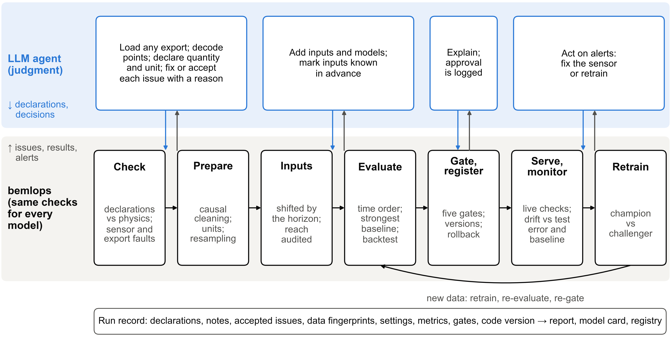
Fig. 1. Division of labor between the LLM agent and the package. The agent’s declarations and decisions flow down to the package; issue reports, results and alerts flow back up. Every run leaves one record.

Declarations as the interface
The interface between the agent and the package is a declaration: for each column, a physical quantity and a unit, for example zone_air_temperature [degF]. Point names are ambiguous and vendor-specific, whereas a declaration is explicit and can be checked. Each of the 28 quantities (including a generic other) carries a canonical unit and its conversions, a plausible range, a narrower typical range from which the most likely unit is inferred when the declared one does not fit, and behavioral flags, for example that solar irradiance is zero at night and an idle meter may sit at zero. Two flags record knowledge that the package cannot infer: flat_ok marks sensors whose long flat stretches are normal, such as a CO₂ sensor at its floor, and known_ahead marks values known at forecast time, such as schedules or weather forecasts. Only declared columns are used, and the quantity of the target fixes the task type (regression or, for binary quantities such as occupancy status, classification).

Data checks and preparation
Errors found by the data check block fitting until the agent fixes the data or the declaration, or accepts the issue with a written reason; they include a unit that does not fit the values or changes part-way through a series, a cumulative meter declared as interval energy, decimal commas and an empty target. Warnings, such as stuck sensors, spikes, placeholder values, text entries, duplicates, out-of-order rows and gaps, are handled by a standard preparation step that logs every action.
Preparation sorts and de-duplicates the rows, converts units, sets text, placeholder values and impossible readings missing, masks stuck stretches and spikes, and resamples to a regular grid. Cleaning is causal: a spike is judged against the median of the four preceding readings, and a stretch of identical values is masked only from the point at which it is detectable (6 h by default). Interval totals are computed only from complete intervals, inputs are filled forward only, up to a limit, and the target is never filled.

Inputs that cannot reach past the forecast time
For a forecast $h$ steps ahead, the prediction for interval $T$ uses measured data up to $T−h$ only; lags and rolling means are shifted accordingly, and only inputs declared known_ahead may be used at $T$. Every input records how far back it reaches, an audit refuses any input that reaches forward, and inputs correlated with the target above 0.995 are flagged as possible copies of it. In estimation mode ($h=0$), the target is estimated from other inputs at the same moment, as a virtual sensor or an M&V baseline.

Evaluation
The data are split in time order into training, validation and test sets (70/15/15% by default), with a gap of $h$ steps between consecutive sets; there is no random split. Hyperparameters are tuned by random search with time-ordered cross-validation on the training set only. Every task includes baselines without machine learning. For numeric forecasts these are persistence, the value at the same time on the previous day and in the previous week, a time-of-day profile (separately for weekdays and weekends), a 168-h time-of-week profile, and, where an outdoor temperature is declared, a TOWT regression [7] with one level per time of week and a single piecewise-linear temperature term with the CalTRACK knots (30, 45, 55, 65, 75 and 90 °F), merging segments with fewer than 20 training hours; unlike the original, it does not fit separate temperature terms for occupied and unoccupied hours. The TOWT regression uses the temperature available at prediction time: the measured value for estimates and the value lagged by the horizon for forecasts, since no weather forecast is assumed. For numeric estimates the baselines are the training mean, the two profiles and TOWT; for binary targets they are persistence, the share of positive labels and a time-of-day probability profile. The strongest baseline on the validation set becomes the reference for the task. The candidates are ridge or logistic regression, a random forest, gradient boosting and, for regression, gradient boosting on the change from the latest value; the agent can add its own. The candidate or baseline with the lowest validation error is chosen, even when it is a baseline, and the chosen model and the reference are refitted on the training and validation data and scored once on the test set.
Accuracy is reported as skill against the reference, based on the root mean square error (RMSE),
$S=1−\frac{{RMSE}_{model}}{{RMSE}_{ref}}$ (1)
where RMSE is replaced by the Brier score [53] for binary targets. A skill of 0.05 on RMSE corresponds to a mean-square-error skill of about 0.10. For energy-like targets, CV(RMSE) and NMBE are computed on the test predictions aggregated to hours (hourly totals for energy and hourly means for power), for the model and for its reference baseline, and compared with the hourly limits of ASHRAE Guideline 14-2014 [21], 30% and ±10% (a 2023 edition has since been published). These limits are the guideline’s hourly calibration criteria; they are used here as a familiar threshold, with $n−1$ in the denominators corresponding to $p=1$ in the guideline’s $n−p$:
$CV(RMSE)=\frac{100}{|\overline{y}|}\sqrt{\frac{\sum_{t=1}^{n}{e_{t}^{2}}}{n−1}}≤30\%$ (2)
$\left|NMBE\right|=\frac{100}{|\overline{y}|}\left|\frac{\sum_{t=1}^{n}{e_{t}}}{n−1}\right|≤10\%$ (3)
where $e_{t}=y_{t}−{\hat{y}}_{t}$. Each run also reports a rolling-origin backtest over three blocks after training, refitting before each block; because it overlaps the validation period, it checks stability rather than testing independently. A 90% prediction interval ${\hat{y}}_{t}±q_{0.9}$ uses the 90th percentile of the absolute validation errors, in the manner of split conformal prediction; because its width is calibrated once, it does not adapt to changes in operation [54]. Grouped permutation importance [55] shows which inputs the model relies on.

Promotion gates, monitoring and retraining
A model reaches production only through a registry that evaluates five gates from the run record: every data error is resolved or accepted, the test skill is at least 0.05, the Guideline 14 limits are met where they apply, no input is flagged as a possible copy of the target or as reaching forward, and the test set has at least 200 rows. The Guideline 14 gate applies only to estimation-mode energy models, which are M&V baselines; for forecasts, which may use lags of the metered target, the limits are reported but not gated. The gates read the single test window, not the backtest. Overriding a gate requires a written reason and is logged; in the experiments, promotion followed the gates without a human step, whereas in operation the registry records the approval of the person responsible.
Every live prediction re-runs the data checks and rebuilds every trained input with the training code. A drift check on recent data recommends retraining when the recent primary error exceeds 1.5 times the error at test time, or when more than 20% of the recent values of an input fall outside its training range widened by 10% on each side; for forecasts it also scores persistence on the same rows and, when the model loses to it, recommends falling back to persistence and retraining; and it reports new sensor faults. Retraining reuses the production configuration on newer data, scores the champion and the challenger on rows that start after both training periods plus the horizon, and promotes the challenger only if it passes the gates and has the lower error.
Table 2 maps the framework to the nine MLOps principles of Kreuzberger et al. [34]. A feature store is unnecessary because features are rebuilt from the declared configuration by the same code in training and serving, and an online endpoint because building forecasts are produced on a schedule. Reproducibility means re-executing the agent’s frozen decisions with the same package version, not re-running the agent, which is not deterministic.
Table 2. MLOps principles [34] and their implementation in the framework.
Principle | Implementation
P1 CI/CD automation | Tests, including end-to-end model tests, run on every commit; models are delivered through gated promotion
P2 Workflow orchestration | Train, retrain and reproduce pipelines, and a command-line interface with exit codes for any scheduler
P3 Reproducibility | Configuration, declarations, notes, seeds, library versions, code commit, package fingerprint and data fingerprints in every run record; reproduction checks that every metric matches
P4 Versioning | Code commit and package fingerprint; numbered model versions; data fingerprints
P5 Collaboration | Report and model card per run; decisions and accepted issues recorded with reasons
P6 Continuous training and evaluation | Champion–challenger retraining on rows that neither model has seen
P7 Metadata tracking | Run records and a registry event log
P8 Continuous monitoring | Live data validation, comparison of training and live inputs, drift and fault monitoring
P9 Feedback loops | Monitoring recommends retraining; data checks feed back to the agent

Implementation and agent instructions
bemlops is a Python package (BSD 3-Clause license) built on pandas and scikit-learn (modules in Supplementary Table S4). A typical session declares the columns, checks and prepares the data, fits the run and registers the model in about a dozen lines of code. The evaluated version has 51 automated tests, including one that perturbs every value after the forecast time and checks that no input changes. Every run record carries the git commit of the case-study code and a fingerprint of the package source.
The agent learns the workflow from an Agent Skill [56], a short instruction file loaded on demand, with the workflow steps, seven rules (for example, never split building time series at random, and never change a declaration to silence a check), a playbook for messy data and a reference for decoding BAS point names. It succeeds the prompt template of the preliminary study: instead of prescribing code, it prescribes conduct.

Study design

Datasets and tasks
Three public datasets were used (Table 3). BDG2 [13,57], two years of hourly meter data from North America and Europe, carries the energy results; its authors’ cleaned electricity meters were used, and buildings with at least 90% of hourly readings at sites with weather data were eligible (1,256 buildings at 16 sites). The Room-level Occupancy and Building Operation Dataset (ROBOD) from Singapore [58,59] and data of six office rooms and their building systems in Aalborg, Denmark [60,61] add indoor-environment, occupancy and system-level energy targets, which matter for energy through demand-controlled ventilation, pre-cooling and setbacks. A script downloads and checksum-verifies all three, so every result can be reproduced; the raw data are not redistributed. The record of Building 59 at Lawrence Berkeley National Laboratory [62] was not used, because its repository does not allow scripted download.
Table 3. Datasets used in the study.
 | BDG2 [13] | ROBOD [58] | Aalborg offices [60]
Location and climate | 16 sites in North America and Europe | Singapore; tropical | Aalborg, Denmark; temperate
Buildings or spaces | 200 buildings sampled from 1,256 eligible | 5 rooms (2 lecture rooms, 2 offices, 1 library) | 6 office rooms and building systems
Period and resolution | 2016–2017; 1 h | Sep–Dec 2021 (weekdays, in blocks); 5 min | Feb–Dec 2023; 5 min
Targets | Electricity | CO₂, temperature, humidity, PM2.5, people count, presence, chilled-water and plug-load energy | CO₂, temperature, people count, room in use, ventilation electricity, district heating
Tasks | 200 | 45 | 27
Role in this study | Closer to held out | Development and evaluation | Development and evaluation
License | CC BY-SA 4.0 | CC BY 4.0 | CC BY 4.0

BDG2 contributes one task per building, hourly electricity 24 h ahead, with one configuration decided by the agent for the whole dataset; as the dataset has no weather forecasts, weather enters only up to the forecast time. ROBOD contributes forecasts 30 min ahead of the room variables, forecasts 1 h ahead of chilled-water and plug-load energy, and a virtual people counter that estimates the current count from Wi-Fi connections, CO₂, sound, light and plug loads. The Aalborg data contribute forecasts 1 h ahead of the room variables and of ventilation and district-heating power, the latter also 24 h ahead. All tasks use 15-min resolution (hourly for BDG2), the default 70/15/15% time-ordered split and small hyperparameter searches: ridge regression and two gradient-boosting models, one predicting the level and one the change from the latest value (logistic regression and gradient boosting for binary targets), with three settings each, and for ROBOD also a random forest and six settings. The models are therefore deliberately ordinary: the results show how often a routinely configured model is worth deploying against strong simple rules, not how good the best possible model is.

Pre-specified analysis plan
Every experiment was specified in an analysis plan committed to the repository, together with the frozen package version, before any of them was run (case_studies/ANALYSIS_PLAN_v3.md; the commit history records the order). The plan fixes the samples and seeds, the baselines, the arms, the outcomes and the thresholds, and states that every number is reported as computed. One amendment was made before any result was used: a smoke test showed that the first version of the TOWT baseline was numerically unstable when a temperature segment had few training hours, and the corrected version (0.3.1) produced every result reported. The BDG2 sample is the first 200 buildings of a fixed order, in which the eligible buildings were shuffled with seed 0 and taken round-robin over sites (4 to 15 buildings per site). The experiments are numbered here in the order of the research questions; the plan labels the M&V, protocol, lifecycle and fault experiments E5, E2, E4 and E3. Analyses not in the plan are marked as exploratory.

Roles of the agent and the author
An LLM agent (Claude Opus 5.5, Anthropic, operated in Claude Code) followed the Agent Skill to load the data, decode the point names, write the declarations and make the judgment calls, for example reading the undocumented units of the Aalborg data from the magnitudes of the values and excluding the presence flag of ROBOD from the inputs of the people counter because it derives from the same camera ground truth. These decisions are frozen in the case-study scripts and copied into every run record; the agent’s transcripts were not archived. The same agent wrote the package and the analysis scripts, so the case studies show the framework operated by an agent, not an independent test of agents (Section 6.6). The author set the research questions, the datasets and the analysis plan, reviewed the code, the analyses and the text, and traced every reported number to the result files with an automated tool.
Several detectors were revised on ROBOD and Aalborg data during development (Supplementary Material, Table S1), so the data checks are partly in-sample there. BDG2 prompted no revision and its configuration was fixed before its first run, but it is not strictly held out, because its first 20 buildings were analyzed in an earlier version of this study. On ROBOD, the chilled-water meters read zero for whole days while the air-handling unit (AHU) ran with its cooling-coil valve open (9 days in Room 3, 1 in Room 4 and 10 in Room 5); the case-study agent missed this fault, independent agent instances found it (Supplementary Material, Section S3), and the loader sets those days to missing.

Experiments
E1 (RQ1, portfolio and many targets). All 272 tasks are run through the full workflow. The outcomes are skill against the strongest baseline, a Diebold–Mariano (DM) test against it [63], a day-block bootstrap interval for skill, the Guideline 14 results, the interval coverage and the gate decisions, also under stricter gates.
E2 (RQ2, M&V pseudo-savings). For the BDG2 sample buildings with at least 90% of readings in both years, 2016 is the baseline period and 2017 the reporting period. No efficiency measures are known to have been installed, so the true savings are taken to be zero and any predicted savings are error [3]. The framework runs in estimation mode (concurrent weather and calendar, no lags of the metered target), selects among ridge regression, gradient boosting and its baselines on a time-ordered split within 2016, and refits the chosen configuration on all of 2016; a TOWT regression fitted on all of 2016 is the M&V reference. The outcome is the annual pseudo-savings error, predicted minus metered 2017 consumption divided by metered consumption. To link the protocol to M&V decisions, the error of TOWT is also estimated from 2016 in four ways (in-sample, shuffled and blocked five-fold cross-validation, and the time-ordered split) and compared with the error realized in 2017. Buildings whose 2017 mean load differs from the 2016 mean by more than 30% are flagged as likely non-routine changes.
E3 (RQ3, evaluation protocol). The same random forest is evaluated with shuffled five-fold cross-validation, equivalent to the random split of the preliminary study; with feature selection on all rows before shuffling, its full recipe, and, as a control, inside each fold; with blocked five-fold cross-validation, which removes from training a buffer of the longest input look-back plus the horizon around each test block; and with forward chaining, which tests blocked folds 2–5 with training on earlier data only [47]. Errors are compared on the same rows of folds 2–5. E3 uses the 22 regression tasks of ROBOD Rooms 4 and 5 and of Aalborg Room A and its systems, and the first 40 BDG2 buildings.
E4 (RQ4, lifecycle and gate audit). For the first 50 BDG2 sample buildings with at least 90% of readings in both years, the day-ahead task is deployed with a model trained on 2016 and operated through 2017. One model is fitted per month on all earlier data, so that every policy is simulated from the same models: static; monthly; quarterly; drift-triggered retraining at tolerances of 1.1, 1.25, 1.5 and 2.0 (the error-ratio and input-range triggers of Section 3.6); gated retraining at 1.5, in which the challenger must also pass the gates and beat the champion on rows neither has trained on; the same with a fallback that serves persistence in the month after the model lost to it; and persistence. The outcomes are the mean monthly and pooled 2017 RMSE per building. In the gate audit, each monthly model’s gate decision is compared with its realized skill against its own reference over the following three months. The earlier Aalborg lifecycle case (district heating and Room A CO₂, May to December 2023) is repeated on the frozen version.
E5 (RQ5, data faults). Eight known faults are planted at random positions in the Aalborg Room A data of February to June 2023, with ten seeds: a change from °C to °F in the last 40% of the zone temperature, a three-day stuck meter, ten spikes, twenty −999 placeholders in the target, twenty “OFFLINE” text entries, a 12-h outage, a day of duplicated rows and thirty rows out of order. A fault counts as detected when the check reports an issue of that type on that column that it did not report on the clean data. The same random forest, forecasting CO₂ 1 h ahead, is trained on clean data prepared by the framework and by a quick script that coerces text, sorts, averages duplicates, resamples and fills forward; on faulty data prepared by the quick script, with and without a unit fix; by a competent script that also drops sentinel values and impossible readings and fills only gaps of up to 1 h, with the unit fix; and by the framework after the same unit fix, coded by the author, resolves its one blocking error. All arms are scored against the clean target over the same test period. Warnings raised on the untouched data of all three datasets are counted by type.
A formative usability study, in which fresh agent instances built two models with and without the framework, is reported in the Supplementary Material (Section S3); with one run per cell, it answers no research question.

Statistical analysis
The DM test compares the losses of the model and of the reference on the test window through the loss differential $d_{t}=e_{t,model}^{2}−e_{t,ref}^{2}$ (Brier losses for binary targets), whose mean over the $n$ test observations is $\overline{d}$,
$DM=\frac{\overline{d}}{\sqrt{{\hat{σ}}_{HAC}^{2}/n}}$ (4)
where ${\hat{σ}}_{HAC}^{2}$ is a heteroskedasticity- and autocorrelation-consistent variance with a Bartlett kernel and a lag equal to the larger of the horizon and the Newey–West bandwidth $⌊4(n/100)^{2/9}⌋$ [64]. A model is counted as better than its reference when DM < 0 with a two-sided p-value below 0.05 from the normal distribution; the small-sample correction of Harvey et al. [65] and a Benjamini–Hochberg correction [66] across tasks are sensitivity analyses. Skill intervals for single tasks come from a bootstrap of whole test days (500 resamples). Because tasks share rooms, systems and test windows, shares of tasks have 95% intervals from a cluster bootstrap over rooms, building systems and BDG2 buildings (2,000 resamples). Retraining policies are compared with a bootstrap over buildings, and fault arms that share a seed with paired Wilcoxon signed-rank tests.

Results

Portfolio and many targets (RQ1)
All 272 tasks ran through the full workflow to an evaluated and gated result with no manual step beyond the declarations in the case-study scripts (Table 4; every task in Supplementary Table S12).
Table 4. Results of the 272 tasks by dataset.
Dataset | Tasks | Clusters | Test days, median (range) | Skill, median (IQR) | Baseline kept | Better than baseline (DM), % (95% CI) | Machine-learning model refused by gates
ROBOD | 45 | 5 | 5 (3–8) | 0.05 (0.00 to 0.25) | 14 | 42 (24–62) | 8/31
Aalborg | 27 | 7 | 48 (26–48) | 0.12 (0.04 to 0.22) | 2 | 74 (61–88) | 5/25
BDG2 | 200 | 200 | 108 (79–112) | 0.16 (0.03 to 0.28) | 40 | 66 (59–72) | 18/160
All | 272 | 212 | 103 (3–112) | 0.15 (0.00 to 0.27) | 56 | 62 (56–69) | 31/216
Note: Skill is defined on RMSE (Brier score for binary targets) against the strongest baseline on validation; a kept baseline has skill 0. “Better than baseline (DM)”: share of tasks in which the model was better than its reference in a Diebold–Mariano test (p < 0.05), with 95% cluster-bootstrap intervals over buildings, rooms and building systems. “Machine-learning model refused by gates”: machine-learning models that won on validation but failed a promotion gate.
Across the 200 BDG2 buildings, a routinely configured model was significantly better than the strongest baseline in 131 (66%; 95% interval 59–72%), with a median skill of 0.16 (interquartile range 0.03–0.28). The references were strong and varied: persistence in 59 buildings, the value a week earlier in 54, TOWT in 51, a time-of-week or time-of-day profile in 32 and the value a day earlier in 4. In 40 buildings a baseline won on validation and was kept, and 18 of the 160 machine-learning models that won on validation failed a promotion gate, so 142 buildings (71%) received a promoted model. The models met the hourly Guideline 14 limits in 159 buildings and their references in 150 (Fig. 2), so the limits separate predictable meters from difficult ones more than good models from poor ones.
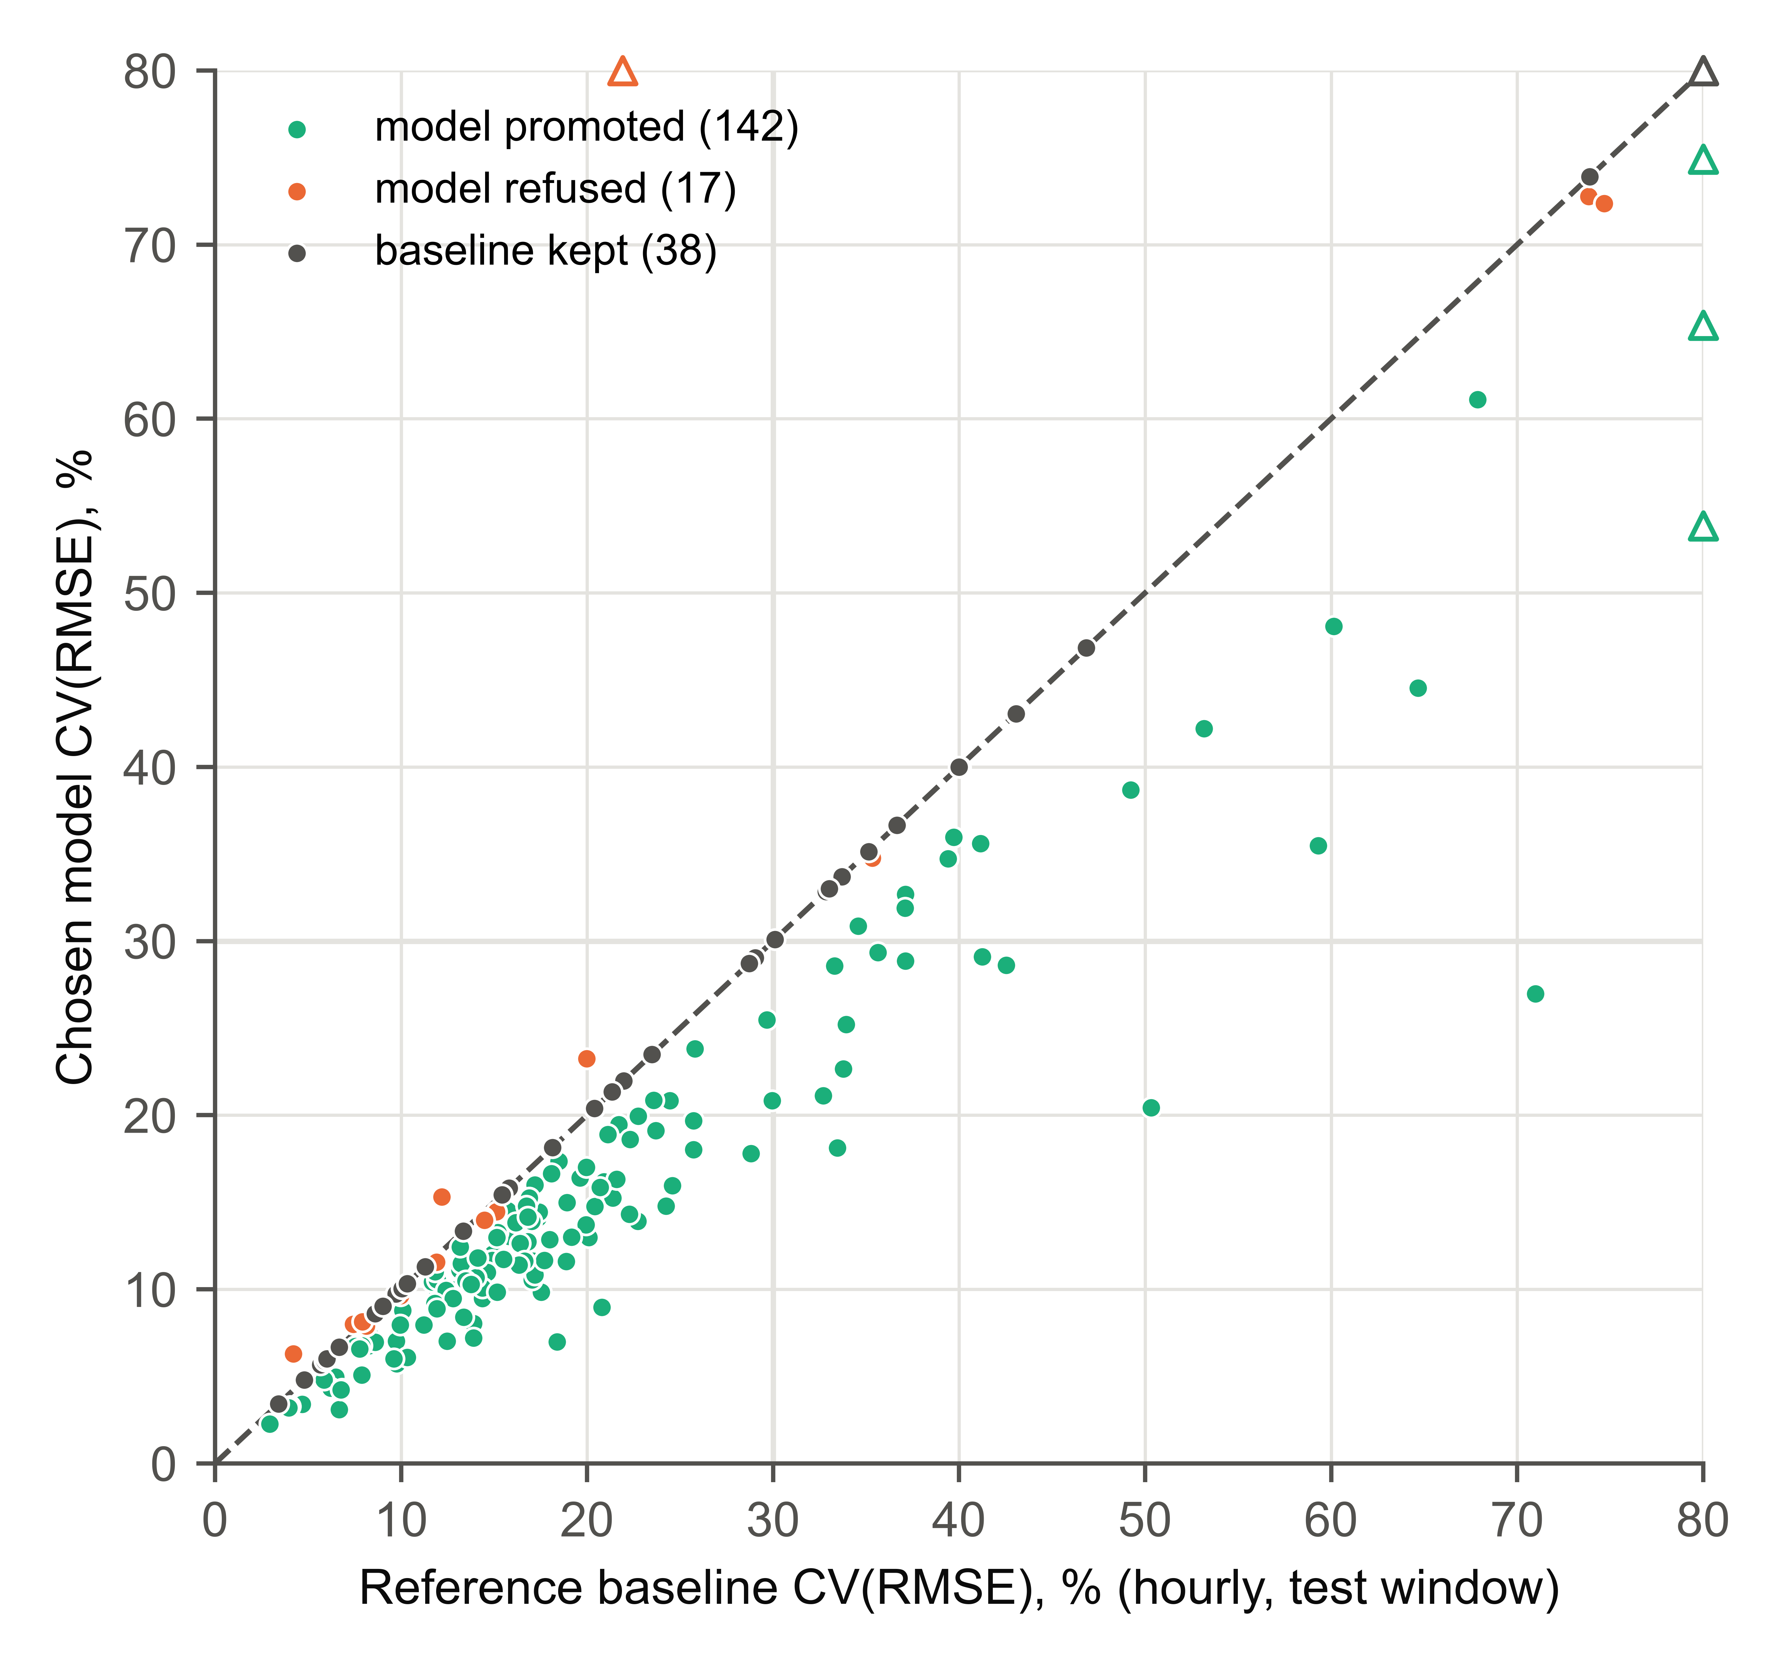
Fig. 2. Hourly CV(RMSE) of the chosen model against that of its reference baseline on the test window for 197 BDG2 buildings (three buildings whose meters read zero almost throughout the test window are omitted). Points below the diagonal are models that beat their reference; baselines kept on validation lie on it. Triangles: values above 80%, drawn at the edge.
The room and system tasks show how much this depends on the target (Table 5, Fig. 3). Models were significantly better in 20 of the 27 Aalborg tasks (74%; 61–88%) but in only 19 of the 45 ROBOD tasks (42%; 24–62%), whose test windows covered only 3–8 weekdays. CO₂ was consistently predictable (8 of 11 tasks; median skill 0.11), because it lags occupancy and ventilation, which the inputs measure, and so was the current people count estimated from Wi-Fi, CO₂, sound and plug loads (median skill 0.42). Occupant counts 30 min or 1 h ahead barely beat persistence (median skill 0.00), and well-controlled room temperature reached 0.06. Among the room and system energy targets, plug loads were the hardest (1 of 5 significant), and heating and cooling energy reached a median skill of 0.12.
Table 5. Results by target.
Target | Tasks | Skill, median (IQR) | Better (DM) | Promoted | Most frequent reference | 90% coverage, median
Whole-building electricity | 200 | 0.16 (0.03 to 0.28) | 131 | 142 | persistence | 89%
Plug-load electricity | 5 | 0.16 (0.00 to 0.19) | 1 | 3 | time of day profile | 84%
Fan electricity | 1 | 0.46 (0.46 to 0.46) | 1 | 1 | persistence | 91%
Heating/cooling energy | 7 | 0.12 (0.00 to 0.22) | 4 | 4 | persistence | 81%
CO2 | 11 | 0.11 (0.06 to 0.16) | 8 | 8 | persistence | 92%
Room temperature | 11 | 0.06 (0.00 to 0.13) | 6 | 6 | persistence | 91%
Humidity | 5 | 0.36 (0.00 to 0.43) | 3 | 3 | persistence | 89%
PM2.5 | 5 | 0.09 (0.05 to 0.14) | 2 | 4 | persistence | 91%
Occupancy count | 11 | 0.00 (−0.01 to 0.17) | 4 | 4 | persistence | 91%
People count, estimated now | 5 | 0.42 (0.19 to 0.67) | 4 | 4 | time of day profile | 96%
Occupancy (yes/no) | 11 | 0.25 (0.00 to 0.28) | 6 | 6 | persistence | –
Note: “Better (DM)” and “Promoted” give numbers of tasks. Coverage: share of test values inside the 90% interval.
Fig. 3. Skill against the strongest no-machine-learning baseline on the test window for all 272 tasks. Filled markers: model significantly better than the baseline (DM test, p < 0.05); open markers: not significant, including the kept baselines at zero; triangles: skill below −0.5, drawn at the edge.
Over all 272 tasks, the model was significantly better than its reference in 170 (62.5%; 56–69%); the small-sample correction and the Benjamini–Hochberg correction changed this to 169 and 168. A baseline was kept in 56 tasks and 31 of the 216 machine-learning models that won on validation were refused, so 185 tasks (68%) received a promoted model and 87 (32%) kept the simple rule. Stricter gates, requiring a significant DM result, a positive lower bootstrap bound, a skill of at least 0.10 or seven test days, would have promoted 167–173 models (Supplementary Table S13). The nominal 90% intervals covered a median of 81–96% of the test values per target type.
The data checks found faults in the BDG2 meters although the dataset authors had cleaned them (Supplementary Table S11). Stuck stretches were masked in 88 of the 200 meters, typically a small share of the readings (median 0.95%), and two faults affected whole sites. At one site (Gator, 14 sampled buildings), every meter changes value only at midnight: the hourly readings are daily totals spread evenly over the day. The stuck check flagged all 14 meters and masked 70–74% of their readings; an hourly forecast is not meaningful for these meters, and 12 of the 14 received no promoted model. At another site (Lamb, 14 buildings), the meters read zero or close to it for a total of 7 weeks to 10.5 months of 2017. The checks did not flag this, because zero is a valid reading for a meter whose equipment is off. In 10 of these buildings the stretch fell in the test window; the framework kept persistence or refused the model in 9, but promoted one model whose test window was mostly dead readings. In an exploratory sensitivity analysis that leaves out the 24 buildings with either fault, a model was significantly better in 73% of the remaining 176 buildings (67–80%), with a median skill of 0.18.
In an exploratory analysis, the forecasts were also scored on each day’s peak hourly demand, which matters for demand response. For the 157 buildings in which a model won on validation, the mean absolute error of the forecast daily peak was a median of 9.6% of the actual peak for the model and 12.1% for its reference, and the model was better in 137.

Measurement and verification pseudo-savings (RQ2)
Of the 200 buildings, 152 at 12 sites had at least 90% of hourly readings in both years. In 17, the 2017 mean load differed from the 2016 mean by more than 30%, a likely non-routine change; 8 of these are Lamb buildings with months of zero readings (Table 6, Fig. 4).
Table 6. Annual pseudo-savings error in 2017 of baselines fitted on 2016, with no efficiency measure installed.
Buildings | Baseline model | Absolute pseudo-savings error, median (IQR) | Within ±5% | CV(RMSE) 2017, median | Meets 30%/±10% in 2017
All buildings (152) | TOWT regression | 5.2% (2.5–14.4%) | 73/152 | 20.9% | 88/152
All buildings (152) | Framework (estimation mode) | 5.3% (2.7–14.3%) | 74/152 | 20.9% | 89/152
Without flagged non-routine change (135) | TOWT regression | 4.5% (2.3–9.7%) | 73/135 | 18.9% | 88/135
Without flagged non-routine change (135) | Framework (estimation mode) | 4.5% (2.5–9.6%) | 74/135 | 18.9% | 89/135
Note: Pseudo-savings error: predicted minus metered 2017 consumption, divided by metered consumption; the true savings are zero. CV(RMSE) and the 30%/±10% limits on hourly values of 2017.
Fitted on 2016, the TOWT regression had a median absolute pseudo-savings error of 5.2% over the 152 buildings and of 4.5% (interquartile range 2.3–9.7%) over the 135 without a flagged change, and it was within ±10% in 103 of those 135. The errors were biased: the median signed error was +3.6%, so TOWT would have reported savings of a few percent that no measure produced; whether this reflects gradual operational changes or model error cannot be separated with these data. The framework chose TOWT itself in 51 buildings, gradient boosting in 48, a profile in 49 and ridge regression or the training mean in 4. Its median absolute error was 5.3%, the same as that of TOWT (paired Wilcoxon p = 0.97; lower in 71 buildings, higher in 81), and the median hourly CV(RMSE) in 2017 was 20.9% for both: for annual savings, the machine-learning candidates added nothing over the M&V standard.
A machine-learning model passed all gates, which in estimation mode include the Guideline 14 limits, in only 25 of the 152 buildings; in 101 a baseline had been chosen on validation. In those 25 buildings the median absolute pseudo-savings error was 3.7%, against 5.7% in the others: the gates picked out buildings whose baseline could be trusted.
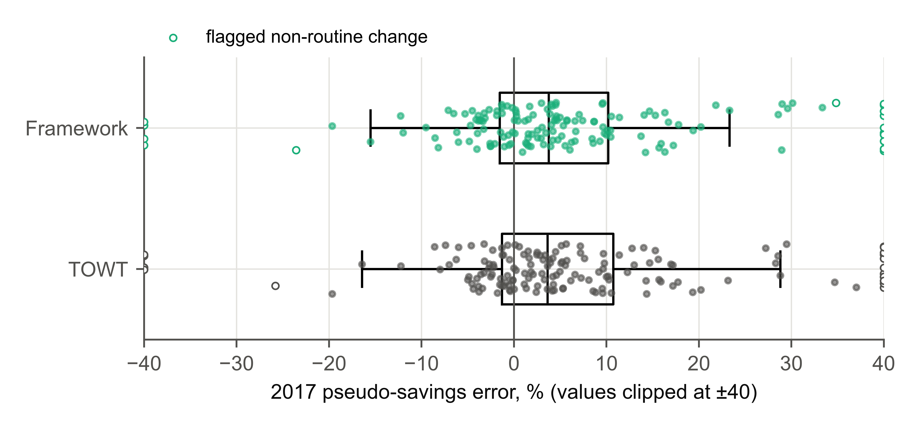
Fig. 4. Annual pseudo-savings error in 2017 of TOWT and of the framework’s model, both fitted on 2016, for 152 BDG2 buildings with no efficiency measure installed. Open markers: buildings flagged for a likely non-routine change; values beyond ±40% are drawn at the edge.
The evaluation protocol changed the M&V decision (Table 7, Fig. 5). Every estimate of the error of TOWT made from the 2016 data understated the error realized in 2017, the time-ordered split least (median ratio of estimated to realized CV(RMSE) 0.97). Shuffled cross-validation would have accepted 120 baselines as meeting the hourly limits, 32 of which then missed them in 2017; the time-ordered split would have accepted 88, of which 13 missed.
Table 7. Error of the TOWT baseline estimated from the 2016 data in four ways, against the error realized in 2017 (152 buildings).
Estimate of baseline-model error (2016) | Estimated / realized 2017 CV(RMSE), median (IQR) | Estimate meets limits | …but 2017 does not
In-sample fit | 0.81 (0.65–0.99) | 121/152 | 33
Shuffled CV | 0.83 (0.66–1.01) | 120/152 | 32
Blocked CV | 0.91 (0.73–1.10) | 114/152 | 28
Time-ordered split | 0.97 (0.74–1.32) | 88/152 | 13
Note: “Estimate meets limits”: hourly CV(RMSE) ≤ 30% and |NMBE| ≤ 10% as estimated from 2016; “…but 2017 does not”: of those, the buildings whose 2017 values miss the limits.
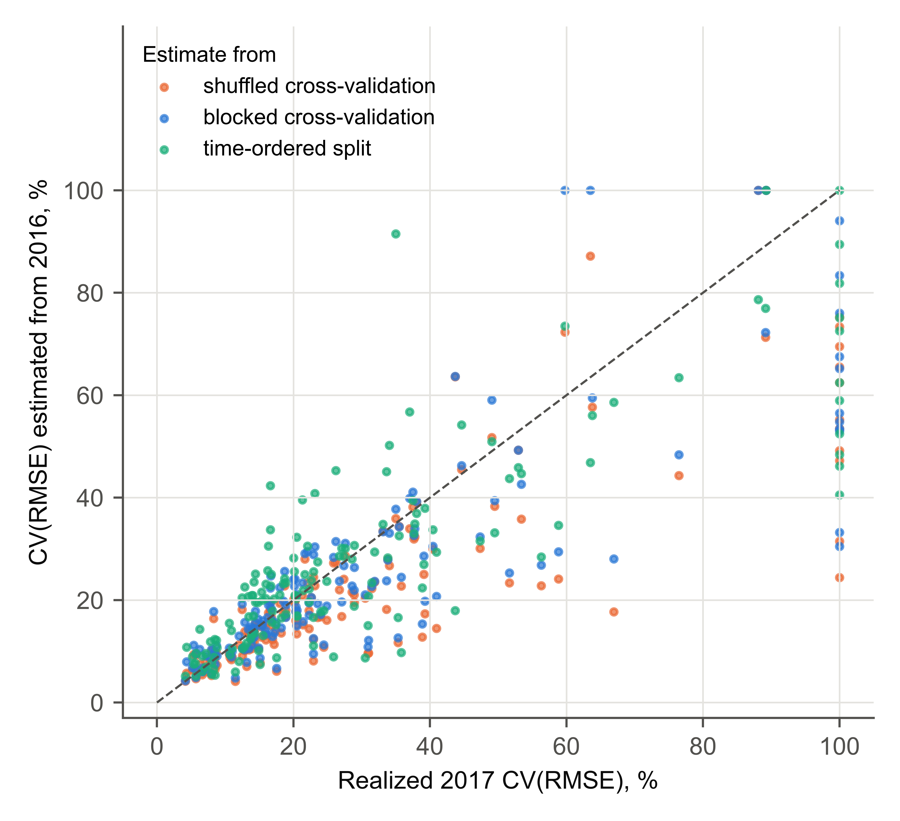
Fig. 5. Hourly CV(RMSE) of the TOWT baseline estimated from the 2016 data by shuffled and blocked five-fold cross-validation and by the time-ordered split, against the CV(RMSE) realized in 2017, for 152 BDG2 buildings. Points below the diagonal understate the error; values above 100% are drawn at the edge.

Evaluation protocol (RQ3)
Table 8 and Fig. 6 compare the protocols on 62 tasks: 16 from ROBOD, 6 from Aalborg and 40 BDG2 buildings. On the same rows, forward chaining gave a higher RMSE than shuffled cross-validation in every task, with a median ratio of 1.69 (95% interval 1.53–1.78; 1.75 for BDG2), so the random split of the preliminary study understated the error of a model used forward in time by a median of 41% (range 6–92%). Blocked cross-validation, which still trains on data after each test block, gave a median ratio of 1.42, and the median R² fell from 0.92 with shuffling to 0.77 with blocking. The ratio was largest where neighboring rows are near-duplicates, as at the Gator buildings whose hourly readings are daily totals (3.8–5.5), and at a building whose consumption changed level (12.2). Feature selection on all rows, the other step of the earlier recipe, added no measurable optimism: it gave the same RMSE as selection inside each fold (ratios 0.995–1.003), so the random split did all the damage.
Table 8. The same random forest, inputs and rows evaluated with shuffled, blocked and forward-chaining cross-validation.
Dataset | Tasks | Blocked / shuffled, median (95% CI or range) | Forward chaining / shuffled (same rows), median (95% CI or range) | Tasks with forward > shuffled | Selection on all rows / in-fold selection, median
ROBOD | 16 | 1.27 (range 1.02–2.46) | 1.71 (range 1.06–2.79) | 16/16 | 1.00
Aalborg | 6 | 1.43 (range 1.38–1.94) | 1.52 (range 1.43–3.05) | 6/6 | 1.00
BDG2 | 40 | 1.55 (1.35–1.75) | 1.75 (1.62–1.94) | 40/40 | 1.00
All | 62 | 1.42 (1.35–1.64) | 1.69 (1.53–1.78) | 62/62 | 1.00
Note: Ratios of RMSE, per task. Intervals: cluster bootstrap over rooms, systems and buildings, given only where there are at least five clusters; otherwise the range. Forward chaining and shuffled cross-validation are compared on the rows of blocked folds 2–5.
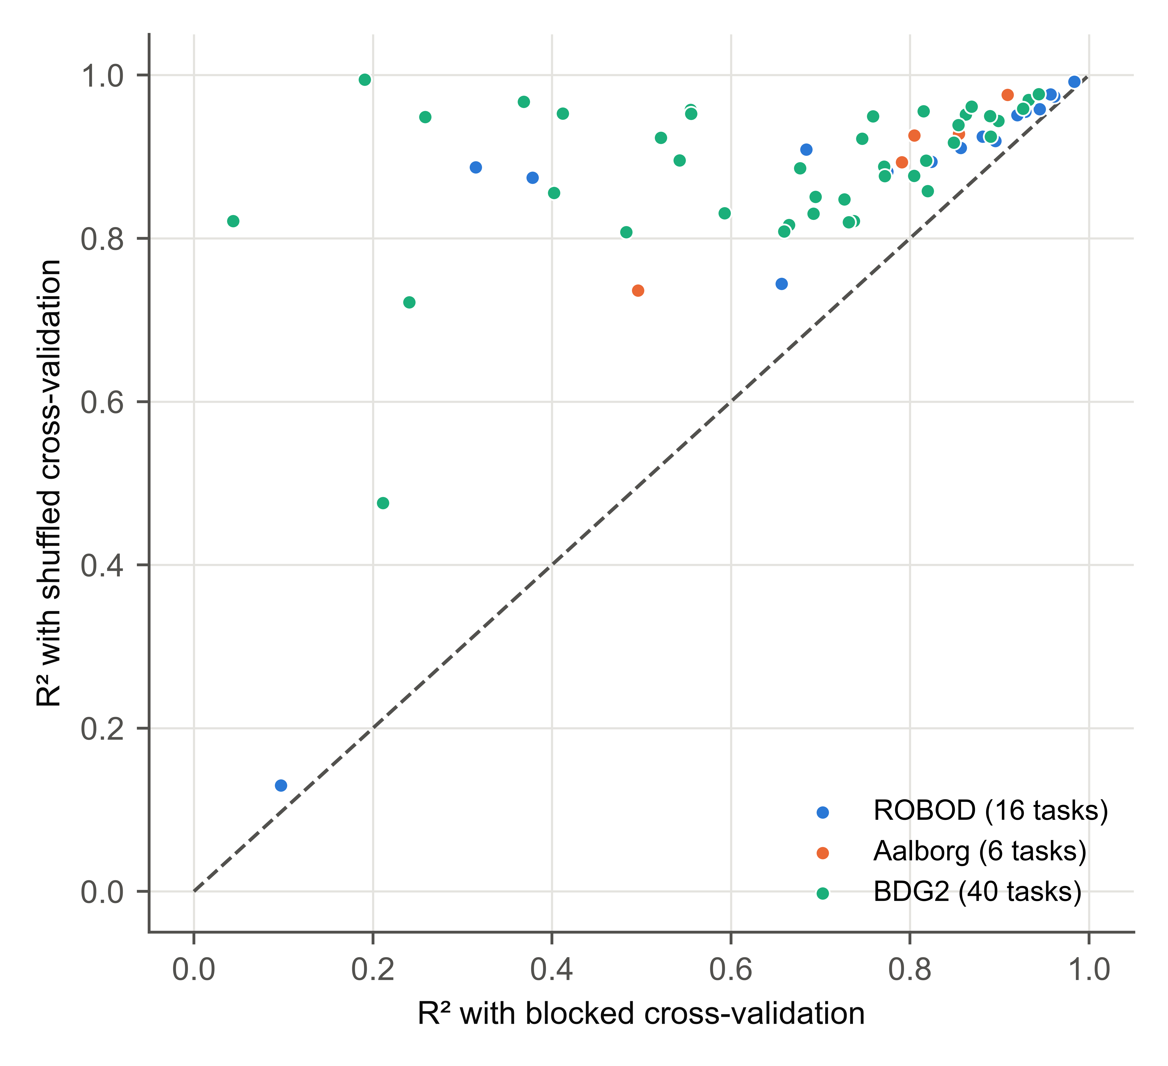
Fig. 6. Coefficient of determination of the same model on the same rows with shuffled and with blocked cross-validation, for 62 tasks. Every point lies above the diagonal: shuffling made every model look better than it is.
For the 40 BDG2 buildings, the protocol also changed verdicts. On the same rows, the median hourly CV(RMSE) was 8.7% with shuffling, 13.8% with blocked cross-validation and 15.9% with forward chaining, and shuffled cross-validation would have placed 37 models within the hourly Guideline 14 limits, 8 of which forward chaining did not confirm (Supplementary Table S14). With the M&V result of Section 5.2, this shows that the protocol changes decisions, not only error estimates.

Retraining over a year of operation and the gate audit (RQ4)
For 50 BDG2 buildings at 12 sites, retraining every month on all earlier data gave the lowest error over 2017 in most buildings (Table 9, Fig. 7). Relative to it, the median building’s mean monthly RMSE was 6.5% higher for the static model (95% interval 4.2–11.1%; higher in 37 of 50 buildings), 1.8% higher for quarterly retraining and 28% higher for persistence, which nevertheless beat the monthly retrained model in 10 buildings. The pooled RMSE over 2017 ranked the policies in nearly the same order.
Table 9. Mean monthly RMSE of each retraining policy relative to monthly retraining, over 2017 for 50 BDG2 buildings.
Policy | Mean monthly RMSE vs monthly retraining, median (95% CI) | Buildings worse than monthly | Retrains advised (promoted), median | Pooled RMSE vs monthly, median
Static | +6.5% (+4.2 to +11.1) | 37/50 | – | +8.0%
Quarterly | +1.8% (+0.5 to +3.0) | 35/50 | – | +1.3%
Drift 1.1 | +1.1% (+0.0 to +2.3) | 31/50 | 2 (2) | +1.3%
Drift 1.25 | +2.0% (+1.4 to +6.4) | 34/50 | 1 (1) | +3.1%
Drift 1.5 | +4.8% (+1.7 to +7.1) | 35/50 | 0 (0) | +4.6%
Drift 2.0 | +5.9% (+3.0 to +8.8) | 35/50 | 0 (0) | +5.6%
Gated 1.5 | +4.8% (+1.8 to +7.1) | 36/50 | 0 (0) | +4.6%
Gated + fallback | +2.1% (−0.3 to +5.5) | 30/50 | – | +3.2%
Persistence | +28.3% (+12.0 to +50.4) | 40/50 | – | +26.6%
Note: Intervals from a bootstrap over buildings. “Retrains advised (promoted)”: median per building; for the gated policy, a retrain is promoted only if the challenger passes the gates and beats the champion on rows neither has seen.
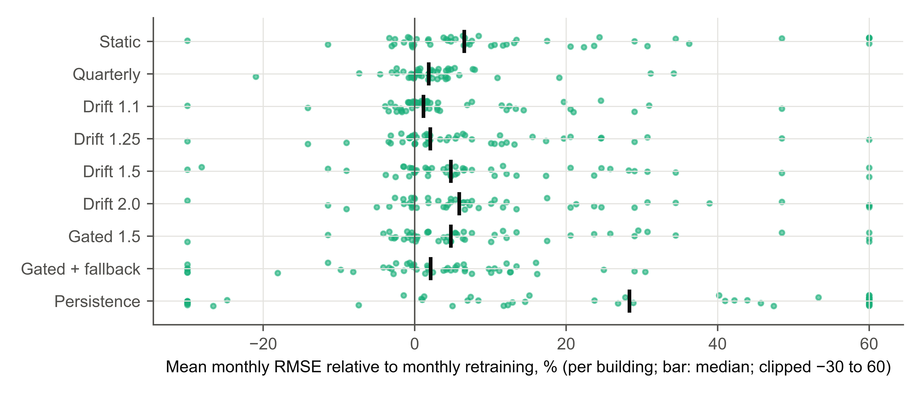
Fig. 7. Mean monthly RMSE of each retraining policy relative to monthly retraining, per building (50 BDG2 buildings, 2017). Bars mark the median; values outside −30% to 60% are drawn at the edge.
Drift-triggered retraining was only as good as its tolerance. At the default of 1.5, the error-ratio and input-range triggers advised 48 retrains in 50 building-years (a median of none per building), and the median building’s error was 4.8% higher than with monthly retraining. Lowering the tolerance to 1.25 and 1.1 raised the retrains to 84 and 126 and brought the error to within 2.0% and 1.1% of monthly retraining. Gated retraining at 1.5 advised 76 retrains and promoted 18, with the same error as ungated retraining at 1.5. Serving persistence in the month after the model lost to it reduced the gap to 2.1%.
The gate audit tested whether the gates’ decisions were borne out over the following three months (Table 10). Of the models the gates promoted, 86% realized a skill of at least 0.05 against their own reference and 8% were worse than it; of those they refused, all for a test skill below 0.05, 54% then realized a skill of at least 0.05. Test and realized skill were moderately correlated (Spearman’s ρ = 0.54). The gates were thus reliable when they promoted and conservative when they refused, the price of a threshold applied to one test window.
Table 10. Gate audit: the gate decision of each monthly machine-learning model against its realized skill over the following three months (496 models, 50 BDG2 buildings).
Realized-skill threshold | Promoted, realized ≥ threshold | Promoted, realized < 0 | Refused, realized ≥ threshold
0.00 | 364/397 | 33/397 | 66/99
0.05 | 340/397 | 33/397 | 53/99
0.10 | 306/397 | 33/397 | 41/99
Note: Of the 600 monthly models, 96 were baselines kept on validation and 8 machine-learning models could not be scored on the following three months; both are excluded.
The Aalborg case was repeated on the frozen version, whose drift check also compares the model with persistence (Supplementary Tables S8–S10). For district heating, the check recommended retraining in July because the model had lost to persistence, although its error ratio (1.42) was below the tolerance; the gated model’s mean monthly RMSE was 1.38 kW, 40% below the static model (2.28 kW) and below persistence (1.56 kW), which it beat in six of eight months. In the earlier version, without that comparison, the gated model had lost to persistence in five of the eight months. Monthly retraining reached 1.41 kW. For Room A CO₂, the gated model averaged 33.1 ppm, 12% below the static model (37.4 ppm) and below persistence (36.1 ppm), and monthly retraining reached 32.3 ppm.

Data faults (RQ5)
Six of the eight planted fault types were detected in every seed, the unit change always as a blocking error, spikes in 9 seeds of 10, and the three-day stuck ventilation meter in 5 (Table 11): when its frozen value lies at the meter’s night-time floor, a stuck meter looks like equipment that is switched off. These rates are optimistic, because several detectors were revised on this dataset.
Table 11. Detection of planted faults in the Aalborg Room A data over ten seeds. A fault counts as detected when the check reports a new issue of that type on that column.
Planted fault | Detected as | Detection rate
unit change mid-series (degC to degF) | out_of_range:RoomA:Sensor__room_temperature | 100%
stuck sensor (3 days) | stuck:Ventilation:EL_meter__power | 50%
10 single-sample spikes | spikes:Outdoor:Temperature_air | 90%
20 placeholder values (-999) | sentinel:RoomA:Sensor__CO2 | 100%
20 ‘OFFLINE’ text entries | non_numeric:Outdoor:Wind__velocity | 100%
12-hour outage | index:gaps | 100%
one day of rows exported twice | index:duplicates | 100%
30 rows out of order | index:unsorted | 100%

Table 12 compares the same random forest prepared in six ways. On faulty data, the framework, after the unit fix had resolved its one blocking error, had a lower mean absolute error (MAE) than the quick script, with or without the same unit fix (median paired difference 1.9 ppm; Wilcoxon p = 0.01). The RMSE did not differ, but it varied between seeds about five times more for the quick script. The competent script matched the framework in MAE (p = 0.56) and was 0.5 ppm better in RMSE (p = 0.004). On clean data, too, the quick script had a lower RMSE than the framework’s preparation (33.8 against 34.8 ppm). The framework masks whatever its checks flag, and in this record they flagged hundreds of CO₂ readings, such as 702 ppm, as single-sample spikes that are plausibly real rises when people enter, so some of this cost is likely due to false alarms. The framework’s default handling thus reproduced a competent script and avoided the larger, seed-dependent errors of a quick script, at a small cost in RMSE.
Table 12. The same random forest with the same inputs, forecasting CO₂ 1 h ahead and scored against the clean target over the same test period (mean ± standard deviation over ten seeds). Differences are paired by seed against the framework on faulty data (positive: framework better), with Wilcoxon signed-rank p-values.
Pipeline | RMSE (ppm) | MAE (ppm) | ΔMAE vs framework (p) | ΔRMSE vs framework (p)
Clean data, framework preparation | 34.8 ± 0.4 | 19.9 ± 0.3 | +0.20 (0.16) | +0.45 (0.05)
Clean data, quick script | 33.8 ± 0.3 | 19.6 ± 0.3 | – | –
Faulty data, quick script | 34.4 ± 1.3 | 21.6 ± 1.7 | +1.85 (0.010) | −0.03 (0.92)
Faulty data, quick script + unit fix | 34.5 ± 1.3 | 21.6 ± 1.8 | +1.64 (0.010) | +0.01 (1.00)
Faulty data, competent script + unit fix | 33.9 ± 0.4 | 19.7 ± 0.2 | −0.03 (0.56) | −0.53 (0.004)
Faulty data, framework (after unit fix) | 34.5 ± 0.3 | 19.8 ± 0.2 | – | –

On the untouched data, the checks raised 120 distinct warnings on the BDG2 meters and weather stations, 41 on ROBOD and 21 on Aalborg, mostly stuck stretches and spikes (Supplementary Table S11); some were real faults, such as the daily-total meters, and some were not, such as the CO₂ spikes above.

Discussion

When machine learning is worth deploying for building energy
Day ahead, routinely configured models beat references that include TOWT and the value a week earlier in two-thirds of the 200 buildings, with a median skill of 0.16. The improvement is useful but not universal: across all tasks the framework kept the simple rule in 87 of 272, which for an operator of many buildings saves maintenance and keeps the fallback obvious. The exploratory peak analysis suggests that where the models win, they also win on the size of each day’s peak, which matters for demand response.
For annual savings the picture is different. As M&V baselines, the machine-learning candidates matched TOWT but did not beat it, and the framework itself chose TOWT or a profile in two-thirds of the buildings. Over a year, the weekly schedule and the temperature response carry most of what a model can know about consumption without information on operation, and TOWT captures both with few parameters. This supports keeping TOWT as the M&V reference [3] and spending modeling effort where the time scale is short and recent history is informative. The hourly Guideline 14 limits, in turn, discriminated little between forecasts and their references (159 models and 150 references met them), so they mostly separate predictable meters from difficult ones. As a gate they are more useful for M&V baselines, where an error estimate decides whether a baseline is accepted.

Evaluation protocol and the decisions it drives
A random split understated the error of every model, by a median of 41% against forward chaining on the same rows, and it changed decisions: shuffled cross-validation accepted 32 M&V baselines that then missed the hourly limits in the reporting year, and placed 8 more day-ahead models within them than forward chaining confirmed. That random splits mislead on dependent data is known [48,49,51]; what these results add is the size of the effect on building operational data and its consequence for M&V, where a baseline accepted on an optimistic error estimate turns model error into reported savings. Even a time-ordered split within the baseline year understated the reporting-year error and accepted 13 baselines that then failed, so M&V error estimates should come from time-ordered validation and be read as lower bounds. For model predictive control and demand response, an error understated by 40% would make constraint margins and flexibility offers too tight; the framework offers no random split, which is the simplest way to remove that risk.

Lessons for the model lifecycle
Monthly retraining was the best policy, and drift-triggered retraining approached it only with a tolerance well below the default. This agrees with Li et al. [44], who found at large scale that building energy models updated with new data outperform static ones. Drift detectors have been compared across HVAC devices [45]; here, a trigger based on the ratio of recent to test-time error depended on a test-time error measured on a short window, so slow changes rarely crossed a fixed tolerance. Where a monthly refit costs seconds, a schedule is the safer default, with the drift check as a second line of defense. Persistence beat the monthly retrained model in 10 of 50 buildings, so monitoring should score the baseline alongside the model; in the Aalborg district-heating case, with that comparison added, the gated model was retrained in July and beat persistence in six of eight months, where the earlier version had lost to it in five.
In the gate audit, a promoted model beat its reference over the following three months in 92% of cases, whereas refusals were often too cautious; a gate that reads one test window cannot be better than that window. Where false refusals cost more than false promotions, the threshold can be lowered or the backtest added to the evidence. The value of the gates when a fault would otherwise be trained into production was not tested.

What the data checks caught and missed
On BDG2, which its authors had already cleaned, the checks found that the meters of a whole site held daily totals, which makes an hourly forecast meaningless. They missed months of zero readings at another site, and on ROBOD they missed dead chilled-water meters that independent agent instances found. Both misses have one cause: zero is a valid reading for a meter whose equipment is idle, so a single-column check cannot tell a dead meter from an idle one. Zero readings also mattered in the ASHRAE Great Energy Predictor III competition on the same dataset [14]. The needed checks use what the declarations already say: a whole-building meter should not idle for a week, and a chilled-water meter should not read zero while its AHU runs with the valve open. Declaring the scope of a meter and checking related points against each other are the natural next guardrails.
The checks directed judgment rather than replacing it: a CO₂ sensor floor, change-of-value logging and gaps in camera counts each raised a warning that the agent settled with evidence now in the record. Conversely, the right response to the daily-total meters, forecasting daily rather than hourly consumption, is a judgment that the single configuration used for all 200 buildings did not make.

Design rationale and hypotheses
Three reasons for the design were not measured and are stated as hypotheses. Rigorous defaults should matter most for less careful users, because they apply whoever writes the surrounding code; in the formative usability study, capable agents told to be rigorous built models of similar accuracy with or without the framework. Comparable records should reduce the cost of review: the eight agents of that study produced eight evaluation designs. And an agent-facing design should lower the cost of applying the same checks to many buildings. Testing the first needs a multi-run benchmark with primed and unprimed prompts, agents of several providers and an auditor blind to the arm.

Threats to validity
Internal validity. The same agent built the framework and ran the case studies, and its transcripts were not archived. Detectors were revised on ROBOD and Aalborg data, so the checks and fault-detection rates are partly in-sample there; BDG2 is not strictly held out, because 20 of its buildings were analyzed earlier. The unit fix in the fault experiment was coded by the author, who knew what had been planted, and was given to every script arm. The TOWT reference is the framework’s own implementation with the CalTRACK knots, without the separate occupied and unoccupied temperature terms of the original and not the OpenDSM implementation; a full implementation might be more accurate, which would strengthen the finding that the machine-learning models did not beat it in M&V.
Construct validity. Skill is defined on RMSE, and the promotion threshold depends on that choice. Fault detection is counted per column and type, not per located sample. The M&V test assumes that no efficiency measure was installed in 2017, which the dataset does not document, and the Guideline 14 limits are used as a familiar threshold, not as a claim of compliance.
Statistical conclusion validity. Each task of E1 was scored on one test window, which covered only 3–8 weekdays for ROBOD; the DM tests, bootstrap intervals and backtest address this only in part. The lifecycle experiment covers one year in 50 buildings from one start month, and the Aalborg case one trajectory for each of two tasks.
External validity. The datasets are public and partly curated, whereas commercial BAS exports are messier; even so, the BDG2 sample contained two site-wide meter faults. The room-level records are short, and no weather forecasts were available. The models and searches were deliberately ordinary; stronger models, including deep and foundation models [12], might beat the baselines more often.

Conclusions
This study divided the work of building data-driven energy models between an agent, which supplies building-specific judgment through declarations of physical quantities, and a domain package, which applies the same checks to every model, from physical plausibility to gated promotion, monitoring and retraining. A pre-specified evaluation on public data of 200 BDG2 buildings and 72 room and system tasks answers the research questions as follows.
- RQ1: Day ahead, routinely configured models beat references that include TOWT significantly in 66% of the buildings (median skill 0.16) and in 62.5% of all tasks; elsewhere the framework kept the simple rule.
- RQ2: As M&V baselines over a reporting year, the models matched TOWT but did not beat it (median absolute annual savings error 5.3% against 5.2%).
- RQ3: On the same rows, shuffled cross-validation understated the error of forward chaining in all 62 tasks, by a median of 41%, and changed verdicts: in M&V it accepted 32 baselines that failed in the reporting year, against 13 for a time-ordered split.
- RQ4: Over a year in 50 buildings, monthly retraining gave the lowest error, and drift-triggered retraining at the default tolerance was 4.8% worse in the median building. Of the models the gates promoted, 86% realized a skill of at least 0.05 over the next three months, but about half of those they refused would also have reached it.
- RQ5: The checks detected six of eight planted fault types in every seed and found a site of daily-total meters in cleaned BDG2 data, but missed months of zero readings. Their default handling matched a competent hand-written script in mean absolute error and beat a quick script by 1.9 ppm, at a cost of about 1 ppm in RMSE on clean data.
For practice: estimate a building model’s error in time order, because that estimate decides M&V verdicts; compare every model with the strongest simple rule, including TOWT, and keep the rule where the model does not beat it; retrain on a schedule and monitor the baseline alongside the model; and check meters against what they measure, not only against their own history. The framework makes these the default for whoever builds the model, a design hypothesis that this study did not test with independent users. Future work should test it in a multi-run benchmark with primed and unprimed agents, add checks for dead meters and across related sensors, make prediction intervals adaptive, take declarations from Brick models, and deploy the framework in operating buildings.

CRediT authorship contribution statement
Liang Zhang: Conceptualization, Methodology, Software, Validation, Formal analysis, Investigation, Data curation, Visualization, Writing – original draft, Writing – review & editing, Supervision, Project administration. [Author to confirm, and to add any co-authors and their roles.]

Declaration of competing interest
The author declares no known competing financial interests or personal relationships that could have appeared to influence the work reported in this paper. [Author to confirm.]

Data availability
All code (the bemlops package, version 0.3.1), the pre-specified analysis plan, configurations, case-study scripts, result tables, the run record behind every reported number, and the prompts and deliverables of the usability study are available at https://github.com/TensorBuildLab/MLOps-building-energy-and-environment-prediction under the BSD 3-Clause license. The datasets are public: BDG2 [57] (CC BY-SA 4.0; the files are taken from the project repository’s master branch, which includes corrections made after the archived version 1.0), ROBOD [59] (CC BY 4.0) and the Aalborg office data [61] (CC BY 4.0); a script in the repository downloads them and verifies their checksums. Test predictions and saved models are not published because they contain the measured data; the case-study scripts regenerate them. [Author to add the DOI of the archived release (for example on Zenodo) before submission.]

Declaration of generative AI and AI-assisted technologies in the manuscript preparation process
During the preparation of this work the author used Claude Opus 5.5 (Anthropic) in Claude Code in order to draft and revise the text of the manuscript and to check the references against bibliographic databases. After using this tool, the author reviewed and edited the content as needed and takes full responsibility for the content of the published article. The use of LLM agents in the research itself, to write the software, to run the case studies and as the subjects of the usability study, is described in Section 4 and the Supplementary Material. [Author to confirm this statement against the final writing process.]

Acknowledgements
[Funding sources and acknowledgements to be completed by the author. If there was no specific funding: “This research did not receive any specific grant from funding agencies in the public, commercial, or not-for-profit sectors.”]

References
[1] IEA, Tracking Clean Energy Progress 2023, International Energy Agency, Paris, 2023. https://www.iea.org/reports/tracking-clean-energy-progress-2023.
[2] J. Drgoňa, J. Arroyo, I. Cupeiro Figueroa, D. Blum, K. Arendt, D. Kim, E.P. Ollé, J. Oravec, M. Wetter, D.L. Vrabie, L. Helsen, All you need to know about model predictive control for buildings, Annu Rev Control 50 (2020) 190–232. https://doi.org/10.1016/j.arcontrol.2020.09.001.
[3] J. Granderson, S. Touzani, C. Custodio, M.D. Sohn, D. Jump, S. Fernandes, Accuracy of automated measurement and verification (M&V) techniques for energy savings in commercial buildings, Appl Energy 173 (2016) 296–308. https://doi.org/10.1016/j.apenergy.2016.04.049.
[4] K. Amasyali, N. El-Gohary, A review of data-driven building energy consumption prediction studies, Renew Sustain Energy Rev 81 (2018) 1192–1205. https://doi.org/10.1016/j.rser.2017.04.095.
[5] C. Zhang, J. Lu, Y. Zhao, Generative pre-trained transformers (GPT)-based automated data mining for building energy management: Advantages, limitations and the future, Energy Built Environ 5 (2024) 143–169. https://doi.org/10.1016/j.enbenv.2023.06.005.
[6] S. Khadka, L. Zhang, Scaling data-driven building energy modelling using large language models, in: 2024 ASHRAE Annual Conference, Indianapolis, IN, paper IN-24-C-009, 2024. https://doi.org/10.63044/s24kha09.
[7] J.L. Mathieu, P.N. Price, S. Kiliccote, M.A. Piette, Quantifying Changes in Building Electricity Use, With Application to Demand Response, IEEE Trans Smart Grid 2 (2011) 507–518. https://doi.org/10.1109/tsg.2011.2145010.
[8] E. Maddalena, Y. Lian, C. Jones, Data-driven methods for building control — A review and promising future directions, Control Eng Pract 95 (2020) 104211. https://doi.org/10.1016/j.conengprac.2019.104211.
[9] L. Candanedo, V. Feldheim, Accurate occupancy detection of an office room from light, temperature, humidity and CO2 measurements using statistical learning models, Energy Build 112 (2016) 28–39. https://doi.org/10.1016/j.enbuild.2015.11.071.
[10] J. Kallio, J. Tervonen, P. Räsänen, R. Mäkynen, J. Koivusaari, J. Peltola, Forecasting office indoor CO2 concentration using machine learning with a one-year dataset, Build Environ 187 (2021) 107409. https://doi.org/10.1016/j.buildenv.2020.107409.
[11] T. Hong, P. Pinson, Y. Wang, R. Weron, D. Yang, H. Zareipour, Energy Forecasting: A Review and Outlook, IEEE Open Access J Power Energy 7 (2020) 376–388. https://doi.org/10.1109/oajpe.2020.3029979.
[12] P. Emami, A. Sahu, P. Graf, BuildingsBench: A large-scale dataset of 900K buildings and benchmark for short-term load forecasting, in: Advances in Neural Information Processing Systems 36, Datasets and Benchmarks Track, 2023, pp. 19823–19857. https://doi.org/10.52202/075280-0871.
[13] C. Miller, A. Kathirgamanathan, B. Picchetti, P. Arjunan, J. Park, Z. Nagy, P. Raftery, B. Hobson, Z. Shi, F. Meggers, The Building Data Genome Project 2, energy meter data from the ASHRAE Great Energy Predictor III competition, Sci Data 7 (2020) 368. https://doi.org/10.1038/s41597-020-00712-x.
[14] C. Miller, P. Arjunan, A. Kathirgamanathan, C. Fu, J. Roth, J.Y. Park, C. Balbach, K. Gowri, Z. Nagy, A.D. Fontanini, J. Haberl, The ASHRAE Great Energy Predictor III competition: Overview and results, Sci Technol Built Environ 26 (2020) 1427–1447. https://doi.org/10.1080/23744731.2020.1795514.
[15] C. Fan, M. Chen, X. Wang, J. Wang, B. Huang, A review on data preprocessing techniques toward efficient and reliable knowledge discovery from building operational data, Front Energy Res 9 (2021) 652801. https://doi.org/10.3389/fenrg.2021.652801.
[16] W. Kim, S. Katipamula, A review of fault detection and diagnostics methods for building systems, Sci Technol Built Environ 24 (2018) 3–21. https://doi.org/10.1080/23744731.2017.1318008.
[17] J. Granderson, G. Lin, Y. Chen, A. Casillas, J. Wen, Z. Chen, P. Im, S. Huang, J. Ling, A labeled dataset for building HVAC systems operating in faulted and fault-free states, Sci Data 10 (2023) 342. https://doi.org/10.1038/s41597-023-02197-w.
[18] OpenDSM contributors, OpenDSM eemeter: open-source implementation of the CalTRACK methods for measuring energy savings, 2026. https://github.com/opendsm/eemeter (accessed 7 November 2026).
[19] Lawrence Berkeley National Laboratory, RMV2.0: an open-source tool for M&V 2.0 baseline modeling and savings estimation, 2026. https://github.com/LBNL-ETA/RMV2.0 (accessed 7 November 2026).
[20] T.A. Reddy, D.E. Claridge, Uncertainty of “Measured” Energy Savings from Statistical Baseline Models, HVAC&R Res 6 (2000) 3–20. https://doi.org/10.1080/10789669.2000.10391247.
[21] ASHRAE, ASHRAE Guideline 14-2014: Measurement of Energy, Demand, and Water Savings, ASHRAE, Atlanta, GA, 2014.
[22] C. Zhang, X. Tian, Y. Zhao, J. Lu, Automated machine learning-based building energy load prediction method, J Build Eng 80 (2023) 108071. https://doi.org/10.1016/j.jobe.2023.108071.
[23] C. Zhang, J. Lu, J. Huang, Y. Zhao, End-to-end data-driven modeling framework for automated and trustworthy short-term building energy load forecasting, Build Simul 17 (2024) 1419–1437. https://doi.org/10.1007/s12273-024-1149-y.
[24] C. Zhang, J. Zhang, Y. Zhao, J. Lu, Automated data-driven building energy load prediction method based on generative pre-trained transformers (GPT), Energy 318 (2025) 134824. https://doi.org/10.1016/j.energy.2025.134824.
[25] T. Xiao, P. Xu, Exploring automated energy optimization with unstructured building data: A multi-agent based framework leveraging large language models, Energy Build 322 (2024) 114691. https://doi.org/10.1016/j.enbuild.2024.114691.
[26] Z. Jiang, W. Xu, B. Dong, OptAgent: an Agentic AI framework for Intelligent Building Operations, arXiv preprint arXiv:2601.20005, 2026. https://doi.org/10.48550/arXiv.2601.20005.
[27] Q. Huang, J. Vora, P. Liang, J. Leskovec, MLAgentBench: Evaluating language agents on machine learning experimentation, in: Proceedings of the 41st International Conference on Machine Learning (ICML 2024), PMLR 235, 2024, pp. 20271–20309.
[28] J. Chan, N. Chowdhury, O. Jaffe, J. Aung, D. Sherburn, E. Mays, G. Starace, K. Liu, L. Maksin, T. Patwardhan, A. Madry, L. Weng, MLE-bench: Evaluating machine learning agents on machine learning engineering, in: International Conference on Learning Representations (ICLR 2025), 2025, pp. 50466–50494.
[29] S. Guo, C. Deng, Y. Wen, H. Chen, Y. Chang, J. Wang, DS-Agent: Automated data science by empowering large language models with case-based reasoning, in: Proceedings of the 41st International Conference on Machine Learning (ICML 2024), PMLR 235, 2024, pp. 16813–16848.
[30] D. Sculley, G. Holt, D. Golovin, E. Davydov, T. Phillips, D. Ebner, V. Chaudhary, M. Young, J.-F. Crespo, D. Dennison, Hidden technical debt in machine learning systems, in: Advances in Neural Information Processing Systems 28 (NIPS 2015), 2015, pp. 2503–2511.
[31] E. Breck, S. Cai, E. Nielsen, M. Salib, D. Sculley, The ML test score: A rubric for ML production readiness and technical debt reduction, in: 2017 IEEE International Conference on Big Data, 2017, pp. 1123–1132. https://doi.org/10.1109/BigData.2017.8258038.
[32] E. Breck, N. Polyzotis, S. Roy, S. Whang, M. Zinkevich, Data validation for machine learning, in: Proceedings of Machine Learning and Systems 1 (SysML 2019), 2019, pp. 334–347.
[33] M. Mitchell, S. Wu, A. Zaldivar, P. Barnes, L. Vasserman, B. Hutchinson, E. Spitzer, I. Raji, T. Gebru, Model cards for model reporting, in: Proceedings of the Conference on Fairness, Accountability, and Transparency (FAT* '19), 2019, pp. 220–229. https://doi.org/10.1145/3287560.3287596.
[34] D. Kreuzberger, N. Kühl, S. Hirschl, Machine Learning Operations (MLOps): Overview, definition, and architecture, IEEE Access 11 (2023) 31866–31879. https://doi.org/10.1109/ACCESS.2023.3262138.
[35] S. Schelter, D. Lange, P. Schmidt, M. Celikel, F. Biessmann, A. Grafberger, Automating large-scale data quality verification, Proc VLDB Endow 11 (2018) 1781–1794. https://doi.org/10.14778/3229863.3229867.
[36] A. Gong, J. Campbell, Great Expectations (software), 2026. (accessed 29 October 2026). https://doi.org/10.5281/zenodo.5683574.
[37] N. Bantilan, pandera: Statistical data validation of pandas dataframes, in: Proceedings of the 19th Python in Science Conference (SciPy 2020), 2020, pp. 116–124. https://doi.org/10.25080/Majora-342d178e-010.
[38] M. Zaharia, A. Chen, A. Davidson, A. Ghodsi, S. Hong, A. Konwinski, S. Murching, T. Nykodym, P. Ogilvie, M. Parkhe, F. Xie, C. Zumar, Accelerating the machine learning lifecycle with MLflow, IEEE Data Eng Bull 41 (2018) 39–45.
[39] R. Kuprieiev, DVC: Data Version Control (software), 2026. (accessed 29 October 2026). https://doi.org/10.5281/zenodo.3677553.
[40] Evidently AI, Evidently: open-source ML and LLM evaluation and observability framework (software, Apache-2.0), 2026. https://github.com/evidentlyai/evidently (accessed 29 October 2026).
[41] M. Löning, A. Bagnall, S. Ganesh, V. Kazakov, J. Lines, F. Király, sktime: A unified interface for machine learning with time series, arXiv preprint arXiv:1909.07872, 2019. https://doi.org/10.48550/arXiv.1909.07872.
[42] J. Herzen, F. Lässig, S. Piazzetta, T. Neuer, L. Tafti, G. Raille, T. Van Pottelbergh, M. Pasieka, A. Skrodzki, N. Huguenin, Darts: User-friendly modern machine learning for time series, J Mach Learn Res 23 (2022) 1–6.
[43] O. Shchur, A. Turkmen, N. Erickson, H. Shen, A. Shirkov, T. Hu, B. Wang, AutoGluon–TimeSeries: AutoML for probabilistic time series forecasting, in: Proceedings of the Second International Conference on Automated Machine Learning (AutoML 2023), PMLR 224, 9/1–21, 2023.
[44] A. Li, C. Zhang, F. Xiao, C. Fan, Y. Deng, D. Wang, Large-scale comparison and demonstration of continual learning for adaptive data-driven building energy prediction, Appl Energy 347 (2023) 121481. https://doi.org/10.1016/j.apenergy.2023.121481.
[45] K. Derzsi, F. Stinner, L. Patrun, J. Klingebiel, D. Müller, Performance-based drift detection for active machine learning model adaption: A comparative analysis across 35 HVAC devices, J Phys Conf Ser 3140 (2025) 022002. https://doi.org/10.1088/1742-6596/3140/2/022002.
[46] B. Heidrich, N. Ludwig, M. Turowski, R. Mikut, V. Hagenmeyer, Adaptively coping with concept drifts in energy time series forecasting using profiles, in: Proceedings of the Thirteenth ACM International Conference on Future Energy Systems, 2022, pp. 459–470. https://doi.org/10.1145/3538637.3539759.
[47] L.J. Tashman, Out-of-sample tests of forecasting accuracy: an analysis and review, Int J Forecast 16 (2000) 437–450. https://doi.org/10.1016/s0169-2070(00)00065-0.
[48] D.R. Roberts, V. Bahn, S. Ciuti, M.S. Boyce, J. Elith, G. Guillera‐Arroita, S. Hauenstein, J.J. Lahoz‐Monfort, B. Schröder, W. Thuiller, D.I. Warton, B.A. Wintle, F. Hartig, C.F. Dormann, Cross‐validation strategies for data with temporal, spatial, hierarchical, or phylogenetic structure, Ecography 40 (2017) 913–929. https://doi.org/10.1111/ecog.02881.
[49] C. Bergmeir, J. Benítez, On the use of cross-validation for time series predictor evaluation, Inf Sci 191 (2012) 192–213. https://doi.org/10.1016/j.ins.2011.12.028.
[50] C. Bergmeir, R. Hyndman, B. Koo, A note on the validity of cross-validation for evaluating autoregressive time series prediction, Comput Stat Data Anal 120 (2018) 70–83. https://doi.org/10.1016/j.csda.2017.11.003.
[51] S. Kapoor, A. Narayanan, Leakage and the reproducibility crisis in machine-learning-based science, Patterns 4 (2023) 100804. https://doi.org/10.1016/j.patter.2023.100804.
[52] B. Balaji, A. Bhattacharya, G. Fierro, J. Gao, J. Gluck, D. Hong, A. Johansen, J. Koh, J. Ploennigs, Y. Agarwal, M. Berges, D. Culler, R. Gupta, M. Kjærgaard, M. Srivastava, K. Whitehouse, Brick: Towards a unified metadata schema for buildings, in: Proceedings of the 3rd ACM International Conference on Systems for Energy-Efficient Built Environments (BuildSys '16), 2016, pp. 41–50. https://doi.org/10.1145/2993422.2993577.
[53] G. Brier, Verification of forecasts expressed in terms of probability, Mon Weather Rev 78 (1950) 1–3. https://doi.org/10.1175/1520-0493(1950)078<0001:VOFEIT>2.0.CO;2.
[54] I. Gibbs, E. Candès, Adaptive conformal inference under distribution shift, in: Advances in Neural Information Processing Systems 34 (NeurIPS 2021), 2021.
[55] L. Breiman, Random Forests, Mach Learn 45 (2001) 5–32. https://doi.org/10.1023/a:1010933404324.
[56] B. Zhang, K. Lazuka, M. Murag, Equipping agents for the real world with Agent Skills, 2025. https://www.anthropic.com/engineering/equipping-agents-for-the-real-world-with-agent-skills (accessed 28 October 2026).
[57] C. Miller, A. Kathirgamanathan, B. Picchetti, P. Arjunan, J.Y. Park, Z. Nagy, P. Raftery, B.W. Hobson, Z. Shi, F. Meggers, buds-lab/building-data-genome-project-2 [dataset], Zenodo, version 1.0, 2020. https://doi.org/10.5281/zenodo.3887306.
[58] Z. Tekler, E. Ono, Y. Peng, S. Zhan, B. Lasternas, A. Chong, ROBOD, room-level occupancy and building operation dataset, Build Simul 15 (2022) 2127–2137. https://doi.org/10.1007/s12273-022-0925-9.
[59] Z.D. Tekler, E. Ono, Y. Peng, S. Zhan, B. Lasternas, A. Chong, ROBOD, Room-level Occupancy and Building Operation Dataset [dataset], figshare, 2022. https://doi.org/10.6084/m9.figshare.19234530.
[60] S. Melgaard, H. Johra, V. Nyborg, A. Marszal-Pomianowska, R. Jensen, C. Kantas, O. Larsen, Y. Hu, K. Frandsen, T. Larsen, K. Svidt, K. Andersen, D. Leiria, M. Schaffer, M. Frandsen, M. Veit, L. Ussing, S. Lindhard, M. Pomianowski, L. Rohde, A. Hansen, P. Heiselberg, Detailed operational building data for six office rooms in Denmark: Occupancy, indoor environment, heating, ventilation, lighting and room control monitoring with sub-hourly temporal resolution, Data Brief 54 (2024) 110326. https://doi.org/10.1016/j.dib.2024.110326.
[61] S.P. Melgaard, H. Johra, V.Ø. Nyborg, A. Marszal-Pomianowska, R.L. Jensen, C. Kantas, O.K. Larsen, Y. Hu, K.M. Frandsen, T.S. Larsen, K. Svidt, K.H. Andersen, D. Leiria, M. Schaffer, M. Frandsen, M. Veit, L.F. Ussing, S.M. Lindhard, M.Z. Pomianowski, L. Rohde, A.R. Hansen, P.K. Heiselberg, A Danish high-resolution dataset for six office rooms with occupancy, indoor environment, heating, ventilation, lighting and room control monitoring [dataset], Zenodo, version 3, 2024. https://doi.org/10.5281/zenodo.10673763.
[62] N. Luo, Z. Wang, D. Blum, C. Weyandt, N. Bourassa, M. Piette, T. Hong, A three-year dataset supporting research on building energy management and occupancy analytics, Sci Data 9 (2022) 156. https://doi.org/10.1038/s41597-022-01257-x.
[63] F. Diebold, R. Mariano, Comparing predictive accuracy, J Bus Econ Stat 13 (1995) 253–263. https://doi.org/10.1080/07350015.1995.10524599.
[64] W.K. Newey, K.D. West, Automatic Lag Selection in Covariance Matrix Estimation, Rev Econ Stud 61 (1994) 631–653. https://doi.org/10.2307/2297912.
[65] D. Harvey, S. Leybourne, P. Newbold, Testing the equality of prediction mean squared errors, Int J Forecast 13 (1997) 281–291. https://doi.org/10.1016/s0169-2070(96)00719-4.
[66] Y. Benjamini, Y. Hochberg, Controlling the False Discovery Rate: A Practical and Powerful Approach to Multiple Testing, J R Stat Soc Series B Stat Methodol 57 (1995) 289–300. https://doi.org/10.1111/j.2517-6161.1995.tb02031.x.

