Does domain semantics help large language models integrate open data for urban building energy modeling? The Meta-Urban schema, a verified open-data catalog, and a reproducible alignment benchmark

Highlights
- Meta-Urban 2.0: a LinkML schema for open UBEM data with SHACL and OWL versions
- Verified catalog of 91 open datasets coded on six independent facets
- Only 3 of 48 non-geometric building datasets can be linked to individual buildings
- Concept definitions, not labels, raise local LLM mapping accuracy by 12 to 17 points
- Ignoring survey weights shifts CBECS energy use intensity by -16% to +102%

Abstract
Urban building energy modeling (UBEM) draws on dozens of open datasets that describe the same buildings, places and periods with different variables, codes, units, granularities and statistical designs. We ask whether a domain schema makes their integration by large language models (LLMs) more reliable. Meta-Urban 2.0 is a schema with a dataset level (a DCAT 3 profile with six UBEM facets) and a variable level (concept, unit, code list, weights and imputation flags), with an 81-concept vocabulary. A catalog of 91 open datasets coded with it shows that only 3 of 48 datasets carrying characteristics, operation, energy or simulation data share an identifier with building footprints. On 2,048 variables of the CBECS 2018 and RECS 2020 codebooks, we benchmark two locally run 8-billion-parameter LLMs against double-annotated gold labels under four levels of schema context, five repeats each. Concept definitions raised top-1 mapping accuracy from 0.42-0.43 to 0.55-0.59, while concept labels alone helped little; restricting the context to ten retrieved candidates cut input tokens by 82% but lost accuracy where the retriever missed. Both models detected survey weights and imputation flags almost perfectly but could not link a flag to its variable when only a naming convention does so, and one model got a fifth of unit multipliers wrong. These errors matter: a correct pipeline reproduces EIA’s published totals within 0.01%, whereas ignoring survey weights biases energy intensity by -16% to +102% across building types. The schema, catalog, benchmark, code and all model outputs are open.
Keywords: urban building energy modeling; open data; metadata schema; FAIR; large language models; schema matching; building stock; CBECS

1. Introduction
Buildings and construction account for 32% of global energy use and 34% of energy-related CO2 emissions [1], and urban building energy modeling (UBEM) is the standard way to estimate how policies, technologies and climate change will affect a whole building stock [2–5]. Bottom-up, physics-based UBEM needs weather, the location and shape of every building, non-geometric characteristics such as use type, vintage and systems, assumptions on how buildings are operated, and measured energy use to calibrate and validate the result [6–8]. Almost every one of these inputs now has an open source.
The difficulty is not finding data. It is combining it. Weather comes as station records, reanalysis grids or typical years; footprints come as polygons from remote sensing, crowdsourcing or cadastres; building characteristics come as weighted sample surveys released at census-division level; measured energy comes as anonymized meters without location, or as utility totals by service territory. Each source codes its variables differently: the 2018 Commercial Buildings Energy Consumption Survey (CBECS) writes 1=New England, the 2020 Residential Energy Consumption Survey (RECS) writes 1 Mobile home, the first reports energy in thousand Btu and floor area in square feet, and both ship hundreds of imputation flags and replicate weights next to the data. Chen et al. [9] found that cities usually have enough public data for UBEM but that the data lack standard formats and common keys. Reviews since then have catalogued inputs and sources for people to read [7,10–13], and Malhotra et al. [8] found that most UBEM studies cannot be reproduced. Standards such as CityGML and its Energy ADE describe buildings and their energy systems [14–16], but not the datasets that feed them: their granularity, statistical design, license and the keys that link one to another.
Large language models (LLMs) are an obvious candidate to automate this integration, and the schema-matching literature now uses them routinely [17–20]. Two things are missing for UBEM. First, a target: an LLM can only align data to a schema that exists in machine-actionable form. Second, evidence: results on public benchmarks overestimate LLMs on real data [21], outputs vary from run to run [22], and in buildings, mapping real BACnet point names to Brick classes reaches only 27% to 36% accuracy [23]. Whether a domain schema actually helps, as opposed to any list of field names, has not been tested.
An earlier preprint of this work [24] proposed a taxonomy, a per-category table of metadata fields, and three single-session ChatGPT demonstrations. It did not test whether the schema helped, did not release the schema in machine-readable form, and on re-examination its demonstrations contained errors (Section 6.4). This paper replaces it. It asks four questions:
- RQ1. Which UBEM workflow steps are well served by open data, at which granularity, under which access terms, and with which keys that allow records to be linked to buildings?
- RQ2. Can a single schema describe these datasets and their variables well enough to answer practical modeling queries?
- RQ3. Does giving an LLM the schema’s semantics (definitions, units, hierarchy) improve alignment over identifiers alone, labels alone, and non-LLM baselines, and how consistent are the results?
- RQ4. How much do alignment and statistical-design errors change UBEM quantities?
The contributions are:
- Meta-Urban 2.0, a schema written in LinkML [25] and compiled to JSON Schema, SHACL and OWL, with a dataset level that profiles DCAT 3 [26] and a variable level with units (QUDT), code lists, aggregation semantics, weights and imputation flags, plus an 81-concept SKOS vocabulary (Section 3).
- A catalog of 91 open datasets coded with the schema and verified against publisher pages, and computed gap indicators, including a new linkage indicator (Section 4).
- An alignment benchmark with two tasks on 2,048 survey variables, blind double-annotated gold labels, four levels of schema context, and a protocol that follows current schema-matching practice, run with open-weight LLMs that a city or utility can operate on its own hardware (Section 5).
- A downstream analysis on CBECS 2018 that quantifies the effect of each class of alignment error on UBEM quantities (Section 6).
- An open repository from which every number and figure in this paper is regenerated (https://github.com/TensorBuildLab/UBEM-schema).

2. Related work

2.1 Open data for UBEM
UBEM reviews agree that data are the main bottleneck [2,4,27–29]. Goy et al. [10] related data availability to the choice of UBEM approach. Chen et al. [9] built a standardized city buildings dataset from heterogeneous city data. Wang et al. [7] classified UBEM inputs into geometric, non-geometric, weather and calibration data and assessed their availability and cost. Jin et al. [11] reviewed more than 190 open city-level building energy datasets. Bishop et al. [12] organized multi-domain urban energy data into seven domains with formats and sources. Anselmo et al. [13] reviewed the integration of GIS and remote sensing in UBEM. On the GIS side, open footprints and heights now cover most of the world [30–34], with known completeness gaps in crowdsourced data [35], and data quality measurably changes UBEM results [36].
Gap. These works are inventories and categorizations for human readers. None releases a machine-actionable profile per dataset, none separates the dimensions along which datasets differ, and none measures whether datasets can be linked to individual buildings.

2.2 Semantic models for buildings and cities
At building scale, Brick, Haystack, RealEstateCore, BOT, SAREF4BLDG, BuildingSync, BEDES and the proposed ASHRAE 223P standardize equipment, points and building descriptions [37–44]; Pritoni et al. [45] compared them. At city scale, CityGML 3.0 and the Energy ADE model buildings, their thermal zones and energy systems [15,16,46], and urban energy ontologies support specific workflows [47–50]. Dataset-level metadata is the domain of DCAT, schema.org and the FAIR principles [26,51,52].
Gap. Building and city models describe objects, not datasets. Generic dataset vocabularies have no notion of a UBEM workflow role, a survey weight, a top-code or a join key. Meta-Urban sits between them and maps to both rather than replacing either.

2.3 LLMs for schema matching and data integration
Schema matching has a long history [53–55] and a standard benchmark suite [56]. LLMs entered with Narayan et al. [17], and the current design is retrieve-then-rerank: a retriever proposes candidate targets and an LLM chooses [18,19,57]. Studies report that both too little and too much context hurt [20,58], that outputs are inconsistent across runs [22], and that confidence estimates need calibration [59,60]. In buildings, language models have been used for schema matching of energy data [61], LLM-generated SQL for data transformation [62,63], Brick metadata [23,64–66] and UBEM itself [67].
Gap. No benchmark exists for aligning open UBEM data, and no study has ablated the semantic content of the target schema to test whether it, rather than the LLM, drives accuracy.
Table 1 places this paper among the closest prior work.
Table 1. Closest prior work and what this paper adds. Y: yes; P: partly; -: no.
Work | Dataset inventory | Facets separated | Machine-actionable profile | Variable-level semantics | Linkage indicator | LLM benchmark with gold
Goy et al. 2020 [10] | P | - | - | - | - | -
Wang et al. 2022 [7] | P | - | - | - | - | -
Malhotra et al. 2022 [8] | - | P | - | - | - | -
Jin et al. 2023 [11] | Y | - | - | - | - | -
Bishop et al. 2024 [12] | Y | P | - | - | - | -
CityGML Energy ADE [16] | - | - | Y (objects) | Y (objects) | - | -
Zhang et al. 2023 preprint [24] | P | - | - | P | - | - (3 demos)
This paper | Y (91, verified) | Y (6) | Y (LinkML) | Y | Y | Y

3. The Meta-Urban 2.0 schema

3.1 Design requirements
We derived six requirements from the UBEM workflow and from the failures of the 2023 version. R1: say which workflow step a dataset can feed. R2: say how fine its locations and time steps are, separately. R3: say how it was produced, because a weighted survey, a remote-sensing product and a simulation must be handled differently. R4: say how it can be joined to other data. R5: at variable level, say what each column means, in which unit, with which codes, and whether it is data, a weight or a flag. R6: be machine-validated and reuse existing standards.

3.2 A faceted taxonomy
The 2023 taxonomy listed seven categories that mixed three different things: content (weather, geometry), spatial scale (“macroscopic” vs. “microscopic” energy data) and distribution channel (“data lake”). A dataset such as the Building Data Genome Project fell into two categories at once. Meta-Urban 2.0 replaces the list with six independent facets (Table 2), so that a dataset is a point in a six-dimensional space and gaps can be counted along each.
Table 2. Facets of the Meta-Urban taxonomy (controlled values in schema/meta_urban.yaml).
Facet | Values
UBEM workflow role | boundary conditions; geometry and inventory; building characteristics; operation and use; calibration and validation; reference simulation; context and coupling
Statistical nature | census; weighted sample survey; administrative record; measured monitoring; remote-sensing derived; crowdsourced; reanalysis; typical year; climate projection; simulation; standard or code; compilation
Spatial granularity (finest public) | 17 ordered levels from building or station to nation, plus none and unknown
Temporal resolution | ISO 8601 duration, static, or irregular
Access | open download; open API; free registration; request or agreement; restricted or commercial
Join keys | 25 key types, from UBID, parcel id and address to census geographies, grid cells, climate zones and timestamps

3.3 Dataset and variable levels
The DatasetProfile class profiles dcat:Dataset: title, publisher, license, DOI, descriptor paper, distributions, the six facets, coverage, record count, sampling weights, known limitations and the provenance of the profile itself (who verified it, when, against which pages). A schema rule requires every weighted sample survey to name its weights. The VariableProfile class profiles csvw:Column: the concept it maps to and the mapping relation (SKOS exact, close, broad, narrow, related), the QUDT unit and a multiplier (CBECS reports energy in thousand Btu), aggregation semantics (static, instantaneous, total or average over a period), the entity it describes, the code list, missing-value codes, and two flags that the 2023 version lacked: whether the variable is a sampling weight and whether it is an imputation flag for another variable.

3.4 Concept vocabulary
The vocabulary (schema/vocab/ubem_concepts.yaml) has 81 concepts: 8 grouping concepts and 73 mapping targets organized by workflow role with skos:broader. Each target has a definition, the entity it describes, a QUDT quantity kind and canonical unit where applicable, generic synonyms, and mappings to CityGML 2.0 building attributes and EnergyPlus weather file fields. It is also mapped with SKOS mapping relations to Brick 1.4.4 (46 links, including RealEstateCore classes where Brick deprecates its own location classes), BEDES 2.5 (84 links) and the CityGML Energy ADE 1.0 (38 links). Every target was checked verbatim against the official release files, whose versions and checksums are recorded with the vocabulary. Only 4 of the 168 links are exact: Brick and the Energy ADE describe equipment, points and objects, BEDES composes building characteristics from terms and qualifiers, and Meta-Urban concepts describe what a dataset column measures, so most links are close, broader, narrower or related. We relate Brick sensor classes to the quantities they measure rather than equate them. Ten concepts have no counterpart in any of the three, including survey and replicate weights, appliance use, time use, thermal comfort responses and land use, which marks where a dataset-level vocabulary adds to the building-level ones. 64 of the 73 mapping targets have at least one external link.

3.5 Implementation
The schema is written in LinkML and compiled to JSON Schema (used by the validator), SHACL shapes and an OWL ontology. Catalog entries are YAML files validated against the JSON Schema on every commit (GitHub Actions).

4. A verified catalog of open UBEM data (RQ1, RQ2)

4.1 Method
Inclusion criteria were: data obtainable at no cost (directly or after free registration), feeding at least one UBEM workflow role, and of national, multinational or global scope, or a city dataset that serves as a de facto reference. Widely used datasets that need an agreement or payment were kept and flagged, so that the gap analysis can count them. Each entry was drafted by an LLM research agent (Claude, Anthropic; November 2026) instructed to fill every field only from the publisher’s page or a peer-reviewed descriptor, to resolve every DOI through Crossref, to write null rather than guess, and to list the pages it checked. Every entry was then validated against the schema. To estimate the error rate, a random sample of 20 entries (seed 20261113) was re-verified field by field by two separate LLM agents with web access, which had not drafted the entries, against publisher pages, DOI records and descriptor papers (230 field checks; the record is in catalog/verification_2026-11-13.csv). Of the 213 checks that could be settled, 174 (82%) were correct, 35 (16%) were partly correct and 4 (2%) were wrong; 17 could not be settled from public pages. The wrong values were a license recorded as varying by modeling group that is now uniform (CMIP6, CC BY 4.0), CMIP6 dataset-level DOIs recorded as absent, a building id listed as a join key although the release omits it (Model America), and survey weights recorded as absent although the study report derives them (RBSA). The partly correct values were mostly incomplete (a format or coverage detail missing) or out of date (a moved landing page, a dataset that now holds only recent years). All wrong values and the partly correct ones with clear evidence were corrected before the analysis below; none changed the linkage indicator in Section 4.3.

4.2 Landscape
The catalog holds 91 datasets: 15 boundary-condition, 23 geometry, 15 characteristics, 7 operation, 21 calibration, 5 reference-simulation and 5 context datasets (by primary role). Of these, 35 cover the United States only and 23 are global. 93% can be obtained without an agreement, but only 66% state a license that we could verify, 27% have a persistent identifier, and 43% have a peer-reviewed descriptor.
Fig. 1 crosses workflow role with spatial granularity. Geometry is the best-served role: 18 of 23 datasets release individual buildings. Weather is released at stations (5) or on grids coarser than 1 km (10). Building characteristics are the opposite: 6 of 15 datasets release nothing finer than state, region or nation, and the two main U.S. surveys stop at census division (CBECS) and state (RECS). Ten of 21 calibration datasets release no location at all, because meters are anonymized.
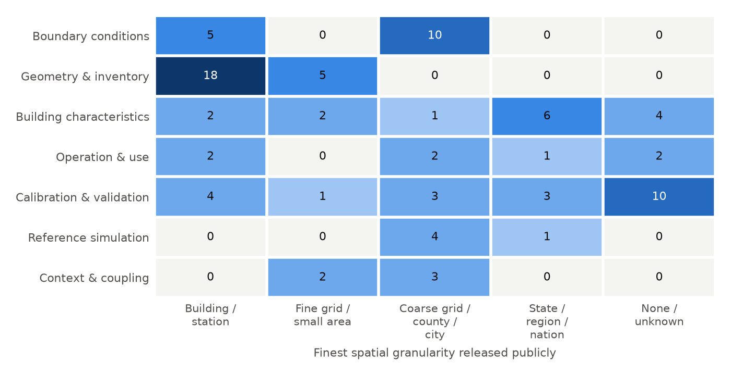
Fig. 1. Number of catalog datasets by primary UBEM workflow role and the finest spatial granularity they release publicly. Darker cells hold more datasets.
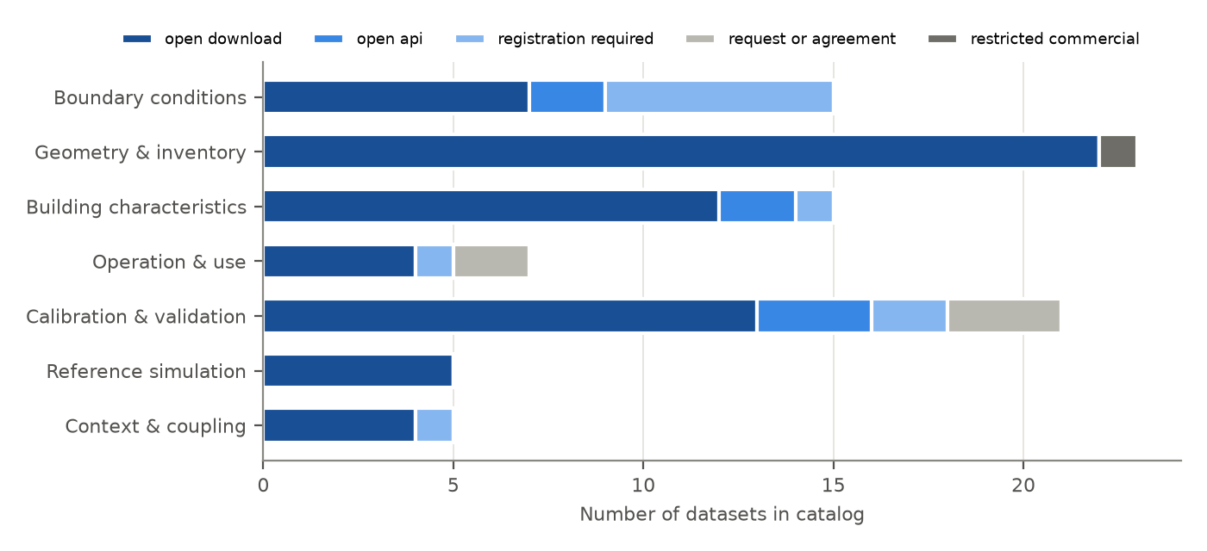
Fig. 2. Access terms by primary role. Blue: obtainable without an agreement; gray: agreement or commercial license required.

4.3 Linkage to buildings
Granularity alone does not say whether a record can be attached to a building. We therefore classified every dataset by its best way of linking to individual building footprints: a shared identifier (UBID, cadastral parcel id, address), building-precise location (coordinates or geometry at building granularity), area codes only, attributes only (building type, vintage), or none. A dataset-internal record id does not count. Of the 48 datasets whose primary role is characteristics, operation, calibration or reference simulation, 3 share an identifier with footprints (all are administrative: energy certificates and benchmarking disclosure), none offers building-precise location without an identifier, 23 can be linked only through area codes, and 21 have no usable key (Table 3). For most of open UBEM, therefore, characteristics and energy can be joined to geometry only statistically, by area and building type, never record by record. This is a stronger and more specific statement than “data lack common keys” [9], and it points to the identifier (UBID or parcel) rather than to more data as the missing piece.
Table 3. Linkage class by primary role (generated: paper/tables/catalog_linkability.csv).
Role | Shared identifier | Building location | Area code | Attribute only | None
Boundary conditions | 0 | 0 | 15 | 0 | 0
Geometry and inventory | 2 | 16 | 5 | 0 | 0
Building characteristics | 2 | 0 | 9 | 0 | 4
Operation and use | 0 | 0 | 4 | 1 | 2
Calibration and validation | 1 | 0 | 7 | 0 | 13
Reference simulation | 0 | 0 | 3 | 0 | 2
Context and coupling | 0 | 0 | 5 | 0 | 0

4.4 Competency questions
Ontology engineering tests a schema with competency questions it must answer. We wrote six and executed them as queries over the catalog (paper/tables/competency.md). For example, “which open datasets report measured energy at building or meter level?” returns ten datasets, none of which carries an identifier or building-precise location that would link it to a footprint (the Building Data Genome 2 metadata, for example, gives 15 distinct coordinates for 1,399 buildings, one per site), and “which datasets lack an explicit license?” returns 31, including most weather products. The answers depend only on the schema’s facets, which shows that the profiles are machine-actionable (RQ2). They inherit the catalog’s error rate estimated in Section 4.1.

5. Alignment benchmark (RQ3)

5.1 Tasks and data
The benchmark uses the public codebooks of CBECS 2018 (1,249 variables) and RECS 2020 (799 variables), which differ in format, units and conventions, and together contain 733 imputation flags and 213 sampling weights. It has two tasks, numbered T2 and T3 for continuity with the repository. A third task we designed, extracting a dataset profile from a publisher’s documentation (T1), is left out: its natural gold standard would be the catalog of Section 4, which was itself drafted with an LLM, so it could not be scored independently.
- T2, variable-to-concept mapping. Input: variable name, label, questionnaire section and up to eight codes. Output: one concept id or none, two alternatives and a confidence. Gold: two independent blind annotations with adjudication and a human audit (Section 5.2). Evaluation sample: 300 substantive variables (150 per survey), stratified by concept, fixed seed. Metrics: Acc@1 (strict and lenient), Acc@3, MRR, macro-F1, rate of false none answers.
- T3, code and unit normalization. Input: the verbatim codebook entry. Output: weight and imputation flags, the flagged variable, unit and multiplier, missing codes and code list. Gold: derived exactly from the codebook. Items: the 300 T2 variables plus a fixed supplement of 60 imputation flags and 30 replicate weights, so that detection is scored on positives too. Metrics: recall and false-alarm rate for the detection fields, field accuracy, code-list Jaccard.

5.2 Gold labels
T3 gold is derived deterministically and unit-tested. For T2, documented rules (meta_urban.gold_draft) pre-fill a draft label for every variable; they map 92.2% of the 1,104 substantive variables to 46 distinct concepts and were used only to stratify the evaluation sample. The gold itself was produced in three blind steps. Two annotators labeled all 300 variables independently, seeing the variable (name, label, question, codes) and the vocabulary but neither the draft label nor any model output. Each recorded the most specific concept and, only for variables that genuinely fit two concepts, the other acceptable ones. A third, separate adjudicator resolved the disagreements, seeing both annotations but again no draft or model output. The annotators and the adjudicator were LLM agents, not people: Claude Opus 5.5 and Claude Sonnet 5.5 (Anthropic) as the two annotators, so that their errors are less correlated than two runs of one model, and Claude Opus 5.5 as adjudicator, each in a fresh context restricted to the annotation files. We chose this because two qualified human annotators were not available, and we mitigate it in three ways: the evaluated models (Qwen3 and Llama 3.1) come from other developers and were never used to build the gold; every label, alternative and rationale is released for inspection; and the first author audited a random sample of 50 adjudicated labels (Section 5.5). Strict accuracy scores against the adjudicated concept; lenient accuracy also accepts the recorded alternatives. The protocol and tooling (meta_urban.gold_sheets) work unchanged with human annotators, and we invite replacement of the gold by expert labels.

5.3 Conditions
Four levels of target context test what the schema contributes: L0 concept ids only; L1 ids and preferred labels; L2 full semantics (definition, broader concept, entity, canonical unit, synonyms); L3 L2 restricted to the top 10 candidates from the lexical retriever (retrieve-then-rerank).

5.4 Models, baselines and protocol
Baselines are a TF-IDF lexical matcher (word and character n-grams) and a sentence-embedding matcher. Models: two open-weight models from different developers, Qwen3 8B [68] and Llama 3.1 8B [69], run locally through Ollama 0.40.16 on a laptop GPU (4-bit quantization, thinking disabled, 8,192-token context, 12-13 November 2026). We chose small local models deliberately. Survey microdata, utility records and building registers are often held under data-use agreements that rule out sending records to a commercial API, and a city energy office is more likely to run an 8B model on its own hardware than to fine-tune or pay for a frontier model. Small models are also the harder test of RQ3: if schema semantics help anywhere, they should help where the model knows least. The harness also runs API-hosted models (Anthropic and OpenAI providers, with cached prompts), so frontier results can be added from the released code. Outputs are constrained to a JSON schema whose concept field is an enumeration of the vocabulary, so every answer is a valid concept id, and generation is capped at 2,048 tokens; a capped answer is scored as invalid. Each condition is run five times at temperature 0.7 to measure self-consistency (pairwise agreement, unanimous share, standard deviation of accuracy), and once at temperature 0 for the point estimate. All prompts and raw responses are cached and released. We report token cost and a coverage-accuracy curve that accepts mappings above a confidence threshold and routes the rest to a human.

5.5 Results
Gold labels. The two annotators agreed on 276 of 300 variables (Cohen’s kappa = 0.91). Both changed the rule-based draft on 26% of the variables, and for 20% the draft was neither the adjudicated concept nor an accepted alternative. Rule-based labels would therefore have been a poor gold standard: scored on the draft labels, the accuracies in this section shift by -2 to +6 points and the L0-L1 contrast for Qwen3 is not significant. The adjudicated gold uses 45 distinct concepts; 5 variables have no applicable concept and 80 (27%) have at least one accepted alternative. [TODO (author): report the human audit of 50 random gold labels, python -m meta_urban.gold_sheets audit_report.]
Task T2. Table 4 and Fig. 3 report top-1 accuracy on the 295 mappable variables. Both open-weight models beat the lexical baseline at every level. Concept ids alone (L0) already give 0.42-0.43, because many ids are readable names. Adding preferred labels (L1) helps Qwen3 a little (+0.05; exact McNemar p = 0.005) and not Llama 3.1 (-0.03; p = 0.22). Adding definitions, broader concepts, entities, units and synonyms (L2) is what helps both: +0.12 (Llama 3.1; 55 variables gained, 20 lost) and +0.17 (Qwen3; 62 gained, 12 lost) over L0, both p < 0.001. With accepted alternatives counted as correct (lenient accuracy), L2 reaches 0.64 and 0.68. The two models do not differ significantly at L0, L2 or L3 (p >= 0.25).
Table 4. T2 variable-to-concept mapping on the adjudicated gold. Acc@1 with bootstrap 95% interval, lenient Acc@1 (accepted alternatives count as correct), Acc@3 and MRR on 295 mappable variables at temperature 0; macro-F1 on all 300; agreement is the mean pairwise agreement of five repeats (one at temperature 0, four at 0.7); tokens are mean input tokens per call. Generated: paper/tables/bench_t2_main.csv.
Method | Level | Acc@1 [95% CI] | Lenient | Acc@3 | MRR | Macro-F1 | Agreement | Tokens
Lexical TF-IDF | - | 0.27 [0.23, 0.32] | 0.35 | 0.57 | 0.44 | 0.30 | - | -
Llama 3.1 8B | L0 | 0.43 [0.37, 0.48] | 0.55 | 0.71 | 0.56 | 0.41 | 0.79 | 477
Llama 3.1 8B | L1 | 0.40 [0.34, 0.45] | 0.50 | 0.63 | 0.50 | 0.43 | 0.87 | 800
Llama 3.1 8B | L2 | 0.55 [0.49, 0.60] | 0.64 | 0.80 | 0.66 | 0.50 | 0.91 | 3,873
Llama 3.1 8B | L3 | 0.52 [0.46, 0.58] | 0.61 | 0.70 | 0.61 | 0.58 | 0.91 | 701
Qwen3 8B | L0 | 0.42 [0.36, 0.47] | 0.52 | 0.57 | 0.49 | 0.48 | 0.98 | 486
Qwen3 8B | L1 | 0.47 [0.42, 0.53] | 0.58 | 0.61 | 0.54 | 0.57 | 0.98 | 809
Qwen3 8B | L2 | 0.59 [0.53, 0.64] | 0.68 | 0.75 | 0.66 | 0.58 | 0.98 | 3,884
Qwen3 8B | L3 | 0.51 [0.46, 0.57] | 0.60 | 0.67 | 0.59 | 0.56 | 0.98 | 710
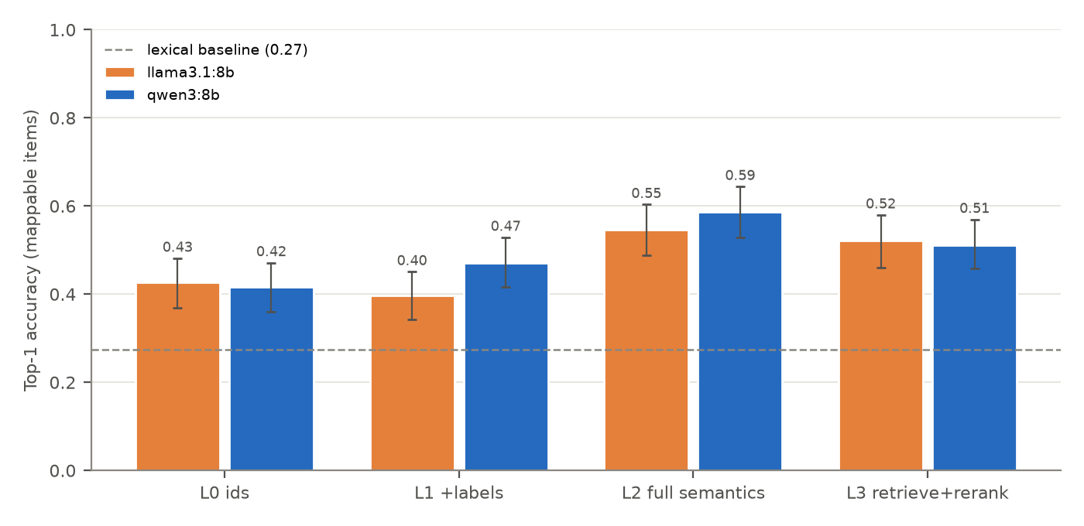
Fig. 3. Top-1 accuracy of variable-to-concept mapping by level of schema context, on the adjudicated gold. Error bars: bootstrap 95% intervals. Dashed line: lexical baseline.
Retrieve-then-rerank (L3) uses 18% of the input tokens of L2 (about 705 instead of 3,880 per call) but does not match it: -0.02 for Llama 3.1 (p = 0.51) and -0.08 for Qwen3 (p = 0.02). The loss comes from the retriever. The gold concept is among the ten lexical candidates for 223 of 295 variables (76%); on those, L3 is as accurate as L2 or better (0.68-0.69 against 0.63-0.66), and on the other 72 it cannot be right, whereas L2 still recovers 28% (Llama 3.1) to 36% (Qwen3) of them. A better retriever, not a larger prompt, is the cheaper route to higher accuracy. L3 also makes the models abstain more often, mostly wrongly: false none answers rise from 2-5% of variables at L2 to 8-13% at L3.
The semantics change the kind of error as well as the rate (paper/tables/bench_t2_errors.csv). At L0, 27% of Qwen3’s answers (12% of Llama 3.1’s) fall in a different top-level group than the gold concept, such as an energy concept for a system variable; at L2 these drop to 16% and 9%. Most remaining errors stay within the right group (23% and 31% of variables at L2). They concentrate on distinctions the vocabulary draws but the codebooks blur. The most frequent error of Llama 3.1 is mapping an end-use consumption total (for example, electricity used for space heating) to the fuel’s consumption concept instead of end-use energy; the most frequent of Qwen3 is mapping “natural gas used for water heating” to the water-heating system instead of the energy source, which the gold accepts as an alternative. Others are heat pumps (heating or cooling) and appliance use (equipment or behavior). Accuracy is higher on CBECS (0.61-0.63 at L2) than on RECS (0.48-0.54), whose questionnaire covers household topics that the vocabulary covers less well.
Repeated runs are stable. The standard deviation of accuracy across five repeats is at most 0.013, and Qwen3’s repeats agree pairwise on 98% of variables; Llama 3.1 is less consistent (79-91%). Self-consistency is therefore not a useful signal of correctness for these models (Fig. 4): accepting only unanimous answers keeps 95% of Qwen3’s mappings at almost unchanged accuracy (0.60 against 0.58). Qwen3’s own confidence is useful (accepting answers with confidence of at least 0.95 maps 51% of variables at 0.84 accuracy), Llama 3.1’s is not (it reports 0.8 or 0.9 for almost everything), and agreement across conditions is the most model-agnostic signal: when both models agree at both L2 and L3, 36% of variables are mapped at 0.83 accuracy. Agreement between cheap local runs can therefore decide which mappings a person must review.
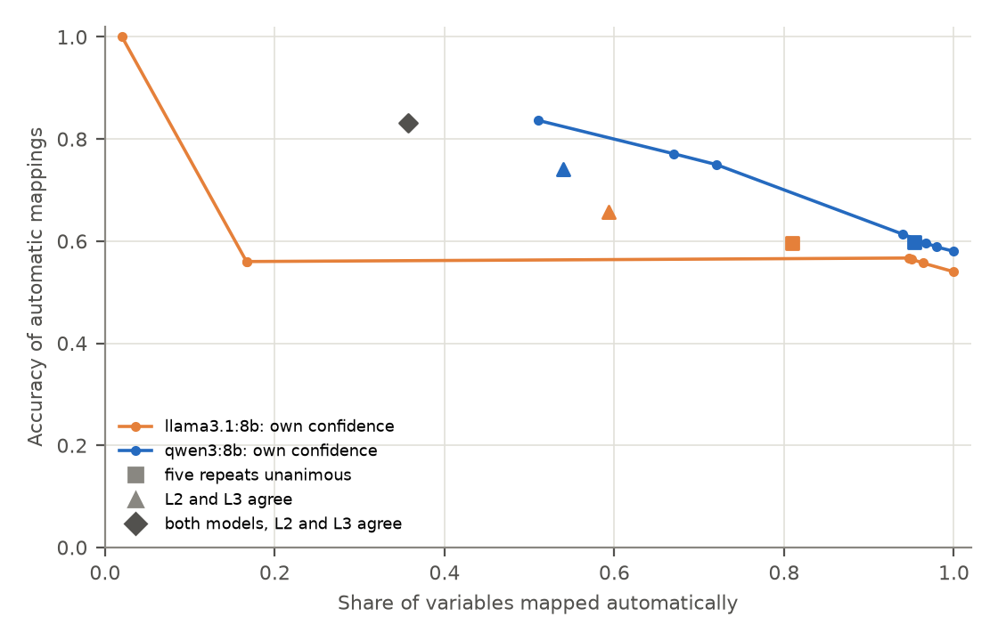
Fig. 4. Coverage and accuracy when only some mappings are accepted automatically (L2). Lines: threshold on the model’s own confidence. Markers: accept only when the five repeats are unanimous, when L2 and L3 agree, or when both models agree at both levels.
Task T3. Because the T2 sample excludes imputation flags and replicate weights, T3 adds a fixed supplement of 60 imputation flags and 30 replicate weights (seed 20261113; benchmark/inputs/t3_extra_sample.csv), so that detection is measured on positives as well as negatives. Table 5 reports each field on the items where it is informative. Both models detect weights, replicate weights and imputation flags almost perfectly, with no false alarms on the 300 substantive variables. Two failures stand out. First, finding the variable that an imputation flag refers to: both models are always right when the codebook names it (RECS: “Imputation indicator for DRYER”) and never right when it must be inferred from the naming convention (CBECS: “Imputation flag: Months in use” for ZMONUSE, which flags MONUSE); they return the flag’s own name instead. The convention is documented in the survey’s user guide, not in the codebook entry, which is the kind of dataset-level knowledge the Meta-Urban profile is meant to carry. Second, units and missing codes: Qwen3 gets the unit right for 96% of variables with a unit and the multiplier for 96% of scaled units, while Llama 3.1 gets 80% and 79%. Missing-value codes match the codebook exactly in only 20-32% of answers (26-57% when an empty-string entry that both models add by habit is ignored), and some answers include codes the codebook does not define.
Table 5. T3 code and unit normalization, three repeats per item (one at temperature 0, two at 0.7). Gold is derived exactly from the codebooks. Generated: paper/tables/bench_t3_fields.csv.
Field (items scored) | Qwen3 8B | Llama 3.1 8B
Valid JSON (390 items) | 1.00 | 0.99
Weight detected (32 weights) / false alarm | 1.00 / 0.00 | 1.00 / 0.00
Replicate weight detected (30) / false alarm | 0.98 / 0.00 | 1.00 / 0.00
Imputation flag detected (60) / false alarm | 1.00 / 0.00 | 1.00 / 0.00
Flagged variable, RECS (label names it; 30) | 1.00 | 1.00
Flagged variable, CBECS (convention only; 30) | 0.00 | 0.00
Unit (52 variables with a unit) | 0.96 | 0.80
Unit given where there is none | 0.04 | 0.06
Multiplier, scaled units (31) | 0.96 | 0.79
Missing codes, exact / ignoring empty strings | 0.32 / 0.57 | 0.20 / 0.26
Code list, mean Jaccard | 0.74 | 0.68
Combined with the sensitivities in Table 6, the multiplier errors matter most: each miss on an energy variable changes its total by a factor of 1,000, so a pipeline built on Llama 3.1’s answers would carry such an error in about one in five scaled energy variables unless a plausibility check catches it. Weight and flag detection, by contrast, is reliable enough to automate.

6. Do alignment errors matter downstream? (RQ4)

6.1 Reference pipeline
Applying the CBECS final weights (FINALWT) to the public microdata gives 5,918 thousand buildings, 96,527 million square feet and 6,789 trillion Btu of major-fuel consumption. These match EIA’s published Tables B1 and C1 to within 0.01%, which validates the pipeline used as the reference below.

6.2 Ignoring the survey design
The 2023 case study processed CBECS records without weights. Doing so reports 6.4 thousand buildings instead of 5.9 million. Less obviously, it also biases intensities. Fig. 5 compares the floor-area-weighted energy use intensity (EUI) by principal building activity with and without weights. For the 16 activities that hold at least 0.5% of buildings, the unweighted EUI is off by -16% (food sales) to +102% (other), with 12 of 16 overestimated: retail other than mall +45%, public assembly +31%, outpatient health care +27%. Inpatient health care holds 4.3% of records but 0.1% of buildings, so unweighted counts also distort the stock mix that archetype-based UBEM samples from.
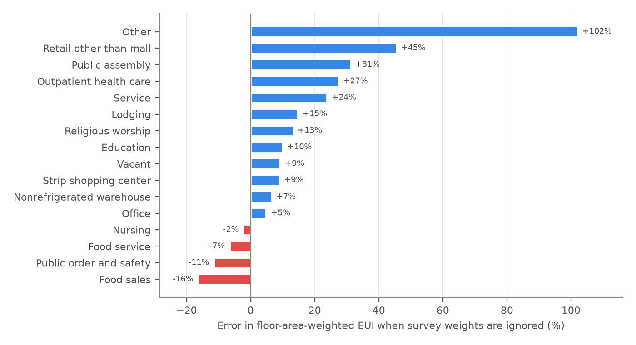
Fig. 5. Error in floor-area-weighted EUI by principal building activity when CBECS 2018 survey weights are ignored, relative to the weighted estimate. Activities with at least 0.5% of weighted buildings are shown.

6.3 Sensitivity to each normalization error
Table 6 injects each T3 error type into the reference pipeline. Unit errors are the most damaging (a dropped “thousand” multiplier or a Btu-kWh confusion changes national EUI by -99.9% or +241%), but they are also the easiest to catch with a plausibility check. Top-codes read as values are subtler: CBECS codes buildings with 10 to 14 floors as 994 and 15 or more as 995, and treating these as numbers raises the weighted mean number of floors by 179%. A withheld climate-zone code kept as a category shifts the hot-zone share by only 2.5%. Combined with the T3 error rates (Table 5), the risks rank differently from the raw sensitivities. Weight and flag detection was essentially error-free, so the largest effect in Table 6 is also the least likely in practice. Multiplier errors are both large and frequent (4% of scaled units for Qwen3, 21% for Llama 3.1), so a plausibility check on intensities (for example, flagging an EUI outside 10 to 2,000 kWh/m2) is the single most valuable guard to put after an LLM-built pipeline. Top-code handling was not tested directly by T3 and remains a silent risk: a top-code is a valid number, so no range check catches it.
Table 6. Effect of single normalization errors on CBECS 2018 quantities (generated: paper/tables/downstream_d3_sensitivity.csv).
Error type | Quantity | Correct | With error | Relative error
Unit multiplier dropped (thousand Btu read as Btu) | National EUI (kWh/m2) | 221.9 | 0.22 | -99.9%
Wrong unit (thousand Btu read as kWh) | National EUI (kWh/m2) | 221.9 | 757.1 | +241%
ft2 read as m2 | Total floorspace (million m2) | 8,968 | 96,527 | +976%
Top-codes read as values (NFLOOR 994/995) | Weighted mean floors | 1.46 | 4.08 | +179%
Withheld code kept (PUBCLIM 7) | Share in hot zone | 0.138 | 0.135 | -2.5%
Survey weights ignored | Buildings (thousand) | 5,918 | 6.4 | -99.9%
Note: for NFLOOR the correct value assumes 12 floors for code 994 and 15 for code 995 (midpoint and lower bound).

6.4 What went wrong in 2023
Re-examined with the gold labels, the 2023 outputs [24] were not “accurate” as reported: the coverage of CBECS was returned as raw codes (“Regions: [3 4 1 2]”), the weights were dropped, and the EIA monthly series was given a timestamp format with hours and seconds. These are exactly the error types that T3 now measures. The legacy outputs are kept in the repository for comparison.

7. Discussion
Does the schema help (RQ3)? The results support a qualified yes. What helps is the semantic content of the target, not its existence. A bare list of concept ids already lets an 8B model beat a lexical matcher by 15 points, because good ids are readable; preferred labels add little; definitions, units, entities and the hierarchy add 12 to 17 points and cut errors that cross workflow roles by a quarter to two fifths. This is the part of a schema that is usually missing from UBEM data descriptions, which list field names but rarely say what a field means. The qualification is that even with full semantics, small local models map only 55-59% of variables exactly and 64-68% acceptably, so they are assistants, not replacements. Two design consequences follow. First, retrieval should be improved before prompts are enlarged: retrieve-then-rerank cut input tokens by 82%, and its losses came almost entirely from variables the lexical retriever never offered. Second, a mapping pipeline needs a routing rule, and model agreement across cheap runs is a better rule than a model’s self-consistency, which was high whether the answer was right or not.
Dataset-level knowledge matters as much as variable-level knowledge. The clearest T3 failure was not a lack of reasoning: both models linked every RECS imputation flag to its variable, where the label names it, and none of the CBECS flags, where only the survey’s naming convention (a leading Z) does so. Conventions like this live in user guides, not in codebook entries. A dataset profile that states them, as Meta-Urban’s variable level does with its flags_variable and weight fields, removes the need for the model to guess. The same holds for survey weights and top-codes, which Section 6 shows to be the errors with the largest effect on UBEM quantities.
Implications for UBEM practice. (i) Treat weights, top-codes and imputation flags as part of the data contract; a pipeline that does not read them is wrong even when every value is transcribed correctly. (ii) Put a plausibility check on intensities after any automated unit handling; one of the two models got a fifth of the scaled-unit multipliers wrong, each a factor-of-1,000 error. (iii) Invest in identifiers (UBID, parcel) rather than in more datasets: without them, characteristics and energy can be joined to geometry only statistically. (iv) Publish machine-actionable profiles with explicit licenses; a third of the catalog states none we could verify.
What the schema does not do. Meta-Urban describes datasets and the meaning of their variables. It does not model buildings, thermal zones or systems, which CityGML, the Energy ADE, Brick and BEDES already do; it maps to them (Section 3.4).
Limitations. (1) The T2 gold was built by LLM annotators, not by domain experts (Section 5.2). Their agreement was high (kappa = 0.91), but two models from one developer may share blind spots, so kappa may overstate reliability; the human audit and the released rationales are the check, and the tooling accepts expert labels unchanged. (2) Only two small open-weight models were tested. The harness runs API-hosted models, and larger models will very likely score higher; our claim is about the relative value of schema context, which held for both models. (3) The benchmark uses two U.S. surveys; codebooks in other languages and administrative registers such as energy performance certificates may behave differently. (4) The catalog is a purposive sample of national and global datasets drafted with an LLM; the verified error rate of a random sample is 2% wrong and 16% partly correct fields, and city portals are out of scope. (5) The vocabulary is version 0.1. Annotators found topics it lacks (energy insecurity, electric vehicles, internet access, outages, campus membership), which version 0.2 should add.

8. Conclusions
Open data for urban building energy modeling are plentiful but hard to combine, and the description of a dataset, not the data, is often where integration fails. We asked four questions. On coverage (RQ1), a verified catalog of 91 open datasets shows that geometry and weather are well served, but only 3 of 48 datasets with characteristics, operation, energy or simulation data share an identifier with building footprints; most can be joined to buildings only statistically. On representation (RQ2), the Meta-Urban 2.0 schema describes these datasets and their variables in a form that validates, compiles to JSON Schema, SHACL and OWL, and answers competency queries directly. On alignment (RQ3), concept definitions raised the top-1 accuracy of two local 8B LLMs from 0.42-0.43 to 0.55-0.59 on 295 survey variables, while labels alone did little; retrieval cut cost by 82% at some loss of accuracy; and model agreement identified a third of the mappings at 0.83 accuracy for automatic acceptance. On consequences (RQ4), the errors that remain are not cosmetic: a dropped multiplier changes energy totals a thousandfold, top-codes read as values nearly triple the mean number of floors, and ignoring survey weights biases energy use intensity by -16% to +102% across building types. The practical recommendation is to publish UBEM datasets with machine-readable semantics, including their weights, flags and conventions, and to let LLMs do the first pass of integration under a routing rule that sends disagreements to a person. Everything needed to repeat or extend this study, including the schema, catalog, gold labels, prompts and all model outputs, is open.

Code and data availability
All code, the schema and its generated artifacts, the catalog and its verification record, gold labels with annotations and rationales, prompts, cached model outputs, and the scripts that produce every table and figure are at https://github.com/TensorBuildLab/UBEM-schema [TODO (authors): make the repository public and archive the submission release on Zenodo for a DOI]. Source data are downloaded from EIA by scripts/download_data.py, which records SHA-256 checksums.

Declaration of generative AI and AI-assisted technologies in the research and writing process
LLMs are the object of study in Section 5. In addition, during the preparation of this work the authors used Claude (Anthropic) to draft and re-verify catalog entries (Section 4.1), to produce and adjudicate the T2 gold labels (Section 5.2), to verify references, to write analysis code, and to draft and edit text. After using this tool, the authors reviewed and edited the content as needed and take full responsibility for the content of the published article.

Declaration of competing interest
The authors declare that they have no known competing financial interests or personal relationships that could have appeared to influence the work reported in this paper. [TODO (authors): confirm.]

Acknowledgments
[TODO (authors): funding statement, or “This research did not receive any specific grant from funding agencies in the public, commercial, or not-for-profit sectors.”]

CRediT authorship contribution statement
Liang Zhang: Conceptualization, Methodology, Software, Investigation, Data curation, Writing - original draft, Writing - review and editing, Visualization. Jianli Chen: [TODO: e.g., Conceptualization, Writing - review and editing]. Jia Zou: [TODO: e.g., Methodology, Writing - review and editing].

References
[1] United Nations Environment Programme, Global Alliance for Buildings and Construction, Global status report for buildings and construction 2024/2025: Not just another brick in the wall, United Nations Environment Programme, Nairobi, 2025. https://www.unep.org/resources/report/global-status-report-buildings-and-construction-20242025.
[2] C.F. Reinhart, C. Cerezo Davila, Urban building energy modeling – a review of a nascent field, Building and Environment 97 (2016) 196–202. https://doi.org/10.1016/j.buildenv.2015.12.001.
[3] M. Ferrando, F. Causone, T. Hong, Y. Chen, Urban building energy modeling (UBEM) tools: A state-of-the-art review of bottom-up physics-based approaches, Sustainable Cities and Society 62 (2020) 102408. https://doi.org/10.1016/j.scs.2020.102408.
[4] F. Johari, G. Peronato, P. Sadeghian, X. Zhao, J. Widén, Urban building energy modeling: State of the art and future prospects, Renewable and Sustainable Energy Reviews 128 (2020) 109902. https://doi.org/10.1016/j.rser.2020.109902.
[5] T. Hong, Y. Chen, X. Luo, N. Luo, S.H. Lee, Ten questions on urban building energy modeling, Building and Environment 168 (2020) 106508. https://doi.org/10.1016/j.buildenv.2019.106508.
[6] C. Cerezo Davila, C.F. Reinhart, J.L. Bemis, Modeling Boston: A workflow for the efficient generation and maintenance of urban building energy models from existing geospatial datasets, Energy 117 (2016) 237–250. https://doi.org/10.1016/j.energy.2016.10.057.
[7] C. Wang, M. Ferrando, F. Causone, X. Jin, X. Zhou, X. Shi, Data acquisition for urban building energy modeling: A review, Building and Environment 217 (2022) 109056. https://doi.org/10.1016/j.buildenv.2022.109056.
[8] A. Malhotra, J. Bischof, A. Nichersu, K.-H. Häfele, J. Exenberger, D. Sood, J. Allan, J. Frisch, C. van Treeck, J. O’Donnell, G. Schweiger, Information modelling for urban building energy simulation—a taxonomic review, Building and Environment 208 (2022) 108552. https://doi.org/10.1016/j.buildenv.2021.108552.
[9] Y. Chen, T. Hong, X. Luo, B. Hooper, Development of city buildings dataset for urban building energy modeling, Energy and Buildings 183 (2019) 252–265. https://doi.org/10.1016/j.enbuild.2018.11.008.
[10] S. Goy, F. Maréchal, D. Finn, Data for urban scale building energy modelling: Assessing impacts and overcoming availability challenges, Energies 13 (2020) 4244. https://doi.org/10.3390/en13164244.
[11] X. Jin, C. Zhang, F. Xiao, A. Li, C. Miller, A review and reflection on open datasets of city-level building energy use and their applications, Energy and Buildings 285 (2023) 112911. https://doi.org/10.1016/j.enbuild.2023.112911.
[12] D. Bishop, P. Gallardo, B.L.M. Williams, A review of multi-domain urban energy modelling data, Clean Energy and Sustainability 2 (2024) 10016. https://doi.org/10.70322/ces.2024.10016.
[13] S. Anselmo, P. Boccardo, Urban building energy modelling: A review on the integration of geographic information systems and remote sensing, Energies 19 (2026) 1667. https://doi.org/10.3390/en19071667.
[14] G. Gröger, L. Plümer, CityGML – interoperable semantic 3D city models, ISPRS Journal of Photogrammetry and Remote Sensing 71 (2012) 12–33. https://doi.org/10.1016/j.isprsjprs.2012.04.004.
[15] T. Kutzner, K. Chaturvedi, T.H. Kolbe, CityGML 3.0: New functions open up new applications, PFG – Journal of Photogrammetry, Remote Sensing and Geoinformation Science 88 (2020) 43–61. https://doi.org/10.1007/s41064-020-00095-z.
[16] G. Agugiaro, J. Benner, P. Cipriano, R. Nouvel, The energy application domain extension for CityGML: Enhancing interoperability for urban energy simulations, Open Geospatial Data, Software and Standards 3 (2018) 2. https://doi.org/10.1186/s40965-018-0042-y.
[17] A. Narayan, I. Chami, L. Orr, C. Ré, Can foundation models wrangle your data?, Proceedings of the VLDB Endowment 16 (2022) 738–746. https://doi.org/10.14778/3574245.3574258.
[18] E. Sheetrit, M. Brief, M. Mishaeli, O. Elisha, ReMatch: Retrieval enhanced schema matching with LLMs, (2024). https://arxiv.org/abs/2403.01567.
[19] Y. Liu, E.H.M. Pena, A. Santos, E. Wu, J. Freire, Magneto: Combining small and large language models for schema matching, Proceedings of the VLDB Endowment 18 (2025) 2681–2694. https://doi.org/10.14778/3742728.3742757.
[20] M. Parciak, B. Vandevoort, F. Neven, L.M. Peeters, S. Vansummeren, Schema matching with large language models: An experimental study, in: 2nd International Workshop on Tabular Data Analysis (TaDA), Co-Located with VLDB 2024, 2024. https://vldb.org/workshops/2024/proceedings/TaDA/TaDA.8.pdf.
[21] M. Kayali, F. Wenz, N. Tatbul, Ç. Demiralp, Mind the data gap: Bridging LLMs to enterprise data integration, in: Conference on Innovative Data Systems Research (CIDR), 2025. https://www.vldb.org/cidrdb/papers/2025/p34-kayali.pdf.
[22] C. Buss, M. Safari, A. Termehchy, S. Lee, D. Maier, Towards scalable schema mapping using large language models, (2025). https://arxiv.org/abs/2505.24716.
[23] M. Jain, R.G. Lutes, S. Katipamula, Automated tagging and semantic mapping of BACnet metadata to Brick schema for building automation systems, Pacific Northwest National Laboratory, Richland, WA, 2025. https://www.pnnl.gov/publications/automated-tagging-and-semantic-mapping-bacnet-metadata-brick-schema-building.
[24] L. Zhang, J. Chen, J. Zou, Taxonomy, semantic data schema, and schema alignment for open data in urban building energy modeling, (2023). https://arxiv.org/abs/2311.08535.
[25] S.A.T. Moxon, H. Solbrig, N.L. Harris, P. Kalita, M.A. Miller, S. Patil, K. Schaper, C. Bizon, J.H. Caufield, others, LinkML: An open data modeling framework, GigaScience 15 (2025) giaf152. https://doi.org/10.1093/gigascience/giaf152.
[26] R. Albertoni, D. Browning, S.J.D. Cox, A. Gonzalez Beltran, A. Perego, P. Winstanley, Data catalog vocabulary (DCAT) – version 3, (2024). https://www.w3.org/TR/2024/REC-vocab-dcat-3-20240822/.
[27] U. Ali, M.H. Shamsi, C. Hoare, E. Mangina, J. O’Donnell, Review of urban building energy modeling (UBEM) approaches, methods and tools using qualitative and quantitative analysis, Energy and Buildings 246 (2021) 111073. https://doi.org/10.1016/j.enbuild.2021.111073.
[28] E. Kamel, A systematic literature review of physics-based urban building energy modeling (UBEM) tools, data sources, and challenges for energy conservation, Energies 15 (2022) 8649. https://doi.org/10.3390/en15228649.
[29] T. Hong, J. Malik, J. Langevin, Z. Liu, D. Yan, Ten questions on building stock modeling to inform energy efficiency and sustainability, Building and Environment 284 (2025) 113465. https://doi.org/10.1016/j.buildenv.2025.113465.
[30] M.P. Heris, N.L. Foks, K.J. Bagstad, A. Troy, Z.H. Ancona, A rasterized building footprint dataset for the United States, Scientific Data 7 (2020) 207. https://doi.org/10.1038/s41597-020-0542-3.
[31] W. Sirko, S. Kashubin, M. Ritter, A. Annkah, Y.S.E. Bouchareb, Y. Dauphin, D. Keysers, M. Neumann, M. Cisse, J. Quinn, Continental-scale building detection from high resolution satellite imagery, (2021). https://arxiv.org/abs/2107.12283.
[32] N. Milojevic-Dupont, F. Wagner, F. Nachtigall, J. Hu, G.B. Brüser, M. Zumwald, F. Biljecki, N. Heeren, L.H. Kaack, P.-P. Pichler, F. Creutzig, EUBUCCO v0.1: European building stock characteristics in a common and open database for 200+ million individual buildings, Scientific Data 10 (2023) 147. https://doi.org/10.1038/s41597-023-02040-2.
[33] T. Esch, E. Brzoska, S. Dech, B. Leutner, D. Palacios-Lopez, A. Metz-Marconcini, M. Marconcini, A. Roth, J. Zeidler, World settlement footprint 3D – a first three-dimensional survey of the global building stock, Remote Sensing of Environment 270 (2022) 112877. https://doi.org/10.1016/j.rse.2021.112877.
[34] M. Pesaresi, M. Schiavina, P. Politis, S. Freire, K. Krasnodębska, J.H. Uhl, A. Carioli, C. Corbane, L. Dijkstra, P. Florio, H.K. Friedrich, J. Gao, S. Leyk, L. Lu, L. Maffenini, I. Mari-Rivero, M. Melchiorri, V. Syrris, J. Van Den Hoek, T. Kemper, Advances on the Global Human Settlement Layer by joint assessment of Earth observation and population survey data, International Journal of Digital Earth 17 (2024) 2390454. https://doi.org/10.1080/17538947.2024.2390454.
[35] M. Haklay, P. Weber, OpenStreetMap: User-generated street maps, IEEE Pervasive Computing 7 (2008) 12–18. https://doi.org/10.1109/mprv.2008.80.
[36] R. Nouvel, M. Zirak, V. Coors, U. Eicker, The influence of data quality on urban heating demand modeling using 3D city models, Computers, Environment and Urban Systems 64 (2017) 68–80. https://doi.org/10.1016/j.compenvurbsys.2016.12.005.
[37] B. Balaji, A. Bhattacharya, G. Fierro, J. Gao, J. Gluck, D. Hong, A. Johansen, J. Koh, J. Ploennigs, Y. Agarwal, M. Bergés, D. Culler, R.K. Gupta, M.B. Kjærgaard, M. Srivastava, K. Whitehouse, Brick: Metadata schema for portable smart building applications, Applied Energy 226 (2018) 1273–1292. https://doi.org/10.1016/j.apenergy.2018.02.091.
[38] Project Haystack, Project haystack, version 4 (haystack 4.0.0) documentation, (n.d.).
[39] K. Hammar, E.O. Wallin, P. Karlberg, D. Hälleberg, The RealEstateCore ontology, in: The Semantic Web – ISWC 2019, Springer, 2019: pp. 130–145. https://doi.org/10.1007/978-3-030-30796-7_9.
[40] M.H. Rasmussen, M. Lefrançois, G.F. Schneider, P. Pauwels, BOT: The building topology ontology of the W3C linked building data group, Semantic Web 12 (2021) 143–161. https://doi.org/10.3233/sw-200385.
[41] ETSI, SAREF4BLDG: An extension of SAREF for the building domain, European Telecommunications Standards Institute, 2025. https://saref.etsi.org/saref4bldg/.
[42] N. Long, K. Fleming, C. CaraDonna, C. Mosiman, BuildingSync: A schema for commercial building energy audit data exchange, Developments in the Built Environment 7 (2021) 100054. https://doi.org/10.1016/j.dibe.2021.100054.
[43] Lawrence Berkeley National Laboratory, Building energy data exchange specification (BEDES), (n.d.).
[44] ASHRAE SPC 223P, ASHRAE standard 223P: Semantic data model for analytics and automation applications in buildings (proposed standard), (n.d.).
[45] M. Pritoni, D. Paine, G. Fierro, C. Mosiman, M. Poplawski, A. Saha, J. Bender, J. Granderson, Metadata schemas and ontologies for building energy applications: A critical review and use case analysis, Energies 14 (2021) 2024. https://doi.org/10.3390/en14072024.
[46] G. Agugiaro, R. Padsala, Further development of the CityGML energy application domain extension 3.0, The International Archives of the Photogrammetry, Remote Sensing and Spatial Information Sciences L-4/W2-2026 (2026) 1–8. https://doi.org/10.5194/isprs-archives-l-4-w2-2026-1-2026.
[47] V. Corrado, I. Ballarini, L. Madrazo, G. Nemirovskij, Data structuring for the ontological modelling of urban energy systems: The experience of the SEMANCO project, Sustainable Cities and Society 14 (2015) 223–235. https://doi.org/10.1016/j.scs.2014.09.006.
[48] J. Allan, L. Fierz, A. Bollinger, K. Orehounig, Linked data ontology for urban scale building energy simulation, in: Proceedings of eSim 2020: 11th Conference of IBPSA-Canada, 2020. https://publications.ibpsa.org/proceedings/esim/2020/papers/esim2020_1148.pdf.
[49] A. Chadzynski, N. Krdzavac, F. Farazi, M.Q. Lim, S. Li, A. Grisiute, P. Herthogs, A. von Richthofen, S. Cairns, M. Kraft, Semantic 3D city database — an enabler for a dynamic geospatial knowledge graph, Energy and AI 6 (2021) 100106. https://doi.org/10.1016/j.egyai.2021.100106.
[50] R. Ma, Q. Li, B. Zhang, H. Huang, C. Yang, An ontology-driven method for urban building energy modeling, Sustainable Cities and Society 106 (2024) 105394. https://doi.org/10.1016/j.scs.2024.105394.
[51] Schema.org, Dataset – a schema.org type, (n.d.).
[52] M.D. Wilkinson, M. Dumontier, Ij.J. Aalbersberg, G. Appleton, M. Axton, A. Baak, N. Blomberg, J.-W. Boiten, L.B. da Silva Santos, P.E. Bourne, J. Bouwman, A.J. Brookes, T. Clark, M. Crosas, I. Dillo, O. Dumon, S. Edmunds, C.T. Evelo, R. Finkers, A. Gonzalez-Beltran, A.J.G. Gray, P. Groth, C. Goble, J.S. Grethe, J. Heringa, P.A.C. ’t Hoen, R. Hooft, T. Kuhn, R. Kok, J. Kok, S.J. Lusher, M.E. Martone, A. Mons, A.L. Packer, B. Persson, P. Rocca-Serra, M. Roos, R. van Schaik, S.-A. Sansone, E. Schultes, T. Sengstag, T. Slater, G. Strawn, M.A. Swertz, M. Thompson, J. van der Lei, E. van Mulligen, J. Velterop, A. Waagmeester, P. Wittenburg, K. Wolstencroft, J. Zhao, B. Mons, The FAIR guiding principles for scientific data management and stewardship, Scientific Data 3 (2016) 160018. https://doi.org/10.1038/sdata.2016.18.
[53] E. Rahm, P.A. Bernstein, A survey of approaches to automatic schema matching, The VLDB Journal 10 (2001) 334–350. https://doi.org/10.1007/s007780100057.
[54] H.-H. Do, E. Rahm, COMA – a system for flexible combination of schema matching approaches, in: VLDB ’02: Proceedings of the 28th International Conference on Very Large Databases, 2002: pp. 610–621. https://doi.org/10.1016/B978-155860869-6/50060-3.
[55] S. Melnik, H. Garcia-Molina, E. Rahm, Similarity flooding: A versatile graph matching algorithm and its application to schema matching, in: Proceedings 18th International Conference on Data Engineering (ICDE), 2002: pp. 117–128. https://doi.org/10.1109/ICDE.2002.994702.
[56] C. Koutras, G. Siachamis, A. Ionescu, K. Psarakis, J. Brons, M. Fragkoulis, C. Lofi, A. Bonifati, A. Katsifodimos, Valentine: Evaluating matching techniques for dataset discovery, in: 2021 IEEE 37th International Conference on Data Engineering (ICDE), 2021: pp. 468–479. https://doi.org/10.1109/ICDE51399.2021.00047.
[57] N. Seedat, M. van der Schaar, Matchmaker: Self-improving large language model programs for schema matching, in: NeurIPS 2024 Workshop on Generative AI for Health (GenAI4Health), 2024. https://arxiv.org/abs/2410.24105.
[58] L.-Y. Gan, A. Das, J. Walker, K. Diepold, E. Simperl, Less is more? When dataset context hurts LLM-generated dataset descriptions, (2026). https://arxiv.org/abs/2606.02334.
[59] X. Wang, J. Wei, D. Schuurmans, Q.V. Le, E.H. Chi, S. Narang, A. Chowdhery, D. Zhou, Self-consistency improves chain of thought reasoning in language models, in: International Conference on Learning Representations (ICLR), 2023. https://iclr.cc/virtual/2023/poster/11718.
[60] M. Xiong, Z. Hu, X. Lu, Y. Li, J. Fu, J. He, B. Hooi, Can LLMs express their uncertainty? An empirical evaluation of confidence elicitation in LLMs, in: International Conference on Learning Representations (ICLR), 2024. https://iclr.cc/virtual/2024/poster/18135.
[61] Z. Pan, G. Pan, A. Monti, Semantic-similarity-based schema matching for management of building energy data, Energies 15 (2022) 8894. https://doi.org/10.3390/en15238894.
[62] A. Sharma, X. Li, H. Guan, G. Sun, L. Zhang, L. Wang, K. Wu, L. Cao, E. Zhu, A. Sim, T. Wu, J. Zou, Automatic data transformation using large language model – an experimental study on building energy data, in: 2023 IEEE International Conference on Big Data (BigData), 2023: pp. 1824–1834. https://doi.org/10.1109/BigData59044.2023.10386931.
[63] A. Sharma, J. Tandel, X. Li, L. Wang, A. Fariha, L. Zhang, S.A.A. Naqvi, I.B. Riaz, L. Cao, J. Zou, DataMorpher: Automatic data transformation using LLM-based zero-shot code generation, in: 2025 IEEE 41st International Conference on Data Engineering (ICDE), 2025: pp. 4536–4539. https://doi.org/10.1109/ICDE65448.2025.00346.
[64] O.B. Mulayim, L. Paul, M. Pritoni, A.K. Prakash, M. Sudarshan, G. Fierro, Large language models for the creation and use of semantic ontologies in buildings: Requirements and challenges, in: Proceedings of the 11th ACM International Conference on Systems for Energy-Efficient Buildings, Cities, and Transportation (BuildSys ’24), 2024: pp. 312–317. https://doi.org/10.1145/3671127.3698792.
[65] Z. Zheng, S. Marié, E. Farazdaghi, E. Yahia, K. Makhoul, T. Lagarde, R. El Meouche, F. Ababsa, Mastering building management systems data points tagging with minimal examples: Unveiling the power of large language models, Energy and Buildings 328 (2025) 115173. https://doi.org/10.1016/j.enbuild.2024.115173.
[66] Z. Wang, J. Ma, J. Cai, M. Qu, Point2Brick: Automating building semantic model creation via multi-stage confidence-aware large language model agents, Energy and Buildings 362 (2026) 117516. https://doi.org/10.1016/j.enbuild.2026.117516.
[67] S. Choi, S. Yoon, GPT-based data-driven urban building energy modeling (GPT-UBEM): Concept, methodology, and case studies, Energy and Buildings 325 (2024) 115042. https://doi.org/10.1016/j.enbuild.2024.115042.
[68] A. Yang, others, Qwen3 technical report, (2025). https://doi.org/10.48550/arXiv.2505.09388.
[69] A. Grattafiori, others, The llama 3 herd of models, (2024). https://doi.org/10.48550/arXiv.2407.21783.

