NASA SPACE APPS 2026 | BE AN EARTH SYSTEM TREND DETECTIVE
Project Update & Questions for Mentor
Project: Water Storage Trends in Bangladesh (2020–2026) • October 2026
What we are studying:
Bangladesh gets heavy monsoon rain every year, yet satellite data shows that total water levels in the northern parts of the country are steadily dropping. Even during the rainy season, the north often stays in a water deficit while the south has plenty of water. This note summarizes what we have done so far, where our work falls short, and what we should work on next.

1. Datasets & What We Have Done So Far
We wrote Python scripts to compare water storage and rainfall across all 8 divisions of Bangladesh from 2020 to 2026:
- Water Storage Data (NASA GRACE): We analyze the CSR GRACE/GRACE-FO mascon dataset, which measures monthly changes in total water thickness from space.
- Rainfall Data (NASA POWER / GPM IMERG): We wrote a script that automatically downloads monthly satellite rainfall data for Bangladesh directly from the NASA POWER API.
- Division-Level Breakdown: Using division boundary maps (GeoJSON), we calculated average water storage and rainfall for each of the 8 divisions.
- Long-Term Trend Check (2020–2026): We removed the normal seasonal monsoon ups and downs across 79 monthly observations (2020–2026), using standard statistical tests (Mann-Kendall and Theil-Sen slope) to measure how fast water is changing per year.
- Maps & Reports: Our scripts generate division maps, bar charts, Excel/CSV tables, and simple HTML pages to view the results.
Water Storage Trend by Division (2020–2026):
Division | Yearly Change | 95% Confidence Range | p-value | What It Means
Rangpur | -3.42 cm/yr | -4.46 to -2.47 cm/yr | < 0.001 | Rapid downward trend
Rajshahi | -2.40 cm/yr | -3.44 to -1.48 cm/yr | < 0.001 | Rapid downward trend
Mymensingh | -1.69 cm/yr | -2.63 to -0.76 cm/yr | < 0.001 | Clear downward trend
Dhaka | -1.19 cm/yr | -1.96 to -0.47 cm/yr | 0.003 | Moderate downward trend
Sylhet | -0.44 cm/yr | -1.09 to +0.29 cm/yr | 0.223 | No clear trend (stable)
Khulna | -0.38 cm/yr | -0.82 to +0.06 cm/yr | 0.086 | No clear trend (stable)
Barishal | +0.30 cm/yr | -0.29 to +0.89 cm/yr | 0.337 | No clear trend (stable)
Chattogram | +0.39 cm/yr | +0.02 to +0.73 cm/yr | 0.038 | Slight upward trend
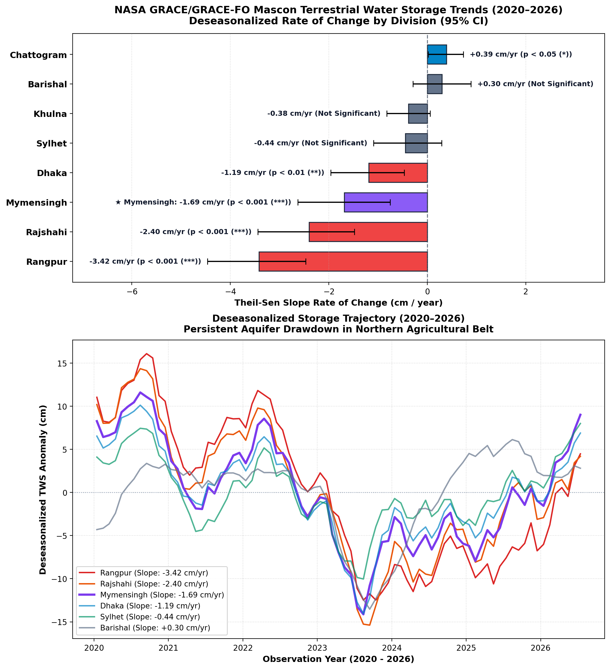
Figure 1: Deseasonalized Water Storage Rates & Trajectories by Division (2020–2026).
2. Current Limitations
Right now, our analysis has a few important gaps:
- Cannot separate groundwater from surface water: GRACE satellites measure all water combined (rivers, wet soil, and underground water). We have not separated underground water from soil moisture and surface water yet.
- Low map resolution: Each GRACE grid square is about 50 km wide. Smaller divisions like Barishal or Mymensingh only cover about 14 to 15 grid squares, so we cannot zoom in to the district or village level.
- Rainfall and water storage are analyzed separately: We have scripts for rainfall and scripts for water storage, but we have not connected them statistically to see how many months it takes for rain to refill the ground.
- No farming or pumping data included: Dry-season Boro rice farming (December to March) uses a lot of pumped groundwater in the north, but we have not added crop or well-pumping data to prove this is the main cause.
3. Possible Next Steps (Where Should We Focus?)
We want to make our project more useful and scientifically solid. Here are four directions we could take next:
• Option A — Isolate groundwater using soil moisture data: Combine our GRACE data with NASA GLDAS or ERA5 soil moisture data. By subtracting surface water and soil moisture, we can estimate how much actual groundwater is being lost.
• Option B — Connect water loss to dry-season farming: Add satellite crop data (MODIS vegetation data) and local irrigation statistics to check how closely northern water loss matches Boro rice irrigation in the dry winter months.
• Option C — Measure how rain refills the ground: Compare monthly rainfall against water storage changes to see how much rain actually soaks into the northern aquifers versus running off.
• Option D — Focus on practical usefulness and local impact: Instead of adding more satellite datasets, focus on comparing our results with local well measurements (from the Bangladesh Water Development Board) and making a clear, easy-to-read dashboard for local planners.
4. Questions for Our Mentor
1. Out of Options A, B, C, and D, which direction do you think is the most realistic and valuable for us to pursue next?
2. Do you know if local groundwater well data (for example, from BWDB or BADC) is available so we can check our satellite numbers against real ground measurements?
3. How can we make this work genuinely useful for water management or agricultural planning in Bangladesh, rather than just another student data project?

