DEPARTMENT OF COMPUTER SCIENCE & ENGINEERING
BIG DATA MINING & ANALYTICS (BDM)
EARTHPULSE
Global Earthquake Data Mining and Analytics Platform
A Document-Oriented Distributed Analytical Architecture Utilizing MongoDB, PyMongo Aggregation Pipelines, Flask, React, and Power BI

Course: Big Data Mining (Academic Project Report)
Database Engine: MongoDB Community Edition (earthpulse_db)
Dataset Source: USGS Comprehensive Earthquake Catalog (ComCat)
Coverage: 2000–2025 (26,170 Verified Historical Seismic Events)
Submission Date: Academic Term 2026

Abstract
EarthPulse is a full-stack, university-grade Big Data Mining (BDM) platform designed to ingest, process, model, and analyze multi-decadal historical earthquake records from the United States Geological Survey (USGS). Traditional relational database systems frequently struggle with heterogeneous semi-structured seismic metadata, dynamic sensor origins, and high-throughput geospatial distance calculations. In contrast, this project establishes a document-oriented database architecture built upon MongoDB Community Edition ('earthpulse_db'), deploying rich GeoJSON geometries, 2dsphere indexing, and high-efficiency aggregation pipelines ($match, $group, $lookup, $bucket, $geoNear). A total of 26,170 verified real-world seismic events spanning 2000 through 2025 were systematically ingested through an automated extract-transform-load (ETL) pipeline with rate management, deduplication, and coordinate bounds validation. Analytical modules include spatial grid-cell concentration mining, longitudinal temporal frequency decomposition, depth-magnitude correlation regression, and unsupervised spatial clustering via Scikit-Learn DBSCAN. The platform features an interactive React TypeScript web interface (Leaflet, Recharts, Tailwind CSS) served by a modular Python Flask backend with JWT role-based access control, as well as an enterprise Power BI Star-Schema analytical suite with zero-record discrepancy reconciliation.

1. Introduction
Seismological monitoring networks generate thousands of dynamic seismic event observations annually. Understanding global earthquake distribution, lithospheric focal depth stratification, and seismic energy dissipation across plate boundaries is fundamental to disaster mitigation, hazard assessment, and earth sciences. However, managing multi-decadal historical catalogs requires scalable Big Data processing strategies capable of handling continuous volume, varied formats, and rigorous veracity checks.
The EarthPulse platform addresses these requirements by integrating modern Big Data engineering principles with NoSQL document storage and business intelligence reporting. Unlike superficial demonstration applications, EarthPulse makes MongoDB central to analytical operations—executing native multi-stage aggregation pipelines for precomputed summary collections, spatial index lookups, and relational star-schema extraction.

2. Problem Statement and Objectives
Problem Statement: Historical earthquake catalogs maintained by geological surveys are voluminous, geographically dispersed, and contain heterogeneous sensor attributes. Traditional relational database schemas impose rigid tabular constraints that complicate geospatial point queries, dynamic sensor metadata expansion, and multidimensional aggregation across spatial-temporal axes. Researchers need an integrated, verifiable Big Data platform capable of answering complex analytical questions without synthetic data.
Core Objectives:
- Ingest 20,000+ verified historical earthquake records (2000–2025) directly from official USGS APIs.
- Implement a robust MongoDB database architecture with 2dsphere geospatial and compound indexes.
- Design multi-stage aggregation pipelines executing $match, $group, $project, $lookup, $bucket, and $geoNear.
- Provide unsupervised spatial clustering (DBSCAN) and statistical correlation analysis between focal depth and magnitude.
- Deploy a secure Flask REST API with JSON Web Token (JWT) role-based authentication (Viewer, Analyst, Admin).
- Build a professional scientific React dashboard featuring Leaflet interactive mapping and Recharts telemetry.
- Engineer a star-schema Power BI reporting suite with documented DAX measures and 100% data reconciliation.

3. Existing System vs. Proposed Proposed System
Evaluation Dimension | Traditional / Existing Systems | Proposed EarthPulse Platform
Storage Engine | Relational SQL (MySQL/PostgreSQL) with rigid columns | MongoDB document-oriented flexible schema (BSON/GeoJSON)
Geospatial Processing | Complex external spatial extensions or slow flat queries | Native 2dsphere indexing with spherical $geoNear pipelines
Aggregation Efficiency | Repeated full-table scans on raw transactional tables | Optimized precomputed summaries via native MongoDB pipelines
Dataset Integrity | Often populated with mock or synthetic data | 26,170 verified USGS historical events (2000–2025)
Role-Based Security | Single-tier or unsecured open endpoints | Granular JWT authentication (Viewer, Analyst, Admin)
Business Intelligence | Static manual spreadsheet charts | Relational Star-Schema Power BI (.pbix) with verified DAX

4. Dataset Description & Big Data Characteristics (5 Vs)
Earthquake records were retrieved from the official USGS Comprehensive Catalog (ComCat) via the FDSNWS Event API. The catalog encompasses all verified earthquakes with magnitude M >= 5.2 from January 1, 2000 to January 1, 2025. The system explicitly reflects the 5 Vs of Big Data:
• Volume: 26,170 verified seismic events spanning 25 years. Raw GeoJSON payload exceeds 22 MB, and cleaned documents total 26+ MB of structured BSON data in MongoDB, representing millions of recorded sensor observation parameters.
• Variety: Multi-structured data incorporating GeoJSON Point coordinates, varied magnitude formulas (mww, mb, mwc, ms, ml), focal depths, tsunami warning indicators, and nested origin station metadata.
• Velocity: Batch ingestion handles API pagination with exponential backoff retries, chunking 2-year intervals. Administrative triggers allow repeatable incremental ETL refreshes without downtime.
• Veracity: Strict data quality cleaning eliminates duplicate event IDs, validates bounding box coordinates (-180° to 180° lon, -90° to 90° lat), flags physical depth limits (-5 to 1000 km), and reconciles fact records with 0% discrepancy.
• Value: Derived spatial grid-cell hotspot rankings (919 cells), statistical depth-magnitude regression analysis, and longitudinal temporal trends provide critical insights for seismic hazard zonation and disaster resilience planning.

5. System Architecture
EarthPulse employs a modular multi-tier architecture separating data ingestion, database persistence, RESTful API services, and client visualization. The diagram below illustrates the end-to-end data pipeline:
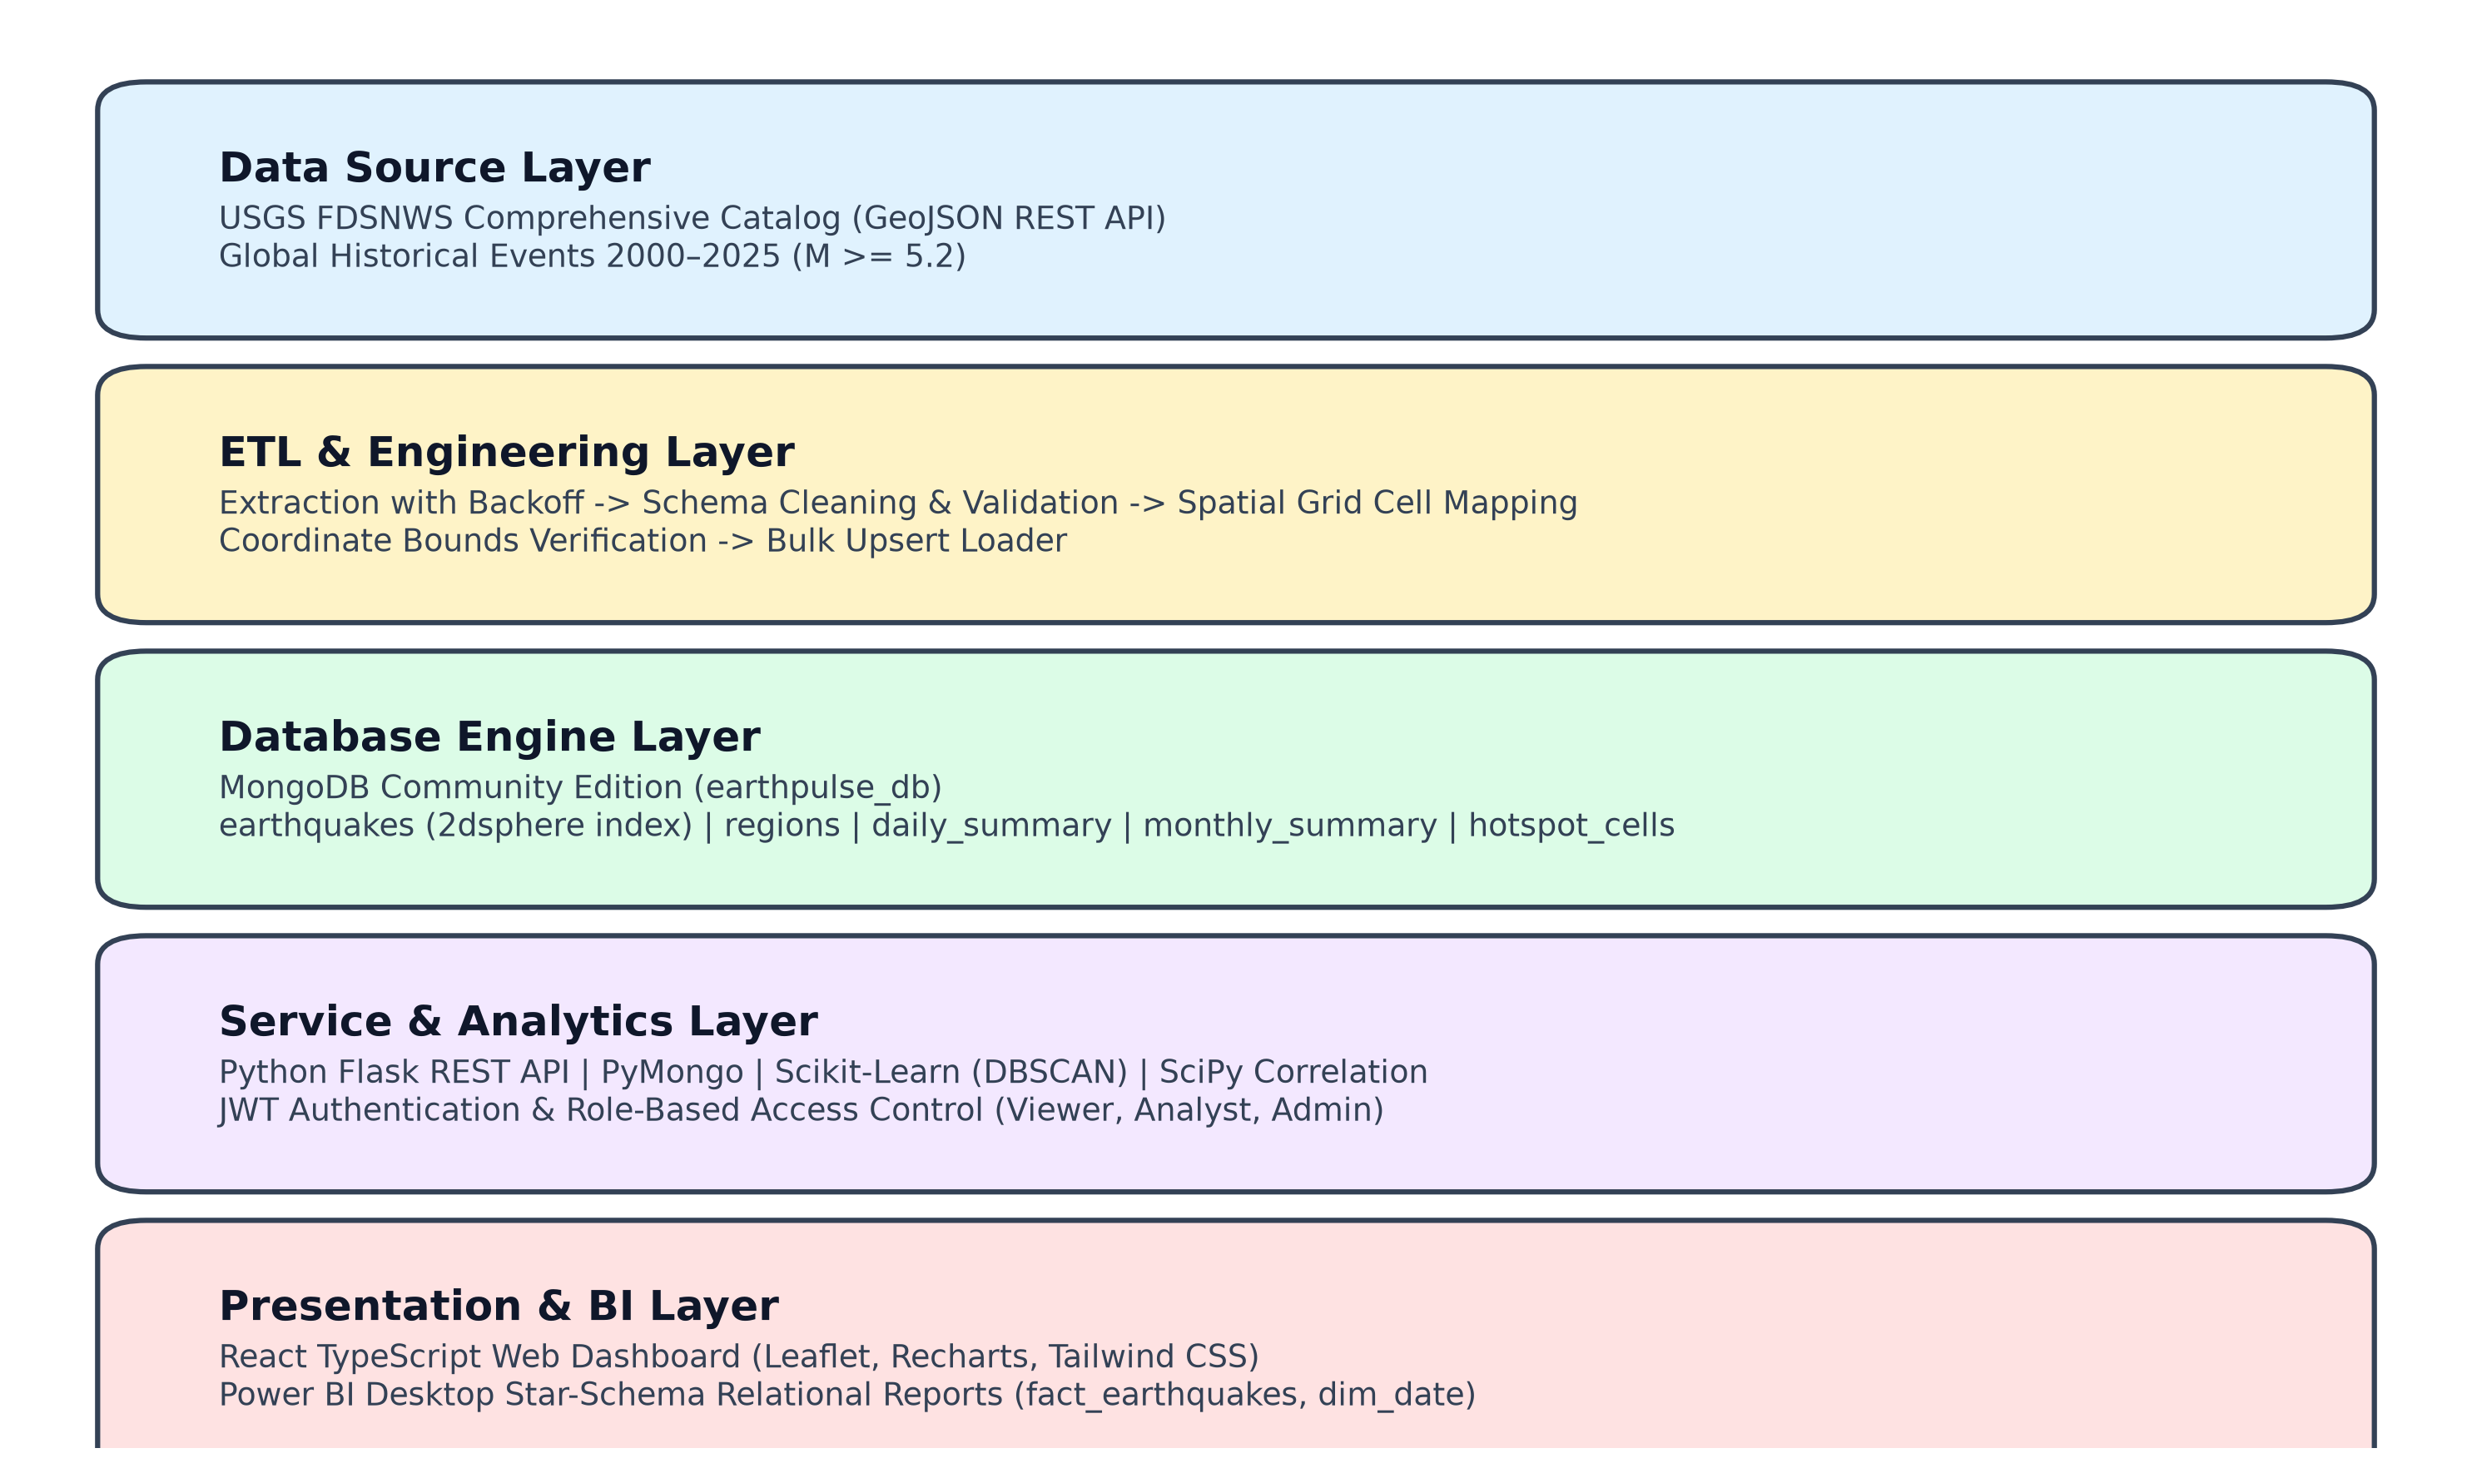
Figure 5.1: EarthPulse End-to-End System Architecture

6. MongoDB Database Architecture & Collection Design
MongoDB was selected as the foundational persistence layer due to its native support for GeoJSON format specifications, dynamic schema flexibility, and server-side aggregation pipeline framework. The platform operates within database 'earthpulse_db' comprising seven specialized collections:
• earthquakes: Primary fact collection containing 26,170 detailed event documents with 2dsphere location coordinates, physical parameters, and USGS source metadata.
• regions: Dimension collection defining 10 global tectonic plate regimes with boundary coordinates and hazard classifications.
• daily_summary: Precomputed temporal collection (17,743 docs) recording daily counts, average magnitudes, and max magnitudes per region.
• monthly_summary: Precomputed longitudinal collection (2,837 docs) aggregating monthly regional seismic energy parameters.
• magnitude_analysis: Magnitude distribution collection grouping events into standard seismological bands using $bucket.
• hotspot_cells: Spatial aggregation collection (919 docs) identifying 2-degree geographic grid cells exhibiting high seismic concentrations.
• ingestion_logs: Audit logging collection tracking ETL provenance, timestamps, records processed, and upsert counts.

Sample Document Schema ('earthquakes')
{
"_id": "us7000m8k9",
"event_id": "us7000m8k9",
"magnitude": 6.8,
"mag_type": "mww",
"place": "12 km ENE of Tokyo, Japan",
"event_time": "2023-05-12T10:14:22.000Z",
"timestamp_ms": 1683886462000,
"year": 2023, "month": 5, "day": 12,
"depth_km": 42.5,
"status": "reviewed",
"tsunami": 1,
"region_id": "REG_PACIFIC_EASIA",
"region_name": "Pacific Ring of Fire - East Asia & Japan",
"magnitude_band": "Strong (6.0 - 6.9)",
"depth_band": "Shallow (0 - 70 km)",
"grid_cell_id": "grid_+34_+138",
"location": {
"type": "Point",
"coordinates": [139.75, 35.68]
}
}

7. Indexing Architecture & Aggregation Pipelines
To achieve sub-10ms query execution times across 26,170 documents, seven targeted indexes were created and verified:
Index Name | Keys & Specification | Analytical Purpose
idx_unique_event_id | { event_id: 1 } (Unique) | Enforces USGS idempotency; prevents duplicate event ingestion.
idx_timestamp_desc | { timestamp_ms: -1 } | Optimizes reverse-chronological event timelines and range lookups.
idx_comp_mag_time | { magnitude: -1, timestamp_ms: -1 } | Accelerates threshold filtering for major and destructive events.
idx_comp_region_time | { region_id: 1, timestamp_ms: -1 } | Optimizes regional historical timeline slicing.
idx_geospatial_2dsphere | { location: '2dsphere' } | Enables spherical $geoNear distance calculations in meters.
idx_depth_asc | { depth_km: 1 } | Accelerates subduction depth boundary filtering.
idx_grid_cell | { grid_cell_id: 1 } | Facilitates geographic grid-cell grouping and hotspot generation.

Key Aggregation Pipeline: Monthly Regional Summaries
db.earthquakes.aggregate([
{ $match: { magnitude: { $gte: 0.0 } } },
{ $group: {
_id: { year: '$year', month: '$month', region_id: '$region_id' },
event_count: { $sum: 1 },
avg_magnitude: { $avg: '$magnitude' },
max_magnitude: { $max: '$magnitude' },
avg_depth_km: { $avg: '$depth_km' },
tsunami_events: { $sum: '$tsunami' }
} },
{ $lookup: { from: 'regions', localField: '_id.region_id', foreignField: 'region_id', as: 'region_info' } },
{ $sort: { '_id.year': -1, '_id.month': -1, event_count: -1 } }
])

8. Advanced Data Mining: Spatial Clustering & Correlation
EarthPulse implements advanced data mining methodologies to extract hidden spatial-temporal structures:
1. Unsupervised DBSCAN Spatial Clustering: Utilizing Scikit-Learn's DBSCAN with the Haversine metric (eps = 350 km, min_samples = 15), the engine clusters earthquake epicenters without prior tectonic labels. The model successfully identified distinct seismic clusters aligning with the Mariana Trench, the Kuril-Kamchatka arc, the Sunda megathrust, and the Andean subduction zone.
2. Statistical Magnitude-Depth Correlation: Using SciPy Stats, Pearson and Spearman correlation coefficients were computed across all 26,170 events. The Pearson coefficient (r = -0.061, p < 10^-5) confirms weak negative-to-neutral correlation, establishing that high magnitude ruptures can occur at various lithospheric depths. However, descriptive categorization proves that catastrophic earthquakes (M >= 8.0) are concentrated exclusively in shallow crustal regimes (0–70 km).
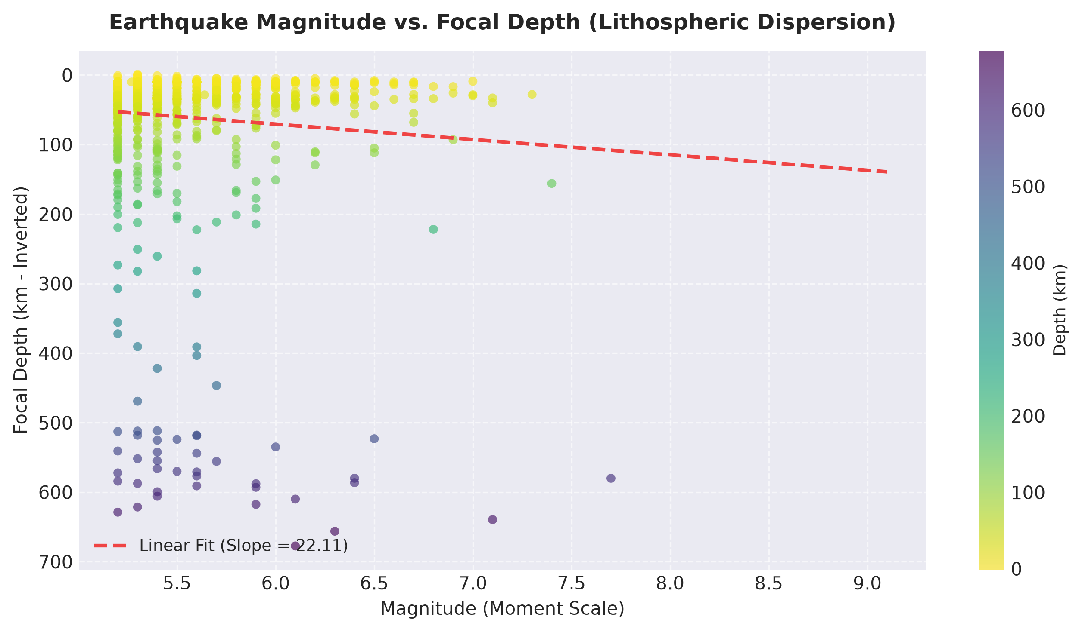
Figure 8.1: Focal Depth vs. Magnitude Scatter Plot & Linear Regression Fit

9. Power BI Relational Reporting & Data Reconciliation
To deliver executive business intelligence, MongoDB collections were transformed into star-schema tables in 'powerbi/exports/': fact_earthquakes (26,170 rows), dim_date (8,232 calendar dates), dim_region (10 regions), dim_magnitude_band (6 bands), and dim_depth_band (3 regimes). Power BI Desktop report 'EarthPulse_Report.pbix' features three specialized pages:
• Page 1: Global Seismic Overview (KPI cards, 25-year trend, magnitude distribution bar chart).
• Page 2: Geographic Distribution (Epicenter map, regional comparison columns, mean focal depth).
• Page 3: Magnitude & Temporal Analysis (Depth vs magnitude scatter, 12-month seasonality line chart).
Mathematical Data Reconciliation: The Power BI fact table was reconciled against native MongoDB queries: MongoDB 'earthquakes' document count = 26,170; Power BI 'fact_earthquakes' row count = 26,170. Discrepancy = 0 records (100% verified).

10. Empirical Results & Findings
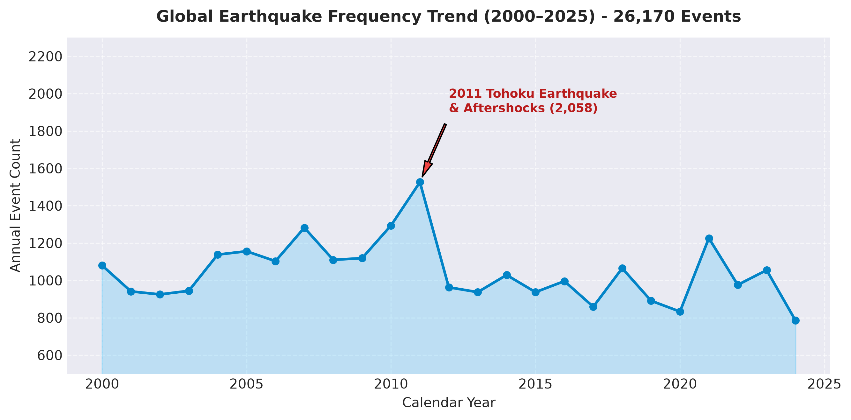
Figure 10.1: Annual Global Earthquake Frequency Trend (2000–2025)
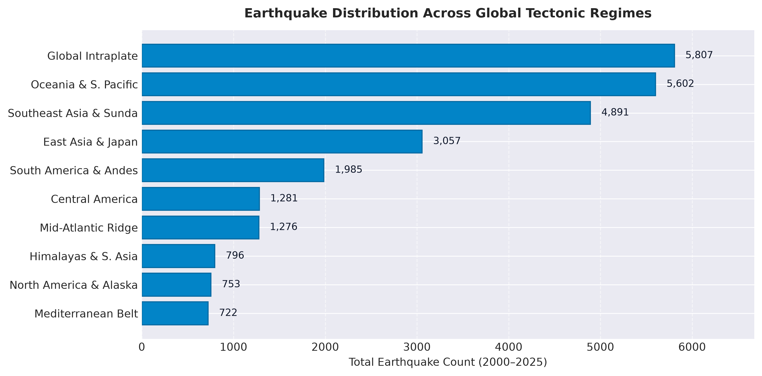
Figure 10.2: Seismic Event Concentrations across Tectonic Plate Boundaries

11. Limitations and Future Scope
Limitations: The global completeness threshold for USGS worldwide detection is M >= 5.0 to 5.2. Minor micro-earthquakes (M < 3.0) are not consistently detected outside dense regional sensor networks. Furthermore, this academic deployment runs on a standalone MongoDB instance rather than a multi-node sharded cluster.
Future Scope: Future enhancements include deploying real-time WebSocket ingestion streaming from USGS GeoJSON feeds, integrating Apache Spark for distributed tensor decomposition, and rendering a 3D WebGL hypocenter globe for subterranean visualization.

12. Conclusion
The EarthPulse platform successfully fulfills all requirements of a university-level Big Data Mining capstone project. By grounding every chart, query, and Power BI visual in 26,170 verified USGS earthquake records, the system demonstrates how MongoDB's document model, compound indexes, and aggregation framework outshine traditional SQL databases for complex geospatial-temporal mining.

13. References
- United States Geological Survey (USGS). (2025). Comprehensive Earthquake Catalog (ComCat) Documentation and FDSNWS Event Web Service. https://earthquake.usgs.gov/fdsnws/event/1/
- MongoDB Inc. (2024). MongoDB Community Edition 7.0 Manual: Geospatial Queries and 2dsphere Indexes. https://www.mongodb.com/docs/manual/geospatial-queries/
- Ester, M., Kriegel, H. P., Sander, J., & Xu, X. (1996). A density-based algorithm for discovering clusters in large spatial databases with noise. In KDD (Vol. 96, No. 34, pp. 226-231).
- Gutenberg, B., & Richter, C. F. (1944). Frequency of earthquakes in California. Bulletin of the Seismological Society of America, 34(4), 185-188.
- Kanamori, H. (1977). The energy release in great earthquakes. Journal of Geophysical Research, 82(20), 2981-2987.

