SchedOpt: A Constraint Programming Approach to Class Timetable Optimization in the Ateneo de Zamboanga University’s Registrar



A RESEARCH PRESENTED TO
THE FACULTY OF THE COLLEGE OF SCIENCE AND INFORMATION TECHNOLOGY
ATENEO DE ZAMBOANGA UNIVERSITY

IN PARTIAL FULFILLMENT
OF THE REQUIREMENTS FOR CS.413

SAKILI, ALI ADIB S.
YU, JEROLD CHARL D.

CHAPTER I
INTRODUCTION
1.1. Background of the Study
Schedule optimization plays a role in managing time, manpower, and activities and enhances efficiency in organizing tasks. Its purpose is to distribute workloads by allocating resources in an optimal manner; it coordinates time, energy, and efficiency, boosting productivity. Developing a schedule optimizer, therefore, eliminates intensive manual supervision, input, verification, and correction of the university’s scheduling process. It guarantees the efficient use of energy and resources, allocating them accordingly.
Timetabling is one of the most important parts of the education system. It is the practice of allotting different classes, teachers, and students to specific times and different venues in such a way that the students follow the curriculum, the resources are used, and the individuals are helped. A well-planned schedule of classes optimizes production, minimizes conflict, and eases operations of the classes on a daily basis (Enenche, 2019). However, schedules are subject to constraints, including but not limited to room occupancy, the availability of instructors and students, alongside the considerations for their workloads and preferences, and the limited timeslots in which each student can attend. All of which contribute to the growing complexity of the process. (Adawiah, 2023)
Ateneo de Zamboanga University, is still using the traditional manual scheduling system for generating class timetables and faculty assignments. Prior to the start of the current semester, there are a countless number of programs and courses that require assignments, and this is the time when the university tackles the major challenge of creating course timetables. The need for automating this scheduling approach has been largely evident; implementing SchedOpt, a timetabling system using constraint programming, is a process that is automated, and it is performed by systematically designing schedules with rooms or courses that have special requirements, such as faculty workloads, rooms that should not be used at the same time, and the rooms that might be optimally used, can be examples of them. It speeds up the whole process of scheduling by ensuring that no student is assigned to the same course at a given time, ensuring a more reasonable course selection with satisfactory scheduling when choosing during the online consultation phase of the enrollment. The timetabling system can significantly reduce the time and consume much less energy for the scheduling part and assure the accuracy, efficiency, and fairness in the end; thus, the university will be able to improve the academic experience for the students and the staff. This, among many other benefits that will be discussed in the coming sections, make SchedOpt a viable option to replace the traditional scheduling system ad pave way for a new, advanced, and innovative solution to the Ateneo de Zamboanga University’s persistent challenge.
SchedOpt, however, does not solely use constraint programming for its operations. It is a combination of the aforementioned, founded by constraints, functions, and configurations made by Cielomi Jalon, et al for their 2024 paper, entitled: “Optimization of Classroom Usage Through Effective Scheduling”. Initially a submission to the Ateneo de Zamboanga Univeristy’s Mathematics department, it has since reached the institution’s Vice President for Higher Education, Father Rene S. Tacastacas, who validated the concerns and gave a green light for a full development in coordination with the AdZU registrar.
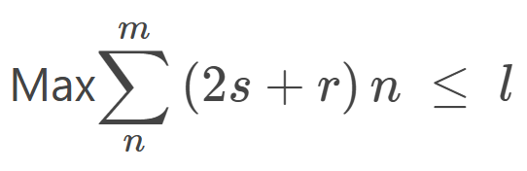
(Jalon, et al, 2024)
Figure 1 General function for maximizing classroom utilization by Cielomi Jalon, et al. 2024
As shown in Figure 1, the mathematical model’s proposed general optimization function for determining the number of classes allowed per day for small, medium, and large classrooms, not including the Multipurpose Covered Court fields is defined as Max ∑_{n}^{m} (2s + r)n ≤ l where:
- n = lower bound of classroom list
- m = upper bound of classroom list
- s = special classes (<90 minutes)
- r regular classes (90 minutes)
- l = max number of schedules
In addition, this general function will abide by the second semester of the school year 2023-2024’s data which came out at 866 classes and a total room count of The total number of rooms is 52. This, however, only serves as an example and does not reflect other semesters and school years. Figure 2 will discuss an application

(Jalon, et al, 2024)
Figure 2. Example application of the general function using the list of small rooms by by Cielomi Jalon, et al. 2024
As shown in Figure 2, small rooms are taken as an example. The set of small rooms is defined as: S = {C 205, LRC 204 A, LRC 207, LRC 303A, LRC 208, LRC 211, LRC 305, LRC 311}, with 7 as the maximum number of allowed classes held for each room for regular classes and 3 for special classes. Because there are 8 rooms in the set, the total is calculated as number of rooms x maximum number of classes. Therefore, the maximum number of classes that small rooms can host is 56 per day.
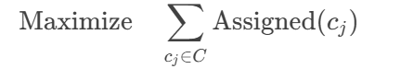
Figure 3. Application of Constraint Programming
With the help of the presented optimization function from the mathematical model of Cielomi Jalon, constraint programming can be defined as Max ∑_{cj∈C} Assigned(cj) where cj∈C checks if the course is within the bounds of the set of constraints and Assigned(cj) returns 1 if so. Otherwise, it is set to 0

1.2 Purpose and Description
As previously mentioned, efficient and adaptive scheduling is a major requirement and need not just for the Ateneo de Zamboanga University. While traditional manual timetabling methods are still viable, it involves extensive supervision and a potential for errors in great numbers, inefficient use for the university's resources such as rooms and buildings. All of which are deterrents for the university's registrar office. In alignment with these highlighted issues, SchedOpt has been designed using a mathematical model, enhanced further by constraint programming tools and techniques as a solution that automates the scheduling process via four key areas of improvement: efficiency through automation, conflict-free scheduling in minutes, optimal university resource allocation, and finally, scalability and flexibility to varying schemas.
Because SchedOpt is developed using a constraint programming approach, it adheres to various rules, both strict and lenient, also known as constraints. These constraints ensure that the system follows a guideline and set of criteria when looking for a solution and calculating possible and valid combinations. The following are the hard and soft constraints SchedOpt wishes to follow.
1.2.1 Constraints
1.2.1.1 Hard Constraints
Hard constraints are essential or non-negotiable rules and requirements that must be satisfied for a system to be considered successful or valid. They represent the essential or crucial concepts of SchedOpt
- Each course must be assigned a room, timeslot, and weekday
- No two courses must have the same room, timeslot, and weekday.
- Rooms must be large enough to accommodate the number of students enrolled in a course
- Consecutive classes must not exceed 3 hours
- An activity hour be set in place in which no classes may be held
1.2.1.2 Soft Constraints
Soft constraints are those that ideally should be met and satisfied and are not necessarily a requirement to SchedOpt’s success. These constraints provide flexibility and quality to the system but may be broken when not often done. It is, however, viewed as objectives to maximize the system’s effectiveness and overall performance
- Smaller courses must ideally be assigned to small rooms but may utilize large rooms when none are available
- Smaller courses may be paired with other smaller courses or larger ones when the number of students enrolled is too low.
- Classes may be held at different rooms on alternate days
- PE and NSTP-type classes have their own special timeslots but may be moved around if necessary

1.2.2. Visual Representation of Constraints
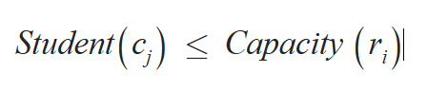
Figure 4. Representation for student count and room capacity
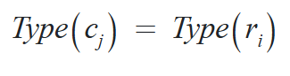
Figure 5. Representation of courses with their specialized rooms
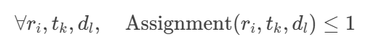
Figure 6. Representation of assignments of all courses must be assigned one set of room, timeslot, and day but not exceed 1
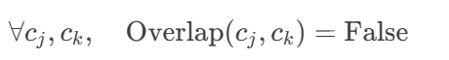
Figure 7. Representation of no two courses may overlap in their schedule at a given timeslot, day, and room
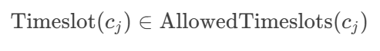
Figure 8.Representation of PE and NSTP-type classes

1.3. Objectives
1.3.1. General Objective
To Enhance the scheduling system based on Cielomi’s mathematical model, which utilizes constraint programming, named SchedOpt, for the Ateneo de Zamboanga University that optimizes resource usage such as rooms and timeslots, and provide a conflict-free weekly schedule per semester to address the challenges of manual, labor-intensive scheduling procedures used by the AdZU registrar presently.
1.3.2. Specific Objectives
- Design a constraint programming system named SchedOpt that ensures the creation of a non-conflicting weekly course schedule, optimizing the use of available classrooms and minimizing unused space
- Set priority courses for rooms that are in close proximity to each other to limit wasting time in traveling from one room to another
- Develop SchedOpt into capable of adjusting assignments when there are post-enrollment changes including additional courses offered or late student assignments.
1.3. Scope and Limitations
This research focuses developing SchedOpt for Ateneo de Zamboanga University (AdZU), with the goal of automating and replacing the AdZU registrar's present manual scheduling procedure. Beneficial characteristics of the system include prioritizing room assignments to minimize travel time between courses, avoiding conflicts and overlaps in course scheduling, and assigning rooms efficiently to minimize unused space. Furthermore, the system's adaptability enables schedule modifications in reaction to post-enrollment modifications, including the addition of additional courses or late student assignments. The period of study will span one year, covering the implementation phase, the testing phase (which will be conducted during the summer and the first semester), and the evaluation of the system's effectiveness.
However, the biggest limitation presented by this research is its sole compatibility with AdZU-specific constraints. It does not acknowledge the more general university management responsibilities or educational institutions with vastly differing scheduling procedures, variables, and constraints. Moreover, the constraints and limitations set during the system's initial design determine how adaptable it is to changes, which may necessitate further adjustments for unforeseen and future scenarios like addition of new rooms, courses or modifications in given time slots.

1.4. Significance of the study
The study could be of importance to the following:
Registrar Staff: SchedOpt is aimed at reducing the burden of the staff in manually creating timetabling schedules and reducing human error.
College Institution: SchedOpt aims to efficiently utilize all resources of the Ateneo de Zamboanga University efficiently.
Faculty and Instructors: Instructors can benefit from SchedOpt by Fewer scheduling conflicts or time overlaps between classes, making their teaching assignments more manageable.
Future Research: SchedOpt aims to build a foundation on future research on the application of Cielomi’s mathematical model, utilizing constraint programming in other fields.

1.5. Conceptual Framework
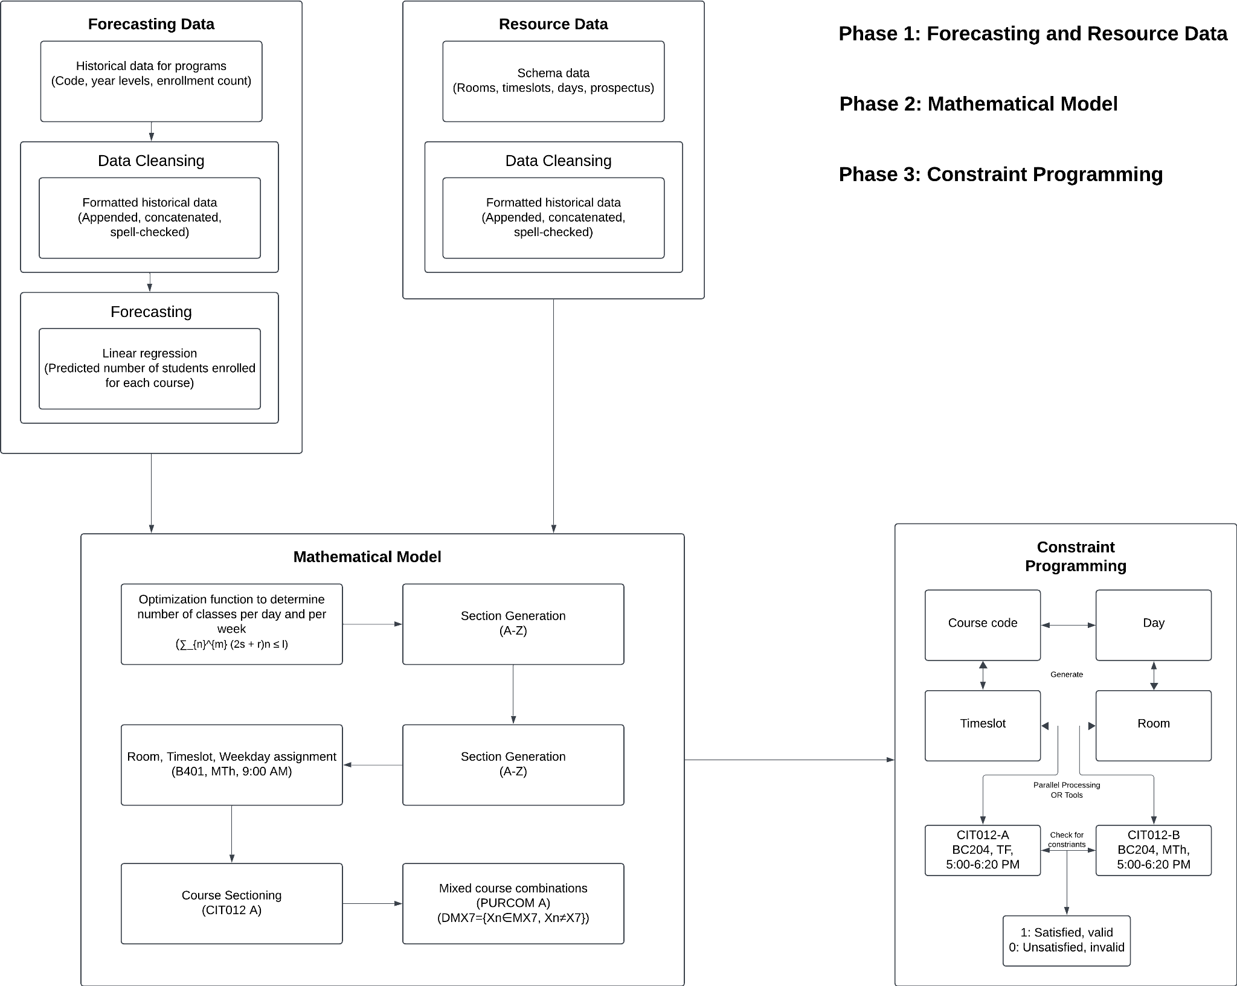
Figure 9. Conceptual Framework
SchedOpt undergoes a three-phase process consisting of: First, importing and inputting of data. Second, importing of the mathematical model and assessment of miscellaneous resources such as number of rooms, number of allowed classes, number of weekdays and schema, and mixed-course defining.Third, performing constraint programming to determine whether solutions are valid or invalid. To go more in-depth:
First Phase (Importing of forecasting and resource data). SchedOpt requires the importing of forecasting and resource data through Microsoft Excel (.xlsx) files, or manual inputting from the user interface itself. For forecasting the data, the imported excel file is handled, read, and uploaded before it is cleaned. This ensures that the data retains their integrity by appending, concatenating or performing spell-checks through a dictionary. The forecasting data is then run through linear regression to generate a prediction of the number of students that would enroll in a given course. Resource data include rooms data, schemas such as timeslots and day combinations. These are similarly cleaned before the system proceeds to the second phase
Second Phase (Mathematical Model). Following the importing, cleaning and forecasting, the mathematical model is applied. Using the presented optimization function from Figure 1, the number of possible schedules is determined by the number of rooms and the number of max allowed classes per day. Sections are generated afterwards, followed by assigning a valid combination of rooms, timeslots, and days. Then courses are sectioned and assigned based on the number of students enrolled. For subjects that are more generalized and are not considered major or block-subjects, courses and sections may be mixed together, combining smaller sections into medium and medium into large.
Third Phase (Constraint Programming). The final phase involves the application of the constraint programming where the course codes, rooms, timeslots, and weekdays are once again assessed if they meet all resources. Through parallel processing and OR tools, SchedOpt performs constraint programming to efficiently generate items or schedules. These schedules are checked through assessing all constraints If the system finds that all hard constraints are satisfied, the system returns Assigned(cj) from Figure 3 as 1 for valid solutions. Otherwise 0 for invalid solutions.
CHAPTER II
REVIEW OF RELATED LITERATURES
2.1. University Timetabling
University Timetabling refers to the process of developing an organized timetable that allots particular time periods to different jobs, activities, or events. It is crucial in educational environments for managing student groups, teacher availability, room assignments, and class schedules. It minimizes conflicts between subjects, teachers, and rooms while providing a guarantee that every course is optimally placed equally across all available time periods. The goal of timetabling is to balance faculty and student demands and preferences with the efficient use of resources, such as classroom space and teaching staff (Wren, 1996).
This section of the Review of Related Literatures reviews the various presented approaches to handling University Timetabling problems. The University Timetabling Problem (UTTP), which entails scheduling classes, instructors, students, and rooms while taking into account a number of restrictions, is reviewed in this section. Babaei, Karimpour, and Hadidi (2015) investigate how to create conflict-free timetables by combining metaheuristic approaches like genetic algorithms with operational research techniques like constraint programming. In order to develop flexible and scalable schedules, Rudová, Müller, and Murray (2011) concentrate on the use of search algorithms, such as weighted constraint satisfaction problems (WCSP) and iterative forward search (IFS).
2.1.1 University Course Timetabling Problem
Babaei, Karimpour, and Hadidi propose in their 2015 research on surveys for approaches in a common university problem known as the University Course Timetabling (UCTTP). The researchers define the problem as the allocation of key resources, students, professors/teachers while it adheres to a specific institution’s hard and soft constraints, highlighting various operational and artificial-intelligent systems as predominant methods in approaching the said problem.
Resources according to the researchers are listed as rooms, students, timeslots, professors/teachers and events which require assignment without contradicting another. Timeslots are thereby, hourly or any temporally measured variable in which a course can be assigned alongside the students participating and the professors or teachers facilitating the class. Next constraints are classified into either soft or hard constraints. Hard constraints refer to requirements that must be satisfied for the system to work. These constraints require utmost importance and adherence to generate solutions without conflicts which include: courses must not be assigned at two rooms of the same timeslot simultaneously, the capacity of rooms should be proportional to the number of students enrolled in that course. Soft constraints meanwhile, do not necessarily require satisfaction but will increment the benefit of the solution as the complexity grows with the number of soft constraints satisfied. These include lunch break timeslots, room change in case of unavailability by either the professor or students and the temporal quantity of each timeslot defined (Babaei, Karimpour, Hadidi. 2015). The researchers however, stress the importance of satisfying a minimum of both constraints but were unable to give a specific answer as institutions vary from each other, thereby requiring or containing different complexities and constraints.
The researchers present operational research techniques such as graph coloring, integer/linear programming and constraint programming to focus on developing conflict-free schedules. Highlighting both the advantages and disadvantages of each technique which all boil down to the rising computational complexity, leading to inefficiency in large datasets or in this case, large institutions with greater numbers of resources and events. For these institutions, metaheuristic methods, including genetic algorithms are adopted due to its ability to explore complex spaces and develop solutions to satisfy both hard and soft constraints. In both cases, the approaches balance minimizing the violation of constraints while maximizing schedule quality (Babaei, Karimpour, Hadidi. 2015)..
The researchers also emphasize the growing dependence on distributed multi-agent systems (MAS) to improve a proposed system’s scalability and flexibility. As the institution’s size grows, it requires more fine tuning that allows it to adapt to new changes without breaking down or revisiting segments of the system. This research paper documents the importance of blending computational efficiency with adaptability in scheduling systems. The surveyed approaches provide a foundation for developing advanced scheduling systems tailored to a specific institution that satisfies its needs and aligning itself with the objectives of Schedule Optimizing System for universities with possibilities of extending beyond the realm of educational institutions as it may also prove to be beneficial for other professional settings.
2.1.2 Search Operations on Complex University Timetabling
Rudová, Müller, and Murray's 2011 research on utilizing search algorithms for complex timetabling operations offers a thorough framework for handling difficult university course scheduling issues. The authors emphasize the importance of a strong course structure model that takes into account both hard and soft constraints. The research showcases how to create timetables that balance professor/teacher availability, room limitations, and student preferences by utilizing constraint satisfaction approaches and iterative forward search (IFS). The authors used Purdue University as a case study, effectively scheduling hundreds of thousands of student requests and thousands of courses every semester.
The research makes a distinction between soft and hard constraints, such as instructor-specific requirements and student time preferences, as well as room availability and non-overlapping schedules. Weighted constraint satisfaction problems (WCSP), which enable scalable and adaptable solutions to intricate scheduling issues, are used to describe these constraints. In order to handle dynamic changes in timetables and guarantee that previously allocated schedules are not excessively disrupted (Rudova, et al. 2011).
The research also describes how domain-specific limitations might be used to meet certain institutional needs. Examples include balancing room utilization and making sure students' classes are close to one another. Another point made is the insights into effectively managing multi-level scheduling concerns by merging departmental and central timetabling issues.
Overall, the researchers wrote a paper to detail a comprehensive perspective that offers useful approaches for university schedule optimization systems, especially when it comes to managing extensive, practical limitations and adjusting to changing scheduling requirements. The goals of a university-wide Schedule Optimizing System are tightly aligned with its guiding principles and algorithms, which include the IFS and MPP, and serve as a basis for creating flexible and effective scheduling solutions.

2.2. Constraint Programming
Constraint Programming (CP) is a method used mostly in the computer science field. It involves resolving combinatorial scenarios. In order to develop a solution that satisfies these restrictions, algorithms are used to define the problem using constraints that characterize the properties of a solution. In CP, constraints define the relationships or limitations between variables, which stand in for the unknowns in a problem. They act as the bridge to determine whether the programming objective is satisfied or not. Such constraints can either be hard which mean utmost priority and adherence, or soft which means relatively flexible but beneficial to adhere. Scheduling is a typical application of constraint programming, where the goal is to allocate activities to time slots while meeting a number of constraints, including task dependencies, resource limitations, and availability (Rossi, et al. 2008). .
Constraint Programming’s specialty lies in its specialty. Unlike metaheuristic algorithms and search operations which both aim to fulfill one specific objective, CP focuses on satisfying every presented constraint, both hard and soft, to devise a viable solution. This essentially allows CP to find all possible valid arrangements for events or tasks rather than maximizing one numerical value for assessment (Rossi, et al. 2008).. CP works by scanning a search space and eliminating infeasible combinations to limit the search space, while keeping the constraints ready to be assessed until the space is eventually reduced to only the acceptable combinations.
Constraint Programming has four main components: Variables, Domains, Constraints, and Search. Rossi, et al. (2006.) defines variables as the set of items that need to be assigned and related to similar variables in different sets that are applicable to the solution. Domains are all the possible combinations and values that variables may be placed into. Constraints are the rules to be followed, that come in hard and soft constraints. These constraints serve as the backbone for programming employing CP to work as they clearly state the rules of relation that must be satisfied. Finally, search is the strategy used by the CP paradigm.
2.2.1. Constraint Programming in Educational Timetabling
In their 2002 paper, Valouxis and Housos examine how Constraint Programming (CP) can be used to solve high school scheduling issues. They highlight how CP can handle intricate constraints and improve solution efficiency by incorporating Operations Research (OR) methodologies. To address the hard constraints such as preventing scheduling conflicts and guaranteeing teachers have a balanced workload and the soft constraints including reducing idle time and involving teacher preferences for early or late shifts, the authors model the issue as a Constraint Satisfaction Problem (CSP) and use foundational principles of CP (Valouxis, Housos. 2003).
The researchers emphasize on reducing idle time and considering teacher preferences for early or late shifts as additional constraints, offering a strong framework for scheduling instructors and course sections. ILOG Solver was used as the main CP tool by the researchers to navigate complex search spaces and handle their own listen constraints. Additionally, the research presented is refined using local search algorithms for one and two-day intervals in exchange for the original solution. The CP engine is guided by what the researchers refer to as lower bounds provided by Operational Research methodologies.
Summarizing their paper, optimal solutions were obtained without idle hours for smaller sample sizes with 5-6 course sections and 11-15 professors. Furthermore, minimal errors were found for slightly larger sample sizes. Regardless, the researchers found that the results were almost ideal for problems that involved greater volumes of professors and course sections. Its scalability was also demonstrated by the execution time which varied from 15 minutes to an hour, depending on the sample size. The accuracy of the model is further demonstrated by numerical results; for example, in Problem 2, the computed lower bound for teacher preference adherence was 1535, which corresponded to the actual cost attained (Valouxis, Housos. 2003).
2.3. Mathematical Model by Cielomi Jalon, 2024.
According to Jalon, Tee, and Alvarez in their 2024 paper on effective scheduling, a persisting challenge faced by the Ateneo de Zamboanga University, as well as most educational institutions globally include inefficient scheduling systems that often lead to underutilized resources, scheduling conflicts, and disruptions in academic activities. All of the mentioned ultimately hinder student learning outcomes and institutional productivity of staff, especially administrators and registrar personnel. Under the guidance of Mr. Rey S. Reyes at Ateneo de Zamboanga University, timetabling optimization focuses on maximizing classroom utilization, minimizing delays, and enhancing the overall educational experience through mathematical modeling and automated scheduling tools (Jalon, et al. 2024)
Jalon et al. (2023) integrates mathematical optimization models with algorithmic programming to generate conflict-free schedules. Through a general maximization function, the paper tackles the method of determining the maximum classes that may be held at a given day. It is defined as:
The paper also discussed vital constraints and resources that may generally be applicable to all educational institutions, with tweaking and personalization. In particular, room sizes may vary according to the authors and the number of classes allowed may change depending on the scale and capacity of the university in question. Another influential point made by Jalon, et al. is the combination of classes for generalized, minor subjects. All concepts presented in the paper have been validated by the Ateneo de Zamboanga University’s administration which makes it a good foundation for researching the delve in this topic. SchedOpt, for one, is currently utilizing the contents as reference.
Ultimately, the researchers have shown that an effective and accurate mathematical model, is vital and extremely useful in developing a system that aims to solve university-wide issues. Through the introduction of viable operations research models and mathematically-verified approaches, future researchers may be equipped with a blueprint for institutions that aim to balance growth with resource constraints. Immediate adoption of such systems can skyrocket academic excellence and operational sustainability on a national scale (Jalon, et al. 2024). .

REFERENCES
Adawiah, R. (2023). Teacher’s constraints and Challenges in Implementing Student Attitude Assessment in Junior High School. Open Education Studies, 5(1). https://doi.org/10.1515/edu-2022-0204
Babaei, H., Karimpour, J., & Hadidi, A. (2015). A survey of approaches for university course timetabling problems. Computers & Industrial Engineering, 86, 43–59.
Dills, A., & Hernandez-Julian, R. (2008). Course scheduling and academic performance. Economics of Education Review, 27, 646–654.
Edwards, F. (2012). Early to rise? The effect of daily start times on academic performance. Economics of Education Review, 31, 970–983.
Enenche, U. L. a. W. R. E. N. C. E. (2019, January 1). The importance and usefulness of Timetable to schools. https://www.academia.edu/40472867/The_Importance_and_Usefulness_of_Timetable_to_Schools
Jalon, C, Tee, K.Z. Alvarez, M. (2024). Optimization of Classroom Usage Through Effective Scheduling. Ateneo de Zamboanga University, pp. 1-10
Rossi, F., Van Beek, P., & Walsh, T. (2008). Constraint programming. Foundations of Artificial Intelligence, 3, 181–211.
Rossi, F., Van Beek, P., & Walsh, T. (2006). Handbook of constraint programming. Elsevier.
Rudová, H., Müller, T., & Murray, K. (2011). Complex university course timetabling. Journal of Scheduling, 14, 187–207.
Steiner, E., Pferschy, U., & Schaerf, A. (2024). Curriculum-based university course timetabling considering individual course of studies. Central European Journal of Operations Research. https://doi.org/10.1007/s10100-024-00923-2
Valouxis, C., & Housos, E. (2003). Constraint programming approach for school timetabling. Computers & Operations Research, 30(10), 1555–1572.
Wren, A. (1996). Scheduling, Timetabling and Rostering – A Special Relationship? In (Burke & Ross, 1996a), pp. 46–75.

