Tenzin Rabjam

CIS 3540

9/25/2018

1. What is a point in time restore (mark)?

Ans. Point in time allows to restore a database into a state it was in any point of time.

2. What do you need to backup and what options on the database need to be set to be able to do a point in time restore (mark)?

Ans. For option to work, the database needs to be either in the FULL or Bulk-Logged recovery model and you need to be doing transaction log backups.

3. Test your own point in time (mark) restore with the Mafia Works db.

RESTORE DATABASE MafiaWorks FROM DISK = 'C:\ MafiaWorks.BAK'

WITH NORECOVERY

GO

RESTORE LOG MafiaWorks FROM DISK = 'C:\ MafiaWorks.TRN'

WITH RECOVERY,

STOPAT = 'Sep 23, 2018 05:31:00 PM'

GO

Or

Through the options on SQL server management studio

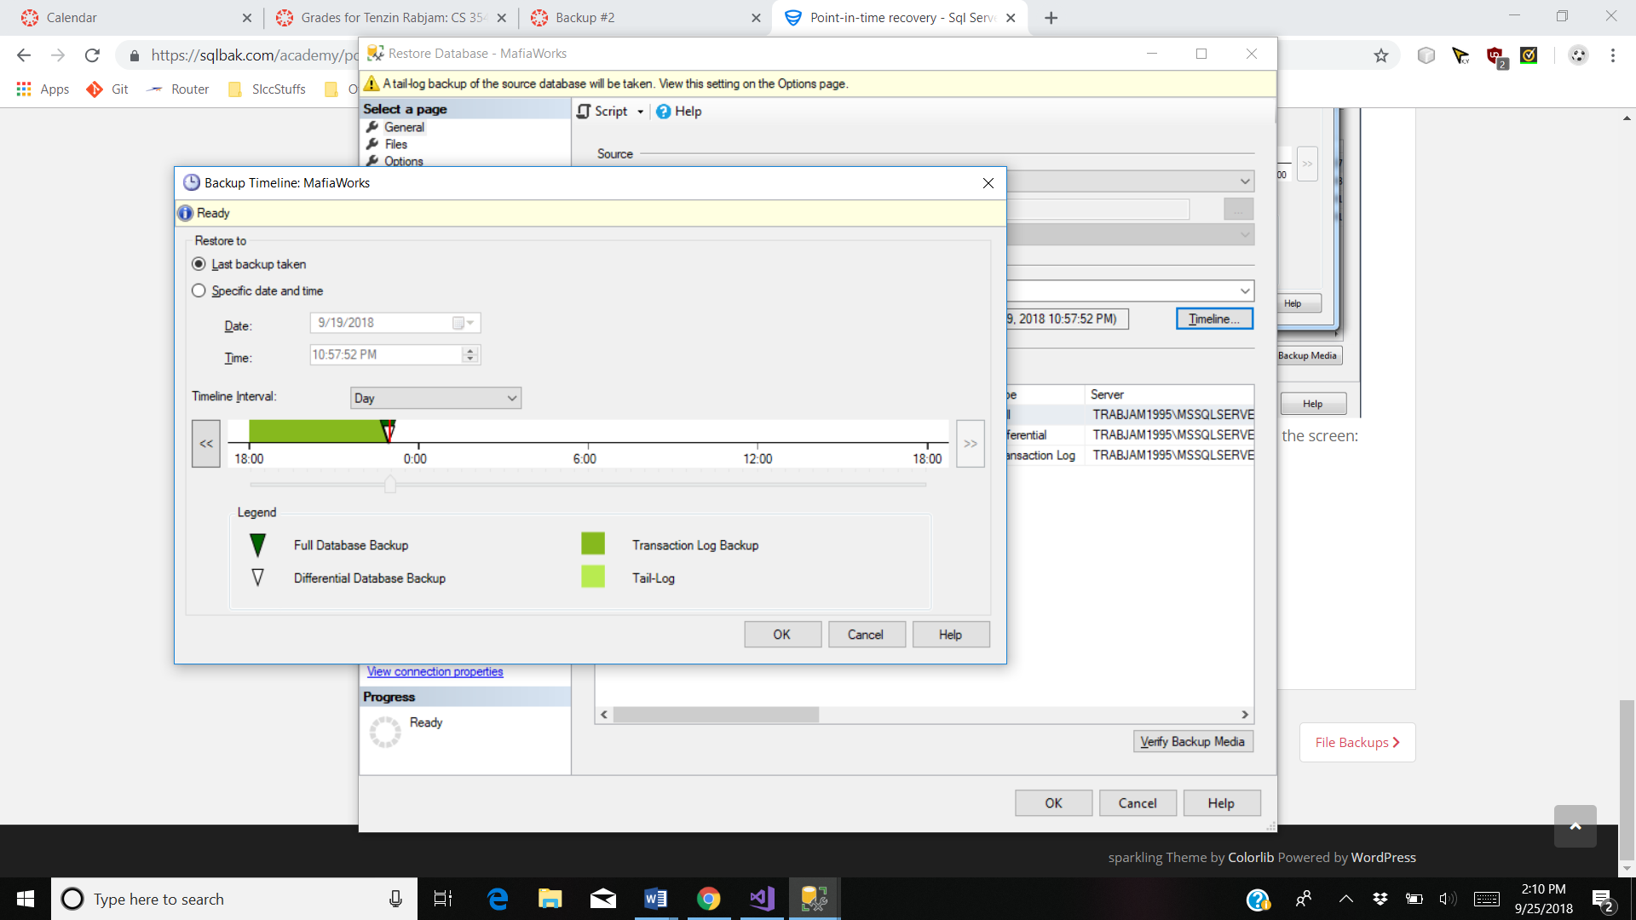

4. What is the maintenance plan wizard?

Ans. The Maintenance Plan Wizard creates a maintenance plan that Microsoft SQL Server Agent can run on a regular basis. This allows you to perform various database administration tasks, including backups, database integrity checks, or database statistics updates, at specified intervals.

5. Build a simple maintenance plan.

For a simple maintenance plan, I have a created a maintenance plan called Database backups, which has three sub plans for three different type of backups(full, differential and transaction logs).

