Project Title:

**Travel Blog**



**Submitted By:**

* Savio Nazareth | 2462362 | savio.john@btech.christuniversity.in
* Tenzin Rigzin | 2460462 | tenzin.rigzin@btech.christuniversity.in
* Shamith Gowda | 2462530 | shamith.m@btech.christuniversity.in

**Course:** Web Design Fundamentals **Instructor Name:** Narendra Kumar **Institution:** Christ University **Date of Submission:** 11/08/2025

**2. Abstract**

This project is a front-end travel blog website titled "WanderBliss," designed entirely using HTML5 and CSS3. It features a clean, modern UI/UX layout with a focus on showcasing travel destinations, recent blog posts, blogger information, and an Instagram feed. The goal was to create an engaging and visually appealing interface that is easy to navigate and mobile-friendly. Core technologies include HTML5 for semantic structure and CSS3 for styling, flexbox layouts, and responsive design principles. The final outcome is a fully functional front-end that could be enhanced with dynamic features in the future, serving as a template for travel bloggers or tourism-based websites.

3. Objectives

* Create an attractive, user-friendly interface for travel blog readers.
* Ensure responsive design for seamless use on desktops and mobiles.
* Organize content logically to improve navigation and discoverability.
* Enhance visual appeal using consistent styling and interactive elements

4. Scope of the Project

Focus: Front-end design only.

Excludes: Backend processing, API integration, or JavaScript-driven features.

Designed for desktop, tablet, and mobile devices.

Uses open-source images and pure HTML/CSS (no frameworks like Bootstrap).

5. Tools & Technologies Used

* HTML5 for semantic structure
* CSS3 for styling and layout (including Flexbox and CSS Grid)
* Basic inline CSS for image styling
* Responsive design techniques for mobile compatibility

6.HTML Structure Overview

The HTML structure includes a sticky header with navigation, a main container featuring a highlighted post, a grid of recent posts, and a sidebar with author bio and categories. The footer contains social media previews and a newsletter signup. Semantic tags (header, main, section, aside, footer) organize content clearly.

7. CSS Styling Strategy

Primary styling in blog.css + internal style block for image adjustments.

Layout achieved using Flexbox and CSS Grid.

Media queries planned for responsiveness.

Hover effects for interactive UI.

Mobile-first design considerations.

8. Key Features

* Sticky navigation bar for easy access to menus
* Featured post with image and summary highlights
* Responsive grid displaying recent blog cards
* Sidebar with author bio and clickable categories
* Footer including Instagram gallery and newsletter subscription
* Back-to-top button for smooth scrolling

9. Challenges Faced & Solutions

* **Challenge:** Ensuring responsive layout across multiple screen sizes.  
  **Solution:** Used CSS Grid and media queries to adapt columns and stack content on smaller devices.
* **Challenge:** Maintaining consistent spacing and alignment.  
  **Solution:** Applied universal box-sizing and margin/padding resets, with flexible containers.

10. Outcome

The project successfully delivered a clean, responsive travel blog interface that is visually appealing and easy to navigate. User feedback highlighted the clear organization and smooth responsiveness on both desktop and mobile devices.

11. Future Enhancements

* Integrate JavaScript for dynamic content loading and interactivity.
* Add dark mode toggle for user preference.
* Implement a content management system (CMS) backend for easy blog updates.
* Enhance accessibility features for better usability.

12. Sample Code

<!DOCTYPE html>

<html lang="en">

<head>

<meta charset="UTF-8">

<meta name="viewport" content="width=device-width, initial-scale=1.0">

<title>WanderBliss </title>

<link rel="stylesheet" href="blog.css">

<style>

img {

width: 250px;

height: 300px;

object-fit: cover;

display: block;

margin: 10px 0;

}

.card img,

.featured-post img,

.bio img {

margin-left: 0;

}

.insta-grid img {

width: 100px;

height: 100px;

object-fit: cover;

}

.bio img {

width: 200px;

height: 250px;

object-fit: cover;

}

</style>

</head>

<body>

<header class="site-header">

<div class="logo">🌍 WanderBliss </div>

<nav>

<ul>

<li><a href="#">Home</a></li>

<li><a href="destination.html">Destinations</a></li>

<li><a href="traveltips.html">Travel Tips</a></li>

<li><a href="about.html">About</a></li>

</ul>

</nav>

</header>

<main class="container">

<section class="featured-post">

<div class="featured-content">

<h2>Exploring the Hidden Beaches of Bali</h2>

<p>Discover the serene beauty of Bali’s lesser-known coastal gems, where turquoise waters meet golden sands...</p>

<a href="bali.html" class="read-more">Read More</a>

</div>

<img src="beach.jpg" alt="Featured Destination">

</section>

<div class="content-grid">

<section class="recent-posts">

<h3>Recent Posts</h3>

<div class="post-grid">

<article class="card">

<h4>Hiking the Swiss Alps</h4>

<a href="swiss.html">Read More</a>

<img src="alps.jpg" alt="Post 1">

</article>

<article class="card">

<h4>Street Food in Bangkok</h4>

<a href="bangkok.html">Read More</a>

<img src="food.jpg" alt="Post 2">

</article>

<article class="card">

<h4>Road Trip Through New Zealand</h4>

<a href="newZealand.html">Read More</a>

<img src="roadtrip.jpg" alt="Post 3">

</article>

<article class="card">

<h4>Paris in the Spring</h4>

<a href="paris.html">Read More</a>

<img src="paris.jpg" alt="Post 4">

</article>

<article class="card">

<h4>Camping in Patagonia</h4>

<a href="patagonia.html">Read More</a>

<img src="camp.jpg" alt="Post 5">

</article>

<article class="card">

<h4>Safari in Kenya</h4>

<a href="kenya.html">Read More</a>

<img src="safari.jpg" alt="Post 6">

</article>

</div>

</section>

<aside class="sidebar">

<div class="bio">

<h4>About Me</h4>

<p>Hi, I’m Savio! I’ve been traveling for 10 years and love sharing stories from the road.</p>

<img src="face.jpg" alt="Blogger" height="20px" width="20px">

</div>

<div class="categories">

<h4>Categories</h4>

<ul>

<li><a href="#">Adventure</a></li>

<li><a href="#">Food</a></li>

<li><a href="#">Culture</a></li>

<li><a href="#">Nature</a></li>

<li><a href="#">City Life</a></li>

</ul>

</div>

</aside>

</div>

</main>

<footer class="site-footer">

<div class="instagram">

<h4>Instagram</h4>

<div class="insta-grid">

<img src="insta1.jpg" alt="Insta 1">

<img src="insta2.jpg" alt="Insta 2">

<img src="insta3.jpg" alt="Insta 3">

<img src="insta4.jpg" alt="Insta 4">

</div>

</div>

<div class="newsletter">

<h4>Join the Journey</h4>

<form>

<input type="email" placeholder="Your Email">

<button type="submit">Subscribe</button>

</form>

</div>

</footer>

<a href="#" class="back-to-top">↑</a>

</body>

</html>

13. Screenshots of Final Output

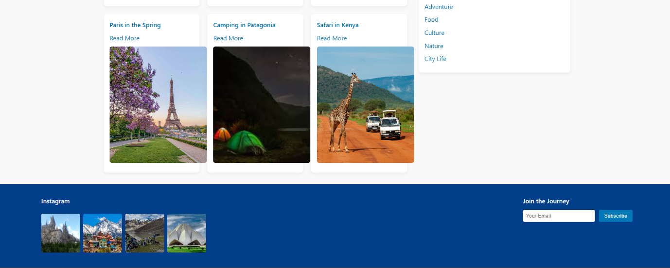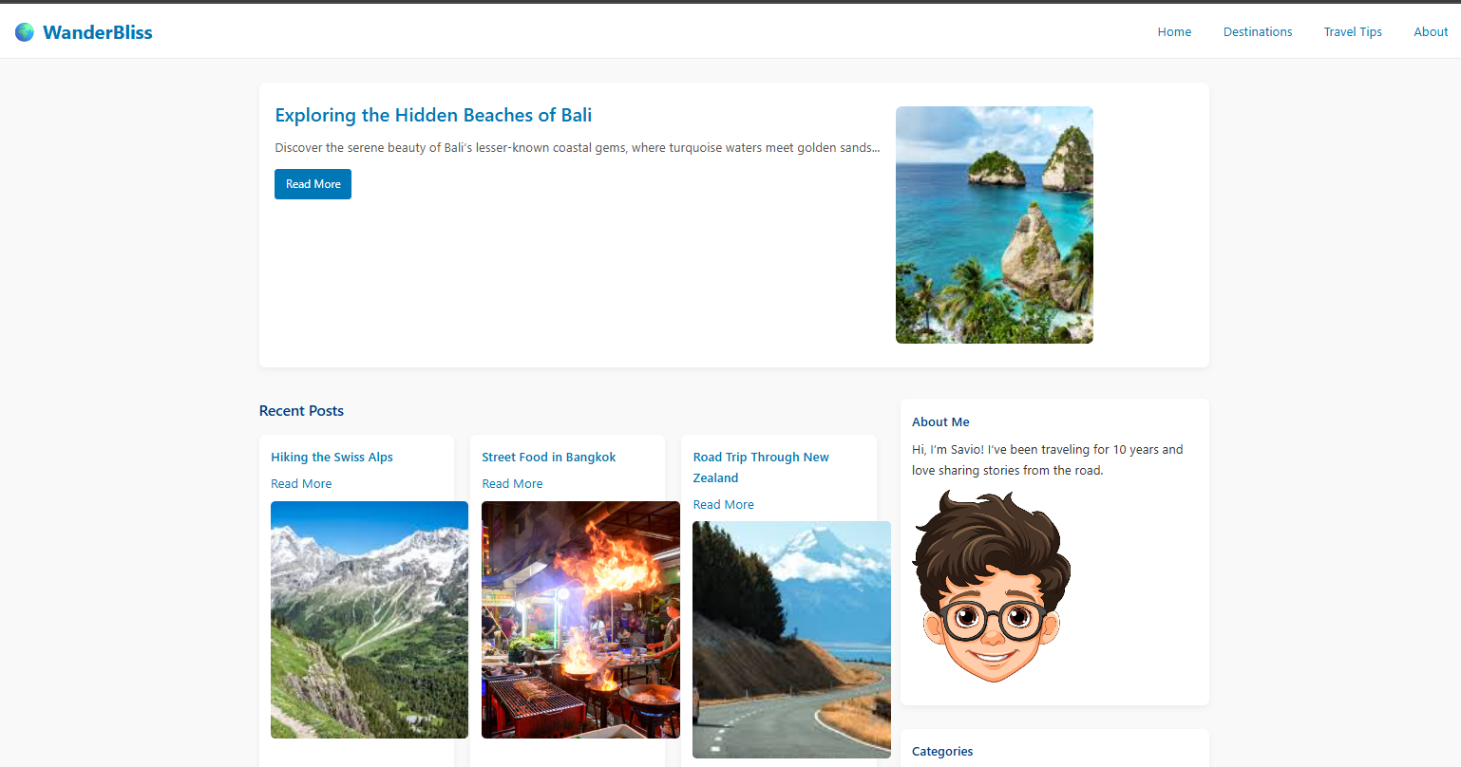

14. Conclusion

The "WanderBliss" Travel Blog front-end successfully demonstrates creative use of HTML5 and CSS3 for building aesthetically pleasing, responsive websites. Through this project, I gained in-depth experience in semantic structuring, layout management, and applying UI/UX principles without JavaScript or external frameworks. It serves as a scalable foundation for future full-stack development.