

NIT6150

Advanced Project

System Analysis and Design Report

Sentinel: A Serverless, Multi-Region Website Health Monitoring Platform on AWS

Team Leader: Tenzing Tsering Lama
Team Members: Samrat Neupane
Md. Malik

Client: Dr. Ayesha Ashfaq
VU Sydney

Supervisor: Dr. Ayesha Ashfaq
VU Sydney

Coordinator: Dr. Quan Vu
College of Engineering and Science
Victoria University, Melbourne
Table of Contents
1. Introduction 3
2. System Development Approach 3
3. Functional Requirements 5
Functional Requirement List 5
Data Requirements 6
4. Use Case Diagram and Descriptions 8
Use Case Descriptions 8
System Behaviour Flowchart 10
Application Design: Alarm and Incident Flow 11
5. Non-Functional Requirements 13
Look and Feel Requirements 13
Usability and Humanity Requirements 13
Performance Requirements 14
Operational Requirements 14
Maintainability and Support Requirements 14
Security Requirements 15
Cultural and Political Requirements 15
Legal Requirements 15
6. System Navigation and User Interface Design 17
7. Project Cost Estimate 19
Labour Cost Estimate 19
AWS Infrastructure Cost Estimate 20
8. Work Breakdown Structure and Project Schedule 21
Work Breakdown Structure 21
Project Schedule (Gantt Chart) 22
9. Issues Needing Consideration 24
10. Human Factors 26
11. Privacy 27
12. Professional Ethics 28
13. Individual Contribution 29
14. Meeting Minutes 30
15. Version Control 32
CI/CD Pipeline Design 32
16. Conclusion 36
17. References 37

Introduction
This System Analysis and Design Report is the second formal deliverable of the NIT6150 Advanced Project, following on from the approved project proposal for Sentinel, a serverless, multi-region website health monitoring platform built on Amazon Web Services (AWS). Where the proposal established the project's purpose, scope, and high-level plan, this report moves into the analysis and design stage: it defines the system's functional and non-functional requirements, models the system's data and behaviour through diagrams, sets out the system's navigation and interface design, and details the project's cost, schedule, and risk management approach.

This report follows the structure required by the NIT6150 System Analysis and Design Report Rubric, addressing the system development approach used, functional and non-functional requirements, use case modelling, system navigation and interface design, cost estimation, work breakdown and scheduling, risk and issue management, human factors, privacy, and professional ethics, together with the required project documentation (meeting minutes, version control, and individual contribution records).

System Development Approach
Sentinel is developed using an Agile, iterative development approach, informed by DevOps practice, rather than a traditional sequential (Waterfall) model. The project is broken into three incremental phases (a single-region canary, a scheduled multi-site crawler with dashboarding, and a closed-loop alarm and notification system), each of which delivers a working, independently testable increment of the system. Within each phase, the team works in short, weekly cycles: a working session or check-in defines the goal for the week, implementation and testing happen iteratively against real AWS deployments, and the team reviews progress before moving to the next increment. This mirrors the core Agile principle of delivering working software frequently and adapting the plan based on what is learned at each step, rather than committing to a complete upfront design before any code is written.
The choice of an Agile approach is justified by the nature of the project itself. Waterfall's sequential, heavily front-loaded planning model suits projects with fixed, fully understood requirements from the outset (Mishra & Alzoubi 2023). Sentinel's requirements, by contrast, are expected to be refined iteratively: exact alarm thresholds, dashboard layout, and even secondary metrics (such as SSL certificate expiry and DNS resolution time) were only finalised after early phases produced working, observable data to reason about. An iterative approach allows the team to validate assumptions, such as which CloudWatch metrics are actually useful to look at, against a real deployment rather than a paper design.

The project's development style also reflects the DevOps culture increasingly adopted across the IT industry for infrastructure and platform engineering work of this kind. Narang and Mittal (2022) observe that software development practice has been trending away from both purely traditional (Waterfall) and purely Agile (Scrum, Kanban) models towards a DevOps-oriented culture that merges iterative development with continuous integration, deployment automation, and operational monitoring, precisely the combination of concerns this project addresses directly as its subject matter. Building a monitoring platform using the same iterative, automation-first, infrastructure-as-code discipline that the platform itself is designed to support reflects genuine IT industry professionalism rather than an academic simplification of practice.

Table 1 summarises the comparison between Waterfall, plain Agile/Scrum, and the Agile/DevOps hybrid approach adopted for this project.

Criterion | Waterfall | Agile / Scrum | Agile + DevOps (adopted)
Requirements | Fixed upfront | Evolve each sprint | Evolve each phase, validated against live AWS deployments
Delivery style | Single delivery at project end | Working increment each sprint | Working, independently deployable increment each phase
Team fit (3 people) | Heavy documentation overhead for a small team | Lightweight, suited to small teams | Lightweight, and matches the DevOps skill set the unit teaches
Feedback loop | Long (design fully committed before build) | Short (each sprint) | Short, plus automated feedback from CloudWatch on real system behaviour
Industry alignment | Common in fixed-contract, regulated projects | Common in product engineering | Standard for cloud/infrastructure and SRE-style engineering roles (Narang & Mittal 2022)

Table 1. Comparison of software development approaches and justification for the adopted Agile/DevOps hybrid.

Functional Requirements
Functional requirements describe what the system must do. They are identified below and kept strictly separate from the non-functional (quality) requirements addressed in Section 4, following the classification distinction formalised in requirements engineering literature (Kurtanović & Maalej 2017).

Functional Requirement List
• FR1: The system shall check the availability of each configured public website within a defined timeout window.
• FR2: The system shall measure and record the response latency (in milliseconds) of each configured website on every check.
• FR3: The system shall read its list of monitored websites from a JSON configuration object stored in Amazon S3, without requiring a code redeployment to add or remove a site.
• FR4: The system shall execute all configured checks automatically on a five-minute schedule, without manual triggering.
• FR5: The system shall publish availability and latency metrics for each site, for each run, to Amazon CloudWatch as custom metrics.
• FR6: The system shall display the health of every monitored site on a CloudWatch Dashboard, visible to an authenticated AWS user.
• FR7: The system shall evaluate each published metric against a configured threshold and raise a CloudWatch Alarm when the threshold is breached.
• FR8: The system shall publish a notification to an Amazon SNS topic whenever an alarm enters the ALARM state, tagged by metric type.
• FR9: The system shall record a permanent, queryable log entry in Amazon DynamoDB for every alarm event, including the metric type, measured value, threshold, and timestamp.
• FR10: The system shall be deployable, in full, to more than one AWS Region using the same AWS CDK application.
• FR11: The system shall be fully definable and deployable as Infrastructure-as-Code, such that the entire stack can be created or destroyed via AWS CDK commands.

Data Requirements
Sentinel's data model spans three storage services, each suited to a different kind of data: a JSON configuration object in Amazon S3 (the list of monitored sites), custom time-series metrics in Amazon CloudWatch (availability and latency observations), and a NoSQL incident log in Amazon DynamoDB (permanent alarm records). Because the system spans several purpose-built AWS data stores rather than a single relational database, the data model is expressed as an object-oriented / entity-style diagram showing each data entity, its key attributes, and the relationships between them, rather than a traditional relational ERD with foreign keys.

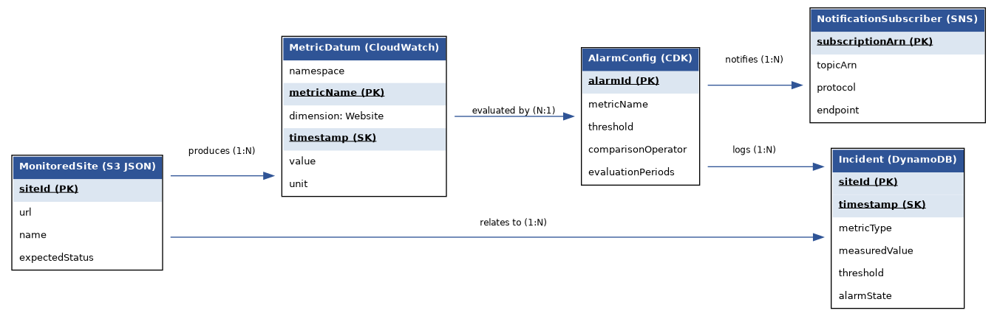
Figure 1. Data model showing the relationships between the monitored-site configuration, published metrics, alarm configuration, incident log, and notification subscribers.

Data Types and Sizes
Table 2 defines the data types and sizes used across the system's three data stores.

Data Element | Store | Data Type | Size / Format
siteId | S3 JSON | String | Up to 64 characters
url | S3 JSON | String (URL) | Up to 2,048 characters
name | S3 JSON | String | Up to 128 characters
expectedStatus | S3 JSON | Integer | 3-digit HTTP status code
namespace | CloudWatch | String | Fixed: “Sentinel/Monitoring”
metricName | CloudWatch | String (Enum) | “Availability” | “Latency” | “SSLDaysRemaining” | “DNSResolutionTime”
dimension: Website | CloudWatch | String | Matches siteId, up to 64 characters
timestamp | CloudWatch / DynamoDB | ISO 8601 datetime | e.g. 2026-08-05T14:05:00Z
value | CloudWatch | Double | Milliseconds (latency) or 0/1 (availability)
siteId (PK) | DynamoDB Incident | String | Partition key, up to 64 characters
timestamp (SK) | DynamoDB Incident | String (ISO 8601) | Sort key
metricType | DynamoDB Incident | String | Up to 32 characters
measuredValue | DynamoDB Incident | Number | Decimal, up to 2 places
threshold | DynamoDB Incident | Number | Decimal, up to 2 places
alarmState | DynamoDB Incident | String (Enum) | “ALARM” | “OK” | “INSUFFICIENT_DATA”
subscriptionArn (PK) | SNS | String (ARN) | Up to 256 characters

Table 2. Data types and sizes across the system's data stores.

Use Case Diagram and Descriptions
Figure 2 presents the overall use case diagram for Sentinel. Three actors interact with the system: a DevOps Engineer (the human administrator who configures, deploys, and reviews the system), the EventBridge Scheduler (a system actor that automatically triggers scheduled checks), and an On-call Responder (a human who receives and acts on alert notifications). Include and extend relationships capture the automatic chain from a scheduled check through to metric publication, alarm evaluation, and, where a threshold is breached, notification and incident logging.

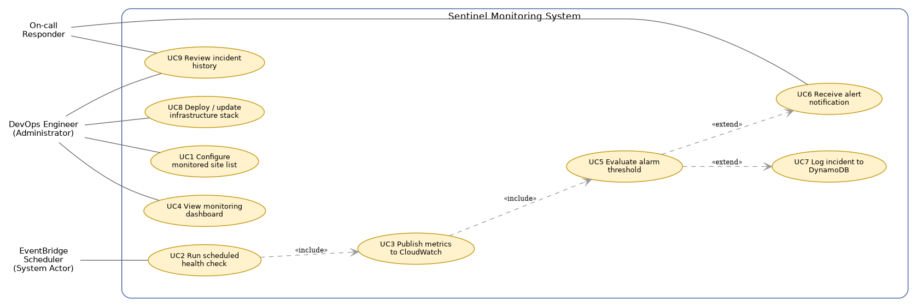
Figure 2. Use case diagram for the Sentinel monitoring platform.

Use Case Descriptions
ID | Use Case | Actor(s) | Description
UC1 | Configure monitored site list | DevOps Engineer | The engineer edits the JSON site-list object in the S3 configuration bucket to add, remove, or update a monitored website. Pre-condition: the engineer has S3 write access. Post-condition: the updated list is used on the next scheduled run.
UC2 | Run scheduled health check | EventBridge Scheduler | The scheduler automatically invokes the crawler Lambda every five minutes. Pre-condition: the Lambda and schedule rule are deployed. Post-condition: every configured site has been checked for this run.
UC3 | Publish metrics to CloudWatch | System (included in UC2) | For each site checked, the Lambda publishes availability and latency data points to CloudWatch using the PutMetricData API. Pre-condition: the Lambda's execution role has CloudWatch write permission. Post-condition: new data points are visible in CloudWatch within seconds.
UC4 | View monitoring dashboard | DevOps Engineer | The engineer opens the CloudWatch Dashboard to review the current health of all monitored sites. Pre-condition: the engineer is authenticated to the AWS account. Post-condition: none (read-only).
UC5 | Evaluate alarm threshold | System (included in UC3) | CloudWatch automatically compares each new metric data point against its configured alarm threshold. Pre-condition: an alarm is configured for the metric. Post-condition: the alarm's state (OK / ALARM) is updated if the threshold condition changes.
UC6 | Receive alert notification | On-call Responder | When an alarm enters the ALARM state, SNS delivers a notification to the subscribed responder. Pre-condition: a valid SNS subscription exists. Post-condition: the responder is aware of the incident.
UC7 | Log incident to DynamoDB | System (extends UC5) | When an alarm fires, a subscriber Lambda writes a permanent incident record to DynamoDB. Pre-condition: the logging Lambda is subscribed to the SNS topic. Post-condition: the incident is queryable in the DynamoDB table.
UC8 | Deploy / update infrastructure stack | DevOps Engineer | The engineer runs AWS CDK commands to deploy or update the entire stack. Pre-condition: the engineer has the required IAM permissions and the account is CDK-bootstrapped. Post-condition: AWS resources match the current CDK code.
UC9 | Review incident history | DevOps Engineer, On-call Responder | Either actor queries the DynamoDB incident table to review past alarm events for a given site. Pre-condition: the actor has DynamoDB read access. Post-condition: none (read-only).

Table 3. Use case descriptions, actors, and pre/post-conditions.

System Behaviour Flowchart
Figure 3 shows the end-to-end flow of a single scheduled run, from the EventBridge trigger through to metric publication and, where applicable, alarm notification and incident logging. This flowchart complements the use case diagram by showing the decision logic (timeout handling, status code evaluation, and threshold breach handling) that the use cases above describe at a higher level.
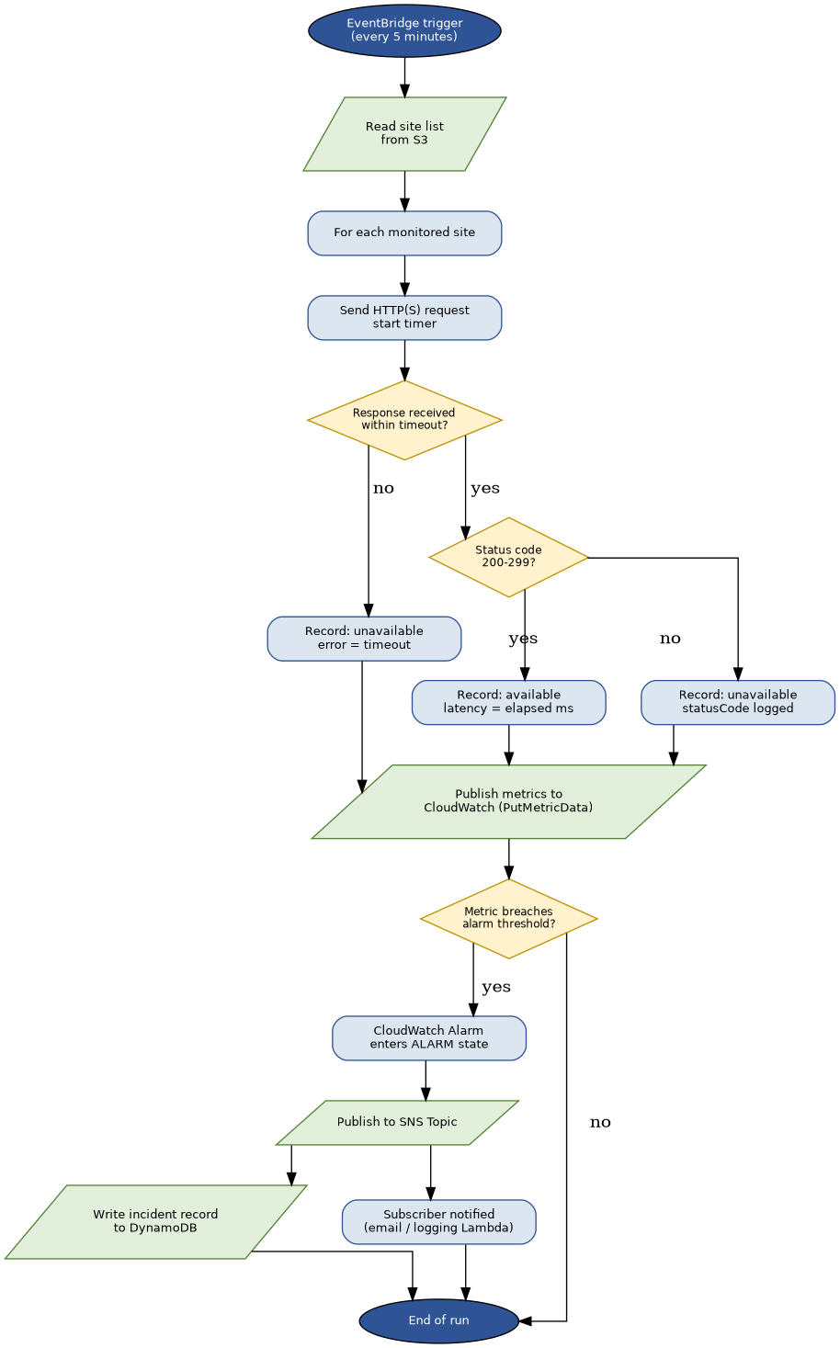
Figure 3. Flowchart of a single scheduled monitoring run.

Application Design: Alarm and Incident Flow
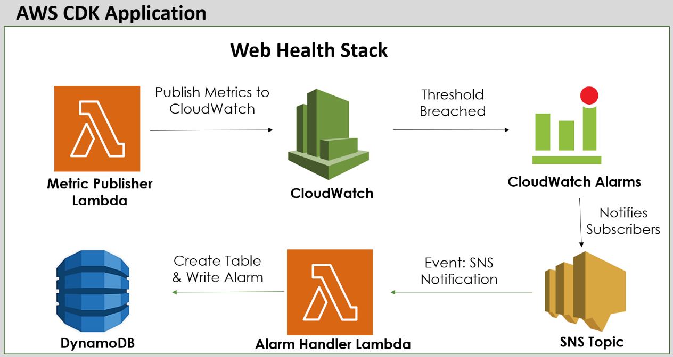
This diagram illustrates the runtime data flow that occurs once the crawler Lambda has published a metric that breaches a configured threshold. It complements the system behaviour flowchart already in Section 3 of the report by focusing specifically on the alarm-to-incident pathway, showing each AWS service involved and the exact event that triggers the next step in the chain.

Walkthrough of the Flow
- Crawler Lambda (Metric Publisher) : on each scheduled run, the crawler checks every configured site and calls the CloudWatch PutMetricData API to publish an Availability value (1 or 0) and, where the check succeeded, a Latency value in milliseconds. Each data point is tagged with a SiteId dimension so that every site's metrics remain distinguishable from one another.
- Amazon CloudWatch: receives and stores each published data point as part of a continuous time series, under the Sentinel/Monitoring namespace. This is the same metric store that feeds the CloudWatch Dashboard described in Section 5 of the report.
- CloudWatch Alarms: continuously evaluate the incoming metric data against the thresholds defined in Section 4 (Assumptions and Constraints) of the proposal. An alarm's state changes to ALARM only when its configured evaluation period confirms a genuine, sustained breach, rather than reacting to a single transient reading.
- SNS Topic : the moment an alarm enters the ALARM state; it publishes a message to a dedicated SNS topic. SNS then fans that single event out to every subscriber independently, without either subscriber needing to know the other exists.
- Email / Slack Subscriber: a human on-call responder (see Section 9, Human Factors) receives a plain-language notification identifying the affected site, the metric that breached, its measured value, and the configured threshold.
- Incident Logger Lambda: a second subscriber to the same SNS topic, triggered by the identical event. Its sole responsibility is to extract the alarm's details and write a structured incident record.
- DynamoDB Incident Table: stores the permanent, queryable record of the incident, keyed by site identifier and timestamp, matching the data model already defined in Section 2 (Functional Requirements) of the report.

Non-Functional Requirements
Non-functional requirements describe the quality attributes the system must exhibit, independent of specific functional behaviour. Following the classification approach used in requirements engineering research (Kurtanović & Maalej 2017), each non-functional requirement below is kept distinct from the functional requirements listed in Section 2 to avoid the common pitfall of mixing the two categories.

Look and Feel Requirements
• The system's primary interface is the native AWS CloudWatch Dashboard; no custom visual branding is required, but widgets are grouped logically (status summary, per-site graphs, incident table) for readability, consistent with the layout shown in Figure 5.
• Any future public-facing status page (identified as a stretch goal in the project proposal) would follow a minimal, high-contrast layout so that system status is legible at a glance.

Usability and Humanity Requirements
• Dashboard widgets shall be labelled clearly and grouped by function (overall status, latency, availability, incidents), consistent with heuristics for visibility of system status and match between system and real-world meaning (Nielsen 1994).
• Alarm names and SNS notification messages shall use plain, specific language (e.g. “Latency alarm: example-site-2 exceeded 2000ms”) rather than raw AWS resource identifiers, so an on-call responder can act without needing to decode internal naming.
• The system shall not require specialised AWS expertise to interpret an alert; a notification alone shall contain enough information (site, metric, value, threshold) to understand the nature of the incident.

Performance Requirements
• Each individual site check shall complete, or time out, within 5 seconds, consistent with the timeout defined in the canary logic.
• A full scheduled run, across all configured sites, shall complete within the Lambda's configured timeout (10 seconds for Phase 1; reassessed as the monitored-site count grows in later phases).
• CloudWatch Alarms shall evaluate within one evaluation period (5 minutes) of a threshold breach, matching the scheduled check cadence.

Operational Requirements
• The system shall run entirely on managed, serverless AWS services (Lambda, EventBridge, CloudWatch, SNS, DynamoDB, S3), requiring no server patching, scaling configuration, or operating system maintenance from the team.
• The system shall operate within AWS Free Tier limits at the project's scale, as detailed in Section 6 (Project Cost Estimate).
• The system shall be deployable to a second AWS Region using the same CDK application, with no manual, region-specific reconfiguration beyond the target Region parameter.

Maintainability and Support Requirements
• All infrastructure shall be defined as code (AWS CDK) and version-controlled in GitHub, so that the system's configuration can be audited, rolled back, or redeployed at any time.
• Operational procedures (adding a monitored site, interpreting an alarm, redeploying, tearing down) shall be documented in a maintained runbook, separate from the README, consistent with standard DevOps documentation practice.
• CloudWatch Logs retention shall be explicitly configured (rather than left indefinite) to keep the system's operational footprint predictable and low-cost.

Security Requirements
• All AWS access shall be performed through IAM users and roles following the principle of least privilege; the Lambda's execution role shall be scoped only to the specific S3 object, CloudWatch namespace, SNS topic, and DynamoDB table it needs.
• No long-lived credentials, account IDs, or secrets shall be committed to the GitHub repository at any time; all sensitive configuration is excluded via .gitignore.
• The system shall only send outbound HTTP(S) requests to websites the team has explicit permission to monitor, to avoid the checks being misinterpreted as a denial-of-service pattern or unauthorised security scan (Ben-Shimol et al. 2025).
• SNS topics and DynamoDB tables shall not be publicly accessible; access is restricted to the Lambda execution roles and authenticated IAM identities within the account.

Cultural and Political Requirements
• The system's interface (CloudWatch Dashboard, alert text) is presented in English only, consistent with the project's academic scope and target audience.
• The system does not collect, display, or process any information relating to individual people, so no requirements arise regarding gender, religion, or other personal or cultural attributes.
• No symbols, colours, or terminology with unintended political or cultural connotations are used in dashboard design or alert messaging.

Legal Requirements
• The system is built entirely on AWS managed services and is subject to the AWS Customer Agreement and Acceptable Use Policy; monitored websites must be owned by, or have explicit permission granted to, the team.
• The system stores no personal data; consequently, no additional obligations arise under data protection legislation such as the Australian Privacy Act 1988 beyond standard AWS account security practice.
• Open-source and AWS SDK dependencies used in the Lambda and CDK code are limited to permissively licensed packages (MIT, Apache 2.0), avoiding copyleft licensing obligations for a project intended for portfolio and academic use.

System Navigation and User Interface Design
Because Sentinel is an infrastructure monitoring platform rather than a conventional multi-page web application, its primary user interface is the native AWS CloudWatch Dashboard rather than a custom-built frontend. Figure 4 shows the navigation path a DevOps Engineer follows through the AWS Console to reach the system's operational views, and Figure 5 presents a sketch of the CloudWatch Dashboard layout itself.

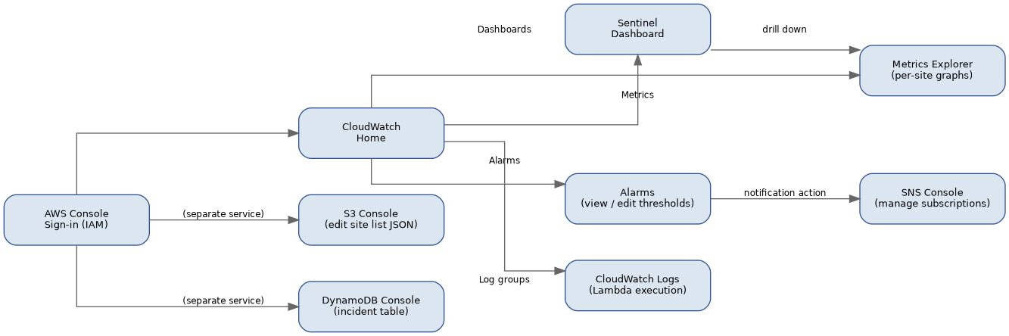
Figure 4. System navigation for the DevOps Engineer through the AWS Console.

The dashboard sketch below reflects the intended widget layout: a top-level status summary (overall health, 7-day availability, active alarm count), per-site latency and availability graphs, and a table of recent incidents drawn from the DynamoDB incident log. This design groups information from most to least urgent, following the visibility-of-system-status and recognition-rather-than-recall usability heuristics (Nielsen 1994), so a responder can assess system health within a few seconds of opening the dashboard.

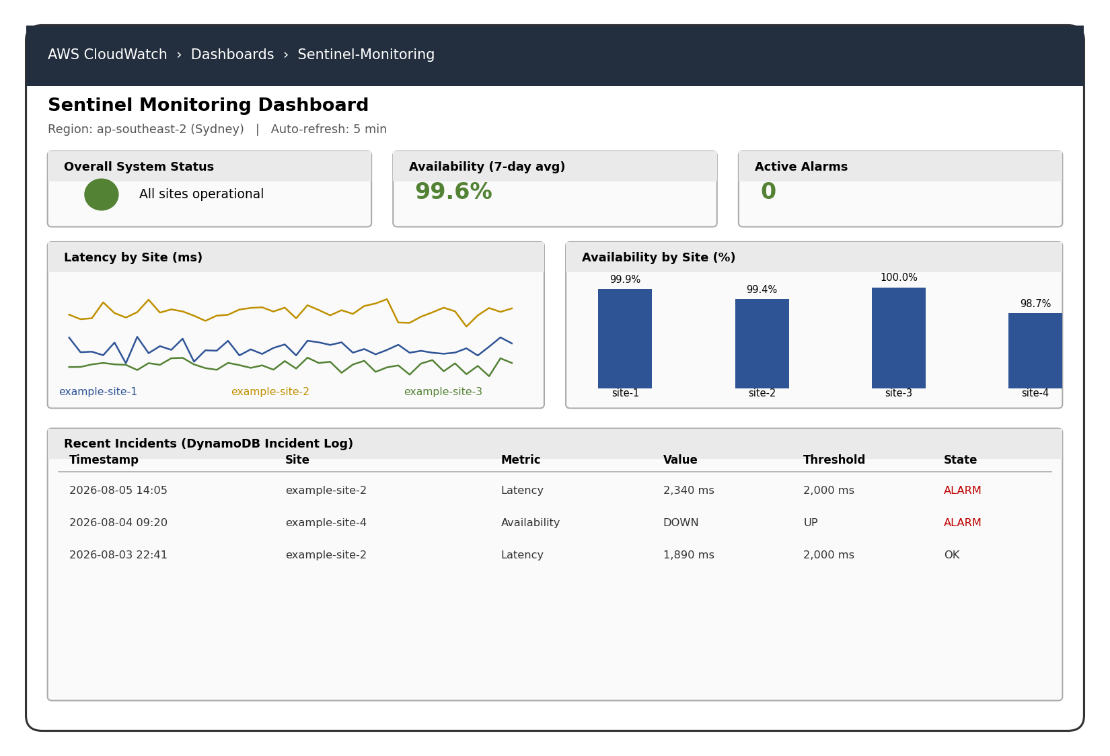
Figure 5. A rough Sketch of the Sentinel CloudWatch Dashboard layout (illustrative data shown).

As identified in the project proposal, a custom public-facing status page (built on S3, CloudFront, and a small API Gateway/Lambda backend) remains a possible future extension. Such a page would reuse the same underlying CloudWatch and DynamoDB data sources but present a simplified, public-safe view (a single status indicator per site plus recent incident history) without requiring AWS Console access, and is noted here as a design consideration rather than a committed deliverable for the current phases.

Project Cost Estimate
The project's cost is considered in two parts: the team's own labour (estimated at industry-comparable rates for the purpose of realistic costing, though not actually paid, as this is an academic project) and the ongoing AWS infrastructure cost.

Labour Cost Estimate
Labour cost is estimated using indicative Australian junior DevOps / cloud engineer hourly rates, to give a realistic sense of what this project would cost if delivered commercially. Each phase's estimate is based on the hours implied by the schedule in Section 7.

Phase | Estimated Hours | Indicative Rate (AUD/hr) | Estimated Cost (AUD)
Setup and Planning (Weeks 1-2) | 20 | $55 | $1,100
Phase 1: Canary Lambda (Weeks 3-4) | 30 | $55 | $1,650
Phase 2: Crawler, Dashboard, Multi-Region (Weeks 5-8) | 60 | $55 | $3,300
Phase 3: Alarms, Notifications, Logging (Weeks 9-11) | 45 | $55 | $2,475
Finalisation and Submission (Week 12) | 15 | $55 | $825
Total | 170 | — | $9,350

Table 4. Indicative labour cost estimate, based on typical junior DevOps/cloud engineer rates in the Australian market.

AWS Infrastructure Cost Estimate
As detailed in the original project proposal, the AWS infrastructure cost is expected to remain within Free Tier limits at this project's scale:

AWS Service | Free Tier Allowance | Project Usage | Estimated Monthly Cost
AWS Lambda | 1,000,000 requests + 400,000 GB-s / month | ~8,640 invocations / month | $0.00
Amazon CloudWatch | 10 custom metrics + 10 alarms free | 4 metrics x monitored sites; a handful of alarms | $0.00
Amazon S3 | 5 GB storage, 20,000 GET / 2,000 PUT (12-month) | Single small JSON file, read every 5 min | $0.00
Amazon SNS | 1,000 free email notifications / month | Only fires on genuine incidents | $0.00
Amazon DynamoDB | 25 GB storage + 25 RCU/WCU | Small incident log table | $0.00
Multi-Region duplication | Free Tier applies per account, not per Region | Second Region deployment | $0.00
Contingency buffer | — | — | $10.00 (one-off)

Table 5. AWS infrastructure cost estimate, based on published AWS Free Tier limits (Amazon Web Services n.d.-d, n.d.-e).
Total estimated project cost: approximately AUD $9,350 in labour if delivered commercially, plus a one-off AUD $10 contingency buffer for AWS usage, against an ongoing AWS infrastructure cost of effectively AUD $0 per month within Free Tier limits.

Work Breakdown Structure and Project Schedule
The project is broken down into five top-level work packages, aligned with the phases defined in the project proposal. Table 6 sets out the work breakdown structure (WBS), and Figure 6 presents the corresponding project schedule as a Gantt chart.

Work Breakdown Structure
1. Setup and Planning
1.1 AWS account, IAM, and billing alert setup
1.2 CDK toolchain installation and bootstrap
1.3 GitHub repository structure and initial README
1.4 Finalise project proposal
2. Phase 1: Canary Lambda
2.1 Metric definition (availability, latency)
2.2 Canary Lambda development
2.3 CDK stack for Phase 1 and deployment
2.4 Manual testing and CloudWatch Logs verification
2.5 Phase 1 documentation (README, initial runbook)
3. Phase 2: Crawler, Scheduling, Dashboard, Multi-Region
3.1 S3 site-list configuration and access design
3.2 Multi-site crawler logic
3.3 EventBridge scheduled trigger
3.4 CloudWatch custom metric publication
3.5 CloudWatch Dashboard construction
3.6 Multi-region CDK deployment
4. Phase 3: Alarms, Notifications, Logging
4.1 Threshold definition
4.2 CloudWatch Alarms configuration
4.3 SNS topic, subscriptions, and metric-type tagging
4.4 DynamoDB incident table and logging Lambda
4.5 End-to-end failure testing
5. Finalisation
5.1 Final documentation pass (README, runbook)
5.2 Cost and teardown review
5.3 Demonstration preparation and submission

Project Schedule (Gantt Chart)
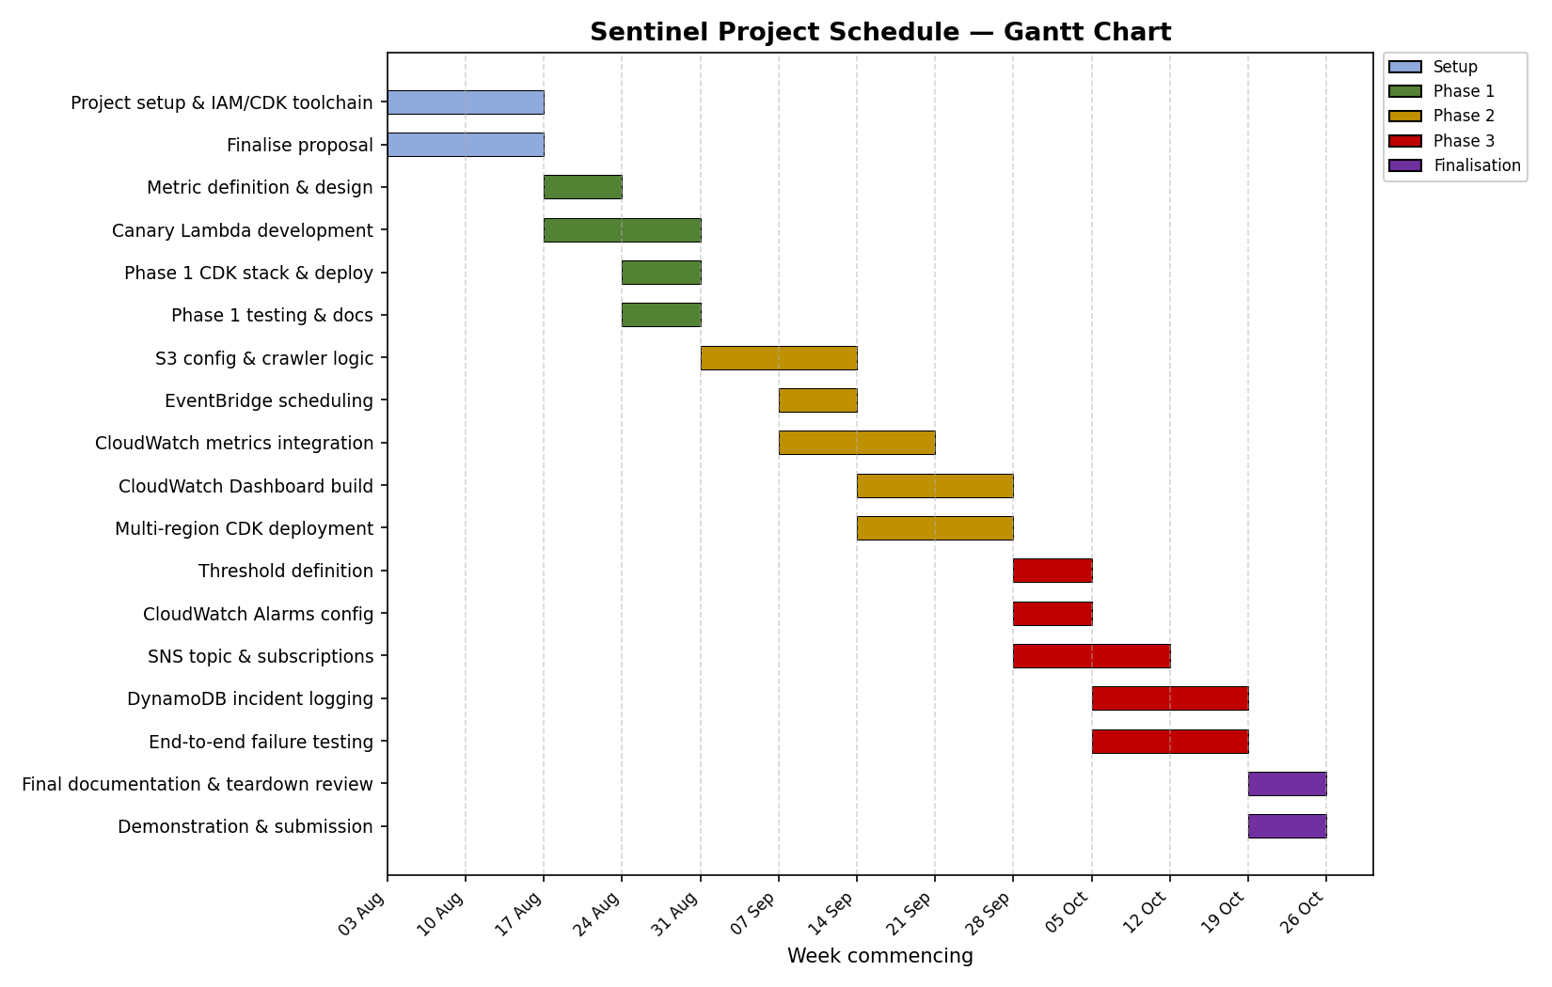
Figure 6. Project schedule as a Gantt chart, spanning the 12-week semester timeline.

The schedule follows a phased structure that mirrors the WBS above: each phase's tasks are sequenced so that design and definition tasks (e.g. metric or threshold definition) precede implementation tasks, and implementation precedes testing and documentation within the same phase. Some tasks within Phase 2 and Phase 3 run in parallel (for example, CloudWatch metric integration and dashboard construction), reflecting the fact that dashboard widgets can be built against metrics as soon as they begin publishing data, rather than waiting for the entire phase to complete sequentially. This parallelism is consistent with the Agile, incremental approach justified in Section 1, and keeps the 12-week timeline realistic for a three-person team with one primary developer.

Issues Needing Consideration
Table 7 sets out the risks and issues identified for this project, their likely impact and probability, and the team's planned mitigation. Risks are drawn from technical, schedule, cost, and team-related categories.

Risk / Issue | Description | Impact | Probability | Mitigation
AWS Free Tier overage | Unexpected usage pushes a service beyond Free Tier limits, incurring cost | Low | Low | AWS Budgets billing alert configured from Week 1; monitored-site count kept small and fixed
Alert fatigue from noisy thresholds | Thresholds set too aggressively generate false-positive alarms, reducing trust in the system | Medium | Medium | Conservative initial thresholds (Section 4, Security and Performance requirements); evaluation periods tuned during Phase 3 testing
Schedule slippage due to single primary developer | Most technical delivery is concentrated in one team member; illness or unavailability could delay a phase | Medium | Medium | Weekly meetings surface blockers early; supporting members (research/testing) can absorb some implementation load if required
CDK/AWS service version changes | AWS CDK or service APIs change during the project, breaking previously working code | Low | Low | Dependency versions pinned in package.json; changes tested in isolation before merging to main
Multi-region deployment complexity | Deploying identical infrastructure to a second Region introduces configuration drift or region-specific service gaps | Medium | Medium | Second Region chosen for AWS service parity; CDK environment configuration tested early in Phase 2 rather than left to the end
Monitored test site unavailability | A site used for testing becomes permanently unavailable, disrupting availability/latency test data | Low | Low | Multiple independent test sites used; canary logic tested against both reachable and deliberately broken endpoints
Incomplete teardown leaving orphaned resources | Some AWS resources (e.g. S3 buckets with objects, retained DynamoDB tables) may not delete cleanly with cdk destroy | Low | Medium | Explicit removal policies set in CDK; manual verification step included in the Week 12 cost and teardown review

Table 7. Risk matrix identifying issues, impact, probability, and mitigation.

Human Factors
Sentinel is ultimately built to support a human responder acting under time pressure during a real incident, so human factors have been considered directly in its design rather than treated as an afterthought.

• Alert fatigue: overly sensitive thresholds erode a responder's trust in alerts over time, leading to alerts being ignored. Thresholds and evaluation periods are set conservatively (see Section 4 and the risk matrix in Section 8) specifically to avoid this.
• Cognitive load during an incident: notification messages are written in plain language identifying the site, metric, measured value, and threshold, rather than raw AWS identifiers, so a responder does not need to context-switch into the AWS Console simply to understand what is wrong (see Section 4, Usability and Humanity Requirements).
• Single point of responsibility: because the team is small, the on-call responder role may fall to whichever team member is available; the DynamoDB incident log and CloudWatch Dashboard are designed to be understandable by any team member, not only the primary developer, reducing dependency on one person's tacit knowledge.
• Team workload distribution: the research and testing responsibilities assigned to supporting team members are deliberately scoped to be meaningful and non-trivial, avoiding a human factor risk common in group projects were uneven task design leads to disengagement.

Privacy
Sentinel's privacy profile is intentionally narrow: the system is designed to avoid handling personal data at all, rather than collecting it and then protecting it.

• No personal or user-identifiable data is collected, stored, or processed at any point; the system records only technical metrics (availability, latency, and related metadata) about public website infrastructure.
• The monitored-site list itself (URLs and site names) is operational configuration data, not personal data, and is stored in a private, access-controlled S3 bucket rather than a public location.
• Because the system sends automated HTTP(S) requests to third-party websites, it only monitors sites the team has explicit permission to check, avoiding the privacy and security concerns that would arise from probing infrastructure without authorisation (Ben-Shimol et al. 2025).
• Incident records in DynamoDB contain only technical fields (site identifier, metric type, value, threshold, timestamp); no logs of website content, user traffic, or visitor data are captured at any stage.
• Should the optional public-facing status page (Section 5) be built in future work, it would expose only aggregate, non-sensitive status information (up/down, uptime percentage), with no operational or account-level detail visible to the public.

Professional Ethics
The team's approach to this project has been considered against the Software Engineering Code of Ethics and Professional Practice jointly published by the ACM and IEEE Computer Society (Gotterbarn, Miller & Rogerson 1997), which sets out obligations to the public, to clients, to the product, and to the profession.

• Obligation to the public: the system is designed to only ever monitor infrastructure the team is authorised to check, avoiding any use of the platform as an unauthorised scanning or reconnaissance tool, consistent with the Code's principle that software engineers act consistently with the public interest.
• Obligation to the product: the team has committed to honest, evidence-based claims about the system's capabilities in this report and the proposal, for example, describing cost estimates as Free-Tier-bound projections rather than guarantees, and explicitly separating tested functionality (Phase 1) from planned functionality (Phases 2 and 3) rather than overstating current progress.
• Obligation to colleagues and the profession: infrastructure, decisions, and their justifications are documented transparently (README, runbook, this report) so that any team member, or a future engineer, can understand and verify the system's design rather than relying on undocumented tribal knowledge.
• Obligation of competence: where the team has used AI-assisted tools during planning and documentation, all technical claims (AWS service limits, pricing, referenced literature) have been independently verified against primary sources rather than accepted uncritically, consistent with the Code's expectation that engineers maintain professional competence and intellectual honesty in their work.
• Academic integrity: this report and the accompanying codebase represent the team's own work and understanding; external sources (AWS documentation, academic literature) are cited according to Harvard referencing conventions throughout, per Section 16 (References).

Individual Contribution
Table 8 records each team member's contribution to this System Analysis and Design stage of the project, consistent with the individual assessment component of the rubric.

Team Member | Contribution to this Stage
Tenzing Tsering Lama (Team Leader) | Led system development approach justification, functional/non-functional requirements, use case and data modelling, diagram construction, system navigation and UI design, cost estimate, WBS/schedule, and overall report assembly and editing.
Samrat Neupane | Contributed to the use case diagram and use case descriptions, the data requirements and data model, and the project cost estimate; reviewed drafts of the full report. Reviewed the full report drafted by Tenzing, providing feedback and corrections before each section was finalised.
Md. Malik | Contributed to the functional requirements list, the non-functional requirements, and the system behaviour flowchart; reviewed drafts of the full report. Reviewed the full report drafted by Tenzing, providing feedback and corrections before each section was finalised.

Table 8. Individual contribution to the System Analysis and Design stage.

Meeting Minutes
The team meets weekly, as set out in the project proposal's Project Documentation and Version Control section. Minutes from meetings held during the System Analysis and Design stage are recorded below and are also maintained in the docs/meetings directory of the GitHub repository for ongoing version control.

Week 1 team meeting
Time: 30 minutes, Victoria University, Sydney Campus
Attendees: Tenzing Tsering Lama, Samrat Neupane, Md. Malik
Items discussed:
• Reviewed supervisor feedback on the approved project proposal.
• Agreed the System Analysis and Design Report structure against the rubric.
• Assigned initial research topics: Samrat to use cases for the project, Malik to functional and non-functional requirements for the project
Decisions made: Agreed to use an Agile/DevOps hybrid development approach for the project, matching the phased structure already set out in the proposal.
Action items: Tenzing to draft the functional requirements and use case diagram by the next meeting; Samrat and Malik to bring initial research notes.

Week 2 team meeting
Time: 30 minutes, Victoria University, Sydney Campus
Attendees: Tenzing Tsering Lama, Samrat Neupane, Md. Malik
Items discussed:
• Reviewed draft functional requirements and use case diagram.
• Discussed Samrat's findings on CloudWatch alarm evaluation periods, used to inform the performance non-functional requirements.
• Discussed Malik's findings on IAM least-privilege scoping for the Lambda execution role, used to inform the security non-functional requirements.
Decisions made: Agreed on the final non-functional requirement categories and confirmed the data model would be expressed as an entity-style diagram rather than a relational ERD, given the mix of S3, CloudWatch, and DynamoDB data stores.
Action items: Tenzing to build the data model, flowchart, and dashboard mockup diagrams; Samrat and Malik to review the risk matrix and human factors / privacy sections once drafted.

Version Control
Version control for this stage follows the plan established in the project proposal's Project Documentation and Version Control section, applied here to both this report and the design artefacts (diagrams) that support it.

• This report, its source diagrams (data model, use case, flowchart, Gantt chart, dashboard mockup, navigation diagram are committed to a docs/ directory in the sentinel-aws-monitor GitHub repository, alongside the project proposal.
• Each substantive revision to this report is committed with a descriptive message following the project's established convention (for example, docs: add system analysis and design report, docs: add use case and data model diagrams).
• As with the proposal, credentials and account-specific configuration remain excluded from version control at all times via. gitignore.

CI/CD Pipeline Design
Continuous Integration and Continuous Deployment (CI/CD) is the orchestration of building, testing, and deploying the application automatically and consistently throughout its lifecycle, rather than relying on a developer to manually run each step by hand. This section sets out the CI/CD design adopted for the Sentinel project, implemented using GitHub Actions and triggered by the same pull-request-based workflow.
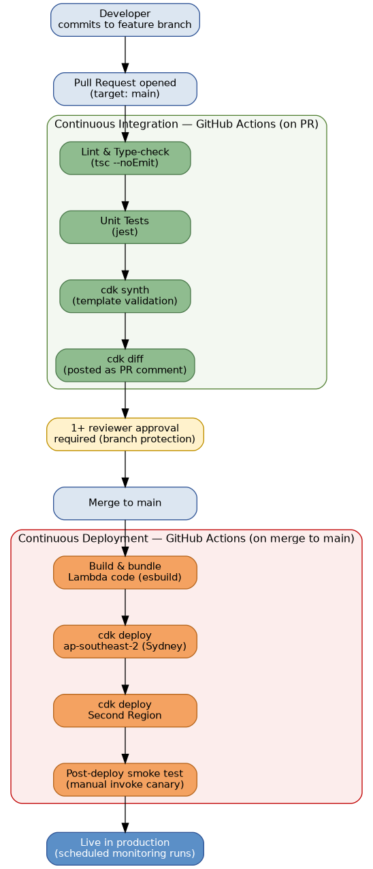
Figure B. CI/CD pipeline design, showing Continuous Integration on pull request and Continuous Deployment on merge to main.

Continuous Integration (runs on every Pull Request)
When a team member opens a pull request against main, an automated workflow runs before any human review takes place. This gives reviewers concrete, automatically generated evidence to review alongside the code itself, rather than relying solely on a manual read-through.
- Lint and type-check — runs the TypeScript compiler in no-emit mode (tsc --noEmit) to catch type errors before they can reach main.
- Unit tests — runs the project's Jest test suite against the Lambda business logic (for example, checkSite() and crawl()), independent of any live AWS deployment.
- cdk synth — synthesizes the CDK application into a CloudFormation template, confirming the infrastructure code itself is valid and will actually produce a deployable template.
- cdk diff — computes what would change in AWS if this pull request were deployed, and posts the result as a comment on the pull request, so the required reviewer (per the branch protection rule already in place) can see the exact infrastructure impact before approving.

Continuous Deployment (runs on merge to main)
Once a pull request has been approved and merged, a separate workflow deploys the change automatically, without requiring anyone to run cdk deploy manually from their own machine.
- Build and bundle — compiles and bundles the Lambda source code using esbuild, the same bundling step NodejsFunction performs locally, ensuring the deployed artifact matches what was validated during Continuous Integration.
- Deploy to the primary Region (Sydney) — runs cdk deploy against the ap-southeast-2 stack instance.
- Deploy to the second Region — runs cdk deploy against the second regional stack instance, once the primary Region's deployment has completed successfully, satisfying the multi-region deployment requirement set out in the project proposal.
- Post-deployment smoke test — manually invokes the canary Lambda in each Region immediately after deployment and confirms a successful, well-formed response, providing an automated first check that the deployment is genuinely functioning before it is considered complete.

Conclusion
This report has set out the system analysis and design for Sentinel, moving the project from the high-level plan established in the proposal into a concrete technical foundation ready for implementation. An Agile, DevOps-informed development approach was justified against the project's own nature and supporting literature, and used to structure the remainder of the analysis around three incremental, testable phases rather than a single upfront design.
The system's functional requirements, data model, and use case diagram together describe a coherent, closed-loop monitoring pipeline: a scheduled check produces metrics, metrics are evaluated against configured thresholds, and a breach reliably results in both a human notification and a permanent incident record. The non-functional requirements extend this technical picture across the eight required quality dimensions, ensuring the system is not only functionally correct but also performant, secure, maintainable, and usable under real incident conditions. The system navigation and dashboard design, cost estimate, work breakdown structure, and Gantt schedule translate this design into a realistic, achievable delivery plan for a three-person team working within a single semester.
Beyond the technical design, this report has also considered the human and ethical dimensions of the project: the risks the team is likely to face, the human factors that shape how a responder actually experiences an incident, the privacy-by-omission approach taken to data collection, and the professional obligations the team holds to the public, to each other, and to the profession. Taken together, these sections demonstrate that Sentinel has been designed deliberately, not just functionally, with the same discipline expected of a genuine industry engagement.
With this analysis and design stage complete, the project is now positioned to move into implementation with a clear, justified technical direction, a defined set of requirements to build and test against, and a realistic schedule to deliver against, carrying forward the same iterative, documented approach established here.

References
Amazon Web Services n.d.-a, AWS Cloud Development Kit (CDK) developer guide, viewed 4 August 2026, <https://docs.aws.amazon.com/cdk/v2/guide/home.html>.

Amazon Web Services n.d.-b, AWS global infrastructure: Regions and Availability Zones, viewed 4 August 2026, <https://aws.amazon.com/about-aws/global-infrastructure/regions_az/>.

Amazon Web Services n.d.-c, REL10-BP01: deploy the workload to multiple locations, AWS Well-Architected Framework, viewed 4 August 2026, <https://docs.aws.amazon.com/wellarchitected/latest/framework/rel_fault_isolation_multiaz_region_system.html>.

Amazon Web Services n.d.-d, What is AWS Lambda?, AWS Lambda developer guide, viewed 4 August 2026, <https://docs.aws.amazon.com/lambda/latest/dg/welcome.html>.

Amazon Web Services n.d.-e, What is Amazon CloudWatch?, Amazon CloudWatch user guide, viewed 4 August 2026, <https://docs.aws.amazon.com/AmazonCloudWatch/latest/monitoring/WhatIsCloudWatch.html>.

Amazon Web Services n.d.-f, What is Amazon DynamoDB?, Amazon DynamoDB developer guide, viewed 4 August 2026, <https://docs.aws.amazon.com/amazondynamodb/latest/developerguide/Introduction.html>.

Amazon Web Services n.d.-g, What is Amazon Simple Notification Service?, Amazon SNS developer guide, viewed 4 August 2026, <https://docs.aws.amazon.com/sns/latest/dg/welcome.html>.

Artac, M, Borovšak, T, Di Nitto, E, Guerriero, M & Tamburri, DA 2017, 'DevOps: introducing infrastructure-as-code', in Proceedings of the 2017 IEEE/ACM 39th International Conference on Software Engineering Companion (ICSE-C), IEEE, Buenos Aires, pp. 497-498, viewed 4 August 2026, <https://doi.org/10.1109/ICSE-C.2017.162>.

Ben-Shimol, L, Grolman, E, Elyashar, A, Maimon, I, Mimran, D, Brodt, O, Strassmann, M, Lehmann, H, Elovici, Y & Shabtai, A 2025, 'Observability and incident response in managed serverless environments using ontology-based log monitoring', IEEE Transactions on Cloud Computing, vol. 13, no. 4, pp. 1161-1176, viewed 4 August 2026, <https://doi.org/10.1109/TCC.2025.3598060>.

Gotterbarn, D, Miller, K & Rogerson, S 1997, 'Software engineering code of ethics', Communications of the ACM, vol. 40, no. 11, pp. 110-118, viewed 4 August 2026, <https://doi.org/10.1145/265684.265699>.

Guerriero, M, Garriga, M, Tamburri, DA & Palomba, F 2019, 'Adoption, support, and challenges of infrastructure-as-code: insights from industry', in Proceedings of the 2019 IEEE International Conference on Software Maintenance and Evolution (ICSME), IEEE, Cleveland, OH, pp. 580-589, viewed 4 August 2026, <https://doi.org/10.1109/ICSME.2019.00092>.

Kurtanović, Z & Maalej, W 2017, 'Automatically classifying functional and non-functional requirements using supervised machine learning', in Proceedings of the 2017 IEEE 25th International Requirements Engineering Conference (RE), IEEE, Lisbon, pp. 490-495, viewed 4 August 2026, <https://doi.org/10.1109/RE.2017.82>.

Mishra, A & Alzoubi, YI 2023, 'Structured software development versus agile software development: a comparative analysis', International Journal of System Assurance Engineering and Management, vol. 14, no. 4, pp. 1504-1522, viewed 4 August 2026, <https://doi.org/10.1007/s13198-023-01958-5>.

Narang, P & Mittal, P 2022, 'Software development methodologies: trending from traditional to DOSE, an empirical study', in Proceedings of the 2022 IEEE Delhi Section Conference (DELCON), IEEE, New Delhi, viewed 4 August 2026, <https://doi.org/10.1109/DELCON54057.2022.9753613>.

Nielsen, J 1994, 'Enhancing the explanatory power of usability heuristics', in Proceedings of the SIGCHI Conference on Human Factors in Computing Systems (CHI '94), ACM, Boston, MA, pp. 152-158, viewed 4 August 2026, <https://doi.org/10.1145/191666.191729>.

Rajan, RAP 2018, 'Serverless architecture: a revolution in cloud computing', in Proceedings of the 2018 Tenth International Conference on Advanced Computing (ICoAC), IEEE, Chennai, pp. 88-93, viewed 4 August 2026, <https://doi.org/10.1109/ICoAC44903.2018.8939081>.

