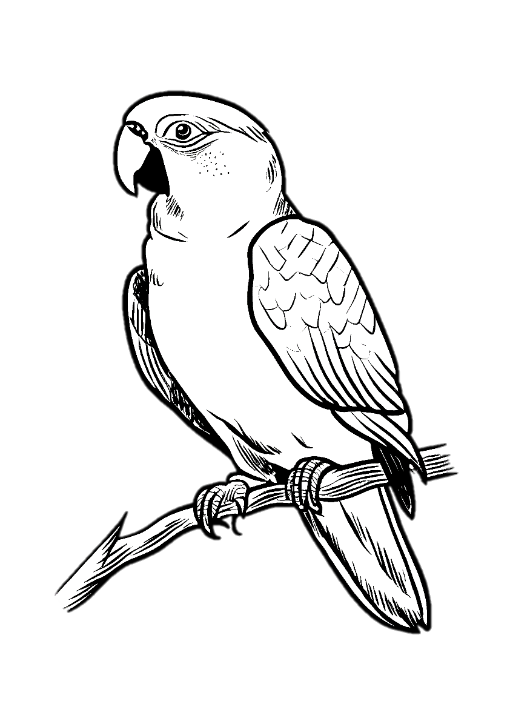

Polly
  - Nirvana
Intro:
Mim Sol Re Do
Mim Sol Re Do Mim
Sol Re Do Mim
Polly wants a cracker
Sol Re Do Mim
I think I should get off her first
Sol Re Do Mim
I think she wants some water
Sol Re Do
To put out the blow torch
Re Do Sol Sib Re
Isn't me, have a seed
Do Sol Sib Re
Let me clip your dirty wings
Do Sol Sib Re
Let me take a ride, cut yourself
Do Sol Sib
Want some help, please myself
Got some rope, haven't told
Promise you, have been true
Let me take a ride, cut yourself
Want some help, please myself
Mim Sol Re Do Mim
Polly wants a cracker
Maybe she would like some food
She asked me to untie her
A chase would be nice for a few
Isn't me, have a seed
Let me clip your dirty wings
Let me take a ride, cut yourself
Want some help, please myself
Got some rope, haven't told
Promise you, have been true
Let me take a ride, cut yourself
Want some help, please myself
Mim Sol Re Do
Mim Sol Re Do Mim
Polly said
Polly says her back hurts
She's just as bored as me
She caught me off my guard
Amazes me the will of instinct
Isn't me, have a seed
Let me clip your dirty wings
Let me take a ride, cut yourself
Want some help, please myself
Got some rope, haven't told
Promise you, have been true
Let me take a ride, cut yourself
Want some help, please myself

