Assignment_1



**ENERGY UTILITY PLATFORM**

**Teacher**: Andreea Vesa

**Student**: Furcovici Teodora-Melania

**Group**:30443

1. **Conceptual architecture diagram**

* There are 2 types of users: client and administrator
* A **user** can visualize all its associated devices. Beside this, all available devices can be seen, in case he wants to add a new device to its account
* An **administrator** can visualize all the user, devices and also all the available devices from the platform.
* Another **administrator**`s power is that he can delete/update each user/device or even create a new device.

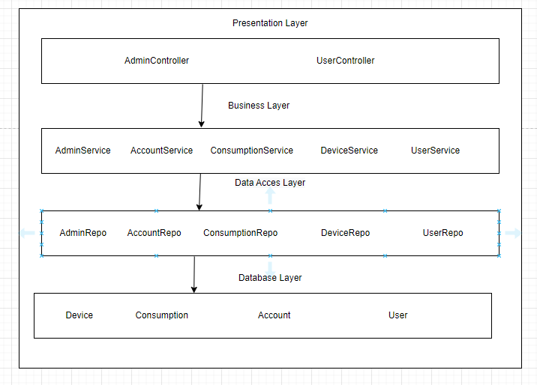

1. **Database diagram**

* Each user is associated with an account
* Table user contains the type of user (i.e, Administrator/Client).
* Between user and device there is a one-to-many relationship, because one user can possess multiple devices
* Between consumption and device there is a one-to-many relationship, because on one device can be registered more than one consumption

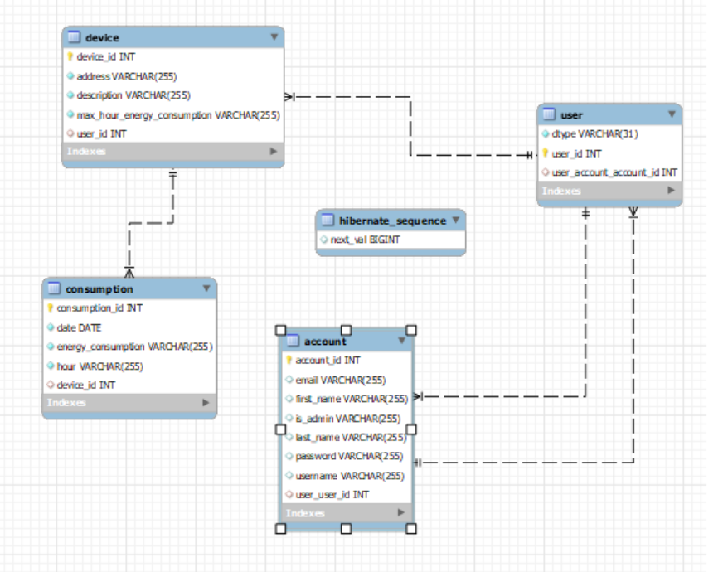

1. **UML Deployment Diagram**

* For deployment, I have created 2 containers, one for frontend and another for backend
* The one for frontend contains only the React Application, while the one for backend contains both the database and the Java Spring application

