CANNY EDGE DETECTOR

General presentation

Canny edge detection is a technique to extract useful structural information from different vision objects and dramatically reduce the amount of data to be processed. It has been widely applied in various [computer vision](https://en.wikipedia.org/wiki/Computer_vision) systems. Canny has found that the requirements for the application of [edge detection](https://en.wikipedia.org/wiki/Edge_detection) on diverse vision systems are relatively similar. Thus, an edge detection solution to address these requirements can be implemented in a wide range of situations. The general criteria for edge detection include:

1. Detection of edge with low error rate, which means that the detection should accurately catch as many edges shown in the image as possible
2. The edge point detected from the operator should accurately localize on the center of the edge.
3. A given edge in the image should only be marked once, and where possible, image noise should not create false edges.

To satisfy these requirements Canny used the [calculus of variations](https://en.wikipedia.org/wiki/Calculus_of_variations) – a technique which finds the [function](https://en.wikipedia.org/wiki/Function_(mathematics)) which optimizes a given [functional](https://en.wikipedia.org/wiki/Functional_(mathematics)). The optimal function in Canny's detector is described by the sum of four [exponential](https://en.wikipedia.org/wiki/Exponential_function) terms, but it can be approximated by the first [derivative](https://en.wikipedia.org/wiki/Derivative) of a [Gaussian](https://en.wikipedia.org/wiki/Gaussian_function).

Among the edge detection methods developed so far, Canny edge detection algorithm is one of the most strictly defined methods that provides good and reliable detection. Owing to its optimality to meet with the three criteria for edge detection and the simplicity of process for implementation, it became one of the most popular algorithms for edge detection.

Method

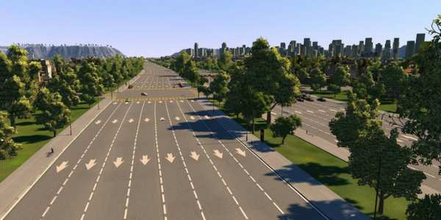

ORIGINAL IMAGE

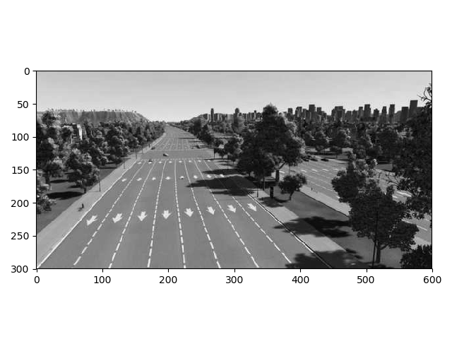

The Process of Canny edge detection algorithm can be broken down to 5 different steps:

1. 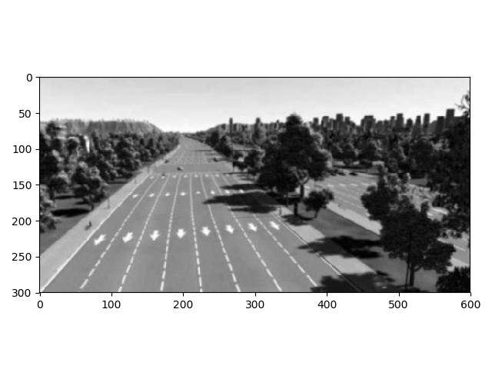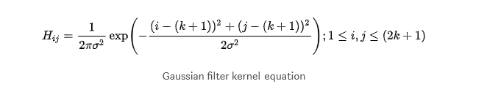**Apply** [**Gaussian filter**](https://en.wikipedia.org/wiki/Gaussian_filter) **to smooth the image in order to remove the noise**

This is mainly used for clearing the image and removing noise.

1. 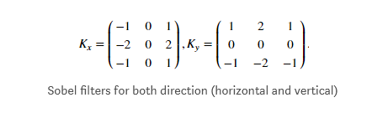**Find the intensity gradients of the image**

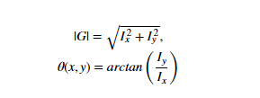We used sobel filters to compute the gradients but other kernels like prewit or Roberts are also good. This step generates 2 aditional matrices one for the horizontal gradient and one for the vertical. These two are used to determine the intensity of the gradient on the original pixels and the gradient direction.

1. 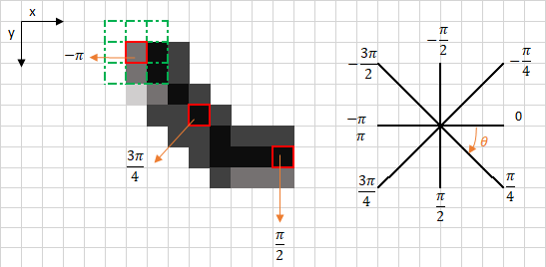**Apply non-maximum suppression to get rid of spurious response to edge detection**

The aim of this step is to remove all pixels which don’t have the maximum gradient intensity in the direction of the gradient.

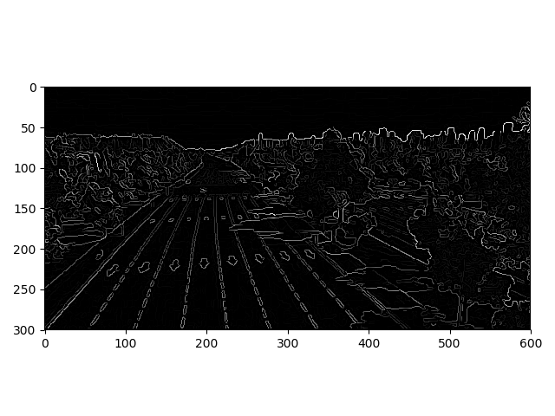

1. **Apply double threshold to determine potential edges**

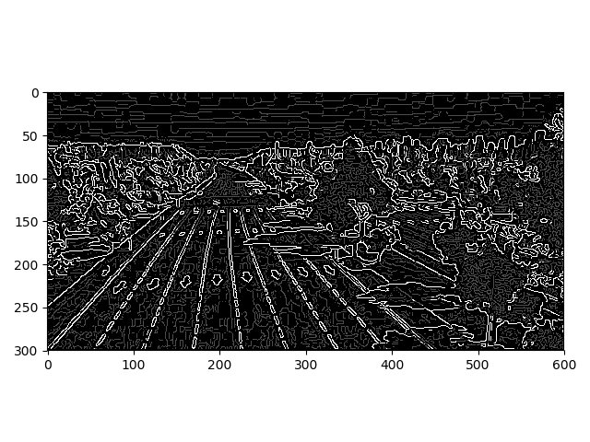With what was left from the previous step is created a new image with only 3 possible values: strong pixels(255), weak pixels(75) and 0 using a double thresholding scheme. The strong pixels represent edges that are guaranteed to be edges meanwhile the weak represent only possible edges that could be transformed in strong edges during the next step.

1. **Track edge by hysteresis**: Finalize the detection of edges by suppressing all the other edges that are weak and not connected to strong edges

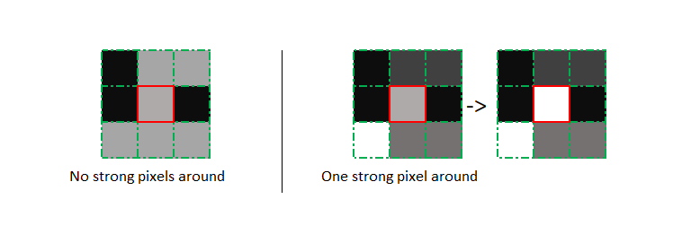This mainly sums up to transforming weak pixels that are in the vicinity of strong one into strong pixels.

FINAL RESULT