# QA Back-End Technologies Basics

# Exam Prep I

## Contacts

You are given a .NET solution that implements a console application for simulating a contact book application. Your task is to create and implement **tests** using the **Integration** **Tests** **project** and **NUnit**.

### Introduction

ContactsConsoleAPI is a console-based application built using the .NET Framework and the app manages a collection of movies.

It allows users to perform various operations, such as searching, adding, reading, updating and deleting movies from database.

This application is designed to showcase **essential software development concepts and practices**.

### Architecture Overview

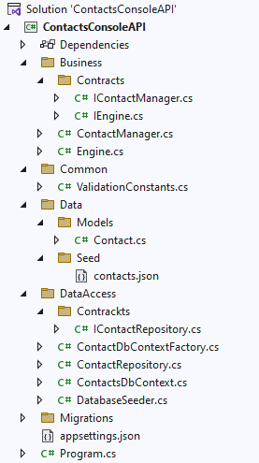

### Data Validation Overview

The **Common** folder in the application contains shared constants that can be used across multiple layers of the application. In particular, the **ValidationConstants** class provides a centralized place to define the rules and constraints related to data validation for the domain models, particularly contacts in this context.

Don't forget to use the data in this class while writing your tests.

### Functionality Overview

When the application is executed, it presents a menu with options that the user can select from, as shown below:

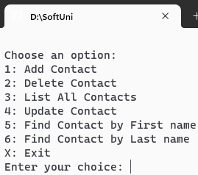

**Users interact with the application** by entering **commands** or **data** into the console. The application processes these inputs and performs the corresponding actions.

For example, when listing all the contacts, the application, through **the ContactManager**, calls the **GetAllContactsAsync method** on the **ContactsRepository**. This **method is responsible for retrieving all contacts records from the database**.

This retrieval is performed **asynchronously**, ensuring that the **application remains responsive**. Once the data is fetched, the **method iterates over the collection of Contact objects and prints their details** to the console.

#### Add Contact

The application promts the user to enter data for the details below:

* First Name
* Last Name
* Address
* Phone number
* Email
* Gender
* ULID

**Input data** is **validated** according to the **rules**, defined in the **business** **layer** and the **model's** **data** **annotations**.

#### Delete Contact

Deletes the input contact from the database.

#### List All Contacts

Retrieves a list with all contacts, present in the database.

#### Update Contact

Updates a contact's information.

#### Find Contact by First Name

Finds a contact in the database by the contact's first name, that the user types in the console.

#### Find Contact by Last Name

Finds a contact in the database by the contact's last name, that the user types in the console.

## Integration Tests

Your task is to **implement the test methods in the provided test project**. These methods are placeholders that represent the **various scenarios** you will test within the application.

Navigate to **ContactsConsoleAPI.IntergrationTests.NUnit** and use the **IntegrationTests.cs** to start writing your tests.

The whole solution is already configured with the necessary packages and references and works seamlessly.

#### Additional Notes

* The test should be isolated, meaning it shouldn't be affected by or affect other tests.
* Integration tests often involve asynchronous operations, especially when dealing with database operations. Using await ensures that these asynchronous operations complete before assertions are made.
* While the data used in the test is arbitrary, it should resemble realistic data that the application might handle.

Good luck! 😊

#### How to submit your work

* From the Solution Explorer in Visual Studio, right click on your **IntegrationTest Project and choose Open Folder in File Explorer**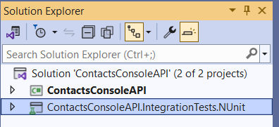
* **Choose Open Folder in File Explorer**
* Create a **.zip archive** with the following files:  
  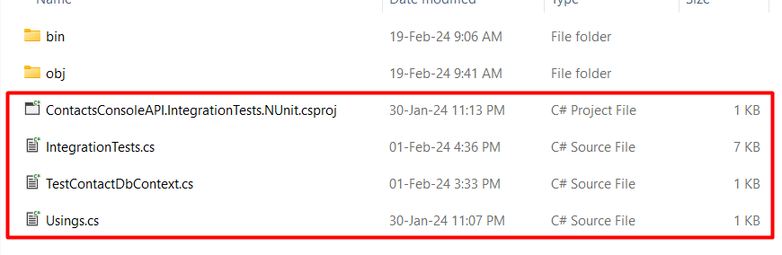

**NB!:** ZIP archive (**NOT rar**, or any other)! **Don't include** **bin and obj folders**.

* Attach your archive in the Judge system.
* Don't mind that it will give you "Compile Time Error". Third task of your exam will be checked manualy.