# Contents:

1.Software Configuration Management and Source Control Systems

* Vocabulary: Clone a Repo, Commit a Changeset, Push the Changes, Pull Changes, Merge Changes

2. Introduction to Git

* Working with git, Git Bash, and TortoiseGit

3. Introduction to Hit Hub

## Source Control Systems : Lesson Summary

* Source Control Systems keep the source code (+ other project assets) in a shared repository
  + 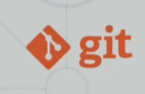Developers can clone a repository, pull the latest version, commit & push local changes, view the change logs, etc.
* Git is the most popular source control system
  + Other version control systems : SVN, TFS, Perforce
* GitHub is the #1 site for Git project hosting
  + Git hosting + issue tracker + project tracker + build system

# **Software Configuration Management**

### Working on Shared Code: Source Control System

* Version Control = Software Configuration

Management (SCM) = source control system

* + A software engineering discipline
  + Consists of techniques, practices

And tools for working on shared

Source code and files

* + Mechanisms of Management, control

And tracking the changes

* + Defines the process of change

Management

* + Keeps track of what is happening in

The project over

* + Solves conflict in changes

## Change Log

* Version control systems keep their own

change log (version history). It shows:

* + Who?
  + When?
  + Why?
  + What had been changed?
* Old versions could be restored

# Vocabulary

### Repository(Repo)

* Repo holds the project in a remote server

### Clone

* Download a local copy of the remote project

### Commit

* Saves a set of changes locally

### Sync (Pull/Push)

* Pull - take and merge the changes from the Remote
* Push – send local changes to the Remote

### Branch

* Branching is the act of cloning the Repo, locally working on changes and only merging back the Branch via a pull request once ready with all the changes, which will have a final review made. This way the conflicts and all issues can be solved at once instead of implementing solutions for each small change being made to the remote Repo.

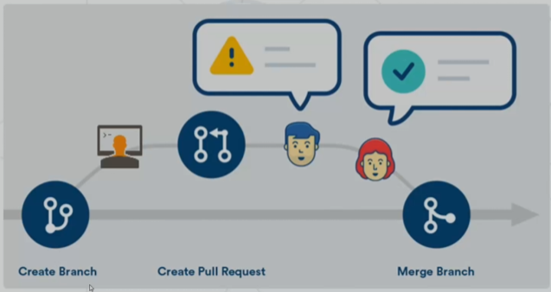

### What is Git?

* 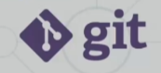Git == distributed source-control system
  + The most popular in the world
  + Free, open-source software
* Works with local and remote repositories
* Git bash – command line interface for Git
* Runs on Linux,macOS and Windows (msysGit)
  + <https://git-scm.com/>

### Using Git

* Console-based Git Client
  + git, Git Bash
* Windows GUI client – Tortoise Git

# Github Licenses and their differences

MIT License – You can use this code in anyway you wish to however I have no responsibility around it’s usage and there’s no copyright

GNU General Public License v3.0 – If you’re going to use my code for commercial purposes you either have to pay me or open your own code as well to be opensource

Apache License 2.0 – Again use the code as you wish, same as MIT License, however this time I’m keeping copyrights over my code, this mean you cant sell it directly