# Introduction and basic Syntax

## C# Programming language

* Object oriented by nature, statically typed, compiled
* Runs on .Net Framework / .Net Core

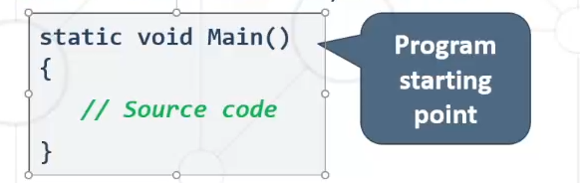

## Using Visual Studio

* Visual Studio (VS) is a powerful IDE for C#
* Create a Console Application

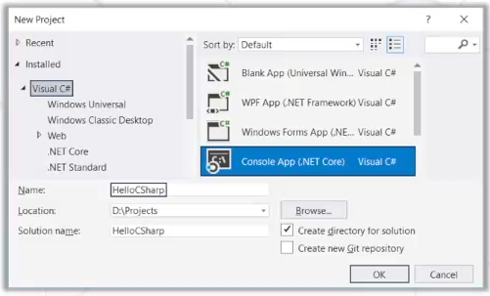

## Running the Program

* Start the program from VS using [Ctrl + F5]

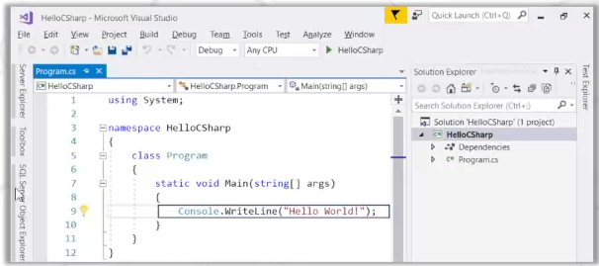

## Declaring Variables

* Defining and initializing variables.

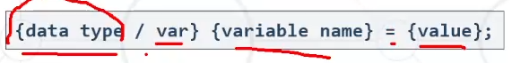

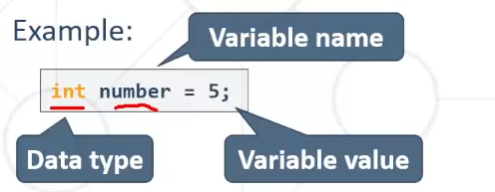

“=” – оператор за присвояване

## Reading from the Console

* We can read/write to the console, using the **Console** class
* Use the **System** namespace to access **System.Console** class



* Reading input from the console using **Console.Readline()**:

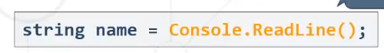

Tip : with F12 while selecting a class/namespace it opens a detailed view of all classes under that namespace

## Converting Input from the Console

* **Console.Readline()** returns a **string**
* Convert the string to number by **parsing:**

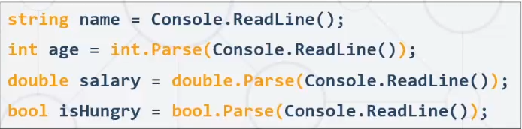

## Printing to the Console

* We can **print** to the console using the **Console** class
* Use the **System** namespace to access **System.Console** class
* 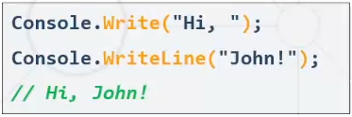 Writing output to the console:
  + **Console.Write()**
  + **Console.WriteLine()**

Tip: Hotkeys –

* Ctrl + X – Delete current line
* Ctrl + D – Duplicate current line
* Ctrl + Z – Undo most recent action
* Ctrl + C – Copies the current line of code

## Using PlaceHolders

* Using **placeholders** to print on the console
* Examples:

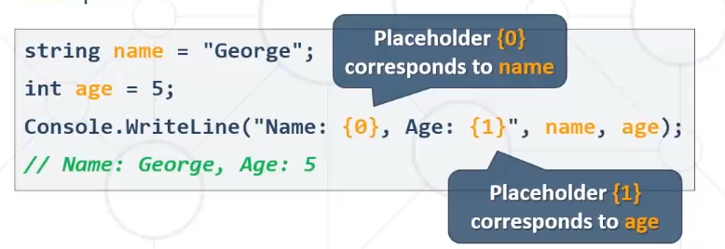

## Using String Interpolation

* Using string interpolation to print on the console
* Examples:

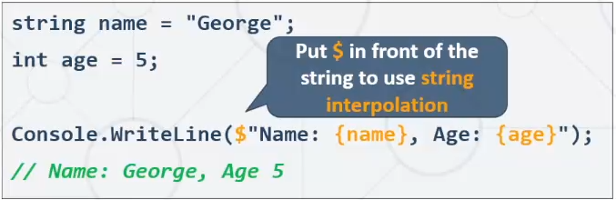

## Formatting Numbers in Placeholders

* **D** – Format number to certain digits with leading zeros
* F **–** Format floating point number with certain digits after decimal point
* Examples:

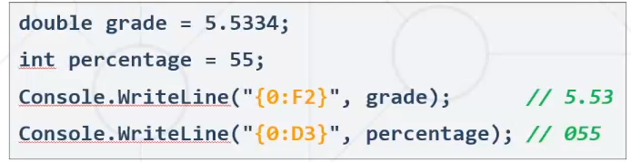

# Comparison Operators

Operator Notation in C#

Equals ==

Not Equals !=

Greater Than >

Greater Than or Equals >=

Less Than <

Less Than or Equals <=

## Comparing Numbers

* Values can be compared:

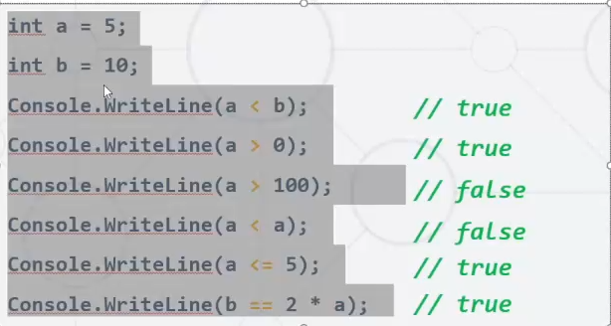

# Implementing Control-Flow Logic

## The If Statement

* The most simple **conditional statement**
  + Test for a condition
* Example: Take as an input a grade and check if the student has passed the exam (grade >= 3.00)

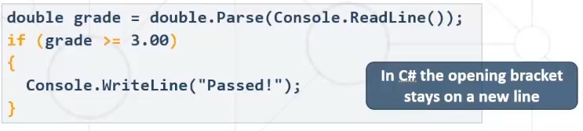

## The If-else Statement

* Executes **one branch** if the condition is **true** and **another** if it is **false**
* Example: Upgrade the last example, so it prints “Failed!” if the mark is lower than 3.00:

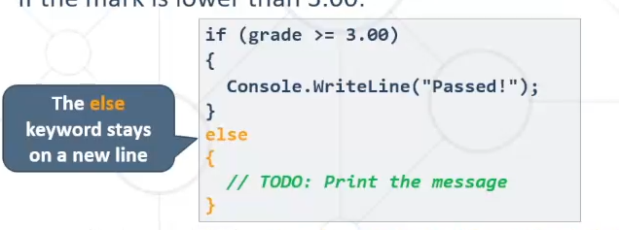

## The Switch Case Statement

* Switch-case statement works as a sequence of if-else
* Example: Read an input and print its corresponding month:

