8/19/2020

Teodor Grigor – Student ID 19412013

[company name]

Dai Makai-Mura

Game Techniques 1

Contents

1. About Game 2
2. Game Objectives 3
3. Game Mechanics 4
4. Screen flow diagrams, Characters, NPC, Background design 5
5. Pseudo design 7
6. Implementation of game 9
7. Testing 10
8. Planning 11
9. Evaluation and future developments 12
10. References 13

# About Game

Dai Makai-Mura is a Japanese game (in English is translated as Ghouls ‘n Ghosts) and it is classified as a side-scrolling game. It was originally released as an Arcade Game in 1988. This game has a story about the Knight Arthur that needs to defeat the evil Lucifer and therefore restore the souls of ‘Prin-Prin’ and the ones from the people.

This game has a total of 6 levels, each level having a different theme and story. But to unlock the 5th level Arthur needs to play and win the levels from 1 to 5 twice because they have a different symbolic. This game is similar to the Ghosts ‘n Goblins which is another game from the same sequel.

My game is different than the original game due to some changes to the game objectives. One difference is that in my game the player has to reach the portal (also known as end-portal in the game) to finish the level.

Another difference is that the player has three lives. Whenever the player gets hit by an enemy than he loses automatically one life and is respawned at the initial position of the current level. When the player starts a new level than the lives are automatically restored – the players start a level all the time with 3 stars. In case that the users remain without any lives than the level is automatically lost therefore the player can choose to go to the main menu or to restart the level.

In the game, there is only one possible enemy and the characters are moving right to left and back in a default area. The last level of the game (the 4th level) is randomly created, therefore it will be different at all the time.

A big difference is that in my game the game content scrolls up and down instead of left and right. For instance, the player to advance has to jump and increase the altitude. While the altitude increases the background colour changes from light-blue to black, the black colour representing the space.

# Game Objectives

The game objective of the original game is to win the entire game, but even if it may seem that you need to play only 6 levels to win it has 11 because the player needs to play the levels from 1 to 5 twice. The main objective is to defeat the evil (Lucifer) and restore the souls of Prin-Prin and the people.

While jumping you can jump twice, this means that you have a chance to jump higher or to dodge an enemy. While jumping if you hit treasures of gold than it is going to rain with gold for a few seconds, gold that you can pick.

To be able to defeat Lucifer you need to pick up the special weapon that is appearing only the second time when you play the levels from 1 to 5. In this game, there are different sets of equipment such as armour and a special weapon. The armour lets the player release a powerful magical attack, while the weapons give the player the possibility to attack (use) a special attack.

In my version of the game, the jumping is done the same way as the original game but there is no type of currency available – you can not pick coins during the game at all. Using the left and right arrows the player can choose to move to the right or left side of the game space. The player can walk only on ground (in the game it appears as blocks of bricks) therefore if the player attempts to navigate outside the area of the ground it will fall due to the gravity (the player can not walk on the air).

The collision between the main character and the enemy character is done using the collision – the enemies can not attack you or shoot things in the air – only the main character can shoot two types of bullets by pressing the ‘1’ and ‘2’ keys. Each bullet has something different: one bullet is faster and the other has two lives – it can hit up to two enemies before disappearing in the air.

# Game Mechanics

In the original game, the player can play only with one character which is Arthur, but this character is fully customizable with weapons and armours. Each weapon and/or armour has its specialities; overall the weapons and the armours give you different types of special attacks. The enemies character are non-playable characters but they can affect your status such as giving damage and in the end if you don’t manage to badge their attacks you will be defeated because you are out of health. The playable character is the main character, Arthur. You can control his movements, attacks and even the equipment. By movements, I mean that you can jump or move left/right.

In my version of the game the player can not choose the playable character- it is automatically assigned and it is a witch. The witch can move left, right and can jump up to two times at a time. If the witch attempts to walk on the air she will fall without losing any lives.

The bullets are static characters, therefore, the player can not interact with them – the only way that the player can do to the bullets is shooting them in a direction therefor the direction (left or right) can be changed based on what the character is facing.

# Screen flow diagrams, Characters, NPC, Background design

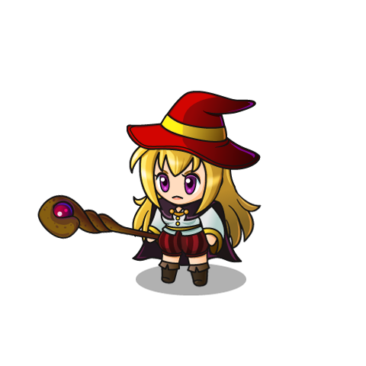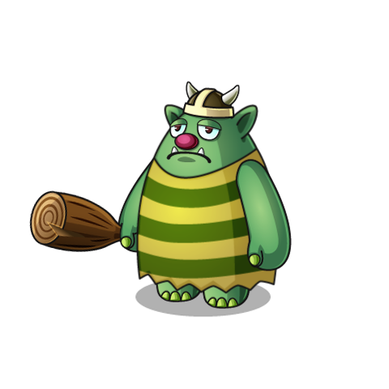In the game, there is only one playable character, a witch. The witch wears a red hat with a purple suit of a warrior and in the hands, the character holds a wizard weapon. With this weapon, it can shoots ‘bullet’ in the game. Due to the human body-type in the game the witch can not fly or levitate therefore she can walk only on the grounds and if she attempts to jump in case that she doesn’t reach any grounds she will fall until a new ground that is under the witch is reached. The enemy is a green bear that has the characteristics of a human. It can walk on two feet only and in hands it has a bat of wood.

Figure Enemy

The in-game background is made of one colour and the colour is changed based on the character’s altitude – while the player attempts to go higher the colour will be darkened and in the end, it will be black, while at the bottom is a light blue. The light blue attempts to simulate the sky colour while the black colour tries to simulate the galaxy.

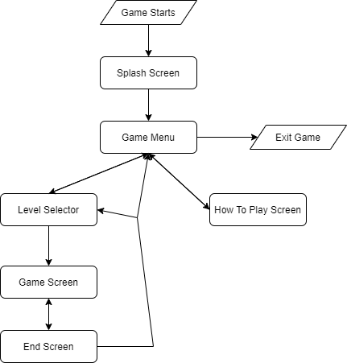

Figure Screen Flow Diagram

# Pseudo design

Run the game

If the game started then

The splash screen will be shown

If the splash screen was shown for 2 seconds then

The game menu will be shown

If the game menu is shown then

If the Exit button is clicked then

The game is closed

If the How to play button is pressed then

The Instruction screen is shown

If the Play button is pressed then

The Level selector screen will be shown

If the instruction screen is shown then

If the Back button is pressed then

The game menu will be shown

If the level screen selector is shown then

If the Back button is pressed then

The game menu will be shown

If a game level button is pressed then

The game screen will be shown with the current level data

If the game screen is shown then

The elements are shown in the game window

If the left or right key is pressed then

The character will move into that direction

If the character finished moving or the character attempts to move on the air

It will fall until it reaches a ground

If the spacebar is pressed then

The character jumps

If the character jumps above ground then

It will fall on the last ground reached

If the character shoots bullets then

If the bullet collides with an enemy then

The enemy will be killed

The enemies are moving constantly in their designated area

If the player collides with an enemy then

It loses one life

If the number of lives is equal to 0 then

The End screen will be shown

If the End screen is shown

If the Level selector is clicked then

The level selector screen will be shown

If the return to the menu is clicked then

The game menu screen is shown

If the next level is clicked then

The game screen will be shown with the next level

# Implementation of game

In the game were implemented the following items:

* A background – the background is based on colours
* A graphical character – the main character, the witch
* The character can move by pressing the keyboard keys
* NPC are included – the enemy bear
* The main character can interact with other NPCs by shooting bullets
* In the game is present a life system
* The main character can fully interact with the NPCs
* All NPCs can move – the enemies are moving in a default area, while the bullets are moving towards a side of the screen
* The game contains 4 playable levels

# Testing

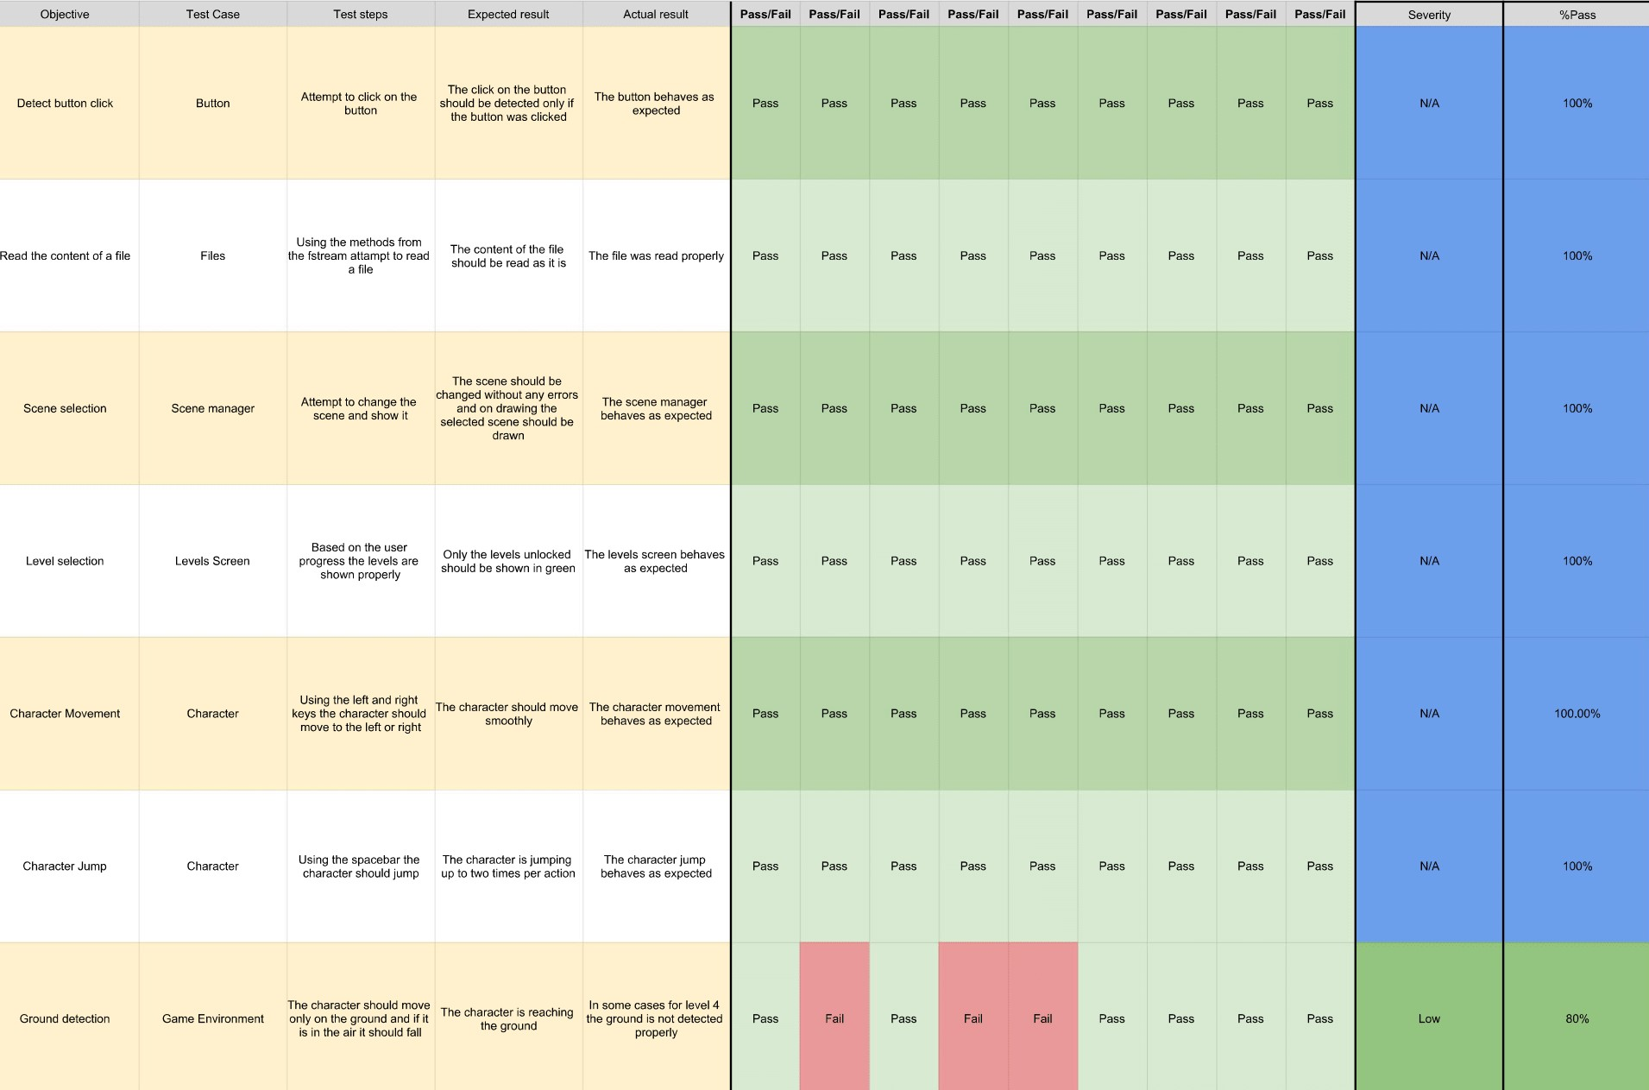

# Planning

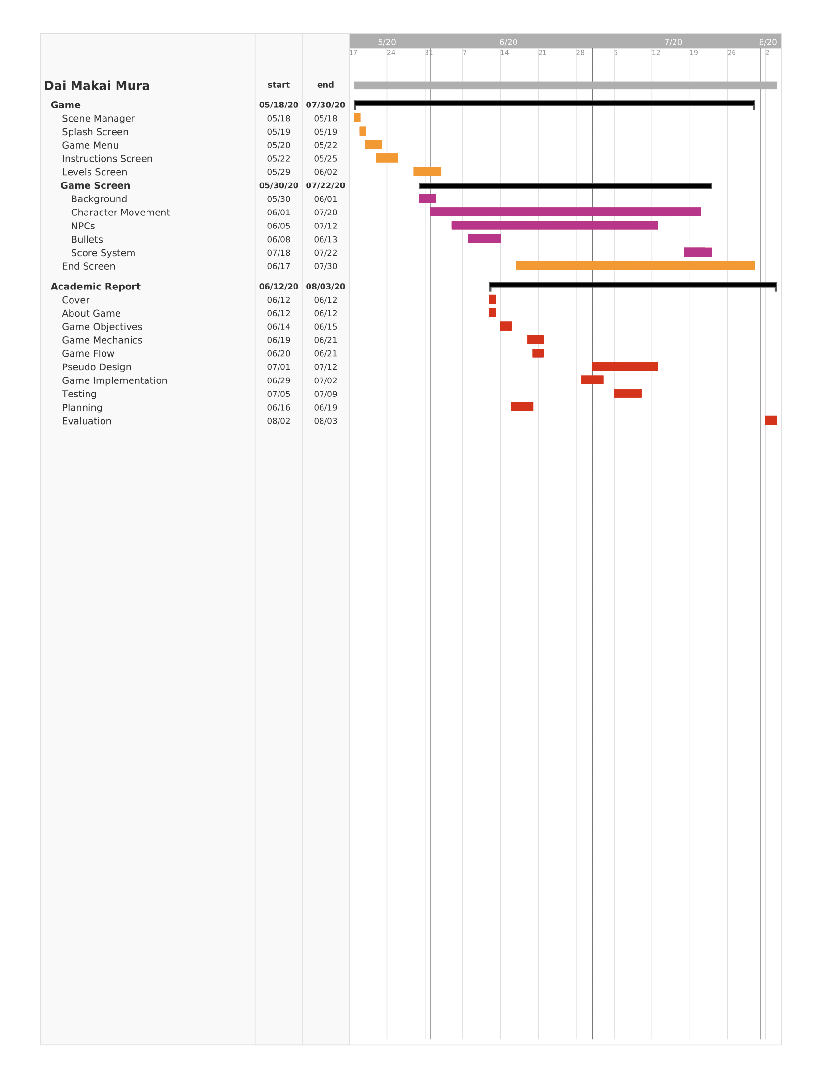

* 1. **Evaluation and future developments**

Creating the Dai-Makai Mura game helped me to manage the classes and at the same time learn more about them. In the beginning, I encountered some problems with the class initialization and duplication but I managed to fix them. Another big problem was to make the character to move only on the bricks (the game’s ground) because it was hard to detect them. I could have used the collision between objects but I thought that it would be better to detect the ground elements based on their positions.

In the future, it would be better if I could add some other enemies with their abilities because this way the people will be more engaged with the game due to more possible scenarios. Also, the player should be able to choose the character from a range of characters such as wizard, rogue, warrior and others and each character should have their techniques of fighting.

* 1. **References**

[Figure 1][Figure 2]

(2017). PIPOYA FREE 2D Game Character Sprites. Available: https://pipoya.itch.io/pipoya-free-2d-game-character-sprites. Last accessed 19th Aug 2020

[Figure Bullet]

(2015). Bullet Game Asset. Available: https://opengameart.org/content/bullets-game-asset. Last accessed 19th Aug 2020