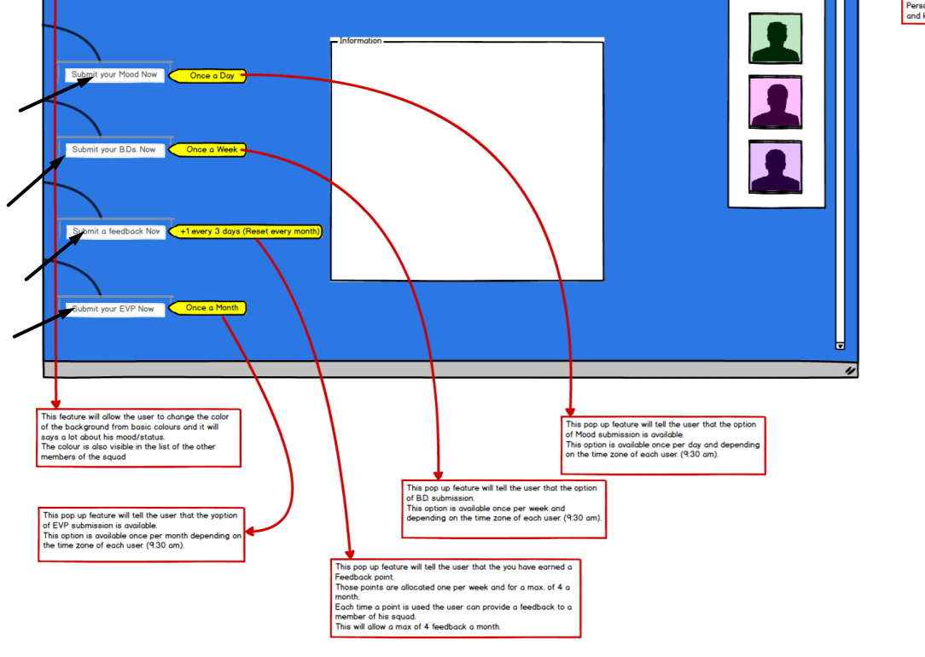

Q. If I submit my mood then where is it display? Same as all yellow points describe in details please.

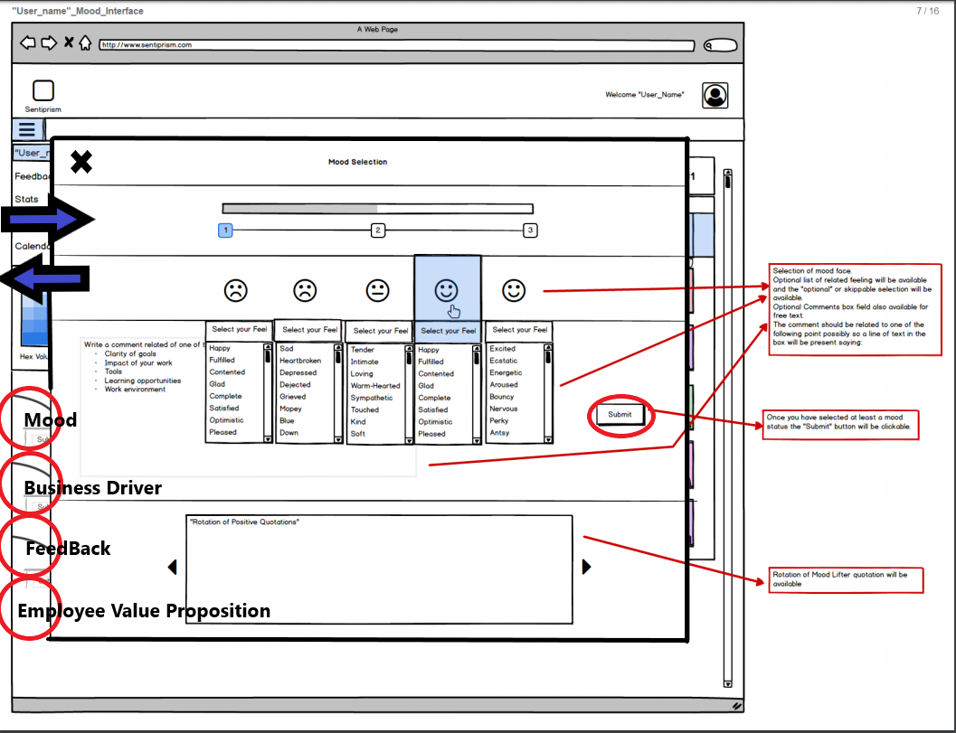A. All the yellow points are slide information that appear with the criteria described. For example for the Mood, once a day the side pop up appear and once you click on it you will have this:

The Mood Selection page is opening like a slider or a pop up (Up to you) as long is available within the same page and NOT opening a new window. Each selection page will have the submit button and the slide-back button. In easy word once the mood selection (or Business Driver, Feedback or EVP) is available you can click on the side pop up and a slider page will come from left to right.

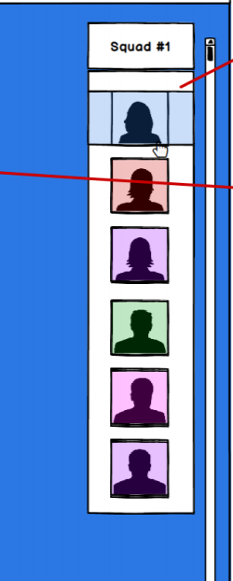

Q. Squad 1 it’s static fields and in squad have all registered user right? If I’m wrong then let me know in details.

A. “Squad 1” is not static as each account holder will be able to change the name of the team. For example it could be “Falcon team” or “Blue squad” or whatever. Each member of that team will appear in that column with the background color (Or border color, up to you guys) of the color chosen in the main page. For Example in the example provided the background color picked is blue so there should be a reference of the color chosen (Example in the pic below).

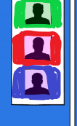

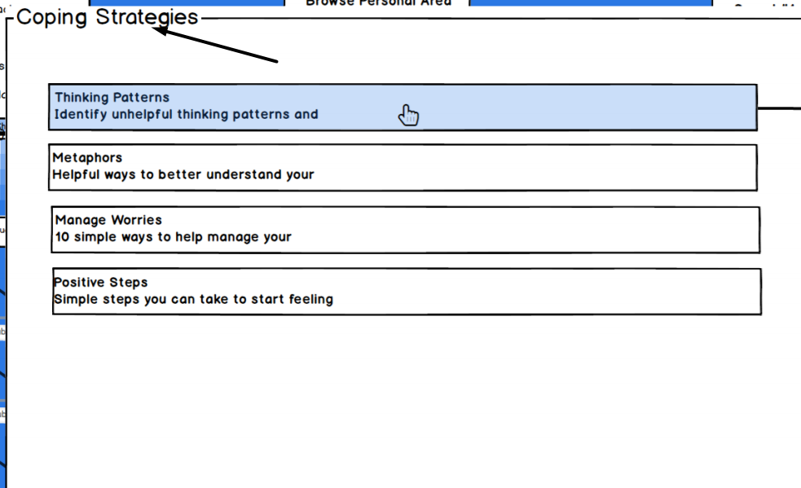

Q. Where is it coping strategies? Please let me know and it’s just info right?

Q. Same as, help right now?

A. This has been taken from the App “What’s Up?” at the following link:

<https://play.google.com/store/apps/details?id=com.jacksontempra.apps.whatsup>

If you could emulate the same pattern would be great but it should be in the slider in the main page. Like in the picture below you should be able to slide the desired square like in the apple products.

Each section selected should open a bigger square within the same page with the information and if the user is looking for something else he could just go back to slide again to another one. If you download the app “What’s Up!” you can actually copy paste the content. Just skip the “donate” section of the app and include where you can the rest.

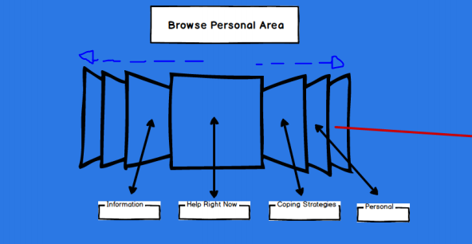

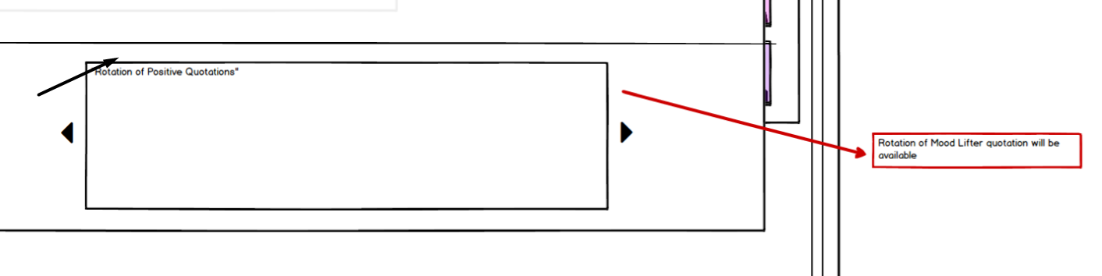

Q. who can add this questions and where?

A. You can find free API quote generator like:

<https://talaikis.com/random_quotes_api/>

<https://quotesondesign.com/api-v4-0/>

<https://quotes.rest/>

<https://market.mashape.com/andruxnet/random-famous-quotes>

If you could include some free API for free quotation would be great, those quotation should increase the morale of the user during the submission of data.

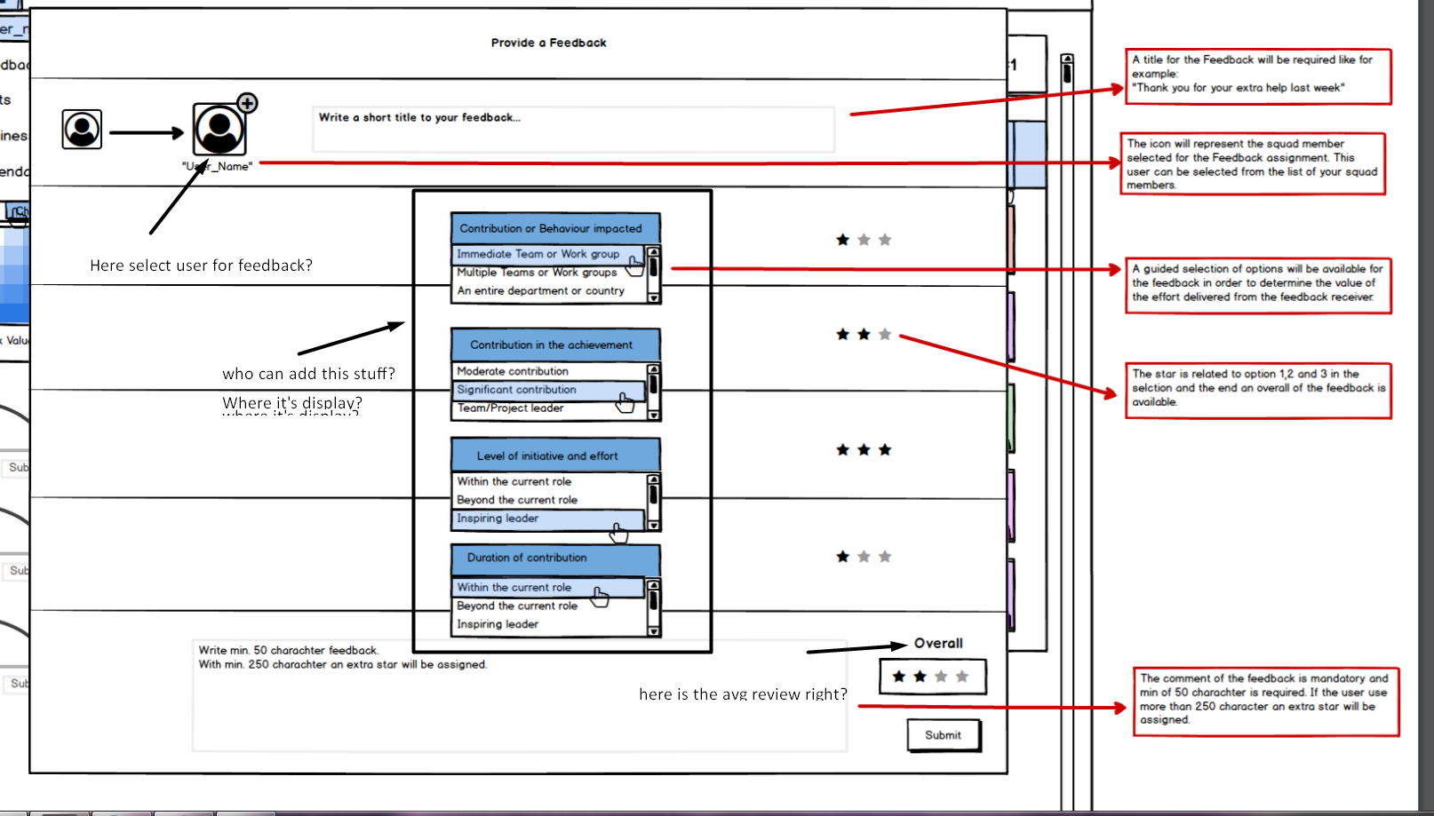

Q. please see this image and let me know in details please. I have ask question in black color in image so please check it.

**From top to bottom**

A. Yes, the bigger square is the receiver of the feedback and can be selected from you’re the team. A selection of the people will allow the user to pick the one wanted within the team like in the pic.



A. Once you have selected the user that will receive the feedback a guided multiple selection will be available. Those selections are static and one answer is requested for each row. 1 star for the first option, 2 stars for the second option and 3 stars for the 3rd option. Once all the rows are answered the user has the possibility to write down free text for the feedback which is mandatory before the submission. With more than 250 words there should be an added star to the overall count. In the example the overall is 2.xx but if the user write more than 250 words the overall will be 3.xx.

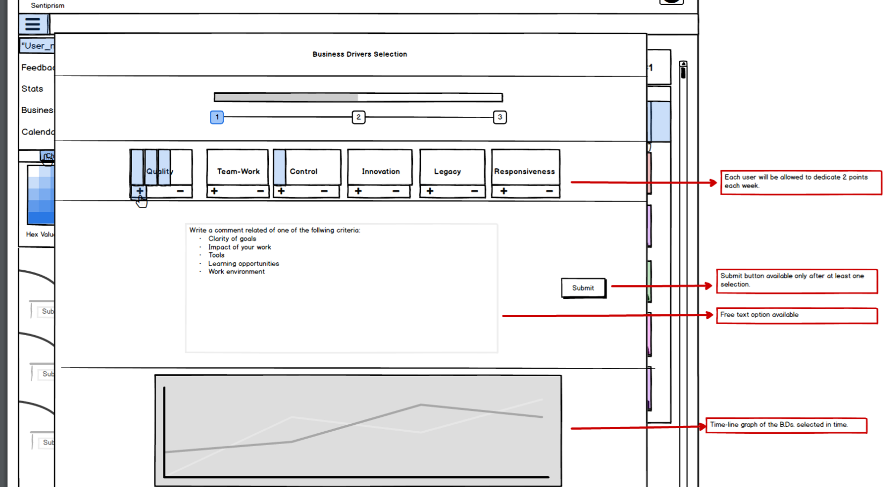

Q. in this screen I am not understanding any point can you please describe me in details?

A. Each week the user will receive 2 points to allocate to the options above: “Quality”, “Team-Work”, “Control” etc.. Each point allocate will add a bar to the criteria selected like in the picture. Those are represented like batteries because the user will need to show where the battery should be recharged. This works like the Mood selection explained previously with the sliding page of the pop up on the left. So basically each week there will be a pop up on the left saying to the user to spend his 2 points in the Business Driver selection.

Free text will be also available if the user want to explain his selection.

The graph should represent an history of the team selection during time.

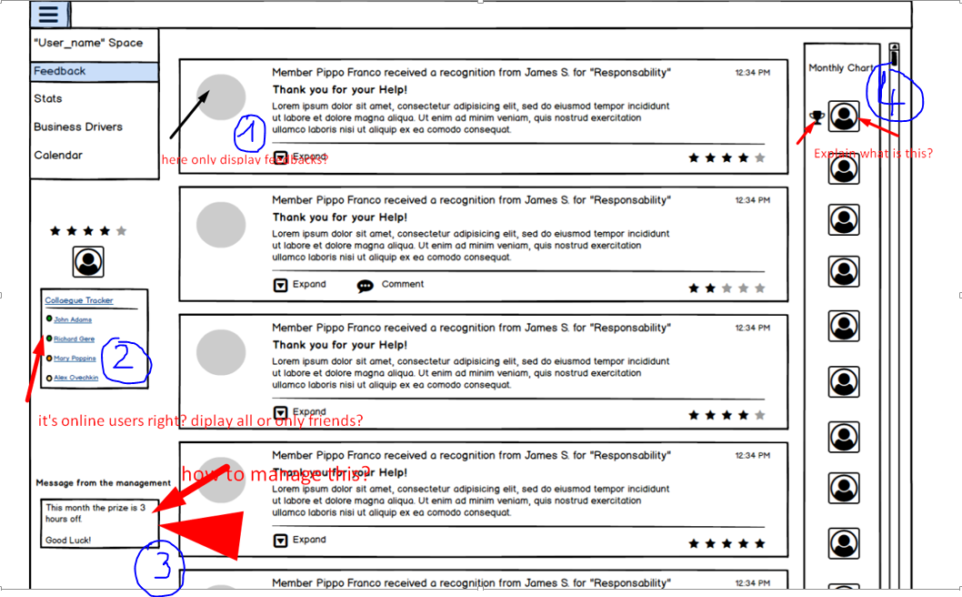

Q. please see this image and tell me in details for those which I have mentioned in this image.

A. 1) In the grey circle only the initials on the user will be shown like for example if the user is called “Pippo Franco” the circle will show **P.F.**

A. 2) Remove the “colleague tracker” from your work-flow as is not a necessary feature.

A. 3) That field is a free text space used by the account holder/manager to write down the price of the month, (Reward system of the feedback chart). For example in this case the account holder decided to write that the winner will receive 3 hours off.

A. 4) That is a chart for the people under the same account holder that received more feedback. For example if a member of the team received 5 feedback from the rest of the team and the second one receive 3 feedback the winner of the chart will be the user that received 5 feedback and will be entitled to the 3 hours off as per “message from the management”.

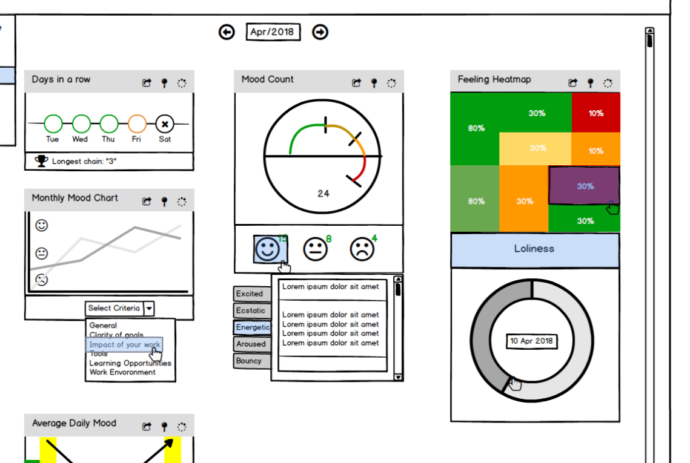

Q. also tell me in details for all charts.

A. The charts are not easy to explain but they should explain themselves. As you will have a database table with submission of information like mood, business drivers, EVP and feedback and out of them some dashboard should be available. For example the first one has 3 green circle which means that the team has submitted an average of 3 happy faces in a row Tue, Wed and Thu.

Or the mood count, for example, is showing with a fancy data visualization the number of mood selections plus the feeling and the free text. There is also an heat map with the % of feeling selected using colors in order to show the degree of the feeling. I think that the graph part should be left for last as we should work on the data information available.

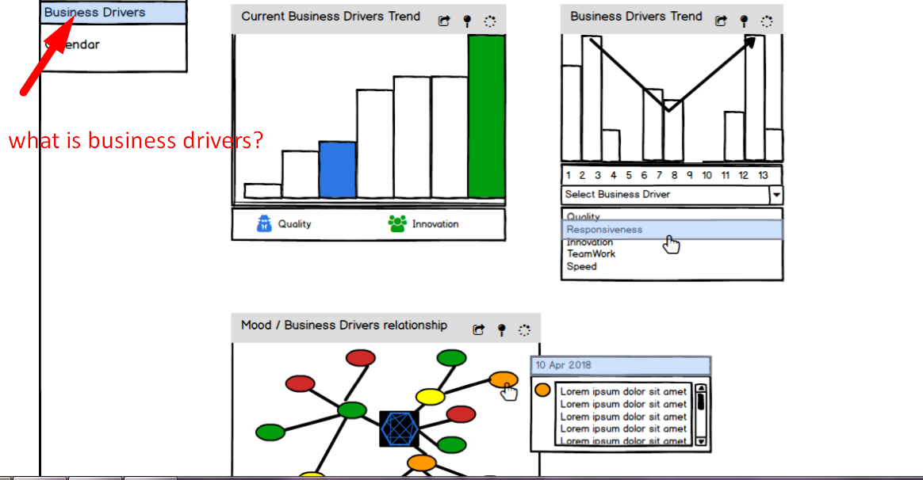

Q. what is business drivers? And also it’s chart describe in details.

A. Business Drivers is what I have explained before:

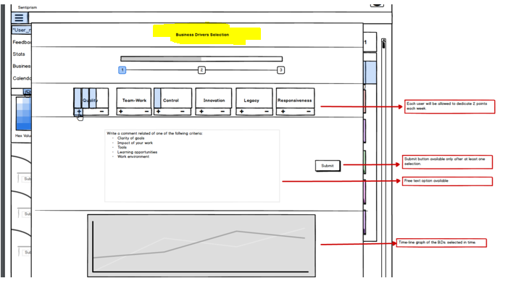

But as I answered in the previous question, I would leave the dashboard at the end as we should be able to provide data visualization of all the information that we have.

Q. also please describe overview of web. How to use and what is the purpose of this web?

A. There is no need of describing the overview or the purpose. I have provided you the information necessary. It’s a survey based service depending on the time with **anonymous information submission**.

**I hope is clear this time because if not we might have a chat.**