Microprocessors

TEOMAN ÜNAL

This project deals with memory interfacing and ROM addressing. It aims to access data stored in a Read-Only Memory (ROM) controlled by a microcontroller or embedded system and send this data to external devices. By reading data from specific ROM addresses, the program interacts with various external devices, providing a foundational structure for accessing and controlling fixed data stored in ROM for diverse applications.

metin, ekran görüntüsü, yazı tipi, meneviş mavisi içeren bir resim

Açıklama otomatik olarak oluşturuldu

8086 and the other devices connection circuits are below

metin, diyagram, ekran görüntüsü, çizgi içeren bir resim

Açıklama otomatik olarak oluşturuldu

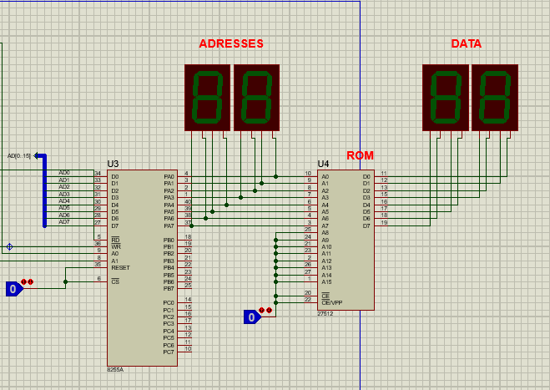

And all device circuits are below

diyagram, metin, plan, çizgi içeren bir resim

Açıklama otomatik olarak oluşturuldu

This is the link for short video showing the project in work:

https://youtu.be/vIeK6gcubcg

All codes are below

DATA SEGMENT

PORTA EQU 00H

PORTB EQU 02H

PORTC EQU 04H

PORT_CON EQU 06H

DATA ENDS

CODE SEGMENT

MOV AX,DATA

MOV DS, AX

ORG 0000H

START:

MOV DX, PORT_CON

MOV AL, 10000000B

OUT DX, AL

MOV AL,00H

MOV CX,01FH

XX:

PUSH CX

MOV DX, PORTA

OUT DX,AL

INC AL

MOV cx, 06H

D1: LOOP D1

POP CX

LOOP XX

JMP START

CODE ENDS

END