SymK Product Lifecycle (PLC) — Reference Manual

1. Introduction
This manual defines the reference model for the SymK Product Lifecycle (PLC). It is the authoritative description of how product work is structured across phases and how human-facing artifacts are linked to machine-readable representations (JSON, YAML, etc.).
The PLC reference is intentionally tool-agnostic. It describes what must exist and how phases connect. Individual repositories and projects implement this reference using their own conventions (file names, folder layouts, automation scripts).

1.1 Audience
This document is intended for:
- Architects who design product lifecycles and governance.
- Tech leads who need a clear interface between product work and automation.
- AI tooling authors who consume PLC data structures (JSON / YAML).

1.2 Scope
The PLC reference covers:
- The list of PLC phases and sub-phases.
- The objective of each phase.
- Expected human-facing artifacts (documents, diagrams, decks).
- Expected machine-facing artifacts (JSON / YAML, registries, indexes).
- How meta-PLC templates relate to project-level PLC instances.

2. Meta PLC vs Project PLC

2.1 Meta PLC
The meta PLC is the template that defines the canonical phases, sub-phases, and expectations for every SymK-compliant product. It lives in the SymK Devkit as a reusable reference and is versioned like any other artifact.
Key properties of the meta PLC:
- Describes the target structure, not a specific product.
- Defines phase names, codes, and their responsibilities.
- Describes mandatory and optional artifacts per phase.
- Provides JSON schemas for machine-readable PLC data.

2.2 Project PLC Instance
A project PLC instance is the concrete instantiation of the meta PLC for a specific product or initiative. It is created when a new project is initialized (for example, by symk-project-init) and lives inside the project's repository under the PLC/ folder.
Key properties of the project PLC instance:
- Uses the same phase and sub-phase codes as the meta PLC.
- Stores the actual decisions, documents, diagrams and metrics for the project.
- May include additional project-specific sub-folders, as long as the core structure remains compatible with the meta PLC.
- Can expose a machine-readable PLC summary (e.g., plc_instance.json) generated from the contents of the PLC/ tree.

2.3 Two Faces of PLC Data
The PLC deliberately has two faces:
- A human face: Markdown docs, decks, diagrams, workshop notes.
- A machine face: JSON/YAML structures used by tools and agents.
The human artifacts are optimized for clarity and collaboration. The machine artifacts are optimized for consistency and automation. Both must refer to the same underlying reality: the state of the product across its lifecycle.

3. PLC Phases and Sub-Phases
The standard SymK PLC is organized into ten phases. Each phase has one or more sub-phases that represent focused work areas. Below is the reference definition for each phase.

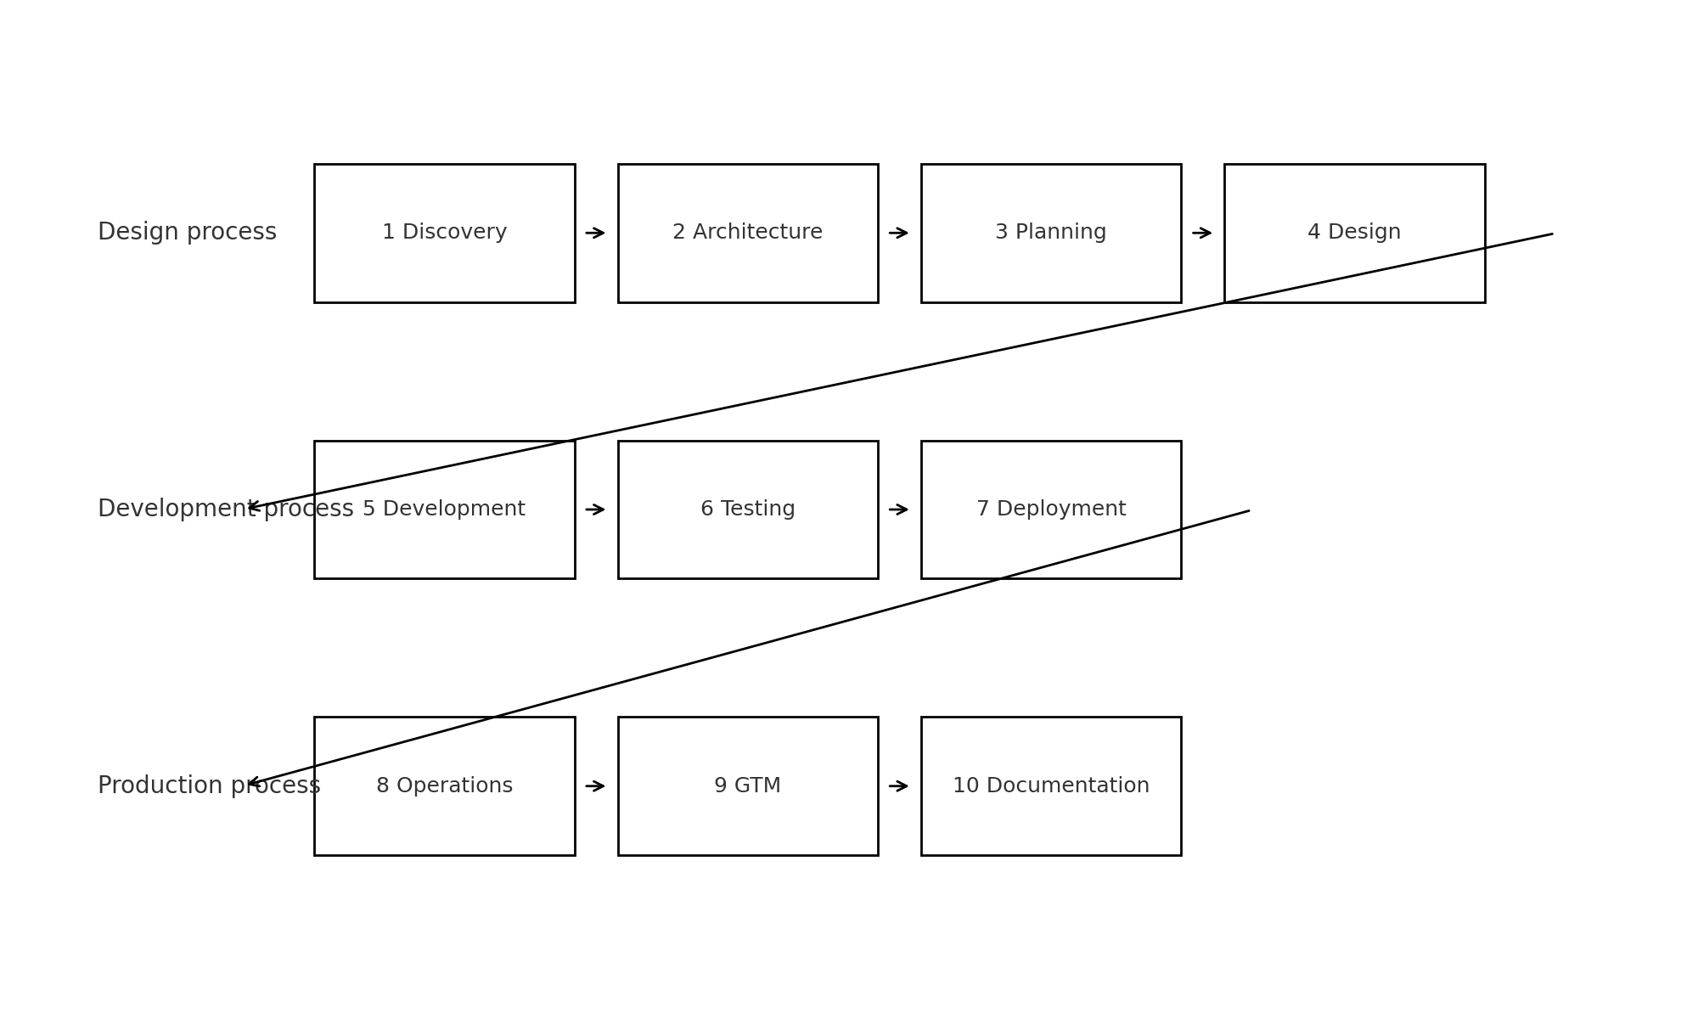

  - 3.1 Phase 1 — Discovery
Goal: Understand the problem space and define the product at a high level.
- Sub-phases:
- 3.1.1 Product Vision
- 1.2 Market Research
- 1.3 Stakeholder Map

3.1.1 Product Vision
Clarifies why the product exists, who it serves, and what long-term change it is expected to create.
- Typical human artifacts:
- - product_vision.md (narrative)
- - elevator_pitch.md
- Typical machine artifacts:
- - product_vision.json (structured fields for mission, target users, outcomes).

3.1.2 Market Research
Maps the market landscape: competitors, benchmarks, trends and regulatory context.
- Typical human artifacts:
- - market_overview.md
- - competitor_matrix.xlsx or .md
- Typical machine artifacts:
- - market_research.json (segments, competitors, key differentiators).

1.3 Stakeholder Map
Identifies and classifies internal and external stakeholders, their goals, and their influence on the product.
- Typical human artifacts:
- - stakeholder_map.md
- - RACI / responsibility matrices.
- Typical machine artifacts:
- - stakeholders.json (roles, groups, influence scores, constraints).

3.2 Phase 2 — Architecture
Goal: Define the technical and information architecture for the solution.
- Sub-phases:
- 2.1 System Blueprints
- 2.2 Reference Stacks
- 2.3 Security Model

2.1 System Blueprints
High-level views of the system: context diagrams, component diagrams, main flows.
- Human artifacts:
- - system_blueprints.md
- - UML / C4 diagrams (PNG/SVG).
- Machine artifacts:
- - architecture_map.json (services, domains, integrations).

2.2 Reference Stacks
Defines approved technology stacks and their constraints (languages, frameworks, databases, infrastructure).
- Human artifacts:
- - reference_stack.md
- - tech_radars or decision records (ADR).
- Machine artifacts:
- - tech_stack.json (components, versions, support status).

2.3 Security Model
Captures security requirements, trust boundaries, threat models, and compliance constraints.
- Human artifacts:
- - security_model.md
- - threat_model diagrams / STRIDE analysis.
- Machine artifacts:
- - security_policies.json (controls, required checks, data classification).

3.3 Phase 3 — Planning
Goal: Plan releases, scope and delivery strategy.
- Sub-phases:
- 3.1 Roadmap
- 3.2 Release Trains
- 3.3 Scope Definition

3.1 Roadmap
Defines major milestones and timeframes for delivering meaningful value increments.
- Human artifacts:
- - roadmap.md or roadmap.xlsx
- Machine artifacts:
- - roadmap.json (milestones, dependencies, target dates).

3.2 Release Trains
Defines release cadence, naming and eligibility criteria for features entering each train.
- Human artifacts:
- - release_policy.md
- Machine artifacts:
- - release_trains.json (cadence, environments, rules).

3.3 Scope Definition
Clarifies what is in scope and out of scope for the product or current delivery wave.
- Human artifacts:
- - scope_definition.md
- Machine artifacts:
- - scope_items.json (epics, boundaries, exclusions).

3.4 Phase 4 — Design
Goal: Turn requirements and architecture into concrete experience and interaction designs.
- Sub-phases: UX Flows, IA Diagrams, Design System.

3.5 Phase 5 — Development
Goal: Implement the solution across backend, frontend and infrastructure. In SymK, development strongly aligns with boundaries, core, adapters and models.

3.6 Phase 6 — Testing
Goal: Validate correctness, quality and risk coverage. Includes test plans, automated QA suites and security testing.

3.7 Phase 7 — Deployment
Goal: Move changes safely into runtime environments with proper configuration, CI/CD pipelines and observability in place.

3.8 Phase 8 — Operations
Goal: Keep the system healthy in production. Includes SRE procedures, incident response playbooks and performance tuning guides.

3.9 Phase 9 — Go-to-Market (GTM)
Goal: Ensure the product can be positioned, sold and supported effectively. Includes positioning, sales enablement and pricing strategies.

3.10 Phase 10 — Documentation
Goal: Maintain technical and user-facing documentation, as well as release notes, in a traceable and consistent way.

4. Machine-Facing PLC Structures
For automation and AI agents, the PLC must be consumable as structured data. A common pattern is to maintain two JSON documents per project:
- - plc_meta.json — derived from the meta PLC reference.
- - plc_instance.json — synthesized from the project PLC contents.

4.1 plc_meta.json (Example Fields)
- Typical fields for the meta PLC structure include:
- - version: semantic version of the meta PLC definition.
- - phases: list of phases, each with code, name, description.
- - subphases: nested list with names, responsibilities, required/optional.
- - required_artifacts: reference names for key docs per sub-phase.

4.2 plc_instance.json (Example Fields)
The instance-level PLC structure maps the reference model to real files and decisions.
- Typical fields:
- - project: name and identifiers for the product.
- - phase_status: per-phase status (planned, in-progress, validated, deprecated).
- - artifacts: paths to human artifacts (Markdown, slides, diagrams).
- - data: embedded or referenced JSON/YAML with structured decisions.

5. Governance and Versioning
The PLC is not just a folder structure; it is a governance mechanism. Changes to the meta PLC should be treated like changes to a core API: they impact all projects.
- Recommended practices:
- - Version the meta PLC (e.g., v1.0.0, v1.1.0) and document changes.
- - Keep a simple CHANGELOG for PLC-related updates.
- - When evolving the meta PLC, provide migration notes for existing projects (e.g., new required artifacts, renamed phases).
- Keep project PLC instances in sync with the meta PLC version they follow.

6. How Tools Consume the PLC
Automation tools (including AI agents) can use the PLC structures in several ways:
- - Navigate the PLC/ tree to find relevant context for a task.
- - Read plc_instance.json to understand the current status and gaps.
- - Suggest missing artifacts or inconsistencies between phases.
- - Generate reports and dashboards about lifecycle coverage.
The stricter and more consistent the PLC structures are, the more reliable and useful these tools become.

7. Summary
The SymK Product Lifecycle (PLC) is the backbone of how products are conceived, planned, designed, built and operated. The meta PLC defines the rules of the game; project PLC instances are where the real work lives. Keeping both aligned enables strong governance, better automation and richer human–AI collaboration.

