# 1)

### ls

lists all unhidden contents within the current directory.

alt text

### ls -l

lists all contents with the long listing format. long list format includes file name, permissions, size, and date modified.

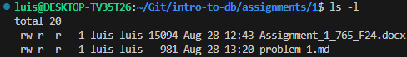

### ls -a

lists all unhidden and hidden contents within the current directory.

alt text

### cd tests

attempts to move to the “tests” directory, fails if “tests” does not exist.

alt text

### pwd

prints the current directory.

alt text

### mkdir example_dir

Creates a directory with the name example_dir if it doesn’t already exist.

alt text

### ls -al > out

Runs the ls command with the -a and -l flags, then copies the output of that command to a file called out.

alt text

### more out

Views the file out within the termal, press q to stop viewing.

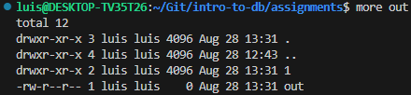

### chmod a+w out

Changes the access writes of the file out to allow all users to write to and delete it.

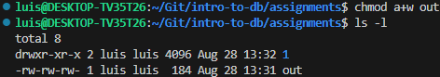

### ls -al

Runs the ls command with the -a and -l flags which lists all unhidden and hidden files with the long listing format.

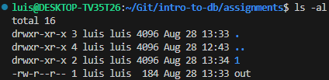

# 2)

### Code

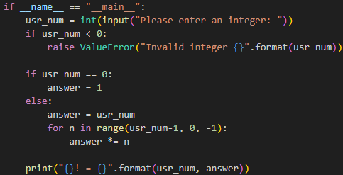

### Output

