# 1)

### ls

lists all unhidden contents within the current directory.

alt text

### ls -l

lists all contents with the long listing format. long list format includes file name, permissions, size, and date modified.

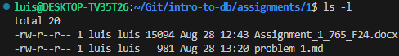

### ls -a

lists all unhidden and hidden contents within the current directory.

alt text

### cd tests

attempts to move to the “tests” directory, fails if “tests” does not exist.

alt text

### pwd

prints the current directory.

alt text

### mkdir example_dir

Creates a directory with the name “example_dir” if it doesn’t already exist.

alt text

### ls -al > out

Runs the ls command with the “-a” and “-l” flags, then copies the output of that command to a file called “out”.

alt text

### more out

Views the file “out” within the termal, press q to stop viewing.

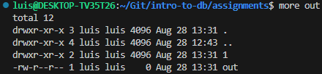

### chmod a+w out

Changes the access writes of the file “out” to allow all users to write to and delete it.

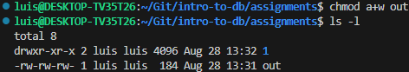

### ls -al

Runs the “ls” command with the “-a” and “-l” flags which lists all unhidden and hidden files with the long listing format.

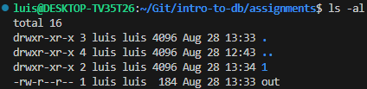

# 2)

### Code

if __name__ == "__main__":  
 usr_num = int(input("Please enter an integer: "))  
 if usr_num < 0:  
 raise ValueError("Invalid integer {}".format(usr_num))  
  
 if usr_num == 0:  
 answer = 1  
 else:  
 answer = usr_num  
 for n in range(usr_num-1, 0, -1):  
 answer *= n  
  
 print("{}! = {}".format(usr_num, answer))

### Output

