1. Consider for the following schema:

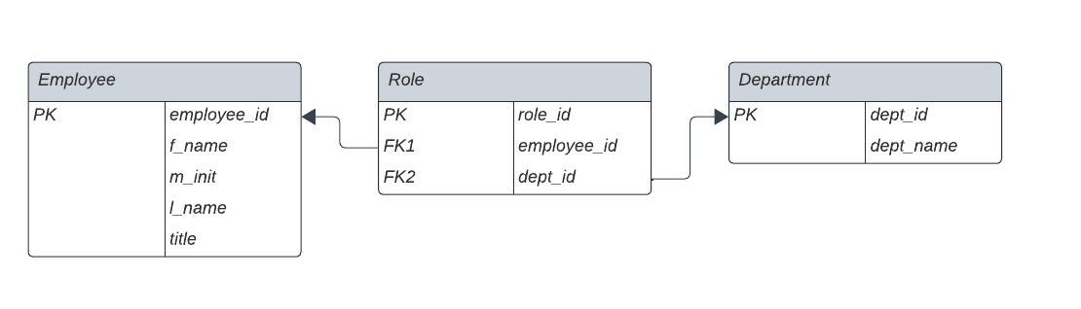

* 1. (3 points) Create tables in PostgreSQL for the three tables, with referentially triggered action on the foreign keys in the Role table “ON DELETE CASCADE”. Make sure to create a textfile with extension .sql first, and then run it using:

localpsql -f myfile.sql

If you create the table by typing in psql directly, you will not later be able to extract that sql code.

* 1. (3 points) Insert at least 5 records into each of the tables

1. Do the following queries
   1. (2 points) List all information from the Employee table sorted by l_name
   2. (2 points) List the f_name and l_name of each Employee entry (from the Employee table) together with dept_name of each Department entry the employee has a role in
   3. (2 points) List the l_name of each Employee entry together with the number of departments in which they have roles
   4. (2 points) Delete one record from the Department table that has at least one entry in the Role table
   5. (2 points) Redo the query from c) and show that the number of roles of that employee has decreased accordingly
   6. (2 points) Add a Boolean-type column to the Department table that is called small_department. Set it to TRUE for those Departments that have two of fewer associated employees. Note that this would have to be updated manually if the number of employees in departments changed, but let’s assume that is intentional
   7. (2 points) Create a view that lists the titles together with each name of a department (no duplicates in the combinations) in which there is a person with that title

When everything works properly, do one clear run of

localpsql -f myfile.sql

submit

* myfile.sql
* typescript file