1、Consider the graph below, which shows the size of the TCP sender’s congestion control window as a function of time (transmission round) in an idealized timing scenario where the sender sends a window’s worth of packets and then receives ACKs at the end of the RTT. Answer the following questions:
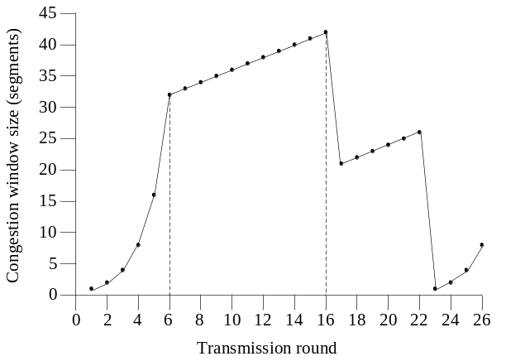
(a) Why does the congestion window curve have one form from rounds 1 to 6, and then another form from rounds 6 through 16?
(b) What event occurs at t=16, given that the result of this event is the sender cutting its congestion control window in half.
(c) What event occurs at t=22, given that the result of this event is the sending cutting its congestion window to 1? How is this event different from that which happened at t=16?
答：
- 因为在rounds1到6期间，TCP发送方处于慢启动阶段，CongWin的大小以指数速率增加：每经过一个RTT收到前面未确认数据的ACK，CongWin翻一倍；而在rounds 6时传输时达到阀值为了拥塞避免，拥塞窗口以线性速率爬升：每过一个RTT，CongWin增加一个MSS
- 在rounds 16时，收到了3个冗余ACK
- 在rounds 22时，超时事件发生
在rounds22时(超时事件发生)是指期望接收的下一个ACK在超时间隔到来时仍然未得到确认； rounds 16时(3个冗余ACK)是期望接收的下一个ACK经过三个RTT后仍然未被确认。
2、Suppose two hosts have a long-lived TCP session over a path with a 100 msec round-trip time (RTT). Then, a link fails, causing the traffic to flow over a longer path with a 500 msec RTT.
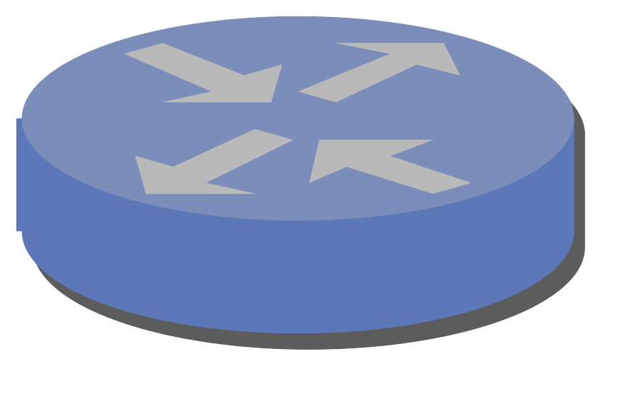
- Suppose the router on the left recognizes the failure immediately and starts forwarding data packets over the new path, without losing any packets. (Assume also that the router on the right recognizes the failure immediately and starts directing ACKs over the new path, without losing any ACK packets.) Why might the TCP sender retransmit some of the data packets anyway?
答：当第一条链接突然损坏后,拥塞窗口的大小以及超时时间间隔都不发生改变，但由于第二条的RTT>第一条的RTT，因而可能会出现在超时间隔到来时，期望接收的下一个ACK依然没有到来，此时超时事件发生，将会发生重传。
- Suppose instead that the routers do not switch to the new paths all that quickly, and the data packets (and ACK packets) in flight are all lost. What new congestion window size does the TCP sender use? Why?
答：新的拥塞窗口大小将被设置为1MSS，因为此时超时事件会发生，TCP发送方进入一个慢启动阶段。

