1210597 信息安全 李哲
1，Suppose we want to transmit the message 1011001001001011 and protect it from errors using the CRC polynomial x⁸+x²+x+1.
- Determine the message that should be transmitted.
D=1011 0010 0100 1011
G=100000111
∴r=8
∴n=2^{r}D/G=1011 0010 0100 1011 ÷ 1000 0011 1 = 1011 0001 0101 1101
∴R=1001 0011
∴2^{r}D XOR R = 1011 0010 0100 1011 1001 0011
- Suppose the leftmost bit of the message is inverted due to noise on the transmission link. What is the result of the receiver’s CRC calculation? How does the receiver know that an error has occurred?
传送报文变为：0011 0010 0100 1011 1001 0011
计算：0011 0010 0100 1011 1001 0011 ÷ 1000 0011 1 得到余数 1011 0110
∵余数不为0
∴可以判断出传输有错误

- Why does the Ethernet frame include a type field that indicates the network-layer protocol?
因为其指明了数据字段携带网络协议的数据，使得数据链路层的以太网可以为多种网络层协议提供传输服务。类型字段使得以太网和上层协议绑定起来，在发送方，多个上层网络层协议可以复用一个以太网发送数据，帧的类型字段写入上层协议的类型。在接收方，以太网根据接受的帧的类型字段决定将数据送给网络层的哪一个进程。
- Consider the network shown below. Assuming the filtering tables of all bridges (B1-B4) are initially empty, give the filtering tables for each of the bridges B1-B4 after the following transmissions:
- A sends to C
- C sends to A
- D sends to C
Identify ports with the unique neighbor reached directly from that port; that is, the ports for B1 are to be labeled “A” and “B2”.
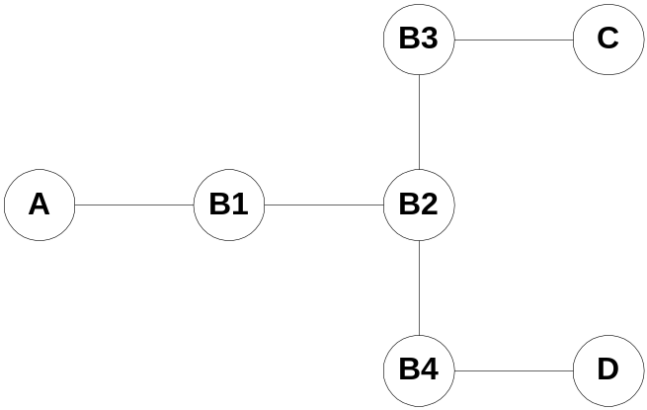
B1 ：
MAC地址 | 端口
A | A
C | B2
B2 :
MAC地址 | 端口
A | B1
C | B3
D | B4
B3 :
MAC地址 | 端口
A | B2
C | C
D | B2
B4 :
MAC地址 | 端口
A | B2
D | D

