Major：Computer science ID：1310617 Name：刘丹

⁶⁸
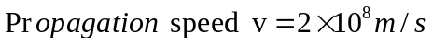
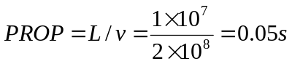
Answer:
Answer:
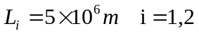
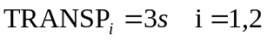
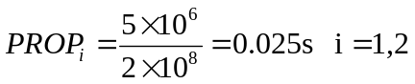
- 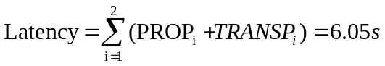
Answer:

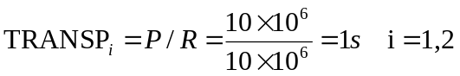
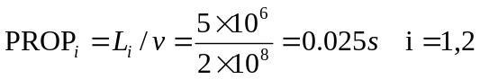

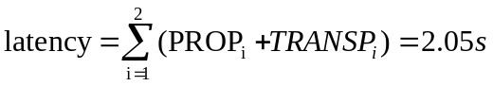

Answer:
