

PMIC Skeleton Patch Release Notes



September 26, 2022

Teradyne

Contents

PMIC Skeleton V1.3.0.1 Patch Release Notes 3

PMIC Skeleton V1.2.0.16 Patch Release Notes 3

PMIC Skeleton V1.2.0.15 Patch Release Notes 3

PMIC Skeleton V1.2.0.14 Patch Release Notes 4

PMIC Skeleton V1.2.0.13 Patch Release Notes 4

PMIC Skeleton V1.2.0.12 Patch Release Notes 5

PMIC Skeleton V1.2.0.11 Patch Release Notes 6

PMIC Skeleton V1.2.0.10 Patch Release Notes 8

PMIC Skeleton V1.2.0.9 Patch Release Notes 9

PMIC Skeleton V1.2.0.8 Patch Release Notes 9

PMIC Skeleton V1.2.0.7 Patch Release Notes 10

PMIC Skeleton V1.2.0.6 Patch Release Notes 10

PMIC Skeleton V1.2.0.5 Patch Release Notes 10

PMIC Skeleton V1.2.0.4 Patch Release Notes 11

PMIC Skeleton V1.1.0.21 Patch Release Notes 11

PMIC Skeleton V1.1.0.20 Patch Release Notes 12

PMIC Skeleton V1.1.0.19 Patch Release Notes 12

# PMIC Skeleton V1.3.0.1 Patch Release Notes

Optimize UI and workflow

Fix bug “\Modules_CommonSheets\TestIntance” => “\Modules_CommonSheets\TestInstance”

Add validation rule for domain check in IO_Levels (formula & domains in diff. category) 

# PMIC Skeleton V1.2.0.16 Patch Release Notes

Debug for empty pin name in portDefine

|  |  |  |
| --- | --- | --- |
| **Protocol Port Name** | **Type** | **Pin** |
| ADG1414_PINS | SCLK |  |
| SYNCN |  |
| DIN |  |
| SDO |  |
| RESETN |  |
| NWIRE_SPMI | SPMI_SCLK | SPMI_SCLK |
| SPMI_SDATA | SPMI_SDATA |

# PMIC Skeleton V1.2.0.15 Patch Release Notes

Keep VDD_Levels_Information as original format.

Fix missing flow table in job list

Merge and add disable addin when installing.

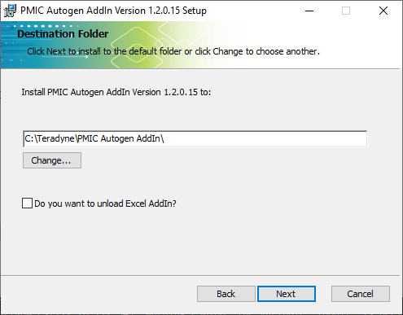

Modify VBT_LIB_PowerLevelStatus_Read from g_Voltage_Corner to GetVoltageCorner

# PMIC Skeleton V1.2.0.14 Patch Release Notes

Change seq. of DC conti’s bin table.

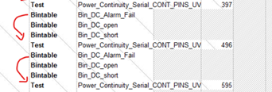

# PMIC Skeleton V1.2.0.13 Patch Release Notes

Debug for bin table of DCTEST_FUNC.

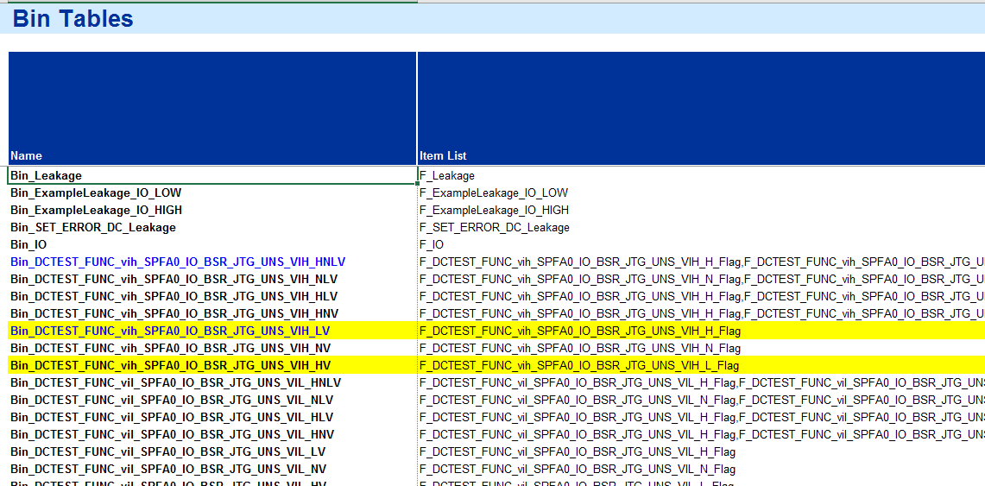

# PMIC Skeleton V1.2.0.12 Patch Release Notes

Add Bin_LDO for LDO summary bin controlled by flag “F_LDO”.

Add Fail flag to each test instance.

Add Bin_LDO and control by Enableword. “A_Enable_MP_SBIN”

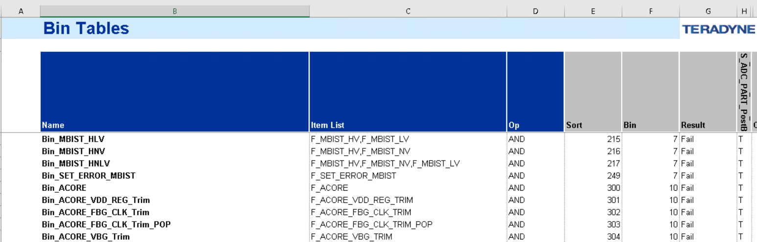

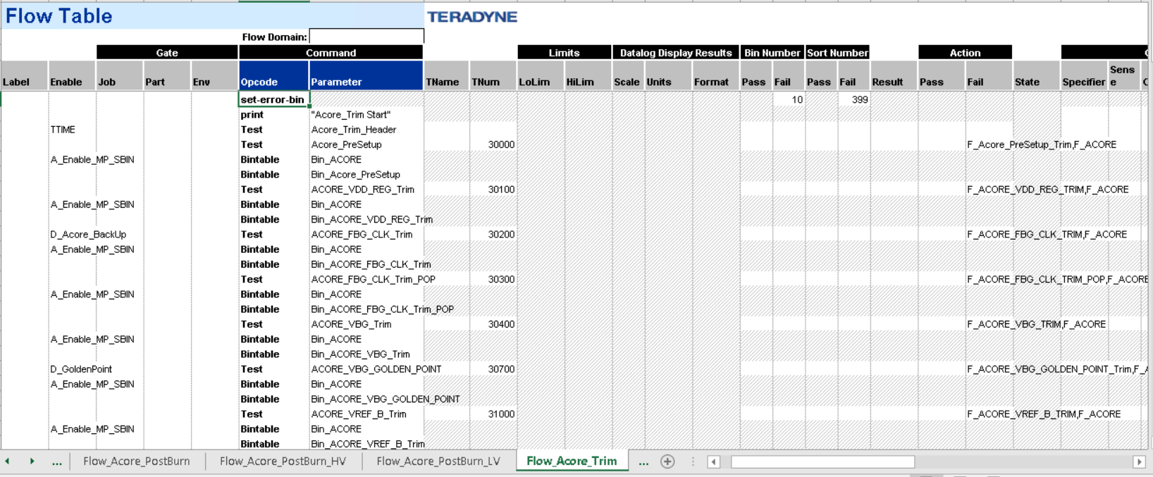

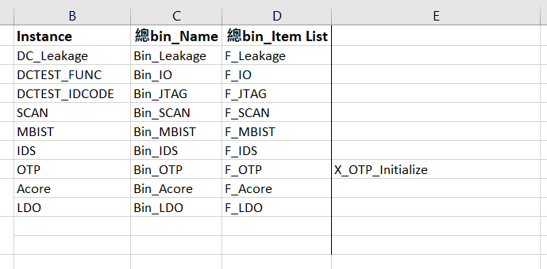

# PMIC Skeleton V1.2.0.11 Patch Release Notes

Request from Orange:   
Add new Bintable and Flag with name “Bin_DC_Alarm_Fail & F_DC_Alarm_Fail” into DC_Conti flow.

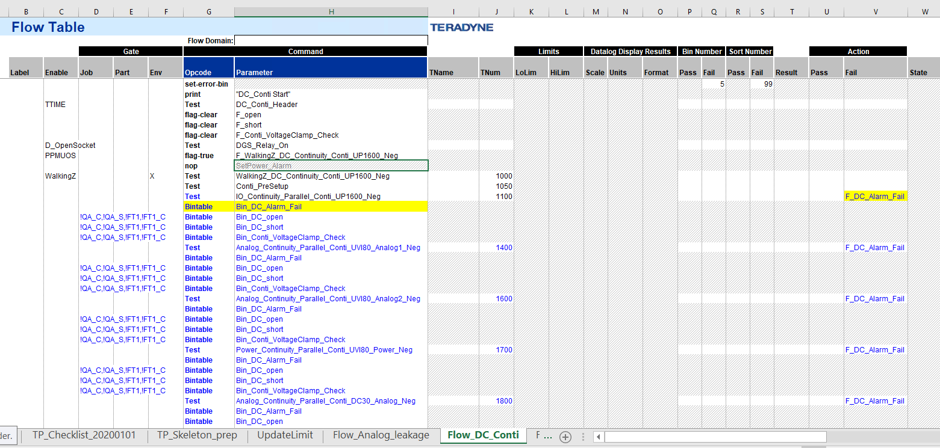

Add the error bin for each flow in the bin table, “AND,9999/9/Fail/T”

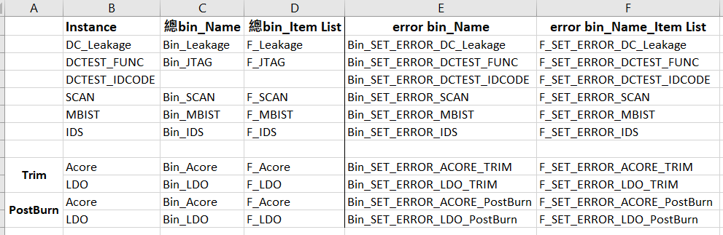

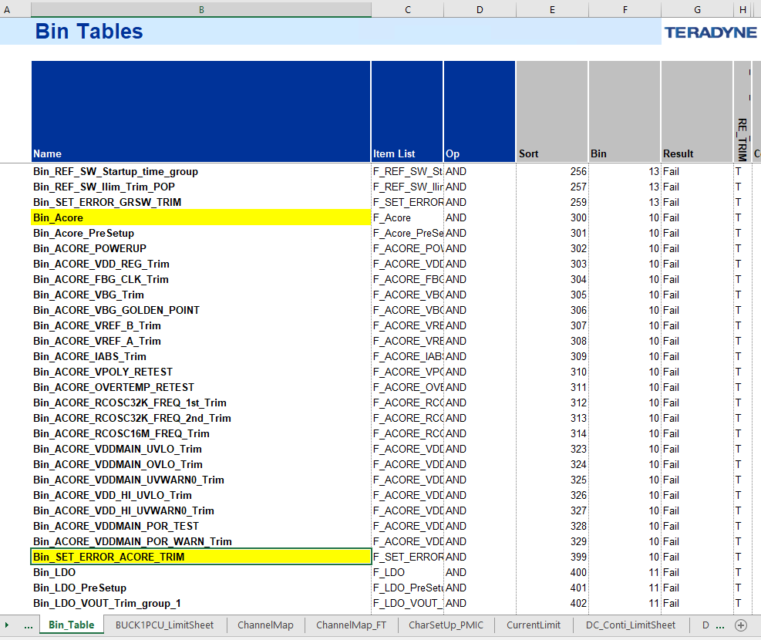

# PMIC Skeleton V1.2.0.10 Patch Release Notes

T-autogen (add-in), BinTable’s name from Block+Payload[1,4,7,8,12,13]+voltage to Block+Payload[1,4,6,7,8,12,13]+voltage

T-autogen (add-in), Debug for VDD_Levels_Information skip column

T-autogen (add-in), Remove duplicate DGS_RELAY_ON

T-autogen (add-in), Add history button & merge release notes

T-autogen (add-in), Debug IOH, IOL for global spec

T-autogen (add-in), Debug change error level from “1” to error in ErrorReport sheet

T-autogen (add-in), Alarm to uninstall old version PMIC add in when installing.

T-autogen (add-in), Add new TrimMethod

* FWTrim
  + Trim – True
  + PostBurn – False
* FW_DTB_AnaI / FW_DTB_AnaV
  + Trim – True
  + PostBurn – False
  + Additional create _Meas instance with {FunctionName} and argument was empty
* FW_ATB_3StepTrim
  + Trim – True, False, False
  + PostBurn – False, False, False

# PMIC Skeleton V1.2.0.9 Patch Release Notes

#296 T-autogen (add-in), If IDS sheet measure pins are not exist in VDD_Levels sheet, show warning messages.

#297 T-autogen (add-in), Investigate that it will auto-generate "IO_Speed" and "IO_Period" in Global Specs.

# PMIC Skeleton V1.2.0.8 Patch Release Notes

#288 T-autogen (add-in), Add two new colunmns in VDD_Levels_Information sheet.

#289 T-autogen (add-in), Confirm whether can remove Limit infos from DTTEST_Continutity sheet or not.

#290 T-autogen (add-in), In Flow_DC_Conti sheet, add 'Conti_VoltageClamp_Check' Flag and BinTable item.

#291 T-autogen (add-in), Check whether PMIC_IDS and VDD_Levels_Information are matched or not.

#292 T-autogen (add-in), Check whether PMIC_Leakage and IO_Pinmap are matched or not.

#293 T-autogen (add-in), Add a validation that MeasurePin in PMIC_Leakage sheet has 'DM' or 'DT' Anolog pin.

# PMIC Skeleton V1.2.0.7 Patch Release Notes

#274 T-autogen (add-in), Adjust the output folder structure.

# PMIC Skeleton V1.2.0.6 Patch Release Notes

#248 T-autogen (add-in), In DC_SPECS sheet, BSCAN_UltraVoltage should contain BSCAN variable.

#249 T-autogen (add-in), Move IGXL_Version.txt file from Other to OTP folder.

#250 T-autogen (add-in), Confirm task #94 which to reduce bin name, whether reduce action-fail or not. If haven’t reduce action-fail, should support.

#251 T-autogen (add-in), When VDD_Levels sheet have extra columns, it will throw error when gen test program.

# PMIC Skeleton V1.2.0.5 Patch Release Notes

#243 T-autogen (add-in), The BSCAN category varible value in DC_Specs sheet is incorrect..

#244 T-autogen (add-in), Adjust the new output folder structure.

#245 T-autogen (add-in), When validate PMIC_Leakage sheet,it should support comma-separate pinname format, meanwhile pinname and forve V should be matched.

# PMIC Skeleton V1.2.0.4 Patch Release Notes

#220 T-autogen (add-in), The plus and minus symbols in Global spec are not correct.

#221 T-autogen (add-in), When domain's Char_apply_pins have 'v' values, add apply_pins varible in level_Bscan sheet.

#222 T-autogen (add-in), Adjust the test order of DCTEST_FUNC and DCTEST_IDCODE flow table sheet.

#223 T-autogen (add-in), Make the output project file and folder structure become correct.

#224 T-autogen (add-in), After RunAutogen once and then change the output folder path, it will lack some files in the new folder.

# PMIC Skeleton V1.1.0.21 Patch Release Notes

#210 T-autogen (add-in), The conti sub flow will need to add additional test item is enable DGS relay.

#212 T-autogen (add-in), Global Specs variables need to reference values from VDD_Level_Information sheet.

#213 T-autogen (add-in), When VDD_Levels sheet don’t have UHV column, in DC Specs’s Ultra Voltage UHV should be 0.

#214 T-autogen (add-in), Apply_pins update: when domain's Char_apply_pins have 'v' values, it will use domain symbols to replace main symbols.

#218 T-autogen (add-in), Besides IDS and VBTPOP sub flow table, remove 'B_DebugPrint_Instrument_Status' from other flows.

# PMIC Skeleton V1.1.0.20 Patch Release Notes

#195 T-autogen (add-in), VDD_Levels_Inforamtion .bas, need add additional code segments.

#196 T-autogen (add-in), Flow table need add 'set-error-bin' opcode at the beginning.

#197 T-autogen (add-in), validate that the domain names of BSCAN_CHAR sheet are included in VDD_Levels sheet.

# PMIC Skeleton V1.1.0.19 Patch Release Notes

#175 T-autogen (add-in), IO_Levels handle BSCAN category with BSCAN_CHAR sheet

If pin's domain is 'FLOATING' in any category domain, this pin will be ignored in gen process. And this pin should not be appeared in Reference Pin Form.

If user typed in 'IOH' or 'IOL', related symbols should be added in Global Spec sheet.

Resolve BSCAN_CHAR sheet, each domain has different amout of IOH&IOL(mA)

Integrate with BSCAN_CHAR, add BSCAN category in Global Spec, DC Spec, Pin Level sheet.

#176 T-autogen (add-in), IO_Levels support different values in each BSCAN domain.