|  |
| --- |
|  |
| Compound Management System |
| Systema Shyam |

|  |
| --- |
| Codescape Consultants PL  [5/3/2011] |

# Product Name: CMS

Feature: CMS Administration

Requested By: Vivek Bansal

Reviewed By: Prateek Goel

Implemented By: Peeyush Raj

Verified By: Utkarsh Jain

SW release version in which Feature included:

## Revision history (in case multiple revisions)

|  |  |  |  |
| --- | --- | --- | --- |
| Revision | Date | By | Description |
| 0.01 | 5/3/2011 | Peeyush Raj | CMS Administration First Draft |
|  |  |  |  |
|  |  |  |  |
|  |  |  |  |
|  |  |  |  |
|  |  |  |  |

# 

# Feature Description: CMS Administration

*Configuring, maintaining and monitoring active network elements, network users and other IP-based elements, if required, via a common Administration panel.*

## Supported System Requirements

* Linux System, preferably Ubuntu/Debian

## System Use Cases

## Audit Log

## User / Role Management

## Device Assignment

## System Settings

## Upgrade System

## Backup / Restore

### Audit Log

All the system logs have to be stored and be accessible by the administrator, so as to debug and rectify the system element error, system error or the network issue.

### User/Role Management

The primary purpose of establishing roles is to give you an easy way to manage access rules for groups of users.

### Device Assignment

Administrator should be capable of assigning devices to a particular network, assigning devices a particular IP or assigning IP device to particular user.

### System Settings

The system administrator should be capable to configure CMS according to requirement. This feature is organization dependent.

### Upgrade System

The system administrator should be capable to upgrade CMS to the new releases. The NMS should be seamlessly integral with the old releases.

### Backup/Restore

The system administrator should have the capability to customize the NMS and save the same settings for the future implementations of the NMS in the delegated organization.

# Feature Design description

## Audit Log

Audit log would be designed so as to handle the

* User trail
* Monitored device logs
* CMS core system logs
* Network logs

### User Trail

User trail would give Administrator the precise idea of

* The allowed actions a user has performed
* this feature is unnecessary
* The total number of visits on some specific page

#### C:\Users\user\Desktop\asdf.jpgUser Trail GUI

Figure 1

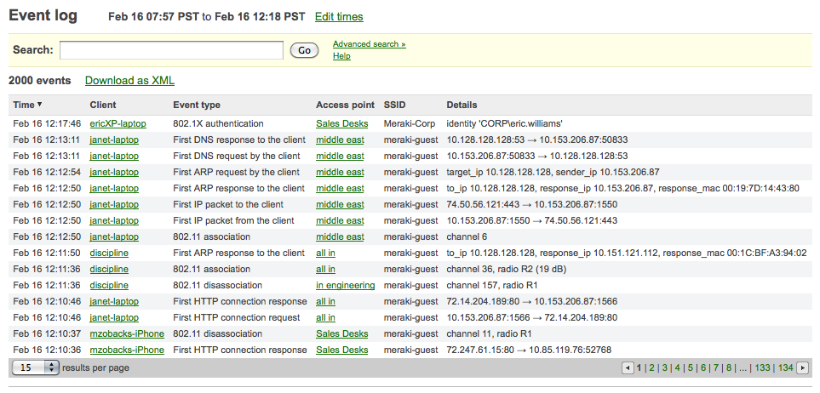Figure 2

## User/Role Management

User role management should meet following requirements

* User Addition/ Deletion/ Update
* Restricted access to users based on previously defined roles, Guest, Operator, Admin etc.
* User Blacklisting/Whitelisting
* User Grouping
* Restricted access to user/user group on device/device group
* Subnet based user/user group access.

## Device Assignment

User role management should meet following requirements

* User Addition/ Deletion/ Update
* Restricted access to users based on previously defined roles, Guest, Operator, Admin etc.
* User Blacklisting/Whitelisting
* User Grouping
* Restricted access to user/user group on device/device group
* Subnet based user/user group access.

## System Settings

System settings should meet following requirements

* Admin should be able to put logo of associated organization

## Upgrade System

Upgrading the system should meet following requirements

* The new Version of CMS should be seamlessly integrable with the older versions
* The newer version of CMS should have support for older versions
* The newer version should not lose the information of previous network device settings
* The newer version should not lose the previous customizations

## Backup/Restore

Upgrading the system should meet following requirements

* The backup scheduling be configurable and should be automatic
* Before any new configuration is saved, the previous settings should be saved
* There should be a cleanup option in the CMS, that would remove all the previous saved states
* Restore should give user option of restoring particular backup image
* Default restore should restore the most recent saved image
* Administrator should be given an option to test and then apply settings
* Administrator should be given an option to create new CMS site, for purpose defined above.

# Implementation Design Description

*<System Architecture be discussed here>*

# Test Report

*<Describe what “development” / Integration unit test has been done – and what the test results here are>*