README

A document to tell you how to set up these notebooks on your own time and how to save your progress with mybinder by downloading and uploading notebooks to an active session.

Contents:

2……………………………………………………………………………… Setting up notebooks with mybinder

3…………………………………….. Saving notebooks and uploading them temporarily to mybinder

Setting up Notebooks with mybinder

The workshop operates on an STFC-hosted notebook system. For use in your own time, you can access all the lesson files by following the steps below.

The files can be accessed through our github repository:

The repository URL is: <https://github.com/stfc-aeg/Virtual-Python-Workshop>

This contains notebooks 1 and 2 for python, along with the model code.

Navigate to mybinder.org, and enter the repository into the marked box.

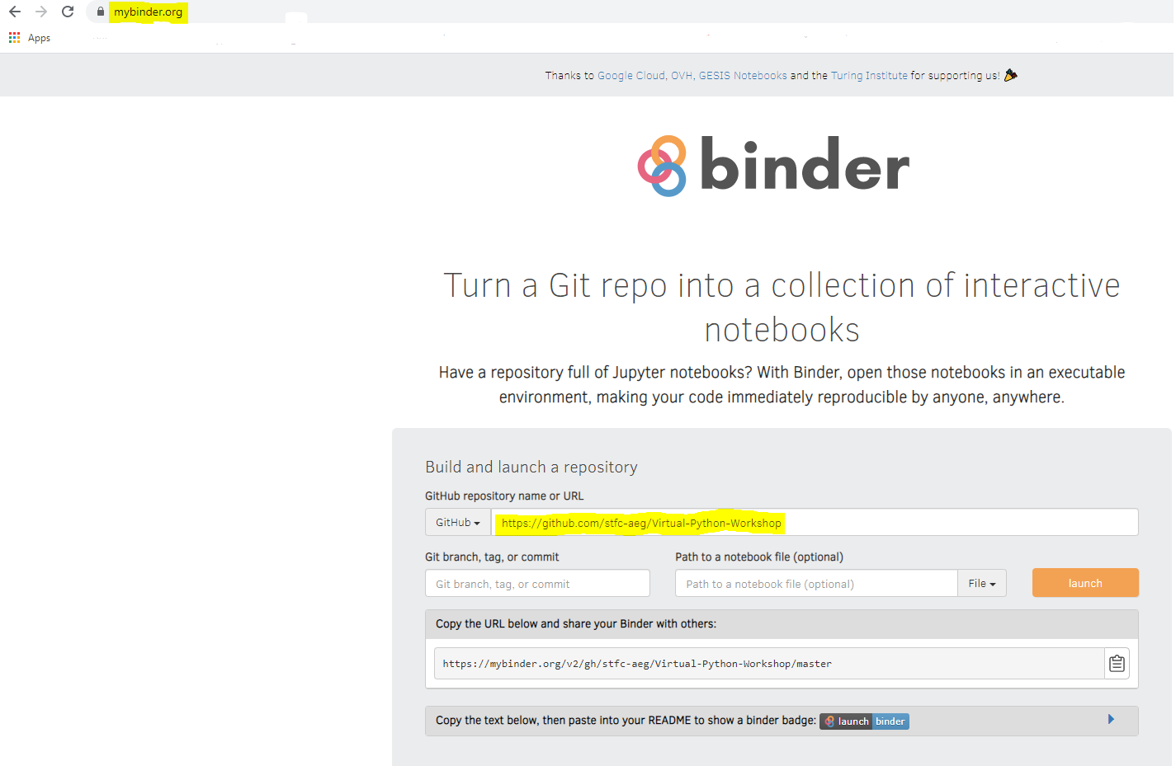

You won’t need to select any of the other options, just click launch! This may take a couple of minutes but will open up the repository so that you can interact with the notebooks within.

From there, follow through ‘Python Lessons/Python’ and select the lesson you want to follow!

Saving Files

Mybinder does not have an ability Notebooks can be downloaded and saved in their native format (.ipynb) directly from mybinder!

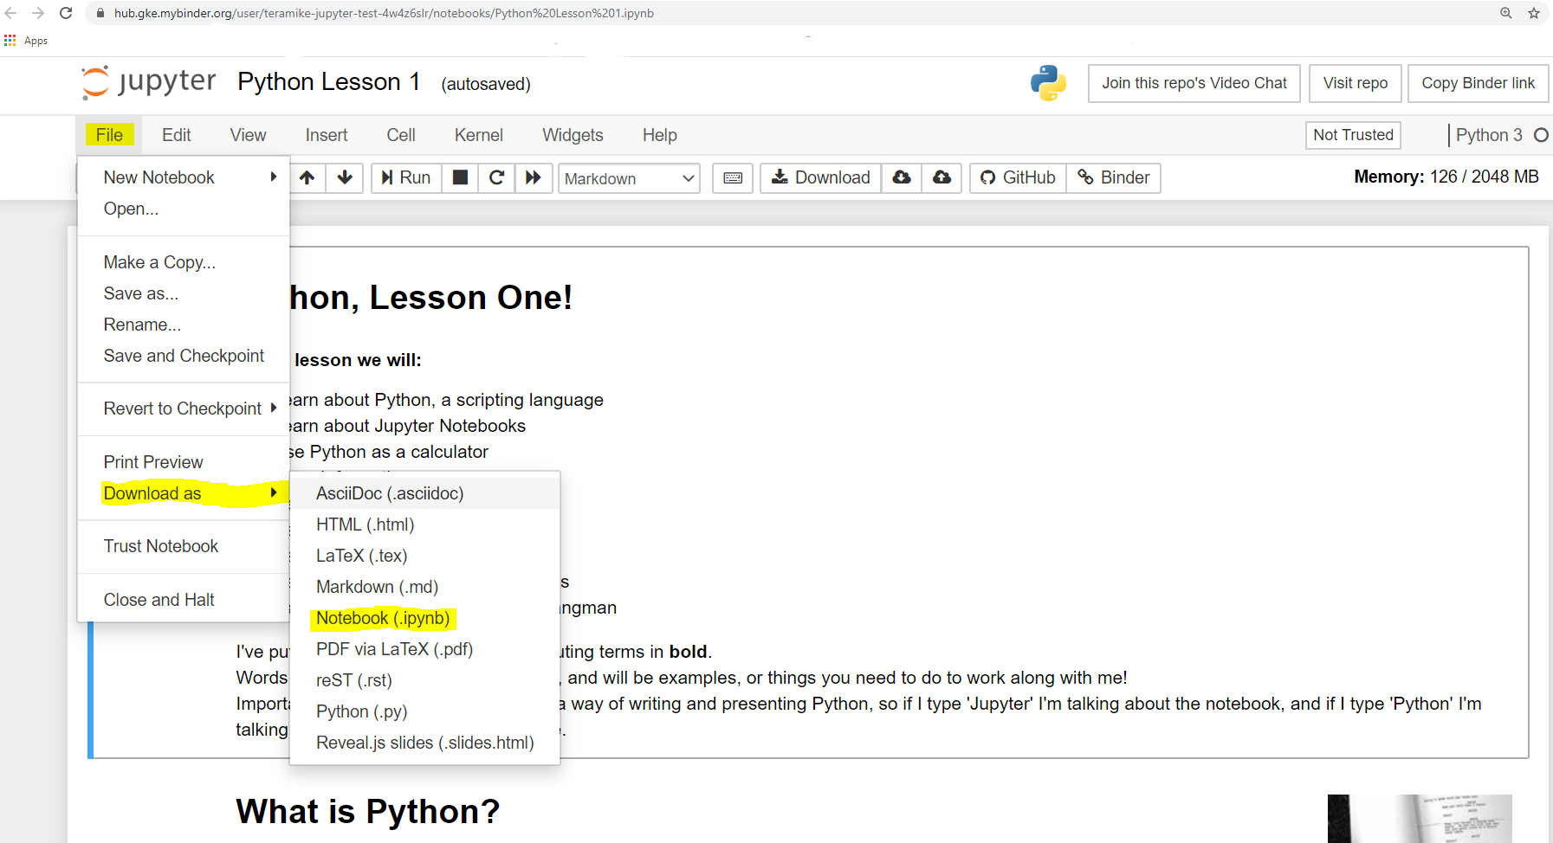

This will go into your downloads folder with the name ‘ipynb.ipynb’. You may want to rename this file.

To reach this folder, open the file explorer and click to it, or type into the windows bar in the bottom corner of your screen.

On the mybinder main page, click ‘upload’ and find the file you downloaded.

You can see with mine, I made a separate folder in my download folder just for .ipynb files.

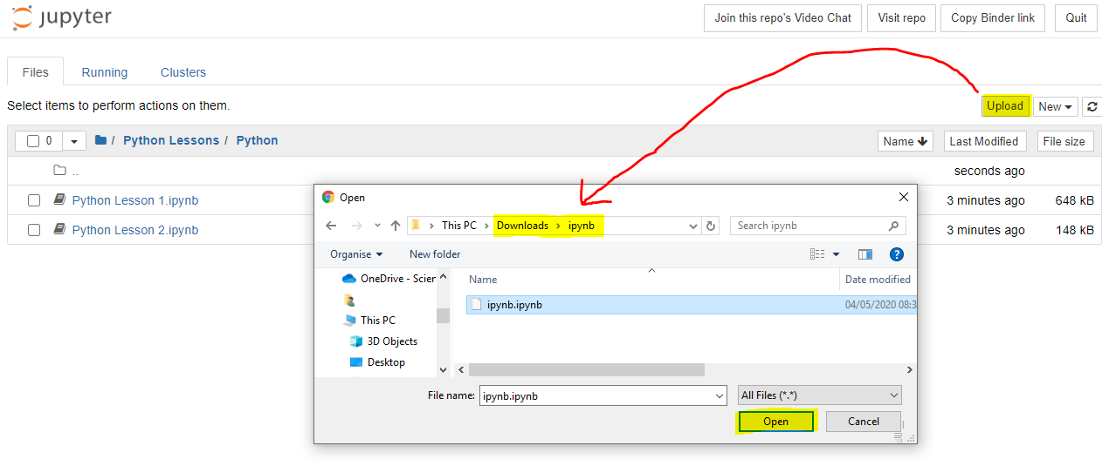Click ‘Open’ and the file will appear on the menu, above the other lessons. You can then run it just like the lesson notebook.

Remember to download it before you quit! Mybinder will reset when you launch it another time.