README

A document to tell you how to set up notebooks on your own time, and how to save your progress with mybinder.

Setting up Notebooks with mybinder

During the workshop, we will provide a direct link to the binder, so these setup steps should not be necessary. Otherwise, follow these instructions:

This workshop is (for now) being run using a website, [mybinder.org], to virtually run the notebooks. Mybinder operates using github repositories, so we have one of those as well.

The repository URL is: [<https://github.com/stfc-aeg/Virtual-Python-Workshop>]. This contains notebooks 1 and 2 for python, along with the model code.

Navigate to mybinder.org, and enter the repository into the marked box.

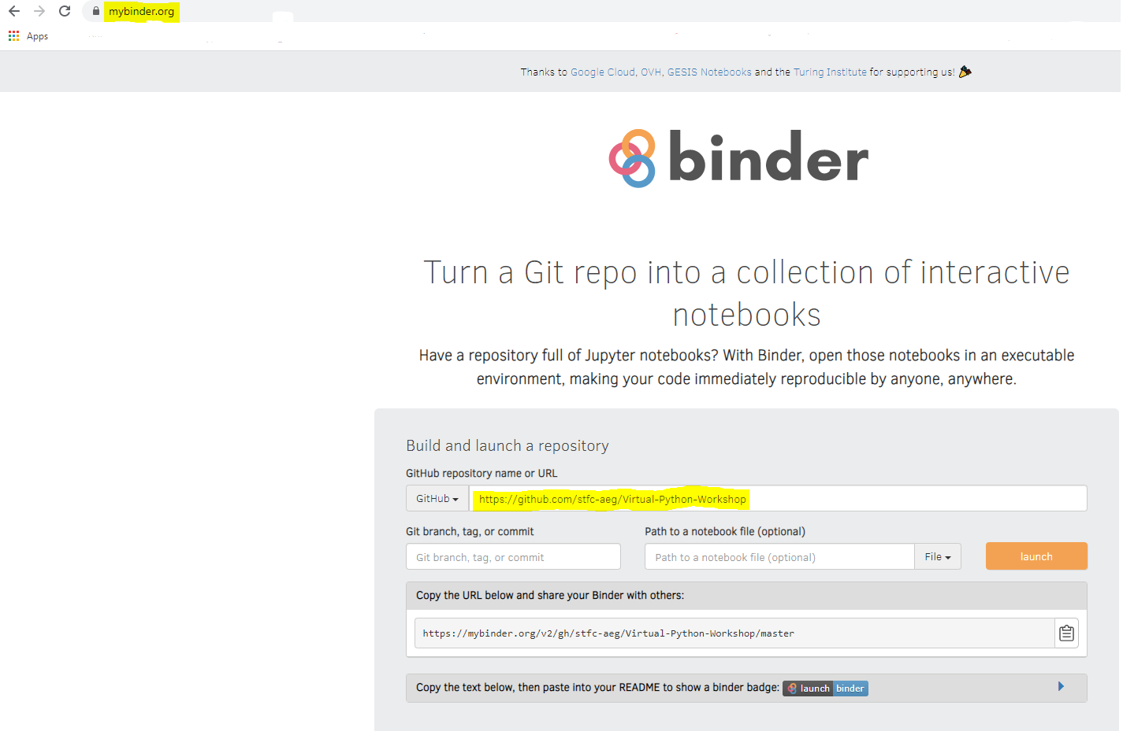

You won’t need to select any of the other options, just click launch! This may take a couple of minutes but will open up the repository so that you can interact with it.

Saving Files

Mybinder does not have an ability Notebooks can be downloaded and saved in their native format (.ipynb) directly from mybinder!

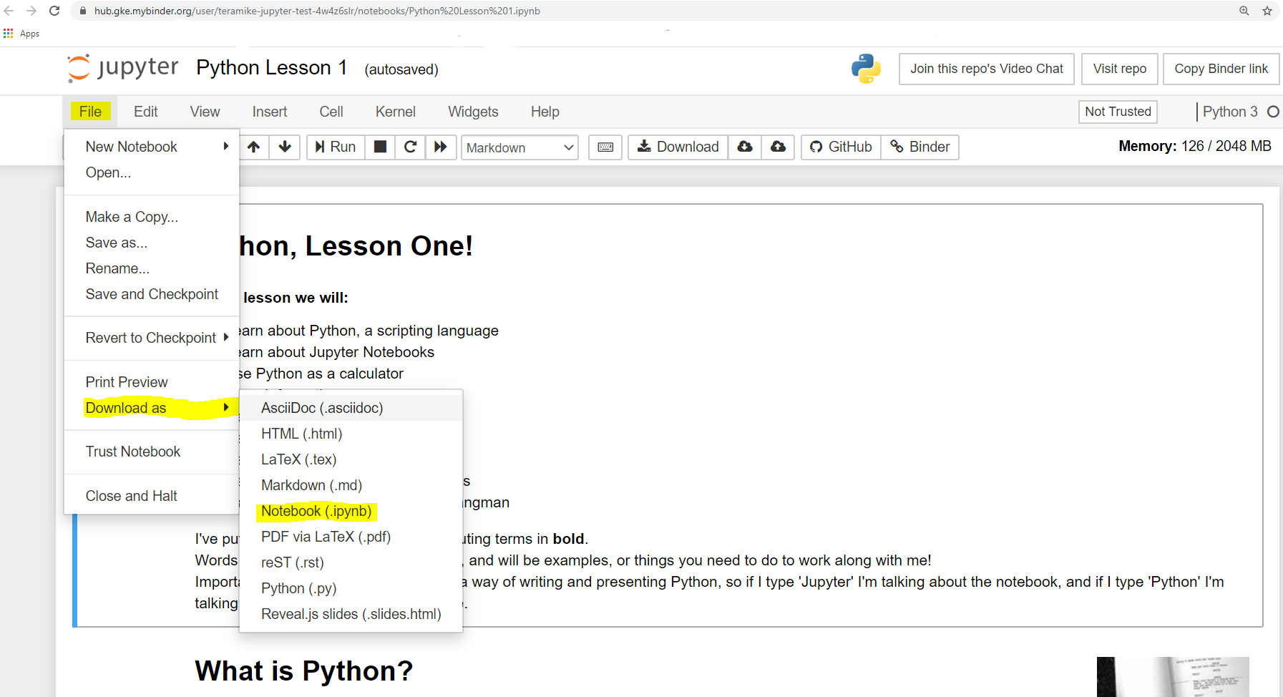

This will go into your downloads folder with the name ‘ipynb.ipynb’. You may want to rename it.

To reach this folder, open the file explorer and click to it, or type into the windows bar in the bottom corner of your screen.

On the mybinder main page, click ‘upload’ and find the file you downloaded.

You can see with mine, I made a separate folder in my downloads just for .ipynb files.

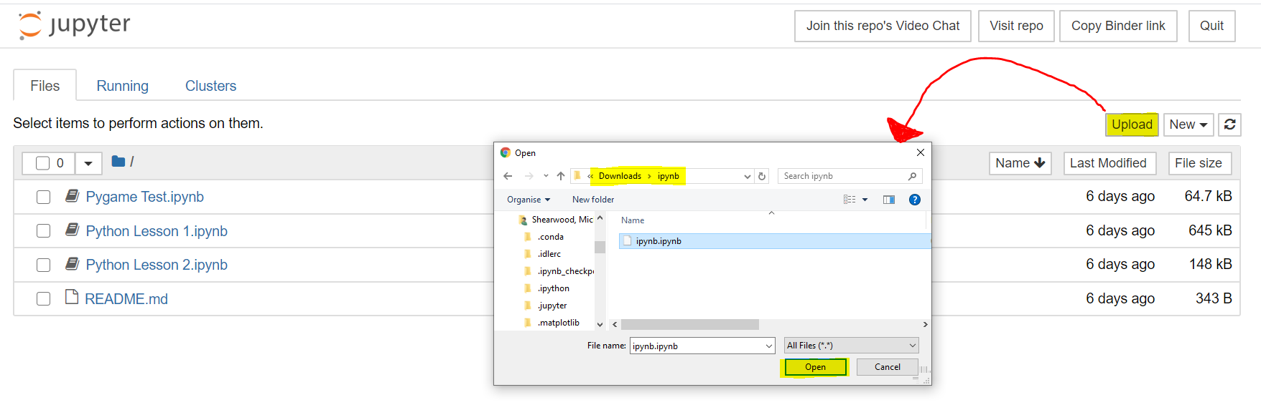Click ‘Open’ and the file will appear on the menu. You can then run it from mybinder and it will be exactly how it was when you downloaded it!