Observations from the registration data for last session:

* Some courses chosen by the students have no course\_departments. They should be auto filled when selected by the students and not blank.

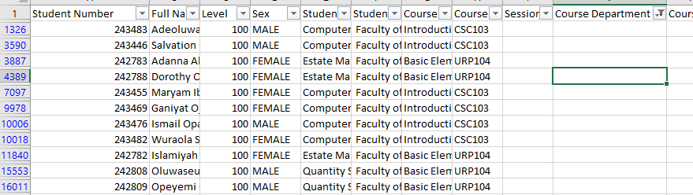

* Some courses have 0 unit and negative course unit (-2) which should not be the case

C:\Users\sduit\AppData\Local\Packages\5319275A.WhatsAppDesktop_cv1g1gvanyjgm\TempState\9E789B0A555E68DD6BA866BB5F6E7CC9\WhatsApp Image 2025-05-09 at 09.32.31_17be618c.jpg

* Some courses have no course status while some have ‘elective’ statuses, we have C, R and E, where should elective status be categorized as?
* Some genders are blank/NA
* Some courses have no semesters attached
* Some matric\_numbers have “\_old” attached

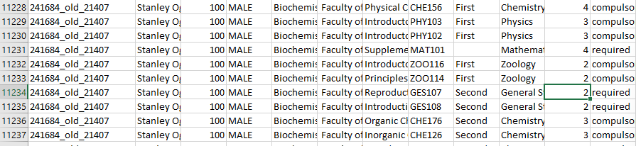

* Students registering for GEO339/GIT33 code which does not exist
* 220514 has no complete name. How are these cases possible on the registration portal? 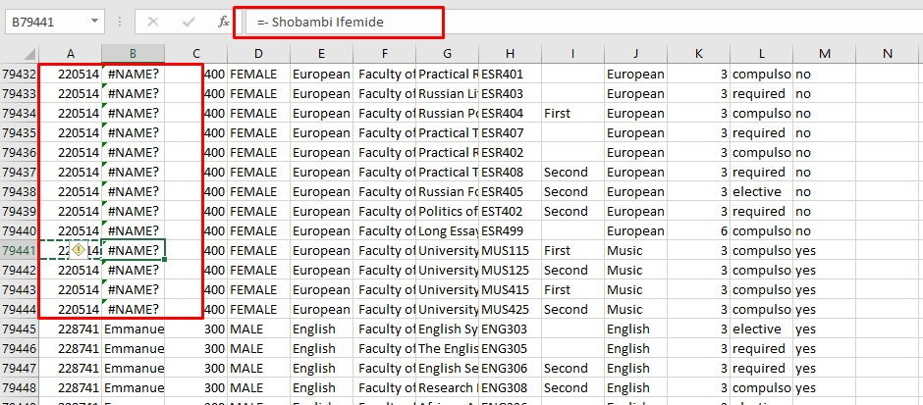
* Same students having 2 different departments (243681 and 238119)