GLOWUP

Front End Assignment 4
JavaScript interactions in the GlowUp website
Team | Tamiris Mukieva and Alina Abdubek
Group | SE-2516
Repository | github.com/Teraflu7/glowup
Deployment | teraflu7.github.io/glowup/
Technology | HTML5, CSS3, Bootstrap 5.3.8, vanilla JavaScript
This report documents five required JavaScript features: custom form validation, an FAQ accordion, a popup form, background-color controls, and a live date and time display.
October 2026

1. Project objective and result
The objective was to transform the existing responsive GlowUp website into an interactive multi-page experience using JavaScript. The completed version preserves the original visual design while adding accessible controls, clear form feedback, and responsive behavior.

Requirement coverage
Requirement | Implementation | Main files | Owner
Form validation | Required values, email format, password length and match | about.html; js/signup.js | Alina
FAQ accordion | Hidden answers, smooth open/close, one item at a time | faq.html; js/faq.js | Tamiris
Popup form | Native dialog, close button, backdrop, Escape | about.html; css/signup-dialog.css | Alina
Background color | Four-color cycle and reset with status text | index.html; js/home.js | Tamiris
Date and time | Localized display updated every second | index.html; js/home.js | Tamiris

Integration approach
- Each page loads its JavaScript module with defer, after the shared and component-specific CSS.
- Native HTML controls provide a reliable keyboard baseline; JavaScript adds state and feedback.
- ARIA attributes expose accordion state, validation state, and live status information.
- The features were tested locally and then verified from the deployed GitHub Pages site.

2. Form validation and popup
Alina implemented the contact interaction in about.html. The form is placed inside a native dialog that is closed by default. The opening button calls showModal(), while the close button, backdrop selection, and Escape key all dismiss it. Focus returns to the opening control.

Validation logic
- All fields are required and text values are trimmed before checking.
- Email is checked against a readable email pattern.
- The password must contain at least eight characters, and confirmation must match exactly.
- Invalid controls receive aria-invalid, an inline error message, and focus on the first problem.
- Success feedback appears only when every rule passes.
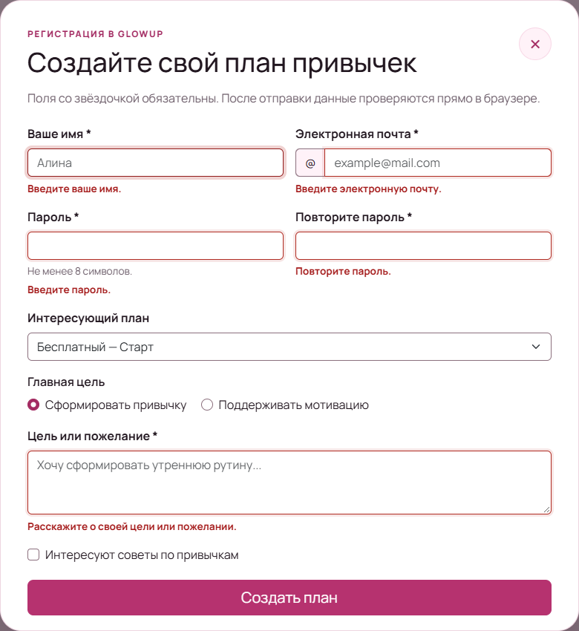
Figure 1. Inline validation messages identify every missing or invalid field.
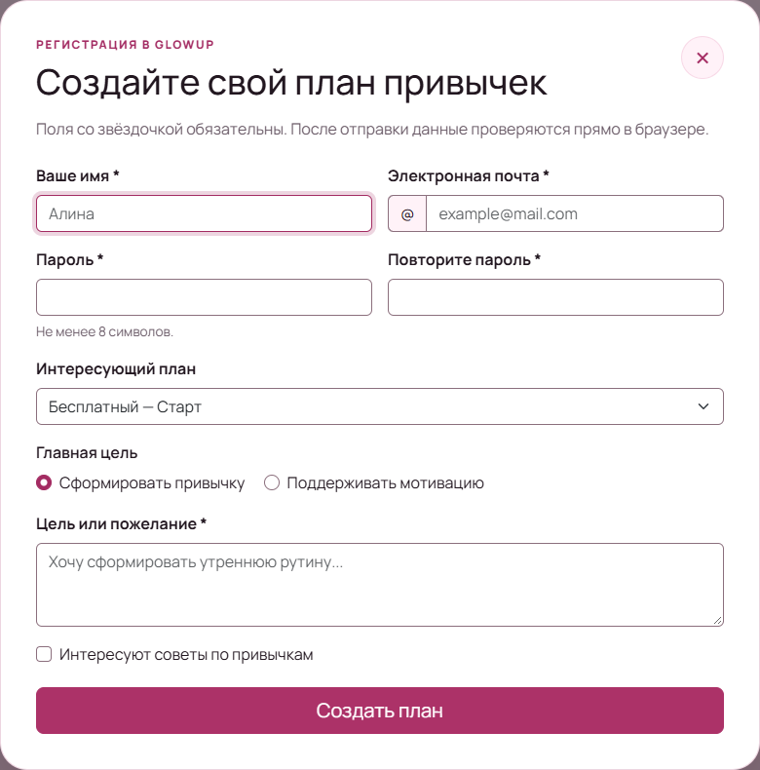
Figure 2. The responsive contact dialog opens above the About page.

3. FAQ accordion
Tamiris converted the four FAQ questions into native buttons. All answers are hidden when the script initializes. Selecting a question expands its connected panel with a smooth transition; selecting it again closes it, and opening a new question closes the previous answer.

Accessibility details
- aria-controls connects each trigger to its answer panel.
- aria-expanded reports the current state to assistive technology.
- Native buttons support Tab, Enter, and Space without custom key emulation.
- Reduced-motion preferences disable nonessential animation.
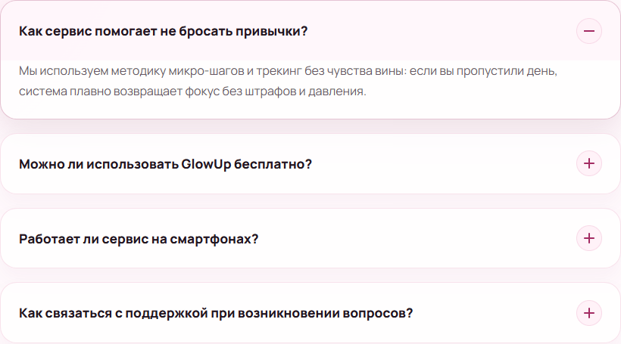
Figure 3. One FAQ answer is expanded while the other answers remain collapsed.

4. Background controls and live clock
Tamiris added an interaction panel to the home page. The background control cycles through four soft colors by updating the existing --bg CSS custom property. A separate reset action restores the first theme, and a live text message reports the selected color.

Figure 4. The home page after changing to another background theme.
The same module creates a Date object, formats the value with Intl.DateTimeFormat, writes it to a semantic time element, and updates the display every second. The machine-readable datetime attribute remains synchronized with the visible value.

Figure 5. The localized current date and time display updates without reloading the page.

5. Responsive behavior and verification
The interactive components adapt to narrow screens without horizontal scrolling. The dialog uses a bounded viewport width and internal scrolling when necessary, while buttons and messages remain large enough for touch interaction.
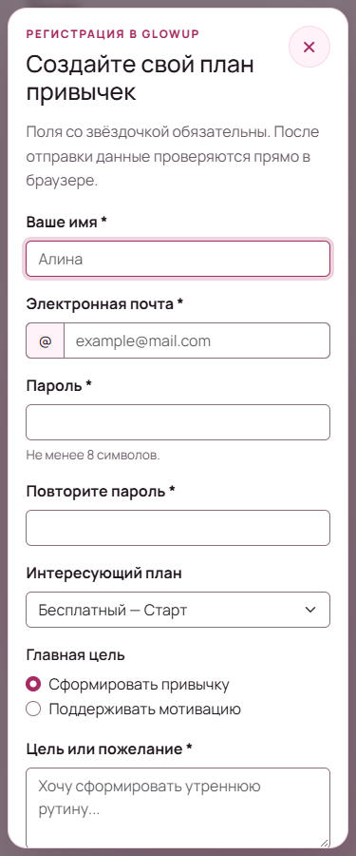
Figure 6. The popup form remains usable at a 375 px mobile viewport.

Functional test results
Check | Evidence | Result
Form rules | Empty, malformed email, short password, mismatch, valid values | Passed
Dialog closing | Close button, backdrop, Escape; focus restoration | Passed
Accordion | Hidden initially; open, close, single-open behavior | Passed
Home controls | Four colors, reset, visible status, one-second clock update | Passed
Responsive | 375 px, 768 px, and 1440 px | Passed
Browsers | Google Chrome and Microsoft Edge | Passed
Console/network | No JavaScript errors; local resources return successfully | Passed
Deployment | GitHub Pages workflow and public feature resources | Passed

6. Team contribution
Member | Primary implementation | Files
Tamiris Mukieva | FAQ accordion; background color changer; live date and time | index.html, faq.html, js/home.js, js/faq.js, related CSS
Alina Abdubek | Popup contact form; custom form validation; inline feedback | about.html, js/signup.js, css/signup-dialog.css
Both members | Integration review, cross-browser checks, screenshots, deployment and defense preparation | README.md, REPORT.md, REPORT.docx, report-assets/

7. Deployment
The shared main branch is published through GitHub Pages at https://teraflu7.github.io/glowup/. The successful deployment contains the same home, FAQ, and signup JavaScript modules documented in this report.

8. Reflection and conclusion
Assignment 4 changed GlowUp from a mostly static responsive website into an interactive application. The team practiced DOM selection, event listeners, state changes, validation, the Date API, focus management, accessible feedback, and organization of JavaScript by page.
All five required features are implemented, responsive, documented, and deployed. The repository history records contributions from both team accounts, and the project is ready for submission and defense.
Final result: all Assignment 4 requirements completed and verified

