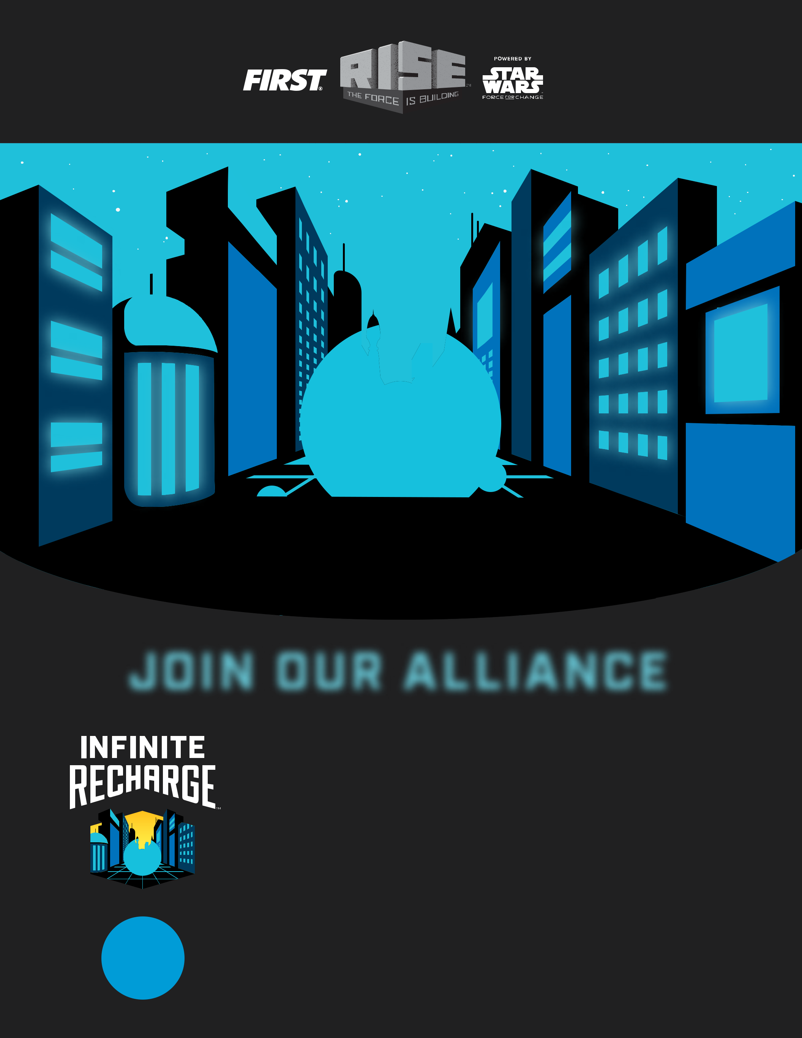

**JOIN OUR ALLIANCE**

GRADES

**9 -12**

Join Lincoln Tigers Robotics Team

Lincoln Tigers Robotics FRC team is back!

Interested in Robotics? Join our team, in order to develop skills such as teamwork, Mechanics, Electronics, Programming, etc.

No experience required

We meet Wednesday and Friday at lunch and Friday afterschool

Come by Room 703 for more information

We are going for the FRC 2020 Infinite Recharge Season





