Supplementary Information

Relative contribution of groundwater to plant transpiration estimated with stable isotopes

Authors
Adrià Barbeta^{1,2,3}*, Josep Peñuelas ^{2,3}
Authors’ e-mail addresses:
Adrià Barbeta: adria.barbeta.margarit@gmail.com; a.barbeta@creaf.uab.cat
Josep Peñuelas: josep.penuelas@uab.cat

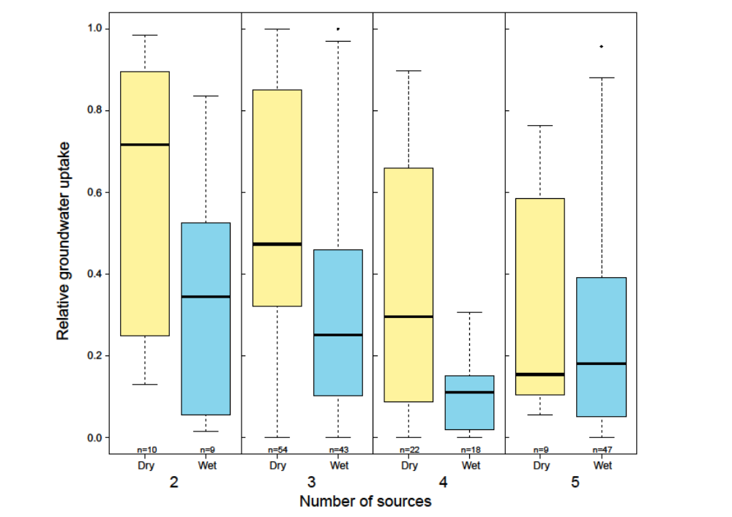

Figure S1. Relative groundwater uptake and the number of sources considered. Boxplots of the relative groundwater uptake in dry and wet seasons for the number of sources used in the isotope mixing models. Box size represents the interquartile range, the black line is the median, the whiskers indicate variability outside the upper and lower quartiles, and individual points are outliers. The number of sources had a significantly negative effect (P<0.05) on the average groundwater use.

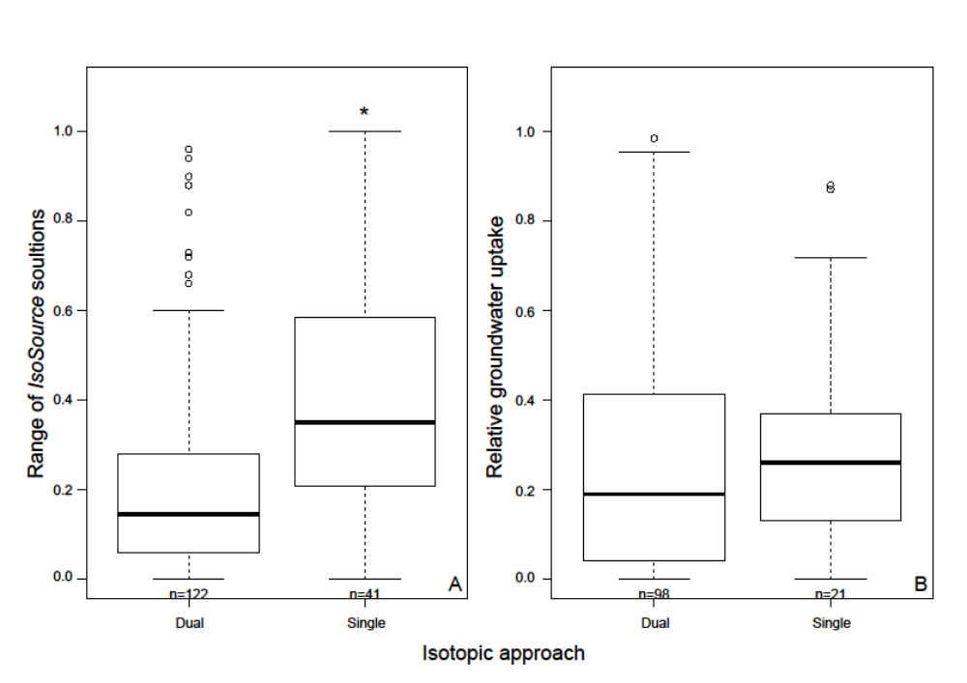

Figure S2. Effect of methodology in studies of plant-water sources. Boxplots of the range of solutions provided by isotope mixing models (A) and the average relative groundwater uptake (B) depending on the number of isotopes used. Box size represents the interquartile range, the black line is the median, the whiskers indicate variability outside the upper and lower quartiles, and individual points are outliers. The asterisk (*) denotes significant differences between groups (P<0.05).

Supplementary Tables
Table S1. Summary table of the mean relative groundwater use for each site, species and season.
Table S2. Output of the GLMM analyzing the factors determining the probability of plant groundwater utpake. The reference levels from which the posterior mean of the effects have been calculated are: ‘Dry season’ for Precipitation season, ‘Dunes’ for the Landscape position and ‘Herbaceous species’ for Plant type.
Table S3. Output of the GLMM analyzing the factors determining the relative contribution of groundwater to plant transpiration. The reference levels from which the posterior mean of the effects have been calculated are: ‘Dry season’ for Precipitation season, ‘Bedrock’ for the Groundwater matrix and ‘Trees’ for Plant type.

Table S1.
Study | Species | Precipitation season | Mean relative groundwater use
Barbeta et al. 2015 | Arbutus unedo | Dry | 0.44
Barbeta et al. 2015 | Arbutus unedo | Wet | 0.21
Barbeta et al. 2015 | Phillyrea latifolia | Dry | 0.41
Barbeta et al. 2015 | Phillyrea latifolia | Wet | 0.24
Barbeta et al. 2015 | Quercus ilex | Dry | 0.36
Barbeta et al. 2015 | Quercus ilex | Wet | 0.25
Berry et al. 2014) | Abies fraseri | Wet | 0.19
Berry et al. 2014 | Picea rubens | Wet | 0.15
Bertrand et al. 2014 | Alnus incana | Wet | 0.11
Bertrand et al. 2014 | Pinus sylvestris | Wet | 0.11
Bertrand et al. 2014 | Populus nigra | Wet | 0.16
Bertrand et al. 2014 | Prunus avium | Wet | 0.16
Bertrand et al. 2014 | Salix alba | Wet | 0.51
Bertrand et al. 2014 | Salix purpurea | Wet | 0.25
Cramer et al. 1999 (site 1) | Casuarina glauca | Dry | 0.75
Cramer et al. 1999 (site 1) | Casuarina glauca | Wet | 0.45
Cramer et al. 1999 (site 2) | Eucalyptus camaldulensis | Dry | 0.53
Cramer et al. 1999 (site 2) | Eucalyptus camaldulensis | Wet | 0.46
Cramer et al. 1999 (site 3) | Casuarina glauca | Dry | 0.48
Cramer et al. 1999 (site 3) | Casuarina glauca | Wet | 0.21
Cramer et al. 1999 (site 3) | Eucalyptus camaldulensis | Dry | 0.21
Cramer et al. 1999 (site 3) | Eucalyptus camaldulensis | Wet | 0.26
Dai et al. 2014 | Haloxylon ammodendron | Dry | 0.90
Dai et al. 2014 | Haloxylon ammodendron | Wet | 0.00
Dai et al. 2014 | Haloxylon persicum | Dry | 0.12
Dai et al. 2014 | Haloxylon persicum | Wet | 0.10
Deng et al. 2014 | Cyclobalanopsis glauca | Dry | 0.15
Deng et al. 2014 | Cyclobalanopsis glauca | Wet | 0.08
Drake et al. 2011 | Euclayptus gomphocephala | Dry | 0.09
Drake et al. 2011 | Euclayptus gomphocephala | Wet | 0.35
Estrada-Medina et al. 2013 | Gymnopodium floribundum | Dry | 0.75
Estrada-Merina et al. 2013 | Gymnopodium floribundum | Wet | 0.29
Estrada-Merina et al. 2013 | Piscidia piscipula | Dry | 0.02
Estrada-Merina et al. 2013 | Piscidia piscipula | Wet | 0.12
Feikema et al. 2010 | Eucalyptus camaldulensis | Dry | 0.80
Feikema et al. 2010 | Eucalyptus camaldulensis | Wet | 0.06
Feikema et al. 2010 | Eucalyptus grandis | Dry | 0.18
Feikema et al. 2010 | Eucalyptus grandis | Wet | 0.02
Gu et al. 2015 | Cyclobalanopsis glauca | Dry | 0.13
Gu et al. 2015 | Cyclobalanopsis glauca | Wet | 0.08
Hao et al. 2013 | Populus euphratica | Dry | 0.84
Hasselquist & Allen 2009 | Grindelia fraxino-pratensis | Dry | 0.76
Hasselquist and Allen 2009 | Grindelia fraxino-pratensis | Wet | 0.30
Hasselquist and Allen 2009 | Nitrophila mohavensis | Dry | 0.11
Hasselquist and Allen 2009 | Nitrophila mohavensis | Wet | 0.15
Jia et al. 2012 | Caragana intermedia | Wet | 0.06
Kolb et al. 1997 | Acer negundo | Dry | 0.98
Kolb et al. 1997 | Acer negundo | Wet | 0.77
Lefroy et al. 2001 | Chamaecytisus proliferus | Dry | 0.25
Lefroy et al. 2001 | Chamaecytisus proliferus | Wet | 0.31
Li et al. 2012 | Artemisia desertorum | Dry | 0.26
Li et al. 2012 | Artemisia desertorum | Wet | 0.12
Li et al. 2012 | Caragana korshinskii | Dry | 0.26
Li et al. 2012 | Caragana korshinskii | Wet | 0.13
Li et al. 2012 | Pinus tabuliformis | Dry | 0.37
Li et al. 2012 | Pinus tabuliformis | Wet | 0.19
Li et al. 2012 | Populus simonii | Dry | 0.88
Li et al. 2012 | Populus simonii | Wet | 0.15
Li et al. 2012 | Salix psammophila | Dry | 0.32
Li et al. 2012 | Salix psammophila | Wet | 0.16
Liu et al. 2010 | Gironniera subaequalis | Dry | 0.39
Liu et al. 2010 | Pometia tomentosa | Dry | 0.63
Liu et al. 2014 | Celtis wightii | Dry | 0.79
Liu et al. 2014 | Cleistanthus sumatranus | Dry | 0.63
Liu et al. 2014 | Lasiococca comberi |  | 0.85
Liu et al. 2015 Liu et al. 2015 | Populus euphratica | Wet | 0.29
Nie et al. 2010 | Alchornea trewioides | Dry | 0.15
Nie et al. 2010 | Alchornea trewioides | Wet | 0.15
Nie et al. 2010 | Ficus orthoneura | Wet | 0.96
Nie et al. 2010 | Radermachera sinica | Dry | 0.93
Nie et al. 2010 | Radermachera sinica | Wet | 0.48
Nie et al. 2010 | Scheffera octophylla | Wet | 0.87
Nie et al. 2010 | Stercolia euosma | Wet | 0.88
Nie et al. 2012 | Alchornea trewioides | Dry | 0.13
Nie et al. 2012 | Radermachera sinica | Dry | 0.47
Pate & Dawson 1999 | Banksia prionotes | Dry | 0.91
Pate & Dawson 1999 | Banksia prionotes | Wet | 0.53
Querejeta et al. 2007 | Brosimum alicastrum | Dry | 0.07
Quejereta et al. 2007 | Cordia dodecandra | Dry | 0.59
Querejeta et al. 2007 | Enterolobium cyclocarpum | Dry | 0.09
Querejeta et al. 2007 | Ficus cotinifolia | Dry | 0.87
Querejeta et al. 2007 | Spondia spurpurea | Dry | 0.77
Querejeta et al. 2007 | Talisia olivaeformis | Dry | 0.03
Saha et al. 2015 | Batis maritima | Dry | 0.43
Saha et al. 2015 | Batis maritima | Wet | 0.06
Saha et al. 2015 | Capparis flexuosa | Dry | 0.38
Saha et al. 2015 | Capparis flexuosa | Wet | 0.09
Saha et al. 2015 | Chromolae frustrata | Dry | 0.06
Saha et al. 2015 | Chromolae frustrata | Wet | 0.04
Saha et al. 2015 | Conocarpus erectus | Dry | 0.30
Saha et al. 2015 | Conocarpus erectus | Wet | 0.11
Saha et al. 2015 | Eugenia foetida | Dry | 0.38
Saha et al. 2015 | Eugenia foetida | Wet | 0.01
Saha et al. 2015 | Piscidia piscipula | Dry | 0.33
Saha et al. 2015 | Piscidia piscipula | Wet | 0.48
Schachtschneider & February 2010 | Acacia erioloba | Dry | 0.30
Schachtschneider & February 2010 | Acacia erioloba | Wet | 0.03
Schachtschneider & February 2010 | Faidherbia albida | Dry | 0.52
Schachtschneider & February 2010 | Faidherbia albida | Wet | 0.12
Schachtschneider & February 2010 | Tamarix usneoides | Dry | 0.19
Si et al. 2014 | Populus euphratica | Wet | 0.24
Snyder & Williams 2000 | Populus fremontii | Dry | 1.00
Snyder & Williams 2000 | Populus fremontii | Wet | 0.85
Snyder & Williams 2000 | Prosopis velutina | Dry | 1.00
Snyder & Williams 2000 | Prosopis velutina | Wet | 0.72
Snyder & Williams 2000 | Salix gooddingii | Dry | 1.00
Snyder & Williams 2000 | Salix gooddingii | Wet | 1.00
Snyder & Williams 2003 | Prosopis velutina | Dry | 0.33
Snyder & Williams 2003 | Prosopis velutina | Wet | 0.07
Song et al. 2014 | Pinus sylvestris | Dry | 0.29
Song et al. 2014 | Pinus sylvestris | Wet | 0.15
Thorburn et al. 1993 | Eucalyptus camaldulensis | Dry | 0.79
Thorburn et al. 1993 | Eucalyptus camaldulensis | Wet | 0.73
Thorburn et al. 1993 | Eucalyptus largiflorens | Dry | 0.88
Thorburn et al. 1993 | Eucalyptus largiflorens | Wet | 0.87
Wei et al. 2013 | Avicennia marina | Dry | 0.35
Wei et al. 2013 | Avicennia marina | Wet | 0.01
Wei et al. 2013 | Casuarina glauca | Dry | 0.01
Wei et al. 2013 | Casuarina glauca | Wet | 0.02
Wei et al. 2013 | Melaleuca quinquinervia | Dry | 0.00
Wei et al. 2013 | Melaleuca quinquinervia | Wet | 0.00
Wu et al. 2013 | Nitraria tangutorum | Dry | 0.47
Wu et al. 2013 | Nitraria tangutorum | Wet | 0.31
Wu et al. 2013 | Reaumuria songarica | Dry | 0.00
Wu et al. 2013 | Reaumuria songarica | Wet | 0.00
Wu et al. 2013 | Tamarix ramosissima | Dry | 0.79
Wu et al. 2013 | Tamarix ramosissima | Wet | 0.36
Xu et al. 2011 | Abies faxonia | Dry | 0.86
Xu et al. 2011 | Abies faxonia | Wet | 0.84
Xu et al. 2011 | Bashania fangia | Dry | 0.53
Xu et al. 2011 | Bashania fangia | Wet | 0.35
Xu et al. 2011 | Betula utilis | Dry | 0.63
Xu et al. 2011 | Betula utilis | Wet | 0.35
Yafen et al. 2012 | Pinus sylvestris | Dry | 0.11
Yafen et al. 2012 | Pinus sylvestris | Wet | 0.01
Zencich et al. 2002 | Banksia attenuata | Dry | 0.45
Zencich et al. 2002 | Banksia attenuata | Wet | 0.32
Zencich et al. 2002 | Banksia ilicifolia | Dry | 0.48
Zencich et al. 2002 | Banksia ilicifolia | Wet | 0.19
Zencich et al. 2002 | Hibbertia hypericoides | Dry | 0.13
Zencich et al. 2002 | Hibbertia hypericoides | Wet | 0.09

Table S2.

Factor | Posterior mean | CI: lower 95% | CI: upper 95% | pMCMC
(Intercept) | 325.28 | 197.12 | 458.05 | <0.001 | ***
Precipitation season: Wet | -107.90 | -182.98 | -32.60 | 0.004 | **
Landscape position: Plains | -65.68 | -166.58 | 27.81 | 0.17
Landscape positions: Slopes | 63.39 | -63.08 | 186.14 | 0.31
Landscape positions: Dunes | 4.76 | -163.44 | 174.28 | 0.97
Plant type: Shrubs | -141.12 | -243.11 | -40.71 | 0.004 | **
Plant type: Herbaceous | -20.06 | -205.74 | 161.85 | 0.82
Precipitation of the dry season | -0.89 | -1.54 | -0.27 | 0.010 | *
Mean temperature of the dry season | -0.21 | -0.61 | 0.16 | 0.26

Table S3.  Factor | Posterior mean | CI: lower 95% | CI: upper 95% | pMCMC
(Intercept) | 1.16 | 0.86 | 1.46 | < 0.001 | ***
Precipitation season: Wet | -0.19 | -0.26 | -0.10 | < 0.001 | ***
Plant type: Shrubs | -0.10 | -0.22 | 0.03 | 0.14
Plant type: Herbaceous | -0.20 | -0.41 | 0.03 | 0.07 | (*)
Groundwater matrix: Saturated soil | -0.30 | -0.63 | 0.01 | 0.06 | (*)
Depth to groundwater | -0.20 | -0.34 | -0.05 | 0.007 | **
Depth to groundwater X Groundwater matrix: Saturated soil | 0.20 | 0.05 | 0.33 | 0.008 | **

