Leakage-Safe Multi-Seed Evaluation of Published BU-Net Components for Resource-Constrained 2D Glioma Segmentation
  - Taha Berk Terekli¹, Livanur Mengeş², Volkan Yusuf Hal³, Ali Emre Döşer⁴
¹ Department of Mathematics, Yıldız Technical University, Istanbul, Turkey
² Department of Computer Engineering, Istanbul Beykent University, Istanbul, Turkey
³ Department of Software Engineering, Istanbul Beykent University, Istanbul, Turkey
⁴ Department of Computer Engineering, Haliç University, Istanbul, Turkey
  - Corresponding author: Taha Berk Terekli
Running title: Controlled evaluation of BU-Net components
Article type: Original research - methodological evaluation

Abstract
Background: Architectural comparisons in glioma segmentation are vulnerable to patient leakage, inconsistent training budgets, incomplete attribution, and selective reporting. We evaluated previously published BU-Net components under a single guarded protocol rather than proposing a new architecture.
Methods: BraTS 2020 training cases formed the canonical labeled cohort. BraTS 2019 was used only to audit identity overlap. All 369 canonical patients were split at patient level into 258 training, 37 validation, and 74 internal held-out test cases. A standard 2D U-Net, the published BU-Net reimplementation with residual extended skip (RES) and wide context (WC) modules, and U-Net+RES were trained with identical preprocessing, loss, optimization, and 2,000-step per-run limits. Development screening preceded a five-seed finalist stage. The test manifest was opened once after candidate and analysis freezing. The primary outcome was patient-level mean Dice across whole tumor, tumor core, and enhancing tumor. Three paired contrasts used 10,000 bootstrap resamples, 100,000 sign-flip permutations, and Holm correction.
Results: On the internal held-out test subset, mean regional Dice was 0.736 for standard U-Net, 0.752 for BU-Net, and 0.756 for U-Net+RES. Relative to standard U-Net, paired differences were +0.017 for BU-Net (95% CI +0.005 to +0.030; Holm p=0.014) and +0.020 for U-Net+RES (95% CI +0.008 to +0.034; Holm p=0.004). BU-Net was lower than U-Net+RES by 0.004 (95% CI -0.008 to -0.000; Holm p=0.050). BU-Net used 8.385 million parameters versus 4.450 million for U-Net+RES and had higher median latency and peak allocated memory.
Conclusions: Under this bounded 2D protocol, the published RES component was associated with a small improvement over standard U-Net. Adding WC in the full BU-Net did not improve the primary endpoint over RES alone and increased resource demand. These internal, single-dataset findings do not establish clinical utility, external generalization, or superiority over 3D, transformer, or self-configuring systems.
Keywords: brain tumor segmentation; BraTS; U-Net; BU-Net; reproducibility; patient-level evaluation; resource profiling

1. Introduction
Glioma segmentation supports quantitative analysis of multimodal magnetic resonance imaging (MRI), but model rankings can be distorted by experimental design. Slice-level partitioning can place images from one patient in multiple subsets. Reusing overlapping BraTS editions can duplicate subjects. A comparison can also favor one architecture through a different loss, augmentation policy, run duration, or stopping rule. Finally, an overlap score alone does not describe boundary error, lesion detection, failure modes, or computational demand.
The BraTS benchmark standardized multimodal glioma MRI and the evaluation of whole tumor (WT), tumor core (TC), and enhancing tumor (ET) [1-4]. U-Net remains a useful reference architecture [5]. Rehman et al. later described BU-Net, a 2D U-Net modification containing residual extended skip (RES) and wide context (WC) modules [6]. These modules are prior work; we do not claim either component as novel. Our question is narrower: what evidence do RES and WC provide when implemented in one codebase and evaluated with matched data, training, statistical, and resource protocols?
Contemporary segmentation systems include self-configuring pipelines and volumetric transformer designs [9,14,15]. They are important context, but they were not trained here. Comparing our internal scores with literature values produced under different cohorts and protocols would not be a controlled benchmark. We therefore position this work as a component and reproducibility study within a 2D U-Net family.
The study makes four contributions:
- a content-based audit of the overlap between BraTS 2019 and BraTS 2020 before selecting one canonical cohort;
- a patient-level development and test workflow with a frozen, one-time internal-test access event;
- a multi-seed, matched-protocol evaluation of standard U-Net, U-Net+RES, and the full BU-Net reimplementation; and
- artifact-derived statistical, resource, subgroup, and qualitative reports released with executable checks.
No contribution is framed as a new network block, clinical device, or state-of-the-art result.

2. Related work
BraTS combines T1, post-contrast T1, T2, and FLAIR MRI with expert tumor annotations [1-4]. The official tasks define WT as labels 1, 2, and 4; TC as labels 1 and 4; and ET as label 4 [2]. Dice and 95th-percentile Hausdorff distance (HD95) are established challenge measures, but each captures a different property of the segmentation.
U-Net introduced an encoder-decoder design with skip connections for biomedical segmentation [5]. BU-Net retained the 2D U-Net form while adding RES modules to the skip pathways and a WC module at the bottleneck [6]. The large separable kernels in these modules aim to increase contextual support. Because RES and WC originated in BU-Net, the present implementation and all component names are attributed to Rehman et al.
Loss design also matters for imbalanced lesions. Tversky and focal Tversky objectives modify the relative weighting of false-positive and false-negative errors [7,8]. We screened these objectives under the same development protocol rather than assigning different losses to different final models.
Methodological guidance recommends choosing metrics for the task, preserving the correct unit of analysis, reporting the split level, declaring primary outcomes, and making software available [10,12]. We therefore used the patient as the statistical unit, treated secondary endpoints as estimation-only analyses, and retained undefined or infinite outcomes instead of silently replacing them. Surface Dice was included at a predeclared 1 mm tolerance [11]. That tolerance is an analytic setting, not a claim of clinical acceptability or interobserver calibration.

3. Materials and methods

3.1 Study design and reporting scope
This was a retrospective computational study of a public, de-identified challenge dataset. The workflow was organized into sequential gates: data integrity and identity audit; patient-level split; preprocessing and evaluator validation; model and loss implementation tests; single-seed development screening; multi-seed confirmation; analysis freezing; one guarded internal-test evaluation; and artifact-derived reporting. CLAIM 2024 informed the reporting checklist [12].
The study did not use the official BraTS 2020 validation set because its reference labels were withheld. In this paper, “internal held-out test subset” refers only to the labeled partition created from the BraTS 2020 training cohort.
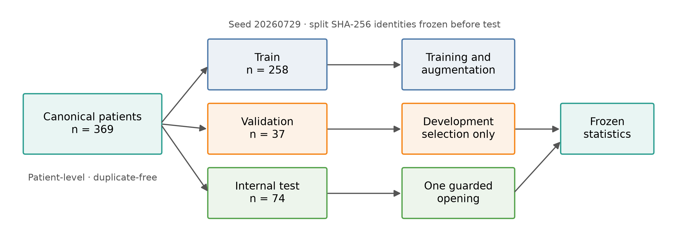
Figure 1. Gated development, freezing, and one-time internal-test analysis flow.

3.2 Cohort audit, canonicalization, and splitting
We inventoried all expected modalities and segmentations by patient and computed file- and image-content signatures. BraTS 2020 training was selected as the canonical labeled cohort. BraTS 2019 contributed no additional training observation and was used only for identity and duplicate auditing.
The audit found 335 complete BraTS 2019 cases and 369 complete BraTS 2020 cases. All 335 BraTS 2019 patients mapped to BraTS 2020 by image content; 34 cases were new in the 2020 edition. The mapped image modalities were content-equivalent. One mapped segmentation differed by 2 voxels, which was recorded as an annotation revision rather than a new patient. The canonical cohort therefore contained 369 unique patients.
Patients, not slices, were partitioned with seed 20260729. The selected candidate minimized imbalance across grade, ET presence, and WT-volume strata while satisfying frozen tolerances. Patient identifiers did not overlap between subsets.
Table 1. Cohort characteristics by patient-level partition.
Partition | Patients | HGG | LGG | ET present | WT volume median (IQR), mm3
Train | 258 | 204 | 54 | 239 | 90936.0 (50321.0-144849.5)
Validation | 37 | 30 | 7 | 34 | 89516.0 (52898.0-149466.0)
Internal test | 74 | 59 | 15 | 69 | 89554.0 (51805.8-141632.2)
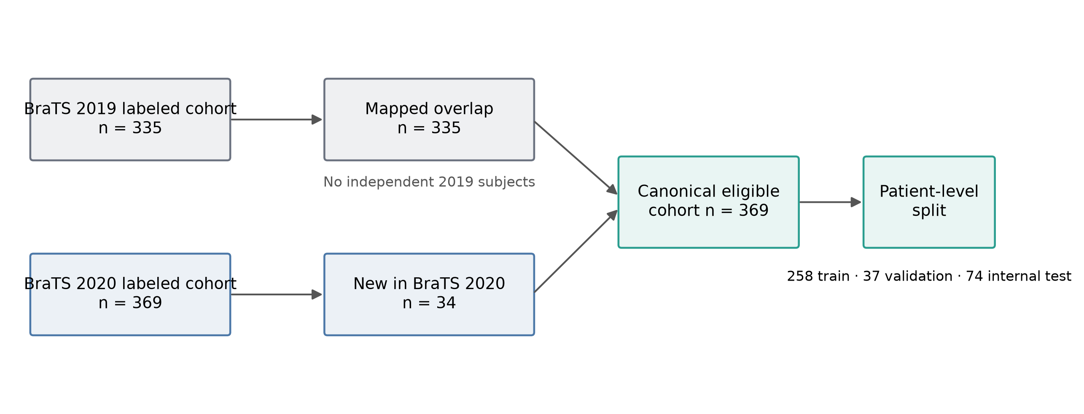
Figure 2. Cohort identity audit and canonical patient flow.

3.3 MRI preprocessing and sampling
Each case used T1, T1ce, T2, and FLAIR in that channel order. Volumes supplied by BraTS were co-registered, skull stripped, and sampled axially at 240 x 240 pixels. For each patient and modality, nonzero voxels were standardized with that volume’s mean and standard deviation. Intensity clipping was disabled.
Training sampled 16 slices per patient per epoch; the probability of selecting a tumor-containing slice was 0.67 and at least one tumor voxel defined a positive slice. Spatial augmentation used independent flips with probability 0.5 and rotations by multiples of 90 degrees. Per-modality intensity augmentation, applied with probability 0.5, used scale 0.9-1.1 and shift -0.1 to 0.1 in standardized units. Validation and test evaluation traversed all slices, including empty slices, deterministically. Cached arrays were memory-mapped outside the raw-data roots.

3.4 Architectures and attribution
All candidates accepted four MRI channels and produced four logits representing background and BraTS labels 1, 2, and 4. The common encoder widths were 16, 32, 64, and 128, followed by a 256-channel bottleneck. Batch normalization and dropout probability 0.3 were shared.
Standard U-Net used ordinary encoder-decoder skip connections. U-Net+RES added the published BU-Net RES pathways but omitted WC. The full BU-Net reimplementation combined RES with the published WC bottleneck module. RES used separable N x 1 and 1 x N branches with N in 9, 11, 13, and 15 across resolution levels, followed by fusion convolutions. WC used two oppositely ordered separable 15-pixel paths whose outputs were summed. Figure 3 identifies publication provenance directly.
The implementation followed the BU-Net prose where the original schematic was ambiguous. Deliberate implementation choices were four mutually exclusive output classes, base width 16, the stated dropout placement, and no imported external code. These choices make the present work a reimplementation study, not an exact reproduction of the original paper.
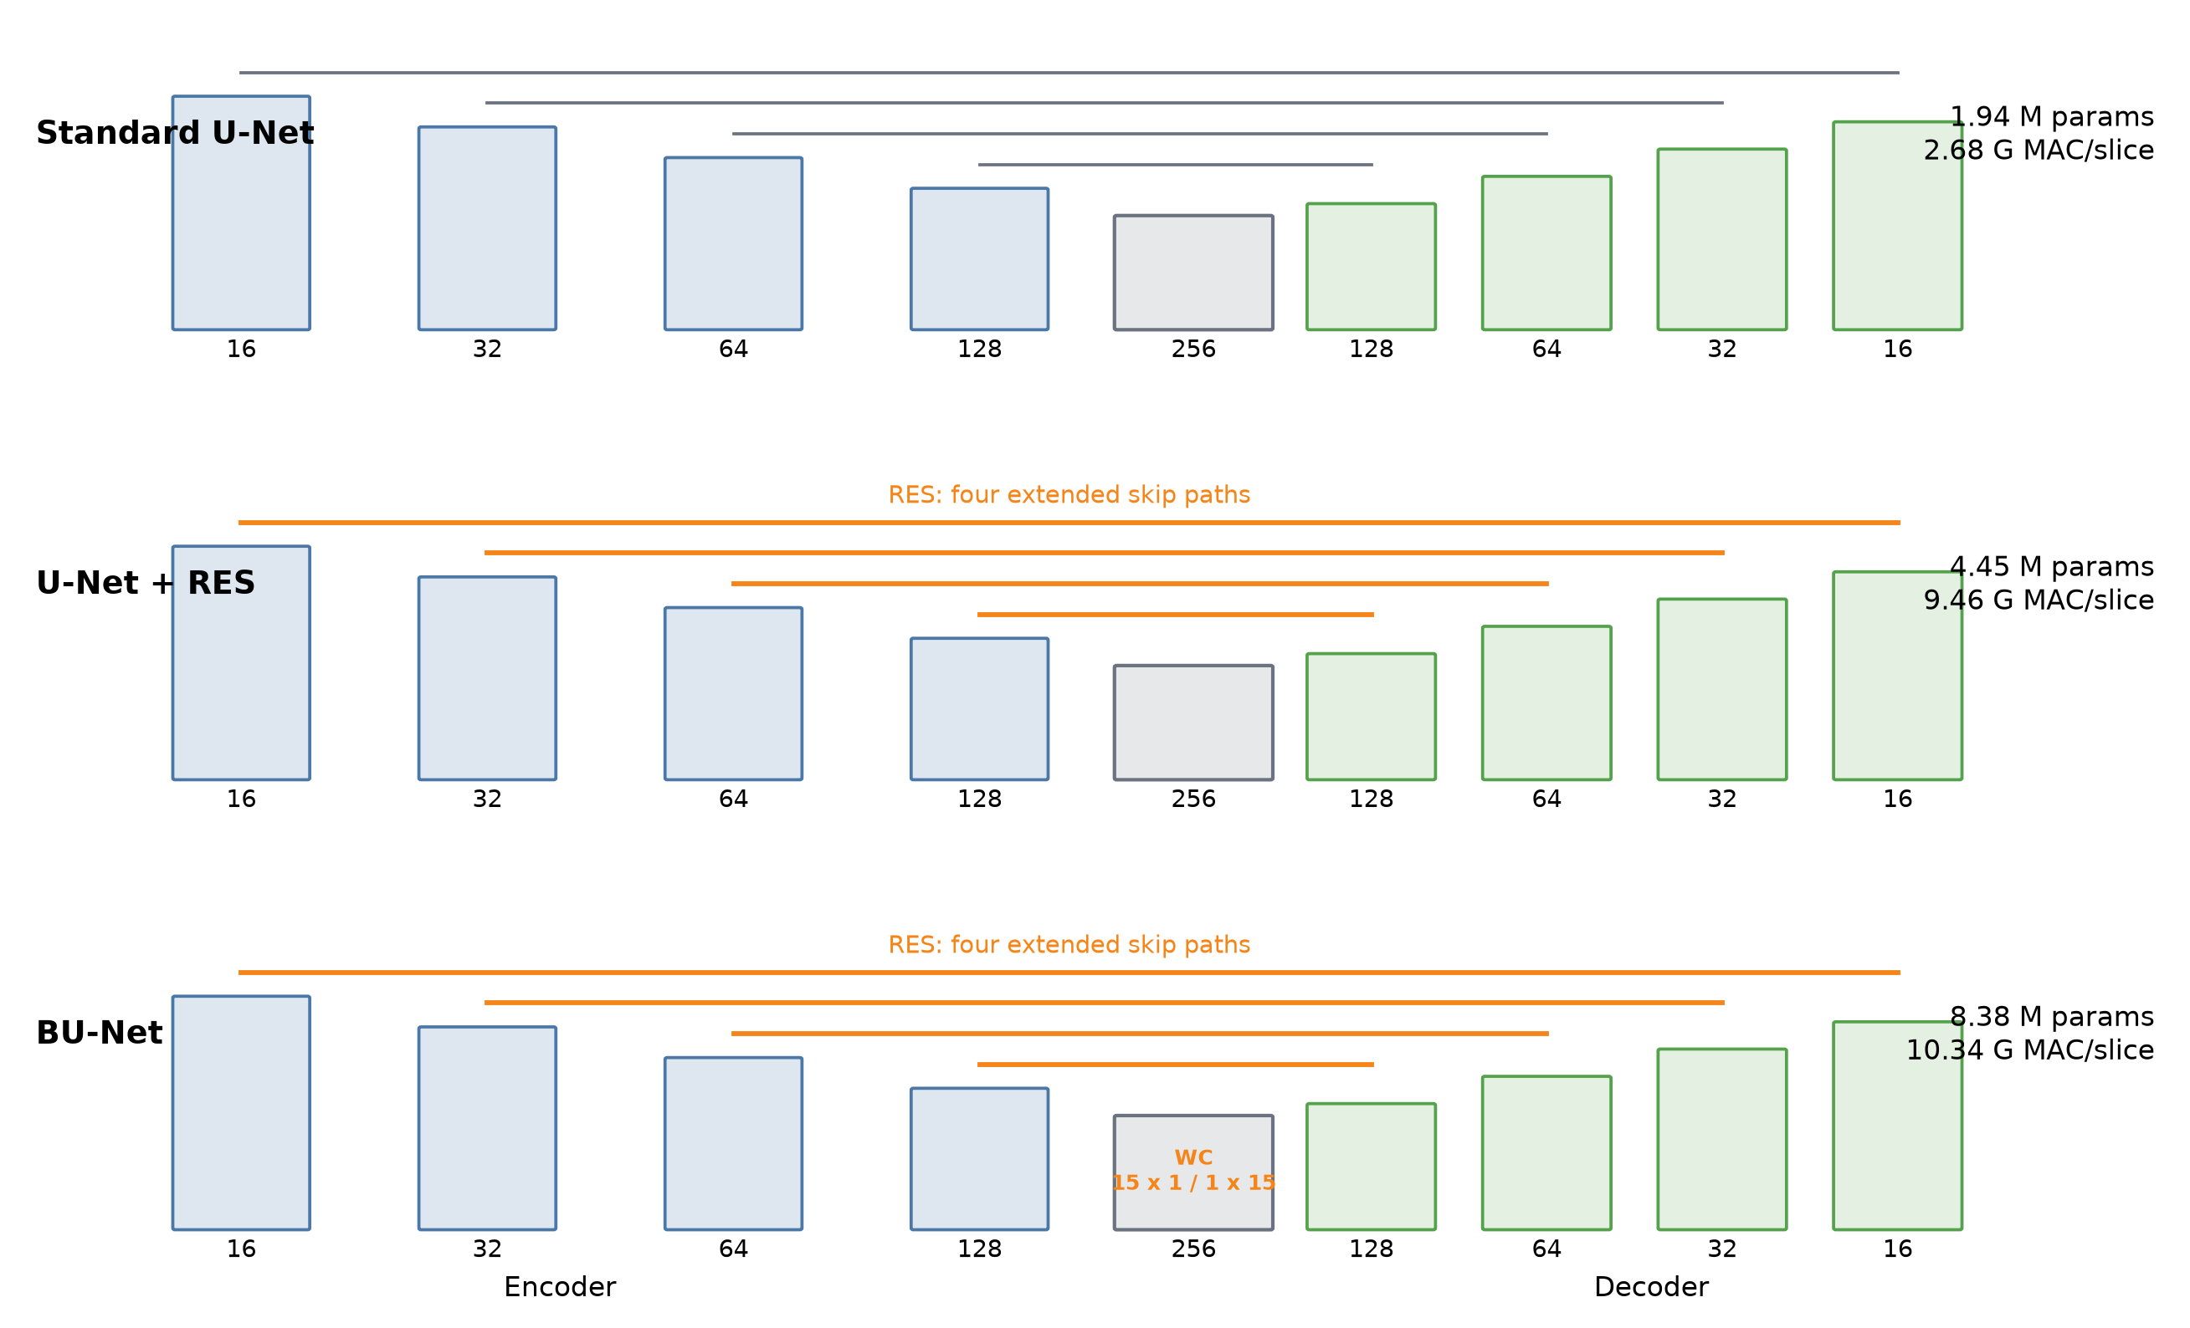
Figure 3. Compared 2D architectures. RES and WC are published BU-Net components from Rehman et al. [6].

3.5 Loss function and development screen
The selected loss was an equal-weight combination of channel-wise binary cross-entropy (BCE) and foreground focal Tversky loss (FTL):
$$L=0.5 L_{BCE}+0.5 L_{FTL},$$
LFTL=1|Cf|c∈Cf​1−TPc+ϵTPc+αFPc+βFNc+ϵγ,
where $C_{f}$ contains the three foreground classes, $α=0.3$, $β=0.7$, $γ=0.75$, and $ϵ={10}^{−5}$. BCE used sigmoid probabilities and one-hot targets; FTL used softmax probabilities. Inference used argmax over the four output classes. No class weights were applied.
The development screen evaluated six architecture arms and seven loss arms once each on the validation subset. Its role was shortlisting, not hypothesis testing or reporting a generalization estimate.
Table 2. Single-seed architecture development screen (n=37 validation patients).
Architecture arm | Mean regional Dice | Eliminated
BU-Net | 0.751 | no
Residual-block U-Net | 0.728 | yes
Residual-block U-Net+WC | 0.741 | no
Standard U-Net | 0.721 | yes
U-Net+RES | 0.745 | no
U-Net+WC | 0.741 | no
Table 3. Single-seed loss development screen (n=37 validation patients).
Loss arm | Mean regional Dice | Eliminated
Cross-entropy + soft Dice | 0.721 | yes
Binary cross-entropy | 0.623 | yes
Binary cross-entropy + focal Tversky | 0.744 | no
Binary cross-entropy + soft Dice | 0.711 | yes
Cross-entropy | 0.700 | yes
Focal Tversky | 0.245 | yes
Soft Dice | 0.238 | yes

3.6 Matched training and multi-seed confirmation
Every reportable run used the same Apple M1 Max MPS device, inputs, batch size 16, AdamW optimizer, learning rate 0.001, weight decay 0.00001, augmentation, and loss. Mixed precision and pretraining were disabled. The realized bounded protocol stopped each run at 2,000 optimizer steps or 0.5 accelerator-hours, whichever occurred first. A 200-step linear warmup preceded cosine decay to 0.01 of the initial rate. Validation occurred at step 2,000, and the highest patient-level mean regional Dice checkpoint was retained.
Three seeds (3 per candidate) confirmed standard U-Net, BU-Net, U-Net+RES, and U-Net+WC. U-Net+WC was eliminated by the predeclared rule. BU-Net and U-Net+RES then received two additional seeds each. Five-seed validation means were 0.743 and 0.740, respectively; the U-Net+RES minus BU-Net paired difference was -0.003 (95% bootstrap CI -0.012 to +0.004). Because this interval included zero, the development ranking was not interpreted as superiority. Standard U-Net, BU-Net, and U-Net+RES were frozen for internal-test evaluation.

3.7 Guarded internal-test evaluation
Before test access, candidate identities, 13 checkpoint hashes, the split hashes, the endpoint, three paired contrasts, inference rules, and statistical procedures were frozen. Test evaluation required an explicit authorization flag and an append-only access log. The test manifest was opened once. No checkpoint, threshold, post-processing stage, or model-selection decision changed afterward.
For each candidate, per-seed endpoint values were averaged within patient before patient-level statistical inference. No test-time augmentation or post-processing was used.

3.8 Outcomes and metric rules
The primary outcome was each patient’s arithmetic mean of WT, TC, and ET Dice. Region Dice values were also reported separately. Secondary estimates included HD95, surface Dice at 1 mm, lesion recall, lesion precision, lesion-wise Dice, false-positive lesion count, and relative volume error.
Lesions used 26-connectivity with a one-voxel minimum. Predicted and reference lesions were paired by maximum-total-IoU matching. If both masks were empty, overlap and surface Dice were 1 and HD95 was 0 mm; if only one mask was empty, overlap and surface Dice were 0 and HD95 was infinity. Undefined rates remained missing. Tables state finite denominators and infinity counts where applicable.

3.9 Statistical analysis
The patient was the only inferential unit. For each candidate, 95% confidence intervals used 10,000 patient-level bootstrap resamples with seed 20260729. Three frozen paired comparisons of mean regional Dice were tested with 100,000 two-sided sign-flip permutations using seed 20260730. Holm’s sequential procedure controlled the family-wise error rate at 0.05 [13]. We report paired mean differences, bootstrap intervals, paired standardized effect $d_{z}$, raw p values, and Holm-adjusted p values. Regional and secondary endpoints were estimation-only; no unplanned multiplicity-adjusted claims were made.
Grade, reference ET presence, and training-derived WT burden tertiles were exploratory. The ET-absent group was descriptive because it contained only five patients.

3.10 Resource profiling and reproducibility
Parameter counts and multiply-accumulate operations (MACs) were computed from the implemented models at a 4 x 240 x 240 slice input. One MAC was reported as two floating-point operations (FLOPs). Per-volume inference latency and allocated memory were measured on the same Apple M1 Max host and summarized across seeds. Development accelerator-hours were retained from each run. These measurements compare the present implementations on one host; they are not deployment benchmarks.
All tables and figures were generated from machine-readable run artifacts. A tracked manifest records hashes for reportable files. A clean-clone audit rebuilt the Gate 12 outputs twice, confirmed byte-identical results, ran static checks and tests, and verified a clean worktree.

4. Results

4.1 Cohort integrity and development selection
The content audit identified complete imaging and labels for all 369 canonical patients, no file-integrity errors, and no patient overlap across partitions. The maximum absolute standardized mean difference across continuous split features was 0.048, below the frozen tolerance of 0.35.
In the single-seed screen, BU-Net had the highest architecture-screen mean regional Dice (0.751); U-Net+RES was within the practical screening margin. BCE+FTL had the highest loss-screen mean (0.744). These development observations only determined which arms advanced.
In the three-seed stage, mean regional Dice was 0.739 for standard U-Net, 0.745 for BU-Net, 0.739 for U-Net+RES, and 0.730 for U-Net+WC. Only U-Net+WC met the elimination rule. The finalist interval spanning zero justified carrying both BU-Net and U-Net+RES into the frozen test analysis.

4.2 Primary internal-test outcome
All 74 test patients had finite primary outcomes. Mean regional Dice was 0.736 for standard U-Net, 0.752 for BU-Net, and 0.756 for U-Net+RES.
Table 4. Internal held-out test Dice estimates (n=74 patients).
Candidate | Mean regional Dice | 95% bootstrap CI | WT Dice | TC Dice | ET Dice
Standard U-Net | 0.736 | 0.692-0.775 | 0.810 | 0.693 | 0.704
BU-Net | 0.752 | 0.716-0.786 | 0.823 | 0.724 | 0.709
U-Net+RES | 0.756 | 0.719-0.790 | 0.827 | 0.726 | 0.715
BU-Net exceeded standard U-Net by +0.017 (95% CI +0.005 to +0.030; $d_{z}$=+0.308; raw p=0.007; Holm p=0.014). U-Net+RES exceeded standard U-Net by +0.020 (95% CI +0.008 to +0.034; $d_{z}$=+0.347; raw p=0.001; Holm p=0.004).
BU-Net minus U-Net+RES was -0.004 (95% CI -0.008 to -0.000; $d_{z}$=-0.229; Holm p=0.050). The estimate was small and close to the multiplicity threshold; it should not be read as a broad ranking beyond this protocol.
Table 5. Frozen paired comparisons for the primary outcome.
Contrast | Paired difference | 95% bootstrap CI | dz | Raw p | Holm p
BU-Net - Standard U-Net | +0.017 | +0.005 to +0.030 | +0.308 | 0.007 | 0.014
U-Net+RES - Standard U-Net | +0.020 | +0.008 to +0.034 | +0.347 | 0.001 | 0.004
BU-Net - U-Net+RES | -0.004 | -0.008 to -0.000 | -0.229 | 0.050 | 0.050
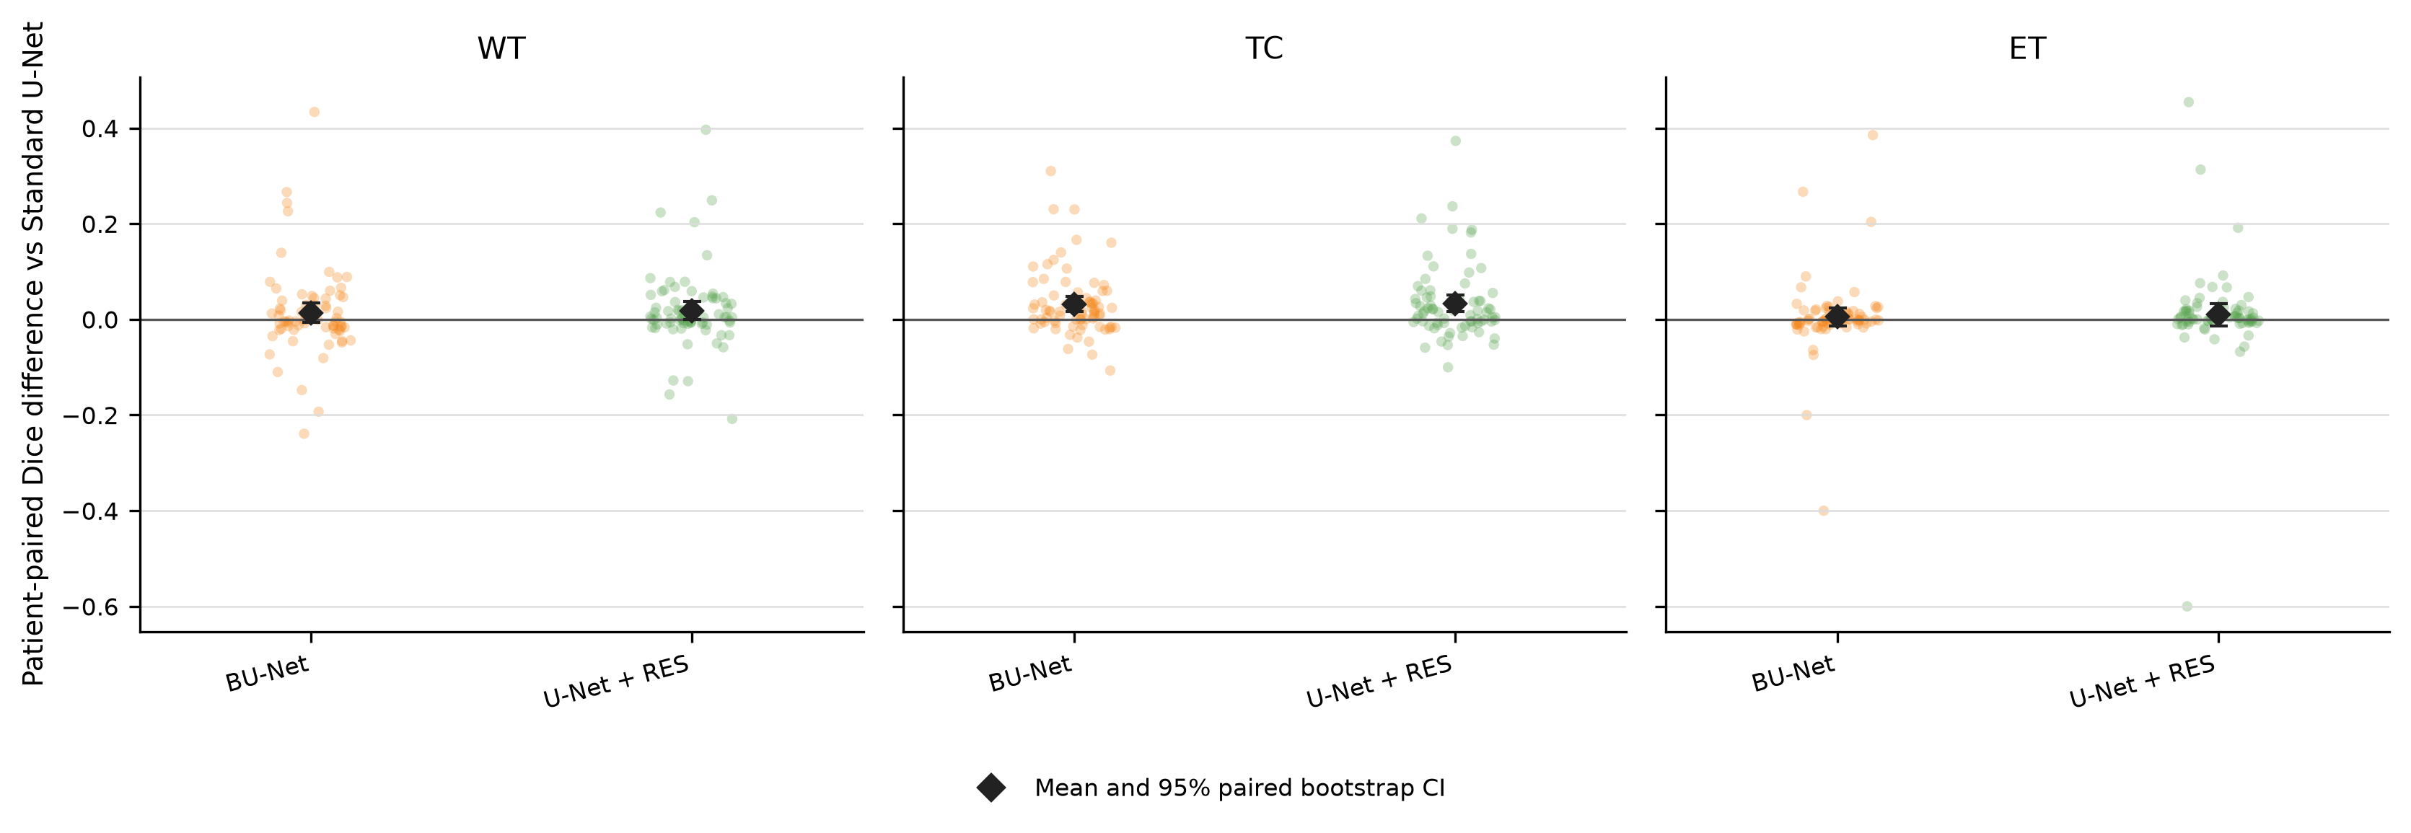
Figure 4. Patient-level paired regional Dice differences.
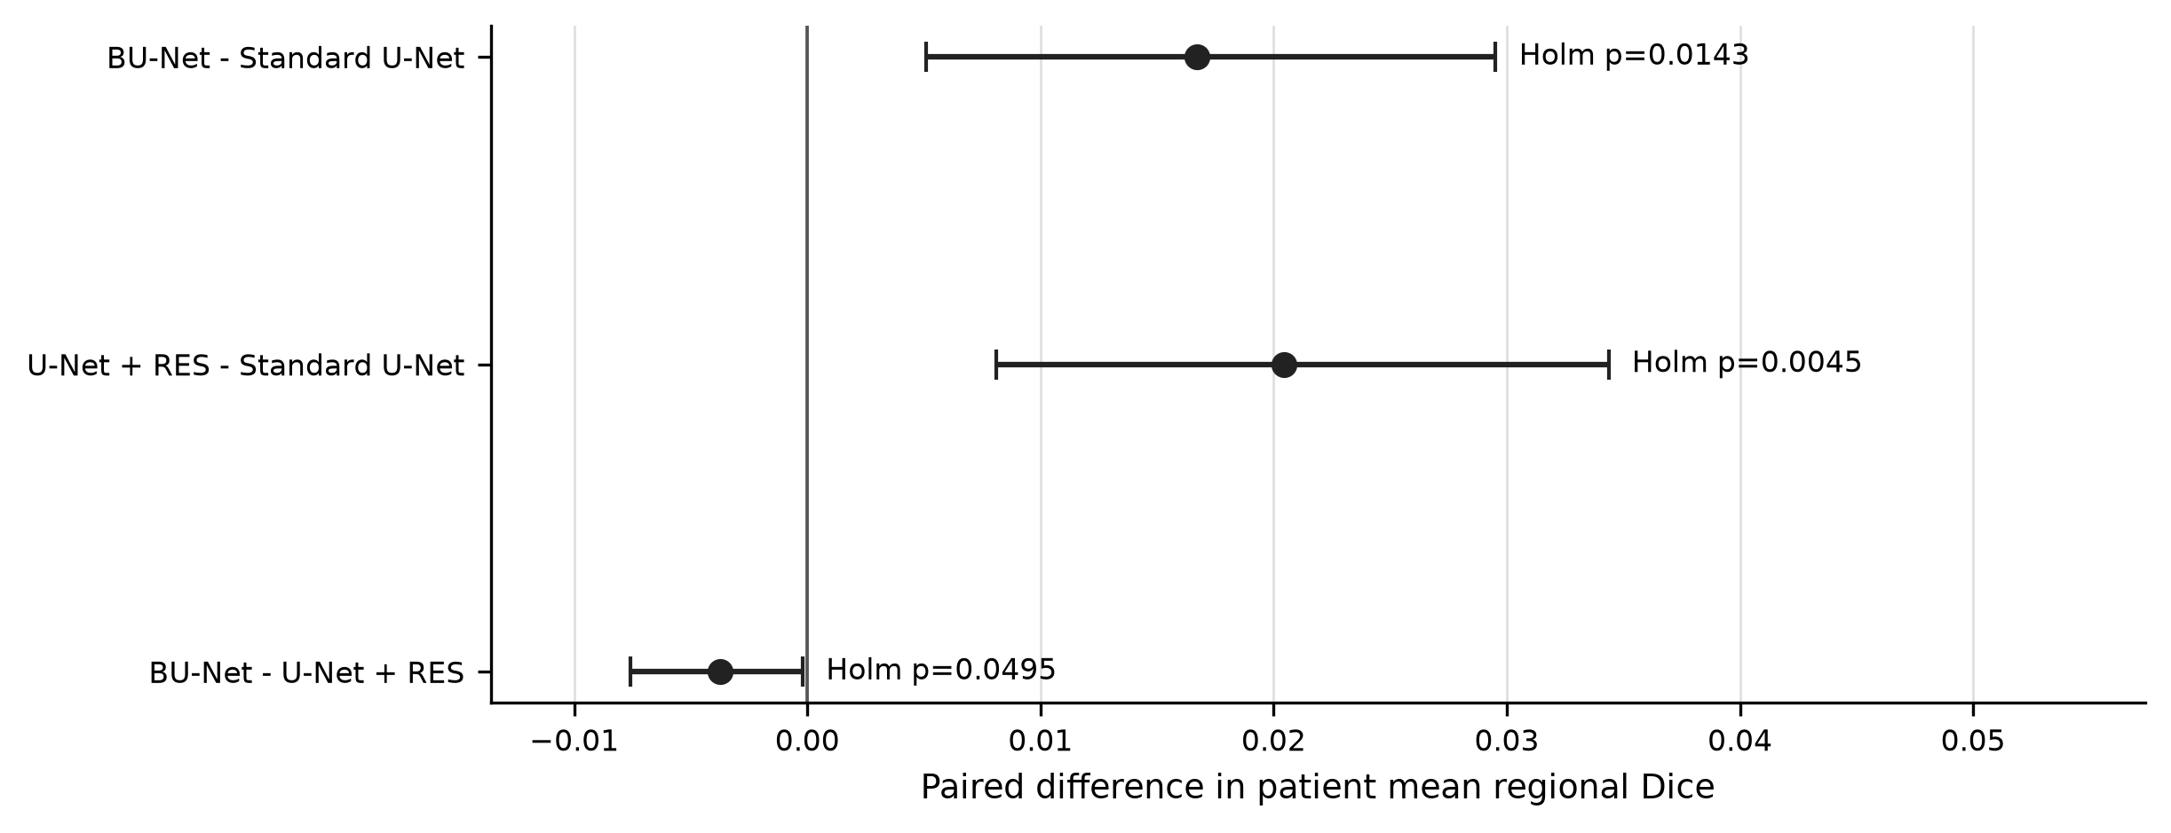
Figure 5. Frozen primary paired effects with 95% bootstrap confidence intervals.

4.3 Regional, boundary, and lesion estimates
The largest regional overlap differences relative to standard U-Net occurred for TC. ET overlap changed less. Surface Dice means favored U-Net+RES numerically across all three regions. In contrast, finite HD95 means were lower for standard U-Net than for either component-based model; several TC and ET observations were infinite because one mask was empty. Thus, overlap improvements did not imply uniformly better boundary outlier behavior.
Table 6. Selected secondary outcomes. HD95 means use finite observations; infinity counts are shown in parentheses.
Candidate | WT surface Dice | TC surface Dice | ET surface Dice | WT HD95 mm | TC HD95 mm | ET HD95 mm | ET lesion recall | ET lesion-wise Dice
Standard U-Net | 0.605 | 0.577 | 0.734 | 21.9 | 17.4 (3 inf) | 14.8 (4 inf) | 0.470 | 0.356
BU-Net | 0.621 | 0.586 | 0.744 | 35.8 | 22.0 (1 inf) | 16.8 (5 inf) | 0.475 | 0.367
U-Net+RES | 0.637 | 0.595 | 0.748 | 31.9 | 21.0 (2 inf) | 16.9 (5 inf) | 0.476 | 0.370
ET lesion recall was approximately 0.47 for all candidates, and ET lesion-wise Dice remained below region-level ET Dice. These estimates expose a lesion-detection limitation that a voxel-overlap summary alone would obscure.

4.4 Resource demand
BU-Net had 4.32 times the parameters and 3.87 times the MACs of standard U-Net. U-Net+RES achieved the highest primary mean with 4.450 million parameters, compared with 8.385 million for BU-Net. Its mean p50 latency was 1.189 s/volume versus 1.258 s/volume, and its mean peak allocated memory was 88.9 MB versus 234.8 MB. Development accelerator-hours per run were similar and do not include preprocessing or study-level engineering time.
Table 7. Architecture and measured resource profile on one host.
Candidate | Parameters, M | MAC/slice, G | FLOP/slice, G | p50 s/volume | p95 s/volume | Peak allocated MB | Development GPU-h/run | Mean regional Dice
Standard U-Net | 1.943 | 2.676 | 5.353 | 0.492 | 0.528 | 67.0 | 0.332 | 0.736
BU-Net | 8.385 | 10.344 | 20.688 | 1.258 | 1.285 | 234.8 | 0.384 | 0.752
U-Net+RES | 4.450 | 9.459 | 18.919 | 1.189 | 1.215 | 88.9 | 0.388 | 0.756
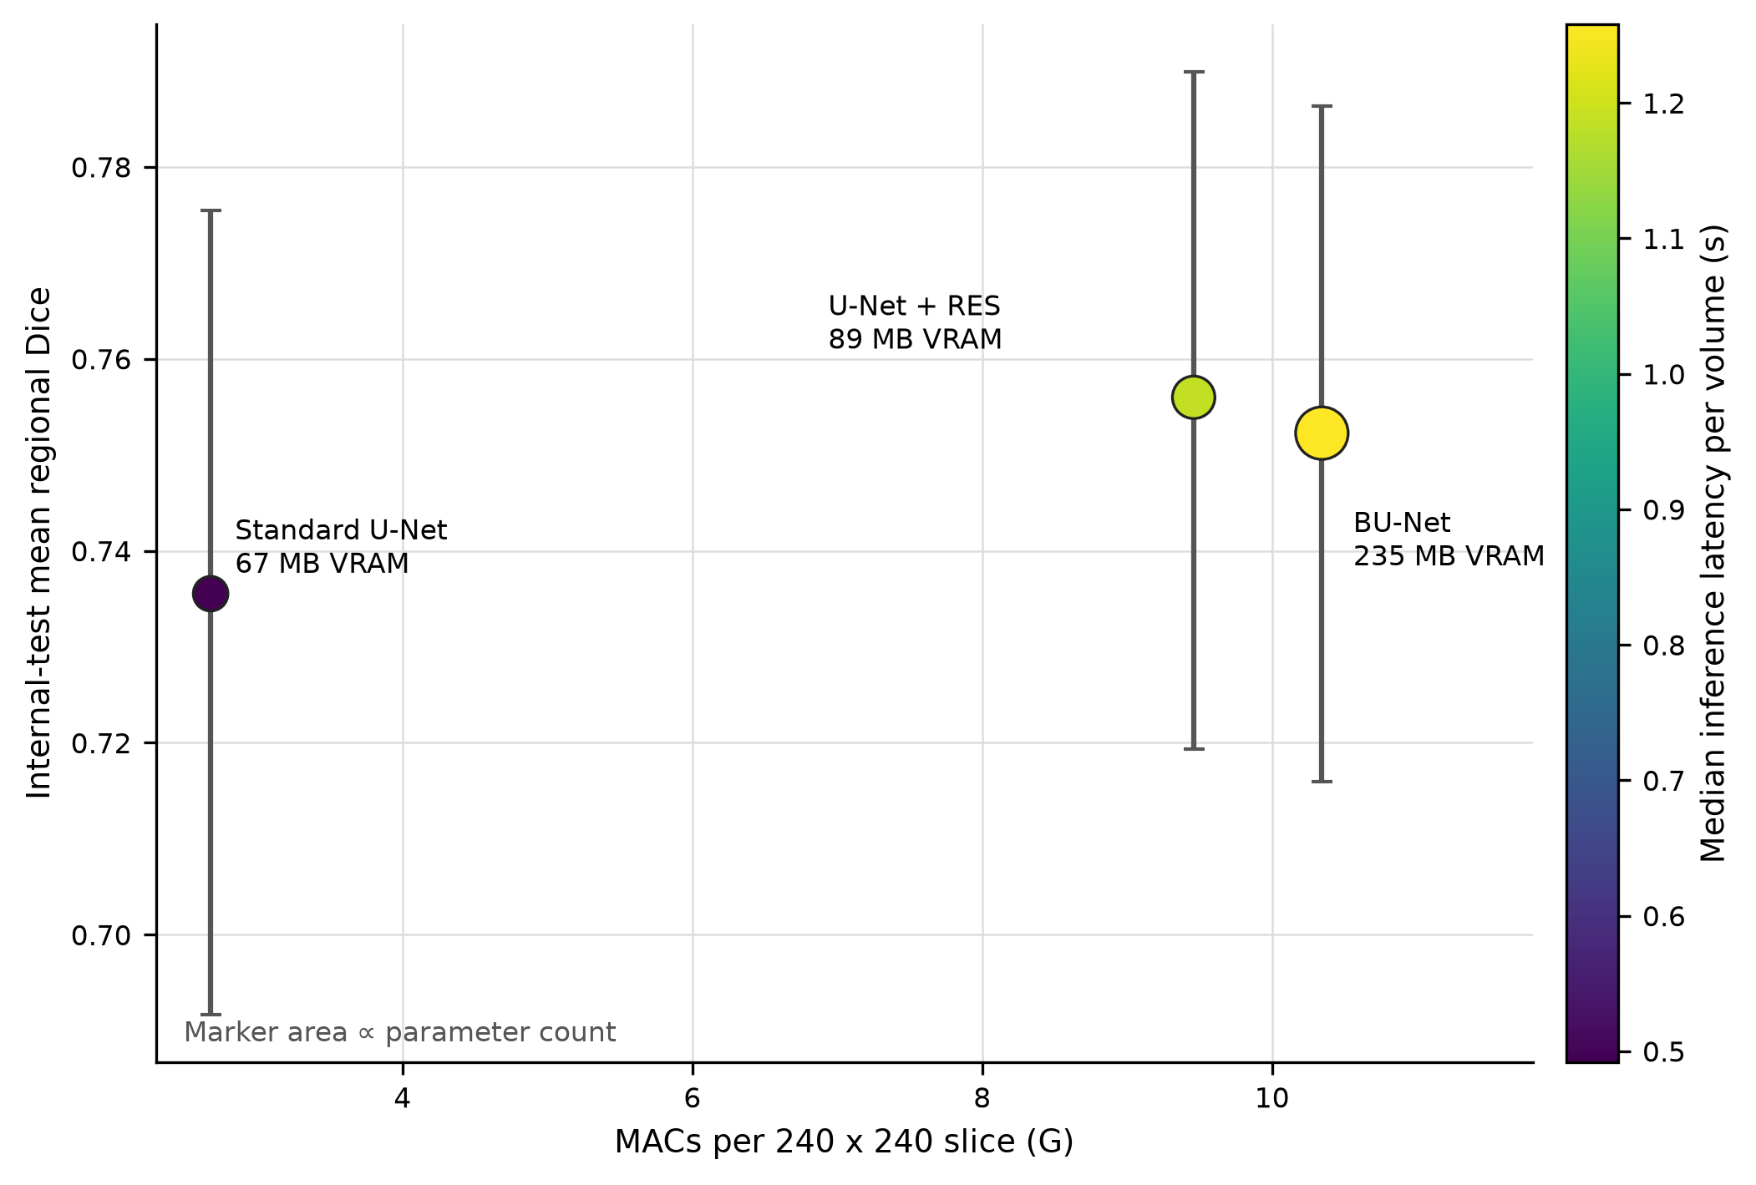
Figure 6. Mean regional Dice in relation to model and runtime resource measures.

4.5 Exploratory subgroups and qualitative review
Exploratory subgroup estimates are reported without confirmatory p values. HGG patients had higher mean scores than LGG patients for all models. The ET-absent subset contained five patients and is descriptive only. Training-set WT tertiles defined small (at most 64,267 mm3), medium (64,267 to 123,163.3 mm3), and large burden groups.
Table 8. Exploratory mean regional Dice by frozen subgroup.
Subgroup | n | Standard U-Net | BU-Net | U-Net+RES | Interpretation
Grade: HGG | 59 | 0.806 | 0.808 | 0.812 | exploratory
Grade: LGG | 15 | 0.457 | 0.534 | 0.537 | exploratory
ET reference: present | 69 | 0.759 | 0.773 | 0.776 | exploratory
ET reference: absent | 5 | 0.418 | 0.470 | 0.480 | descriptive_insufficient_n
WT burden: small | 24 | 0.713 | 0.735 | 0.746 | exploratory
WT burden: medium | 24 | 0.770 | 0.771 | 0.772 | exploratory
WT burden: large | 26 | 0.724 | 0.751 | 0.750 | exploratory
The qualitative panel includes preselected BU-Net success, hard, and failure cases: BraTS20_Training_166 (ET Dice 0.924), BraTS20_Training_137 (ET Dice 0.788), and BraTS20_Training_323 (ET Dice 0.000). The failure case demonstrates that a favorable cohort mean can coexist with near-zero ET overlap in an individual patient. Modality, prediction, false-positive, and false-negative panels were generated from retained test artifacts rather than selected after manuscript inspection.
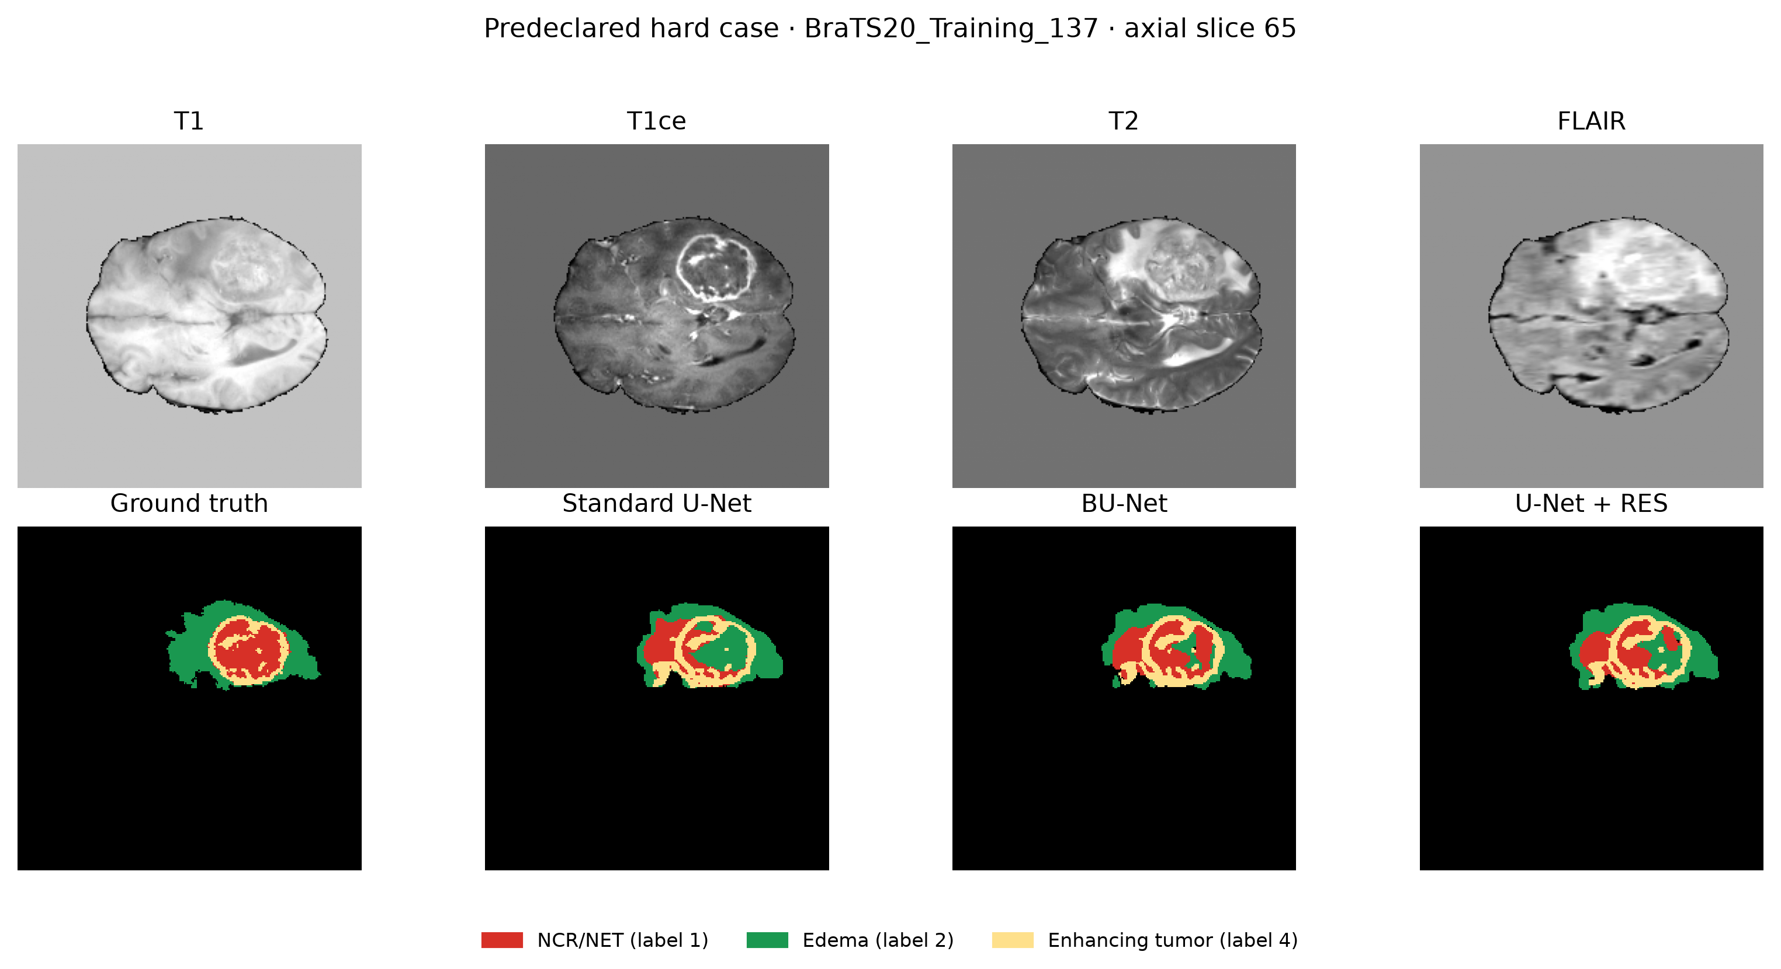
Figure 7. Multimodal MRI, reference labels, and frozen candidate predictions for an internal-test case.
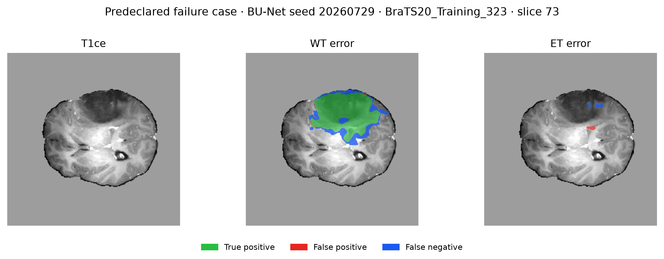
Figure 8. False-positive and false-negative error overlays.
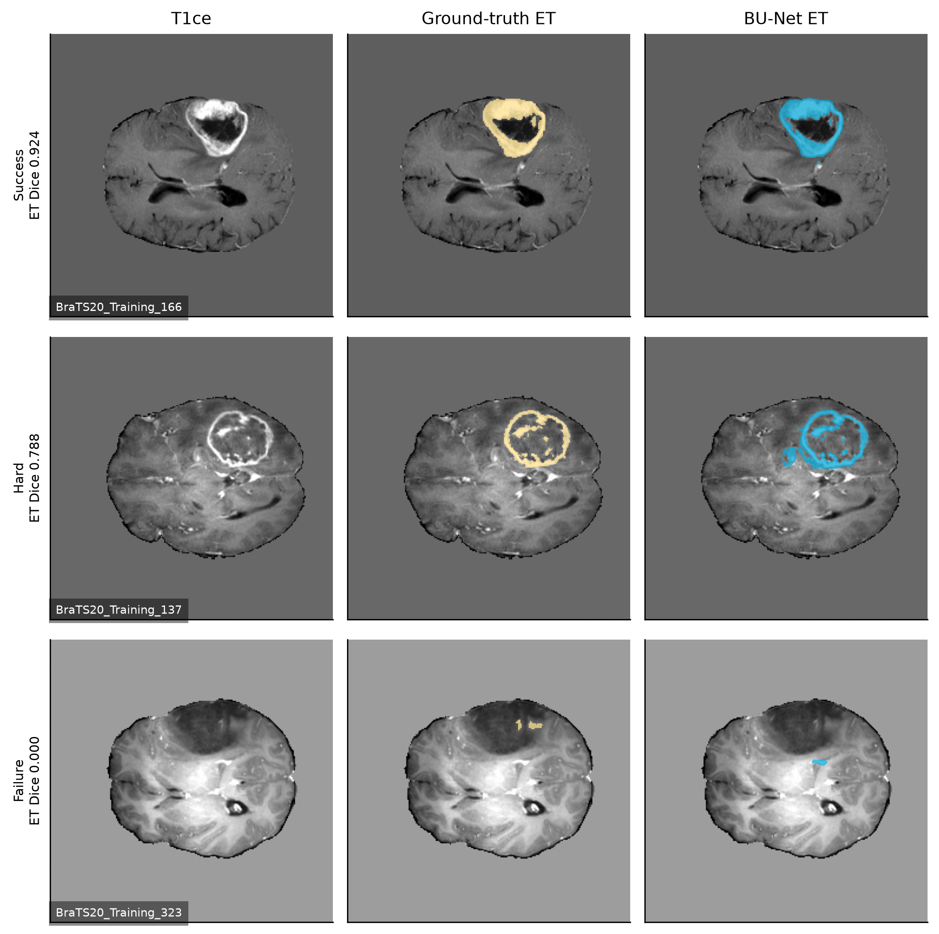
Figure 9. Prespecified BU-Net ET success, hard, and failure cases.
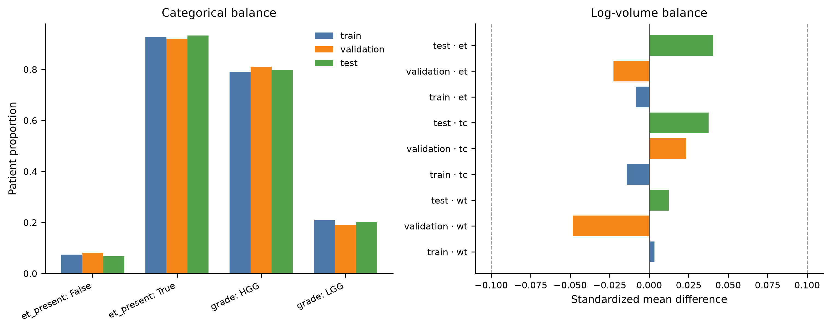
Supplementary Figure S1. Patient-level balance across frozen partitions.

5. Discussion

5.1 Principal findings
This controlled study supports three bounded conclusions. First, both BU-Net and U-Net+RES produced small patient-level improvements in mean regional Dice over standard U-Net after multiplicity correction. Second, U-Net+RES slightly exceeded the full BU-Net on the frozen primary endpoint. Third, BU-Net required substantially more parameters, MACs, latency, and allocated memory than U-Net+RES. Under this implementation and run budget, WC therefore did not provide an observable advantage over RES alone.
The effect sizes were small. BU-Net’s paired standardized effect versus standard U-Net was +0.308, and the BU-Net versus U-Net+RES contrast was -0.229. The latter p value was near 0.05 and its confidence interval lay close to zero. The evidence should be interpreted as a component-specific result under one bounded protocol, not a universal claim that WC is ineffective.

5.2 What the secondary outcomes add
Dice and surface Dice generally favored the component-based models, but finite HD95 means did not. Standard U-Net had lower finite HD95 means in WT, TC, and ET. This discordance can arise because Dice summarizes overlap while HD95 emphasizes distant boundary errors and becomes infinite when only one mask is empty. Reporting both prevents a one-dimensional account of segmentation quality.
Lesion-level estimates also temper the voxel-level results. ET lesion recall and lesion-wise Dice remained modest for every candidate. A model can achieve a high regional Dice on a large focus while missing small enhancing foci or generating disconnected false-positive components. The qualitative failure case reinforces this limitation.

5.3 Development ranking and test behavior
BU-Net ranked first during five-seed development, but U-Net+RES ranked first on the internal test. The development confidence interval between the finalists included zero, so freezing both was important. Selecting only the numerically leading validation model would have hidden this uncertainty. The result illustrates why seed replication, frozen finalist rules, and complete candidate reporting matter.

5.4 Scope relative to broader segmentation systems
nnU-Net, TransBTS, nnFormer, and other 3D systems are relevant modern comparators [9,14,15]. We did not train them. Nor did we perform cross-dataset or multi-institutional external validation. Literature scores cannot substitute for those experiments because acquisition, cohort, preprocessing, compute, and evaluation rules differ. Our results should therefore be read as a reproducible internal ablation of published BU-Net components, not as a leaderboard or state-of-the-art comparison.

5.5 Limitations
This study has several limitations. It used one public dataset and an internal split; external generalization is unknown. The networks were 2D and cannot use through-plane context as a 3D model can. Training was deliberately bounded at 2,000 optimizer steps or 0.5 accelerator-hours, so the results do not describe fully converged scaling behavior. The architecture widths and output encoding are reimplementation choices rather than a bit-exact reproduction of BU-Net. Resource measurements came from one Apple M1 Max host and do not establish deployment performance on clinical hardware. The 1 mm surface tolerance was predeclared but not calibrated against expert interobserver variability. HGG/LGG labels were inherited from the challenge release and were not independently adjudicated. Exploratory subgroups were small, especially the five-patient ET-absent subset. Finally, no prospective workflow, reader study, clinical endpoint, or regulatory assessment was performed.

5.6 Reproducibility and auditability
The released repository contains configuration files, split hashes, model and loss code, evaluator tests, analysis scripts, machine-readable outputs, figure and table generators, resource profiles, a claim ledger, and a tracked-artifact manifest. A clean-clone reproduction report records the exact commit and verifies deterministic output generation. Raw BraTS data and model checkpoints are excluded because redistribution is not authorized; users must obtain the dataset separately and configure local paths.

6. Conclusion
In a leakage-safe, patient-level, multi-seed evaluation of three matched 2D U-Net-family candidates, the published BU-Net RES component improved mean regional Dice relative to standard U-Net. Adding the published WC component in the full BU-Net did not improve the primary endpoint over RES alone and increased computational demand. Boundary and lesion-level results were more mixed than overlap scores. The work provides reproducible internal evidence about these components, while leaving 3D comparison, external validation, clinical calibration, and prospective utility as open questions.

Data and code availability
Code, frozen manifests, derived reports, tables, figures, and reproduction instructions are available at https://github.com/TerekliTahaBerk/bratsarticle. BraTS images and labels are not redistributed. Access to the original dataset is governed by the BraTS data providers. The internal held-out test partition is a study-specific subset of the BraTS 2020 training cohort and is not an official challenge test set.

Ethics statement
This computational study used a publicly distributed, de-identified challenge dataset and involved no direct participant contact or intervention. Authors should confirm the final journal-specific institutional review and exemption wording before submission.

Declarations requiring author confirmation
Funding, competing interests, author contributions, and institutional review wording were not inferable from the repository and must be confirmed by the authors in the target journal’s required format. No declaration has been invented in this manuscript package.

References
- Menze BH, et al. The Multimodal Brain Tumor Image Segmentation Benchmark (BRATS). IEEE Transactions on Medical Imaging. 2015;34:1993-2024. doi:10.1109/TMI.2014.2377694.
- Center for Biomedical Image Computing and Analytics. BraTS 2020 Tasks. University of Pennsylvania. https://www.med.upenn.edu/cbica/brats2020/tasks.html.
- Bakas S, et al. Advancing The Cancer Genome Atlas glioma MRI collections with expert segmentation labels and radiomic features. Scientific Data. 2017;4:170117. doi:10.1038/sdata.2017.117.
- Bakas S, et al. Identifying the Best Machine Learning Algorithms for Brain Tumor Segmentation, Progression Assessment, and Overall Survival Prediction in the BRATS Challenge. arXiv:1811.02629. 2018.
- Ronneberger O, Fischer P, Brox T. U-Net: Convolutional Networks for Biomedical Image Segmentation. MICCAI. 2015. doi:10.1007/978-3-319-24574-4_28.
- Rehman ZU, et al. BU-Net: Brain Tumor Segmentation Using Modified U-Net Architecture. Electronics. 2020;9:2203. doi:10.3390/electronics9122203.
- Salehi SSM, Erdogmus D, Gholipour A. Tversky Loss Function for Image Segmentation Using 3D Fully Convolutional Deep Networks. arXiv:1706.05721. 2017.
- Abraham N, Khan NM. A Novel Focal Tversky Loss Function With Improved Attention U-Net for Lesion Segmentation. IEEE ISBI. 2019. doi:10.1109/ISBI.2019.8759329.
- Isensee F, Jaeger PF, Kohl SAA, Petersen J, Maier-Hein KH. nnU-Net: a self-configuring method for deep learning-based biomedical image segmentation. Nature Methods. 2021;18:203-211. doi:10.1038/s41592-020-01008-z.
- Maier-Hein L, et al. Metrics Reloaded: recommendations for image analysis validation. Nature Methods. 2024;21:195-212. doi:10.1038/s41592-023-02151-z.
- Nikolov S, et al. Clinically Applicable Segmentation of Head and Neck Anatomy for Radiotherapy: Deep Learning Algorithm Development and Validation Study. Journal of Medical Internet Research. 2021;23:e26151. doi:10.2196/26151.
- Tejani AS, Klontzas ME, Gatti AA, Mongan JT, Moy L, Park SH, Kahn CE Jr. Checklist for Artificial Intelligence in Medical Imaging (CLAIM): 2024 Update. Radiology: Artificial Intelligence. 2024;6:e240300. doi:10.1148/ryai.240300.
- Holm S. A Simple Sequentially Rejective Multiple Test Procedure. Scandinavian Journal of Statistics. 1979;6:65-70. doi:10.2307/4615733.
- Wang W, et al. TransBTS: Multimodal Brain Tumor Segmentation Using Transformer. arXiv:2103.04430. 2021.
- Zhou H-Y, et al. nnFormer: Interleaved Transformer for Volumetric Segmentation. IEEE Transactions on Image Processing. 2023;32:4036-4049. doi:10.1109/TIP.2023.3293771.

