各位同學大家好

我們要進行HW2的demo了。demo說明如下：

There are 10000 numbers of college basketball players, with “skill (x1)” and the “athleticism (x2)” for every player.

1. Please judge which high school each player comes from based on your designed generative model and the discriminative model in Part I.
2. Please judge the class of the high school for each player based on your designed generative model and the discriminative model in Part II.

In the demo process, we provide a testingData.xlsx file with the information of the 10000 players, and you need to reply a studentID.xlsx file with your classified result. The format of testingData.xlsx and studentID.xlsx are as below:

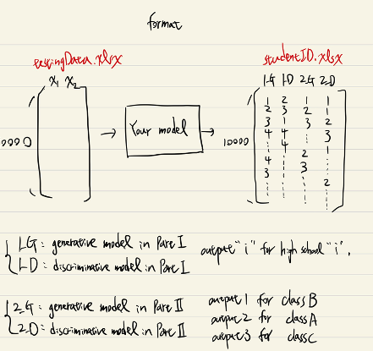

注意事項：

1. 請大家直接上傳 studentID.xlsx 檔案到HW2 demo 這個assignment，不用經過壓縮。
2. 上傳檔案裡的0123456.xlsx只是個範例，給大家參考輸出資料的format。
3. Deadline 是到5/10(三)晚上23:59，請大家準時上傳。
4. 沒交作業的同學也能參與demo，但必須要使用自己model所產生的預測。

奎佐