* It’ll be great to be able to use keyboard up and down keys to select the address autocompletion, now can only use mouse click to select.

* When choosing the bullets list, the bullet and placeholder will collapse, minor UI issue.

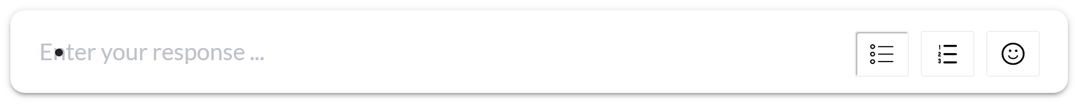

* [BUG] (maybe feature) The 150 words limits don’t work. After testing, the word up limit is 500 words, and then when clicking the send button, no pop-up alert

