Assignment 3

Terry Liu

## Question One

The datat file **Real-Estate.txt** contains information on the homes sold in the Denver area during the yea 2003. The variables in this data file are as follows:

|  |  |
| --- | --- |
| Name | Representation |
| Price | Selling price in $1000 |
| Bedrooms | Number of bedrooms |
| Size | Size of the home in square feet |
| Pool | Swimming Pool(1=Yes,0=No) |
| Distance | Distance from the home to the center of the city |
| Township | Township NO. |
| Garage | Garage attached(1=Yes,0=No) |
| Baths | Number of bathrooms |

### Part A

Give a plot of selling price agaignst distance from the home to the center of the city. Does there seem to be a relationship between the two variables? If so, is the relationship direct or inverse ?

### Answer:

db <- read.table("Real-Estate.txt",header=TRUE)  
  
x <- db$Distance  
y <- db$Size  
  
plot(x,y)

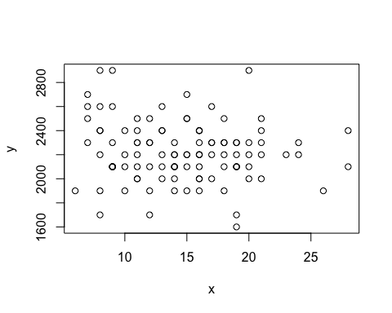

Note that the echo = FALSE parameter was added to the code chunk to prevent printing of the R code that generated the plot.