Assignment 3 – Memory

Name: Terence Qu
UPI: tqu593

Question 1:

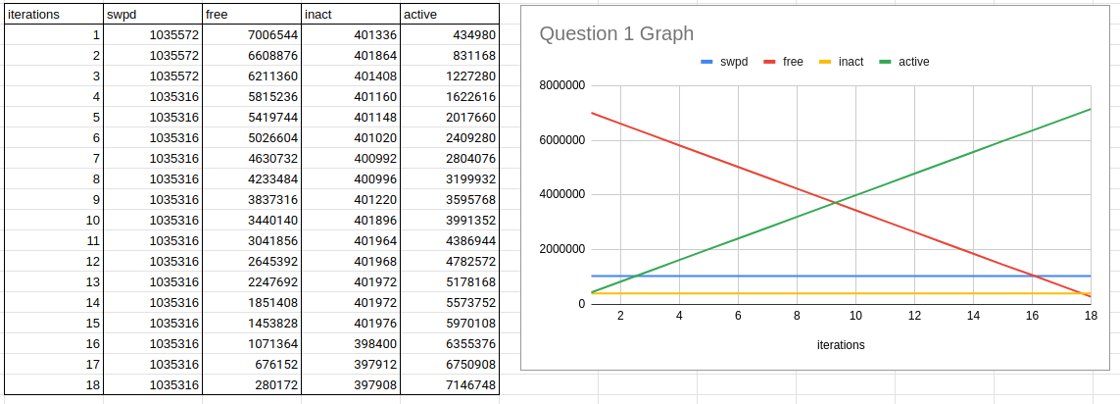
Figure 1: Graph and table for program’s output

The environment I used to collect this data was on a computer with Ubuntu version 18.04.2 LTS and 8196660 bytes of real memory and 2097148 bytes of swap.

Observations:
- Swap memory remained relatively constant until the very end where the program crashed.
- Free memory linearly decreased.
- Active memory linearly increased.
- Inactive memory remained relatively constant.

As the program runs, more and more elements must be stored on a list in the memory, and free memory decreases and active memory increases. Swap memory is not needed until all active memory is used up.

Question 2:

Inactive memory refers to memory that has not been accessed recently. The data is set as inactive so that the data can be reused at a later point with better performance. This results in the system’s efficient use of resources when performing repeated tasks.

Question 3:
[stack]: This is the initial process’s stack.
[heap]: This is the inital process’s heap.
[vvar]: Memory dedicated to variables in vDSO subsystem.
[vdso]: Memory region available to all user-made processes which provides some kernel functionalities.
[vsyscall]: Memory region available for easy access for a small set of system calls.
No changes to the output as the program uses more and more memory.

Question 4:
Map_files does not show the offset, device or inode. Maps does not show the creator, date or time of file creation.

Question 5:
The permission types are as follows:
r: read
w: write
x: execute
p: private
Following the output from the question, r-xp means that write permissions are disabled, r—p means that write and execute permissions are disabled, while rw-p means that only execute permissions are disabled.

Question 6
Free memory contains all memory that is unused.
Available memory contains all memory that is available for the system to use. This includes unused memory and inactive memory.

Question 7.
The OOM killer runs when the system is running out of memory. When it runs, it selects a process rated by how much memory it and its child processes are consuming and then terminates it.

Question 8.
Context switching can occur through interrupts and through switching between multiple processes on the same processor. Therefore, not every context switch can occur from an interrupt and since every interrupt results in a context switch, there must be more context switches than interrupts.

Question 9.

