**Assignment 3**

Subject: COMP122

Name: Tereza Konstari

ID: 301065539

**Q1: Use Just Lee Book store database Determine the average profit generated by orders in the ORDERS table in Just Lee Book database.**

**Note**: The total profit by Order must be calculated before finding the average profit…

**Hint:** First find for each order# and their total profit SUM((ord.paideach-b.cost)*ord.quantity)) And then use Nested Function as AVG of all of these grouped order# results.

**Answer must be $**31.943

SELECT AVG(SUM((ord.paideach-b.cost)*ord.quantity))

FROM orders o JOIN orderitems ord USING (order#)

JOIN books b USING (isbn)

GROUP BY b.cost

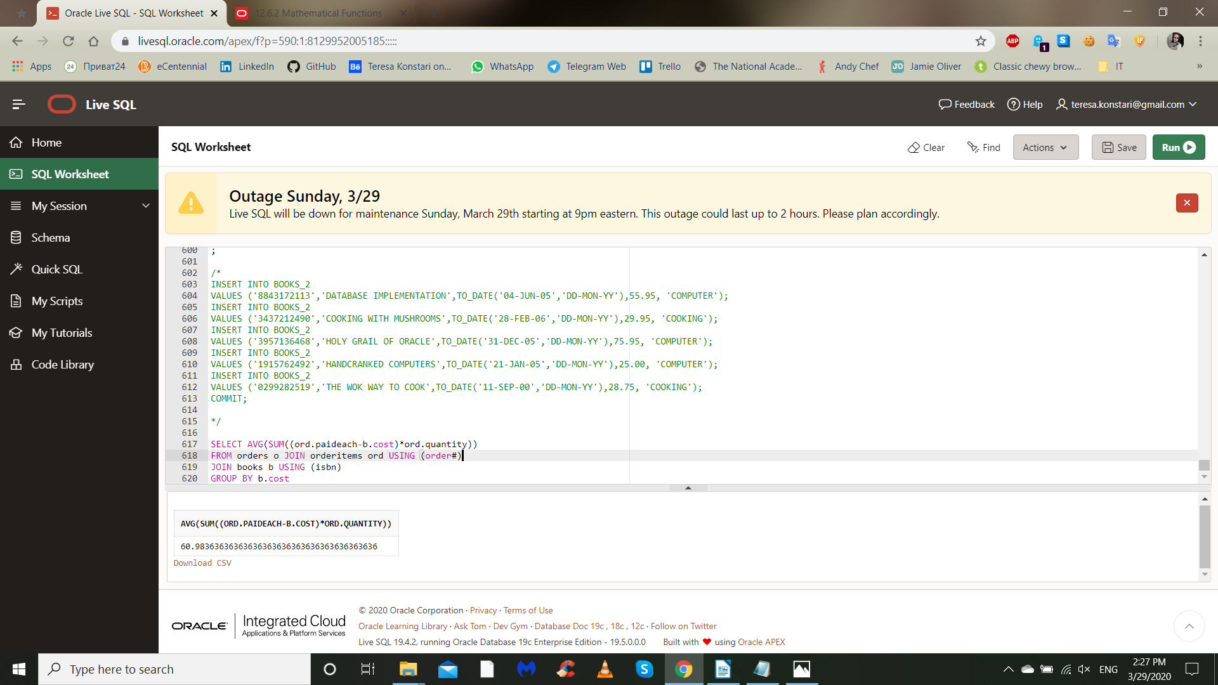

**Q2. Determine the total profit generated by sales to Customer# 1017.**

**Note : Quantity should be reflected in the total profit calculation.**

**Hint:** Use Just Lee Book store database

SELECT o.customer#, ord.quantity, b.cost, ord.quantity*b.cost

FROM orders o, orderitems ord, books b

WHERE o.customer# = 1017

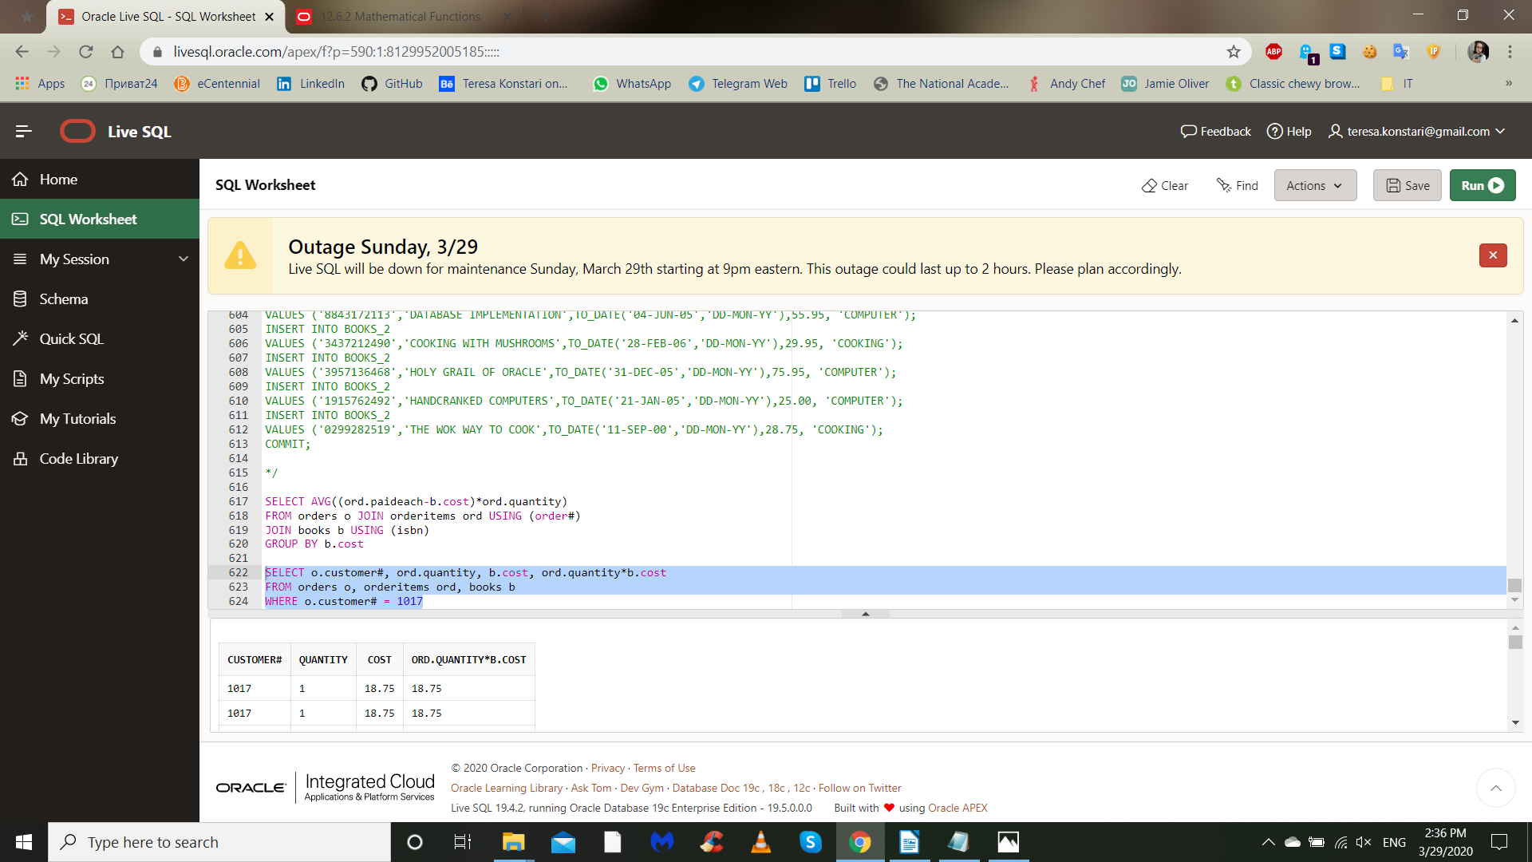

**Q3: List the retail price of the least expensive book in the Computer Category**

SELECT b.title, b.retail, b.category

FROM books b

WHERE category = 'COMPUTER'

ORDER BY b.retail

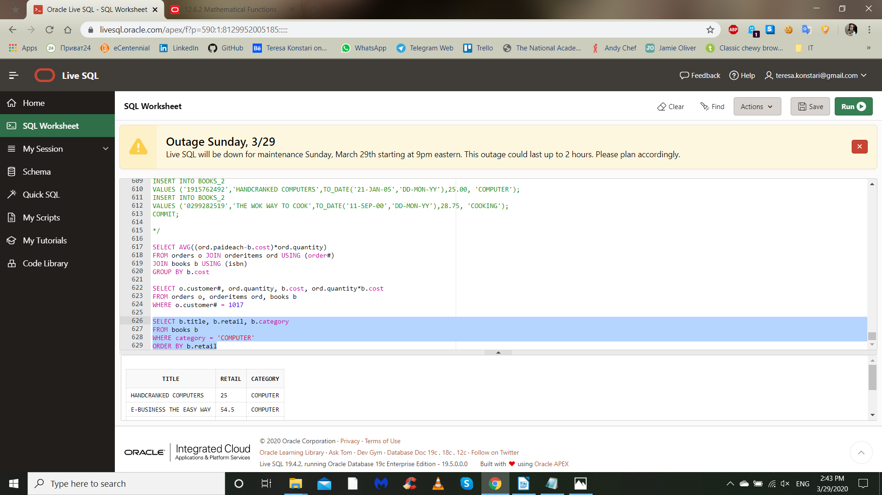

**Q4: Display the oldest (earliest) publication date of all books sold by JustLee Book company**

SELECT b.pubdate, b.title, ord.item#

FROM books b JOIN orderitems ord USING(isbn)

ORDER BY b.pubdate

