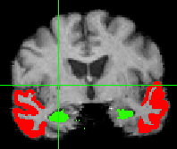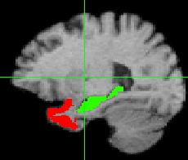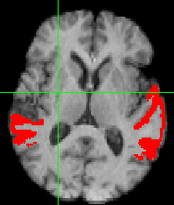



Mediation effects ✕ 10000

**β2 Mediations β3 Mediations**

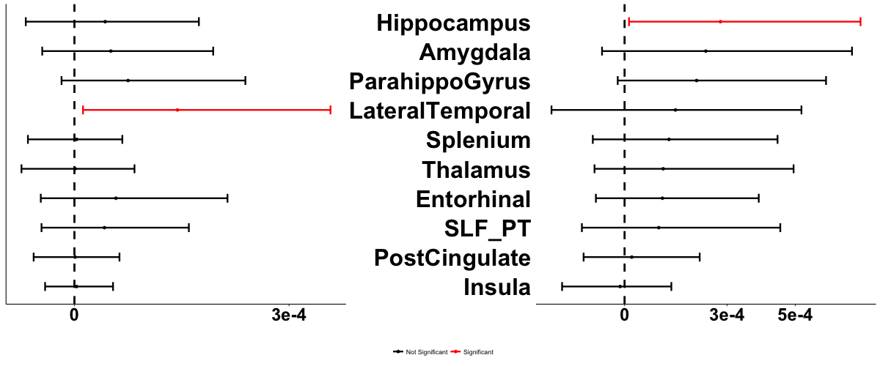

Figure 3. EMCI patterns of mediation of Aβ 🡪 ΔMEM. β2 indicates serial mediations including tau and regional atrophy. β3 indicates mediation pathway involving atrophy alone (see Fig. 1). Top row: single region LTR involved in significant β2 mediations is displayed in warm color representing effect size ✕ 10000; hippocampus involved in significant β3 mediation is similarly displayed in cool color. Bottom row: confidence interval plots around effect sizes for each ROI. Significant ROIs shown in red.