**LMCI: mediations of Aβ 🡪 ΔMEM**

**β2 Mediations β3 Mediations**

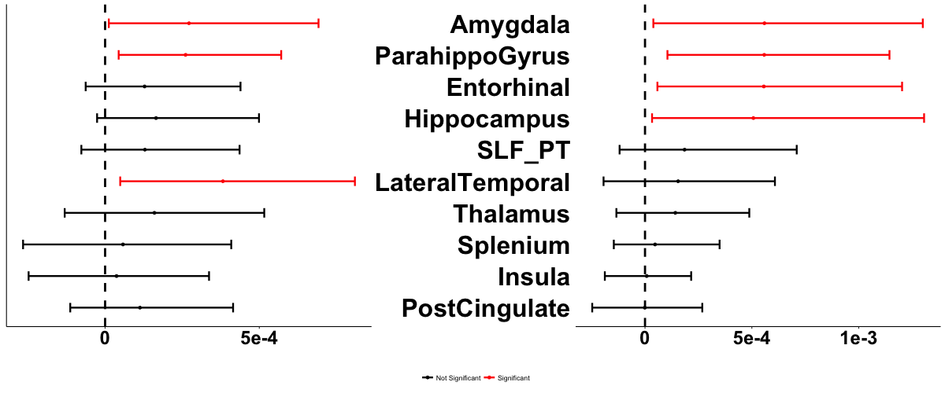

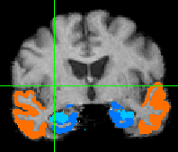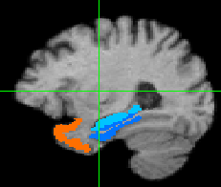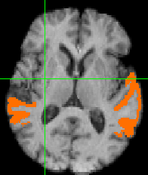

**LMCI: mediations of Aβ 🡪 ΔEF**

**β2 Mediations β3 Mediations**

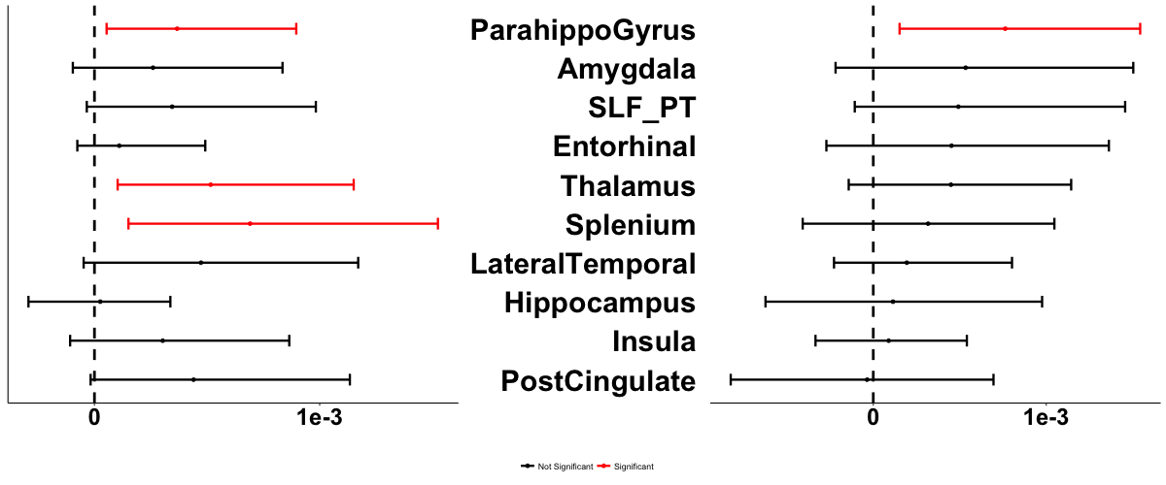

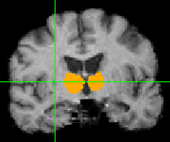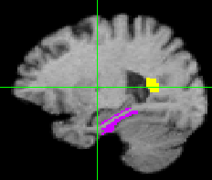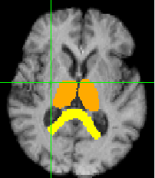



**β3 Effects ×10000 β2 Effects**

Figure 4. LMCI patterns of mediation. β2 indicates serial mediations including tau and regional atrophy. β3 indicates mediation pathway involving atrophy alone (see Fig. 1). Top box: Mediations of Aβ 🡪 ΔMEM. Bottom box: Aβ 🡪 ΔEF. Regions involved in significant β2 mediations are displayed in warm colors representing effect size ✕ 10000; regions involved in significant β3 mediations are similarly displayed in cool colors. Where and ROI is significant in both, the color represents the mediation with the larger effect. Color bars apply to all images. In plots of confidence intervals, red indicates significant mediations.