Cisco Packet Tracer - Network+ Labs
Teresa Jim

Lab 1: Build and Test a First LAN
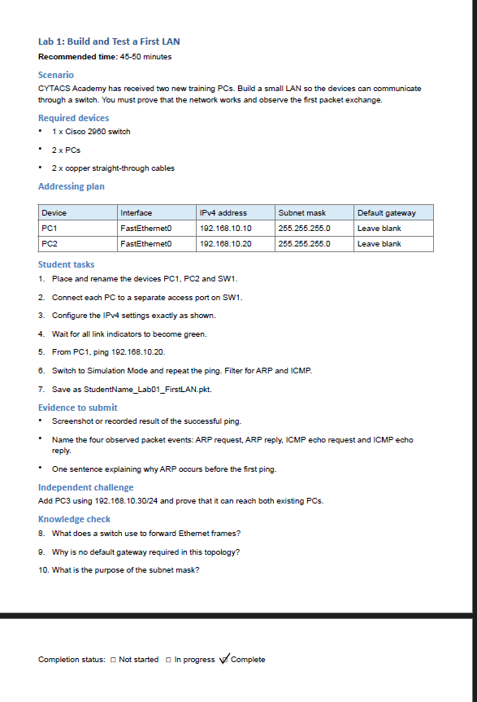
Evidence to Submit:
- Screenshot or recorded result of the successful ping
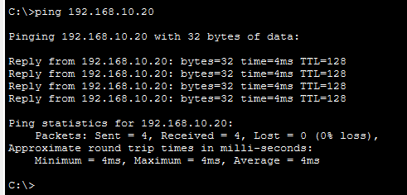

Name for the observed packet events: ARP request, ARP, reply, ICMP, echo request and ICMP echo reply.
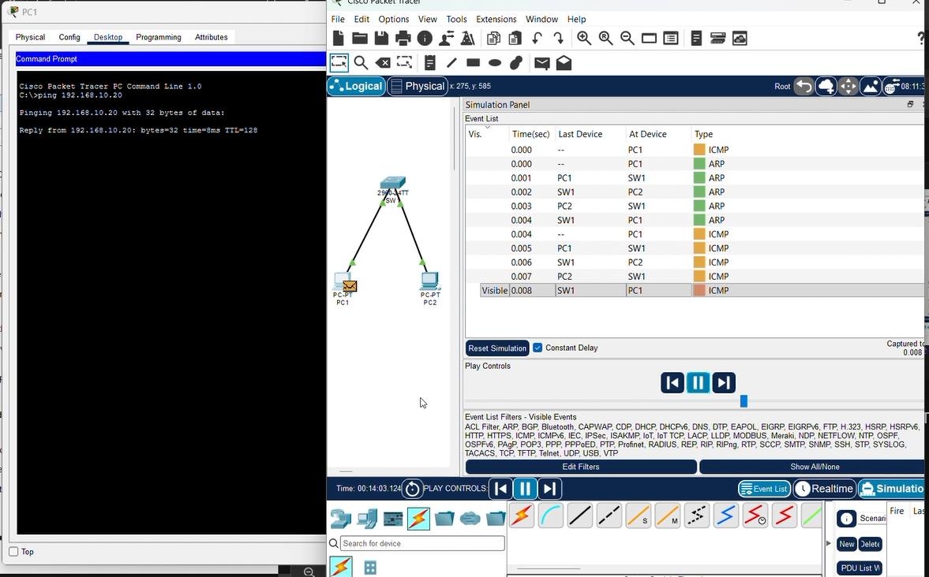
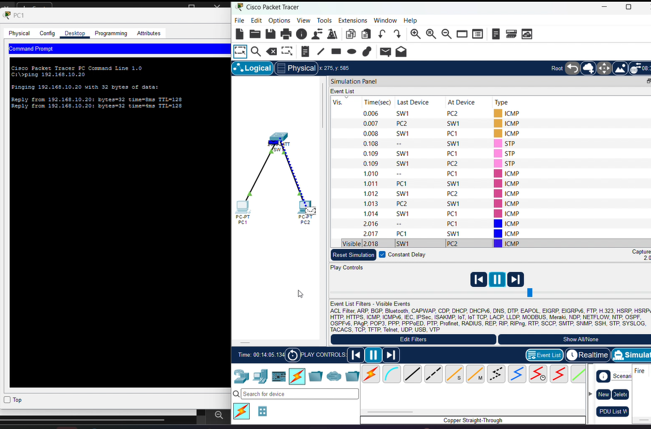
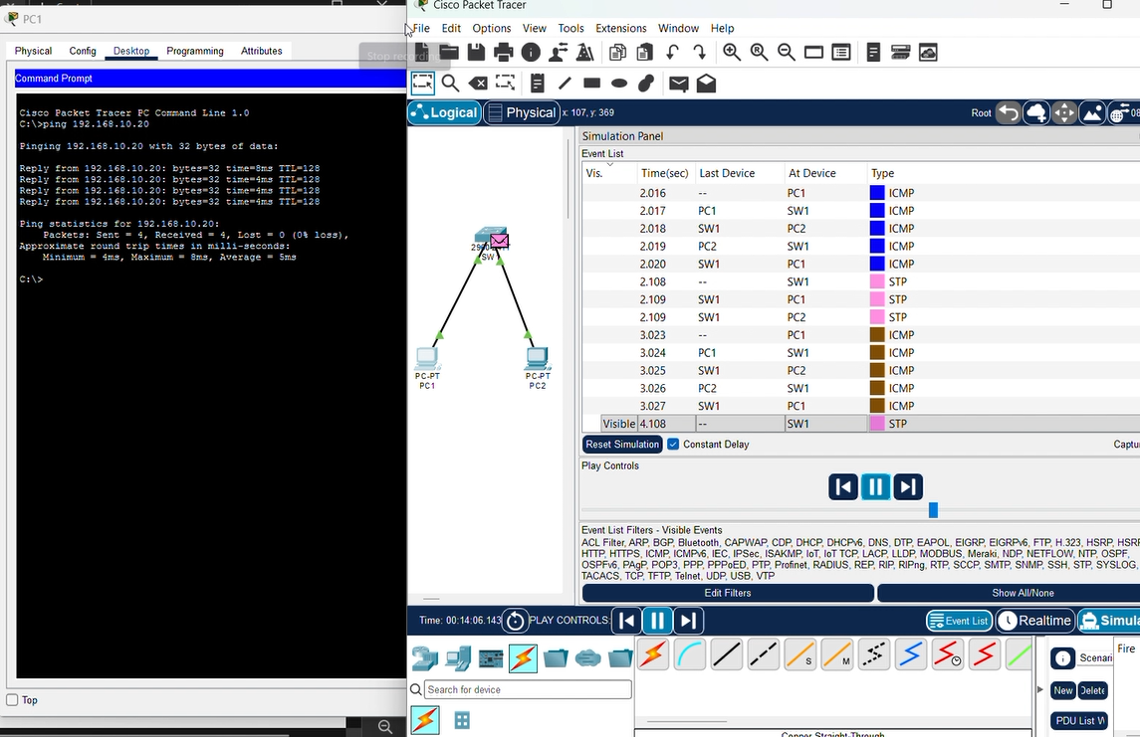

One sentence explaining why ARP occurs before the first ping.
The ARP protocol is the very first step occurring during the ping simply for knowing what each port address, IP and MAC addresses for all devices, for saving to a reference table for the switch for any future outreach with data requests.

Independent Challenge:
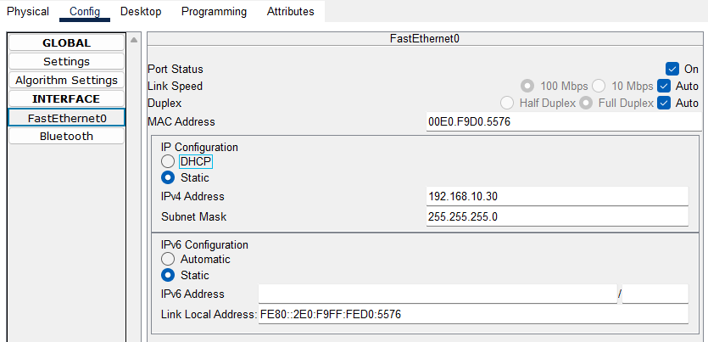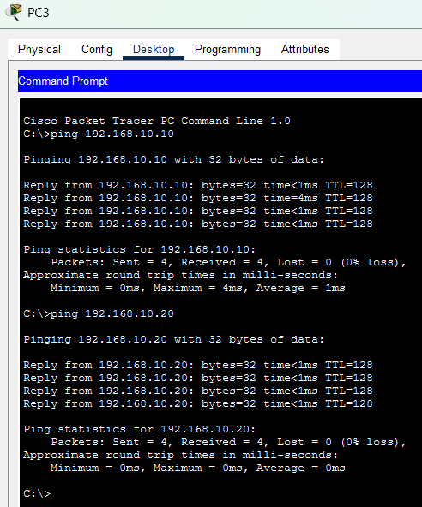

Knowledge Check:

8. What does a switch use to forward Ethernet frames?
A switch uses MAC addresses to forward Ethernet frames.

9. Why is no default gateway required in this topology?
The reason this topology doesn’t require a default gateway simply because we aren’t connecting to the Internet in this example when we are on the same local network.

10. What is the purpose of the subnet mask?
The subnet mask splits an IP address to identify the network and host, also to determine if a router needed.

