Resistance and adhesion annotations in bacterial reference genomes for orofacial filler research
Teresa de Lisieux Guedes Ferreira Lôbo
Universidade Federal de Alagoas, Maceió, Alagoas, Brazil
Correspondence: teresa.lobo@esenfar.ufal.br
Research Article

Abstract
Objectives To characterize resistance and adhesion-related annotations in reference genomes selected for orofacial filler research and test the reproducibility of corrected computational results.
Materials and methods Eighty-two complete RefSeq assemblies from 17 species were audited. A structured annotation screen replaced sequence-string matching. Five ABRicate database screens were re-executed on Galaxy and compared with corrected archived alignments using explicit 80% identity and 70% coverage filters. Archived AMRFinderPlus and Victors outputs were retained separately. Sensitivity analyses examined weighting, genome size and stricter quality criteria.
Results Sixty-six genomes met the stricter quality criterion. The corrected annotation screen identified 1,009 distinct candidate loci, including 543 with named-symbol evidence. Archived AMRFinderPlus identified 158 antibiotic resistance records in 41 genomes. All 410 new Galaxy outputs were audited. Filtered totals were CARD 214, ResFinder 105, VFDB 172, PlasmidFinder 40 and BacMet2 192. The five alignment multisets matched the corrected archived outputs exactly. Explicit filtering removed 97.4% of BacMet2 protein records. Integrated species rankings remained sensitive to analytical choices.
Conclusions Independent re-execution confirmed five corrected database summaries, while annotation and threshold corrections materially changed the original evidence. The dataset supports candidate prioritization for experimental validation.
Clinical relevance These reference-genome annotations do not establish filler-associated biofilm formation, antimicrobial susceptibility or clinical complication risk and should not guide treatment decisions.
Keywords: Bacterial adhesion; Antimicrobial resistance; Reference genomes; Dermal fillers; Reproducibility

Introduction
Delayed inflammatory reactions following hyaluronic acid filler injection have several proposed explanations, and biofilm-associated processes have been investigated in this setting. [1, 2] The presence of bacteria, inflammation and an implanted material does not by itself establish an active biofilm or identify the cause of a clinical lesion. Oral biofilms also depend on interactions among organisms and their local environment. [3] Biofilm-associated persistence therefore cannot be inferred from a list of resistance or adhesion annotations alone. [4]
Reference genomes can help identify molecular candidates for later experimental investigation. Their usefulness depends on transparent sampling and on the meaning of the screen being reported. A protein annotation, a nucleotide alignment and an antimicrobial phenotype are different observations. An integrated count across databases may also give repeated weight to overlapping biological information.
This study characterizes resistance and adhesion-related annotations in a convenience sample of 82 reference genomes representing 17 bacterial species selected for orofacial filler research. It combines an accession-level integrity audit, a corrected annotation screen, reconstruction of archived outputs and independent re-execution of five complementary database screens on Galaxy. The objectives were to determine which observations survive analytical correction, assess reproducibility across execution environments and describe sensitivity to genome quality and weighting. No association with filler complications or clinical risk threshold was tested.

Materials and methods
Study design and sampling. This was a descriptive secondary analysis of public bacterial genomes archived computational outputs and newly executed database screens. No patients, clinical isolates collected for this study, animals, filler materials or botulinum toxin preparations were investigated. The 17-species panel was inherited from the project and was not selected through a systematic review. Taxa and their genome counts are provided in Table 1.
The archived download script queried NCBI Datasets by taxon, restricted retrieval to RefSeq assemblies classified as complete genomes, and selected the first five accessions returned using a head operation. Four assemblies were retrieved for Actinomyces naeslundii and three for Tannerella forsythia. All 17 accession lists matched the first entries in the archived query summaries. This was a convenience selection, without randomization, phylogenetic balancing or a requirement for human or filler-associated origin. RefSeq and NCBI resources provide the source sequences and accession metadata. [5, 6] The accession lists, original query summaries and cryptographic hashes define the analysed snapshot; the original download date was not assumed from file-copy dates.
Genome and annotation audit. Nucleotide FASTA, protein FASTA and GFF files were present for all 82 accessions. Total sequence length, replicon count, N50, GC content, ambiguous bases and links between GFF protein identifiers and protein sequences were checked. Existing NCBI annotation versions were retained; annotations were not regenerated with a uniform current pipeline. PGAP provides the underlying RefSeq annotation framework. [7] Metadata-derived CheckM completeness and contamination estimates were recorded, rather than rerunning CheckM. [8] A post hoc sensitivity subset required matching sequence lengths, no non-pseudogene CDS lacking its referenced protein sequence, completeness at least 95% and contamination at most 5%. These criteria were not part of the original selection. Exact sequence duplicates were checked using a SHA-256 digest of sorted replicon sequences. This does not replace a strain-relatedness analysis.
Resistance and complementary database screens. The archived primary screen used AMRFinderPlus 4.2.7 with database 2026-05-15.1. [9] Records labelled AMR and STRESS were counted separately. Additional screens used ABRicate 1.4.0, as recorded in the archived environment manifest. [10] Databases included CARD,[11] ResFinder,[12] VFDB,[13] Victors,[14] BacMet2[15] and PlasmidFinder. [16] Table 2 distinguishes archived and re-executed counts; complete database metadata recovered from logs are provided in Online Resource 2. These timestamps are local database snapshots, not independently verified release identifiers. The original reference FASTA files were not recovered. To test computational reproducibility, the same 82 nucleotide assemblies were uploaded to a dedicated European Galaxy history and screened independently on 7 October 2026 using ABRicate 1.4.0+galaxy1 against CARD, ResFinder, VFDB, BacMet2 and PlasmidFinder [17]. Each database was applied to the complete 82-element FASTA collection, producing 410 outputs. The command parameters were 80% identity and 70% coverage, with headers retained and job reuse disabled. AMRFinderPlus and Victors were retained from the completed archived analyses; they were not re-executed in this Galaxy round. The exported Galaxy inventory confirmed the same sequence counts and 2026-Apr-3 snapshot timestamps for the five re-executed databases as recorded in archived logs. Matching database names, sequence counts and timestamps do not establish byte-identical reference FASTA files or vendor release identifiers.
All 574 individual outputs were read with their actual headers, including the #FILE header in ABRicate outputs, instead of relying on malformed legacy merged tables. The original ABRicate command declared a minimum identity of 80% and coverage of 70%. Version 1.4.0 uses different search paths for nucleotide and protein databases; the archived BacMet2 output included protein matches below the declared identity threshold. Consequently, every complementary output was explicitly filtered by its reported identity and coverage before counts were reconstructed. For BacMet2, identity refers to the translated protein alignment; for the other complementary databases it refers to nucleotide alignment. Records were retained as database-specific matches, without assuming they were independent genes or directly comparable across databases.
Cross-environment verification. Each exported Galaxy collection was checked for ZIP integrity, exactly 82 distinct accession-labelled members and an actual ABRicate header. Identity and coverage thresholds were applied explicitly to the output fields. Results were compared with archived corrected alignments using all shared biological fields, including assembly accession, sequence, coordinates, strand, reference gene, reference accession, identity and coverage. Execution-dependent input paths were excluded. Multiset comparison preserved repeated records and identified additions or losses. SHA-256 hashes were recorded for each exported file and collection. The audit therefore tests equality of alignment outputs within the available snapshots, rather than establishing complete reference-file provenance.
Corrected adhesion-related annotation screen. The inherited target panel contained 43 categories. The revised screen used non-pseudogene protein-coding annotations and searched gene names, synonyms and product descriptions separately. Named genes required exact tokens or bounded symbols. Broad product terms required bounded descriptive phrases; genus-specific categories were restricted to their intended genus. Protein sequence strings were excluded. Duplicate representations of a CDS were collapsed by contig and locus or protein identifier. A locus could still belong to more than one category; therefore distinct loci and category rows were reported separately. The complete panel and matched terms are supplied in Online Resource 2.
Candidates were classified as named-symbol evidence or product-description evidence. Broad functions such as enolase and sortase were retained for transparency and were not treated as specific biofilm determinants. A positive result means that the source annotation matched the panel. A negative result means no qualifying annotation was found; it does not establish gene absence. No homology-based search against a curated adhesion reference collection, domain validation or manual validation of every candidate was performed.
Descriptive integration and sensitivity. For each species and database, the mean number of records per genome was calculated. The seven-feature score was the arithmetic mean of sample-standardized means for AMRFinderPlus AMR, CARD, ResFinder, BacMet2, VFDB, Victors and PlasmidFinder; the standard deviation used 16 degrees of freedom across 17 species. A feature with zero variance contributed zero. Adhesion candidates were not included in this score. The score has no calibrated clinical interpretation.
Sensitivity analyses used equal weights for four domains (antibiotic resistance, virulence, biocide/metal resistance and plasmid-associated annotations), only AMRFinderPlus and VFDB, exclusion of BacMet2, removal of each database in turn, the stricter QC subset, and records per megabase. The strict-QC model recalculated standardization among represented species; a species with no retained genome was marked unavailable. Resampling 1,000 times within each species with replacement (seed 20261007) described rank stability within this sample and was not used as a population confidence interval. Repeated strain labels were also audited; incomplete labels do not establish independence.
Binary candidate-category profiles were centred and decomposed by singular value decomposition for an exploratory principal component analysis. Constant columns were excluded. Species-category edge lists describe annotation associations, not organism interactions. No hypothesis significance tests or clinical prediction analyses were conducted. Local reconstruction and revision scripts ran in Python 3.12.14 on Windows using pandas and NumPy; figures used Matplotlib 3.11.2. [18] The corrected screen did not require WSL. Source files, software versions and output hashes accompany the reproducibility package.

Results
Genome selection and quality. The dataset comprised 82 assemblies classified as complete genomes. All nucleotide sequence lengths matched NCBI metadata, and all non-pseudogene GFF CDS protein identifiers resolved to available protein sequences. One ambiguous nucleotide was present across the dataset. No exact duplicate genome sequence sets were detected. CheckM estimates ranged from 88.18% to 99.90% completeness and from 0.05% to 19.66% contamination. Sixty-six genomes representing 16 species met the stricter criterion. All five Prevotella intermedia assemblies were excluded from that subset, while only one assembly each remained for Staphylococcus epidermidis and Staphylococcus haemolyticus (Table 1; Online Resource 2).
Correction of the adhesion-related screen. Applying the legacy regular expressions to the same files produced 106,727 occurrences. Of these, 67,614 occurred in amino acid sequence strings, which were not valid annotation evidence. The revised field-based screen identified 1,062 category rows corresponding to 1,009 distinct loci. Named-symbol evidence accounted for 543 distinct loci; descriptive product evidence accounted for the remaining loci. Candidates were found in all 82 genomes across 30 of the 43 panel categories (Fig. 1; Online Resource 2). These broad totals include housekeeping-associated functions and cannot be interpreted as counts of validated biofilm genes.
Candidate profiles differed among the sampled taxa (Fig. 2). The binary matrix summarized annotation-category presence per genome, preserving its distinction from expression or activity. In the corrected matrix, the first two principal components accounted for 34.2% and 25.7% of variance (Online Resource 1; Online Resource 20). Separation in this plot describes annotation patterns that can track taxonomy and panel construction; it does not identify biofilm-forming capacity.
Resistance and complementary records. All 574 archived analysis logs recorded completion. AMRFinderPlus produced 168 records: 158 AMR records in 41 genomes and 10 STRESS records. Species-level counts are provided in Table 1 and Fig. 3. Reconstruction from individual files produced 214 CARD, 105 ResFinder, 172 VFDB, 1,939 Victors and 40 PlasmidFinder records. These complementary records were not added to the AMRFinderPlus count, because the databases can overlap.
The archived BacMet2 screen and the new Galaxy protein screen each contained 7,412 alignment records. Explicit filtering at at least 80% protein identity and 70% reported coverage retained 192 records and removed 7,220 (97.4%). The command identity parameter alone did not enforce the intended protein threshold. No nucleotide-database records were removed by the explicit thresholds (Fig. 3; Online Resource 2).
Independent Galaxy re-execution. All 410 newly executed outputs were exported and audited. The five collections each contained 82 distinct accessions. After threshold filtering, CARD retained 214 records, ResFinder 105, VFDB 172, PlasmidFinder 40 and BacMet2 192. Every shared biological alignment field and its multiplicity matched the corrected archived counterpart, with no added or removed records. Consequently, the fresh searches confirmed these five database summaries and left the reconstructed species scores and sensitivity results unchanged. AMRFinderPlus and Victors counts remain archived observations (Table 2; Online Resources 2 and 3).
Integrated scores and sensitivity. The largest corrected seven-database scores occurred for Staphylococcus haemolyticus (1.63), Enterococcus faecalis (1.13), Staphylococcus capitis (0.93), Staphylococcus epidermidis (0.63) and Streptococcus mitis (0.53). These values reflect within-sample standardization. Staphylococcus haemolyticus and Enterococcus faecalis exchanged the first two positions when the model used only AMRFinderPlus and VFDB. Staphylococcus capitis ranked second after genome-size normalization. Other rankings also shifted with domain weights and database removal (Fig. 4; Online Resource 2).
The strict-QC model retained only one genome for each of two high-scoring staphylococcal species, and no genome for Prevotella intermedia. Although the leading score pattern persisted among retained genomes, this analysis cannot establish robust species-level generalization. Complete rank distributions from within-species resampling, standardized burdens, database correlations and corrected association edges are supplied in Online Resource 2.

Discussion
Correcting two implementation problems changed the evidence that can be supported by this dataset. The original adhesion search counted short patterns in amino acid strings and repeated annotation representations. Searching structured gene and product fields with bounded matching and locus deduplication removed that source of false evidence. The remaining 1,009 loci are annotation candidates for validation; they are not experimentally confirmed determinants of biofilm growth on fillers.
The BacMet2 correction illustrates a separate problem. A command-line identity option did not guarantee that the archived protein matches met the intended threshold. Explicit examination of output fields reduced the count by 97.4%. The corrected total must therefore replace the original burden in text, tables and integration. Nucleotide and translated protein identities remain different measurements; a common numerical threshold does not make their biological interpretation equivalent.
The independent Galaxy searches reproduced all qualifying alignments from five corrected database outputs. This agreement supports the computational stability of the reported counts across local reconstruction and a separate execution environment. It does not resolve every reproducibility requirement: original database FASTA files were unavailable, complete upstream release identifiers were not verified, and the AMRFinderPlus and Victors screens were not repeated. The archived and new results are therefore identified separately in the deposited data. Agreement between screens should not be interpreted as independent biological validation because both use related reference databases and the same genome sequences.
The sampled staphylococci and enterococci merit focused follow-up because of their resistance and adhesion-related profiles. Literature on Staphylococcus epidermidis and Staphylococcus haemolyticus supports the relevance of examining these organisms in device-associated and opportunistic infection research. [19, 20] However, database records in reference genomes do not show that these strains colonize an orofacial filler, cause a delayed inflammatory lesion or respond to a specific treatment. Oral bacterial access to other anatomical sites is a biologically relevant research question, but this dataset did not measure such transmission. [21]
Integrated rankings should be used cautiously. AMRFinderPlus, CARD and ResFinder can describe overlapping resistance information; VFDB and Victors differ in reference composition; and biocide/metal and plasmid-associated matches have different meanings from antibiotic resistance. Equal weights per database can therefore overrepresent domains with more databases. The score also depends on the species included in its standardization and on genome size. The sensitivity results support reporting individual domains alongside any integrated summary rather than presenting a clinical risk ordering.
Selection limits are substantial. The first returned complete RefSeq assemblies were a small convenience sample, and the sampled genomes were not restricted to human or filler-associated origins. Annotation versions varied, some metadata were incomplete, and no sequence-based phylogenetic balancing was performed. Exact duplicate screening did not assess near-identical strains. A complete assembly label also did not ensure that a genome met stricter marker-based QC; the QC sensitivity analysis changed species representation sharply. CheckM estimates were taken from archived NCBI metadata and were not independently recalculated.
The remaining limitations include incomplete reference-file provenance, heterogeneous original genome annotations, and the absence of sequence-homology and domain validation for the adhesion candidates. No antimicrobial susceptibility, gene expression, filler-material colonization or biofilm assay was conducted. The five re-executed screens strengthen computational verification, but their agreement cannot turn genomic annotations into a clinical predictor. In particular, the data contain no evidence about the efficacy, safety or microbiological effects of botulinum toxin preparations.
A subsequent validation study should confirm candidate sequences and domain architecture, use independently characterized strains with balanced sampling and evaluate expression, antimicrobial susceptibility and biofilm growth on defined filler materials. Database FASTA files, checksums and upstream release metadata should be preserved prospectively. Experimental measurements are necessary before relating the annotation profiles to delayed inflammatory reactions or choosing a clinical prevention or treatment strategy.
In conclusion, this corrected analysis provides auditable resistance and adhesion-related annotation profiles for 82 bacterial genomes. It supports targeted hypothesis generation and exposes sensitivity to database thresholds, annotation matching, sample quality and weighting. It does not establish biofilm formation on fillers or predict clinical complications.

Data Availability
The original project snapshot is archived at https://doi.org/10.5281/zenodo.21339092 (version 1.0.4); it predates the corrections and must not be used as the identifier for the revised results. Corrected scripts, accession-level data and provenance are available at https://github.com/TeresaLobo/orofacial-filler-biofilm-risk. The submission package provides the five newly exported Galaxy collections, accession-level SHA-256 hashes, comparison audit, corrected candidate tables and sensitivity outputs as Online Resources 1–3. Primary genome assemblies remain traceable through their RefSeq accessions. Exact reference FASTA snapshots are unavailable. No new experimental or patient data were generated.

Declarations
Ethics approval and consent: This secondary analysis used public microbial reference genomes. No human participants, identifiable patient data, animals or newly collected biological samples were involved. Consent to participate and consent for publication are not applicable.
Funding: No specific funding was reported.
Competing interests: The author declares no competing interests.
Author contributions: Teresa de Lisieux Guedes Ferreira Lôbo: conceptualization, methodology, data curation, formal analysis, validation, visualization and writing. Final responsibility for the manuscript rests with the author.
Use of artificial intelligence: OpenAI Codex assisted with code auditing, computational reconstruction, table and figure preparation, reference checking and English drafting in October 2026. AI tools are not authors. The author is responsible for checking the analyses and the submitted content.

References
1. Artzi O, Cohen JL, Dover JS, Suwanchinda A, Pavicic T, Landau M, et al (2020) Delayed inflammatory reactions to hyaluronic acid fillers: a literature review and proposed treatment algorithm. Clin Cosmet Investig Dermatol. 13:371-378. https://doi.org/10.2147/CCID.S247171
2. Zhang YL, Sun ZS, Hong WJ, Chen Y, Zhou YF, Luo SK (2024) Biofilm formation is a risk factor for late and delayed complications of filler injection. Front Microbiol. 14:1297948. https://doi.org/10.3389/fmicb.2023.1297948
3. Kolenbrander PE, Palmer RJ Jr, Periasamy S, Jakubovics NS (2010) Oral multispecies biofilm development and the key role of cell-cell distance. Nat Rev Microbiol. 8(7):471-480. https://doi.org/10.1038/nrmicro2381
4. Donlan RM, Costerton JW (2002) Biofilms: survival mechanisms of clinically relevant microorganisms. Clin Microbiol Rev. 15(2):167-193. https://doi.org/10.1128/CMR.15.2.167-193.2002
5. O'Leary NA, Wright MW, Brister JR, Ciufo S, Haddad D, McVeigh R, et al (2016) Reference sequence (RefSeq) database at NCBI: current status, taxonomic expansion, and functional annotation. Nucleic Acids Res. 44(D1):D733-D745. https://doi.org/10.1093/nar/gkv1189
6. Sayers EW, Bolton EE, Brister JR, Canese K, Chan J, Comeau DC, et al (2024) Database resources of the National Center for Biotechnology Information. Nucleic Acids Res. 52(D1):D33-D43. https://doi.org/10.1093/nar/gkad1044
7. Tatusova T, DiCuccio M, Badretdin A, Chetvernin V, Nawrocki EP, Zaslavsky L, et al (2016) NCBI prokaryotic genome annotation pipeline. Nucleic Acids Res. 44(14):6614-24. https://doi.org/10.1093/nar/gkw569
8. Parks DH, Imelfort M, Skennerton CT, Hugenholtz P, Tyson GW (2015) CheckM: assessing the quality of microbial genomes recovered from isolates, single cells, and metagenomes. Genome Res. 25(7):1043-55. https://doi.org/10.1101/gr.186072.114
9. Feldgarden M, Brover V, Gonzalez-Escalona N, Frye JG, Haendiges J, Haft DH, et al (2021) AMRFinderPlus and the Reference Gene Catalog facilitate examination of the genomic links among antimicrobial resistance, stress response and virulence. Sci Rep. 11:12728. https://doi.org/10.1038/s41598-021-91456-0
10. Seemann T. ABRicate [Internet]. Version 1.4.0. GitHub; [cited 2026 Oct 7]. Available from: https://github.com/tseemann/abricate.
11. Alcock BP, Huynh W, Chalil R, Smith KW, Raphenya AR, Wlodarski MA, et al (2023) CARD 2023: expanded curation, support for machine learning, and resistome prediction at the Comprehensive Antibiotic Resistance Database. Nucleic Acids Res. 51(D1):D690-D699. https://doi.org/10.1093/nar/gkac920
12. Bortolaia V, Kaas RS, Ruppe E, Roberts MC, Schwarz S, Cattoir V, et al (2020) ResFinder 4.0 for predictions of phenotypes from genotypes. J Antimicrob Chemother. 75(12):3491-3500. https://doi.org/10.1093/jac/dkaa345
13. Chen L, Yang J, Yu J, Yao Z, Sun L, Shen Y, et al (2005) VFDB: a reference database for bacterial virulence factors. Nucleic Acids Res. 33(Database issue):D325-D328. https://doi.org/10.1093/nar/gki008
14. Sayers S, Li L, Ong E, Deng S, Fu G, Lin Y, et al (2019) Victors: a web-based knowledge base of virulence factors in human and animal pathogens. Nucleic Acids Res. 47(D1):D693-D700. https://doi.org/10.1093/nar/gky999
15. Pal C, Bengtsson-Palme J, Rensing C, Kristiansson E, Larsson DGJ (2014) BacMet: antibacterial biocide and metal resistance genes database. Nucleic Acids Res. 42(Database issue):D737-D743. https://doi.org/10.1093/nar/gkt1252
16. Carattoli A, Zankari E, Garcia-Fernandez A, Voldby Larsen M, Lund O, Villa L, et al (2014) In silico detection and typing of plasmids using PlasmidFinder and plasmid multilocus sequence typing. Antimicrob Agents Chemother. 58(7):3895-3903. https://doi.org/10.1128/AAC.02412-14
17. Galaxy Project (2026) European Galaxy server. https://usegalaxy.eu. Accessed 7 October 2026
18. Hunter JD (2007) Matplotlib: a 2D graphics environment. Comput Sci Eng. 9(3):90-95. https://doi.org/10.1109/MCSE.2007.55
19. Otto M (2009) Staphylococcus epidermidis--the 'accidental' pathogen. Nat Rev Microbiol. 7(8):555-567. https://doi.org/10.1038/nrmicro2182
20. Eltwisy HO, Twisy HO, Hafez M, Sayed IM, El-Mokhtar MA (2022) Clinical infections, antibiotic resistance, and pathogenesis of Staphylococcus haemolyticus. Microorganisms. 10(6):1130. https://doi.org/10.3390/microorganisms10061130
21. Parahitiyawa NB, Jin LJ, Leung WK, Yam WC, Samaranayake LP (2009) Microbiology of odontogenic bacteremia: beyond endocarditis. Clin Microbiol Rev. 22(1):46-64. https://doi.org/10.1128/CMR.00028-08

Table 1 Sample composition, strict quality criteria and archived AMRFinderPlus resistance records
Species | Genomes | Strict QC | AMR records
Actinomyces naeslundii | 4 | 4 | 0
Corynebacterium striatum | 5 | 5 | 19
Cutibacterium acnes | 5 | 5 | 0
Enterococcus faecalis | 5 | 5 | 13
Fusobacterium nucleatum | 5 | 3 | 2
Porphyromonas gingivalis | 5 | 5 | 2
Prevotella intermedia | 5 | 0 | 5
Staphylococcus capitis | 5 | 5 | 31
Staphylococcus epidermidis | 5 | 1 | 15
Staphylococcus haemolyticus | 5 | 1 | 39
Streptococcus anginosus | 5 | 4 | 13
Streptococcus mitis | 5 | 5 | 8
Streptococcus oralis | 5 | 5 | 7
Streptococcus sanguinis | 5 | 5 | 2
Tannerella forsythia | 3 | 3 | 1
Treponema denticola | 5 | 5 | 0
Veillonella parvula | 5 | 5 | 1
AMR counts exclude 10 STRESS records. Strict QC requires completeness ≥95%, contamination ≤5% and sequence/annotation integrity checks. CheckM values are archived metadata estimates.

Table 2 Database summaries and independent Galaxy re-execution
Database | Reference type | Archived filtered | New Galaxy
AMRFinderPlus | Protein/HMM | 158 | Not rerun
CARD | Nucleotide | 214 | 214
ResFinder | Nucleotide | 105 | 105
VFDB | Nucleotide | 172 | 172
Victors | Nucleotide | 1939 | Not rerun
BacMet2 | Protein | 192 | 192
PlasmidFinder | Nucleotide | 40 | 40
New Galaxy screens cover all 82 assemblies per database. ABRicate outputs were explicitly filtered at ≥80% identity and ≥70% coverage. Identity is protein identity for BacMet2 and nucleotide identity for the other five complementary databases. Results from different databases may overlap; counts must not be summed as distinct genes. The archived AMRFinderPlus total shown excludes STRESS records. The exported Galaxy inventory confirms 2026-Apr-3 snapshots and sequence counts of CARD 6,052, ResFinder 3,206, VFDB 4,592, BacMet2 746 and PlasmidFinder 488, matching archived logs. Exact reference FASTA checksums are unavailable.

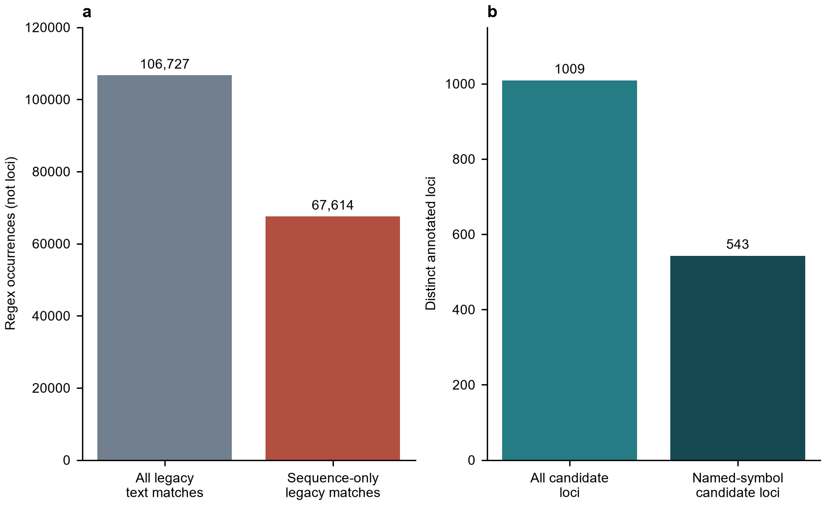
Fig. 1 Correction of the adhesion-related annotation screen. a Legacy occurrences include amino acid sequence-string matches. b Corrected counts represent distinct annotated loci; named-symbol candidates are a subset. Units differ between panels

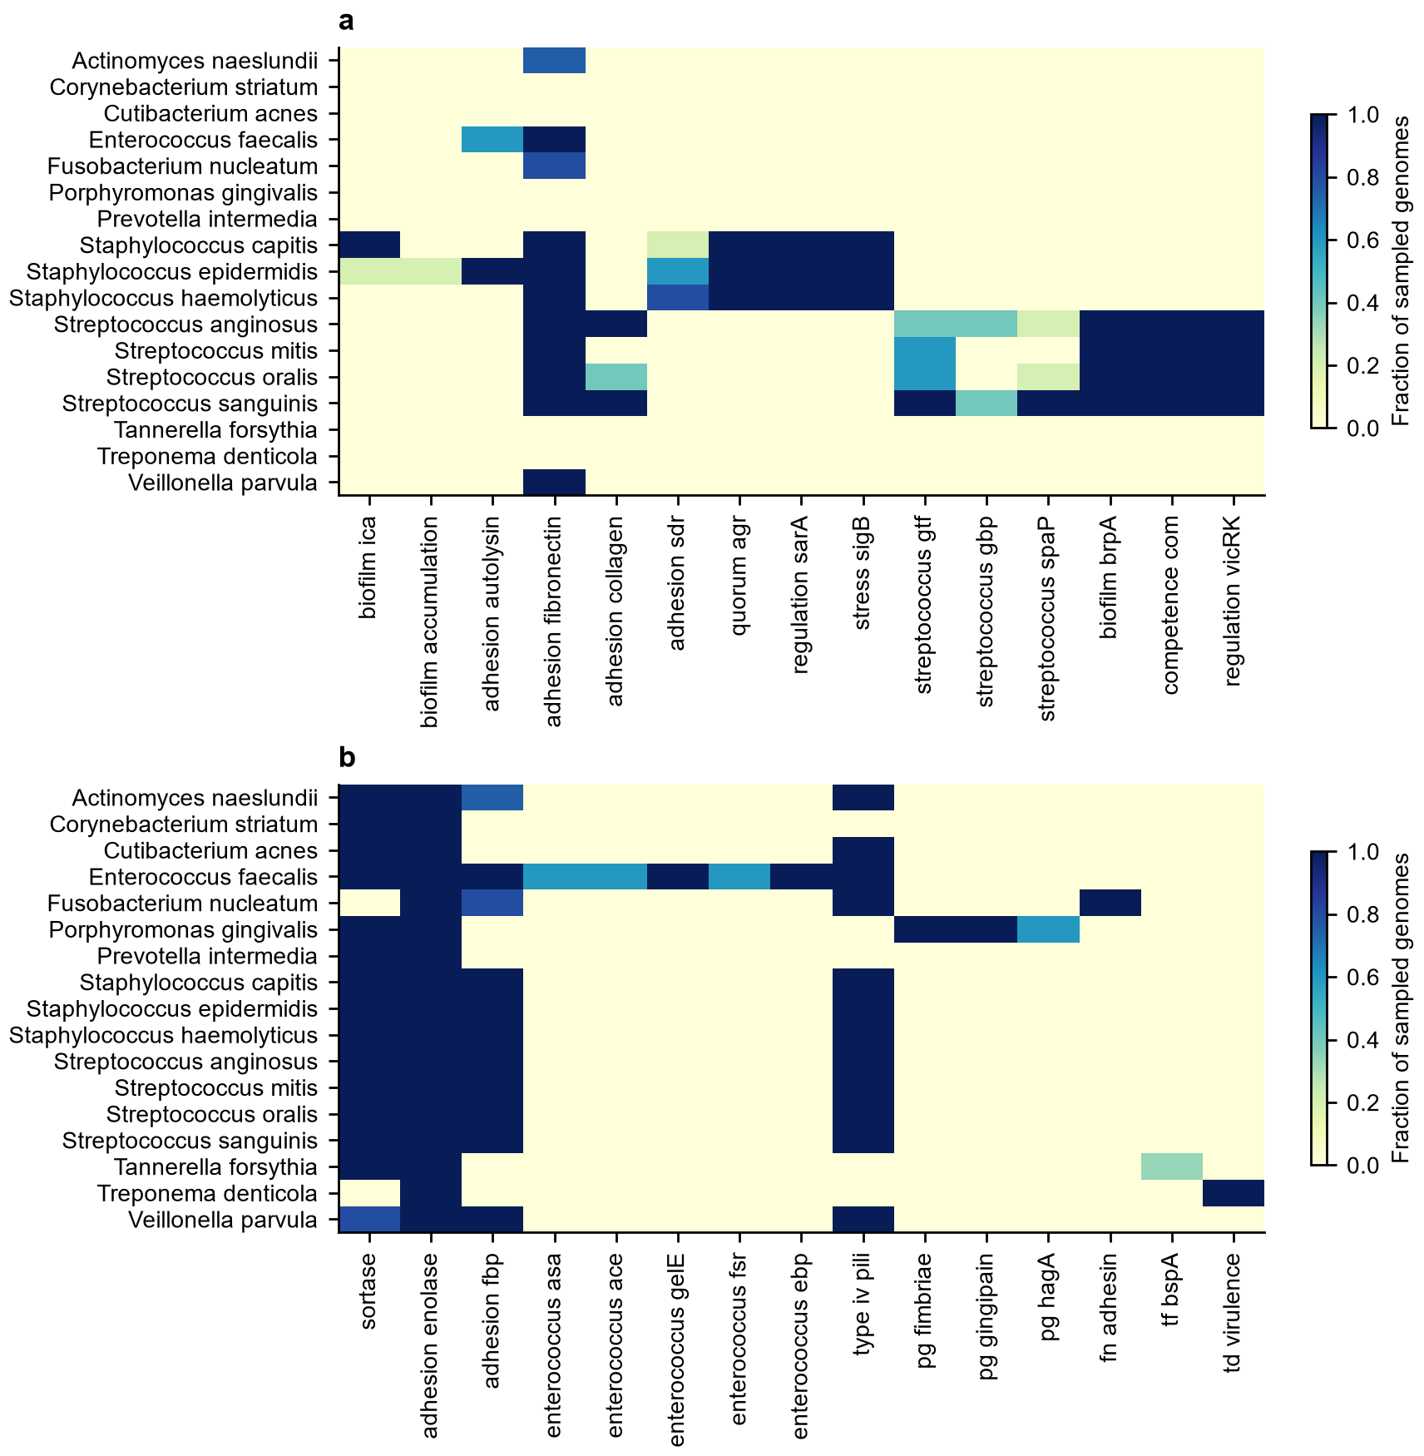
Fig. 2 Fraction of sampled genomes with a qualifying annotation in each positive category. a and b divide categories for readability. Zero means no annotation matched the screen and does not establish gene absence

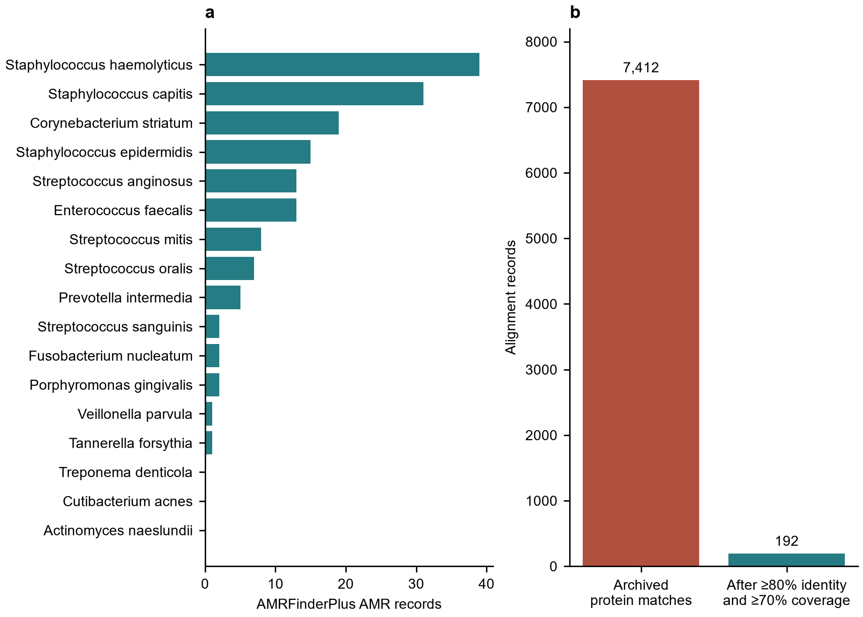
Fig. 3 Antibiotic resistance and BacMet2 alignments. a Archived AMRFinderPlus AMR records. b BacMet2 records before and after explicit protein identity and coverage filtering; new Galaxy and corrected archived alignments were identical

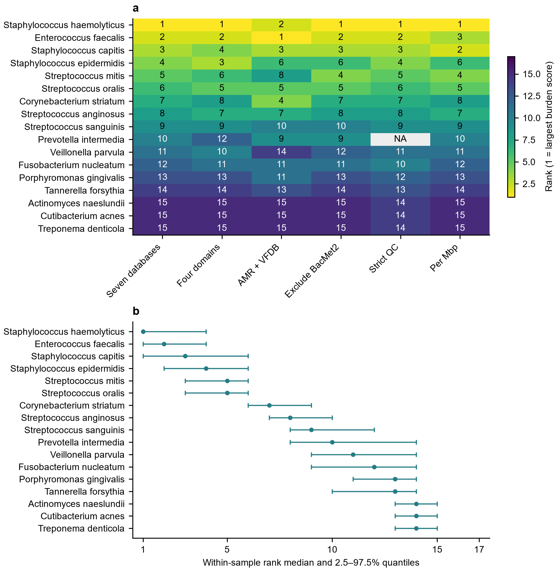
Fig. 4 Sensitivity of descriptive species rankings. a Six models use alternative weights, quality criteria and normalization. b Rank medians and 2.5–97.5% quantiles from 1,000 within-species resamples. NA indicates no retained strict-QC genome. These ranks do not measure clinical risk

Online Resource captions
Online Resource 1 Supplementary methods and exploratory annotation PCA
Online Resource 2 Accession-level metadata, candidate annotations, database records, sensitivity tables and checksummed audit outputs
Online Resource 3 Original Galaxy export collections, job identifiers and comparison with corrected archived results

