Supplementary methods and annotation profiles
Resistance and adhesion annotations in bacterial reference genomes for orofacial filler research
Clinical Oral Investigations
Teresa de Lisieux Guedes Ferreira Lôbo
Universidade Federal de Alagoas; teresa.lobo@esenfar.ufal.br

Computational evidence
The five newly executed ABRicate screens each cover 82 assemblies. Per-file hashes, multiset comparisons and original exports are supplied with Online Resources 2 and 3. AMRFinderPlus and Victors remain archived outputs. The new alignment totals match the corrected archive exactly.

Annotation evidence
The 43-category panel uses structured gene, synonym and product fields, bounded matches, intended-genus restrictions and deduplication. Broad cellular functions remain in the panel. A locus may belong to more than one category; category rows and unique loci have different meanings.

Quality and sensitivity
Strict quality criteria are post hoc. CheckM estimates were read from archived metadata. Resampling uses 1,000 within-species bootstrap draws with seed 20261007 and describes stability within this convenience sample, rather than population confidence. Candidate-category PCA uses centred nonconstant binary columns and singular value decomposition.

Data files
Online Resource 2 contains Tables S1–S11 as CSV/TSV, candidate-screen and reconstruction code, accession selection and input hash manifests. Online Resource 3 contains the five complete Galaxy export ZIPs, job identifiers, raw and filtered counts, per-accession hashes and the alignment comparison audit. All primary genome sequence files are included in the complete repository-data archive accompanying the pack.
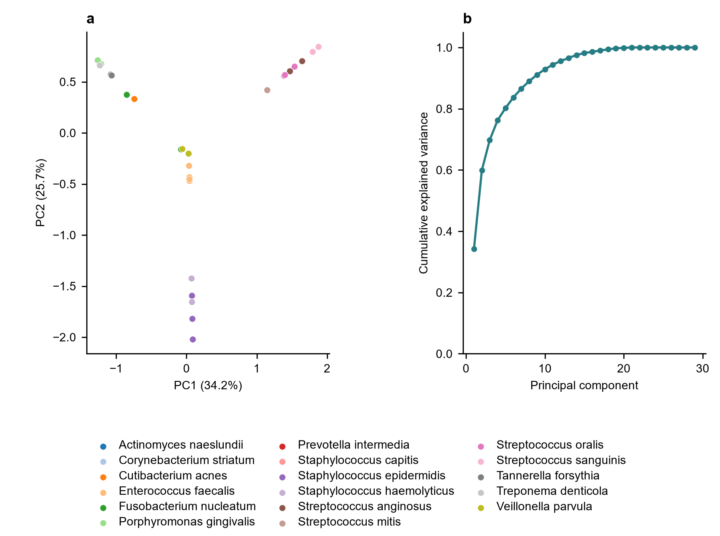
Fig. S1 Exploratory PCA of corrected annotation categories. a Assembly coordinates. b Cumulative explained variance. PC1 and PC2 explain 34.2% and 25.7%. Patterns may track taxonomy and panel construction and do not establish filler biofilm phenotypes

