Article type: Original Research

Resistance and adhesion annotations in 82 bacterial genomes relevant to orofacial filler research

ABSTRACT
Aim: To describe resistance and adhesion-related annotations in a convenience sample of bacterial genomes selected for orofacial filler research, and assess the influence of analytical corrections. Methods: Eighty-two complete RefSeq assemblies representing 17 species were audited. Archived AMRFinderPlus and ABRicate outputs were reconstructed per genome; antibiotic resistance and stress records were separated, and ABRicate records were filtered at 80% identity and 70% coverage. Adhesion-related candidates were identified from structured annotation fields using bounded terms, genus restrictions and locus deduplication. Descriptive species scores were examined under alternative weighting, genome-size normalization and quality-control criteria. Results: All assemblies matched their recorded sequence lengths, and 66 met the stricter post hoc quality criterion. The legacy adhesion screen yielded 106,727 regex occurrences, including 67,614 in amino acid sequences. The corrected screen identified 1,009 distinct candidate loci, of which 543 had named-symbol evidence. AMRFinderPlus identified 158 antibiotic resistance records in 41 genomes and 10 stress records. BacMet2 records decreased from 7,412 to 192 after explicit threshold filtering. Staphylococcus haemolyticus, Enterococcus faecalis and Staphylococcus capitis had the largest corrected seven-database scores, but rankings depended on the model. Conclusions: Analytical correction substantially changed annotation burdens. The resulting dataset supports hypothesis generation and targeted validation, but does not establish biofilm formation on fillers, antimicrobial phenotypes or clinical complication risk.
Keywords: Biofilms. Drug Resistance, Bacterial. Bacterial Adhesion. Dermal Fillers.

INTRODUCTION
Delayed inflammatory reactions following hyaluronic acid filler injection have several proposed explanations, and biofilm-associated processes have been investigated in this setting.^{1,2} The presence of bacteria, inflammation and an implanted material does not by itself establish an active biofilm or identify the cause of a clinical lesion. Oral biofilms also depend on interactions among organisms and their local environment.³ Biofilm-associated persistence therefore cannot be inferred from a list of resistance or adhesion annotations alone.⁴
Reference genomes can help identify molecular candidates for later experimental investigation. Their usefulness depends on transparent sampling and on the meaning of the screen being reported. A protein annotation, a nucleotide alignment and an antimicrobial phenotype are different observations. An integrated count across databases may also give repeated weight to overlapping biological information.
This study describes an archived convenience sample of 82 bacterial genomes from 17 species selected for research at the interface of oral and cutaneous microbiology and orofacial fillers. It audits genome selection and quality, corrects annotation screening and reconstructs database-derived burdens. The exploratory hypothesis was that annotation profiles would differ among sampled species and that integrated rankings would be sensitive to analytical choices. No clinical risk threshold or association with filler complications was tested.

MATERIAL AND METHODS
Study design and sampling. This was a descriptive secondary analysis of public bacterial genomes and archived computational outputs. No patients, clinical isolates collected for this study, animals, filler materials or botulinum toxin preparations were investigated. The 17-species panel was inherited from the project and was not selected through a systematic review. Taxa and their genome counts are provided in Table 1.
The archived download script queried NCBI Datasets by taxon, restricted retrieval to RefSeq assemblies classified as complete genomes, and selected the first five accessions returned using a head operation. Four assemblies were retrieved for Actinomyces naeslundii and three for Tannerella forsythia. All 17 accession lists matched the first entries in the archived query summaries. This was a convenience selection, without randomization, phylogenetic balancing or a requirement for human or filler-associated origin. RefSeq and NCBI resources provide the source sequences and accession metadata.^{5,6} The accession lists, original query summaries and cryptographic hashes define the analysed snapshot; the original download date was not assumed from file-copy dates.
Genome and annotation audit. Nucleotide FASTA, protein FASTA and GFF files were present for all 82 accessions. Total sequence length, replicon count, N50, GC content, ambiguous bases and links between GFF protein identifiers and protein sequences were checked. Existing NCBI annotation versions were retained; annotations were not regenerated with a uniform current pipeline. PGAP provides the underlying RefSeq annotation framework.⁷ Metadata-derived CheckM completeness and contamination estimates were recorded, rather than rerunning CheckM.⁸ A post hoc sensitivity subset required matching sequence lengths, no non-pseudogene CDS lacking its referenced protein sequence, completeness at least 95% and contamination at most 5%. These criteria were not part of the original selection. Exact sequence duplicates were checked using a SHA-256 digest of sorted replicon sequences. This does not replace a strain-relatedness analysis.
Resistance and complementary database screens. The archived primary screen used AMRFinderPlus 4.2.7 with database 2026-05-15.1.⁹ Records labelled AMR and STRESS were counted separately. Additional screens used ABRicate 1.4.0, as recorded in the archived environment manifest.¹⁰ Databases included CARD,¹¹ ResFinder,¹² VFDB,¹³ Victors,¹⁴ BacMet2¹⁵ and PlasmidFinder.¹⁶ Table 2 reports database type, sequence count and timestamp recovered from execution logs. These timestamps are local database snapshots, not independently verified release identifiers. Original database FASTA files were not recovered, limiting exact reconstruction of the alignments.
All 574 individual outputs were read with their actual headers, including the #FILE header in ABRicate outputs, instead of relying on malformed legacy merged tables. The original ABRicate command declared a minimum identity of 80% and coverage of 70%. Version 1.4.0 uses different search paths for nucleotide and protein databases; the archived BacMet2 output included protein matches below the declared identity threshold. Consequently, every complementary output was explicitly filtered by its reported identity and coverage before counts were reconstructed. For BacMet2, identity refers to the translated protein alignment; for the other complementary databases it refers to nucleotide alignment. Records were retained as database-specific matches, without assuming they were independent genes or directly comparable across databases.
Corrected adhesion-related annotation screen. The inherited target panel contained 43 categories. The revised screen used non-pseudogene protein-coding annotations and searched gene names, synonyms and product descriptions separately. Named genes required exact tokens or bounded symbols. Broad product terms required bounded descriptive phrases; genus-specific categories were restricted to their intended genus. Protein sequence strings were excluded. Duplicate representations of a CDS were collapsed by contig and locus or protein identifier. A locus could still belong to more than one category; therefore distinct loci and category rows were reported separately. The complete panel and matched terms are supplied in Tables S2 and S3.
Candidates were classified as named-symbol evidence or product-description evidence. Broad functions such as enolase and sortase were retained for transparency and were not treated as specific biofilm determinants. A positive result means that the source annotation matched the panel. A negative result means no qualifying annotation was found; it does not establish gene absence. No homology-based search against a curated adhesion reference collection, domain validation or manual validation of every candidate was performed.
Descriptive integration and sensitivity. For each species and database, the mean number of records per genome was calculated. The seven-feature score was the arithmetic mean of sample-standardized means for AMRFinderPlus AMR, CARD, ResFinder, BacMet2, VFDB, Victors and PlasmidFinder; the standard deviation used 16 degrees of freedom across 17 species. A feature with zero variance contributed zero. Adhesion candidates were not included in this score. The score has no calibrated clinical interpretation.
Sensitivity analyses used equal weights for four domains (antibiotic resistance, virulence, biocide/metal resistance and plasmid-associated annotations), only AMRFinderPlus and VFDB, exclusion of BacMet2, removal of each database in turn, the stricter QC subset, and records per megabase. The strict-QC model recalculated standardization among represented species; a species with no retained genome was marked unavailable. Resampling 1,000 times within each species with replacement (seed 20261007) described rank stability within this sample and was not used as a population confidence interval. Repeated strain labels were also audited; incomplete labels do not establish independence.
Binary candidate-category profiles were centred and decomposed by singular value decomposition for an exploratory principal component analysis. Constant columns were excluded. Species-category edge lists describe annotation associations, not organism interactions. No hypothesis significance tests or clinical prediction analyses were conducted. Revision scripts ran in Python 3.12.14 on Windows using pandas and NumPy; figures used Matplotlib 3.11.2.¹⁷ The corrected screen did not require WSL. Source files, software versions and output hashes accompany the reproducibility package.

RESULTS
Genome selection and quality. The dataset comprised 82 assemblies classified as complete genomes. All nucleotide sequence lengths matched NCBI metadata, and all non-pseudogene GFF CDS protein identifiers resolved to available protein sequences. One ambiguous nucleotide was present across the dataset. No exact duplicate genome sequence sets were detected. CheckM estimates ranged from 88.18% to 99.90% completeness and from 0.05% to 19.66% contamination. Sixty-six genomes representing 16 species met the stricter criterion. All five Prevotella intermedia assemblies were excluded from that subset, while only one assembly each remained for Staphylococcus epidermidis and Staphylococcus haemolyticus (Table 1; Table S1).
Correction of the adhesion-related screen. Applying the legacy regular expressions to the same files produced 106,727 occurrences. Of these, 67,614 occurred in amino acid sequence strings, which were not valid annotation evidence. The revised field-based screen identified 1,062 category rows corresponding to 1,009 distinct loci. Named-symbol evidence accounted for 543 distinct loci; descriptive product evidence accounted for the remaining loci. Candidates were found in all 82 genomes across 30 of the 43 panel categories (Figure 1; Tables S2-S4). These broad totals include housekeeping-associated functions and cannot be interpreted as counts of validated biofilm genes.
Candidate profiles differed among the sampled taxa (Figure 2). The binary matrix summarized annotation-category presence per genome, preserving its distinction from expression or activity. In the corrected matrix, the first two principal components accounted for 34.2% and 25.7% of variance (Figure S1; Table S10). Separation in this plot describes annotation patterns that can track taxonomy and panel construction; it does not identify biofilm-forming capacity.
Resistance and complementary records. All 574 archived analysis logs recorded completion. AMRFinderPlus produced 168 records: 158 AMR records in 41 genomes and 10 STRESS records. Species-level counts are provided in Table 1 and Figure 3. Reconstruction from individual files produced 214 CARD, 105 ResFinder, 172 VFDB, 1,939 Victors and 40 PlasmidFinder records. These complementary records were not added to the AMRFinderPlus count, because the databases can overlap.
The archived BacMet2 protein screen contained 7,412 records. Only 192 passed explicit filtering at at least 80% identity and 70% coverage, removing 7,220 records (97.4%). No complementary nucleotide-database records were removed by these thresholds. The filtered results establish the number of qualifying archived alignments, rather than a new search against a recovered reference database (Figure 3; Table S6).
Integrated scores and sensitivity. The largest corrected seven-database scores occurred for Staphylococcus haemolyticus (1.63), Enterococcus faecalis (1.13), Staphylococcus capitis (0.93), Staphylococcus epidermidis (0.63) and Streptococcus mitis (0.53). These values reflect within-sample standardization. Staphylococcus haemolyticus and Enterococcus faecalis exchanged the first two positions when the model used only AMRFinderPlus and VFDB. Staphylococcus capitis ranked second after genome-size normalization. Other rankings also shifted with domain weights and database removal (Figure 4; Table S9).
The strict-QC model retained only one genome for each of two high-scoring staphylococcal species, and no genome for Prevotella intermedia. Although the leading score pattern persisted among retained genomes, this analysis cannot establish robust species-level generalization. Complete rank distributions from within-species resampling, standardized burdens, database correlations and corrected association edges are supplied in Tables S9-S11.
Table 1. Sample size, post hoc strict QC and AMRFinderPlus AMR records by species.
Species | n | QC n | AMR
Actinomyces naeslundii | 4 | 4 | 0
Corynebacterium striatum | 5 | 5 | 19
Cutibacterium acnes | 5 | 5 | 0
Enterococcus faecalis | 5 | 5 | 13
Fusobacterium nucleatum | 5 | 3 | 2
Porphyromonas gingivalis | 5 | 5 | 2
Prevotella intermedia | 5 | 0 | 5
Staphylococcus capitis | 5 | 5 | 31
Staphylococcus epidermidis | 5 | 1 | 15
Staphylococcus haemolyticus | 5 | 1 | 39
Streptococcus anginosus | 5 | 4 | 13
Streptococcus mitis | 5 | 5 | 8
Streptococcus oralis | 5 | 5 | 7
Streptococcus sanguinis | 5 | 5 | 2
Tannerella forsythia | 3 | 3 | 1
Treponema denticola | 5 | 5 | 0
Veillonella parvula | 5 | 5 | 1
n: sampled genomes; QC n: genomes meeting strict QC; AMR: AMRFinderPlus antibiotic resistance records. Counts exclude the 10 STRESS records; full per-genome outputs are provided in Table S6.
Table 2. Reference database snapshots documented in archived logs.
Database | Type | Sequences | Snapshot
AMRFinderPlus | Protein/HMM | Not recorded | 2026-05-15.1
CARD | Nucleotide | 6,052 | 2026-Apr-3
ResFinder | Nucleotide | 3,206 | 2026-Apr-3
VFDB | Nucleotide | 4,592 | 2026-Apr-3
Victors | Nucleotide | 4,545 | 2026-Apr-3
BacMet2 | Protein | 746 | 2026-Apr-3
PlasmidFinder | Nucleotide | 488 | 2026-Apr-3
ABRicate database timestamps identify local snapshots. Original reference FASTA files were not recovered; release-level provenance remains incomplete.
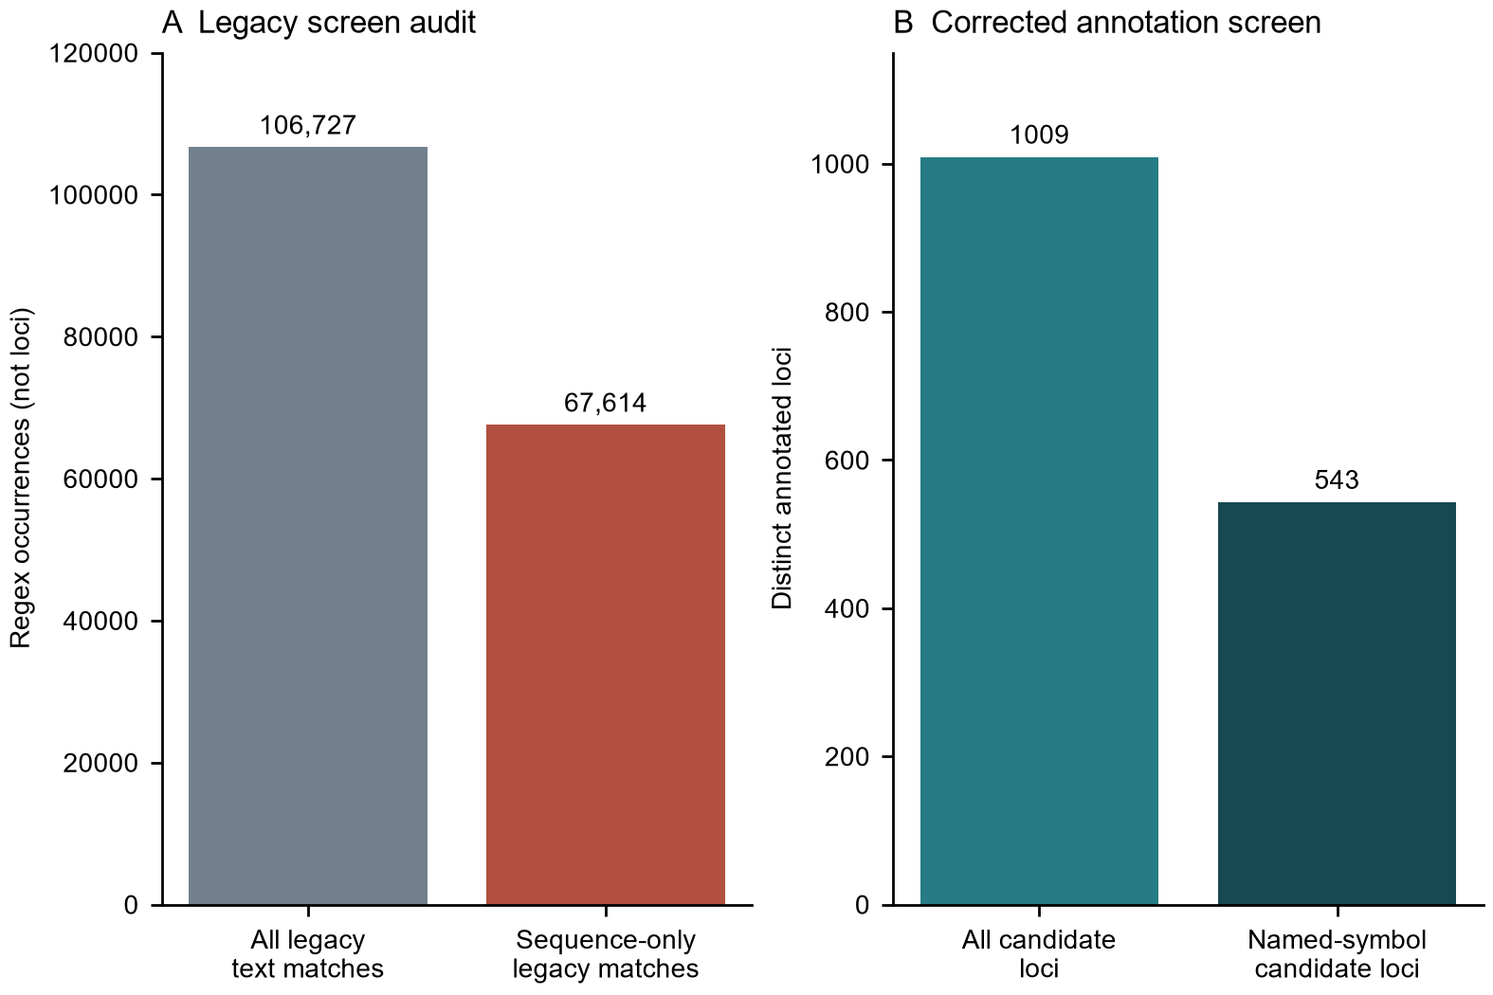
Figure 1. Legacy regex occurrences and corrected candidate loci use different units. Panel A includes matches within protein sequence strings. Panel B counts distinct annotated loci; named-symbol candidates are a subset of all candidates.
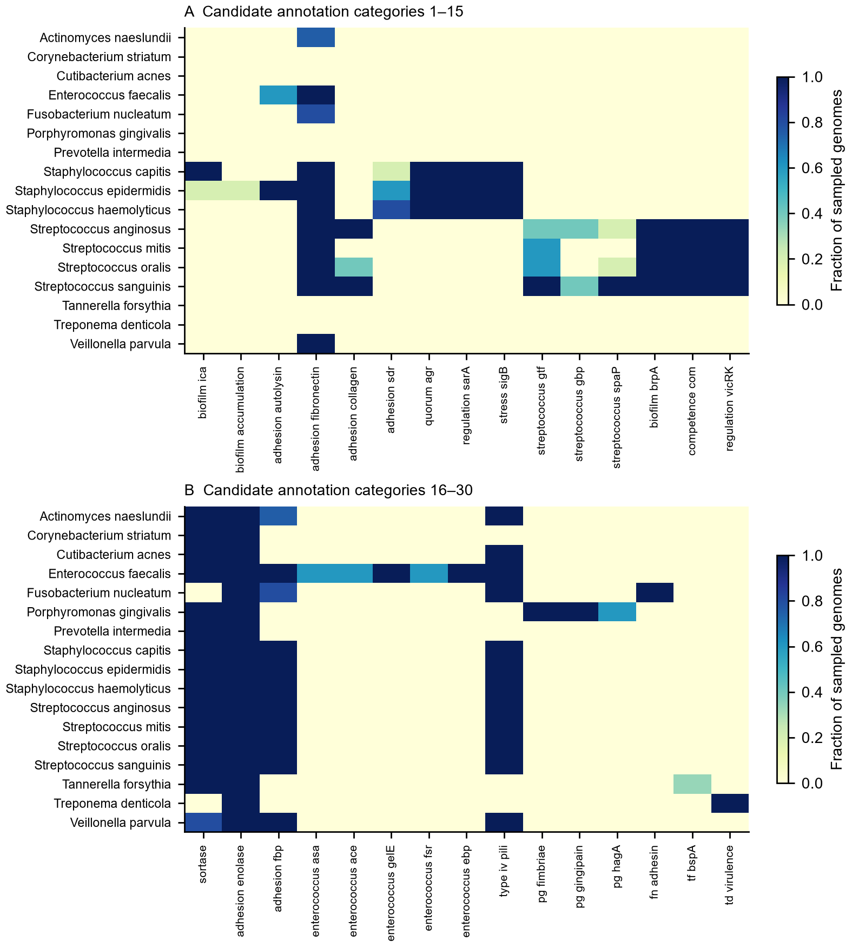
Figure 2. Fraction of sampled genomes with at least one qualifying annotation in each positive category. Panels A and B divide the positive categories for readability. Broad functional categories are included. Zero denotes no matching annotation, not confirmed gene absence.
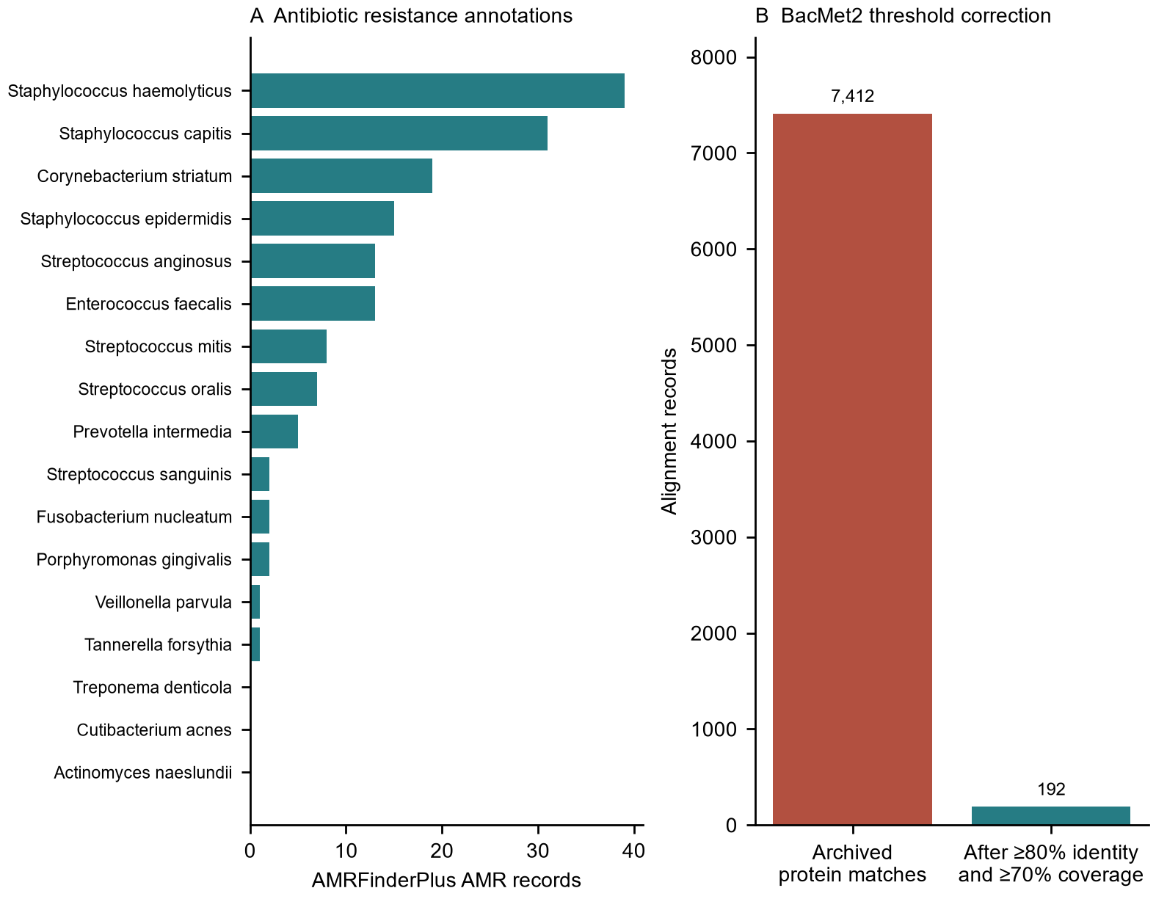
Figure 3. AMRFinderPlus AMR records by species (A) and archived versus explicitly filtered BacMet2 records (B). BacMet2 counts apply at least 80% protein alignment identity and 70% reported coverage.
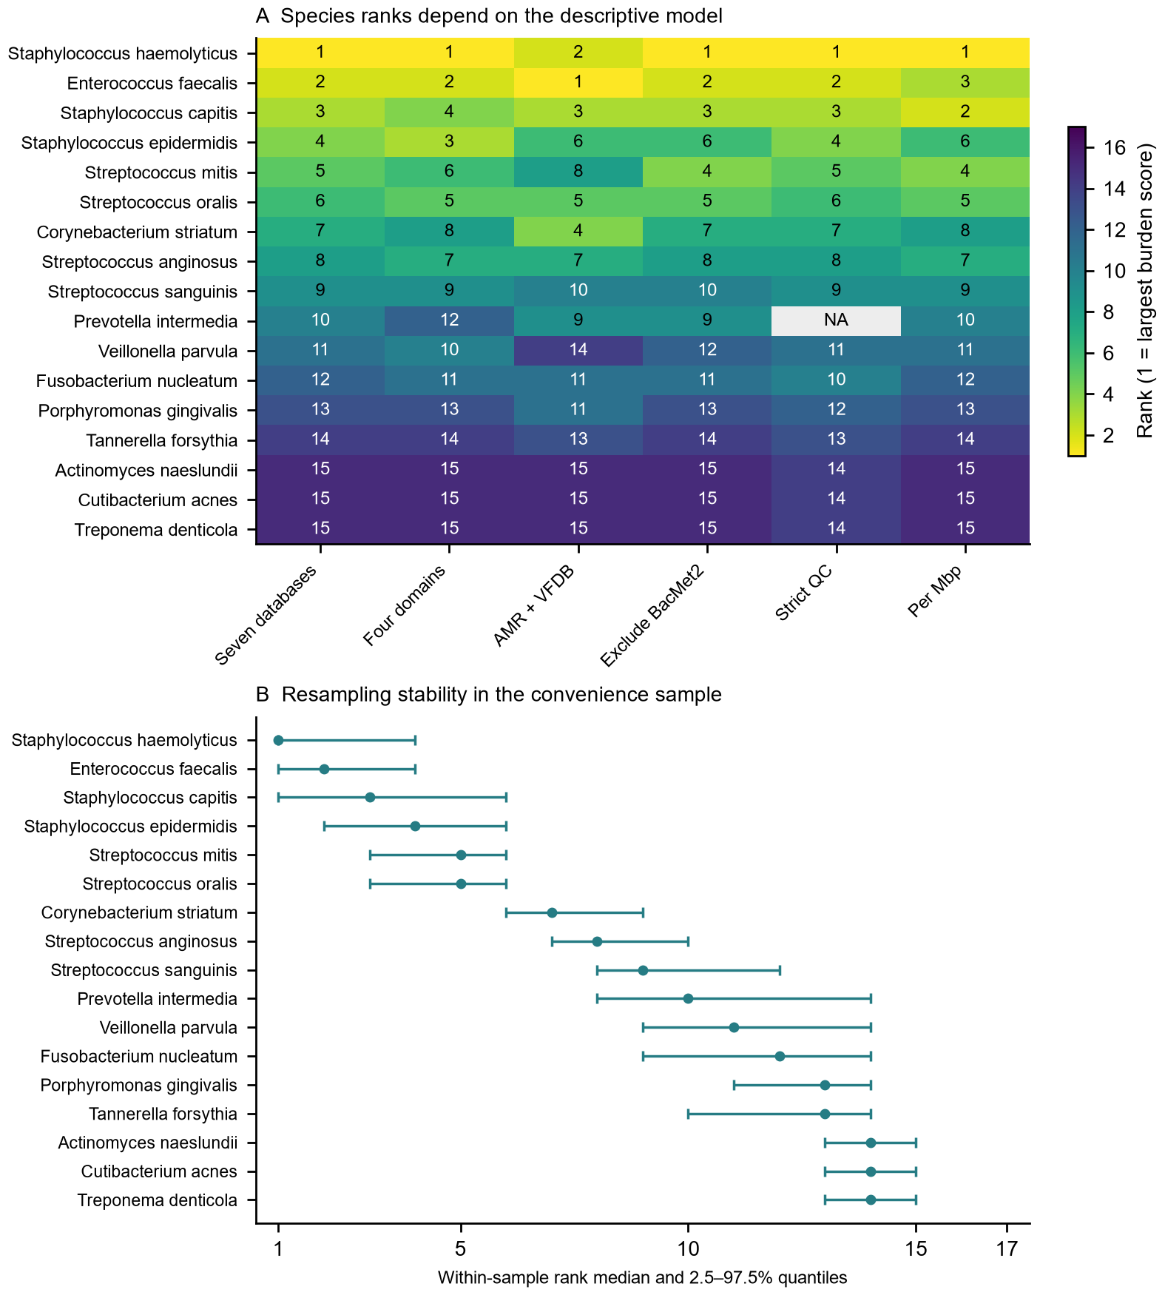
Figure 4. Species ranks under six descriptive models (A) and rank stability under 1,000 within-species resamples (B). Ties use minimum ranks. NA denotes no genome retained by strict QC. Quantiles describe this sample, not a population confidence interval. Ranks do not measure clinical risk.

DISCUSSION
The main finding is that implementation and reporting choices materially changed the inferred annotation burdens. The legacy adhesion search counted short patterns within amino acid sequences and repeated annotation representations. Restricting the search to structured annotation fields removed this source of false evidence. The remaining candidates provide a traceable list for review, but named-symbol evidence still depends on the original annotation and descriptive evidence includes proteins with broad cellular roles.
The BacMet2 correction illustrates a separate problem. A command-line identity option did not guarantee that the archived protein matches met the intended threshold. Explicit examination of output fields reduced the count by 97.4%. The corrected total must therefore replace the original burden in text, tables and integration. Nucleotide and translated protein identities remain different measurements; a common numerical threshold does not make their biological interpretation equivalent.
The sampled staphylococci and enterococci merit focused follow-up because of their resistance and adhesion-related profiles. Literature on Staphylococcus epidermidis and Staphylococcus haemolyticus supports the relevance of examining these organisms in device-associated and opportunistic infection research.^{18,19} However, database records in reference genomes do not show that these strains colonize an orofacial filler, cause a delayed inflammatory lesion or respond to a specific treatment. Oral bacterial access to other anatomical sites is a biologically relevant research question, but this dataset did not measure such transmission.²⁰
Integrated rankings should be used cautiously. AMRFinderPlus, CARD and ResFinder can describe overlapping resistance information; VFDB and Victors differ in reference composition; and biocide/metal and plasmid-associated matches have different meanings from antibiotic resistance. Equal weights per database can therefore overrepresent domains with more databases. The score also depends on the species included in its standardization and on genome size. The sensitivity results support reporting individual domains alongside any integrated summary rather than presenting a clinical risk ordering.
Selection limits are substantial. The first returned complete RefSeq assemblies were a small convenience sample, and the sampled genomes were not restricted to human or filler-associated origins. Annotation versions varied, some metadata were incomplete, and no sequence-based phylogenetic balancing was performed. Exact duplicate screening did not assess near-identical strains. A complete assembly label also did not ensure that a genome met stricter marker-based QC; the QC sensitivity analysis changed species representation sharply. CheckM estimates were taken from archived NCBI metadata and were not independently recalculated.
Further limitations include unrecovered original database FASTA snapshots, the absence of a curated sequence-based validation step for adhesion candidates, and lack of antimicrobial susceptibility, transcriptomic or biofilm assays. Reconstructing and filtering archived outputs is reproducible within the provided snapshot, but it is not equivalent to repeating all searches against verified original reference files. Updated database searches would constitute a new analysis and must record exact database provenance.
A subsequent validation study should confirm selected candidates by sequence homology and domain architecture, use a balanced collection of independently characterized strains, and evaluate expression, antimicrobial susceptibility and biofilm formation on defined filler materials under relevant conditions. If original database snapshots cannot be recovered, a prospective reanalysis with fully archived references would strengthen the computational study. These steps are particularly important before attributing clinical risk or proposing a prevention or treatment strategy.
In conclusion, this corrected analysis provides auditable resistance and adhesion-related annotation profiles for 82 bacterial genomes. It supports targeted hypothesis generation and exposes sensitivity to database thresholds, annotation matching, sample quality and weighting. It does not establish biofilm formation on fillers or predict clinical complications.

DATA AVAILABILITY
The original dataset and workflow are publicly archived as version 1.0.4 at https://doi.org/10.5281/zenodo.21339092 and https://github.com/TeresaLobo/orofacial-filler-biofilm-risk. That release predates the corrections reported here. Revised accession-level tables, annotation candidates, sensitivity results, scripts and file manifests accompany this manuscript. A revised public release and its persistent identifier must be confirmed before submission; the original DOI must not be represented as archiving the corrected results.

REFERENCES
1. Artzi O, Cohen JL, Dover JS, Suwanchinda A, Pavicic T, Landau M, et al. Delayed inflammatory reactions to hyaluronic acid fillers: a literature review and proposed treatment algorithm. Clin Cosmet Investig Dermatol. 2020;13:371-378. doi:10.2147/CCID.S247171.
2. Zhang YL, Sun ZS, Hong WJ, Chen Y, Zhou YF, Luo SK. Biofilm formation is a risk factor for late and delayed complications of filler injection. Front Microbiol. 2024;14:1297948. doi:10.3389/fmicb.2023.1297948.
3. Kolenbrander PE, Palmer RJ Jr, Periasamy S, Jakubovics NS. Oral multispecies biofilm development and the key role of cell-cell distance. Nat Rev Microbiol. 2010;8(7):471-480. doi:10.1038/nrmicro2381.
4. Donlan RM, Costerton JW. Biofilms: survival mechanisms of clinically relevant microorganisms. Clin Microbiol Rev. 2002;15(2):167-193. doi:10.1128/CMR.15.2.167-193.2002.
5. O'Leary NA, Wright MW, Brister JR, Ciufo S, Haddad D, McVeigh R, et al. Reference sequence (RefSeq) database at NCBI: current status, taxonomic expansion, and functional annotation. Nucleic Acids Res. 2016;44(D1):D733-D745. doi:10.1093/nar/gkv1189.
6. Sayers EW, Bolton EE, Brister JR, Canese K, Chan J, Comeau DC, et al. Database resources of the National Center for Biotechnology Information. Nucleic Acids Res. 2024;52(D1):D33-D43. doi:10.1093/nar/gkad1044.
7. Tatusova T, DiCuccio M, Badretdin A, Chetvernin V, Nawrocki EP, Zaslavsky L, et al. NCBI prokaryotic genome annotation pipeline. Nucleic Acids Res. 2016;44(14):6614-24. doi:10.1093/nar/gkw569.
8. Parks DH, Imelfort M, Skennerton CT, Hugenholtz P, Tyson GW. CheckM: assessing the quality of microbial genomes recovered from isolates, single cells, and metagenomes. Genome Res. 2015;25(7):1043-55. doi:10.1101/gr.186072.114.
9. Feldgarden M, Brover V, Gonzalez-Escalona N, Frye JG, Haendiges J, Haft DH, et al. AMRFinderPlus and the Reference Gene Catalog facilitate examination of the genomic links among antimicrobial resistance, stress response and virulence. Sci Rep. 2021;11:12728. doi:10.1038/s41598-021-91456-0.
10. Seemann T. ABRicate [Internet]. Version 1.4.0. GitHub; [cited 2026 Oct 7]. Available from: https://github.com/tseemann/abricate.
11. Alcock BP, Huynh W, Chalil R, Smith KW, Raphenya AR, Wlodarski MA, et al. CARD 2023: expanded curation, support for machine learning, and resistome prediction at the Comprehensive Antibiotic Resistance Database. Nucleic Acids Res. 2023;51(D1):D690-D699. doi:10.1093/nar/gkac920.
12. Bortolaia V, Kaas RS, Ruppe E, Roberts MC, Schwarz S, Cattoir V, et al. ResFinder 4.0 for predictions of phenotypes from genotypes. J Antimicrob Chemother. 2020;75(12):3491-3500. doi:10.1093/jac/dkaa345.
13. Chen L, Yang J, Yu J, Yao Z, Sun L, Shen Y, et al. VFDB: a reference database for bacterial virulence factors. Nucleic Acids Res. 2005;33(Database issue):D325-D328. doi:10.1093/nar/gki008.
14. Sayers S, Li L, Ong E, Deng S, Fu G, Lin Y, et al. Victors: a web-based knowledge base of virulence factors in human and animal pathogens. Nucleic Acids Res. 2019;47(D1):D693-D700. doi:10.1093/nar/gky999.
15. Pal C, Bengtsson-Palme J, Rensing C, Kristiansson E, Larsson DGJ. BacMet: antibacterial biocide and metal resistance genes database. Nucleic Acids Res. 2014;42(Database issue):D737-D743. doi:10.1093/nar/gkt1252.
16. Carattoli A, Zankari E, Garcia-Fernandez A, Voldby Larsen M, Lund O, Villa L, et al. In silico detection and typing of plasmids using PlasmidFinder and plasmid multilocus sequence typing. Antimicrob Agents Chemother. 2014;58(7):3895-3903. doi:10.1128/AAC.02412-14.
17. Hunter JD. Matplotlib: a 2D graphics environment. Comput Sci Eng. 2007;9(3):90-95. doi:10.1109/MCSE.2007.55.
18. Otto M. Staphylococcus epidermidis--the 'accidental' pathogen. Nat Rev Microbiol. 2009;7(8):555-567. doi:10.1038/nrmicro2182.
19. Eltwisy HO, Twisy HO, Hafez M, Sayed IM, El-Mokhtar MA. Clinical infections, antibiotic resistance, and pathogenesis of Staphylococcus haemolyticus. Microorganisms. 2022;10(6):1130. doi:10.3390/microorganisms10061130.
20. Parahitiyawa NB, Jin LJ, Leung WK, Yam WC, Samaranayake LP. Microbiology of odontogenic bacteremia: beyond endocarditis. Clin Microbiol Rev. 2009;22(1):46-64. doi:10.1128/CMR.00028-08.

