Supplementary methods and data guide
Resistance and adhesion annotations in 82 bacterial genomes relevant to orofacial filler research
This supplement describes the corrected annotation screen, the archived-output reconstruction and the sensitivity files. Data tables are supplied as machine-readable CSV or TSV; their contents must be interpreted alongside the main manuscript limitations.

S1 Genome metadata and QC
Accession-level source metadata, sequence integrity, CheckM estimates and strict-QC flags. These are metadata-based quality estimates, not a fresh CheckM run.

S2 Candidate panel
Forty-three inherited annotation categories with explicit symbols, product phrases and genus restrictions. This is an exploratory annotation panel and is not a validated biofilm reference database.

S3 Candidate evidence
Every retained category match includes contig, locus, protein identifier, coordinates, source gene/product annotation, matched terms and evidence tier. Multiple category rows can represent one locus.

S4 Legacy audit
Occurrence counts separately record complete text and amino acid sequence-only regex matches for every genome and original category.

S5 Duplicate audit
Exact sequence-set and repeated strain-label checks. No exact sequence duplicates were detected. Incomplete strain metadata prevents an inference of strain independence.

S6 Database reconstruction
Archived and corrected per-genome counts, removed alignments, AMR/STRESS labels and corrected merged records for all seven databases. The #FILE header is retained as a real header.

S7 Binary matrices
All candidate annotations and the named-symbol evidence subset. Zero means no annotation matched the specified rules.

S8 Integrated genome table
Per-accession quality, sequence size, database counts and deduplicated candidate-locus counts.

S9 Sensitivity
Score and rank tables, standardized burdens, Spearman correlations and 1,000 within-species resamples. Strict-QC species with no retained genome are unavailable. Bootstrap quantiles describe this sample only.

S10 PCA
Centred nonconstant binary annotation columns, SVD coordinates, loadings and explained variance.

S11 Association edges
Species-to-annotation-category links with sampled-genome fractions. These are not demonstrated microbial interaction networks.

Provenance
Input SHA-256 hashes, accession-selection audit, 574 output/log completion checks, reference audit and verified repository evidence.
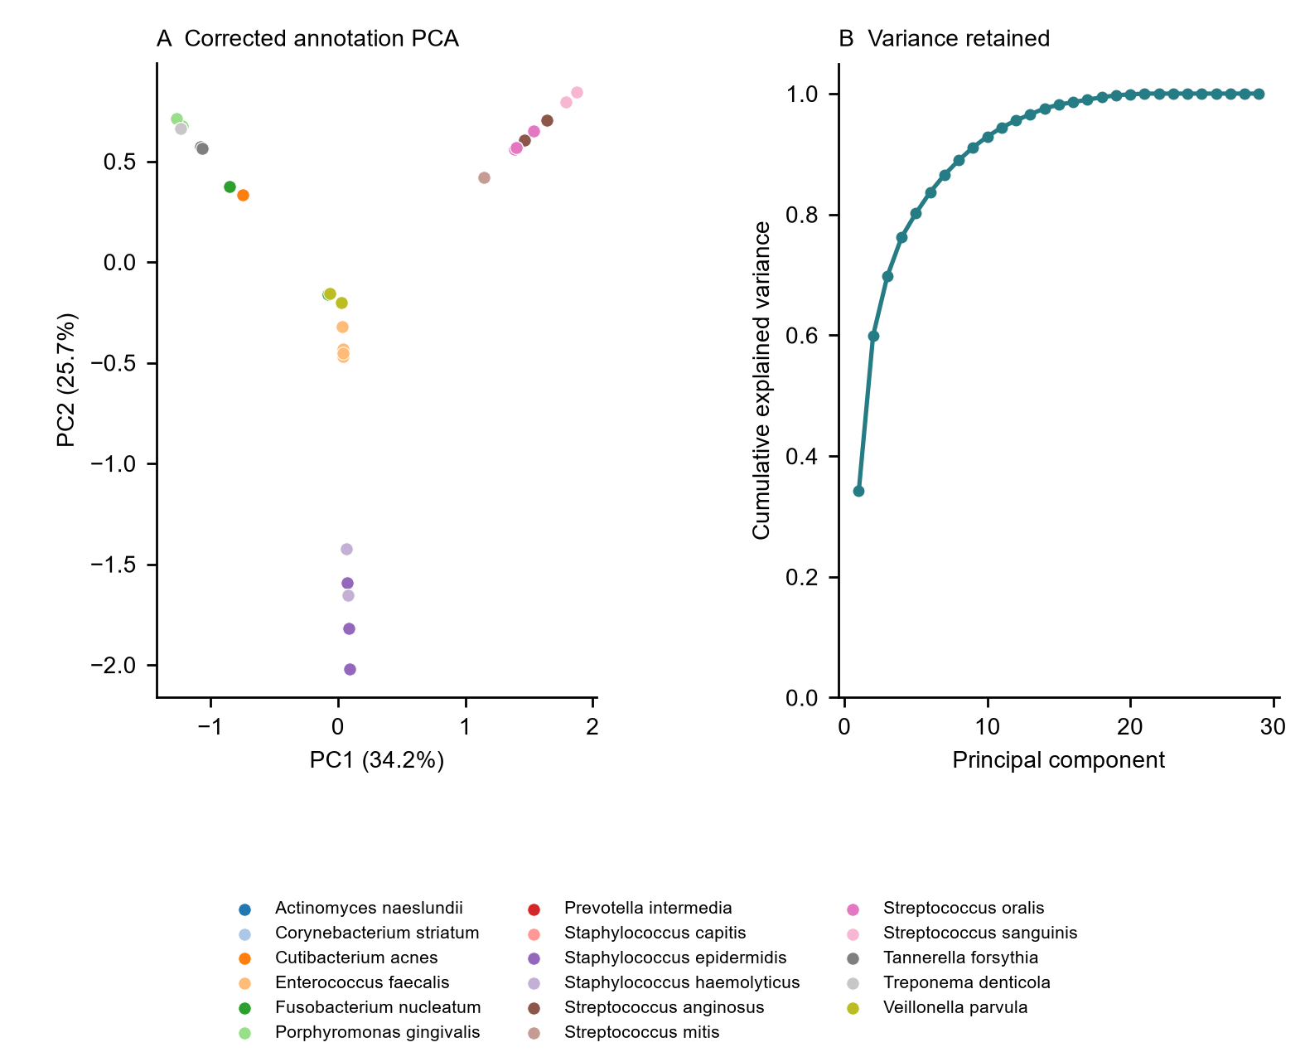
Figure S1. Exploratory PCA of the corrected binary annotation-category matrix (A) and cumulative explained variance (B). PC1 and PC2 explain 34.2% and 25.7% of variance. Points represent assemblies; patterns are not filler-associated biofilm phenotypes.

