**A3 – User interface prototype**

This prototype seeks to preview and test the user interface of our web application, helping to not only identify but also find new user requirements. Takins this into consideration we developed a three-part artefact with: overview of the interface and features common to all pages; sitemap; storyboards.

1 - Interface and common features *

1

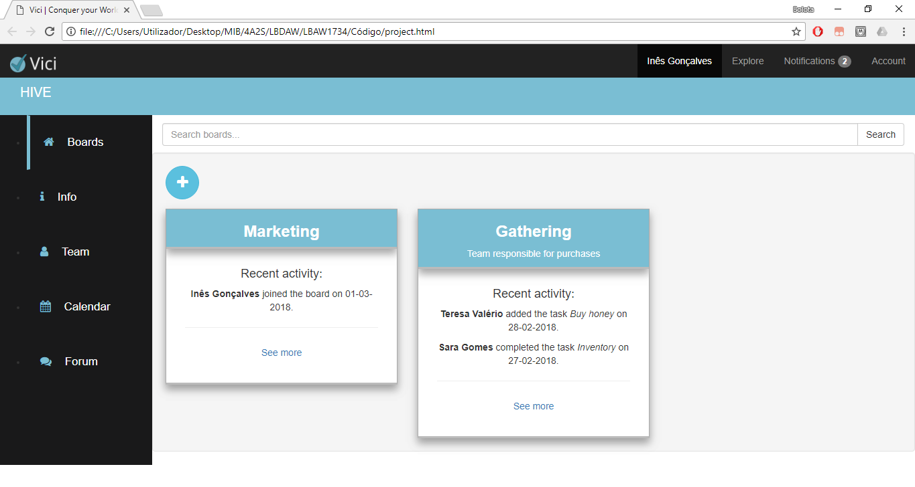

6

5

4

3

2

Figura : Basic interface elements

1. Page title
2. Logo
3. Breadcrumbs
4. Sidebar
5. Navbar
6. Content

* Features common to all pages except homepage.

We opted to have a fixed sidebar to ease transition between pages and a breadcrumb system so the user can keep track of their position on the website and define a clear hierarchy of information. The navbar and its links stay the same throughout the website to make user experience consistent. Colours were chosen to keep a soft look, easy to work with even for long periods of time.

2 - Sitemap

The sitemap was built so the team could have a visual representation of the relationship between different pages. It is important to note that the administration page is only available to users that have administrator permissions.

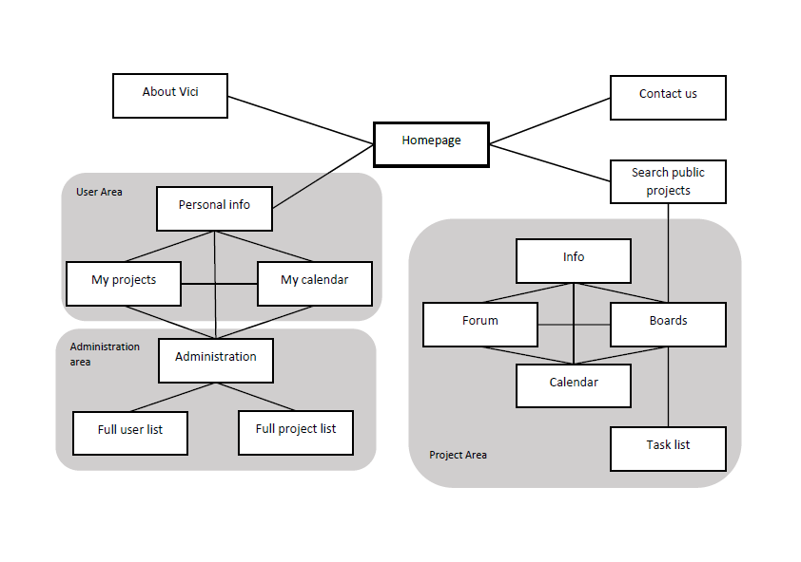

Figura 2: Sitemap

3 – Storyboards

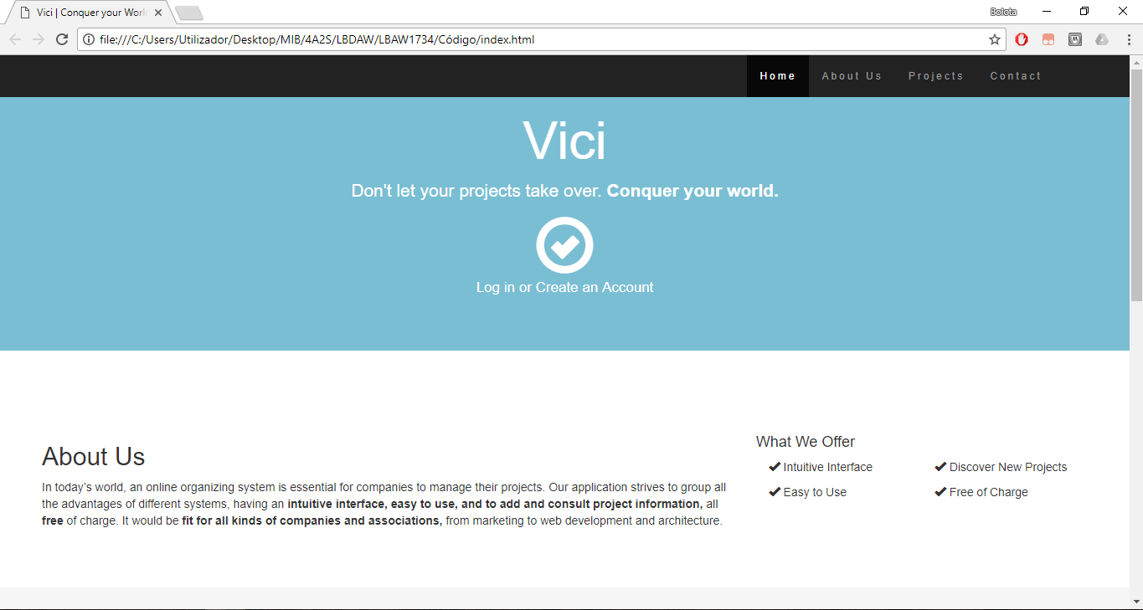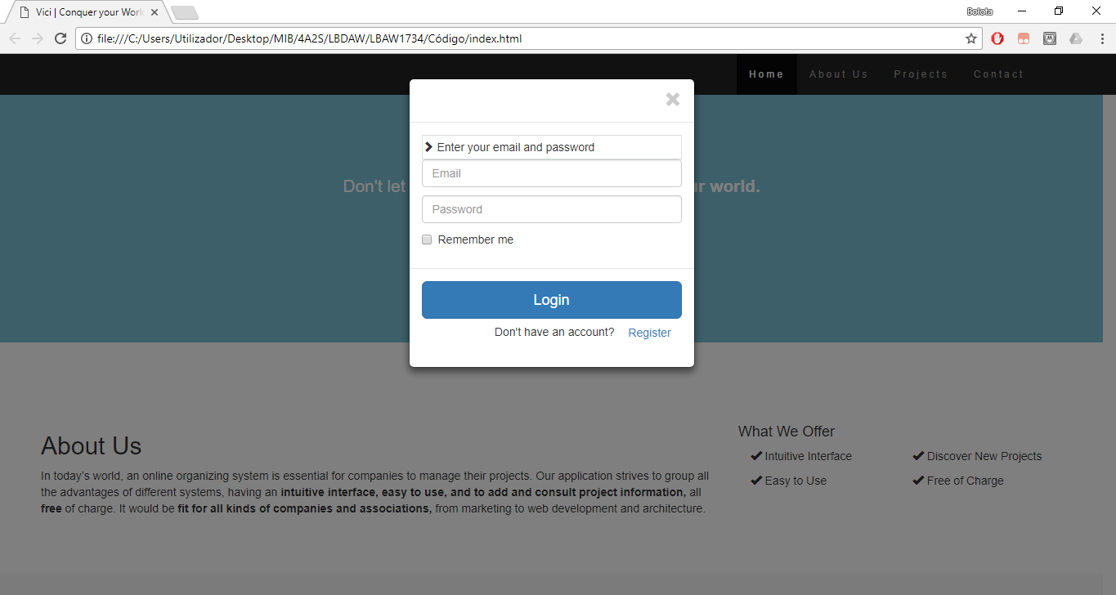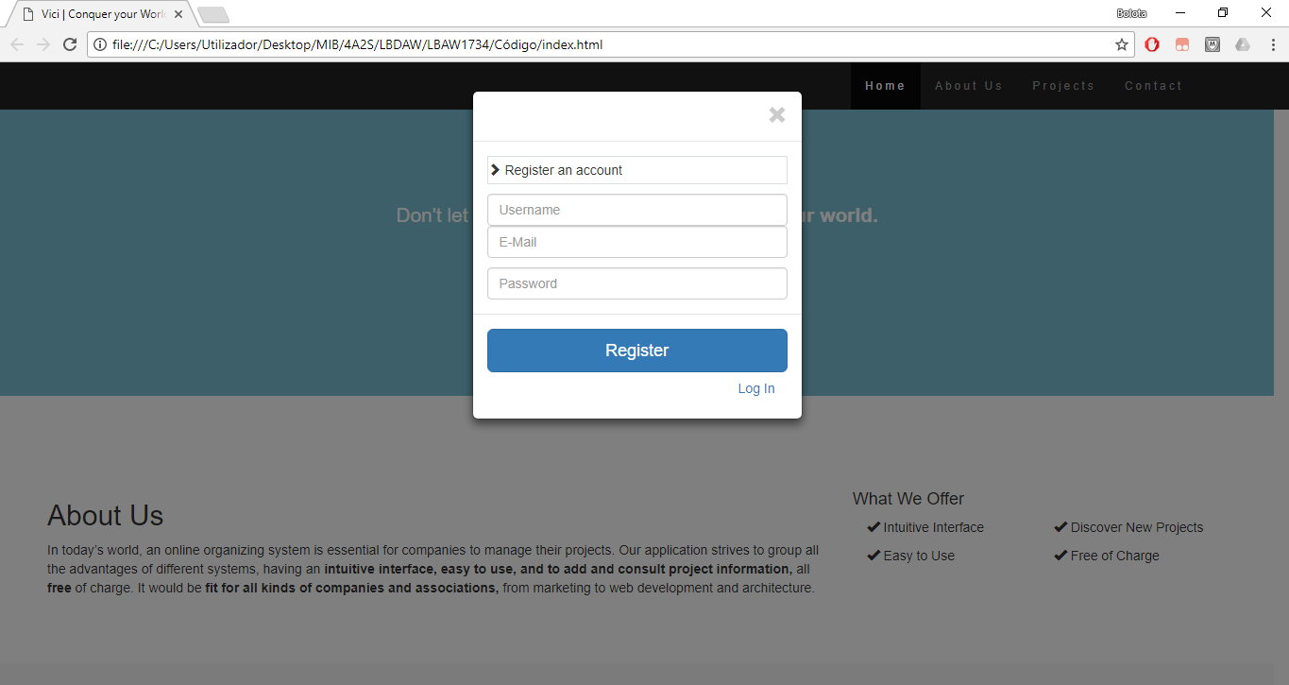

Figura 3: Wireflow centered on the homepage.

After logging in the user can access the main portion on the website and no longer has access to the homepage until log out.

Figura 4: Wireflow centered on the user and project areas

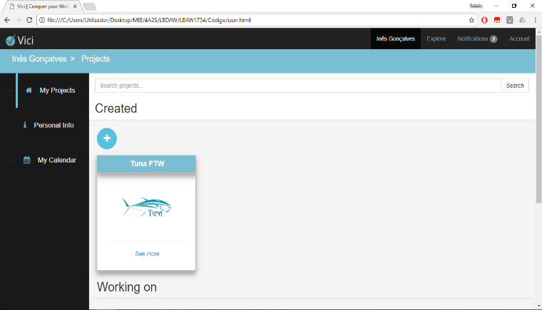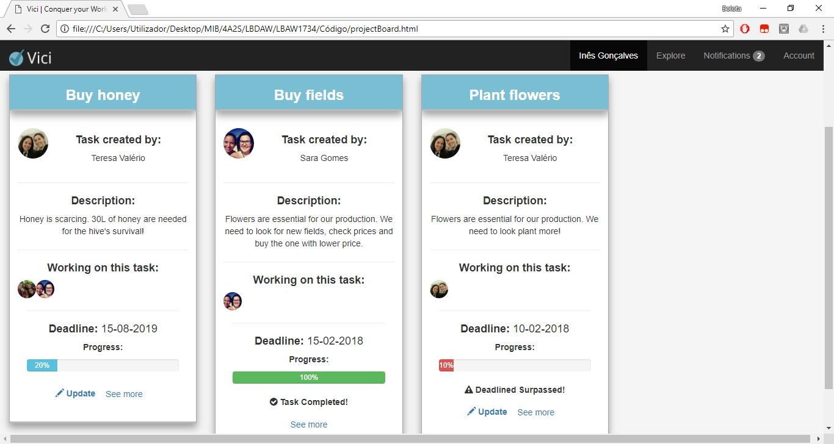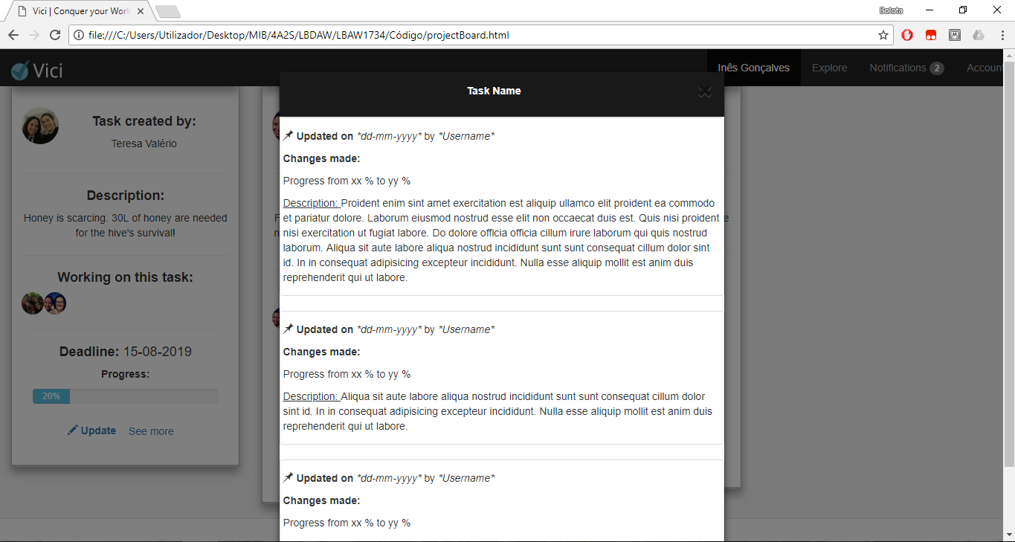

4 – Interfaces

**UI01: Home**

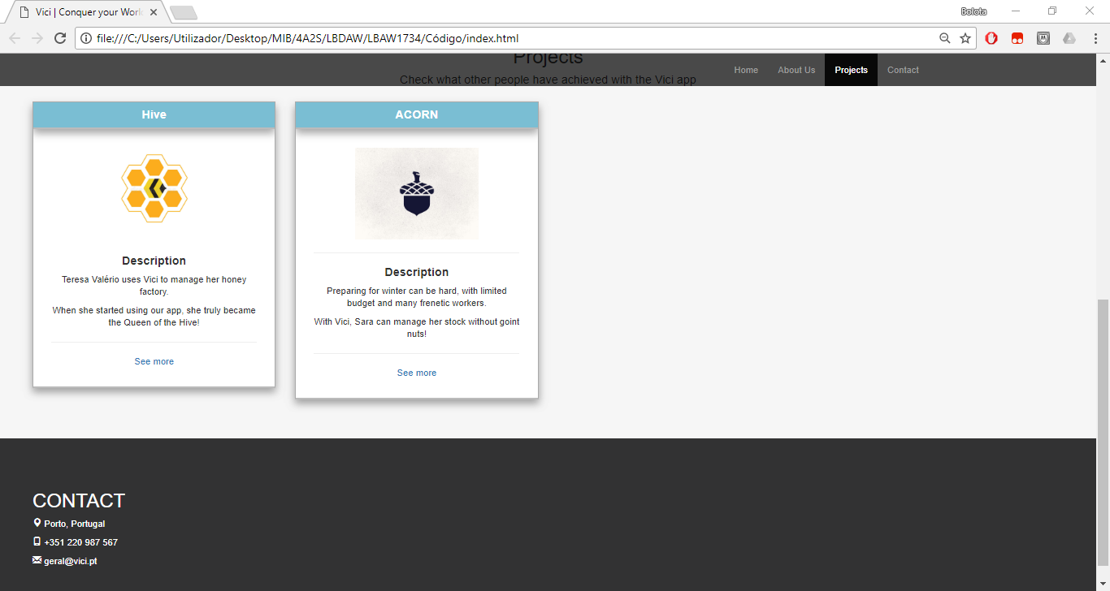

Figura : Homepage.

**UI02 – Log in**

Figura : Log in page.

**UI03 – Register**

Figura : register page.

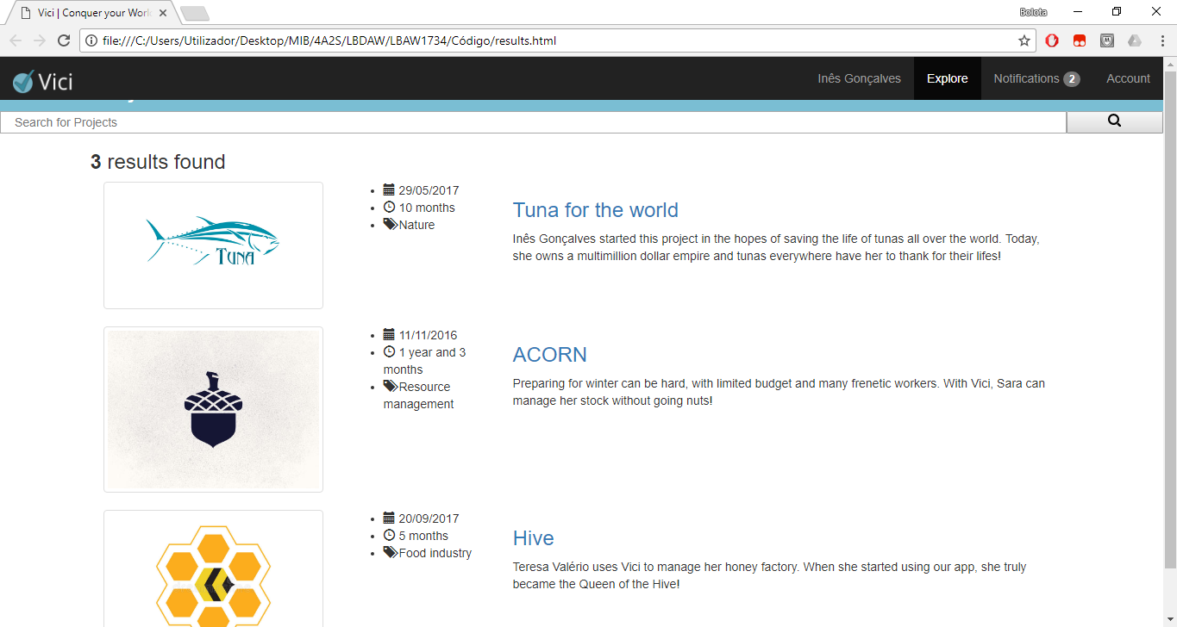**UI04 – Explore**

Figura : explore page.

**UI05 – User projects**

Figura : user projects page.

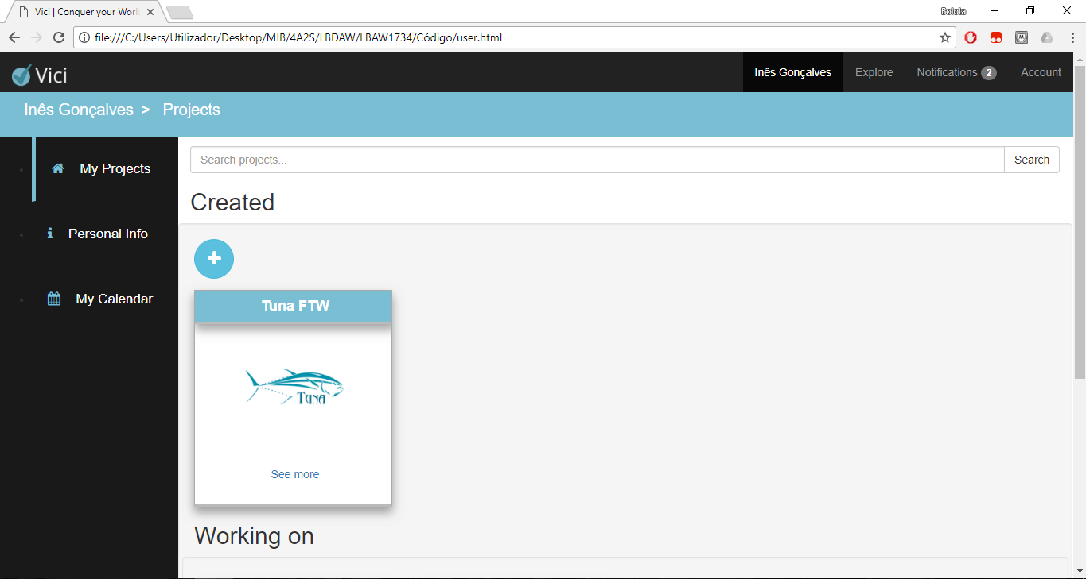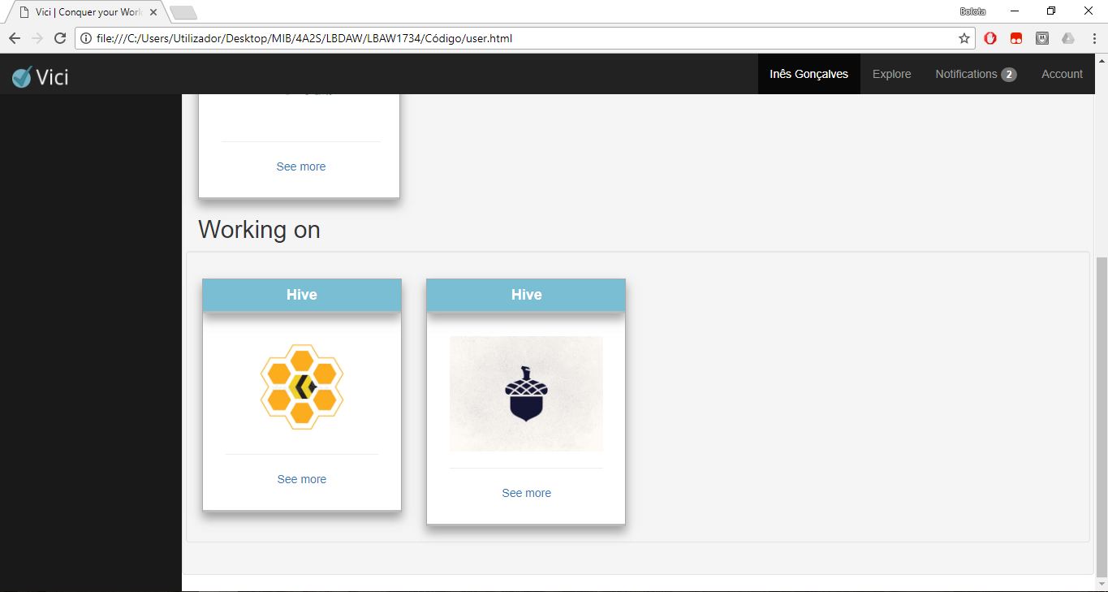

**UI06 – User info**

Figura : user information page.

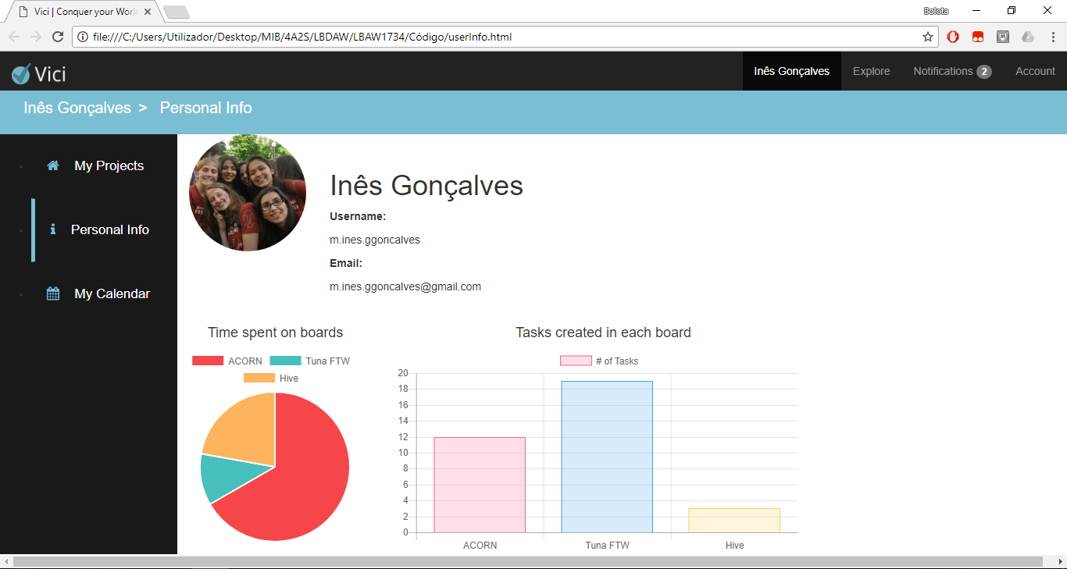

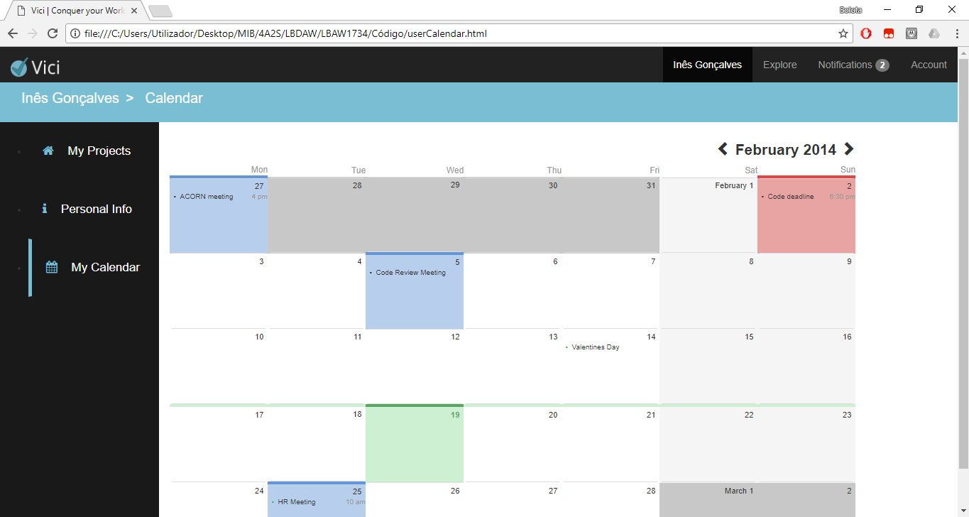**UI07 – User calendar**

Figura : user calendar page.

**UI08 – Project boards**

Figura : project boards page.

**UI09 – Project info**

Figura : project information page.

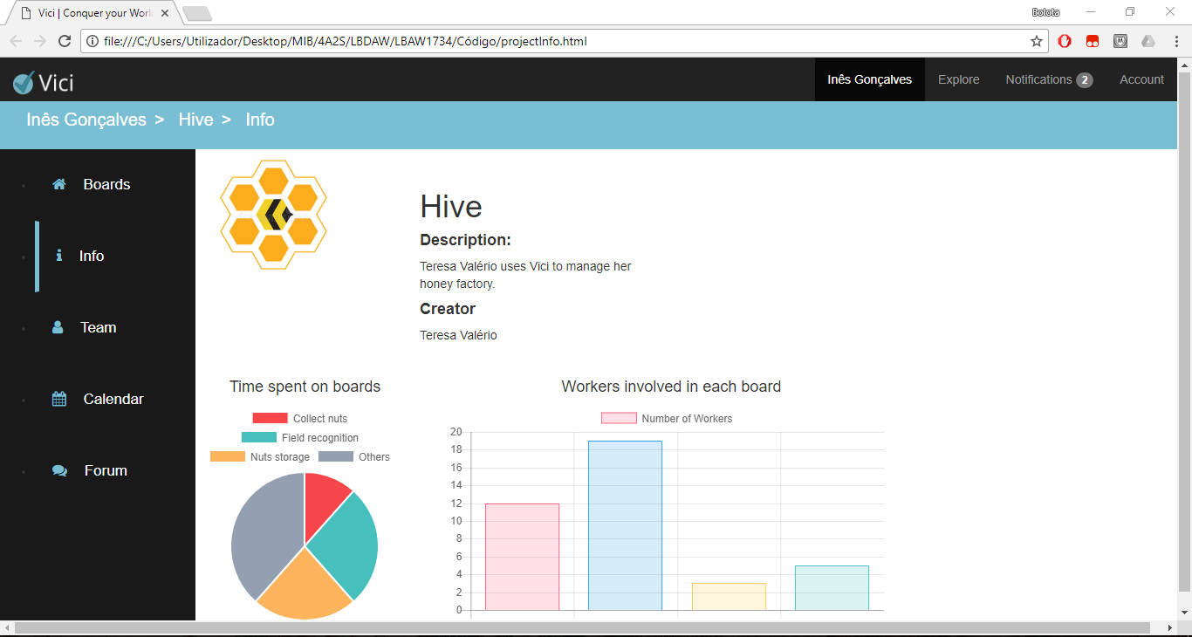

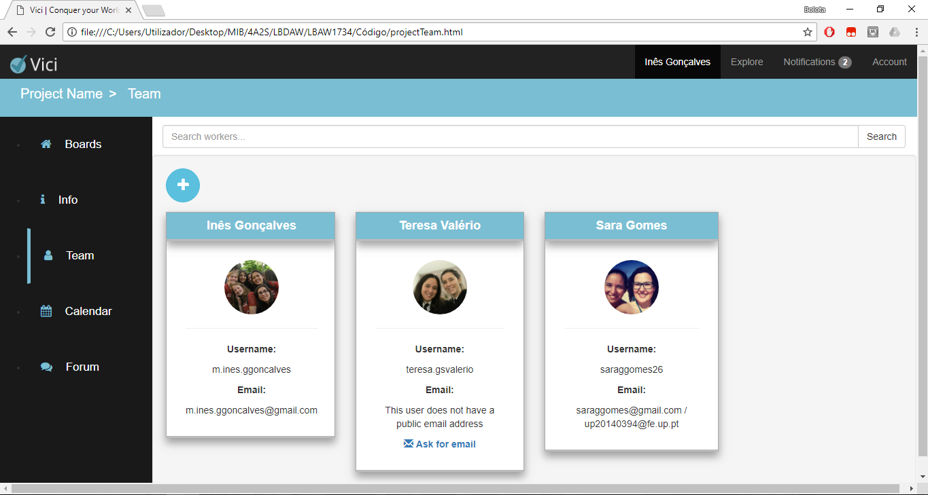**UI10 – Project team**

Figura : project team page.

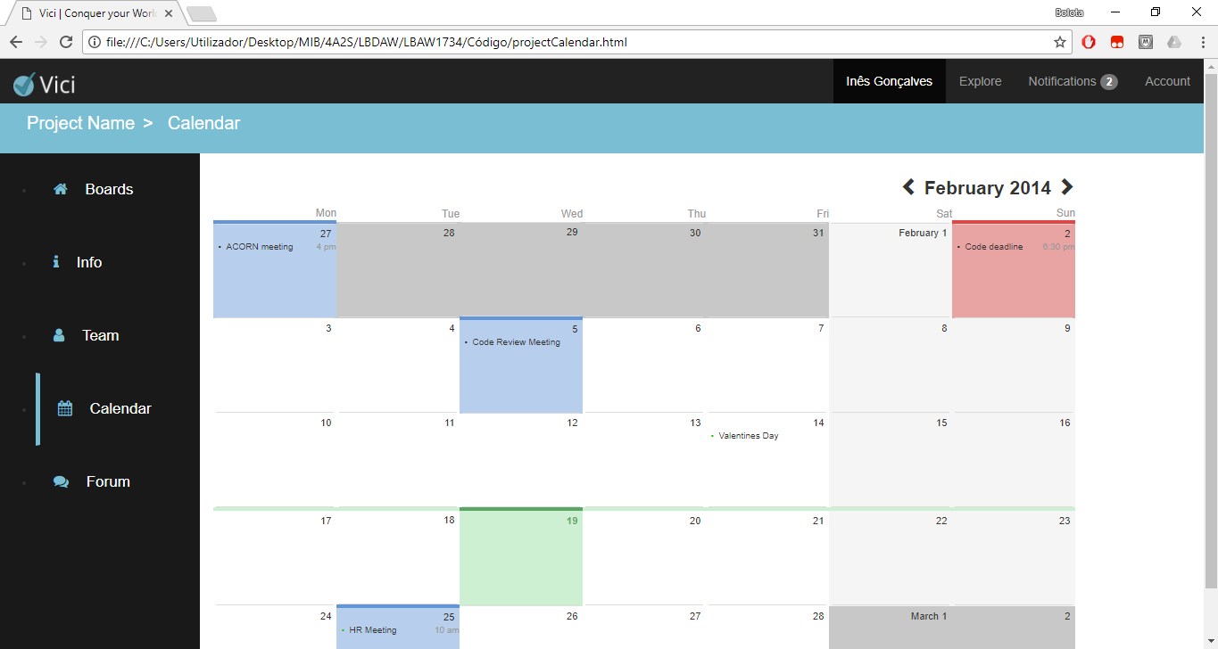**UI11 – Project calendar**

Figura : project calendar page.

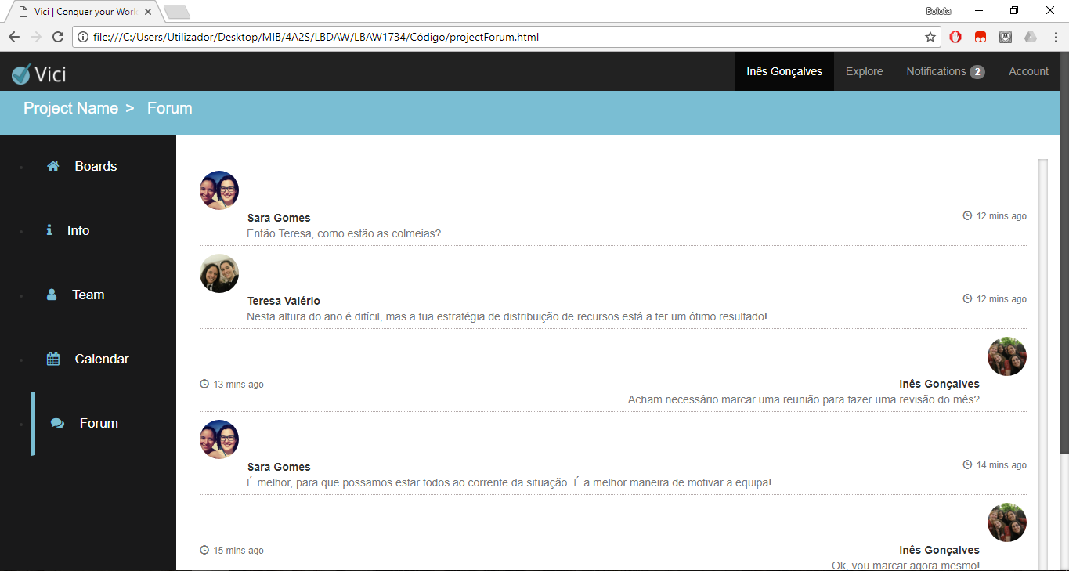**UI12 – Project forum**

Figura : project forum page.

**UI13 – Board tasks**

Figura : board tasks page.

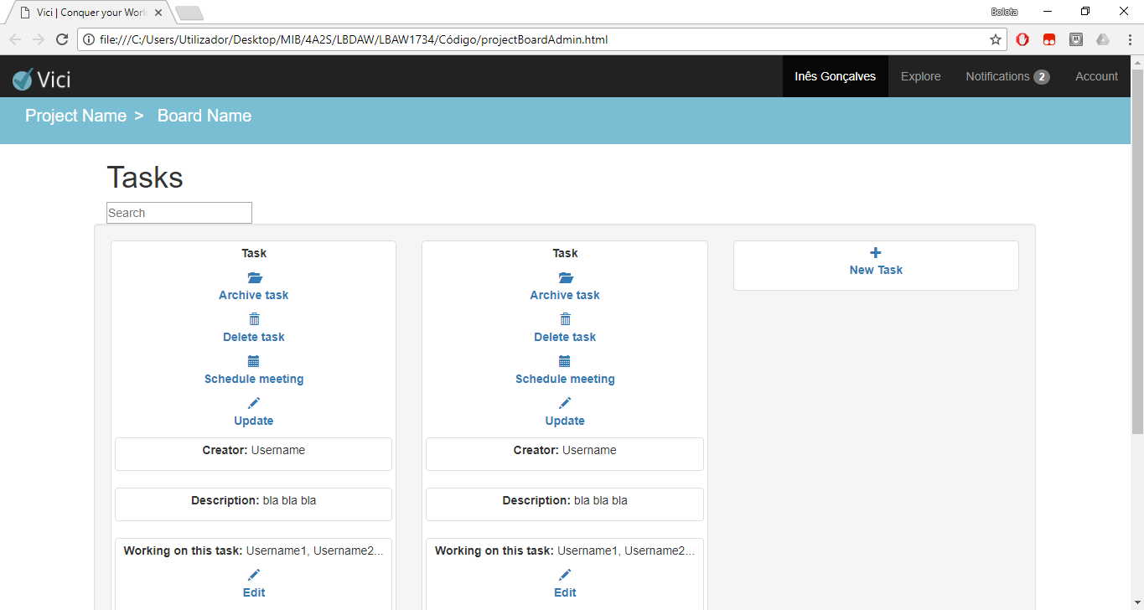**UI14 – Board tasks (coordinator version)**

Figura 18: board tasks page for project coordinators.

**UI15 – Task description**

**UI16:**

Figura : task description page.